

Darshan University

A Project Report on

**“College Management System”**

Under the subject

**Software Engineering (2301CS405)**

B. Tech, Semester – IV

Computer Science & Engineering Department

|  |  |
| --- | --- |
| Submitted By | |
| Student Name: Harshil Solanki | Enrollment No : 23010101256 |
| Academic Year  (2024-2025) | |
| Internal Guide  Prof. R. B. Gondaliya  Darshan University | Dean-DIET  Dr. Gopi Sanghani  Darshan University |

|  |  |
| --- | --- |
|  | **Computer Science & Engineering Department**  **Darshan University** |

**DECLARATION**

We hereby declare that the SRS, submitted along with the **Software Engineering** **(2301CS405)** for entitled **“College Management System”** submitted in partial fulfilment for the Semester-5 of **Bachelor Technology (B. Tech)** in **Computer Science and Engineering (CSE)** Departmentto Darshan University, Rajkot, is a record of the work carried out at **Darshan University, Rajkot** under the supervision of R. B. Gondaliya and that no part of any of report has been directly copied from any students’ reports, without providing due reference.

Harshil Solanki

(Student’s Signature)

Date: __________

|  |  |
| --- | --- |
|  | **Computer Science & Engineering Department**  **Darshan University** |

**CERTIFICATE**

This is to certify that the SRS on **“College Management System” has** been satisfactorily prepared by **Solanki Harshil** (**23010101256**) under my guidance in the fulfillment of the course **Software Engineering (2301CS405)** work during the academic year 2024-2025.

|  |  |  |
| --- | --- | --- |
| Internal Guide  Prof. R. B. Gondaliya  Darshan University |  | Dean-DIET  Dr. Gopi Sanghani  Darshan University |

**Acknowledgement**

I wish to express my sincere gratitude to my project guide Prof. R. B. Gondaliyaand all the faculty members for helping me through my project by giving me the necessary suggestions and advices along with their valuable co- ordination in completing this work.

I also thank my parents, friends and all the members of the family for their precious support and encouragement which they had provided in completion of my work. In addition to that, I would also like to mention the Darshan University personals who gave me the permission to use and experience the valuable resources required for the project from the University premises.

Thus, in conclusion to the above said, I once again thank the faculties and members of **Darshan University** for their valuable support in completion of the project.

Thanking You

**Solanki Harshil**

**ABSTRACT**

The College Management System is designed to streamline and automate various administrative and academic processes within an educational institution. It aims to enhance efficiency, accuracy, and accessibility of information for students, faculty, and administrative staff. This system offers a comprehensive solution for managing student admissions, course registrations, examination schedules, grading, and feedback. It also facilitates faculty management, including assigning roles, tracking performance, and updating course materials. For administrative staff, the system provides tools for managing finances, generating reports, and maintaining secure records. By integrating these functions into a single platform, the College Management System reduces manual workload, minimizes errors, and improves overall communication and collaboration within the institution.

This abstract provides a clear and concise overview of the system, highlighting its main features and benefits. If you need further details or adjustments, feel free to let me know!

**Table of Contents**

–

List of Figures I

List of Tables II

1 Introduction 1

1.1 Product perspective 1

1.2 Product features 1

1.2.1 There are three different users who will be using this product: 1

1.2.2 The features that are required for the Admin are: 1

1.2.3 The features that are required for the Student are: 1

1.2.4 The features that are required for the Faculty are: 1

1.3 Functional Requirement 2

1.3.1 Admin 2

1.3.2 Student 2

1.3.3 Faculty 2

1.4 Non-Functional Requirement 2

1.4.1 Usability: 2

1.4.2 Accuracy: 2

1.4.3 Availability: 2

1.4.4 Maintainability: 2

2 Design and Implementation Constraints 3

2.1 Use case diagram 3

2.2 Activity diagram and Swimlane diagram 4

2.3 Sequence diagram 7

2.4 State diagram 8

2.5 Class diagram 9

2.6 Data flow diagram 10

2.6.1 Context diagram (level-0) 10

2.6.2 DFD Level-1 10

2.6.3 DFD Level-2 11

3 External interface requirement (Screens) 12

3.1 Screen-1: Update Attendance 12

3.2 Screen-2: Download Study Materials 12

3.3 Screen-3: Response to Feedback 14

3.4 Screen-3: Course Assignment 15

3.5 Screen-3: Fee Payment 16

4 Database design 17

4.1 List of Tables 17

5 Stories and Scenario 19

5.1 Story-1: Add New Book in Library Catalogue 19

5.1.1 Scenario# S1.1 19

5.1.2 Scenario# S1.2 19

5.1.3 Scenario# S1.3 19

5.2 Story-2: Search Book 20

5.3 Story-3: Manage due date for borrowed book 20

5.4 Story-4: Renew book 20

5.5 Story-5: Generate a report on book usage and availability 20

6 Test cases 21

7 References 25

# List of Figures

Figure 2.1‑1 Use case diagram for College Management System 3

Figure 2.2‑1 Activity diagram for Next Semester Registration 4

Figure 2.2‑2 Activity diagram for Examination 5

Figure 2.2‑3 Swimlane diagram for Next Semester Registration 6

Figure 2.3‑1 Sequence diagram for Book Issue 7

Figure 2.4‑1 State diagram of Book 8

Figure 2.4‑2 State diagram for Librarian 8

Figure 2.5‑1 Class diagram for Library management system 9

Figure 2.6‑1 Context diagram for Library management system 10

Figure 2.6‑2 DFD level-1 for Library management system 10

Figure 2.6‑3 DFD level-2 for Issue book 11

Figure 3.1‑1 Screen-1: Registration Form 12

Figure 3.2‑1 Screen-2: Login Form 13

Figure 3.3‑1 Screen-3: Add borrower book 14

# List of Tables

Table 3.1‑1 Screen element of Registration form 12

Table 3.2‑1 Screen element of Login form 13

Table 3.3‑1 Screen element of Add borrower book 14

Table 4.1‑1 Table: Book 15

Table 4.1‑2 Table: Borrower 15

Table 4.1‑3 Table: Staff 15

Table 4.1‑4 Table: Student 15

# Introduction

## Product perspective

This project transforms the college management system into an online platform, making it easy to manage various tasks. Admins can handle branches, students, and faculty data, schedule exams, and manage attendance. Students can view grades, update profiles, check class schedules, upload assignments, give feedback, download study materials, and pay fees online. Faculty members can view records, upload content, check salaries, manage assignments, give grades, and respond to feedback. This system simplifies administrative and academic tasks, making everything more efficient and accessible.

## Product features

### There are three different users who will be using this product:

* Admin who will be handle the software.
* Student Accesses academic resources and personal profiles.
* Faculty Manages course content and student assignments.

### The features that are required for the Admin are:

* New branch will be entered in database
* Any changes in branch should be updated in database.
* If University wants to remove branch for their upcoming year then removed from system
* New student data can be add in the database
* if New Faculty join then faculty data can be add in the database
* Admina can schedule exams
* Admin can Upload the feedback for Faculty, course and teaching assistance
* Admin is able to view the Attendance of Students and Staff
* Can Change the Attendance of any Student and Staff
* Assign courses to faculty members

### The features that are required for the Student are:

* can see their grade of the exam
* can view their profile
* can update their profile
* can see their class for the upcoming lectures
* can upload assignment given by faculty
* can give feedback on Faculty, Teaching assistance and Course
* can download the study material uploaded by the faculty
* can Pay their fee using upi or netbanking.

### The features that are required for the Faculty are:

* can view their records
* can upload subject related content so that student can have benefit of it
* can check salary of till the join date
* login in their account
* can view the assignment upload by the student
* can give grade on student assignment
* can upload ppt and pdf
* can respond to feedback if necessary
* can delete their profiles

## Functional Requirement

### Admin

* Add Branch: New branch will be entered in database
* Update Branch: Any changes in branch should be updated in database.
* Remove Branch: If University wants to remove branch for their upcoming year then removed from system
* Add Student : New student data can be add in the database
* Add Faculty : if New Faculty join then faculty data can be add in the database
* Schedule Exams: Admina can schedule exams
* Upload Feedback: Admin can Upload the feedback for Faculty, course and teaching assistance
* View Attendance : Admin is able to view the Attendance of Students and Staff
* Update Attendance: Can Change the Attendance of any Student and Staff
* Course Assignment: Assign courses to faculty members

### Student

* View Grade: Student can see their grade of the exam
* View Student Profile : Student Can view their profile
* Update Profile: Student can update their profile
* View Class : Student can see their class for the upcoming lectures
* Assignment Upload : Student can upload assignment given by faculty
* Give Feedback : Student can give feedback on Faculty, Teaching assistance and Course
* Download Contant : Student can download the study material uploaded by the faculty
* Fee Payment : Student can Pay their fee using upi or netbanking

### Faculty

* Faculty Record : Faculty can view their records
* Upload Video : Faculty can upload subject related content so that student can have benefit of it
* Check Salary : Faculty can check salary of till the join date
* Login : login in their account
* Assignment view : Faculty can view the assignment upload by the student
* Give Grade : Faculty can give grade on student assignment
* Upload study material : Faculty can upload ppt and pdf
* Response to Feedback : Faculty and admin can respond to feedback if necessary
* Profile Deletion: Faculty members can delete their profile

## Non-Functional Requirement

### Usability:

* The UI should be simple enough for everyone to understand and get the relevant information without any special training. Different languages can be provided based on the requirements.

### Accuracy:

* The data stored about the books and the fines calculated should be correct, consistent, and reliable.

### Availability:

* The System should be available for the duration when the library operates and must be recovered within an hour or less if it fails. The system should respond to the requests within two seconds or less.

### Maintainability:

* The software should be easily maintainable and adding new features and making changes to the software must be as simple as possible. In addition to this, the software must also be portable.

# Design and Implementation Constraints

## Use case diagram

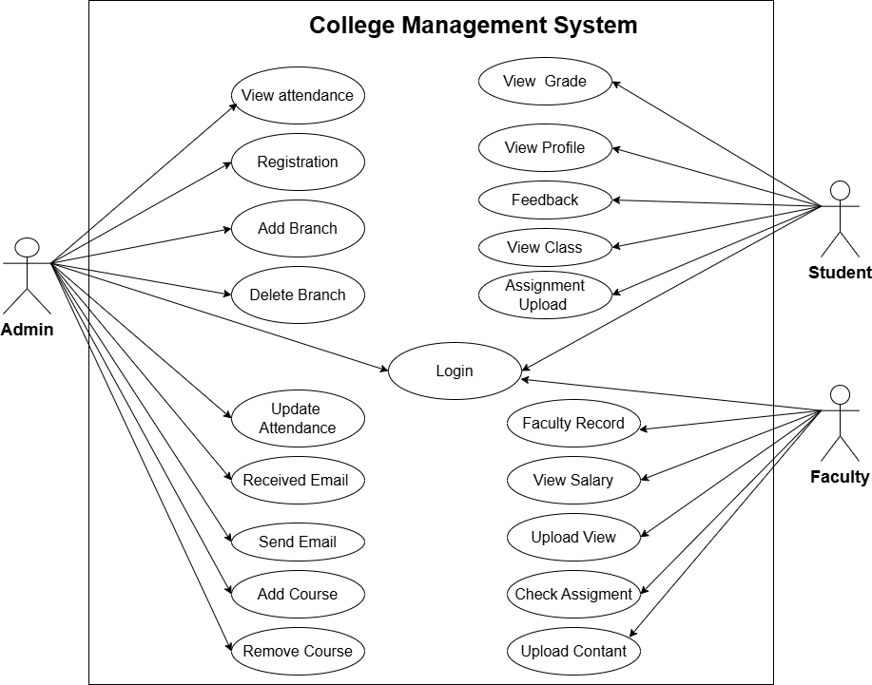

Figure 2.1‑1 Use case diagram for College Management System

## Activity diagram and Swimlane diagram

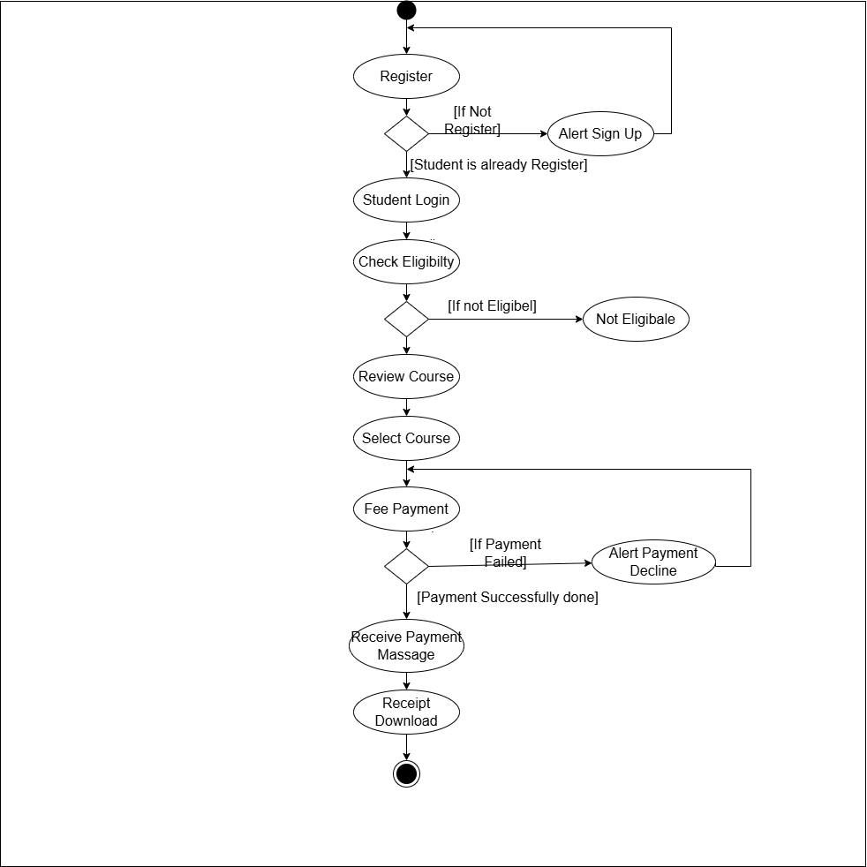

Figure 2.2‑1 Activity diagram for Next Semester Registration

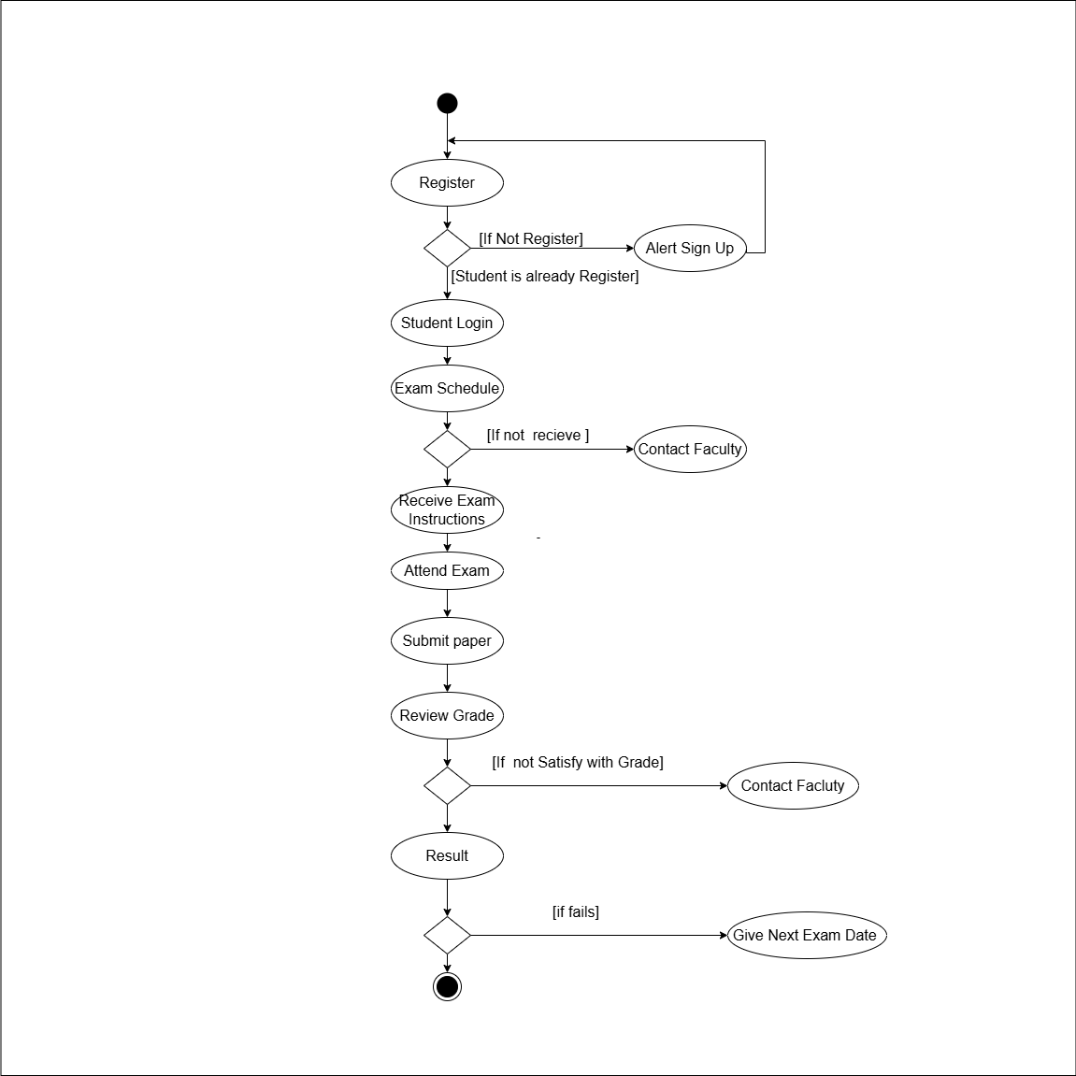

Figure 2.2‑2 Activity diagram for Examination

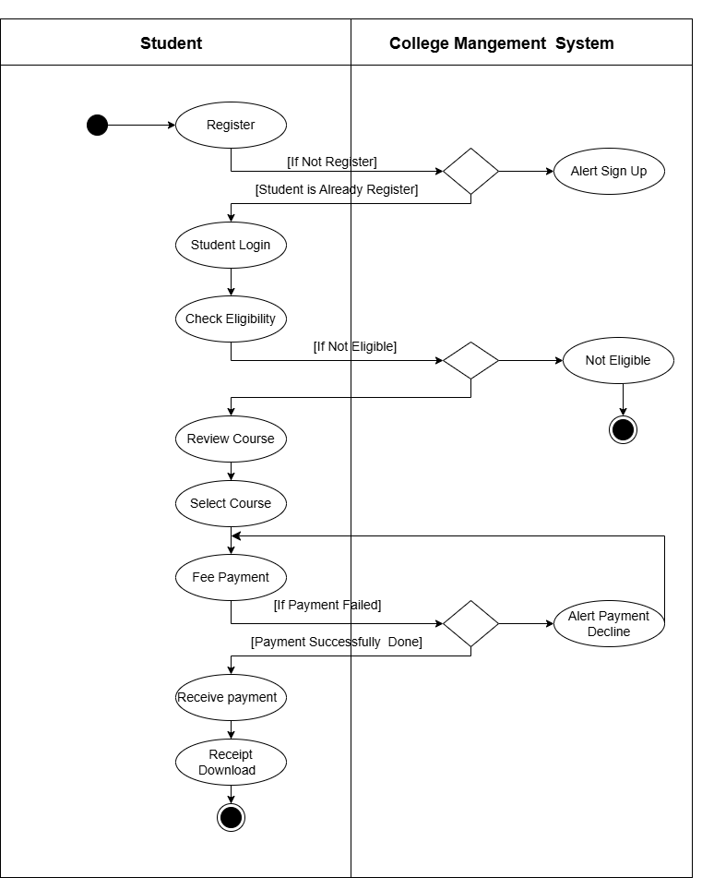

Figure 2.2‑3 Swimlane diagram for Next Semester Registration

## Sequence diagram

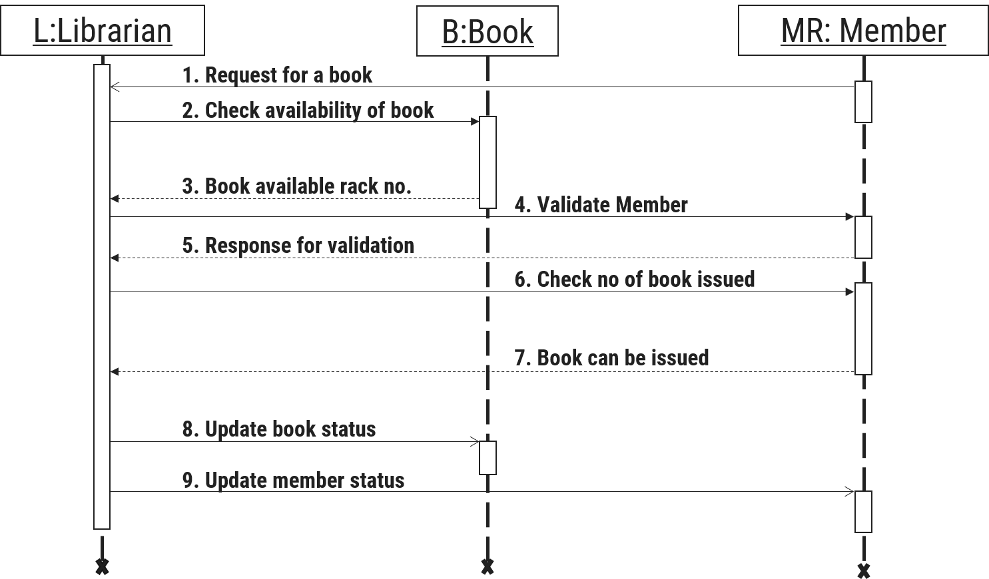

Figure 2.3‑1 Sequence diagram for Book Issue

## State diagram

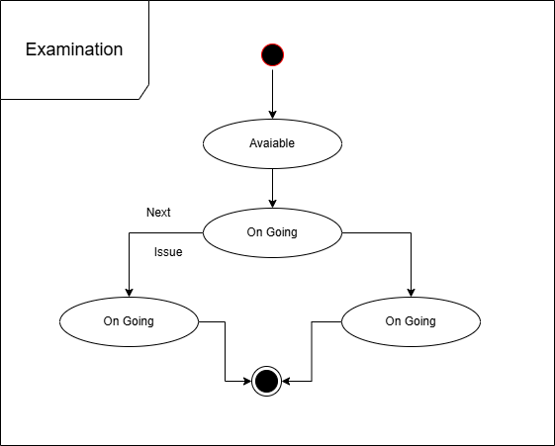

Figure 2.4‑1 State diagram of Examination

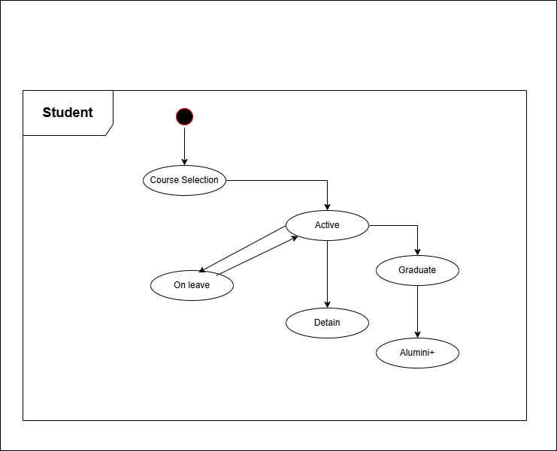

Figure 2.4‑2 State diagram for Student

## Class diagram

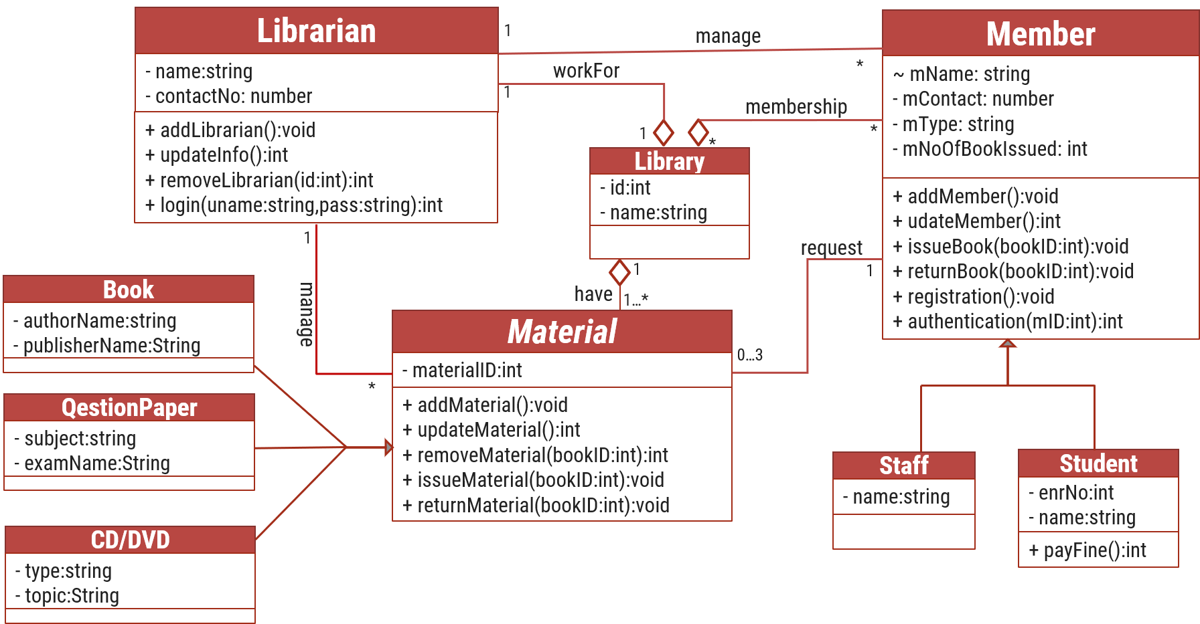

Figure 2.5‑1 Class diagram for Library management system

## Data flow diagram

### Context diagram (level-0)

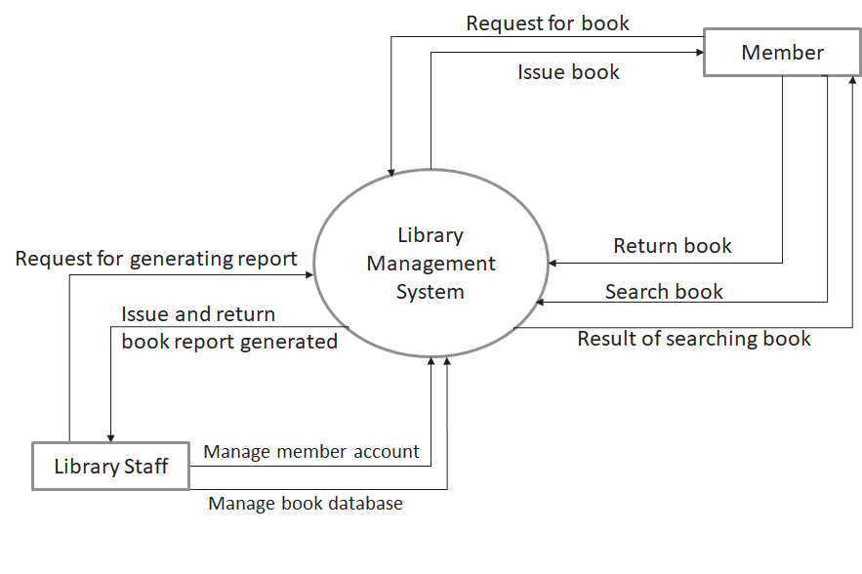

Figure 2.6‑1 Context diagram for Library management system

### DFD Level-1

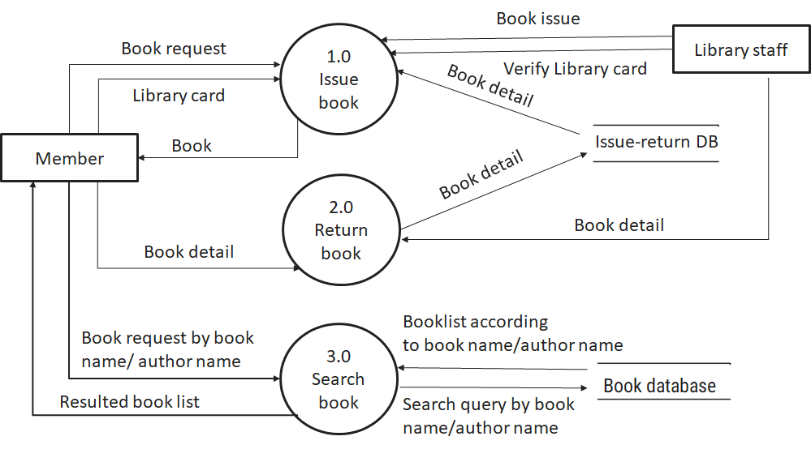

Figure 2.6‑2 DFD level-1 for Library management system

### DFD Level-2

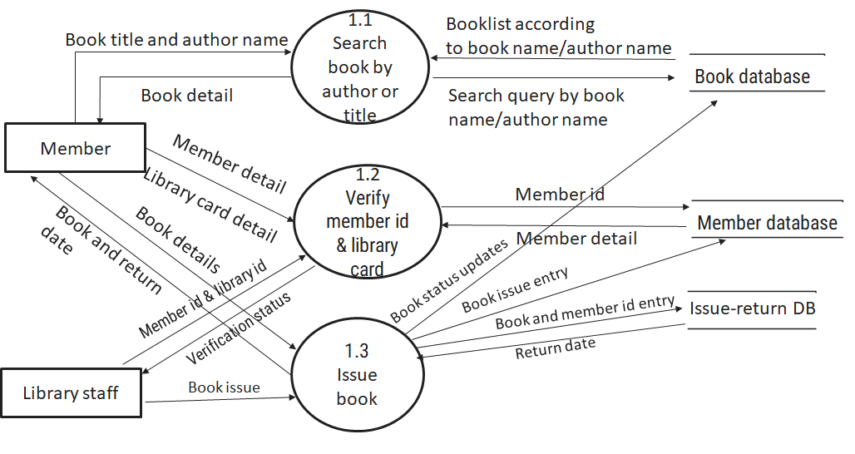

Figure 2.6‑3 DFD level-2 for Issue book

# External interface requirement (Screens)

## Screen-1: Update Attendance

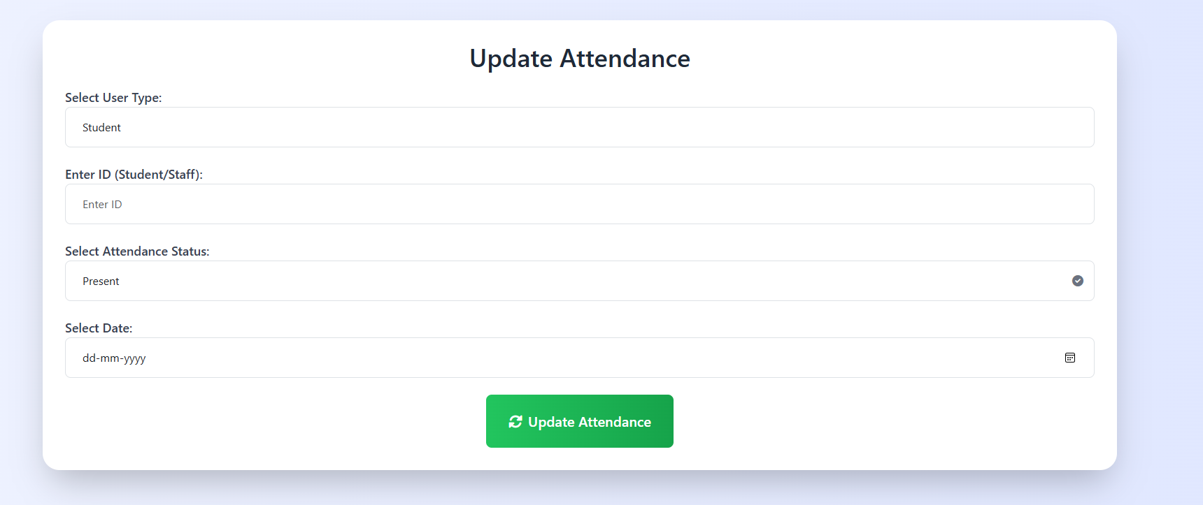

Figure 3.1‑1 Screen-1: Update Attendance

**Purpose:** The purpose of updating attendance is to track and record the presence or absence of individuals, ensuring accurate data for work, school, or events. It helps manage schedules, monitor participation, and maintain accountability.

Table 3.1‑1 Screen element of Update Attendance

|  |  |  |  |  |  |
| --- | --- | --- | --- | --- | --- |
| Sr. | Screen Element | Input Type | O/M | 1/N | Description |
| 1 | User Type | Textbox | M | N | select whether the attendance being updated is for a Student or Staff member, ensuring accurate tracking based on the type of user. |
| 2 | ID | Textbox | M | 1 | unique identification number of the selected Student or Staff, enabling the system to accurately update the attendance record for the specific individual. |
| 3 | Attendance Status | dropdown | M | N | select the attendance condition (e.g., **Present**, **Absent**) for the selected Student or Staff, providing a clear record of their participation. |
| 4 | Date | Datetime | M | 1 | specific date for which the attendance is being updated, ensuring accurate record-keeping of attendance for that day. |

## Screen-2: Download Study Materials

––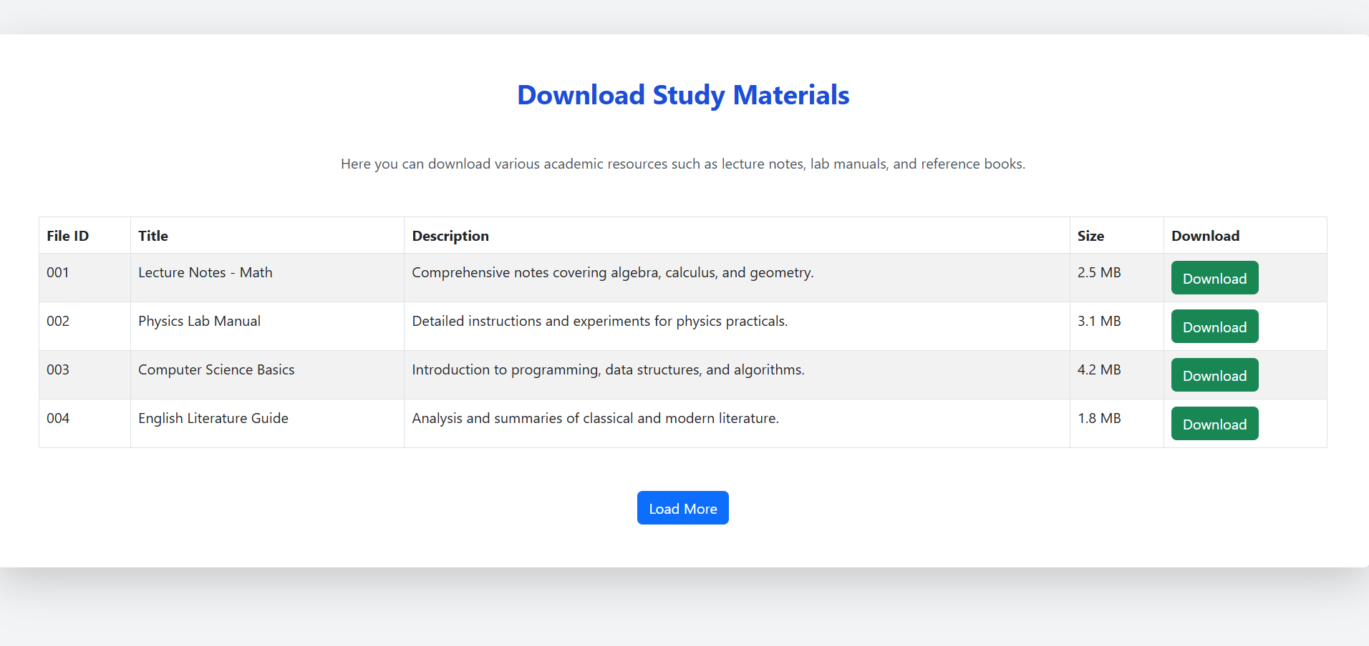

Figure 3.2‑1 Screen-2: Download Study Materials

**Purpose:** The purpose of downloading study material is to provide easy access to educational resources, allowing learners to review and study content at their own pace. It helps in enhancing knowledge and preparing effectively for exams or assignments.

Table 3.2‑1 Screen-3 element of Download Study Materials

|  |  |  |  |  |  |
| --- | --- | --- | --- | --- | --- |
| Sr. | Screen Element | Input Type | O/M | 1/N | Description |
| 1 | File ID | Textbox | M | 1 | A unique identifier assigned to each file, helping in tracking and managing the file within the system. |
| 2 | Title | Textbox | M | 1 | The title represents the file's name or subject, providing users with a quick overview of the file's content. |
| 3 | Description | Textbox | O | 1 | A brief summary that explains the contents or purpose of the file, offering users more context before downloading. |
| 4 | Size | Textbox | O | ------ | Displays the file's size, giving users an idea of how much storage space it will occupy before downloading. |
| 5 | Download | Button | M | 1 | A button that allows users to download the file directly to their device with a single click. |
| 6 | Load more | Button | O | ------ | A button that enables users to view additional files or content, improving the browsing experience without overwhelming the page. |

## Screen-3: Response to Feedback

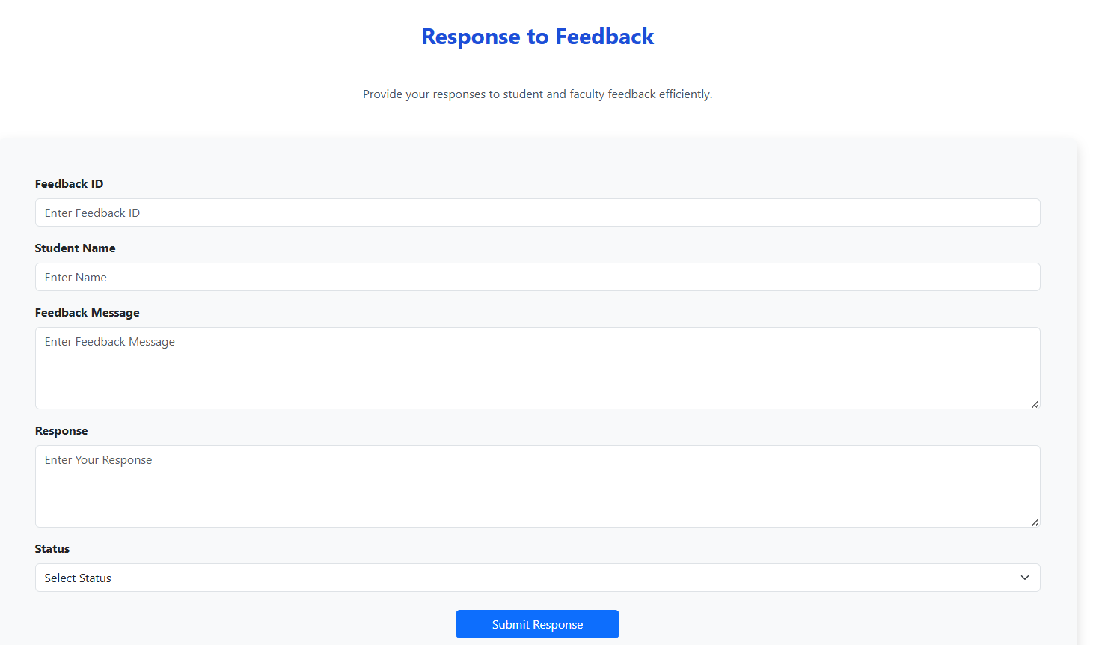

Figure 3.3‑1 Screen-3: Response to Feedback

**Purpose:** The purpose of faculty responding to feedback from students is to acknowledge their concerns, provide guidance, and foster a supportive learning environment. It helps improve teaching methods and ensures that students' voices are heard, promoting continuous growth and development.

Table 3.3‑3 Screen element Response to Feedback

|  |  |  |  |  |  |
| --- | --- | --- | --- | --- | --- |
| Sr. | Screen Element | Input Type | O/M | 1/N | Description |
| 1 | Feedback ID | Textbox | M | 1 | Feedback entry, enabling easy tracking and referencing of specific feedback submissions. |
| 2 | Student Name | Textbox | M | 1 | the name of the student who submitted the feedback, providing context for the response. |
| 3 | Feedback Message | Textbox | M | 1 | It contains the student's feedback, detailing their thoughts, suggestions, or concerns. |
| 4 | Response | Textbox | M | 1 | faculty or staff to provide a reply to the student's feedback, addressing their concerns or comments. |
| 5 | Status | Dropdown | M | N | the current state of the feedback (e.g., **Pending**, **Resolved**, or **Under Review**), showing whether the feedback has been addressed. |
| 6 | Submit Feedback | Button | ----- | ----- | Submit is a button for store the entered data into database. |

## Screen-3: Course Assignment

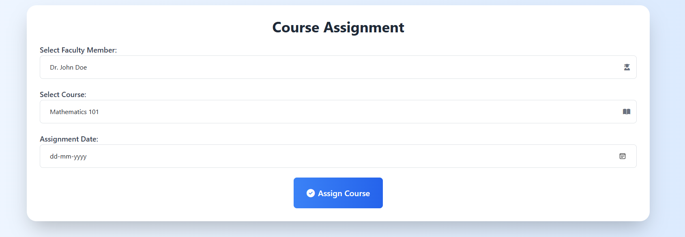

Figure 3.3‑3 Screen-4: Course Assignment

**Purpose:** The purpose of course assignment is to allocate specific courses to faculty members, –ensuring that the right instructor is assigned to teach the course. It helps in managing faculty workloads, scheduling, and ensuring efficient delivery of educational content.

Table 3.3‑4 Screen element of Course Assignment

|  |  |  |  |  |  |
| --- | --- | --- | --- | --- | --- |
| Sr. | Screen Element | Input Type | O/M | 1/N | Description |
| 1 | Faculty Member | Textbox | M | 1 | Profile of the instructor, detailing qualifications, teaching history, and availability. **Course:** Overview including course description, credits, and prerequisites. |
| 2 | Course | Textbox | M | N | Overview including course description, credits, and prerequisites. |
| 3 | Assignment Date | Textbox | M | 1 | Specific deadline for the course assign the date to the faculty |
| 4 | Assign Course | Textbox | ----- | ---- | Middle Name field should be editable and accept only string as a borrower middle name. |

## Screen-3: Fee Payment

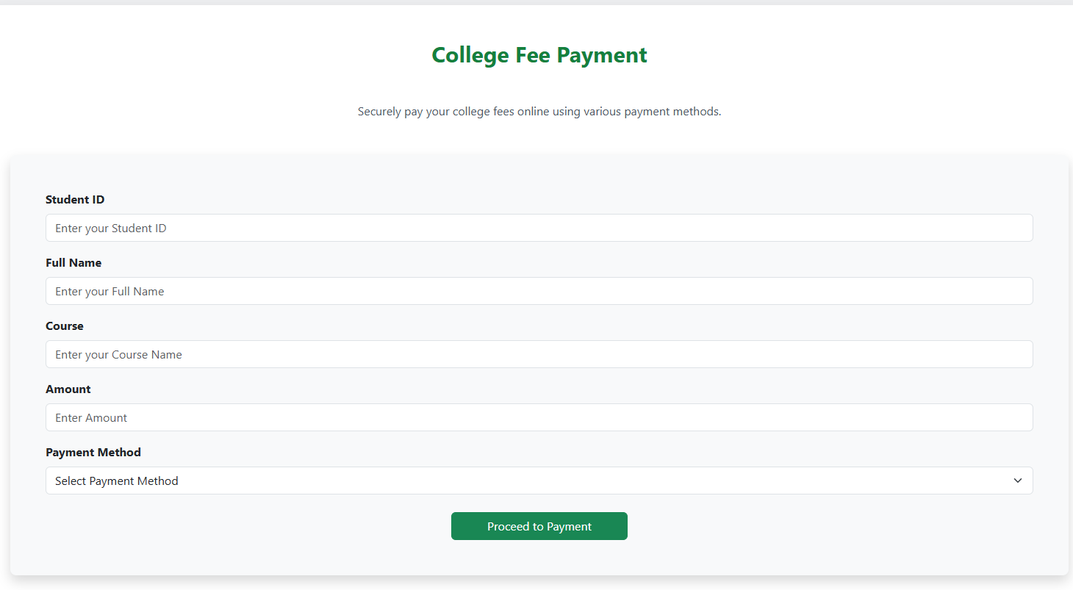

Figure 3.3‑5 Screen-5: Fee Payment

**Purpose:** The purpose of student fee payment to the college is to cover tuition and other academic-related expenses, ensuring continued access to educational services and resources. It supports the college’s financial sustainability and facilitates smooth academic operations for students.

Table 3.3‑1 Screen element of Add borrower book

|  |  |  |  |  |  |
| --- | --- | --- | --- | --- | --- |
| Sr. | Screen Element | Input Type | O/M | 1/N | Description |
| 1 | Borrower ID | Textbox | M | 1 | Borrower ID field should be editable and fill autogenerated Borrower ID. |
| 2 | Student ID | Textbox | M | 1 | Student ID field should be editable and accept Student barcode id. |
| 3 | First Name | Textbox | M | 1 | First Name field should be editable and accept only string as a borrower first name. |
| 4 | Middle Name | Textbox | O | 1 | Middle Name field should be editable and accept only string as a borrower middle name. |
| 5 | Last Name | Textbox | M | 1 | Last Name field should be editable and accept only string as a borrower last name. |
| 6 | Contact | Textbox | M | 1 | Contact field should be editable and accept only 10-digit mobile number. |
| 7 | Grade Id | Textbox | O | 1 | Auto fetch detail from the database if proper student id is entered. |
| 8 | Submit | Button | ----- | ----- | Submit is a button for store the entered data into database. |
| 9 | Cancel | Button | ----- | ----- | Cancel is a button for close add borrower dialog. |

# Database design

## List of Tables

* Admin
* Course
* Faculty
* Student
* Department

Table 4.1‑1 Table: Admin

|  |  |  |  |  |
| --- | --- | --- | --- | --- |
| **Column** | **Data Type** | **Null** | **Keys & Constrains** | **Default Value & Description** |
| **AdminID** | int | NN | PK (Auto Increment) |  |
| **Name** | varchar(100) | NN |  |  |
| **Email** | varchar(100) | AN |  |  |
| **Phone_no** | int | NN |  |  |
| **Role** | varchar(50) | AN |  |  |
| **FacultyID** | int | NN | FK | Reference of Faculty table |

Table 4.1‑2 Table: Course

|  |  |  |  |  |
| --- | --- | --- | --- | --- |
| **Column** | **Data Type** | **Null** | **Keys & Constrains** | **Default Value & Description** |
| **CourseID** | int | NN | PK (Auto Increment) |  |
| **CourseCode** | int | NN |  |  |
| **DepartmentId** | int | NN | FK | Reference of Department table |
| **CourseName** | Varchar(100) | NN |  |  |
| **description** | Varchar(1000) | AN |  |  |

Table 4.1‑3 Table: Faculty

|  |  |  |  |  |
| --- | --- | --- | --- | --- |
| **Column** | **Data Type** | **Null** | **Keys & Constrains** | **Default Value & Description** |
| **FacultyID** | int | NN | PK (Auto Increment) |  |
| **FacultyName** | varchar(100) | NN |  |  |
| **IsAdmin** | Boolean | NN |  |  |
| **Email** | varchar(100) | AN |  |  |
| **Office** | Varchar(100) | AN |  |  |

Table 4.1‑4 Table: Student

|  |  |  |  |  |
| --- | --- | --- | --- | --- |
| **Column** | **Data Type** | **Null** | **Keys & Constrains** | **Default Value & Description** |
| **StudentID** | int | NN | PK (Auto Increment) |  |
| **StudentName** | varchar(100) | AN |  |  |
| **Gender** | varchar(100) | AN |  |  |
| **DOB** | DateTime | AN |  |  |
| **Department** | varchar(100) | AN |  |  |
| **Contact** | number(10,0) | AN |  |  |
| **DepartmentID** | int | NN | FK | Reference of Department table |

Table 4.1‑5 Table: Department

|  |  |  |  |  |
| --- | --- | --- | --- | --- |
| **Column** | **Data Type** | **Null** | **Keys & Constrains** | **Default Value & Description** |
| **FacultyID** | int | NN | PK (Auto Increment) |  |
| **FacultyName** | varchar(100) | NN |  |  |
| **IsAdmin** | Boolean | NN |  |  |
| **Email** | varchar(100) | AN |  |  |
| **Office** | Varchar(100) | AN |  |  |

# Stories and Scenario

## Story-1: Add New Book in Library Catalogue

|  |  |  |
| --- | --- | --- |
| *Story # S1* | : | As a Librarian,  I want to add a new book in library catalogue  So that everyone can easily find and borrow it. |
| Priority | **:** | High |
| Estimate | **:** | XL |
| Reason | **:** | The addition of a new book to the library catalogue is crucial for ensuring that the library's collection is up-to-date and accessible to everyone. |

### Scenario# S1.1

|  |  |  |
| --- | --- | --- |
| *Scenario# S1.1* | : | Adding a New Book with Valid Information |
| Prerequisite | **:** | Librarian is logged in to the Library management system. |
| Acceptance Criteria | **:** | **Given:**  The Librarian is navigated to the library catalog management page. Valid book information, including title, author, ISBN, and other relevant details is added.  **When:**  The librarian selects the "Add New Book" option  And The librarian enters valid book details  The librarian clicks the "Save" button to add the book to the catalog.  **Then t**he system successfully adds the book to the catalog and the librarian receives a confirmation message with the book's identification number. |

### Scenario# S1.2

|  |  |  |
| --- | --- | --- |
| *Scenario# S1.2* | : | Adding a New Book with Invalid Information. |
| Prerequisite | **:** | The librarian is logged into the library management system. |
| Acceptance Criteria | **:** | **Given:** The librarian is on the library catalogue management page  **When:** The librarian selects the "Add New Book" option and the librarian enters an incomplete or incorrect book details and librarian clicks the "Save" button to add the book to the catalogue.  **Then t**he system displays error messages for the incorrect or missing information and the book is not added to the catalogue. |

### Scenario# S1.3

|  |  |  |
| --- | --- | --- |
| *Scenario# S1.3* | : | Attempting to Add a Duplicate Book |
| Prerequisite | **:** | The librarian is logged into the library management system and the librarian is on the library catalogue management page |
| Acceptance Criteria | **:** | **Given**: The book information, including title, author, ISBN, and other relevant details, is available and the book with the same ISBN is already in the catalogue.  **When**: User Clicks on “Add book” button. Enter a number of copies with the same book detail mentioned in the field.  **Then**: Generate unique book id, barcode and spine label for various book of same title. |

## Story-2: Search Book

|  |  |  |
| --- | --- | --- |
| *Story # S2* | : | As a Librarian or member,  I want to search for books by title, author, or keyword,  So that I can quickly find books that match my interests. |
| Priority | **:** | High |
| Estimate | **:** | M |
| Reason | **:** | Implementing a search functionality is essential for enhancing the user experience, as it allows librarian and member to efficiently discover and access the library's resources. |

## Story-3: Manage due date for borrowed book

|  |  |  |
| --- | --- | --- |
| *Story # S3* | : | As Librarian,  I want to manage due dates for borrowed books  So that I can ensure that books are returned on time and avoid overdue fines. |
| Priority | **:** | High |
| Estimate | **:** | M |
| Reason | **:** | Proper due date management is crucial for maintaining the library's collection and ensuring that books are available for all members. |

## Story-4: Renew book

|  |  |  |
| --- | --- | --- |
| *Story # S3* | : | As Librarian,  I want to renew a book that I have borrowed  So that I can extend my borrowing period if needed. |
| Priority | **:** | Medium |
| Estimate | **:** | M |
| Reason | **:** | Book renewal functionality is a convenience feature for librarian, allowing them to keep a book for an extended period if no one else has requested it. |

## Story-5: Generate a report on book usage and availability

|  |  |  |
| --- | --- | --- |
| *Story # S3* | : | As Librarian,  I want to generate reports on library usage and book availability  So that I can make informed decisions about library’s books. |
| Priority | **:** | Medium |
| Estimate | **:** | L |
| Reason | **:** | Reporting functionality helps librarians track the usage of library resources and make data-driven decisions to improve services and collections. |

# Test cases

|  |  |  |  |
| --- | --- | --- | --- |
| Project Name: | EMI Calculator | Test Designed by: | P. U. Jadeja |
| Module Name: | **Login** | **Test Designed date:** | 01-10-2023 |
| Release Version: | **1.0** | **Test Executed by:** | **R. B. Gondaliya** |
|  |  | **Test Execution date:** | 15-01-2023 |

|  |  |  |  |  |
| --- | --- | --- | --- | --- |
| Pre-condition: Web application should be accessible | | | | |
| Test Case ID | **Test Title** | **Test Type** | **Description** | **Test Case ID** |
| TC_001 | Login to web application with valid credential | Functional | Login to Library management system web application through valid credential | TC_001 |
| TC_002 | Login to web application with invalid credential | Functional | Login to Library management system web application through invalid credential | TC_002 |
| TC_003 | Varify login page elements | GUI | varify that all elements are availabe on login page | TC_003 |

|  |  |
| --- | --- |
| **Test Case Title** | Login to web application with valid credential |
| **Test Type** | Functional |
| **Test Priority** | High |
| **Pre-condition** | Web application should be accessible |

|  |  |  |  |  |  |  |  |
| --- | --- | --- | --- | --- | --- | --- | --- |
| **Test Step** | **Test Case Description** | **Expected Result** | **Actual Result** | **Status** | **Comment** | **Data** | **BUG ID** |
| 1 | Access Web application URL | The site launched properly | Site launched successfully | Pass |  | <https://accounts.google.com/ServiceLogin> |  |
| 2 | Enter valid Username in username field | Username field should be editable and accept the Username | Username input accepted | Pass |  | Username:  Rbgondaliya@gmail.com |  |
| 3 | Enter valid Password in Password field | Password field should be editable and accept the password and display as star or dot | Password input displayed in dot and accepted | pass |  | Password: rbgondaliya |  |
| 4 | Enter valid captcha code in captch field | Captch field should editable and accept captcha and captcha is case sensitive | Captcha input accepted | Pass | Step required when human action validation perform | get captcha from image which is near by captcha field |  |
| 5 | Click on login button | User should login into site and navigated to dashboard | User navigated to dashboard and username should br display in top of the right side. | pass |  |  |  |

|  |  |
| --- | --- |
| **Test Case Title** | Login to web application with invalid credential |
| **Test Type** | Functional |
| **Test Priority** | Medium |
| **Pre-condition** | Web application should be accessible |

|  |  |  |  |  |  |  |  |
| --- | --- | --- | --- | --- | --- | --- | --- |
| **Test Step** | **Test Case Description** | **Expected Result** | **Actual Result** | **Status** | **Comment** | **Data** | **Bug ID** |
| 1 | Verify that User is not able to Login with invalid Username and invalid Password | Should be display an error message enter wrong username or password | Display an error of wrong username and password | Pass |  |  |  |
| 2 | Verify that User is not able to Login with Valid Username and invalid Password | Should be display an error message enter wrong password | Display an error of wrong password | Pass |  |  |  |
| 3 | Verify that User is not able to Login with invalid Username and Valid Password | Should be display an error message User not found | Display an error Username not found | Pass |  |  |  |
| 4 | Verify that User is not able to Login with blank Username or Password | Set required field validation message for Username and Password | Display an error of wrong username and password | Fail | Not performa a validation function fix it |  | Bug_002 |

|  |  |
| --- | --- |
| **Test Case Title** | Varify login page elements |
| **Test Type** | GUI |
| **Test Priority** | Medium |
| **Pre-condition** | Web application should be accessible |

|  |  |  |  |  |  |  |  |
| --- | --- | --- | --- | --- | --- | --- | --- |
| **Test Step** | **Test Case Description** | **Expected Result** | **Actual Result** | **Status** | **Comment** | **Data** | **Bug ID** |
| 1 | Launch application with the given url | The site launched properly | Site launched successfully | Pass |  | <https://accounts.google.com/ServiceLogin> |  |
| 2 | Verify that the login screen contains elements such as Username, Password, Sign in button, Remember password check box, Forgot password link, and Create an account link. | All listed control displayed properly on the page | Login page loaded successfully | Pass |  |  |  |
| 3 | Verify that cursor is focused on “Username” text box on the page load | Cursor is focused in Username textbox | Cursor focus in Username textbox | Pass |  |  |  |
| 4 | Verify that tab functionality is working properly or not | When tab pressed cursor move in next control | Cursor moving in next control | Pass |  |  |  |
| 5 | Verify that all the fields such as Username, Password has a valid placeholder | All text fields have proper placeholder | All text fields have proper placeholder | Pass |  |  |  |
| 6 | Verify that the labels float upward when the text field is in focus or filled (In case of floating label) | When field is focused or filled, label display on top of the filled | When field is focus or filled, label display on top of the filled | Pass | step required when fields with floating label |  |  |
| 7 | verify that forgot password link working properly | when click on forgot password load forgot passworg page | forgot password link not working | Fail |  |  |  |

# References

* http://www.w3schools.com/html/html_intro.asp
* https://www.w3schools.com/php/default.asp
* https://www.javatpoint.com/uml