GRIDGUARD AI
Power Outage Prediction & Grid Equipment Failure Advisor
Hackathon Technical Documentation

A decision-support prototype for predictive maintenance,
outage-risk prioritization and field-crew readiness.

Document Item | Details
Project | GridGuard AI
Problem Area | Power outage prediction and grid equipment failure advisory
Application Type | Web-based decision-support prototype
Backend | Python / Flask
Database | SQLite / SQLAlchemy
ML Model | RandomForestClassifier
Data Status | Synthetic demonstration data for hackathon prototyping
Documentation Version | 1.0

Table of Contents
1. Executive Summary
2. Problem Statement
3. Proposed Solution
4. Objectives
5. System Overview and Architecture
6. Data and Dataset Design
7. Machine Learning Methodology
8. Risk, Impact and Priority Engine
9. Maintenance Recommendation Engine
10. Crew Pre-positioning
11. Grid Advisor, Alerts and Scenario Simulation
12. Dashboard and User Experience
13. Software Architecture and API Layer
14. Database Design
15. Model Results
16. Technology Stack
17. End-to-End Operational Workflow
18. Innovation and USP
19. Feasibility, Scalability and Deployment
20. Limitations and Responsible Use
21. Future Scope
22. Conclusion
Appendix A — API Endpoints
Appendix B — Dataset Fields
Appendix C — Reproducibility and Run Instructions

1. Executive Summary
GridGuard AI is a web-based decision-support prototype designed to help electricity utilities move from calendar-based maintenance toward risk-based, condition-aware maintenance planning. The system combines grid-asset metadata, equipment sensor readings, historical incidents and weather conditions to estimate asset failure probability, calculate the potential grid impact of an asset, incorporate weather risk, and produce a single priority score for operational action.
The key design principle is Detect → Predict → Prioritize → Recommend → Prepare. Instead of presenting a failure probability alone, GridGuard AI connects prediction to an operational response: maintenance timing, inspection urgency, crew selection and crew pre-positioning. It also provides an outage-prone area view and a temporary what-if scenario simulator so operators can explore how adverse weather and load conditions could change network risk.
The current prototype is intentionally built as a hackathon demonstration. Its bundled datasets are synthetic and explicitly marked as such in the project. The reported model metrics therefore demonstrate technical feasibility on the prototype dataset; they should not be interpreted as field-validated utility performance.

2. Problem Statement
Power transformers and substations are high-consequence grid assets. Failure can interrupt electricity supply, affect critical facilities and customers, require emergency repair and create significant operational cost. A central challenge is that maintenance decisions are often organized around fixed schedules, while modern equipment can continuously generate condition information such as temperature, vibration, partial discharge and oil-quality indicators.
At the same time, weather can amplify equipment and network risk. Heavy rainfall, high winds and severe-weather conditions can increase the likelihood or consequence of equipment incidents. A useful operational system therefore needs to combine equipment condition, historical failures, weather context and grid importance in one decision workflow.

2.1 Gap Addressed
- Condition data is converted into an asset-level failure probability instead of being viewed only as raw telemetry.
- Historical incident information contributes to both model training and grid-impact assessment.
- Weather variables are joined to asset/location context and contribute to the risk decision.
- Assets are ranked using failure risk, grid impact and weather risk rather than failure probability alone.
- The system produces actionable maintenance and crew recommendations instead of stopping at prediction.
- Scenario simulation lets users test temporary adverse conditions without persisting those changes.

3. Proposed Solution
GridGuard AI provides a unified risk-management layer over five operational data domains: assets, sensors, incidents, weather and field crews. The system stores these records in SQLite through SQLAlchemy, processes them with Pandas, runs a trained Random Forest model, and exposes the results through a Flask JSON API and browser dashboard.

3.1 Core Value Proposition
- Predict: estimate probability of failure for an individual asset.
- Prioritize: combine failure risk with grid impact and weather risk.
- Act: generate maintenance recommendations and urgency windows.
- Prepare: recommend available/suitable field crews and pre-positioning.
- Visualize: show asset risk, crews, alerts and geographic context on a dashboard.
- Simulate: evaluate temporary weather/load scenarios and observe risk transitions.

4. Objectives
- Develop a prototype that predicts power-grid equipment failure probability from multi-source operational data.
- Combine sensor, asset, historical incident and weather information in a common decision pipeline.
- Rank assets according to both likelihood of failure and consequence to the grid.
- Generate prioritized maintenance recommendations with practical timeframes.
- Support field-crew allocation and pre-positioning for high-priority assets.
- Identify areas with elevated outage exposure and provide operator-oriented alerts.
- Provide scenario simulation for temporary changes in weather and load conditions.
- Create a foundation that can later accept real utility data and production-grade integrations.

5. System Overview and Architecture
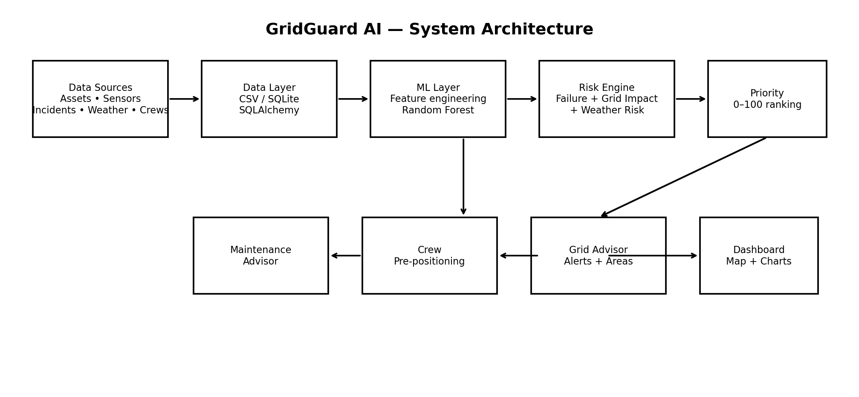
Figure 1. High-level GridGuard AI architecture derived from the implemented project structure.
The Flask application serves the dashboard and API endpoints. SQLAlchemy maps the application to the SQLite database. Data-processing services load and transform the data using Pandas. The ML module loads the trained Random Forest pipeline and produces failure probabilities. The scoring service combines failure, grid-impact and weather components into a priority ranking. Additional services produce maintenance, crew, advisor and scenario outputs.

5.1 Logical Data Flow
- Load asset, sensor, incident, weather and crew records from CSV files and/or SQLite.
- Aggregate recent sensor readings for each asset and associate weather observations with asset location/time.
- Generate the feature row expected by the trained ML pipeline.
- Estimate failure probability and convert it to a Low/Medium/High/Critical risk level.
- Calculate grid impact from customers served, capacity, critical facilities, historical failures and outage duration.
- Calculate weather risk from rainfall, wind speed, storm risk and severe-weather status.
- Compute the final priority score and sort the assets.
- Generate maintenance recommendations and crew recommendations.
- Present results through the dashboard, map, charts, alerts and scenario simulator.

6. Data and Dataset Design
The prototype contains a synthetic demonstration dataset generated by `generate_demo_data.py`. The generator explicitly labels the data as synthetic demonstration data for prototyping, education and hackathon use. The project documentation should retain this distinction when presenting results.
Dataset | Prototype volume | Purpose
assets.csv | 100 assets | Asset metadata and grid-impact attributes
sensor_readings.csv | 5,000 readings | Condition-monitoring time series
incidents.csv | 150 incidents | Historical failure/outage context
weather.csv | 800 records | Regional weather and storm risk
crews.csv | 7 crews | Field resource location and availability

6.1 Asset Data
Asset records include asset ID/type, substation ID, location and coordinates, installation year and age, capacity in MVA, customers served, critical-facility count, historical failures and current health score.

6.2 Sensor Data
The sensor panel includes temperature, vibration, partial discharge, oil quality, load percentage, voltage and current, together with a derived health score. For prediction, the implementation uses the most recent 12 sensor readings for an asset and averages the numeric sensor variables into one feature row.

6.3 Historical Incident Data
Incident records include incident type, severity, duration, customers affected, repair cost, weather-related flag and a failure_occurred target indicator.

6.4 Weather Data
Weather records include regional coordinates, temperature, rainfall, wind speed, humidity, storm risk and severe-weather status. During training, weather is aggregated by region and day; during prediction, the system selects the relevant weather observation by location and temporal proximity.

6.5 Synthetic Data Generation Logic
- Older assets are generated with greater historical-failure tendency and lower health scores.
- Lower asset health is associated with abnormal temperature, vibration, partial discharge and oil-quality values.
- Higher load increases temperature and current in the simulated sensor data.
- Severe weather is represented through higher wind/rain and a storm-risk index.
- Incident severity is correlated with duration, customers affected and repair cost.

7. Machine Learning Methodology
The implemented ML component is a Scikit-learn RandomForestClassifier. The training pipeline joins sensor readings with asset metadata and weather observations. The target variable is `failure_occurred`: an observation is labelled positive when a failure incident for the same asset occurs within ±14 days of the sensor reading.

7.1 Input Features
Feature | Category
temperature | Sensor condition
vibration | Sensor condition
partial_discharge | Sensor condition
oil_quality | Sensor condition
load_percentage | Operating condition
voltage | Electrical condition
current | Electrical condition
age_years | Asset metadata
historical_failures | Asset history
current_health_score | Asset health
rainfall | Weather
wind_speed | Weather
storm_risk | Weather
customers_served | Grid consequence
capacity_mva | Grid consequence
critical_facility_count | Grid consequence

7.2 Training Pipeline
- Load data from SQLite when sufficiently populated, otherwise fall back to the CSV datasets.
- Join sensor readings to assets using asset_id.
- Aggregate weather by location and date and merge weather features into the training rows.
- Create the binary failure target from historical incident dates using the ±14-day window.
- Split data into 75% training and 25% test sets using a fixed random state of 42 and stratification when possible.
- Impute missing numeric values with the median and standardize the numeric features inside a Scikit-learn pipeline.
- Train a Random Forest with 300 estimators, minimum leaf size 3 and balanced-subsample class weighting.
- Evaluate using accuracy, precision, recall, F1 score, ROC-AUC, confusion matrix and classification report.
- Persist the trained model as a Joblib artifact together with feature metadata and evaluation metrics.
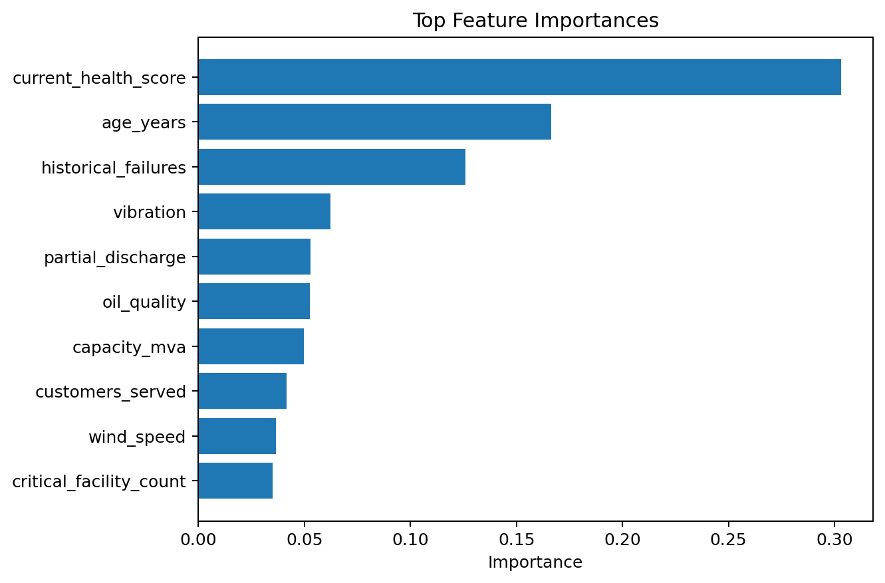
Figure 2. Top feature importances from the saved prototype model metrics.
The saved model reports current_health_score as the strongest feature, followed by asset age and historical failures. Vibration, partial discharge and oil quality also contribute materially, while grid and weather variables provide additional context.

8. Risk, Impact and Priority Engine

8.1 Failure Risk
The Random Forest returns the class-1 probability for failure. The probability is reported as a percentage and mapped to a risk level.
0–30% → Low
31–60% → Medium
61–80% → High
81–100% → Critical

8.2 Grid Impact Score
Grid impact is a consequence-oriented score. The implementation min-max normalizes five components and combines them using the following weights:
Grid Impact = 0.30·Customers + 0.25·Capacity + 0.20·Critical Facilities
+ 0.15·Historical Failures + 0.10·Outage Duration
The outage-duration component is derived from the total duration of historical failure incidents for the asset.

8.3 Weather Risk
Weather Risk = 0.25·Rainfall + 0.30·Wind + 0.35·Storm Risk + 0.10·Severe Weather
The components are normalized to a 0–100 range before the weighted combination. The latest weather observation for each region is used for the current ranking.

8.4 Final Priority Score
Priority Score = 0.50·Failure Risk + 0.30·Grid Impact + 0.20·Weather Risk
This score is bounded to 0–100 and used for the operational ranking. The same Low/Medium/High/Critical thresholds are applied to the priority score.

9. Maintenance Recommendation Engine
The maintenance advisor converts the ranked result into an action-oriented recommendation. The service also inspects recent sensor values for abnormalities and uses asset history to build a reason for the recommendation.
Priority | Implemented recommendation | Indicative timeframe
Critical | Immediate inspection; prepare emergency maintenance, pre-position a crew and enable continuous monitoring | Within 2 hours
High | Schedule maintenance, assign a maintenance crew and increase monitoring | 24–72 hours
Medium | Targeted inspection and increased monitoring | Within 7 days
Low | Routine monitoring / next maintenance cycle | Routine / scheduled cycle

The service also estimates a prototype maintenance cost and produces a predicted failure date based on the risk level/probability. These values are decision-support estimates within the prototype and should be recalibrated against real maintenance and failure records before operational deployment.

10. Crew Pre-positioning
The crew-positioning service links the priority ranking to field-resource information. Crew records contain geographic coordinates, specialization and availability. The dashboard can therefore associate high-priority assets with available or suitable teams and recommend a pre-positioning location.
- Uses asset coordinates and crew coordinates for geographic context.
- Considers crew specialization and current availability.
- Produces per-asset crew recommendations.
- Supports the same recommendation flow during scenario simulation, so crew advice can change as risk changes.

11. Grid Advisor, Alerts and Scenario Simulation

11.1 Grid Advisor
The Grid Advisor summarizes the highest-risk asset, the most outage-prone area, customers at risk, current weather risk, recommended maintenance and crew positioning. This creates an operator-oriented summary instead of requiring users to interpret multiple charts independently.

11.2 Alerts
The dashboard renders active alerts returned by the advisor service. Alerts are based on the current system data and are intended to draw attention to important risk conditions.

11.3 What-if Scenario Simulation
The scenario simulator accepts temporary values for wind speed, rainfall, temperature, storm risk and load percentage. It copies the relevant data in memory, applies the scenario to recent sensor/weather records, recomputes the priority ranking and returns before/after summaries, changed risk levels and recalculated crew recommendations.
Scenario inputs:
wind_speed, rainfall, temperature, storm_risk, load_percentage
The implementation validates scenario ranges and does not persist the temporary conditions to the database. This makes the feature suitable for demonstrations and planning experiments.

12. Dashboard and User Experience
The frontend is implemented as a single-page dashboard served by Flask. The UI uses Chart.js for analytics and Leaflet with OpenStreetMap-backed geographic rendering.

12.1 Main Dashboard Capabilities
- Asset risk register with search and risk-level filters.
- Sortable columns for failure probability, grid impact, weather risk and priority score.
- Risk-colored geographic asset markers.
- Substation and crew map context.
- High/critical asset counts and deployment-route statistics.
- Grid Advisor summary and active alert cards.
- Scenario controls for weather and load stress testing.
The project README identifies the browser entry point as the Flask home route and documents the main API-backed dashboard functions.

13. Software Architecture and API Layer

13.1 Backend
The Flask application initializes configuration, connects SQLAlchemy to the SQLite database, creates database tables when the application starts and registers the API blueprint under `/api`.

13.2 Main API Endpoints
Method | Endpoint | Purpose
GET | /api/assets | Retrieve asset records
GET | /api/weather | Retrieve weather records
GET | /api/incidents | Retrieve historical incidents
GET | /api/crews | Retrieve field crews
GET | /api/model-metrics | Retrieve saved ML evaluation metrics
POST | /api/predict | Predict failure probability for an asset
GET | /api/risk-ranking | Return priority-ranked assets
GET | /api/maintenance-recommendations?persist=false | Return maintenance recommendations
GET | /api/crew-recommendations | Return crew recommendations
GET | /api/grid-advisor | Return advisor summary and alerts
POST | /api/scenario-simulation | Run temporary what-if analysis

13.3 Data Import
The database initialization script imports assets, sensor readings, incidents, weather and crews. It handles the synthetic CSV banner by skipping leading comment lines, performs basic type conversion, avoids duplicate IDs and commits records to SQLite.

14. Database Design
The SQLAlchemy model layer defines seven application entities: Asset, SensorReading, Incident, Weather, Crew, Prediction and MaintenanceRecommendation.
Entity | Key information
Asset | Identity, type, location, age, capacity, customers, critical facilities, failures, health
SensorReading | Timestamped temperature, vibration, partial discharge, oil, load, voltage, current and health
Incident | Failure/outage type, severity, duration, affected customers, repair cost and weather relation
Weather | Timestamp, region, temperature, rainfall, wind, humidity, storm risk and severe weather
Crew | Crew identity, coordinates, specialization, availability and status
Prediction | Prediction value, confidence, risk level and prediction date
MaintenanceRecommendation | Recommended action, priority, predicted failure date, estimated cost and status

Foreign-key relationships connect sensor readings, incidents, predictions and maintenance recommendations to asset IDs, allowing the system to maintain an asset-centric operational view.

15. Model Results
The project includes a saved model-metrics artifact generated from the prototype training pipeline. The current recorded evaluation uses 3,750 training rows and 1,250 test rows.
Metric | Recorded value
Accuracy | 0.9968 (99.68%)
Precision | 0.69231
Recall | 1.0000
F1 Score | 0.81818
ROC-AUC | 0.99848
Test rows | 1,250
Test positives | 9
Random Forest estimators | 300

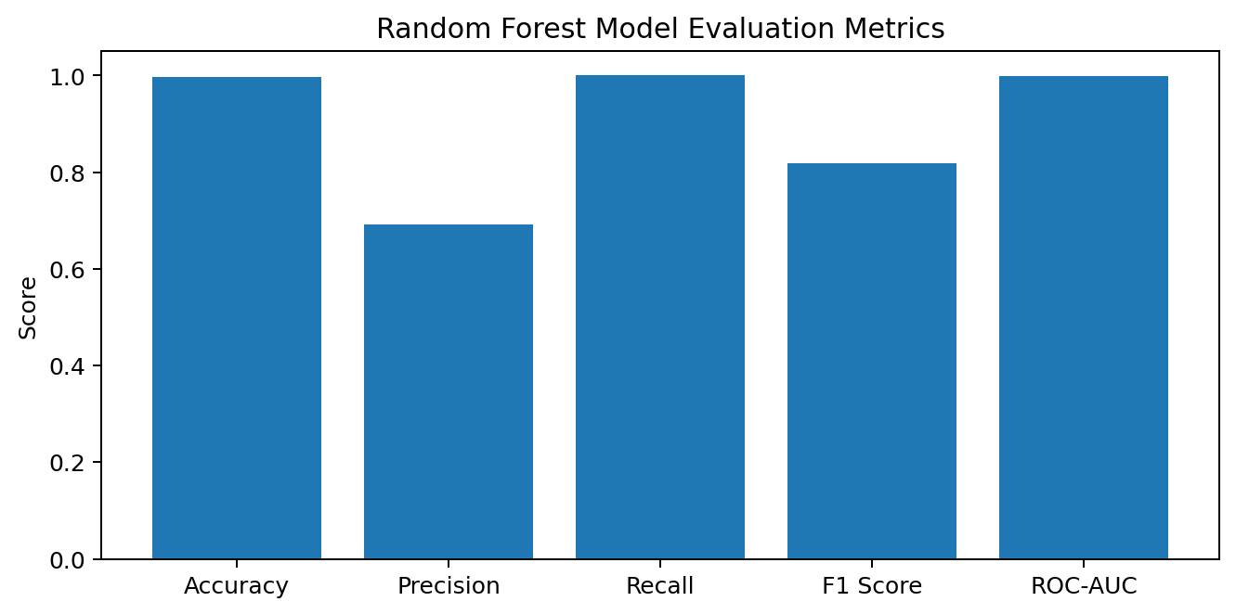
Figure 3. Recorded evaluation metrics for the prototype Random Forest.
The confusion matrix is [[1237, 4], [0, 9]], meaning the prototype test split contained 1,241 negative cases and 9 positive cases. All 9 positive cases were recalled, while 4 negative cases were classified as positive.
Interpretation note: the positive class is small in the synthetic evaluation (9 positives in the test split). The high aggregate accuracy and ROC-AUC should therefore be treated cautiously. Real utility deployment requires larger, temporally representative, independently collected incident data and validation against future unseen failures.

16. Technology Stack
Layer | Technology | Role
Language | Python | Core application and data-processing language
Web framework | Flask | Application server and REST API
ORM / database | SQLAlchemy + SQLite | Persistent application data
Data processing | Pandas + NumPy | Data loading, aggregation and scoring
Machine learning | Scikit-learn | Random Forest training and inference
Model persistence | Joblib | Serialized trained model
Frontend | HTML / CSS / JavaScript | Dashboard interface
Charts | Chart.js | Analytics visualization
Maps | Leaflet + OpenStreetMap | Geographic asset/crew visualization

17. End-to-End Operational Workflow
- Asset and operational data is collected or uploaded.
- The data is stored in SQLite and exposed through the Flask API.
- Recent sensor values are aggregated for each asset.
- Weather observations are associated with the asset's region/time context.
- The Random Forest estimates failure probability.
- Grid impact is computed from consequence-oriented asset and historical outage factors.
- Weather risk is calculated from current regional conditions.
- The priority engine produces a 0–100 score and risk level.
- Maintenance recommendations explain what action should be taken and when.
- Crew recommendations identify suitable resources and pre-positioning needs.
- The dashboard presents rankings, maps, alerts and advisor summaries.
- Operators can run a temporary scenario to evaluate changes under stressed conditions.

18. Innovation and USP
The differentiating aspect of GridGuard AI is not simply predictive maintenance. It connects prediction to operational prioritization. A low-probability failure on a low-impact asset and a similar probability on a critical, high-customer asset should not necessarily receive the same operational response.
- Multi-factor decision making: failure likelihood, consequence and weather are combined.
- Actionable outputs: the system recommends maintenance timing and crew readiness.
- Geographic context: asset and crew positions are visible together.
- Scenario planning: operators can explore temporary weather/load stress.
- Replaceable data layer: the prototype accepts CSV-based datasets and can be adapted to real sources.
- Explainability at the decision layer: the UI exposes component scores and recommendation reasons.

19. Feasibility, Scalability and Deployment

19.1 Technical Feasibility
The prototype uses widely adopted Python libraries and a lightweight Flask/SQLite architecture, making it straightforward to run on a developer workstation or demonstration server. The application separates models, routes, ML logic and service logic, which supports incremental enhancement.

19.2 Scalability Path
- Replace SQLite with PostgreSQL or a managed relational database for multi-user production workloads.
- Stream sensor telemetry through an event or message platform rather than batch CSV files.
- Replace synthetic weather with an authenticated forecast/weather API.
- Add role-based authentication and audit logging.
- Deploy the ML service independently for higher inference throughput.
- Introduce geospatial indexing and routing for large geographic networks.
- Retrain periodically using confirmed future failure outcomes and monitor model drift.

20. Limitations and Responsible Use
- The current datasets are synthetic demonstration data and are not representative of any specific utility.
- The prototype uses regional/location matching for weather rather than a production-grade meteorological spatial join.
- The failure target is created from a ±14-day historical incident window, which is a prototype labelling strategy.
- The evaluation dataset is imbalanced, so accuracy alone is not a sufficient deployment metric.
- Maintenance cost and predicted failure dates are heuristic estimates in the current service.
- The prototype has no authentication or API key requirement.
- Operational deployment would require cybersecurity controls, validation, monitoring, fail-safe procedures and human approval.
GridGuard AI should therefore be treated as a decision-support system, not an autonomous protection or switching system. Any real-world maintenance or grid operation should remain subject to utility procedures, qualified personnel and validated engineering thresholds.

21. Future Scope
- Integrate live transformer/substation telemetry through secure streaming interfaces.
- Connect real-time numerical weather prediction and severe-weather alerts.
- Add temporal sequence models for trend and degradation forecasting.
- Introduce calibrated probability estimates and cost-sensitive decision thresholds.
- Use explainable-AI techniques such as SHAP for asset-level prediction explanations.
- Build outage propagation and network-topology impact analysis.
- Add optimized vehicle routing and travel-time estimation for crew dispatch.
- Implement automated model monitoring, drift detection and scheduled retraining.
- Add user roles, audit logs, notifications and enterprise identity integration.
- Validate the system using historical utility events and prospective field trials.

22. Conclusion
GridGuard AI demonstrates how AI, sensor analytics, historical incidents, weather context and operational resource planning can be combined into one power-grid risk advisory workflow. The prototype goes beyond a standalone failure classifier by turning model output into a prioritized list of assets, recommended maintenance actions, crew-prepositioning guidance, geographic risk context and what-if analysis.
For the hackathon, the prototype establishes a clear path from raw condition data to an operator-oriented decision: identify what may fail, understand how important it is, account for weather, decide what to do first and prepare the right field resources. The next stage is rigorous validation using real utility data and production-grade safety, security and integration controls.

Appendix A — API Endpoints
Endpoint | Method | Input / Output summary
/api/assets | GET | Retrieve asset records
/api/weather | GET | Retrieve weather records
/api/incidents | GET | Retrieve historical incidents
/api/crews | GET | Retrieve field crews
/api/model-metrics | GET | Retrieve saved ML evaluation metrics
/api/predict | POST | Predict failure probability for an asset
/api/risk-ranking | GET | Return priority-ranked assets
/api/maintenance-recommendations?persist=false | GET | Return maintenance recommendations
/api/crew-recommendations | GET | Return crew recommendations
/api/grid-advisor | GET | Return advisor summary and alerts
/api/scenario-simulation | POST | Run temporary what-if analysis

Appendix B — Dataset Fields

B.1 Assets
asset_id, asset_type, substation_id, location, latitude, longitude,
installation_year, age_years, capacity_mva, customers_served,
critical_facility_count, historical_failures, current_health_score

B.2 Sensor Readings
timestamp, asset_id, temperature, vibration, partial_discharge,
oil_quality, load_percentage, voltage, current, health_score

B.3 Incidents
incident_id, asset_id, incident_date, incident_type, severity,
duration_hours, customers_affected, repair_cost, weather_related,
failure_occurred

B.4 Weather
timestamp, region, latitude, longitude, temperature, rainfall,
wind_speed, humidity, storm_risk, severe_weather

B.5 Crews
crew_id, crew_name, latitude, longitude, specialization, availability

Appendix C — Reproducibility and Run Instructions
- Install Python dependencies from requirements.txt.
- Generate a fresh synthetic demonstration dataset with `python generate_demo_data.py` if required.
- Initialize the SQLite database with `python init_db.py`.
- Train/retrain the Random Forest with `python ml\train_model.py`.
- Start the Flask application with `python app.py`.
- Open the local application in a browser at the Flask development URL shown by the application.
The project README documents the same installation, database initialization, model retraining and API usage flow. The database importer is designed to skip duplicate IDs, so a fresh database is recommended when replacing demo records with new records that reuse the same IDs.

Documentation Basis
This document was prepared from the uploaded GridGuard AI project source, including the Flask application, configuration, database models, data generator/importer, ML training and prediction modules, scoring and service modules, frontend dashboard, README, requirements and saved model metrics. No external utility dataset or external performance claim has been added.

