# Global Retail Analytics Dashboard

## 1. Introduction

The Global Retail Analytics Dashboard project was designed to provide a unified, data-driven view of sales performance across multiple countries. By consolidating datasets, cleaning and transforming data, and visualizing insights with Power BI, the dashboard enables business stakeholders to monitor KPIs, track sales trends, and identify top-performing products, stores, and representatives globally.

## 2. Objectives

* Consolidate sales data from multiple countries (Canada, China, India, Nigeria, UK, US).
* Perform data cleaning and transformation to ensure accuracy and consistency.
* Load datasets into a PostgreSQL database for structured querying.
* Develop SQL queries to extract insights on revenue, profit, products, stores, and sales representatives.
* Build an interactive Power BI dashboard for global sales analytics.

## 3. Data Sources

The project used six CSV files containing country-wise sales transactions: - sales_Canada.csv - sales_China.csv - sales_India.csv - sales_Nigeria.csv - sales_UK.csv - sales_US.csv

Each dataset included fields such as Transaction ID, Date, Country, Store Location, Product Name, Quantity Purchased, Total Amount, Profit, Sales Representative.

## 4. Data Cleaning Process

**Excel** - Removed null columns. - Cleaned missing values where required.

**PostgreSQL (SQL scripts)**  - Created a consolidated Sales Data table using UNION ALL.

Removed duplicates - Verified data integrity by querying individual country tables.

## 5. Database Queries & Transformation

Below are Some key SQL queries used:

1. **Combine all sales tables:**

CREATE TABLE public."Sales Data" AS

SELECT * FROM public."Sales Canada"

UNION ALL

SELECT * FROM public."Sales China"

UNION ALL

SELECT * FROM public."Sales India"

UNION ALL

SELECT * FROM public."Sales Nigeria"

UNION ALL

SELECT * FROM public."Sales UK"

UNION ALL

SELECT * FROM public."Sales US";

1. **Country-wise revenue and profit:**

SELECT "Country",

SUM("Total Amount") AS "Total Revenue",

SUM("Profit") AS "Total Profit"

FROM public."Sales Data"

WHERE "Date" BETWEEN '2025-02-10' AND '2025-02-14'

GROUP BY "Country"

ORDER BY "Total Revenue" DESC;

1. **Top 5 best-selling products:**

SELECT "Product Name",

SUM("Quantity Purchased") AS "Total Unit Sold"

FROM public."Sales Data"

WHERE " Date" BETWEEN '2025-02-10' AND '2025-02-14'

GROUP BY "Product Name"

ORDER BY "Total Unit Sold" DESC

LIMIT 5;

1. **Top 5 sales representatives by revenue:**

SELECT "Sales Representative",

SUM("Total Amount") AS "Total Sales"

FROM public."Sales Data"

WHERE "Date" BETWEEN '2025-02-10' AND '2025-02-14'

GROUP BY "Sales Representative"

ORDER BY "Total Sales" DESC

LIMIT 5;

1. **Aggregate statistics:**

SELECT MIN("Total Amount") AS "Min Sales Value",

MAX("Total Amount") AS "Max Sales Value",

AVG("Total Amount") AS "Avg Sales Value",

SUM("Total Amount") AS "Total Sales",

MIN("Profit") AS "Min Profit",

MAX("Profit") AS "Max Profit",

AVG("Profit") AS "Avg Profit",

SUM("Profit") AS "Total Profit"

FROM public."Sales Data"

WHERE "Date" BETWEEN '2025-02-10' AND '2025-02-14';

## 6. Dashboard Development (Power BI)

Steps:

1. Imported Sales Data from PostgreSQL into Power BI.
2. Cleaned and reformatted dates.
3. Created DAX measures and calculated columns (e.g., revenue growth, profit margins).
4. Designed dashboard visuals with KPIs, charts, and trends.

Dashboard Link: [Power BI Report](https://app.powerbi.com/view?r=eyJrIjoiYmViYjgxZjktYzZmMi00NzQ0LWE1OTAtOWI4YzM1NTIwYzlhIiwidCI6ImYyN2Y5NWZjLTFmNjEtNGZiYy1hN2UzLTliMzYwODc0MTUyNiJ9)

**Global Retail Dashboard Visuals**

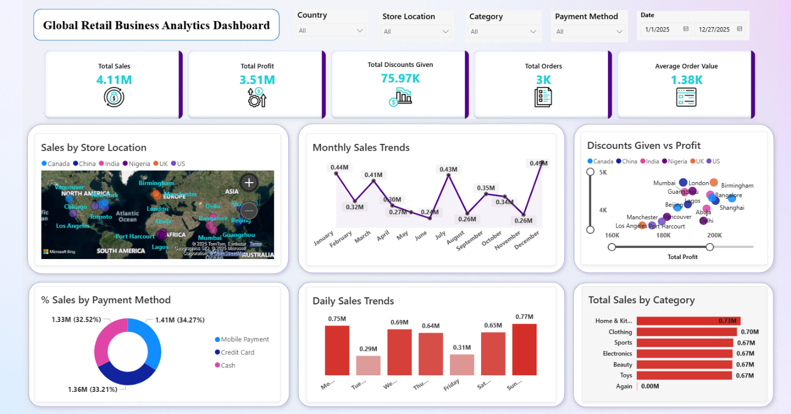

## 7. Project Results & Key Insights

* UK, India, and China are the top revenue-generating countries.
* Home & Kitchen leads category sales, with others contributing ~0.67M each.
* High-performing stores: London, Birmingham, Mumbai, Bangalore, Beijing.
* UK & India show strong profitability; some regions stay low despite discounts.
* Payments are balanced across **Credit Card, Cash, and Mobile**.

## 8. Conclusion

The Global Retail Analytics Dashboard successfully integrates global sales data into a unified reporting system. By leveraging PostgreSQL for data transformation and Power BI for visualization, the project delivers a scalable solution that highlights key trends in revenue, profitability, customer payments, and store performance to support strategic decision-making.

**Report Prepared By:** Simran Pradhan