REAL-TIME INDUSTRIAL
EQUIPMENT FAULT MONITORING
A Data Stream Analytics Mini-Project
GitHub Repository: https://github.com/26yashu/industrial-equipment-fault-monitoring
PROJECT REPORT
Submitted by: ______________________________
Roll Number: _______________________________
Department / Class: _________________________
Submitted to: ______________________________
Academic Year: _____________________________

Abstract
This project demonstrates an end-to-end streaming analytics pipeline for monitoring simulated industrial equipment. A Python producer generates sensor readings for temperature, vibration, pressure and rotational speed (RPM). Apache Kafka transports the events, a Python stream processor evaluates incoming readings using an Isolation Forest model together with configured safety thresholds, and MySQL stores processed readings and anomaly flags. A Streamlit dashboard presents equipment status, telemetry trends and detected anomaly alerts with automatic refresh. This is an educational prototype using simulated data; its alerts are not a substitute for validated industrial monitoring or safety systems.

1. Introduction
Industrial equipment may experience abnormal conditions such as overheating, excessive vibration, pressure loss or overspeed. Streaming analytics can process readings continuously and display unusual values as they arrive. This project demonstrates that workflow with simulated sensor data and a local software stack. The dashboard includes three example assets: MOTOR-01, PUMP-02 and COMPRESSOR-03.

2. Objectives
- Generate time-stamped industrial sensor events using Python.
- Transport events through an Apache Kafka topic.
- Apply machine-learning anomaly scoring and explicit domain thresholds.
- Store readings and anomaly flags in MySQL.
- Display equipment status, telemetry trends and anomaly records in a refreshing dashboard.
- Demonstrate the complete flow from data source to visualization.

3. System Architecture
The system follows six connected layers:
1. Data source
Python producer generates simulated temperature, vibration, pressure and RPM readings.
2. Streaming platform
Apache Kafka topic: industrial-sensor-events.
3. Stream processor
Python consumer reads events and computes a rolling vibration average.
4. Machine learning
Isolation Forest anomaly scoring combined with configured domain safety thresholds.
5. Database
MySQL database industrial_monitor; table sensor_readings.
6. Visualization
Streamlit dashboard at http://localhost:8502 with KPIs, charts and anomaly alerts.

4. Technologies Used
Technology | Purpose
Python | Sensor event generation, stream processing and model integration
Apache Kafka | Event streaming and producer/consumer messaging
scikit-learn / Isolation Forest | Unsupervised anomaly detection
MySQL | Persistent storage of sensor readings and anomaly status
Streamlit | Interactive dashboard and periodic refresh
Pandas / joblib | Feature preparation and model persistence

5. Implementation

5.1 Sensor data generation
The producer emits events with a machine identifier and sensor measurements. Normal readings are generated around baseline values, while selected events simulate high temperature, high vibration, low pressure or overspeed.

5.2 Kafka streaming
The producer publishes JSON events to industrial-sensor-events. The processor consumes events from this topic, separating event generation from downstream processing.

5.3 Stream processing and anomaly detection
The processor prepares sensor features for the trained Isolation Forest model and applies configured domain thresholds. A reading flagged by the combined logic is stored with an anomaly indicator.

5.4 Database storage
Processed events are stored in the MySQL industrial_monitor database in the sensor_readings table.

5.5 Dashboard
The Streamlit interface displays service-status indicators, equipment fleet cards, latest-value KPIs, telemetry charts, vibration versus rolling average, and a detected anomaly table. The supplied screenshots show a three-second refresh setting.

6. Dashboard Screenshots
The following screenshots were supplied from the project dashboard and are included as visual evidence of the interface and displayed telemetry.

Figure 1. Equipment fleet status and latest KPIs
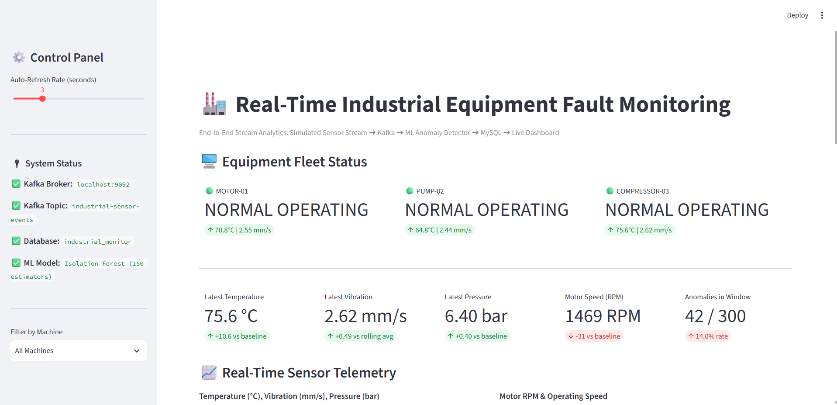
Figure 1: Equipment status for MOTOR-01, PUMP-02 and COMPRESSOR-03, latest sensor metrics, anomaly count and telemetry section.

Figure 2. Real-time sensor telemetry
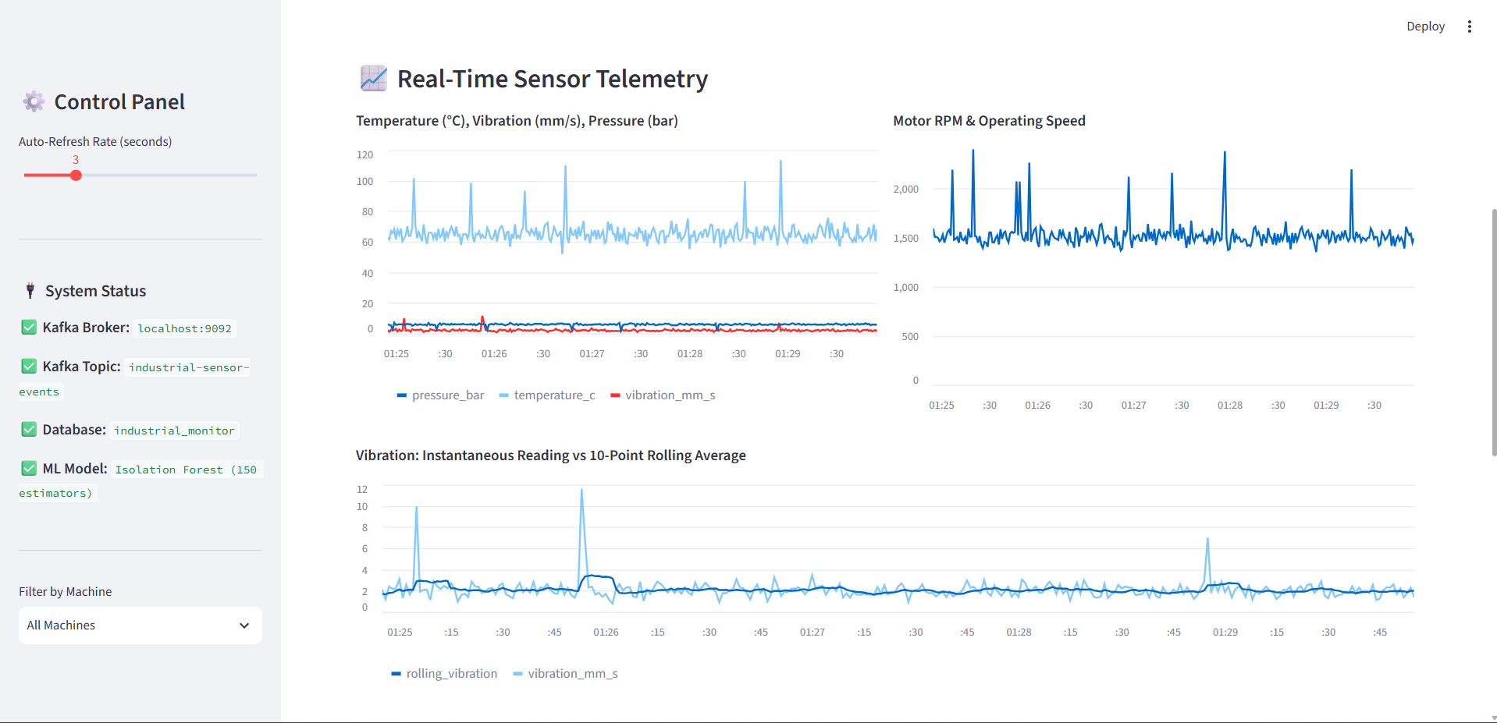
Figure 2: Temperature, vibration, pressure and RPM trends, including instantaneous vibration and the 10-point rolling average.

Figure 3. Detected anomaly alerts
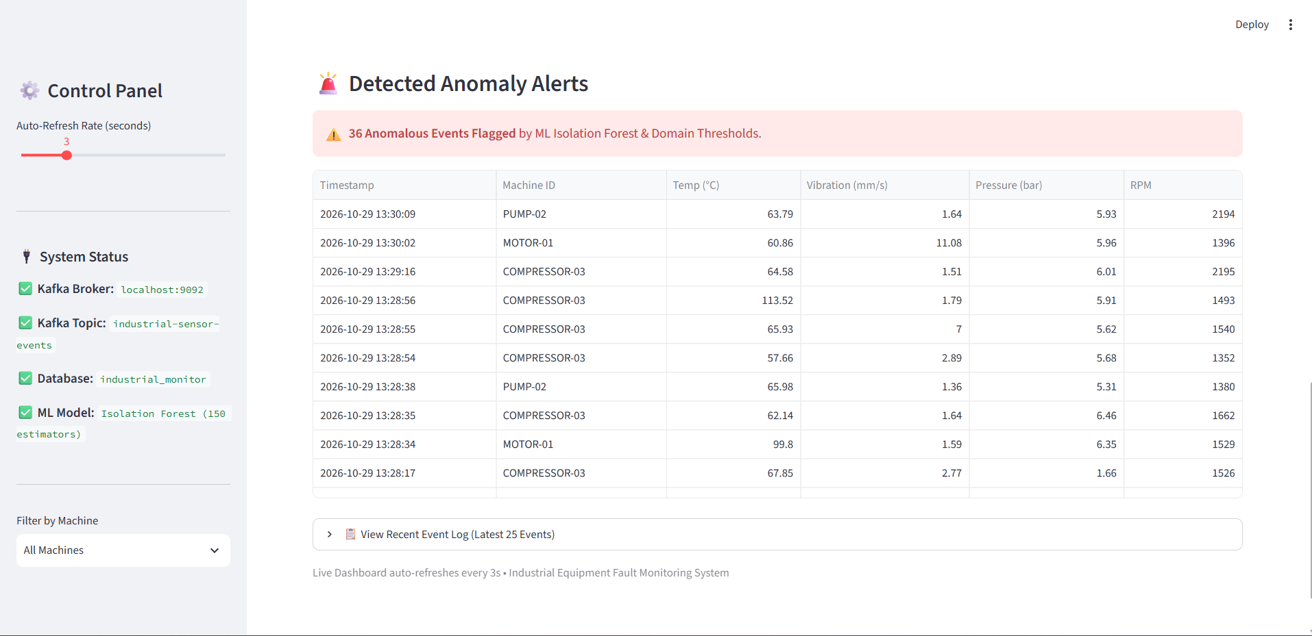
Figure 3: Anomaly alert table showing timestamps, machine identifiers, sensor values and flagged events.

7. Verification and Results
The following results are taken from the verification output supplied by the project setup tool. They are reported test evidence, not an independent audit of the computer.
Check | Status | Reported evidence
Dashboard availability | PASS (reported) | HTTP 200 at localhost:8502; dashboard UI reportedly loaded.
Automatic updates | PASS (reported) | Readings reportedly changed across refreshes; refresh interval set to 3 seconds.
MySQL persistence | PASS (reported) | Row count increased from 567 to 572 during a five-second observation.
Anomaly alerts | PASS (reported) | Overheating, pressure drop and overspeed examples reportedly flagged in MySQL.
Producer/processor logs | PASS (reported) | Verification output reported no recurring errors during its observation period.
The anomaly count displayed in the screenshots can vary with the selected time window and database query; it should not be interpreted as a fixed total.

8. Limitations
- Sensor readings are simulated rather than collected from physical industrial equipment.
- Anomaly results depend on synthetic training data, model settings and configured thresholds.
- A flagged reading indicates an unusual or threshold-violating measurement; it does not prove that a machine has failed.
- The prototype has not been validated for safety-critical industrial use.
- Operation depends on Kafka, Python processes, MySQL and Streamlit remaining available.

9. Future Enhancements
- Connect real sensors or an industrial IoT gateway.
- Evaluate model precision and recall using labeled fault data.
- Add notifications and anomaly acknowledgement workflows.
- Use a dedicated database account and secure secret management.
- Add service health checks, structured logging and reproducible deployment.

10. How to Run the Project
Run each component in a separate terminal. Ensure MySQL is running and use the Kafka configuration file that matches the already initialized storage. Do not reformat Kafka storage.

Terminal 1 — Kafka broker
cd C:\kafka
.\bin\windows\kafka-server-start.bat .\config\server.properties

Terminal 2 — Stream processor
cd C:\Users\DELL\Downloads\industrial_fault_monitoring_project\industrial_fault_monitoring
.\.venv\Scripts\Activate.ps1
python processor.py

Terminal 3 — Sensor producer
cd C:\Users\DELL\Downloads\industrial_fault_monitoring_project\industrial_fault_monitoring
.\.venv\Scripts\Activate.ps1
python producer.py

Terminal 4 — Dashboard
cd C:\Users\DELL\Downloads\industrial_fault_monitoring_project\industrial_fault_monitoring
.\.venv\Scripts\Activate.ps1
streamlit run dashboard.py --server.port 8502
Open http://localhost:8502 in a browser.

11. Conclusion
This project demonstrates the main components of a real-time stream analytics system: generating events, transporting them through Kafka, applying anomaly detection, persisting results in MySQL and visualizing the stream in an auto-refreshing dashboard. The screenshots illustrate the fleet overview, sensor telemetry and anomaly alert table. The prototype can be extended with real equipment data, formal model evaluation and secure deployment.

References
- Apache Kafka documentation — event streaming and producer/consumer concepts.
- scikit-learn documentation — Isolation Forest estimator.
- MySQL documentation — relational data storage.
- Streamlit documentation — interactive Python data applications.

Project Repository
Source code, setup instructions, and project files are available at:
https://github.com/26yashu/industrial-equipment-fault-monitoring

