Privacy-Preserving Deep Learning With
Learnable Image Encryption on Medical Images
ABSTRACT: -
The need for cloud servers for training deep neural network (DNN) models is increasing as more complex architecture designs of DNN models are developed. Nevertheless, cloud servers are considered semi-honest. With great attention to the privacy issues of medical diagnoses using a DNN, previous studies have proposed the idea of learnable image encryption. Though some methods have been presented to partially attack previous encryption schemes, there is still some space for improvement. We proposed a learnable image encryption scheme that is an enhanced version of previous methods and can be used to train a great DNN model and simultaneously keep the privacy of training images. We conducted an experiment on medical datasets from open sources and the result demonstrates the effectiveness of our proposed method in performance and privacy-preserving.

EXSISTING SYSTEM | PROPOSED SYSTEM
- This section introduces the proposed method in detail.  - Our GDSR network aims to improve the perceptual quality and reconstruction accuracy of SR images via a left-right asymmetric network architecture.  - The GDSR consists of three key components: 1) a left-right asymmetric SR network, 2) a global guidance mechanism, and 3) a mask network.  - The left-right asymmetric network architecture mainly consists of two branches: the high-frequency branch (HFB) and the low-frequency branch (LFB).  - The guidance delivers the global feature maps from the LFB to the low-level module of the HFB, helping the HFB generate more high-frequency details.  - The mask network adaptively reconstructs the final output from the LFB and the HFB to improve the perceptual quality and reconstruction accuracy of the SR image. | - Our proposed encryption scheme is enlightened by the original SKK scheme thus, the negative-positive transformation and color shuffling operation are included in our proposed scheme.  - After completing all the steps in the original SKK scheme, we added up the process of statistical smoothing into the images.  - We used the four most commonly used statistical smoothing filters in our method:  - median filter, mean filter, maximum filter, and minimum filter, which aim to fill all elements of a block with its median, mean, maximum, and minimum values respectively.  - Demonstrates the idea of applying a maximum filter on a 3×3 sized block.  - Due to the great success achieved by Deep Neural Networks (DNNs) in various aspects, such as computer vision, voice recognition, natural language processing, DNNs have recently been used in medical fields, which help the healthcare industries in image diagnosis.
EXISTING ALGORITHM  - SRCNN MODEL | PROPOSED ALGORITHM: -  - DNN MODELS
ALGORITHM DEFINITION: -  - The first successful attempt towards super-resolution using only three convolutional layers.  - This effort can be considered as the pioneering work in the CNN-based SR field and inspires numerous later works.  - Replacing the bicubic up sampling operation with an efficient sub-pixel convolution, FSRCNN and ESPCN improve the speed and image quality, which achieve real-time performance. | ALGORITHM DEFINITION: -  - The procedure of implementation of our experiment.  - The images are first encrypted on the client side with our proposed scheme and then those encrypted images will be sent to the server to execute the data augmentation and finally be used as the input to the DNN model.  - Two models, DenseNet-121 and XceptionNet, have been used in our experiment.  - The images are resized into 256 × 256 before inputting to the models with batch size set to 35 and the optimizers set to the stochastic gradient descent (SGD) with the momentum of 0.9 respectively.
DRAWBACKS: -  - The key drawback of bicubic interpolation as super-resolution is that it does not make use of outside knowledge and thus. | ADVANTAGES: -  - The trade-off between accuracy gained and the security of images.  - This scheme is beneficial for those who want to solve the privacy issue regarding sending images.

SYSTEM ARCHITECTURE
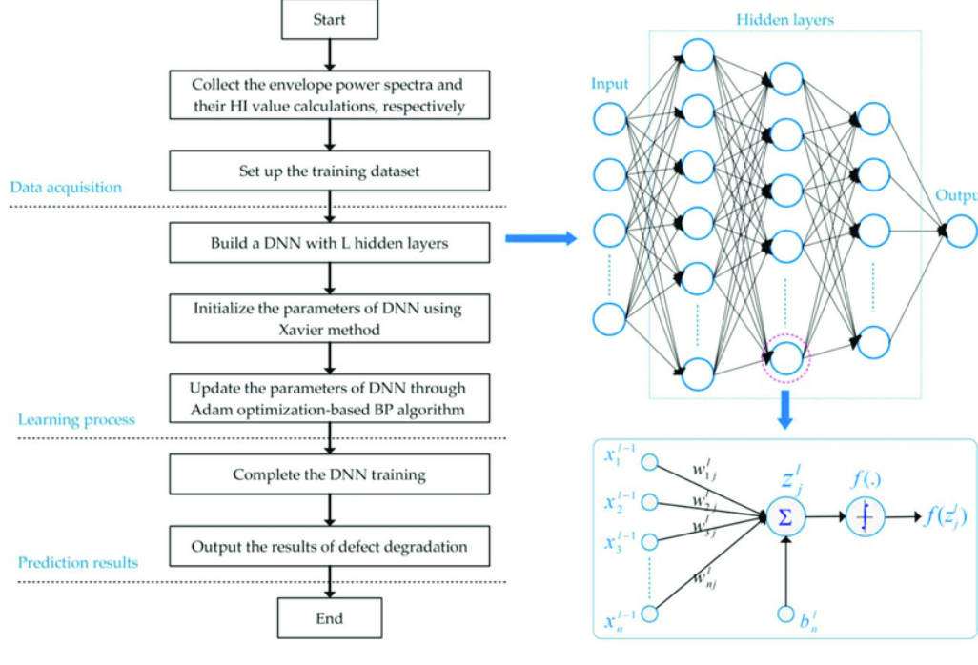

MINIMUMSYSTEM REQUIREMENTS
HARDWARE REQUIREMENTS
- PROCESSOR : Pentium i3 Processor
- RAM : 2GB DD RAM
- HARD DISK : 250 GB

SOFTWARE REQUIREMENTS
- BACK END : PYTHON
- OPERATING SYSTEM : WINDOWS 7
- IDE : Spider3

