WAKEFIT — NORTH INDIA (DELHI NCR) EXPANSION
Milestone M5 — Change Scenario Response — Sponsor Unavailable for 2 Weeks
Detailed Report: Risk Register, Mitigation Plan & Revised M3/M4 | Owner: Chandni C. (Project Manager) | 01 September 2026

1. Executive Summary
On 01 September 2026, with no prior notice, Daljeet Singh — the project's sole confirmed Wakefit stakeholder — informs the team that he will be unreachable for two weeks (02–16 September 2026). This is precisely the window in which WBS 3.2 (stakeholder validation) was due to begin, and it covers the entire remainder of the project's schedule. Daljeet's return date, 16 September, falls one day after the project's fixed 15 September delivery date — meaning the team cannot simply wait for him and validate before submitting, as might be possible if he returned earlier. This report documents the team's full response: the risk raised, the options considered, the mitigation adopted, the resulting revisions to the schedule (M3) and critical path (M4), and the concrete plan for closing the loop with the stakeholder after submission.
2. Background — Why Stakeholder Access Matters Here
This project is structured as an external advisory engagement, not internal Wakefit work. Daljeet Singh is the team's only direct line into real operational information — store-level logistics (the POD/INHP model), the Delhi NCR hub-and-spoke rationale, and practical feasibility checks on the team's recommendations. Every other input the team uses (RHP disclosures, RoC filings, press coverage) is secondary and already carries known limitations, logged separately in the Project Charter's original risk log. WBS 3.2 exists specifically to close that gap. Losing stakeholder access for two weeks, at exactly this point in the schedule, is therefore not a minor scheduling inconvenience — it removes the one checkpoint where the team's analysis gets tested against someone who actually runs this business.
3. Scenario Description
Trigger event: on 01 September 2026, the stakeholder informed the team, without advance warning, that he would be unreachable from 02 to 16 September 2026 inclusive. At the time of the disruption, WBS 3.1 was nearing completion and WBS 3.2 was scheduled to begin the following day. The team had no opportunity to pre-emptively gather input for specific open questions — the response had to be designed and executed reactively, against a schedule that does not move.
4. Stakeholder & Activity Impact Analysis
Affected Activity | Relationship to Stakeholder | Consequence if Unmanaged
WBS 3.2 — Validate framework with stakeholder | Direct — this activity's entire purpose is stakeholder input | Cannot proceed as originally designed
WBS 3.3 — Finalise practical recommendations | Indirect — depends on 3.2's output | Would inherit any gaps left by an unvalidated 3.2
WBS 4.4 — Risk Register & Probability-Impact Matrix | Direct — several risk items (e.g. operational/logistics risks) need real confirmation | Risk ratings would rest on assumption rather than confirmation
WBS 4.5 — Final report & presentation | Indirect — compiles all upstream findings | Would present unvalidated findings as final without disclosure
5. Risk Register Entry (New)
Risk ID | Category | Description | Probability | Impact | Score
R-06 | Stakeholder / Governance Risk | Sole confirmed Wakefit stakeholder unavailable 02–16 Sept, covering the entire remaining schedule; his return (16 Sept) falls after the 15 Sept deadline; breaches the Charter assumption that the mentor remains available through the semester | High (3) | High (3) | 9 — High
Response Owner: Chandni Choudhary (Project Manager) | Status: Active — mitigation in progress (see Section 7)

6. Risk Assessment — Probability-Impact Analysis
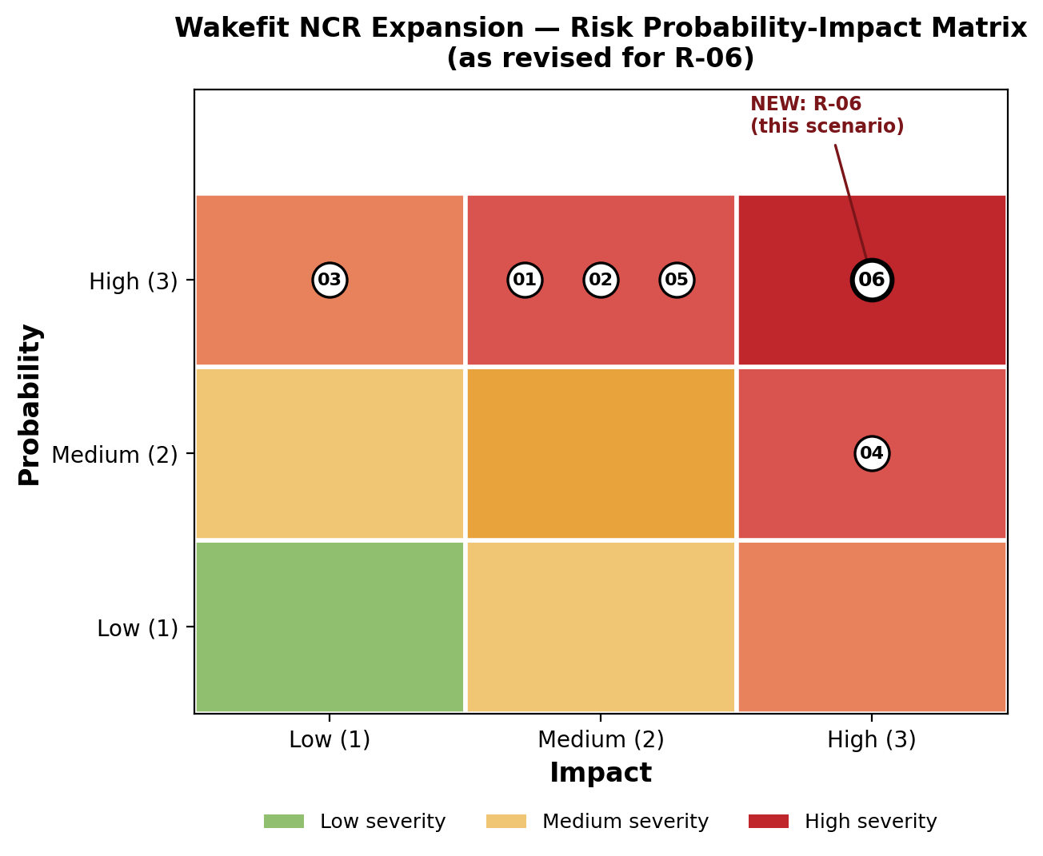
Figure 1: Revised Probability-Impact Matrix showing R-06 at High/High severity.
Probability is rated High (3) because the unavailability is a confirmed fact, not a projected possibility. Impact is rated High (3) for two compounding reasons: first, the project's own CPM calculation (Section 8) confirms that both WBS 3.2 and WBS 4.4 sit on the critical path with zero float, so any unmanaged delay to either is a delay to the whole project; second, the window covers essentially all remaining work, not an isolated task. Probability (3) × Impact (3) = Score 9, the highest band in the project's risk scale.
7. Mitigation Plan — What the Team Actually Did
Step 1 — Ask directly, before assuming (01–02 Sept)
- The team asked Daljeet directly whether any alternate Wakefit contact could be reached during his absence. This is a normal, immediate question in any professional relationship when someone announces an absence — not an act of prediction. No alternate contact was available; the Project Charter and RACI matrix, on review, named only one stakeholder relationship, with no secondary contact defined.
Step 2 — Classify remaining work: blockers vs. non-blockers
Category | Items | Treatment
Blockers (need Daljeet's direct input) | Specific WBS 3.2 framework assumptions; specific WBS 4.4 operational risk items (e.g. logistics/competitive risk severity) | Proceed on secondary sources with conservative assumptions; flag individually
Non-blockers (can proceed on existing validated data) | WBS 3.1 (nearing completion), 3.3 drafting, 4.1–4.3 (internal calculation-based deliverables) | Continue on original schedule, no flag needed
Step 3 — Validate blockers via secondary sources, explicitly flagged
- Where WBS 3.2 and 4.4 need confirmation the team does not have, proceed using RHP disclosures, RoC filings and press coverage, applying conservative (cautious) assumptions rather than guessing the stakeholder's likely answer.
- Each affected finding in the final deliverables is individually labelled “provisional — pending stakeholder confirmation” — not a single blanket disclaimer covering the whole report.
Step 4 — Protect the deadline
- The 15 September submission date does not move. This follows directly from the Project Charter, which states the faculty-approved milestone schedule will not change — delaying submission was never an available option, independent of this disruption.

8. Revised M4 — Critical Path Impact (with Calculation)
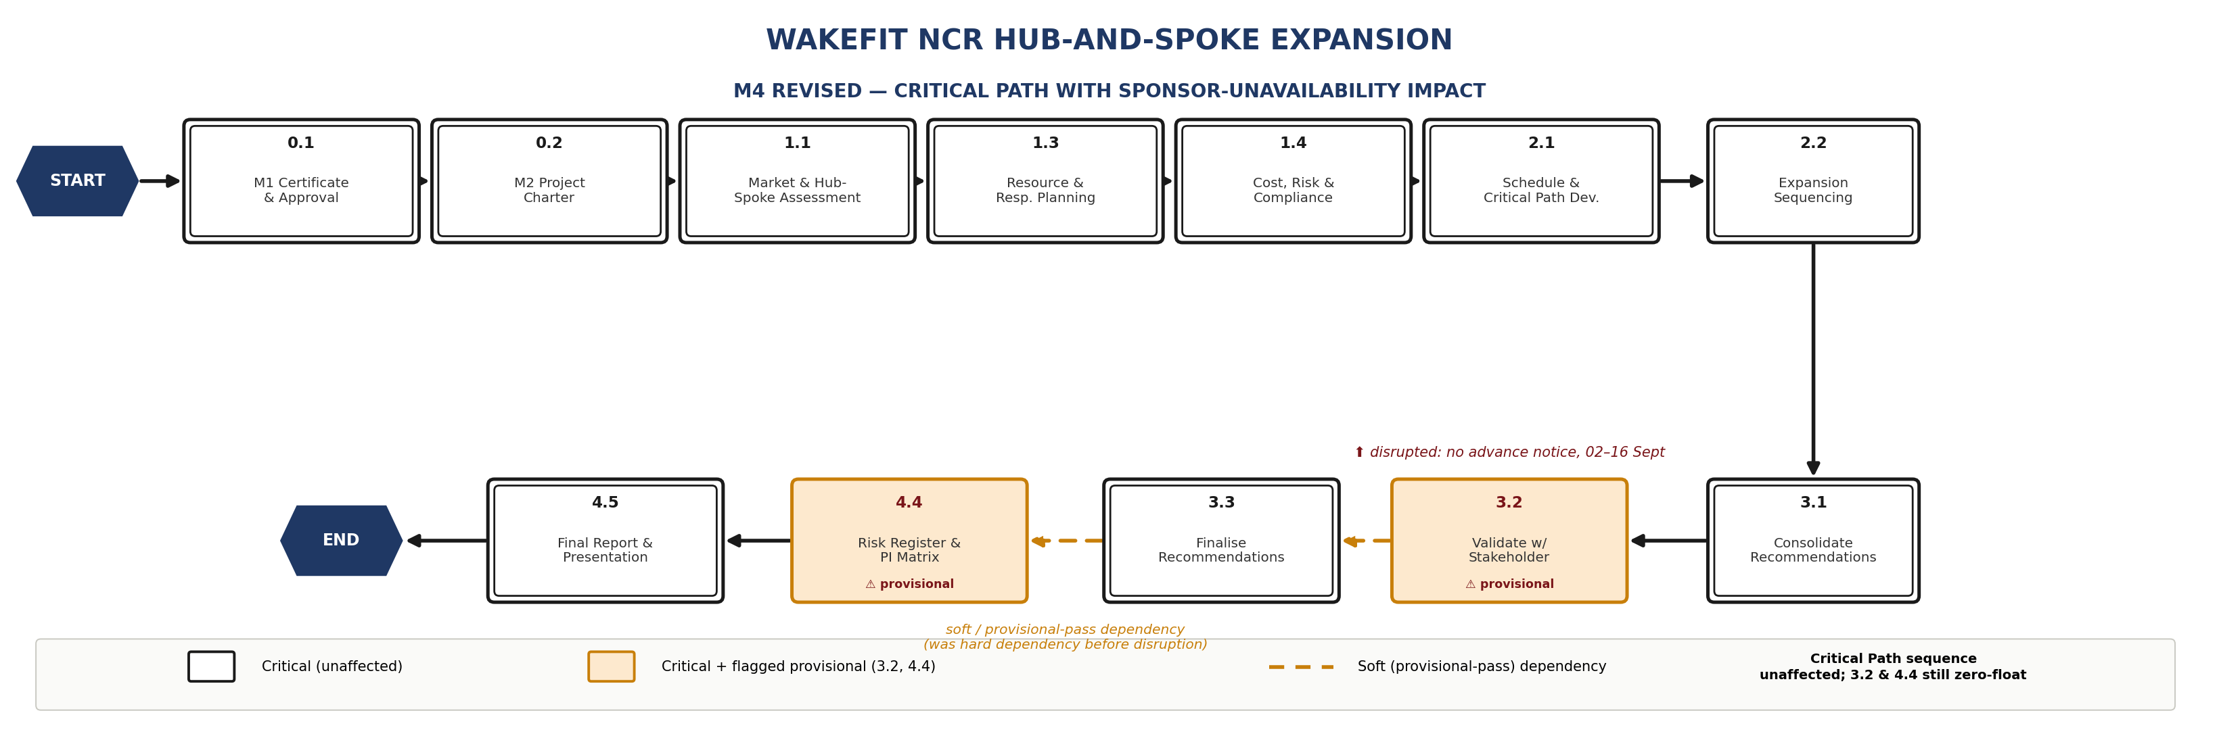
Figure 2: Revised M4 network diagram — 3.2 and 4.4 flagged provisional; critical path sequence unchanged.
The project's CPM forward/backward-pass calculation confirms two directly affected activities carry zero float:
WBS | Duration | ES | EF | LS | LF | Float
3.2 | 2 | 32 | 34 | 32 | 34 | 0 (Critical)
4.4 | 4 | 39 | 43 | 39 | 43 | 0 (Critical)
Because both carry zero float, any unmanaged delay to either is a day-for-day delay to the project end date. The critical path sequence itself does not change; what changes is the nature of the dependency into each — from a hard, fully-validated dependency to a soft dependency with a provisional-pass condition. This is the specific mechanism that absorbs the disruption without consuming the path's zero float.

9. Revised M3 — Schedule Impact
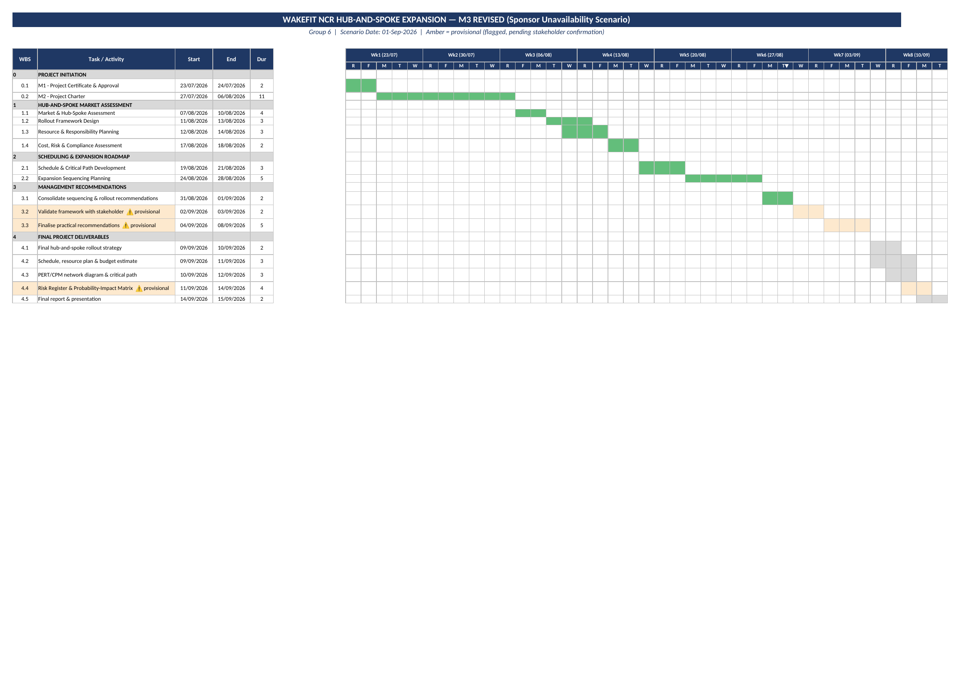
Figure 3: Revised M3 Gantt chart — amber bars mark provisional (flagged) activities.
WBS | Task | Original Plan | Revised Plan
3.1 | Consolidate sequencing & rollout recommendations | 31 Aug – 01 Sept (2 days) | No change — nearing completion at trigger point
3.2 | Validate framework with stakeholder | 02–03 Sept (2 days) | Proceeds via secondary-source validation; specific assumptions flagged provisional
3.3 | Finalise practical recommendations | 04–08 Sept (5 days, unchanged) | Proceeds using 3.2's provisional output; affected findings flagged
4.1–4.3 | Rollout strategy, budget estimate, PERT/CPM diagram | 09–12 Sept (unchanged) | No change — internal, calculation-based deliverables
4.4 | Risk Register & Probability-Impact Matrix | 11–14 Sept (unchanged) | Proceeds on schedule; specific risk-item ratings flagged provisional
4.5 | Final report & presentation | 14–15 Sept (unchanged) | Submitted with all provisional items clearly listed
New | Post-return validation call | — | Added: 16 Sept (after submission)
New | Post-submission addendum (if required) | — | Added: 17–18 Sept (if changes are needed following the validation call)
Net effect: every milestone date through 15 September is preserved exactly as approved. No task is delayed; the disruption is absorbed through explicit, itemised flagging rather than a schedule change.
10. Post-Return Action Plan
Because Daljeet's return (16 September) falls after the submission deadline (15 September), the team cannot adopt a “wait, then validate” approach — there is no buffer day available before submission in which to incorporate his input. The plan below instead closes the loop after submission, on a fixed, dated schedule:
Date | Action | Outcome
15 Sept | Report submitted on schedule. Every stakeholder-dependent finding in WBS 3.2, 3.3 and 4.4 is individually listed as provisional in a dedicated section of the final report. | Deadline met in full; no item is silently presented as confirmed when it is not.
16 Sept | Validation call held with Daljeet, structured specifically around the flagged items — not a general review of the whole report. | Each flagged item is either confirmed as-is or identified as needing a specific change.
17–18 Sept (if required) | A short, targeted addendum is prepared covering only the items that needed a change following the call. | The loop is closed without re-doing or resubmitting completed work.
11. Why the Team Did Not Simply Delay the Deadline
It is worth being explicit about the reasoning here, since the alternative — pausing the project until the stakeholder returns — was considered and rejected. There are two separate timelines at play: the team's own submission deadline (fixed by the Charter and faculty-approved schedule), and Wakefit's own timeline for actually acting on the recommendations (which is not fixed by this project and can accommodate a short follow-up). Delivering a report on time with specific, honestly-flagged open items serves Wakefit better than either (a) delivering nothing for two weeks, or (b) delivering everything on time but presenting unconfirmed assumptions as settled fact. The team therefore chose to protect both the deadline and the integrity of the findings, rather than trading one for the other.
12. Communication Plan
Audience | Method | Frequency | Purpose
Daljeet Singh (Stakeholder) | Direct question on 01–02 Sept; async email during the gap; call on 16 Sept | At trigger, then once on return | Confirm no alternate contact exists; capture priority input; validate flagged items
Faculty Guide | Note within this M5 submission | At submission | Explain the provisional flags and the reasoning behind the approach taken
Project Team | Internal check-in | Throughout 02–16 Sept | Track progress on non-blocker work; keep the blocker list current
13. Monitoring & Escalation Triggers
- Trigger 1 — If no alternate Wakefit contact is identified by 03 September, the team proceeds fully on the secondary-source/provisional-flag basis described above, without further attempts to reach the stakeholder mid-gap.
- Trigger 2 — If the 16 September validation call reveals a material error (not a minor clarification) in a flagged item, the addendum in Section 10 is expanded accordingly and its scope is stated explicitly rather than left open-ended.
14. Lessons Learned & Recommendation
- Relying on a single named stakeholder as the only validation channel is itself a structural risk. Future charters for this type of engagement should name a secondary contact at kickoff, not discover the absence of one during a live disruption.
- Flagging critical-path activities that depend on external stakeholder input — at the charter stage, before any disruption occurs — would let a team recognise this exposure early rather than reactively.
15. Conclusion
This response keeps the project on its committed 15 September delivery date in full, without presenting unconfirmed work as settled. The risk was formally logged and scored, the team's own governance documents were checked for a backup contact before assuming none existed, work was explicitly split into what could and could not proceed without the stakeholder, and a concrete, dated plan closes the loop with Wakefit after submission. The critical-path calculation in Section 8 is what allowed the team to target this response precisely at WBS 3.2 and 4.4, rather than treating the disruption as a general scheduling concern.
Source & Validation Note: The unavailability window and its overlap with WBS 3.2 and 4.4 are derived directly from the project's own M3 schedule. The ES/EF/LS/LF values in Section 8 are taken from the project's CPM forward/backward-pass calculation (M4). The blocker/non-blocker classification, the post-return plan, and the reasoning in Section 11 are the team's own contingency design for this exercise, not a Wakefit-confirmed process.

