SUPERDRINKS COFFEE
MARKET LAUNCH PLAN- Campaign Concept: “THE COFFEE 911”
College life has emergencies. Coffee has solutions.
1. Target Audience - Who & Why
The launch will primarily target college students and young adults who regularly experience long classes, deadlines, presentations, group-project chaos and irregular schedules. The idea is to position SuperDrinks Coffee as an easy, relatable choice for those everyday college moments when people naturally reach for a coffee.
- Primary audience: College students, especially 18–25-year old.
- Why them: Coffee is already part of their study, break and social routines.
- What makes the audience relevant: They are highly active on Instagram and WhatsApp and respond well to humour, relatable situations and participation-based content.
2. Core Launch Idea — “THE COFFEE 911”
Instead of launching SuperDrinks Coffee like a regular beverage, the campaign turns everyday college problems into playful “coffee emergencies.” Students can identify their current situation and get a SuperDrinks Coffee “response”.
Main campaign line: “WHAT’S YOUR COFFEE 911?”
Supporting thought: “Every day has an emergency. Good thing there’s coffee.”
3. The Campus Activation
Set up a small “Coffee 911” station on campus. It looks playful and campaign-led rather than like a conventional product sampling booth.
- Signage: “🚨 COFFEE 911 — WHAT’S YOUR EMERGENCY?”
- Students tell the team their current “emergency” and receive a flavour recommendation.
- A simple “Emergency Board” lets students write their funniest or most relatable college problems.
- Selected responses can become Instagram posts and reels, creating a direct link between offline participation and online content.
Coffee 911 Case | Situation | Suggested Response
THE DEADLINE | Assignment due. Brain gone. | Classic
THE CHAOS | Five things happening at once. | Hazelnut
THE REWARD | Survived the day. Deserve something. | Caramel

4. Online Promotion
Instagram — “Coffee 911 Alerts”
Create short reels and posts that start with a relatable college situation and end with a SuperDrinks Coffee response.
- Example: “🚨 COFFEE 911 ALERT — Presentation in 30 minutes.”
- End frame: “RECOMMENDED RESPONSE: SuperDrinks Coffee ☕”
- CTA: “What’s your Coffee 911?”
- Use real responses from the campus Emergency Board as recurring content.
WhatsApp — Quick Emergency Check
Use college groups to turn the campaign into a simple interactive message:
🚨 COFFEE 911 ALERT 🚨
Quick — what’s your current emergency?
A. Assignment due tomorrow
B. 8 AM class
C. Group project chaos
D. No emergency. I just want coffee 😂
Reply A/B/C/D and we’ll tell you your SuperDrinks Coffee.
Influencers / Student Creators
Creators can use a recurring format: “Hello, Coffee 911? We have a situation.” They reveal a relatable college problem, show the SuperDrinks Coffee response and ask followers to share their own Coffee 911.
5. Offline Promotion Beyond College
- Offices: Introduce a “3 PM Coffee 911” break moment with sampling or desk-drop activity.
- Cafés: Use a simple counter card -“Coffee emergency? Scan → Pick your situation → Meet your flavour.”
- Gyms: Use the campaign around the social/break moment after a session, without making unsupported performance claims.
- College events/ Samavesh (Flagship Event of FIIB) : Set up the Coffee 911 station at fests, club events and student gatherings.
6. Why This Launch Can Work
- It gives the product a memorable launch idea instead of relying only on product sampling.
- The concept is built around situations students already understand, so the communication feels relatable.
- It naturally connects offline activation, Instagram, WhatsApp and creator content under one idea.
- The three coffee variants can each be given a distinct personality through the “response” system.
- The Emergency Board creates user-generated content, giving the campaign fresh material beyond the launch day.

Sample Reel for the Market Launch: https://drive.google.com/drive/folders/1xI0V_IoKfT0ryu3px7KtQSTK0eND7sPU?usp=sharing

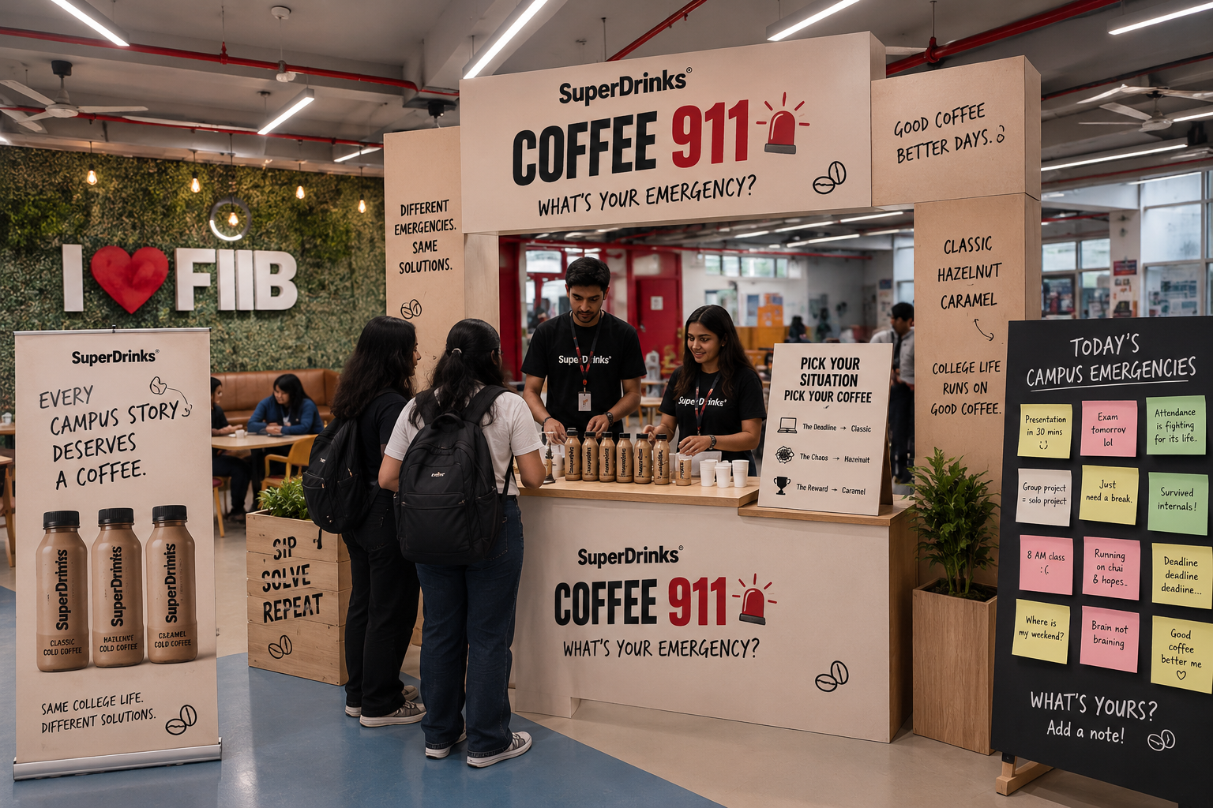

Sample Visual – Coffee 911 Campus Activation
- The visual shows how the SuperDrinks Coffee 911 campaign could come to life inside the FIIB campus. A branded pop-up desk acts as a fun “coffee emergency station,” where students can share their current college situation and choose a coffee accordingly.
- The setup includes a Coffee 911 sign, flavour display, sampling counter, situation-to-coffee guide, and an “Emergency Board” where students can add relatable college problems. The idea is to make the launch interactive and social, rather than just a regular product-sampling activity.

