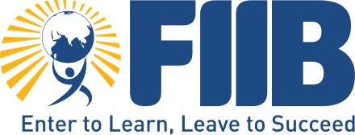
SOCIAL INTERNSHP PROGRAM
INTERIM REPORT

TABLE OF CONTENTS

Sr. No. | Contents | Page No.
1 | Introduction and Context of the Study | 1
2 | Rationale of the Social Internship Program | 2-3
3 | Organisational Context and Partner Institutions | 3
4 | Project Need and Social Problem Identification | 3-4
5 | Objectives of the Social Internship Program | 4-5
6 | Methodology and Internship Design | 5
7 | Phase-wise Description of Internship Activities | 5-7
8 | Observations and Outcomes from the Internship | 8-10
9 | Identification of Social Issue and UN SDG Linkage | 10-11
10 | Sensitivity Analysis and Impact Measurement Approach | 11
11 | Project Category and Expected Output | 11-12
12 | Learning Outcomes for Interns | 12
13 | Challenges Faced During the Internship | 12
14 | Role of Artificial Intelligence (AI) in Enhancing Accessibility and Employability | 12-14
15 | Overall Learning and Reflection | 14
16 | References | 14-15

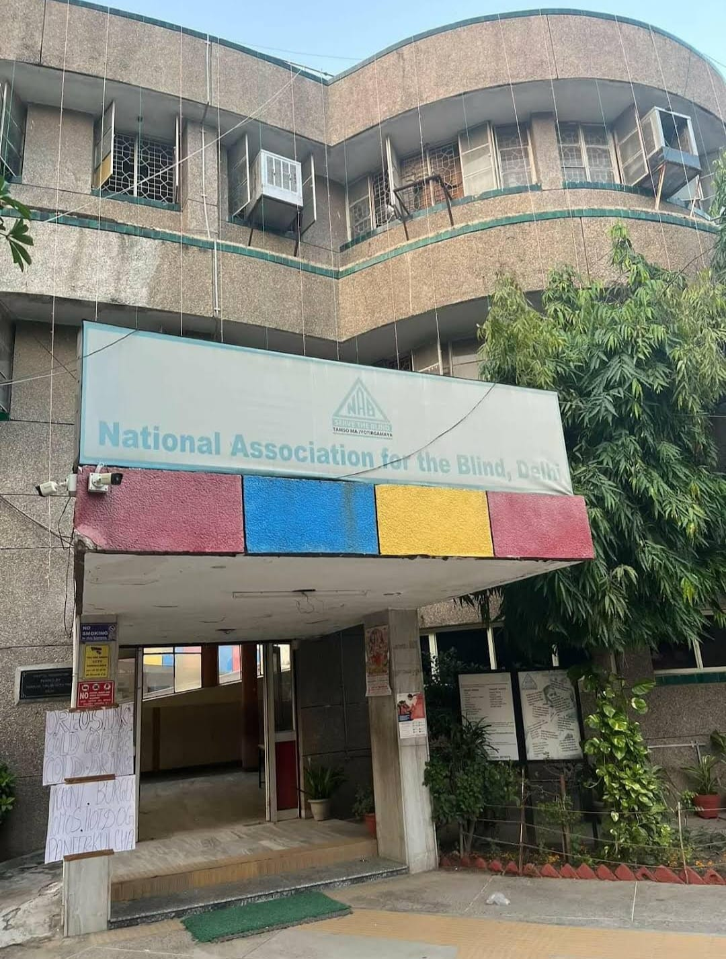

SOCIAL INTERNSHIP PROGRAM (SIP) – INTERIM REPORT
Duration: 2 January 2026 – 17 January 2026
Team Member: Khushboo soni (PGDMFM019)
Kapis kushwha (25PGDMFM018)
Shreya Khanna (25PGDMFM049)
Swyam Sanchi(25PGDMFM043)
Raghav Taneja (25PGDM114)
Organisations: GiFTABLED Foundation, Divyablity, National Association for the Blind (NAB)
Nature of Internship: Social Internship Program (SIP)

1. Introduction and Context of the Study
The Social Internship Programme (SIP) was undertaken as a compulsory and experiential component of the management curriculum to sensitise students to real-world social challenges and enable the practical application of management concepts in non-corporate settings. The SIP was conducted over a period of fifteen days, from 2 January to 15 January, in collaboration with GiftAbled Foundation, Divyablity, and the National Association for the Blind (NAB).
In contemporary society, persons with disabilities (PWDs) continue to face significant barriers in accessing education, employment, and social participation. Despite policy frameworks and legal protections, workforce participation among PWDs remains extremely low. The SIP provided an opportunity to engage directly with this social reality and understand the structural, institutional, and attitudinal factors that contribute to exclusion.
This report presents a detailed account of the internship activities, observations, outcomes, and reflections. It also establishes a clear alignment between the approved SIP proposal and the actual execution of work, ensuring academic continuity and evaluation readiness.

2. Rationale of the Social Internship Program
The rationale behind undertaking a social internship lies in bridging the gap between classroom learning and societal realities. Management education often focuses heavily on profit-oriented organisations; however, the social sector presents equally complex challenges that require strategic thinking, human resource planning, communication skills, and ethical decision-making.
The SIP aimed to expose students to these challenges by involving them in disability inclusion initiatives, employability-focused projects, and field-level engagement. Through this internship, students were expected to develop empathy, social responsibility, and an understanding of inclusive development while simultaneously strengthening professional competencies such as data handling, coordination, and stakeholder engagement.

3. Organisational Context and Partner Institutions

3.1 GiftAbled Foundation
GiftAbled Foundation is a social impact organisation committed to creating an inclusive ecosystem for persons with disabilities. The organisation works across multiple dimensions, including inclusive employment, skill development, accessibility consulting, assistive technology awareness, and community engagement. It collaborates with NGOs, corporate organisations, educational institutions, and policymakers to drive systemic inclusion.
During the SIP, GiftAbled served as the primary Social Sector Organisation (SSO). Internship activities such as data management, outreach, employability assessment, and documentation were aligned with GiftAbled’s mission of empowering PWDs and strengthening inclusive employment pipelines.

3.2 Divyablity
Divyablity supported employability-oriented activities during the SIP, particularly in the areas of resume enhancement and job readiness. Interaction with Divyablity provided exposure to collaborative NGO functioning and highlighted the importance of partnerships in addressing complex social challenges.

3.3 National Association for the Blind (NAB)
The National Association for the Blind played a crucial role in providing offline field exposure. NAB works extensively in the area of education, rehabilitation, and independence for persons with visual impairments. The field visit offered practical insights into assistive technologies, inclusive infrastructure, and organisational operations designed specifically for visually impaired individuals.

4. Project Need and Social Problem Identification
One of the core objectives of the SIP proposal was to identify and understand the employability challenges faced by persons with disabilities. This need was validated extensively during the internship through data collection, telephonic interaction, and offline observation.
Several recurring challenges were identified:
- Low workforce participation despite willingness and capability
- Skill–job role mismatch
- Inaccessible recruitment and interview processes
- Limited career guidance and resume readiness
- Unequal access to digital platforms and assistive technologies
- Employer misconceptions regarding productivity and accommodation costs
These challenges indicate that unemployment among PWDs is not primarily due to a lack of ability, but rather due to systemic barriers and exclusionary practices.

5. Objectives of the Social Internship Program
Based on the proposal and actual internship execution, the objectives of the SIP were as follows:
- To assess the current employment status of persons with disabilities
- To understand disability-specific challenges related to employability
- To support employability readiness through resume guidance and workshops
- To improve access to information related to job portals and application processes
- To develop sensitivity, empathy, and ethical awareness while working with vulnerable communities
- To document observations and insights for future project development.
- To document daily fieldwork activities, roles, and responsibilities undertaken during the SIP.
- To gain practical exposure to disability-inclusive employment initiatives and organisational processes.
- To develop communication, teamwork, and data-handling skills through structured tasks.
- To identify a key social issue and examine its linkage with relevant United Nations Sustainable Development Goals (SDGs).
These objectives guided all phases of internship execution.

6. Methodology and Internship Design
The SIP followed a structured, phased methodology combining administrative work, qualitative interaction, collaborative learning, and field immersion. This mixed-method approach ensured holistic learning and data-driven understanding.
The internship followed a mixed-method experiential approach, combining:
- Administrative and Data Work: Structured data entry, verification, and documentation.
- Qualitative Interaction: Telephonic outreach and direct interaction with persons with disabilities.
- Collaborative Learning: Team meetings, joint decision-making, and group-based workshop facilitation.
- Field Immersion: Offline engagement and observation at the National Association for the Blind (NAB).
This approach ensured both operational exposure and analytical understanding of disability inclusion practices.

7. Detailed Phase-wise Description of Activities

Phase 1: Data Entry, Verification, and Documentation (2–4 January)

The SIP commenced with systematic data entry and verification, forming the foundation of the entire internship. On 2 January, the team collectively worked on entering and verifying 275 records. Responsibilities were evenly distributed among team members to ensure accuracy and accountability. Attention to detail was critical, as errors at this stage could compromise the reliability of the dataset.
On 3 and 4 January, additional records were introduced, and the worksheet was updated accordingly. Team members ensured consistency in data formatting and correctness. This phase provided insights into real-world organisational data management practices and highlighted the importance of teamwork, coordination, and time management.
Key skills developed: Data accuracy, accountability, coordination, and collaborative working.

Phase 2: Job Description Drafting and Organisational Research (5–6 January)
During this phase, the focus shifted towards analytical and conceptual work. The team collaboratively drafted a Job Description (JD) aligned with inclusive hiring practices and explored the official website of GiFTABLED Foundation. The objective was to understand the organisation’s mission, values, and operational framework.
Team discussions revolved around defining role responsibilities, skill requirements, and expectations while ensuring alignment with social impact objectives. This exercise enhanced understanding of human resource practices within social enterprises and emphasised the role of inclusive recruitment strategies.
Key skills developed: Analytical thinking, HR role structuring, organisational research, and teamwork.

Phase 3: Team Coordination and Emotional Intelligence Team Meetings, Progress Review, and Worksheet Updates (7–8 January)
A stand-up meeting was conducted on 7 January to review progress, discuss challenges in data handling, and plan upcoming tasks. The meeting promoted open communication and alignment of individual efforts with team goals.
On 8 January, a new worksheet was introduced. During this phase, one team member was absent due to a personal bereavement. The remaining team members redistributed responsibilities empathetically, ensuring continuity of work without compromising sensitivity. This phase reinforced the importance of emotional intelligence, flexibility, and mutual support in professional environments.

Phase 4: Outreach, Telephonic Interaction, and Online Workshop (9–12 January)
Between 9 and 12 January, the internship became more interaction-focused. The team conducted telephonic outreach to participants to update employment status, clarify doubts, and collect job-related information aligned with individual profiles. This required active listening, respectful communication, and problem-solving skills.
A collaborative meeting with Divyablity was conducted to discuss resume enhancement strategies and identify suitable job portals. Subsequently, an online workshop was organised for persons with disabilities, focusing on resume-building techniques, job portal usage, and employability concepts. The session was interactive, with participant queries addressed clearly and inclusively.
Key skills developed: Communication, stakeholder engagement, workshop facilitation, and inclusive interaction.
Phase 5: Offline Internship and Field Exposure at NAB (13–15 January)
The final phase involved offline field exposure at the National Association for the Blind (NAB), offering first-hand insights into inclusive education and support systems for persons with visual impairments.

Day 1: Orientation and Tour of the NBA and its Assistive Technologies
An orientation session introduced various assistive tools supporting independence and accessibility, including screen readers (NVDA, JAWS), Braille devices, white and smart canes, talking calculators, mobile accessibility features, and tactile labelling tools. Advanced learning aids such as Braille embossers, electronic magnifiers, accessible computer setups, and low-vision optical aids were also demonstrated.
These tools highlighted the critical role of accessibility in enabling education, employment, and independent living.

Day 2 and Day 3: Active Participation
Team members contributed to operational tasks such as proofreading and printing learning materials, handled data management using Microsoft Excel, and provided participant support during activities. These responsibilities provided insights into the daily functioning of an inclusive organisation and reinforced teamwork and responsibility.

8. Observations and Outcomes from the Internship

Key Outcomes During the Internship
- Practical exposure to disability inclusion
The internship provided real-world exposure to working with persons with different types of disabilities, moving beyond theoretical understanding to actual interaction and support.
- Understanding employment challenges faced by persons with disabilities
Through telephonic data collection, it became clear that many individuals are willing and capable of working but face barriers such as a lack of accessible opportunities, skill mismatch, and limited employer awareness.
- Hands-on experience in data collection and verification
Collecting employment status and job-related details helped develop accuracy, patience, and responsibility while handling sensitive personal information.
- Improved communication and empathy skills
Speaking directly with persons with disabilities required clarity, respectful language, and empathy, which significantly improved interpersonal communication skills.
- Team coordination in virtual and offline environments
Organising an online group session as a team and participating in offline field visits strengthened coordination, planning, and collaborative problem-solving abilities.
- Exposure to inclusive institutions and on-ground realities
The visit to the National Association for the Blind offered insight into how structured support systems work at the grassroots level and the importance of physical accessibility.
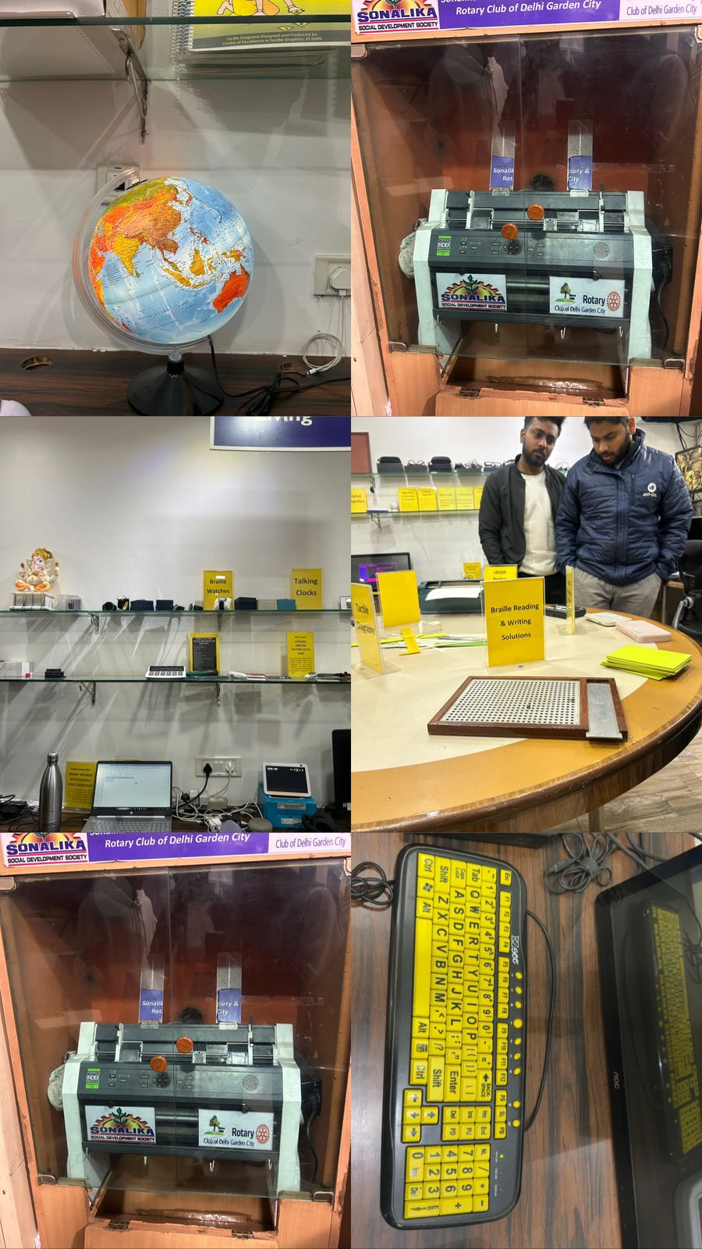
The internship resulted in tangible and intangible outcomes, including skill development, enhanced social sensitivity, improved communication abilities, and a deeper understanding of inclusive employment systems.
Key Observations During the Internship
- Employment gap despite skills
Many persons with disabilities possess relevant skills but remain unemployed due to a lack of suitable job matching and accessible recruitment processes.
- Digital access is uneven
While online sessions are useful, not all participants had equal access to devices, stable internet, or assistive technology, limiting their participation.
- High motivation but low guidance
A strong willingness to work was observed, but many individuals lacked proper career guidance, resume support, or information about inclusive employers.
- Offline interaction creates a stronger impact
Face-to-face engagement at the blind association was more impactful in understanding real challenges compared to online interaction alone.
- Data collection requires sensitivity
Discussing employment status and income-related topics needs careful handling, as some individuals were hesitant or emotionally affected by repeated rejections.
- Need for stronger employer–NGO collaboration
The observations highlighted a gap between NGOs and employers, indicating the need for stronger partnerships to create sustainable employment opportunities.

9. Identification of Social Issue and UN SDG Linkage
The primary social issue identified during the SIP is the employment exclusion of persons with disabilities due to structural, technological, and attitudinal barriers.
This issue aligns strongly with the following UN Sustainable Development Goals:
- SDG 4: Quality Education: through skill development, accessible learning tools, and career readiness initiatives.
- SDG 8: Decent Work and Economic Growth: by promoting inclusive employment and equal job opportunities.
- SDG 10: Reduced Inequalities: by addressing systemic barriers faced by persons with disabilities.
The SIP activities directly support these SDGs by enhancing employability awareness, facilitating data-driven inclusion efforts, and strengthening NGO-led employment initiatives.
10. Sensitivity Analysis and Impact Measurement Approach
The internship emphasised the importance of ethical engagement and impact sensitivity towards social realities and potential impact. Potential indicators for future impact measurement include employability readiness, participant feedback, and accessibility improvements.
towards social realities and potential impact. Impact measurement for future stages can include:
- Number of participants engaged and profiled for employment.
- Improvement in resume readiness and job portal awareness.
- Participant feedback on workshops and guidance sessions.
- Placement facilitation and follow-up employment outcomes.
A combination of qualitative feedback and quantitative indicators will enable rigorous impact assessment while accounting for contextual limitations such as digital access and employer readiness.

11. Project Category and Expected Output
The evolving SIP project leans towards a case study focusing on disability-inclusive employment frameworks. Potential outputs include:
- A structured case study on employment barriers and NGO interventions.
- A preliminary framework for inclusive hiring and employer sensitisation.
- Creative elements such as awareness blogs or posters to support advocacy.
These outputs are directly aligned with the project’s social objectives and the identified SDGs.

12. Learning Outcomes for Interns

The SIP contributed to professional skill development, ethical awareness, teamwork, and the application of management concepts in social contexts.

13. Challenges Faced During the Internship
Challenges included communication barriers, digital accessibility issues, emotional sensitivity during data collection, and time constraints.
14. Role of Artificial Intelligence (AI) in Enhancing Accessibility and Employability for Persons with Disabilities for a better and easier life

14.1 AI-Based Assistive Technologies for Mobility and Independence
One of the major challenges observed during the SIP was limited physical mobility and dependence on others among persons with severe physical disabilities. Recent advancements in AI-powered autonomous wheelchairs address this challenge by enabling independent navigation, obstacle detection, and safe movement in complex environments.
AI-enabled wheelchairs equipped with sensors, computer vision, and robotic assistance can significantly enhance independence for individuals with spinal cord injuries or severe locomotor disabilities. Such technologies reduce dependency on caregivers and improve participation in education, employment, and daily activities.

14.2 AI for Communication Restoration and Inclusion
Communication barriers were repeatedly observed during telephonic outreach and participant interaction, especially among individuals with speech and hearing impairments. Emerging solutions such as AI-based speech restoration wearables (e.g., Revoice) use muscle and nerve signals to convert non-verbal cues into audible speech.
Similarly, AI-enabled sign language translation systems convert speech or text into sign language using avatars and, in some cases, translate sign language back into text or voice. These tools can significantly improve workplace communication, interview accessibility, and social inclusion for the deaf and hard-of-hearing community.

14.3 AI-Based Vision Assistance for the Visually Impaired
During the offline internship at NAB, the importance of assistive technologies for visually impaired individuals was clearly observed. AI-based vision assistance tools now go beyond traditional screen readers by recognising objects, reading printed text aloud, describing surroundings, and detecting obstacles in real time through mobile devices and wearables.
Applications such as image description tools, adaptive reading systems, and navigation assistance help visually impaired individuals independently access public spaces, digital platforms, and workplaces. These technologies strengthen autonomy and reduce reliance on external support.

14.4 AI Interfaces for Severe Motor Disabilities
For individuals with quadriplegia or severe motor impairments, traditional input devices are often inaccessible. Eye-tracking and bite-controlled AI interfaces allow users to operate computers, smartphones, and wheelchairs using eye movement or minimal jaw actions.
Such interfaces enable hands-free digital participation, improving access to education, remote work, and online communication. This directly addresses the digital exclusion observed during online sessions in the SIP.

14.5 AI in Education and Skill Development for Persons with Disabilities
The SIP highlighted uneven access to learning resources and career guidance. AI-driven learning and accessibility tools such as text-to-speech, live captioning, adaptive assessments, and personalised learning assistants help students with cognitive, visual, and hearing impairments learn at their own pace.
These tools support inclusive education, improve comprehension, and enhance employability readiness, aligning strongly with SDG 4: Quality Education.

14.6 AI, Smart Cities, and Inclusive Infrastructure
Beyond individual tools, AI is increasingly being used in smart city planning to evaluate accessibility of public infrastructure, suggest safe navigation routes, and identify design gaps for persons with disabilities.
AI-driven accessibility audits and urban planning tools can support inclusive development at scale, reducing environmental barriers faced by persons with disabilities in daily commuting and employment.

14.7 Strategic Relevance for GiftAbled Foundation
For organisations like GiftAbled Foundation, AI-enabled accessibility tools offer opportunities to:
- Integrate assistive technologies into employability programs
- Partner with AI startups for pilot inclusion projects
- Strengthen employer sensitisation using technology-led solutions
- Enhance impact measurement through data-driven tracking
Adopting AI responsibly can help GiftAbled expand its reach, improve employability outcomes, and strengthen long-term inclusion strategies.

15. Overall Learning and Reflection

The 15-day Social Internship Programme was a holistic learning experience integrating technical skills, communication, teamwork, and social sensitivity. It demonstrated how management education can be applied beyond corporate environments to create meaningful and inclusive social impact. The internship reinforced the importance of responsible leadership, empathy-driven decision-making, and sustainable inclusion practices.

16. References

GiftAbled Foundation. (n.d.). About us. https://giftabled.org

National Association for the Blind. (n.d.). Programs and services. https://www.nabindia.org

World Health Organisation. (2011). World report on disability. World Health Organisation. https://www.who.int/publications/i/item/9789241564182

United Nations Development Programme. (n.d.). Sustainable Development Goals: Goal 4 – Quality education. https://www.undp.org/sustainable-development-goals/quality-education

United Nations Development Programme. (n.d.). Sustainable Development Goals: Goal 8 – Decent work and economic growth. https://www.undp.org/sustainable-development-goals/decent-work-and-economic-growth

United Nations Development Programme. (n.d.). Sustainable Development Goals: Goal 10 – Reduced inequalities. https://www.undp.org/sustainable-development-goals/reduced-inequalities

