MUTUAL FUND PERFORMANCE
COMPARATIVE ANALYSIS

Student | Tanya Grover
Roll No. | 044
Analysis Period | October 2021 to August 2026
Return Frequency | Monthly

Prepared using the NAV and benchmark dataset supplied in the portfolio workbook. The report compares return, volatility, beta, Sharpe ratio, Treynor ratio and Jensen’s alpha to identify the strongest overall performer.

Executive Summary
This report evaluates the allotted Canara Robeco scheme against two peer schemes, HDFC and Parag Parikh, using the Nifty 500 TRI as the market benchmark. The analysis covers approximately 4.83 years from October 2021 to August 2026 and uses a 6.5% annual risk-free rate, as specified in the workbook.
HDFC emerges as the best-performing scheme on an overall risk-adjusted basis. It generated the highest annualised return (16.59%), the highest Sharpe ratio (0.789), the highest Treynor ratio (0.125) and the strongest positive Jensen’s alpha (6.73%). Parag Parikh recorded the lowest volatility (10.65%) and lowest beta (0.647), making it the strongest defensive option. Canara Robeco delivered a lower return than both peers and a negative Jensen’s alpha, indicating underperformance after adjusting for market risk.

Overall Ranking
- 1. HDFC - best overall combination of return and risk-adjusted performance.
2. Parag Parikh - best for lower volatility and lower market sensitivity.
3. Canara Robeco - positive return, but weaker risk-adjusted results and negative alpha.

1. Introduction
Mutual fund performance should not be judged only by absolute return. A scheme that earns a high return by taking substantially higher risk may be less efficient than a scheme producing slightly lower returns with better downside control. Therefore, this report evaluates both return and risk-adjusted performance.

1.1 Schemes Selected

Canara Robeco (Allotted Scheme)
The allotted scheme is represented in the supplied dataset as Canara Robeco. It is evaluated as the focal scheme in the comparison. Its performance is assessed against the two selected peers and the Nifty 500 TRI benchmark.

HDFC (Peer 1)
HDFC is the first peer scheme in the supplied workbook. It provides a useful comparison because its return series covers the same period and is evaluated using the same benchmark, frequency and risk-free rate.

Parag Parikh (Peer 2)
Parag Parikh is the second peer scheme. In this analysis it acts as an important lower-risk comparator because its observed volatility and beta are materially below the other two schemes.

1.2 Benchmark
Nifty 500 TRI is used as the benchmark in the workbook. A Total Return Index incorporates both price movement and dividends, making it more appropriate than a price-only index for evaluating an equity mutual fund portfolio.

2. Methodology
The analysis uses the assumptions and data structure contained in the supplied Excel workbook.
Parameter | Used in Analysis
Period | October 2021 to August 2026
Approx. duration | 4.83 years
Frequency | Monthly returns
Risk-free rate | 6.5% p.a.
Benchmark | Nifty 500 TRI
Fund data | NAV series supplied in workbook

2.1 Measures Used
Annualised Return: Measures the compounded yearly growth rate over the analysis period.
Annualised Standard Deviation: Measures total volatility. Lower values indicate more stable returns.
Beta: Measures sensitivity to benchmark movements. Beta below 1 indicates lower market sensitivity.
Sharpe Ratio: (Portfolio Return - Risk-free Rate) / Total Risk. Higher is better.
Treynor Ratio: (Portfolio Return - Risk-free Rate) / Beta. Higher is better for return earned per unit of systematic risk.
Jensen’s Alpha: Portfolio Return - [Risk-free Rate + Beta × (Benchmark Return - Risk-free Rate)]. Positive alpha indicates performance above the return implied by market risk.

3. Comparative Analysis
Scheme | Return | Risk | Beta | Sharpe | Treynor | Jensen Alpha
Canara Robeco | 9.06% | 13.70% | 0.907 | 0.187 | 0.028 | -1.23%
HDFC | 16.59% | 12.79% | 0.804 | 0.789 | 0.125 | 6.73%
Parag Parikh | 11.72% | 10.65% | 0.647 | 0.490 | 0.081 | 2.52%
Nifty 500 TRI | 10.67% | 14.74% | 1.000 | - | - | 0.00%
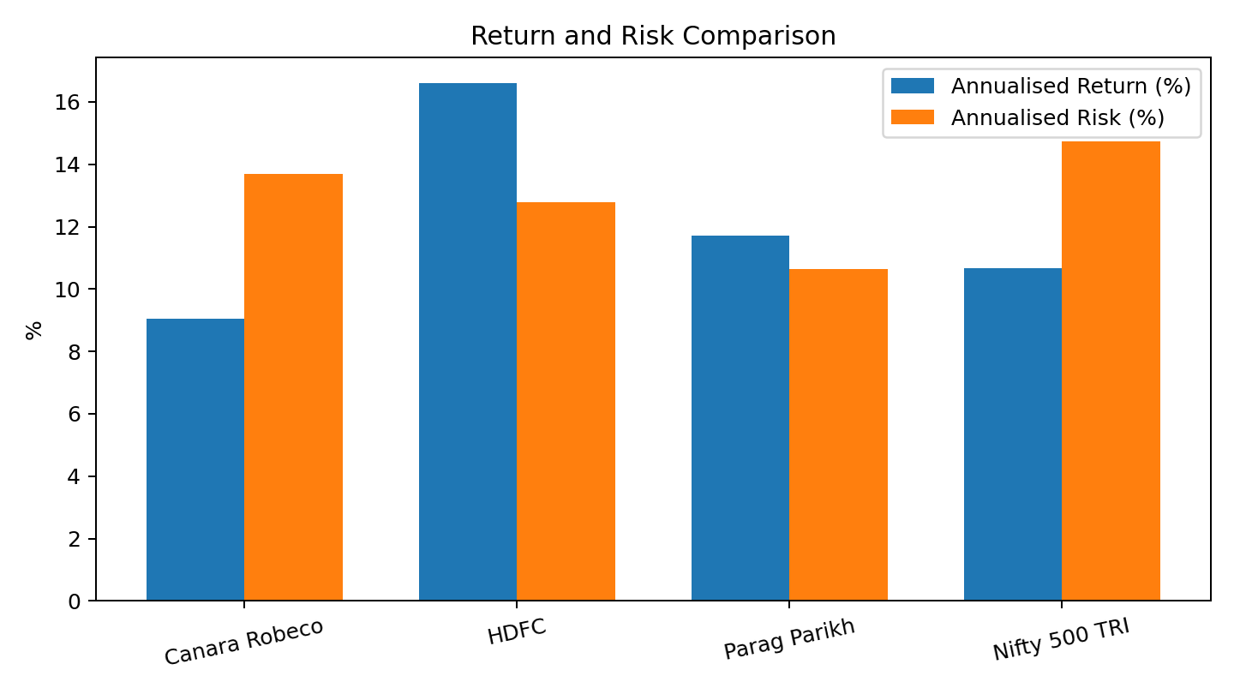
HDFC produced the highest annualised return at 16.59%, comfortably above the benchmark return of 10.67%. Parag Parikh returned 11.72%, also above the benchmark, while Canara Robeco returned 9.06%, below the benchmark. On total risk, Parag Parikh was the least volatile at 10.65%, followed by HDFC at 12.79% and Canara Robeco at 13.70%. All three schemes were less volatile than the Nifty 500 TRI at 14.74%.

3.1 Return
The return ranking is HDFC > Parag Parikh > Canara Robeco. HDFC’s lead is substantial: its annualised return is about 7.53 percentage points above Canara Robeco and 5.92 percentage points above the benchmark. This gives HDFC the strongest raw performance over the period.

3.2 Risk (Standard Deviation)
Parag Parikh has the lowest annualised standard deviation, indicating the smoothest return experience among the three. HDFC combines the second-lowest risk with the highest return, which is particularly favourable. Canara Robeco’s risk is higher than both peers despite generating the lowest return.

3.3 Beta

All three schemes have beta below 1, implying lower sensitivity to benchmark movements. Parag Parikh has the lowest beta (0.647), followed by HDFC (0.804) and Canara Robeco (0.907). Thus, Parag Parikh is the most defensive, while Canara Robeco behaves most similarly to the benchmark among the three.

3.4 Sharpe Ratio
HDFC records the highest Sharpe ratio at 0.789, meaning it generated the strongest excess return per unit of total risk. Parag Parikh ranks second at 0.490. Canara Robeco’s Sharpe ratio of 0.187 is much lower, showing comparatively weak compensation for the volatility undertaken.

3.5 Treynor Ratio
The Treynor ratio tells a similar story. HDFC leads at 0.125, Parag Parikh follows at 0.081 and Canara Robeco is lowest at 0.028. HDFC therefore generated the greatest excess return for each unit of systematic market risk.

3.6 Jensen’s Alpha
HDFC generated a positive Jensen’s alpha of approximately 6.73%, the strongest evidence of value addition after adjusting for beta and the benchmark return. Parag Parikh also generated positive alpha of about 2.52%. Canara Robeco’s alpha is negative at approximately -1.23%, indicating that its realised return was below the return expected for its level of market risk.

4. Discussion of Other Selected Parameters

4.1 Return-Risk Efficiency
HDFC offers the strongest return-risk trade-off because it combines the highest return with lower volatility than Canara Robeco and the benchmark. Parag Parikh is the most conservative option: its return is lower than HDFC, but its volatility and beta are the lowest. Canara Robeco is less efficient in this sample because its lower return is not accompanied by a meaningful risk advantage.

4.2 Benchmark Outperformance
HDFC and Parag Parikh both outperform the Nifty 500 TRI on annualised return, whereas Canara Robeco underperforms it. Importantly, both outperforming peers also carry beta below 1, suggesting that their superior returns were not simply the result of taking greater market exposure.

4.3 Consistency Across Measures
A strong conclusion is supported when several indicators point in the same direction. HDFC ranks first in annualised return, Sharpe ratio, Treynor ratio and Jensen’s alpha. Parag Parikh ranks first on low risk and low beta, but second on the principal risk-adjusted return measures. Canara Robeco does not rank first on any of the major measures considered.

5. Conclusion and Recommendation
Based on the complete set of performance measures, HDFC is the best-performing scheme for the October 2021-August 2026 period. Its 16.59% annualised return is the highest among the schemes and exceeds the Nifty 500 TRI. At the same time, its annualised risk of 12.79% is below both Canara Robeco and the benchmark. Its Sharpe ratio (0.789), Treynor ratio (0.125) and Jensen’s alpha (6.73%) are also the highest, confirming that the superior return remains strong even after adjusting for total and systematic risk.
Parag Parikh ranks second overall and would be particularly suitable for an investor who gives greater importance to lower volatility and lower market sensitivity. Canara Robeco ranks third in this sample because it generated the lowest annualised return, the weakest Sharpe and Treynor ratios, and a negative Jensen’s alpha.
Final Recommendation: HDFC should be identified as the best-performing scheme in this comparative analysis, with Parag Parikh as the strongest lower-risk alternative.

6. Limitations
The conclusion is period-specific and depends on the NAV series, benchmark series and 6.5% risk-free rate contained in the supplied workbook. Past performance does not guarantee future results. The analysis focuses on quantitative performance measures and does not separately assess expense ratio, portfolio concentration, fund-manager changes, tax considerations, exit load or investor-specific suitability.

