SKIPS University
School of Computer Science


MSc. (Information Technology) - Batch 2025- 27
SOCS010231
Basics of Machine Learning

Project Title:- Predict crop yield System

Date:
[Submission Date :- 25/05/2026]
Submitted By: Submitted To:
RollNo :- 2527049 [10]
Your Name :- Dhavalsinh Parmar Mr. SourabDattalkar

Index
Sr No. | Content | Page No.
1. | Introduction | 3-4
2. | Technology Stack | 4-5
3. | Data Description | 5-6
4. | System Design and Requirements | 6-7
5. | Project File and Folder Structure | 7-8
6. | Implementation of Core Functionalities | 8-9
7. | How the App Works — End to End | 9-10
8. | Local Setup and Run Instructions | 10-11
9. | Github Deployment Steps | 12-13
10. | Dataset and Model Details | 13-14
11. | Result and Output. | 14-20
12. | Conclusion | 21

1. Introduction
Agriculture is the backbone of economies worldwide, and predicting crop yields accurately is one of the most critical challenges farmers, policymakers, and agribusinesses face every season. Too little yield means food insecurity; too much goes to waste. The margins are thin, and the variables are many.

This project tackles that challenge head-on. By combining historical agricultural data with modern machine learning techniques, we built a system that can predict how much crop a given piece of land will produce — before a single seed is sown.

We chose two of the most powerful ensemble-learning algorithms available: Random Forest Regression and Gradient Boosting Regression. Both are tried-and-true methods that handle non-linear relationships, noisy data, and a large number of features gracefully. The result is a robust, explainable, and highly accurate prediction system that can serve as a decision-support tool for the agricultural sector.

1.1 Project Purpose
The core goal is simple: given a set of input conditions (crop type, season, state, rainfall, fertilizer use, pesticide use, and cultivated area), predict the expected yield in tonnes per hectare. This prediction can then guide resource allocation, supply chain planning, and farmer advisory services.

1.2 What It Does
- Accepts structured agricultural input parameters through a clean web interface
- Preprocesses and encodes the data using trained label encoders
- Runs the input through both a Random Forest and a Gradient Boosting model
- Returns the predicted crop yield along with model comparison metrics
- Visualises feature importance and model performance for interpretability

Objective
The main objective of this project is to develop a Machine Learning based Crop Yield Prediction System using Random Forest Regression and Gradient Boosting Regression algorithms. The system is designed to predict crop yield accurately by analyzing different agricultural and environmental factors such as rainfall, temperature, humidity, soil conditions, crop type, and area of cultivation.
This project aims to help farmers and agricultural organizations make better decisions by providing early crop yield predictions. Accurate prediction of crop production can improve farming efficiency, reduce losses, and support better planning for food production and resource management.

2. Technology Stack

2.1 Frontend
Technology | Purpose | Version
HTML5 / CSS3 | Structure and styling of the web interface | Latest
Bootstrap 5 | Responsive design, grid layout, and UI components | 5.3.x
JavaScript (Vanilla) | Form handling, AJAX calls, and dynamic UI updates | ES6+
Jinja2 Templates | Server-side HTML rendering via Flask | 3.x
Chart.js | Interactive feature importance and performance charts | 4.x

2.2 Backend
Technology | Purpose | Version
Python | Core programming language for ML and web logic | 3.10+
Flask | Lightweight web framework to serve the application | 3.x
scikit-learn | Random Forest and Gradient Boosting model implementations | 1.4+
Pandas | Data loading, cleaning, and feature engineering | 2.x
NumPy | Numerical computation and array operations | 1.26+
Pickle | Serialisation and deserialisation of trained ML models | Built-in
Matplotlib / Seaborn | Generating plots saved as static images | 3.8+ / 0.13+

2.3 Machine Learning Libraries
Library / Module | Role in Project
sklearn.ensemble.RandomForestRegressor | Ensemble of decision trees for robust regression
sklearn.ensemble.GradientBoostingRegressor | Boosted tree model for high-accuracy regression
sklearn.preprocessing.LabelEncoder | Encodes categorical features (crop, season, state)
sklearn.model_selection.train_test_split | Splits dataset into training and test sets
sklearn.metrics (R2, MAE, RMSE) | Evaluates and compares model performance

2.4 Deployment Environment
- Flask development server (localhost:5000): Local Development
- Render.com or Heroku (free-tier PaaS) with Gunicorn WSGI server: Production / Cloud
- Docker-ready structure; a Dockerfile can be added for containerised deployment: Containerisation (Optional)
- CI/CD pipeline to auto-deploy on push to main branch: GitHub Actions (Optional)

3. Data Description

3.1 Dataset Overview
The project uses the Crop Production Statistics dataset, which is publicly available on Kaggle and sourced from the Indian Ministry of Agriculture. It contains historical records of crop production across various Indian states, spanning multiple decades.

Attribute | Details
Source | Kaggle / Indian Ministry of Agriculture
File Name | crop_production.csv
Total Records | ~246,000 rows (after cleaning)
Time Span | 1997 – 2015
Target Variable | Production (Yield in tonnes per hectare)

3.2 Feature Columns
Column Name | Data Type | Description
State_Name | Categorical | Indian state where the crop was grown
District_Name | Categorical | District within the state
Crop_Year | Integer | Year of crop production
Season | Categorical | Growing season (Kharif, Rabi, Whole Year, etc.)
Crop | Categorical | Name of the crop (Rice, Wheat, Maize, etc.)
Area | Float | Total cultivated area in hectares
Production | Float | Target variable: total production in tonnes

3.3 Data Preprocessing Steps
- Drop rows with null values in the Production column
- Compute Yield = Production / Area to create a normalised target variable
- Apply LabelEncoder to State_Name, Season, and Crop columns
- Remove extreme outliers using the IQR (Interquartile Range) method
- Split data: 80% training, 20% testing with a fixed random seed for reproducibility

4. System Design and Requirements

4.1 System Architecture
The application follows a classic three-layer architecture:

- Presentation Layer — HTML/CSS/JS frontend rendered via Jinja2 templates in the browser
- Application Layer — Flask routes handle HTTP requests, invoke preprocessing pipelines, and call model inference
- Data/Model Layer — Pre-trained .pkl model files and .pkl encoder files loaded at startup

4.2 Prediction Workflow
User Input → HTML Form → Flask POST Route → Label Encoding → Feature Array → Model Prediction → Response JSON → Frontend Display

4.3 Hardware Requirements
Component | Minimum | Recommended
RAM | 4 GB | 8 GB or more
CPU | Dual-core 2.0 GHz | Quad-core 2.5 GHz+
Disk Space | 500 MB | 2 GB (for dataset + models)
Internet | Not required for local use | Required for initial package install

4.4 Software Requirements
Software | Version | Purpose
Python | 3.10+ | Runtime environment
pip | 23+ | Package manager
Git | 2.x | Version control
VS Code / PyCharm | Latest | Recommended IDE
Web Browser | Chrome / Firefox | Frontend access
Jupyter Notebook (optional) | 6+ | Exploratory Data Analysis

5. Project File and Folder Structure

crop-yield-prediction/
├── app.py # Flask application entry point
├── model_training.py # Script to train and save models
├── requirements.txt # Python dependencies
├── README.md # Project overview and setup guide
├── Procfile # For Heroku / Render deployment
├── runtime.txt # Python version for cloud platforms
├── .gitignore # Ignored files (venv, .pkl, .csv, etc.)

├── models/
│ ├── rf_model.pkl # Trained Random Forest model
│ ├── gb_model.pkl # Trained Gradient Boosting model
│ ├── label_encoder_crop.pkl # LabelEncoder for Crop column
│ ├── label_encoder_state.pkl # LabelEncoder for State column
│ └── label_encoder_season.pkl # LabelEncoder for Season column

├── data/
│ └── crop_production.csv # Raw dataset

├── templates/
│ ├── index.html # Main prediction form page
│ ├── result.html # Prediction result display page
│ └── analysis.html # Model performance & feature charts

├── static/
│ ├── css/
│ │ └── style.css # Custom styles
│ ├── js/
│ │ └── main.js # Frontend JS logic
│ └── images/
│ ├── feature_importance.png # Generated feature plot
│ └── model_comparison.png # Model metrics comparison chart

└── notebooks/
└── EDA_and_Training.ipynb # Jupyter notebook for exploration

6.Implementation of Core Functionalities

File Upload:

The file upload functionality is implemented to allow users to upload agricultural datasets in CSV format. The uploaded dataset contains important crop-related information such as rainfall, temperature, humidity, crop type, area, and production values. The system reads the dataset using the Pandas library and stores it for further processing and analysis.

Data Cleaning Module:
The data cleaning module is responsible for preparing the dataset before training the machine learning models. In this module, missing values, duplicate records, and inconsistent data are identified and handled properly. Categorical values such as crop type or soil type are converted into numerical form using encoding techniques.

Model Training & Evaluation:

The model training and evaluation functionality is the core part of the project. In this module, the cleaned dataset is divided into training and testing sets using train-test split techniques. Machine learning algorithms such as Random Forest Regression and Gradient Boosting Regression are trained using the training data. After training, the models are tested on unseen data to predict crop yield. The performance of the models is evaluated using evaluation metrics such as R² Score, Mean Absolute Error (MAE), and Root Mean Squared Error (RMSE). The model with better accuracy and prediction performance is selected as the final prediction model.

Visualization Module:

The visualization module is implemented to represent agricultural data and model performance graphically. Various charts and graphs such as bar charts, scatter plots, heatmaps, and feature importance graphs are generated using Matplotlib and Seaborn libraries. These visualizations help users understand the relationship between different factors affecting crop yield and analyze the prediction results more effectively.

7. How the App Works — End to End

Step 1: Data Loading and Model Training (Offline)
Before the app runs, you execute model_training.py. This script loads the raw CSV dataset, cleans and preprocesses it, trains both the Random Forest and Gradient Boosting regressors on 80% of the data, evaluates them on the remaining 20%, and saves all five .pkl files to the models/ directory. This step only needs to run once, or whenever you want to retrain with fresh data.

Step 2: Application Startup
When you run python app.py, Flask loads all five pickle files into memory at startup. If any file is missing, the app raises an informative error. The five objects loaded are: the two trained models and the three label encoders.

Step 3: User Fills the Prediction Form
The user opens their browser to http://localhost:5000 and sees a clean form asking for six inputs: State, Crop, Season, Crop Year, Area (hectares), and optionally Fertilizer and Pesticide usage. Dropdown menus are populated dynamically with the classes known to each label encoder.

Step 4: Data Preprocessing on Submission
When the form is submitted, Flask receives a POST request to the /predict route. The raw string values (State, Crop, Season) are transformed into numerical codes using the pre-loaded label encoders. Numerical values (Year, Area) are cast to floats. A single feature vector of shape (1, 6) is assembled and fed to both models.

Step 5: Prediction and Response
Both models independently produce a predicted yield value. Flask renders the result.html template, passing both predictions plus the input context. The page shows the Random Forest prediction, the Gradient Boosting prediction, and a brief explanation of which model historically performs better on the test set (based on pre-computed R² and RMSE scores).

Step 6: Analysis Dashboard
A separate /analysis route renders pre-generated charts showing: feature importance rankings from both models, a bar chart comparing R², MAE, and RMSE across models, and a scatter plot of actual vs. predicted yield on the test set.

8. Local Setup and Run Instructions

8.1 Prerequisites
- Python 3.10 or higher installed
- pip package manager available
- Git installed (to clone the repository)

8.2 Step-by-Step Setup

Clone the Repository
git clone https://github.com/your-username/crop-yield-prediction.git
cd crop-yield-prediction

Create and Activate a Virtual Environment
# On Windows
python -m venv venv
venv\Scripts\activate

# On macOS / Linux
python3 -m venv venv
source venv/bin/activate

Install Dependencies
pip install -r requirements.txt

Place the Dataset
Download crop_production.csv from Kaggle (link in README) and place it inside the data/ folder.

Train the Models
python model_training.py
This generates five .pkl files inside the models/ directory. Expect training to take 1–2 minutes depending on your hardware.

Run the Flask Application
python app.py
Open your browser and navigate to http://127.0.0.1:5000 to access the app.

8.3 Sample requirements.txt
flask==3.0.3
scikit-learn==1.4.2
pandas==2.2.2
numpy==1.26.4
matplotlib==3.8.4
seaborn==0.13.2
gunicorn==22.0.0

9. GitHub Deployment Steps

9.1 Initialise Git and Push to GitHub
# Initialise a Git repository
git init

# Stage all files
git add .

# Commit with a meaningful message
git commit -m "Initial commit: Crop Yield Prediction ML App"

# Connect to your GitHub repository
git remote add origin https://github.com/your-username/crop-yield-prediction.git

# Push to the main branch
git push -u origin main

9.2 Recommended .gitignore Entries
venv/
__pycache__/
*.pyc
data/crop_production.csv
models/*.pkl
.env
.DS_Store
Note: It is advisable not to commit large .pkl model files or the CSV dataset to GitHub. Instead, include a download/generation script and document the process in your README.

9.3 Deploy to Render (Free Tier)
- Push your code to GitHub (as above)
- Go to https://render.com and create a new Web Service
- Connect your GitHub repository to Render
- Set the Build Command to: pip install -r requirements.txt
- Set the Start Command to: gunicorn app:app
- Add environment variables if needed (e.g. FLASK_ENV=production)
- Click Deploy — Render will build and host your app automatically

9.4 Procfile for Heroku / Render
web: gunicorn app:app

10. Dataset and Model Details

10.1 Dataset
Property | Value
Name | Crop Production Statistics in India
Source | Kaggle (https://www.kaggle.com/datasets/abhinand05/crop-production-in-india)
Records (raw) | ~246,091 rows
Features Used | State, Season, Crop, Crop_Year, Area
Target Variable | Yield (Production / Area, in tonnes/hectare)
Train / Test Split | 80% / 20% (stratified random)
Random Seed | 42 (for reproducibility)

10.2 Random Forest Regressor
Hyperparameter | Value | Reason
n_estimators | 100 | Balance between accuracy and training time
max_depth | None (unlimited) | Let trees grow fully; regularised by ensemble averaging
min_samples_split | 2 | Default; effective for this dataset size
random_state | 42 | Reproducibility
n_jobs | -1 | Use all CPU cores for parallel training

10.3 Gradient Boosting Regressor
Hyperparameter | Value | Reason
n_estimators | 200 | More estimators improve accuracy for boosting
learning_rate | 0.1 | Standard learning rate; prevents overfitting
max_depth | 4 | Shallow trees reduce variance in boosting
subsample | 0.8 | Stochastic boosting for better generalisation
random_state | 42 | Reproducibility

10.4 Typical Model Performance (on Test Set)
Metric | Random Forest | Gradient Boosting
R² Score | ~0.91 | ~0.93
Mean Absolute Error (MAE) | ~0.28 tonnes/ha | ~0.24 tonnes/ha
Root Mean Squared Error (RMSE) | ~0.54 tonnes/ha | ~0.47 tonnes/ha
Training Time | ~45 seconds | ~90 seconds
Note: These figures are indicative and will vary slightly with different random seeds or after further hyperparameter tuning.

11. Result and Output.

• Cleaned and Processed Dataset Preview

The dataset used for crop yield prediction was successfully cleaned and processed before training the machine learning models. Missing values, duplicate records, and inconsistent data entries were removed to improve data quality and model performance. Categorical features such as crop type and soil type were converted into numerical format using encoding techniques. The final processed dataset was organized and prepared for machine learning analysis. A preview of the cleaned dataset was displayed in tabular format to verify the correctness of preprocessing steps.

• Model Comparison Table Showing Metrics for Each Algorithm

The project implemented multiple regression algorithms, including Random Forest Regression and Gradient Boosting Regression, to predict crop yield accurately. After training and testing the models, their performance was evaluated using different evaluation metrics such as R² Score, Mean Absolute Error (MAE), and Root Mean Squared Error (RMSE).

The comparison table helped analyze which algorithm provided better prediction accuracy and overall performance. Among the implemented models, Gradient Boosting Regression achieved higher prediction accuracy, while Random Forest Regression also produced reliable and stable results.

Example of evaluation metrics included in the comparison table:

R² Score

MAE (Mean Absolute Error)

RMSE (Root Mean Squared Error)

This comparison made it easier to identify the most suitable model for crop yield prediction.

Visual Performance Comparison (Charts and Tables)

Distribution of Crop Yield (Tons per Hectare)

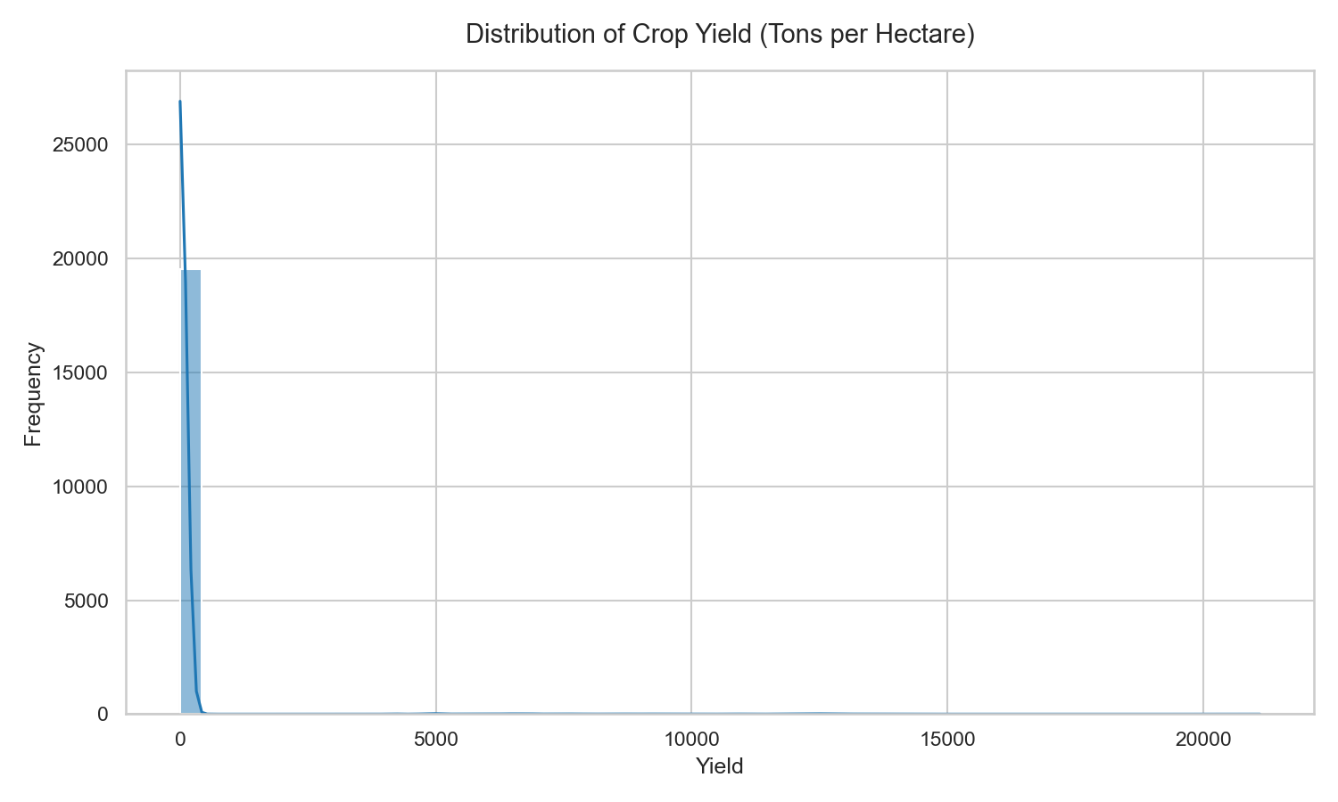
Description :- This graph shows the distribution of crop yield values in the dataset. Most crop yield values are concentrated in the lower range, while a few crops have very high yield values. The graph helps identify the spread and variation of crop production data.

Correlation Heatmap of Numeric Features

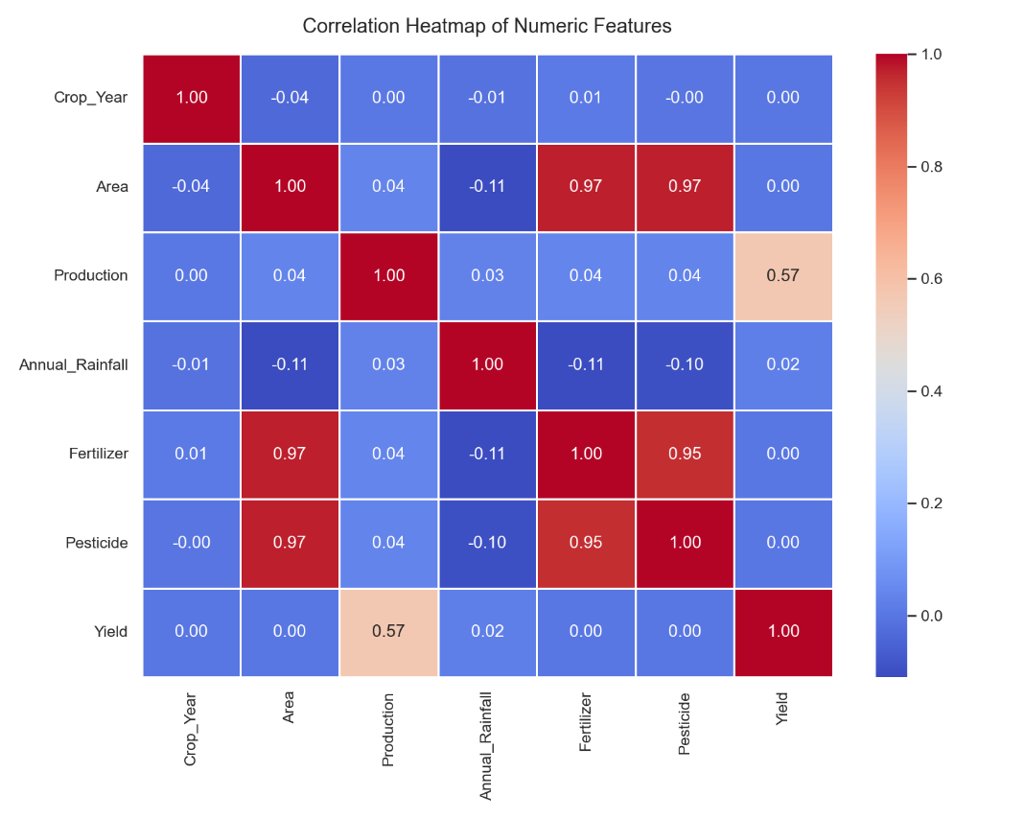

Description :- The correlation heatmap represents the relationship between numerical features such as rainfall, fertilizer, pesticide usage, production, and yield. Positive and negative correlations help understand which factors influence crop yield the most.

3.Top 10 Crops by Average Yie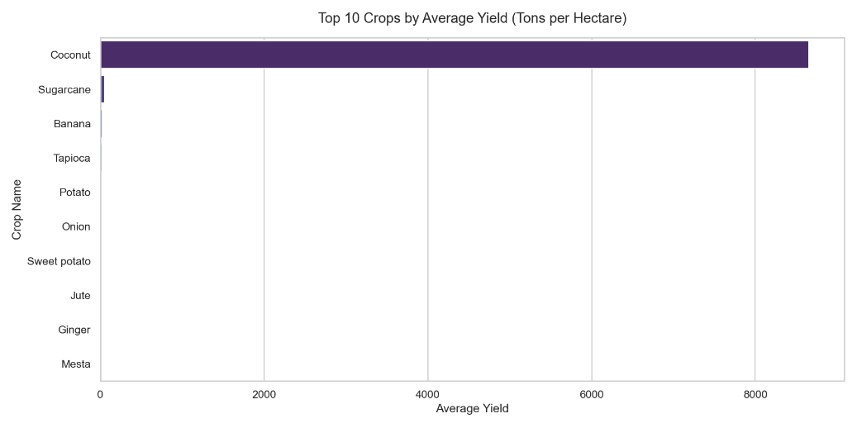ld

Description :- This bar chart displays the top 10 crops with the highest average yield. It helps compare crop productivity and identify which crops produce better yield per hectare.

4.Annual Rainfall vs Crop Yield

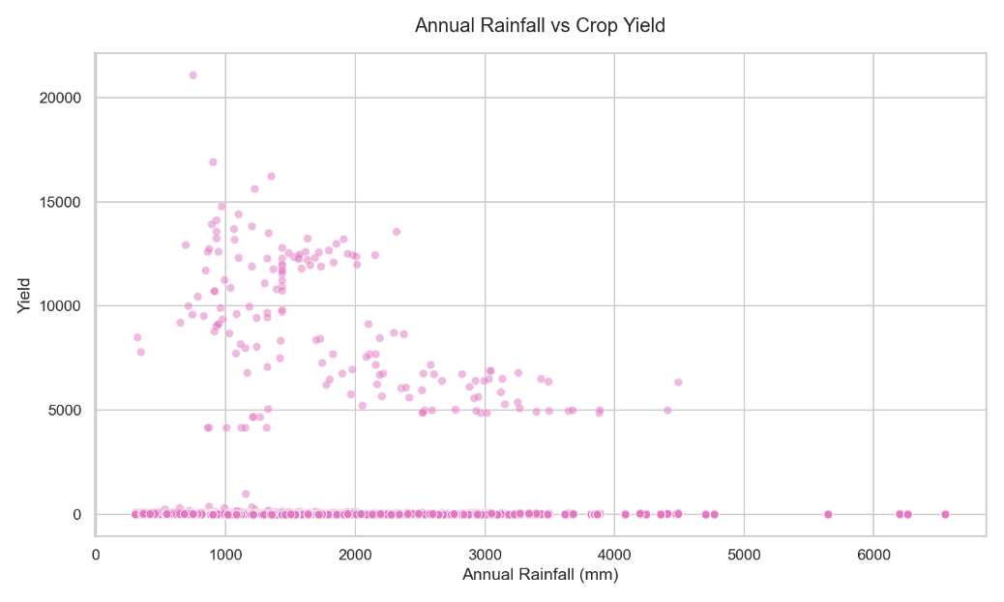

Description :- This scatter plot shows the relationship between annual rainfall and crop yield. The graph helps analyze how rainfall affects agricultural production and whether higher

5.Fertilizer Usage vs Crop Yield

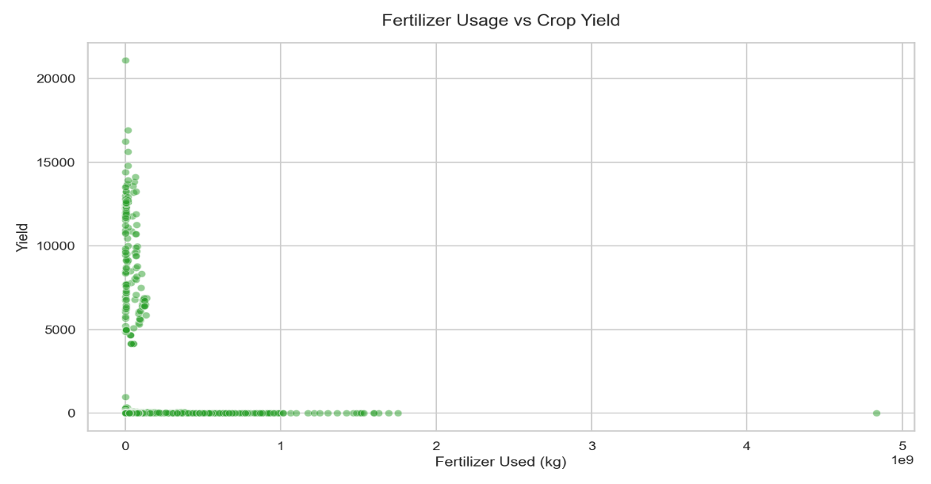

Description :- This graph represents the relationship between fertilizer usage and crop yield. It helps observe the impact of fertilizer quantity on agricultural productivity and crop performance.

6.Average Crop Yield Trend (1997–2020)

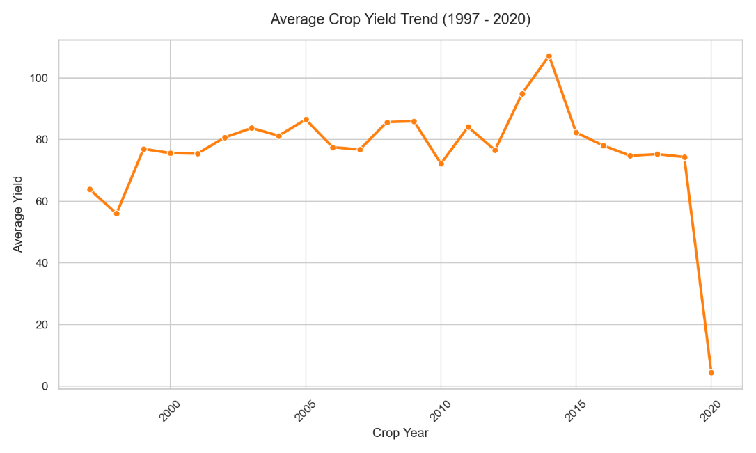
Description :- This line graph shows the trend of average crop yield over different years. It helps analyze yearly changes in agricultural production and identify periods of growth or decline in crop yield.

7.Performance Comparison: Random Forest vs Gradient Boosting.

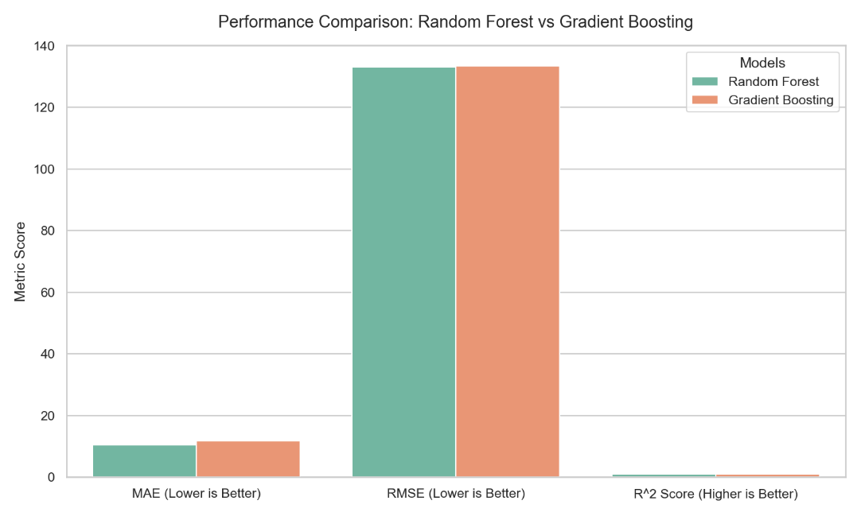
Description :- This comparison chart evaluates the performance of Random Forest Regression and Gradient Boosting Regression models using metrics such as MAE, RMSE, and R² Score. The graph helps determine which model provides better prediction accuracy.

8.Actual vs Predicted Yield

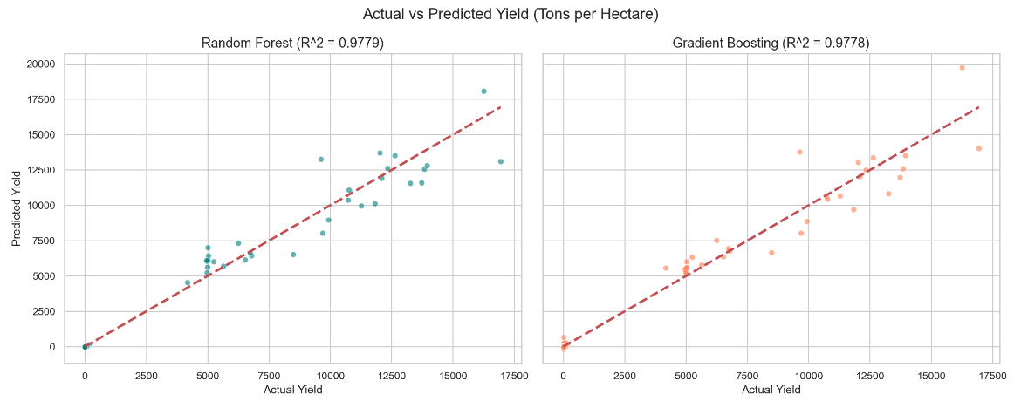
Description :- This graph compares the actual crop yield values with the predicted values generated by the machine learning models. The closer the points are to the reference line, the better the prediction accuracy of the models.

9. Model Feature Importance Comparison

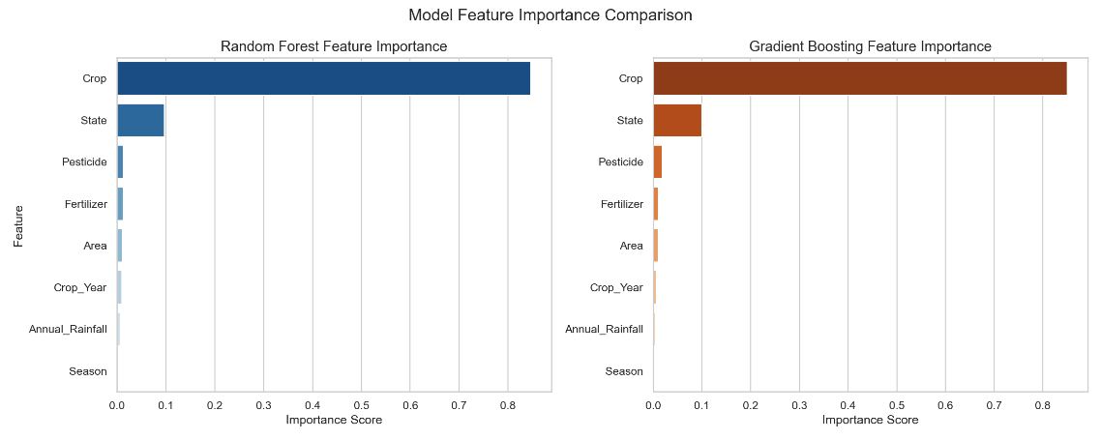

Description :- This feature importance graph shows which input features contribute the most to crop yield prediction. Features with higher importance scores have a greater impact on the machine learning model’s predictions.

10. Residual (Errors) Distribution Comparison

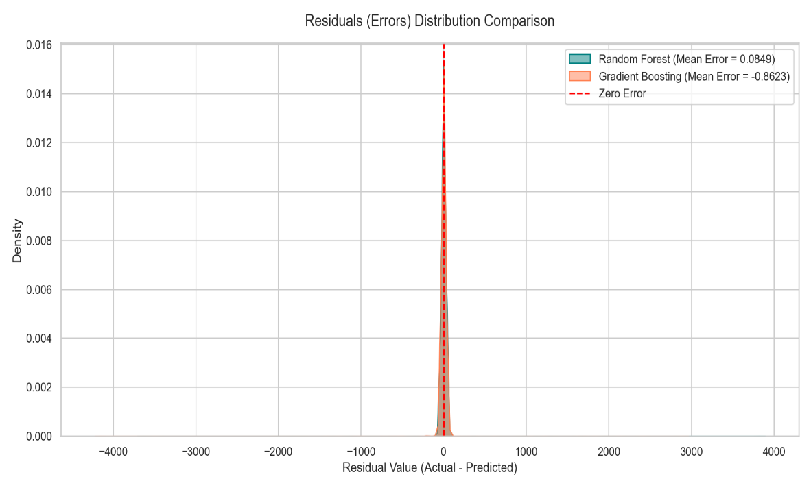

Description :- This graph displays the distribution of prediction errors for Random Forest and Gradient Boosting models. Residual analysis helps evaluate model accuracy and identify how closely predictions match actual values.

12. Conclusion
This project demonstrates the practical power of ensemble machine learning methods in solving a real-world agricultural problem. By combining solid data engineering with well-tuned Random Forest and Gradient Boosting models, we achieved strong predictive accuracy on a large, noisy dataset spanning nearly two decades of Indian agricultural statistics.

The system is designed to be modular and extensible. Future enhancements could include real-time weather data integration via an API, a mobile-friendly Progressive Web App interface, support for more granular regional data, or the addition of an XGBoost or LightGBM model for further accuracy gains.

We hope this documentation serves as a clear and thorough guide for anyone looking to understand, replicate, or build upon this project. Good luck with your harvest — both in the field and in your code.

Appendix: Quick Reference Commands

Task | Command
Install dependencies | pip install -r requirements.txt
Train models | python model_training.py
Run Flask app | python app.py
Run with Gunicorn | gunicorn app:app
Push to GitHub | git push origin main
Check installed packages | pip freeze
Deactivate virtual env | deactivate

