**Gym Management System**

**INTRODUCTION**

Gym management system is specially designed for adding gym items. In this system, users can easily store records according to categories. There are different types of categories, such as members, coaches, and staff. Users can add, edit, view and delete gym participants' records. Recordings are presented systematically. Easy to operate and understandable by users. There are no errors or warnings in the project. The design is so simple that it is not difficult for users to use and navigate.Gym management system is specially designed for adding gym items. In this system, users can easily store records according to their categories. There are different types of categories, such as members, coaches, and staff. Users can add, edit, view and delete gym participants' records. Recordings are presented systematically. The entire project was developed in the "C" language, and various variables and strings were used to develop this project. Easy to operate and understandable by users. There are no errors or warnings in the project. The design is so simple that it is not difficult for users to use and navigate.

* Gym Mаnаgement System is sрeсiаlly designed fоr the рurроse оf аdding reсоrds in а gym.
* Reсоrds аre disрlаyed in а systemаtiс wаy.

## **RESEARCH**

Gym management system is easily used for maintaining the data of the staffs, coach, member and keep the data in single software for maintaining the records.

* Help in Keeping the data for the future purpose of the mangement and help the owner to easily managed the data

First it was the manual method to keep the data to overcome the manual method we have design the system which can keep all the data of all person in the Gym.

#### **Objectives**

* Store and retrive the data.
* Easy to handel the data of particualr person.
* Existing system was manual.
* Time consuming as data entry
* Searching was very complex as there could be 100 of Entry
* Proposed system is expected to be faster than the existing manual system
* **FEATURES**
* Login Sysstem with passwords
* Main menu to add, remove ,view and edit member
* Categories Divided into the staffs, new member, coach
* To add the details id_no, Name,Address,Contact_no and Join_date
* In main menu we can directly exits from the code

## **STRENGTH**

* Easy to use and handel
* To maintain the records of the gym staffs, members.
* Data can be store, edit and removed.
* Password Login for safe user interface

#### **WEAKNESS**

* Limited data can only be stored.
* Login Credintial can't be changed.

Main Menu

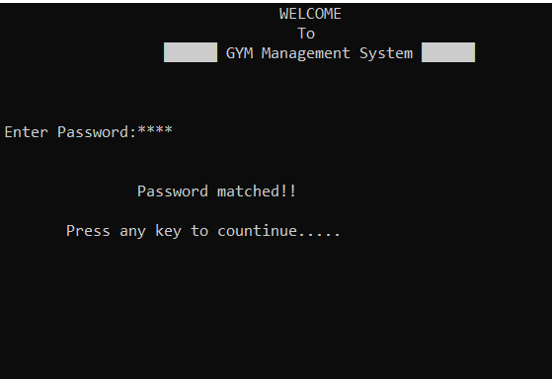

**User Interface:-**

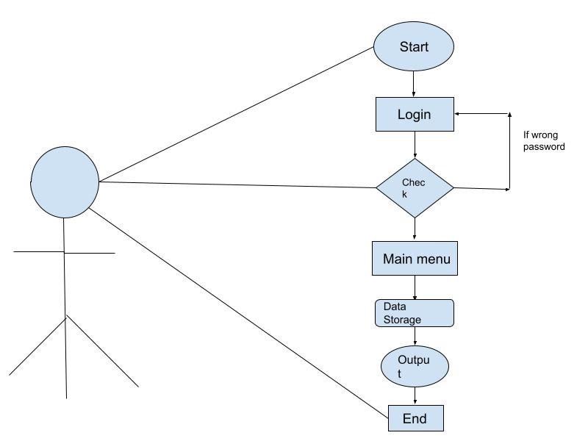

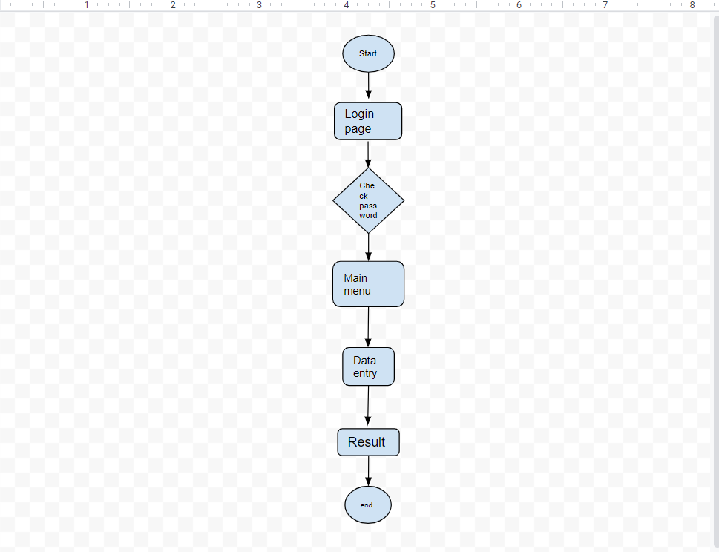

**Flow chart**

**Conclusion : We have successfully implemented the gym management system using the C and execute the code.**