LOVELY PROFESSIONAL UNIVERSITY PHAGWARA, PUNJAB


Subject – CSV205

CA-2
Submitted to – Utkarsh Sir

Submitted by – Abhishek Yadav
Reg No. – 12324568
Roll No. - 21

By click on creating bucket we can create bucket manually
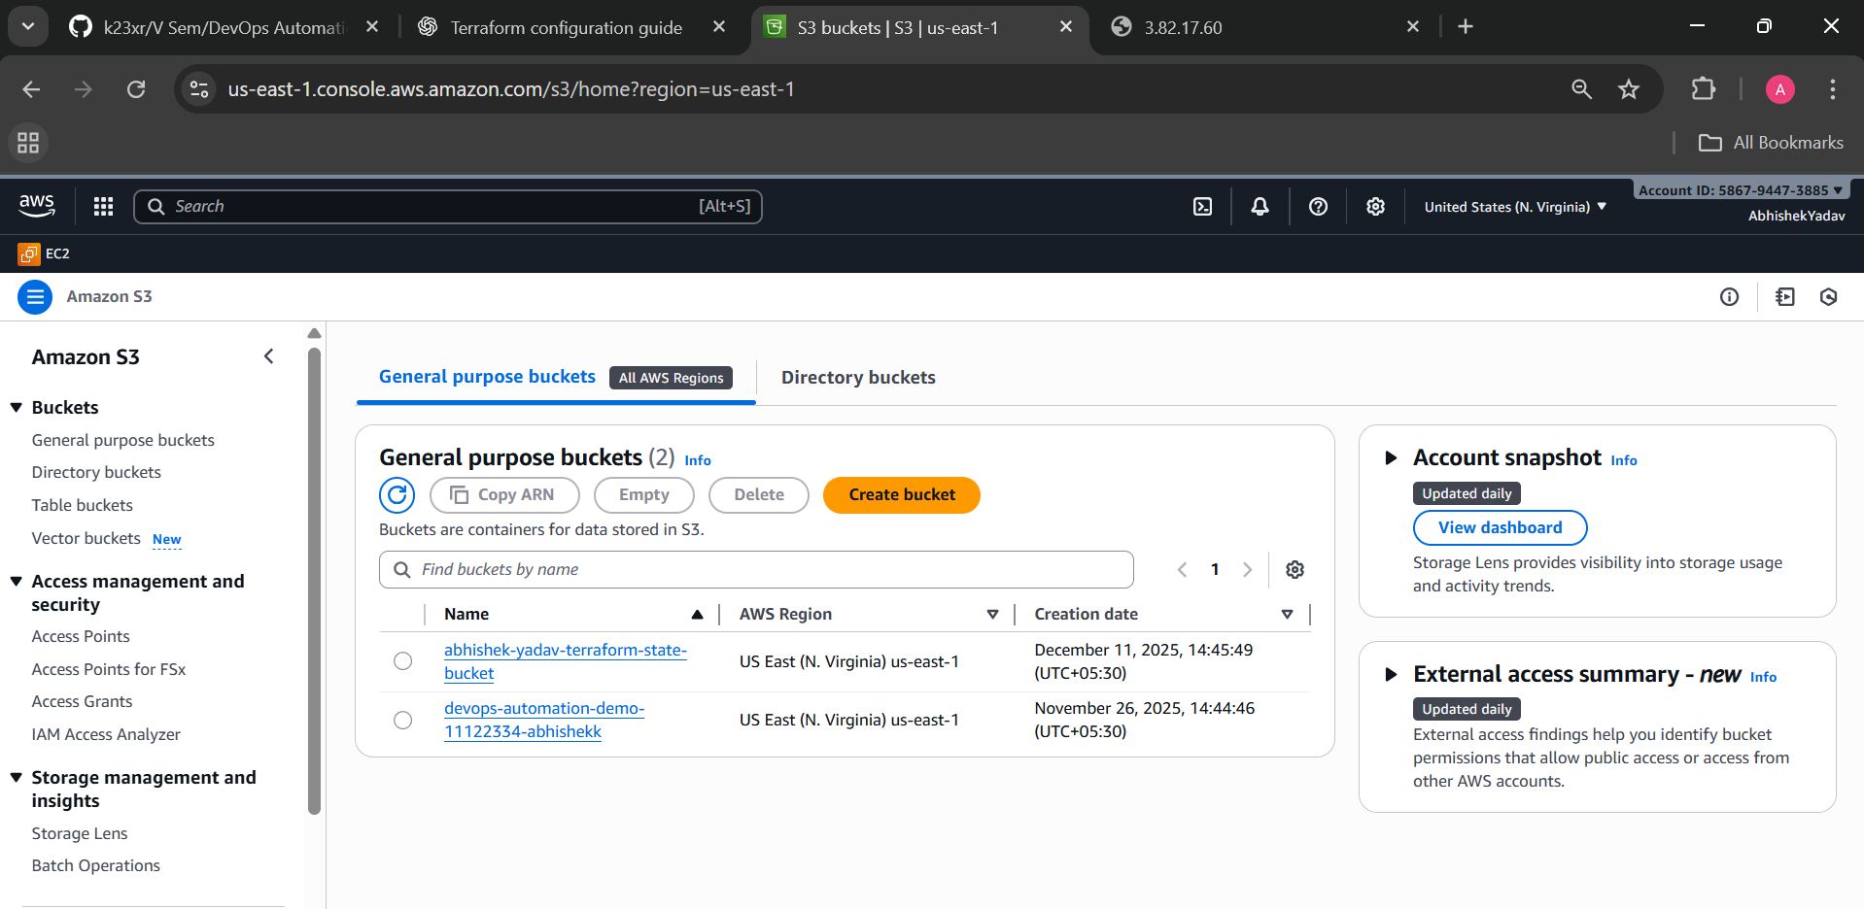

DynamoDB
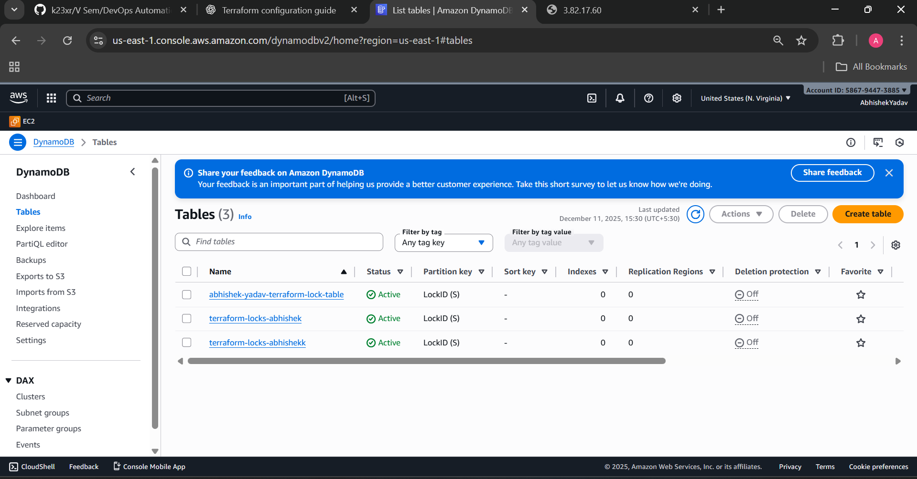

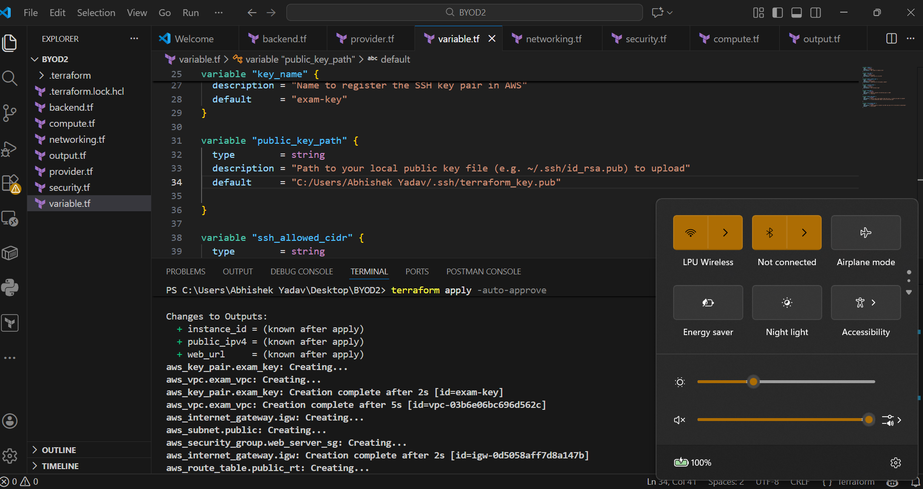

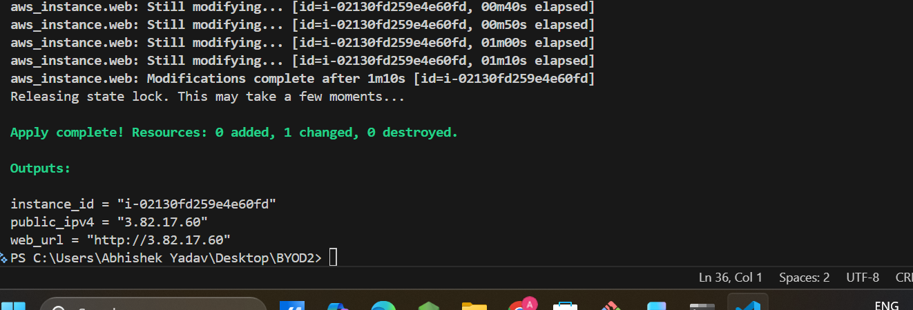

GitHub repo Link: https://github.com/2704Abhishek/BYOD2

