**CodeAlpha Internship Project R-code and Interpretation Report**

**Title:** A Statistical Study on Fast-Food Consumption  
**Intern Name:** Taware Chaitrali Rajendra  
**Domain:** Data Analytics  
**Internship Duration:** 20th July – 20th August

# 1. Introduction

This document contains R code used for analyzing the fast-food consumption dataset collected during the internship. It includes basic visualizations, descriptive statistics, and attribute analysis using Yule’s Q and Coefficient of Variation.

# 2. Pie Chart – Fast-Food Consumption

slices <- c(134, 16)  
labels <- c("Yes (89%)", "No (11%)")  
pie(slices, labels = labels, main = "Fast-Food Consumption")

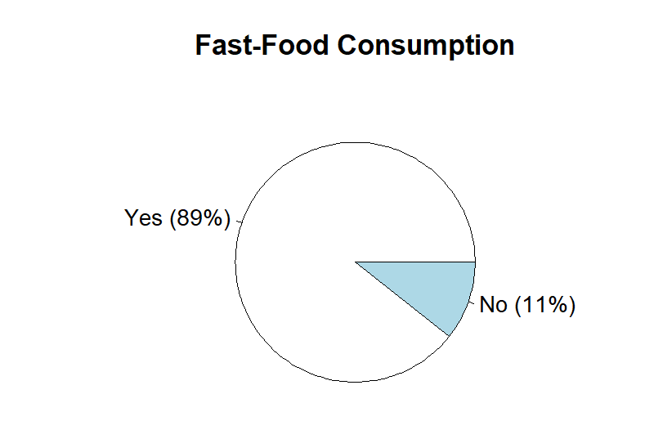

👉 **Interpretation:** Out of 150 participants, 89% reported consuming fast food. This indicates that fast-food consumption is highly prevalent in the study area.

# 3. Pie Chart – Gender Distribution of Consumers

slices <- c(60, 40)

labels <- c("Female (60%)", "Male (40%)")

pie(slices, labels = labels, main = "Gender Distribution")

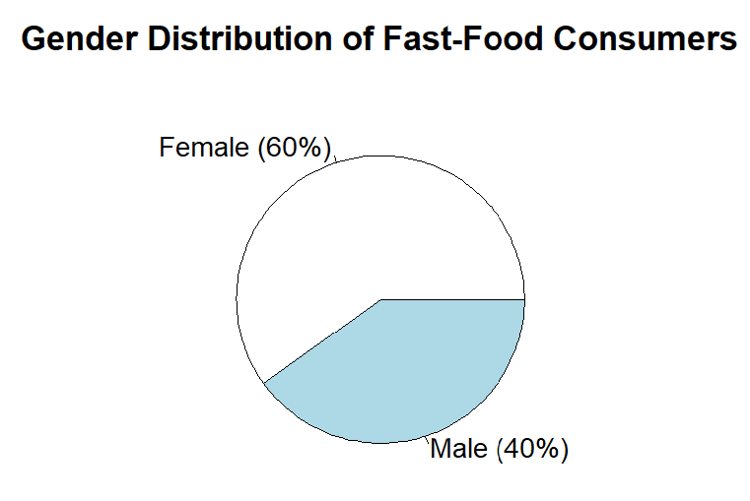

👉 **Interpretation:**  
Female respondents made up a larger share of fast-food consumers compared to males, suggesting higher participation or preference among females.

# 4. Bar Chart – Preferred Fast-Food by Females

foods <- c("Vadapav", "Panipuri", "Pizza", "Chinese", "Pav Bhaji", "Sweets")

female_counts <- c(26, 21, 12, 18, 8, 15)

barplot(female_counts, names.arg = foods, main = "Female Preferences", col = "pink", las = 2)

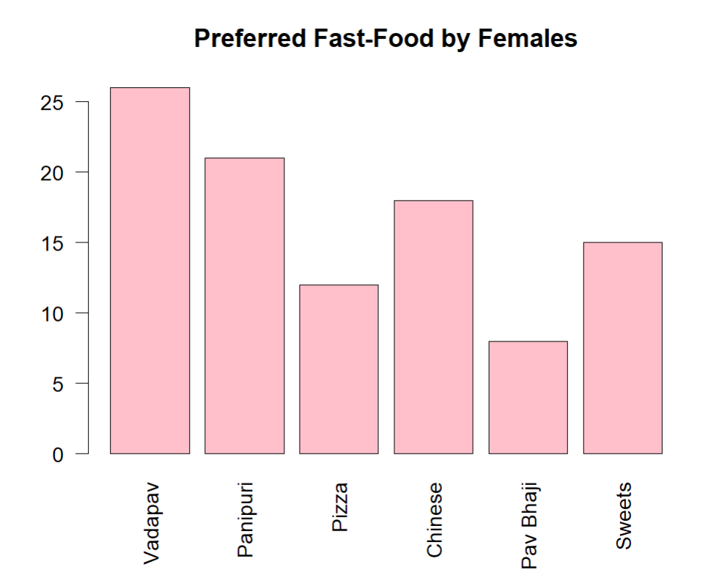

👉 **Interpretation:**  
Among female respondents, Vadapav (26%) and Panipuri (21%) were the most preferred fast-food items. This shows a strong inclination toward local and street food options.

**5. Bar Chart – Preferred Fast-Food by Males**

male_counts <- c(20, 10, 12, 32, 8, 18)

barplot(male_counts, names.arg = foods, main = "Male Preferences", col = "lightblue", las = 2)

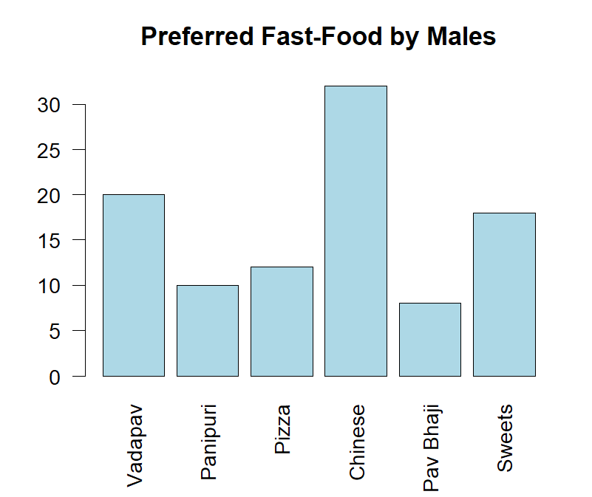

👉 **Interpretation:**  
Among male participants, Chinese food (32%) was the most preferred, followed by Sweets (18%). This highlights a gender-based difference in taste and choice.

**6. Bar Chart – Time of Fast-Food Consumption**

time <- c("Before 12 PM", "12–3 PM", "3–6 PM", "After 6 PM")

counts <- c(5, 20, 90, 35)

barplot(counts, names.arg = time, main = "Fast-Food Consumption by Time", col = "orange")

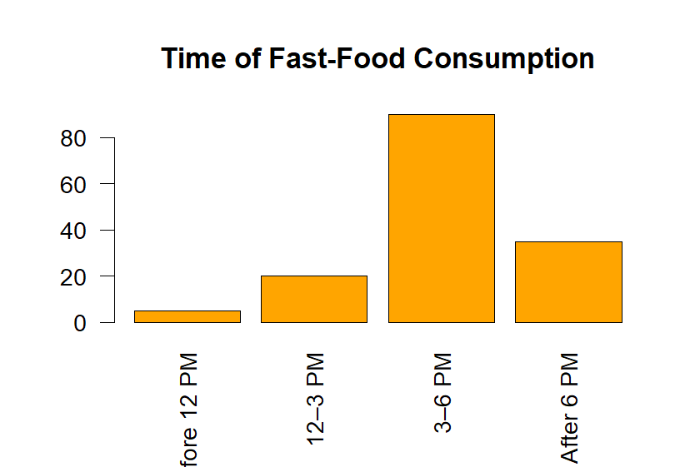

👉 **Interpretation:**  
Most people prefer eating fast food between 3 PM and 6 PM, indicating a strong snack-time culture.

**7. Pie Chart – Mood Influence on Eating**

slices <- c(90, 60)

labels <- c("Mood (60%)", "Other (40%)")

pie(slices, labels = labels, main = "Mood Influence on Fast-Food Choice")

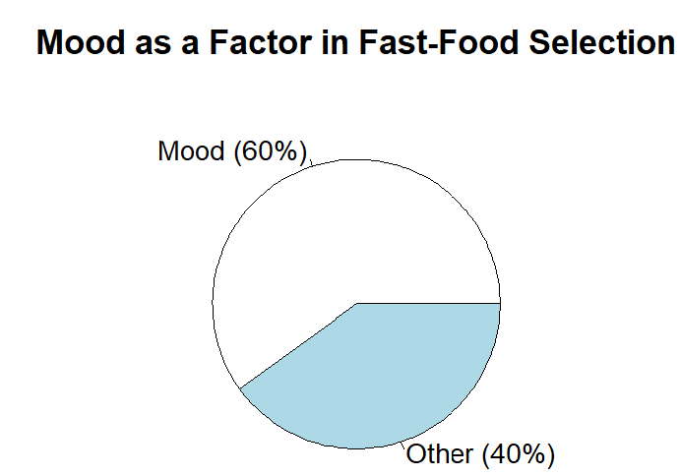

👉 **Interpretation:**  
60% of participants reported that their mood influences fast-food selection. This suggests emotional eating is a key behavioral factor.

**8. Bar Chart – Perception of Health Risk**

unhealthy <- c(53, 65)

healthy <- c(47, 35)

barplot(rbind(unhealthy, healthy), beside = TRUE, names.arg = c("Female", "Male"), col = c("red", "green"), legend = c("Unhealthy", "Healthy"), main = "Perception of Fast-Food Health Impact")

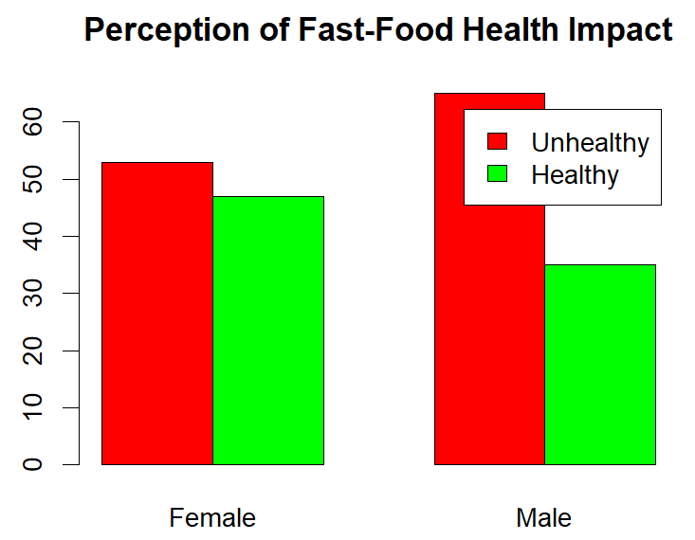

👉 **Interpretation:**  
A higher percentage of males (65%) and females (53%) believe fast food is unhealthy. However, this awareness doesn't necessarily reduce consumption.

**9. Bar Chart – Health Problems After Fast-Food**

yes <- c(17, 28)

no <- c(83, 72)

barplot(rbind(yes, no), beside = TRUE, names.arg = c("Female", "Male"),

col = c("red", "green"), legend = c("Health Problems", "No Problems"), main = "Reported Health Problems After Eating Fast-Food")

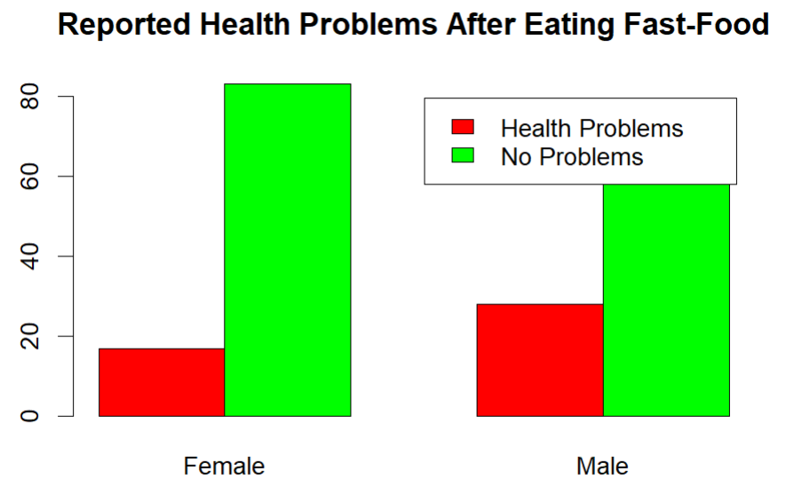

👉 **Interpretation:**  
28% of males and 17% of females experienced health issues after consuming fast food. This suggests a gendered variation in health impact perception or reality.

**10. Yule’s Q – Gender vs Fast-Food Consumption**

data <- matrix(c(83, 7, 50, 10), nrow = 2)  
q <- (data[1,1]*data[2,2] - data[1,2]*data[2,1]) /  
 (data[1,1]*data[2,2] + data[1,2]*data[2,1])  
round(q, 4)

👉 **Interpretation:** There is a positive association between gender and fast-food consumption. Gender plays a role in predicting likelihood of consuming fast food.

**11. Yule’s Q – Gender vs Health Problems**

data <- matrix(c(15, 75, 17, 43), nrow = 2)  
q <- (data[1,1]*data[2,2] - data[1,2]*data[2,1]) /  
 (data[1,1]*data[2,2] + data[1,2]*data[2,1])  
round(q, 4)

**👉 Interpretation**: There is a negative association between gender and health problems from fast food, suggesting different patterns in how males and females experience or report issues.

**12. Coefficient of Variation – Female Height**

height_f <- c(158, 160, 155, 153, 159)  
cv_f <- (sd(height_f) / mean(height_f)) * 100  
print(paste("Female CV for height:", round(cv_f, 2), "%"))

👉 **Interpretation:** Females show more consistency in height and weight, as their coefficient of variation (CV) is lower compared to males.