docker容器下安装logstash：

1、下载镜像 查看镜像

docker run -d --name=logstash logstash:7.7.0

1. 挂载目录到本地目录下

mkdir -p /home/logstash/config/conf.d

docker cp logstash:/usr/share/logstash/config /home/logstash/

docker cp logstash:/usr/share/logstash/data /home/logstash/

docker cp logstash:/usr/share/logstash/pipeline /home/logstash/

chmod 777 -R /home/logstash

1. 进入到容器内部进行插件安装：

docker exec -it logstash1 /bin/bash  
cd /bin/

logstash-plugin install logstash-input-jdbc

logstash-plugin install logstash-output-elasticsearch

logstash-plugin install logstash-codec-json_lines

Ps：要踩的坑，提示各种内存不足，类似于error='Not enough space'，查看jvm大小然后修改大小

find / -name jvm.options

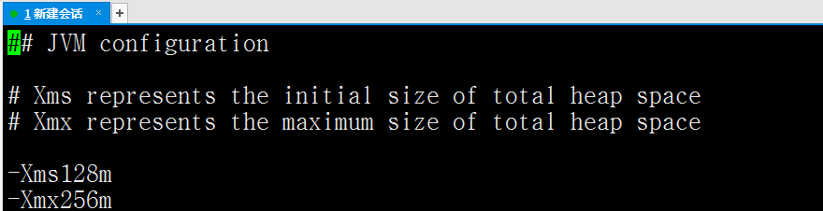

1. 下载jar包放到pipeline下



1. 到pipeline里面编辑logstash.conf

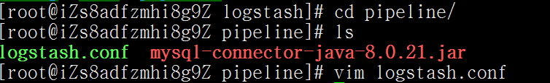

内容如下：

input {

stdin { }

jdbc {

#注意mysql连接地址一定要用ip，不能使用localhost等

jdbc_connection_string => "jdbc:mysql://8.129.217.148:3310/zspoa_member"

jdbc_user => "root"

jdbc_password => "123456"

#这个jar包的地址是容器内的地址

jdbc_driver_library => "/home/logstash/pipeline/mysql-connector-java-8.0.21.jar"

jdbc_driver_class => "com.mysql.cj.jdbc.Driver"

jdbc_paging_enabled => "true"

jdbc_page_size => "50000"

statement => "SELECT * FROM member"

schedule => "* * * * *"

}

}

output {

stdout {

codec => json_lines

}

elasticsearch {

#注意mysql连接地址一定要用ip，不能使用localhost等

hosts => "121.199.2.132:9200"

index => "member"

document_type => "_doc"

document_id => "%{id}"

}

}

6、修改logstash.yml

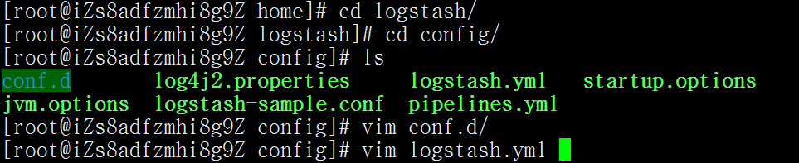

全部内容改成：

http.host: "0.0.0.0"

xpack.monitoring.elasticsearch.hosts: [ "http://121.199.2.132:9200" ]  
- pipeline.id: table1

path.config: "/etc/logstash/pipeline/logstash.conf"

如果需要配置多个表同步则可以多写点配置：

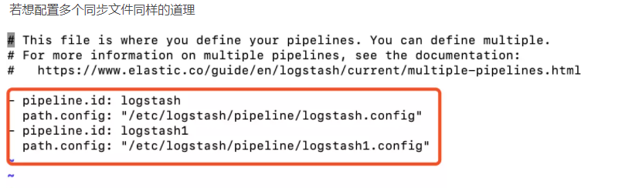7、重启容器：

docker restart logstash

查看执行结果：

docker logs -f --tail=30 logstash1