YENEPOYA INSTITUTE OF ARTS, SCIENCE, COMMERCE AND MANAGEMENT

LOW-LEVEL DESIGN
ON
Anomaly Detection for Smart City Transactions

Submitted By: Mohammed Ziyad

Industry Mentor:

Guided By:

Table Of Contents

- File Structure. ……………………………………………………….. 3

- Module Details. …………………………………………………….. 4
  - Imports. ………………………………………………………. 4
  - Functions. ……………………………………………………. 4
  - Main Execution Block. ………………………………….. 5

- Data Flow. ………………………………………………………………. 6
  - File Input. ……………………………………………………… 6
  - Parsing and Tokenization. …………………………….. 6
  - Summarization Engine. …………………………………. 6-7
  - Output Generation. ………………………………………. 7

- Example Input. ……………………………………………………….. 8

- Example Output. …………………………………………………….. 9

- Technology Stack. …………………………………………………….. 10

- Error Handling. …………………………………………………………. 11-12
- Future Enhancements. ……………………………………………… 13-14

- FILE STRUCTURE

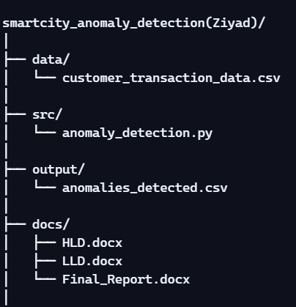

  - data/ → Stores raw input dataset.
  - src/ → Contains the anomaly detection script.
  - output/ → Holds generated anomalies file.
  - docs/ → Documentation in .docx format (HLD, LLD, Final Report).

- MODULE DETAILS

2.1 Imports

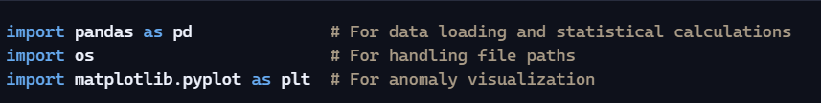

2.1 Functions

- load_data() → Reads the CSV file, trying multiple encodings.
- detect_anomalies() → Computes mean, std, Z-Scores, and flags anomalies where $∣z∣>3$.
- save_anomalies() → Saves anomalies into a separate CSV file.
- summarize()→ Prints totals, mean, std, anomaly percentage, and anomaly preview.
- visualize() → Creates a scatter plot with normal points in blue and anomalies in red.

2.3 Main Execution Block

- Defines input path (CSV) and output path (anomalies file).
- Loads dataset with load_data().
- Detects anomalies using detect_anomalies().
- Saves anomalies with save_anomalies().
- Prints summary stats with summarize().
- Displays anomalies visually with visualize()

- DATA FLOW

3.1 File Input

  - The dataset customer_transaction_data.csv is read from the data/ folder.
  - The script attempts multiple encodings (utf-8, utf-16, latin1) to ensure successful loading.
  - Once loaded, the data is stored in a Pandas DataFrame.

3.2 Parsing and Tokenization

  - Pandas automatically parses the CSV into columns: Transaction_ID, Customer_ID, State, Age, Shop_Category, Sales.

  - No extra tokenization was needed since the dataset is already structured.

3.3 Summarization Engine

- The script calculates mean and standard deviation of the Sales column.
- Each transaction’s Z-Score is computed:
  - $z=\frac{x-μ}{σ}$
- Transactions with $∣z∣>3$are flagged as anomalies.
- A summary is printed: total transactions, anomalies detected, mean, std, anomaly percentage, and a preview of anomalies.
- • $x$→ The individual transaction value (in our case, the Sales amount for one record).
- • $μ$→ The mean (average) of all transaction values in the dataset.
- • $σ$→ The standard deviation, which measures how spread out the transaction values are around the mean.
- • $z$→ The Z-Score, which tells us how many standard deviations a transaction is away from the mean.

3.4 Output Generation

- Anomalies are saved into output/anomalies_detected.csv.
- A scatter plot is generated:
- Blue points → normal transactions.
- Red points → anomalies.
- This provides both a tabular and visual confirmation of detected outliers.

- EXAMPLE INPUT

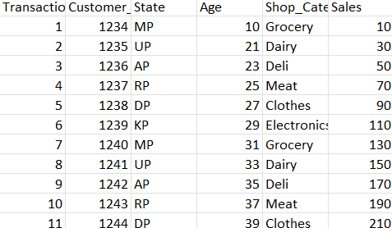

  - Transaction → Transaction number (unique ID for each record)
  - Customer_ID → Customer ID
  - State → State abbreviation
  - Age → Age of the customer
  - Shop_Category → Shop category (e.g., Grocery, Dairy, Electronics)
  - Sales → Sales amount for the transaction

- EXAMPLE OUTPUT

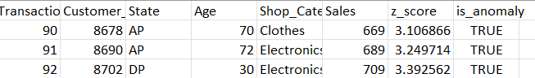

  - z_score → Indicates how many standard deviations the transaction is from the mean.

  - is_anomaly → Boolean flag (TRUE if anomaly, FALSE otherwise).

  - All listed transactions are marked as anomalies because their sales values are significantly higher than the dataset average.

- TECHNOLOGY STACK

• Programming Language → Python 3.x
• Libraries
- pandas → For data loading, manipulation, and statistical calculations (mean, std, Z-Score).
- matplotlib → For visualization of anomalies (scatter plots).
- os → For handling file paths.
• Data Format → CSV (customer_transaction_data.csv) for input, CSV (anomalies_detected.csv) for output.
• Documentation → .docx files for HLD, LLD, and Final Report.
• Environment → Executed on a local machine with Python runtime. (VS Code)

- ERROR HANDLING

7.1 Current Implementation

- Encoding Handling
- Implemented inside load_data().
- The function tries multiple encodings (utf-8, utf-16, latin1).
- If all fail, it raises a ValueError.
- This is the only explicit error handling mechanism in the script.
- Other Errors
- File not found, missing column, or empty dataset currently cause Pandas to raise exceptions.
- These are not explicitly handled in the current version.
- The script stops execution if such errors occur.

7.2 Future Enhancements

- File Path Validation
- Check if the file exists before attempting to load.
- Provide a clear message like: “Dataset not found at path X. Please verify the file location.”
- Column Validation
- Ensure required columns (Sales, Age, etc.) exist before processing.
- Raise a custom error if a column is missing: “Column ‘Sales’ not found in dataset.”
- Empty Dataset Handling
- If the CSV is empty or has no rows, print a warning and stop gracefully.
- Example: “Dataset is empty. Please provide valid input data.”

- FUTURE ENHANCEMENTS

  - Error Handling Improvements

- Add file path validation before loading data.
- Implement column existence checks to ensure required fields (Sales, Age) are present.
- Handle empty datasets gracefully with user-friendly messages.
- Introduce a logging system to track errors and warnings during execution.
- Provide custom exception messages instead of raw Python errors.

  - Data Processing Enhancements

  - Support multiple anomaly detection methods (e.g., IQR, Isolation Forest, DBSCAN) alongside Z-Score.
  - Add configurable thresholds so users can adjust sensitivity.
  - Include data cleaning routines (handling missing values, duplicates, or invalid entries).

8.5 User Interface

    - Build a simple GUI (Tkinter or Flask web app) for non-technical users.
    - Allow users to upload CSV files and view anomalies interactively.
    - Provide export options for results in multiple formats (CSV, Excel, JSON).

