## 針對資料轉換相關邏輯作單元測試。

詳見test class

## 測試呼叫幣別對應表資料 CRUD API,並顯示其內容。

* + Create:

curl --location --request POST 'http://localhost:8080/currency' \

--header 'Content-Type: application/json' \

--data-raw '{

"code": "USDX",

"locale": "zh-TW",

"name": "美元測試",

"createBy": "admin",

"updateBy": "editor"

}'

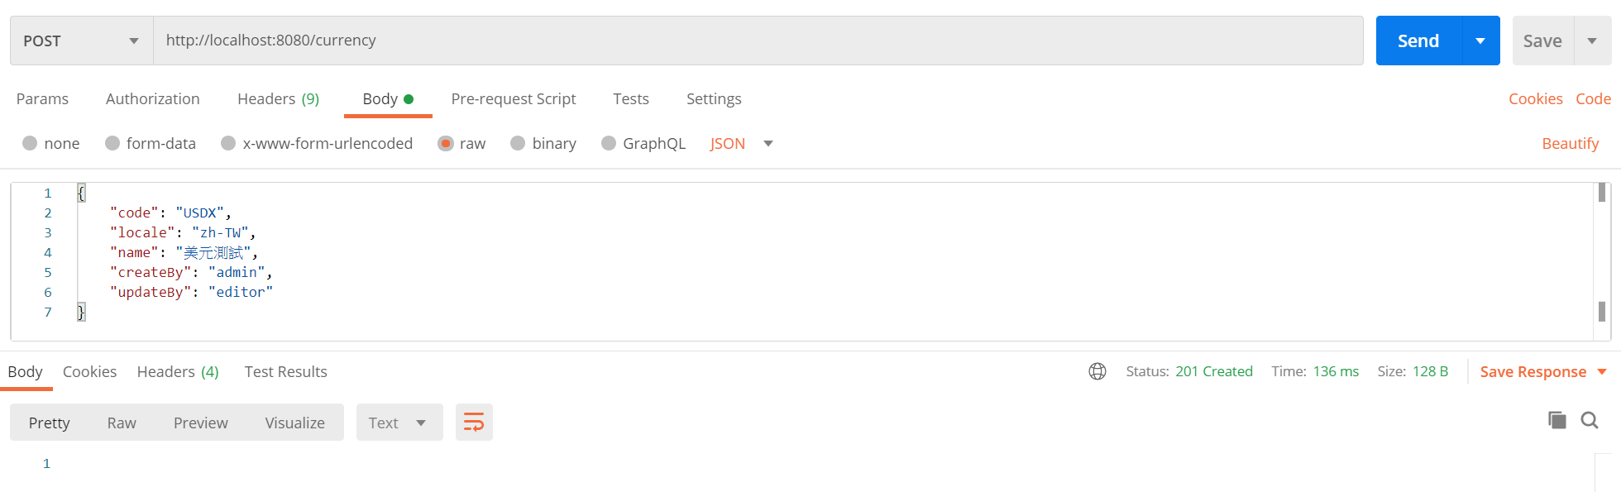

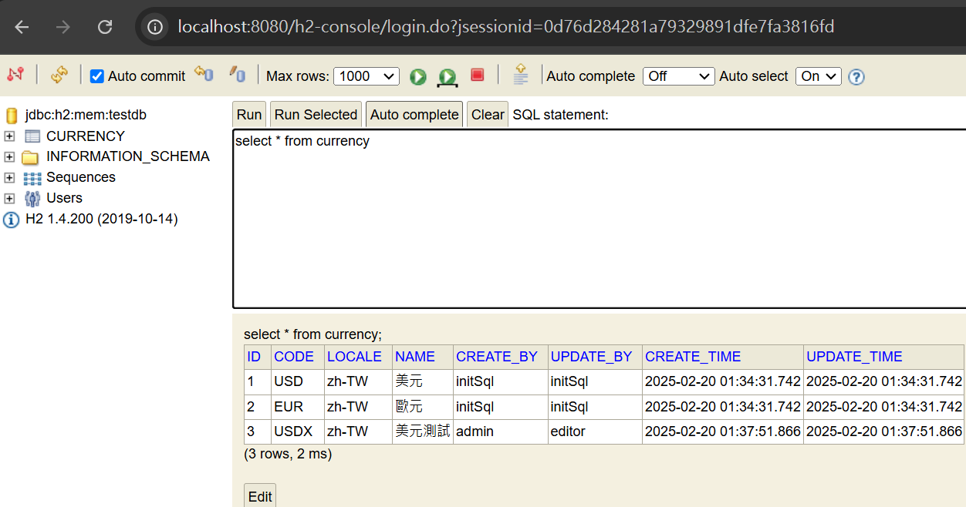

* + Update:

curl --location --request PUT 'http://localhost:8080/currency' \

--header 'Content-Type: application/json' \

--data-raw '{

"id": 3,

"code": "USDX",

"locale": "zh-TW",

"name": "美元測試修改",

"updateBy": "editor"

}'

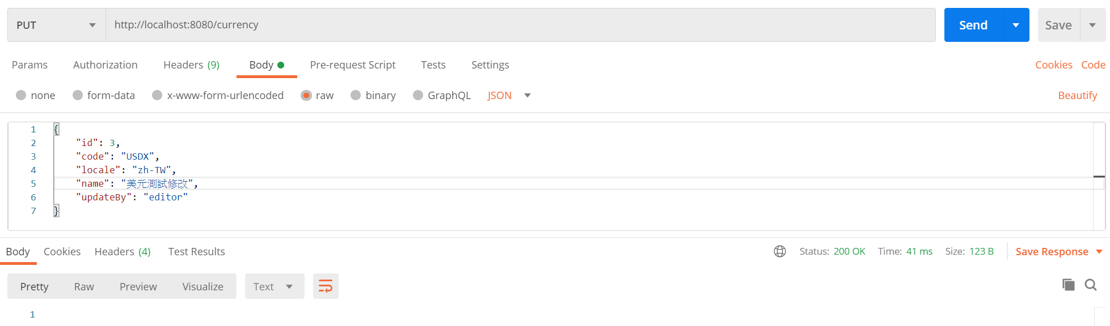

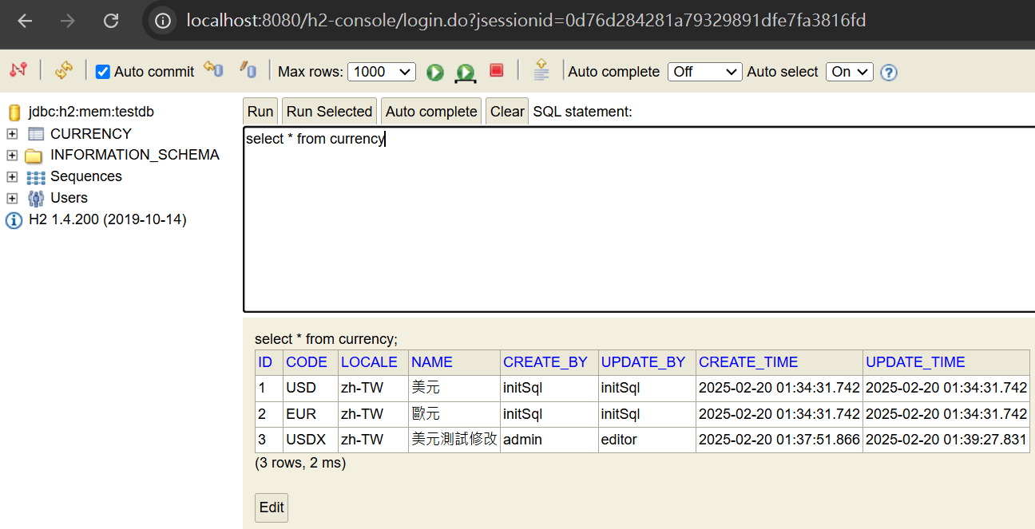

* + Read:

curl --location --request GET 'http://localhost:8080/currency?page=0' \

--header 'Content-Type: application/json' \

--data-raw ''

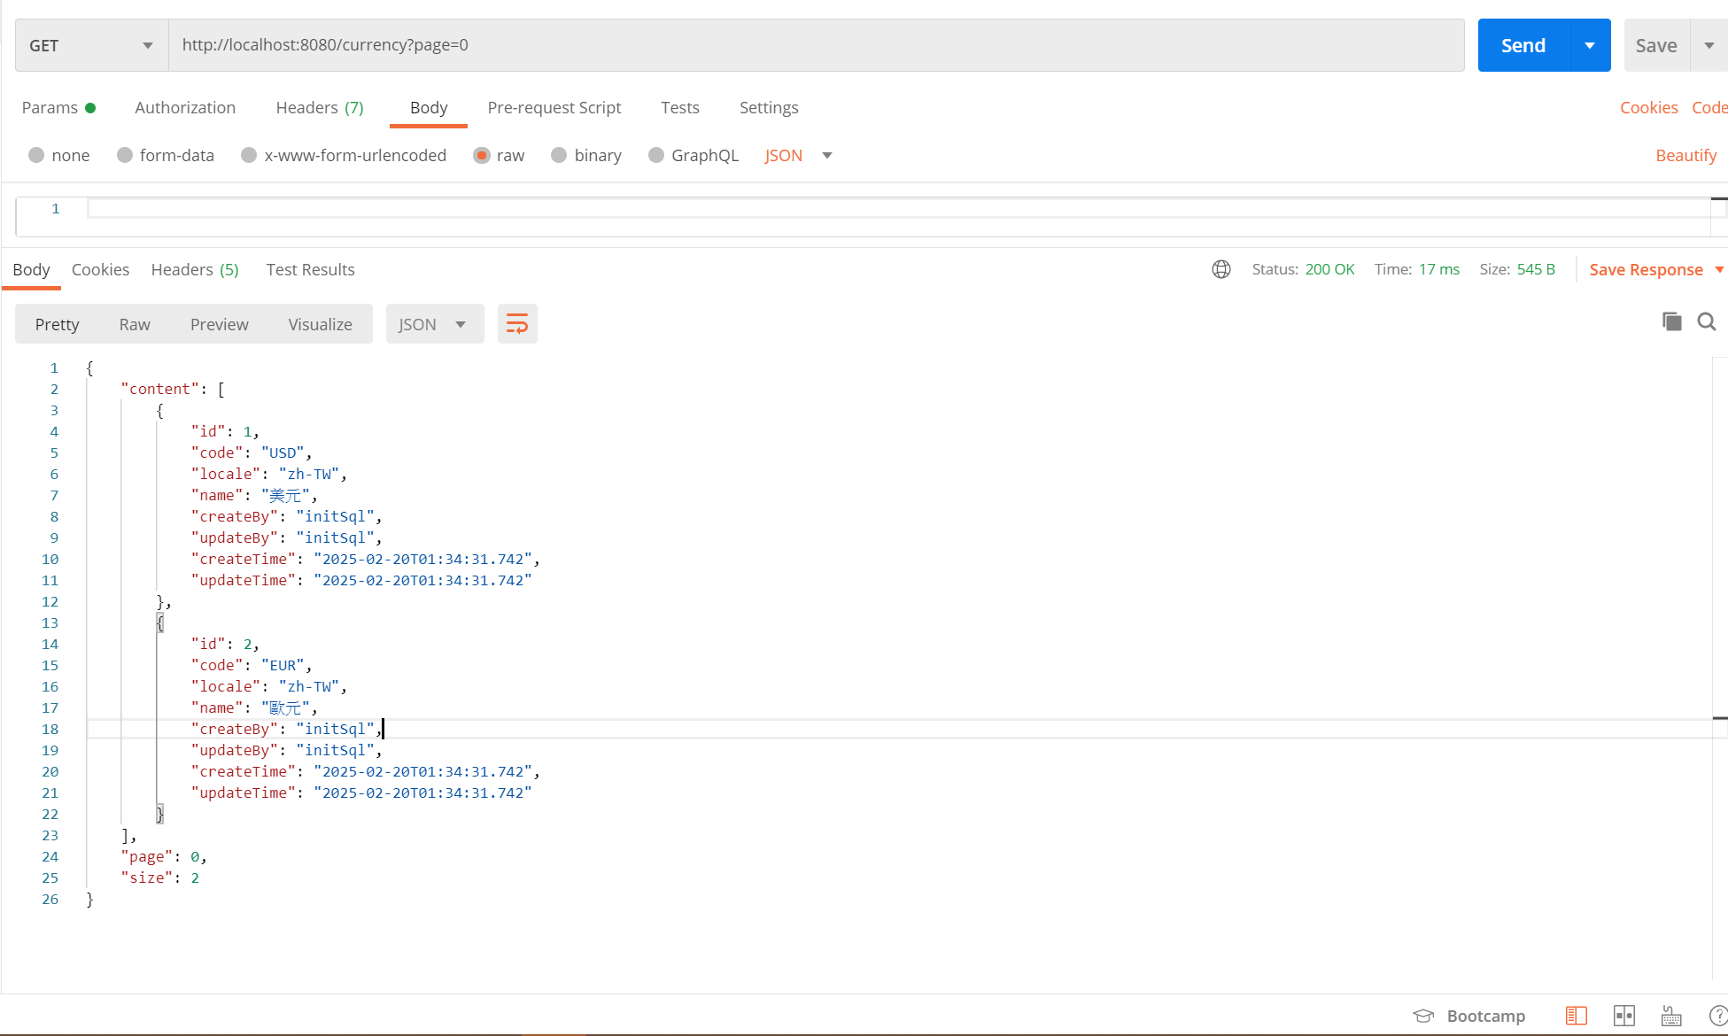

curl --location --request GET 'http://localhost:8080/currency/USD' \

--header 'Content-Type: application/json' \

--data-raw ''

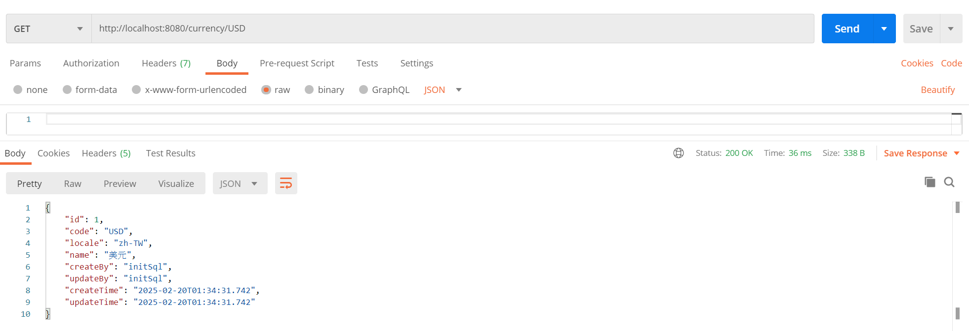

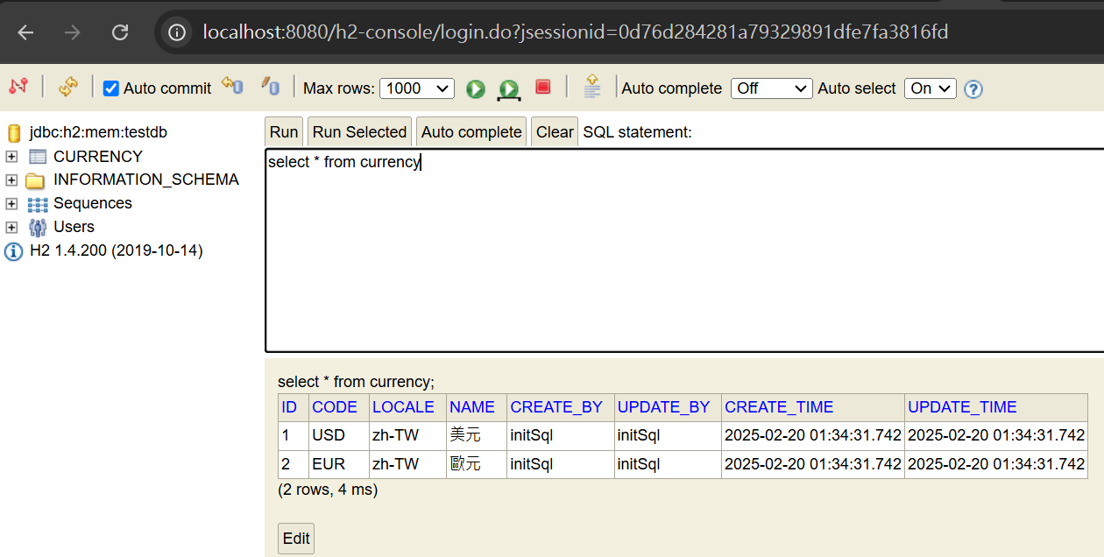

* + Delete

curl --location --request DELETE 'http://localhost:8080/currency/3' \

--header 'Content-Type: application/json' \

--data-raw ''

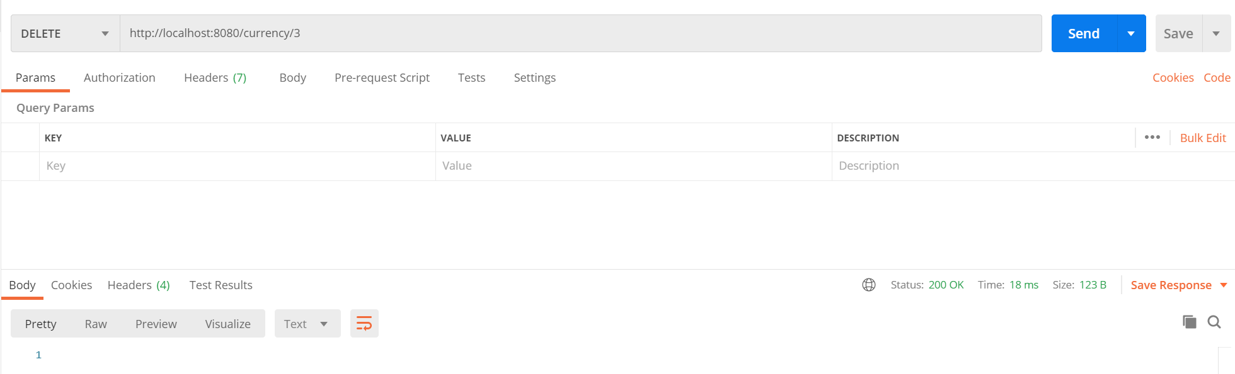

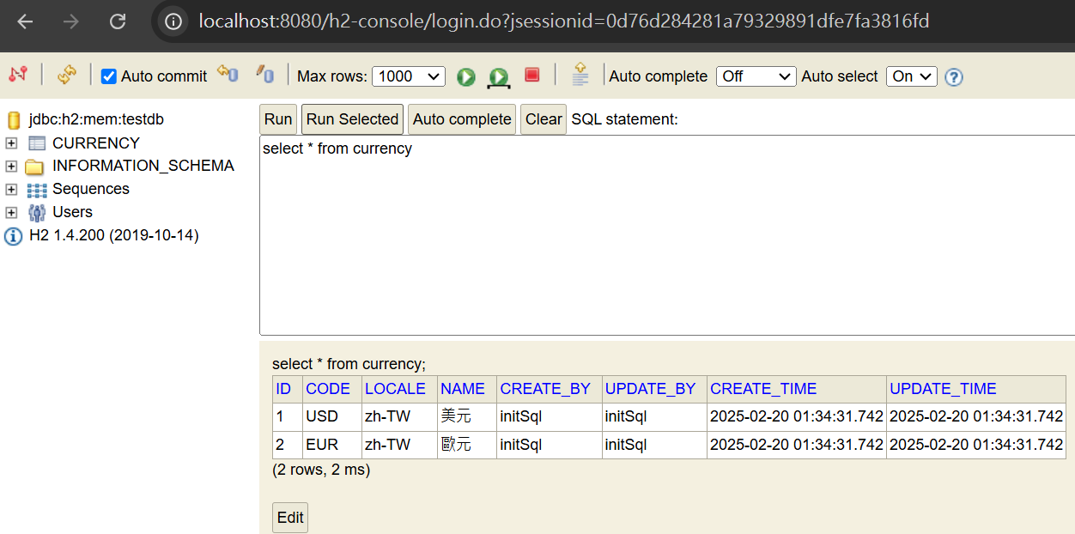

## 測試呼叫 coindesk API,並顯示其內容。

curl --location --request GET 'http://localhost:8080/coindesk/basic' \

--header 'Content-Type: application/json' \

--data-raw ''

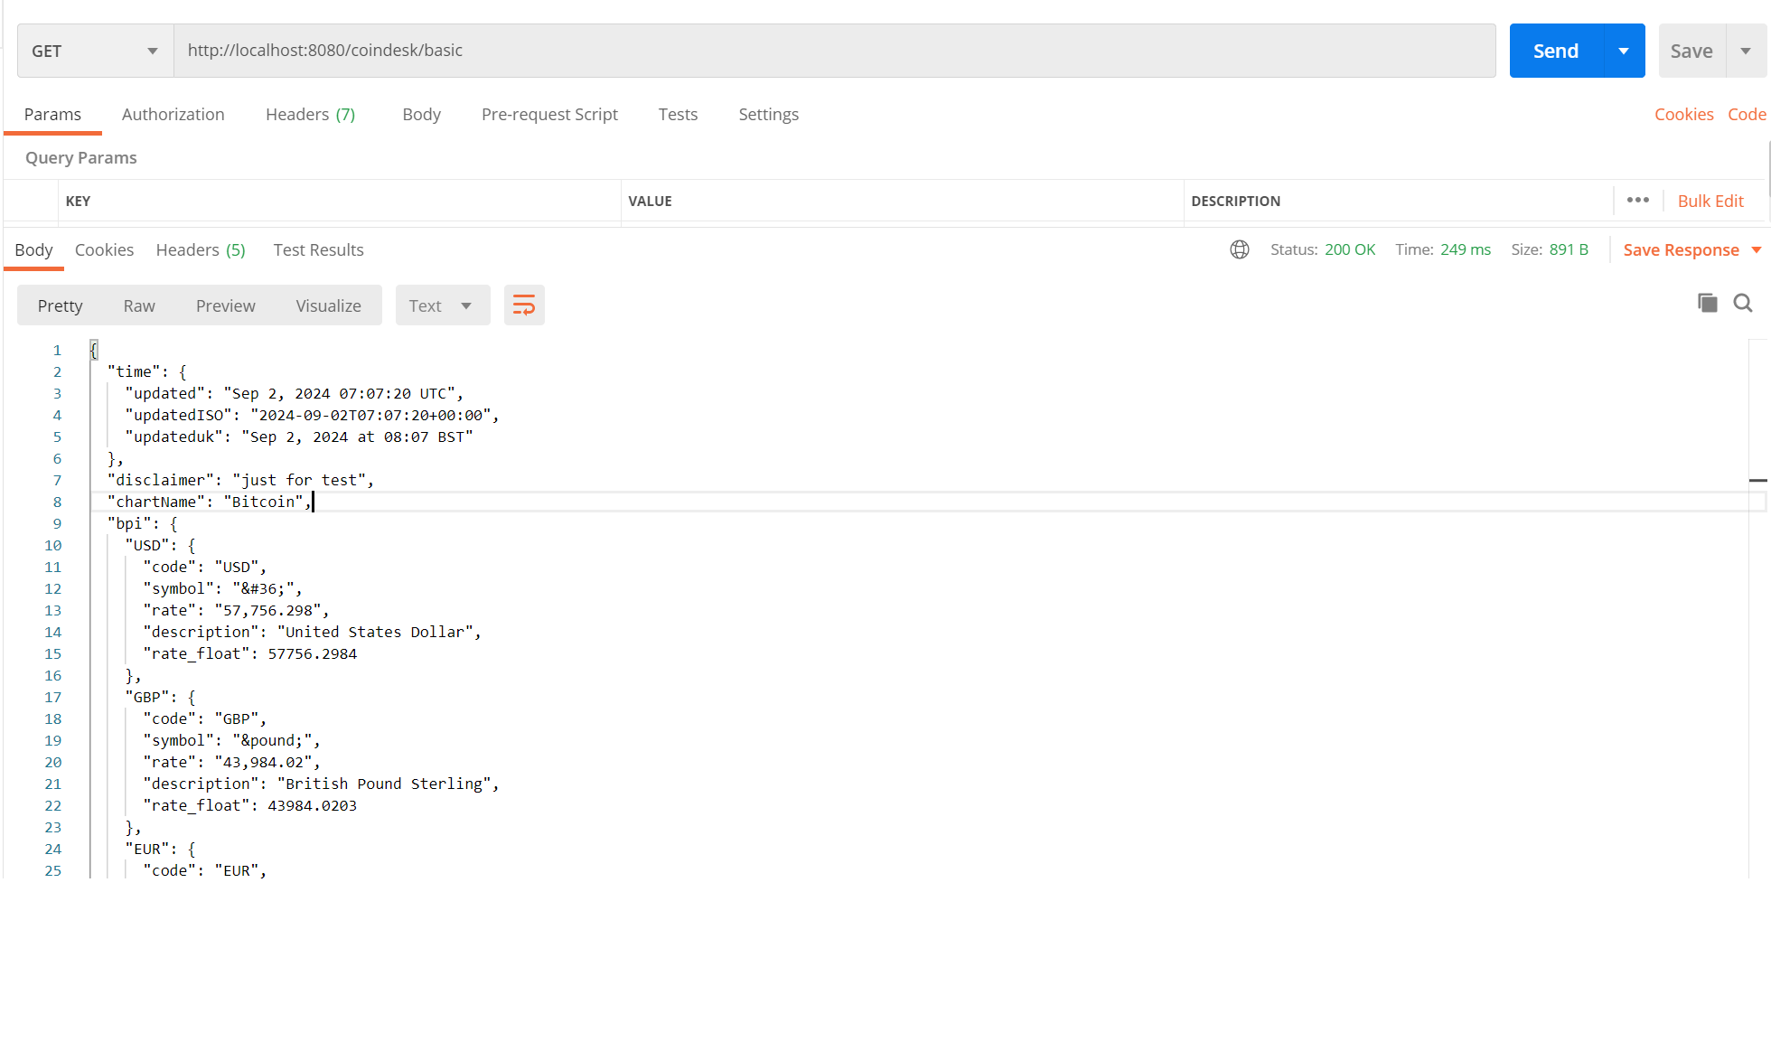

## 測試呼叫資料轉換的 API,並顯示其內容。

curl --location --request GET 'http://localhost:8080/coindesk/enhanced' \

--header 'Content-Type: application/json' \

--data-raw ''

