The University of Newcastle
School of Computer and Information Sciences

COMP3851A – Semester 1, 2026
Project Plan

CoLearnX
A Web-Based Community Training Platform with Credit-Based Enrolment and Content Attribution

Authors:
Huang Yousheng, C3546426
Zhu Zirui, C3543467
Zou Ruiqi, C3543468
Gu Yincheng, C3543317

Industry Supervisor: Desmond Lee (Desmond.Lee@newcastle.edu.au)

Table of Contents

Part I – Project Foundation

1. Background
Community-based training programs play an important role in upgrading skills through peer learning and communities of practice. Training communities often address these issues by patching together spreadsheets, chat groups, and cloud drives, resulting in fragmented management. Existing LMS platforms like Moodle focus on instructor-led delivery rather than community-driven content sharing and lack built-in content attribution and credit-based enrolment.
CoLearnX addresses these gaps as a purpose-built web platform integrating four roles: content creators, trainers, members, and administrators. The workflow spans a shared content library, trainer-led program creation, credit-based member enrolment, and automated record tracking. The project is scoped as a proof-of-concept achievable within the 240-hour per-student timeframe.

2. Aims and Objectives
- Aim 1: Analyse client requirements and define project scope (SRS).
- Aim 2: Identify user roles and responsibilities (RBAC matrix).
- Aim 3: Design core workflow from upload to delivery and credit tracking.
- Aim 4: Produce design artefacts: user stories, use cases, UI prototypes, data model.
- Aim 5: Develop core web prototype with role dashboards and credit enrolment.
- Aim 6: Test, evaluate, optimise, and finalise in Part B.

3. Methods and Activities
- Activity 1: Requirement analysis and project planning.
- Activity 2: System workflow and UX design (wireframes, storyboard, use cases).
- Activity 3: Database and access control planning (27 entities, EF Core).
- Activity 4: Core prototype development using React 19 + Vite 8 + ASP.NET Core 10 SPA template.
- Activity 5: Testing and evaluation (unit, integration, UAT).
- Activity 6: Optimisation and final delivery.

4. Ethics, IP and Confidentiality
The platform follows the Privacy Act 1988 (Cth) and Australian Privacy Principles, collecting only data necessary for registration. RBAC limits each role to required information. Content ownership and usage are recorded for attribution under the Copyright Act 1968 (Cth). Sample data is used in development.

5. References
- Australian Government. (1968). Copyright Act 1968 (Cth). Federal Register of Legislation.
- Australian Government. (1988). Privacy Act 1988 (Cth). Federal Register of Legislation.
- Beck, K., et al. (2001). Manifesto for Agile software development. https://agilemanifesto.org/
- OAIC. (2025). Australian Privacy Principles quick reference.
- Sandhu, R., et al. (1996). Role-based access control models. IEEE Computer, 29(2), 38-47.
- Turnbull, D., et al. (2019). Learning management systems: An overview.
- Wenger-Trayner, E., & Wenger-Trayner, B. (2015). Communities of practice: A brief introduction.

Part II – Requirements Specification

7. Stakeholders and Personas
Name | Role | Email | Notes
Huang Yousheng | Member | huang.yousheng@colearnx.com | 120 credits, primary demo learner
Jane Smith | Trainer | jane.smith@colearnx.com | Senior UI/UX Trainer, INFT2051
Alex Lee | Creator | alex.lee@colearnx.com | Uploads and manages learning materials
Desmond Tan | Administrator | desmond.tan@colearnx.com | Platform admin and credit ledger

8. Scope Definition
In scope (Part A PoC):
- Authentication and role-based dashboards
- Shared content library with admin review
- Program browse/detail and credit enrolment
- Participation records and content attribution
- Low-fidelity UI pages aligned to wireframes
Out of scope (Part B / future):
- Production PayPal integration
- Live Google/Microsoft OAuth
- Commercial-scale analytics
- Public marketplace

9. Functional Requirements
ID | Module | Requirement
FR-01 | Authentication | Users can register with email, password, and role selection.
FR-02 | Authentication | Users can log in and receive a JWT session token.
FR-03 | Authentication | Users can reset password via email token (PoC: UI + stub API).
FR-04 | Authentication | OAuth buttons for Google/Microsoft shown as placeholders.
FR-05 | Authentication | Remember-me extends refresh token lifetime.
FR-06 | Authentication | Protected routes redirect unauthenticated users to login.
FR-07 | Member | Member dashboard shows credit balance, upcoming programs, recommendations.
FR-08 | Member | Member can search and filter the program catalog.
FR-09 | Member | Member can view program detail with trainer info and syllabus.
FR-10 | Member | Member can enrol using credits with atomic debit.
FR-11 | Member | Member can view enrolled programs and learning progress.
FR-12 | Member | Member can add programs to wishlist.
FR-13 | Member | Member can view earned certificates and badges.
FR-14 | Member | Member can view subscription and payment history (PoC UI).
FR-15 | Trainer | Trainer can create draft training programs.
FR-16 | Trainer | Trainer can attach materials from the shared library.
FR-17 | Trainer | Trainer can set credit price, capacity, and schedule.
FR-18 | Trainer | Trainer can publish programs to the catalog.
FR-19 | Trainer | Trainer can view enrolled members for own programs.
FR-20 | Trainer | Trainer can record participation and mark completion.
FR-21 | Creator | Creator can upload learning materials (PDF, video, link).
FR-22 | Creator | Creator can edit and version own materials.
FR-23 | Creator | Creator can view usage statistics and attribution.
FR-24 | Creator | Creator receives notification when material is adopted.
FR-25 | Creator | Creator earns royalty credits when material is used (PoC log).
FR-26 | Admin | Admin can review and approve/reject uploaded content.
FR-27 | Admin | Admin can manage users and assign roles.
FR-28 | Admin | Admin can audit platform-wide credit ledger.
FR-29 | Admin | Admin can process refunds and disputes.
FR-30 | Admin | Admin dashboard shows operational KPIs.
FR-31 | Credits | All credit changes recorded in CreditTransaction ledger.
FR-32 | Credits | Credit balance cannot go negative.
FR-33 | Certificates | Certificates issued on program/stage completion.
FR-34 | Certificates | Certificates downloadable as PDF with verification code.
FR-35 | Notifications | In-app notifications for enrolment, review, and reminders.

10. Non-Functional Requirements
ID | Category | Requirement
NFR-01 | Performance | Homepage loads in under 3 seconds on local dev environment.
NFR-02 | Performance | API responses under 500ms for catalog queries (PoC scale).
NFR-03 | Security | Passwords stored as BCrypt hashes; JWT for API auth.
NFR-04 | Security | HTTPS in production; role-based API authorization.
NFR-05 | Privacy | Collect only data required for registration; sample data in dev.
NFR-06 | Privacy | Comply with Privacy Act 1988 (Cth) and APPs principles.
NFR-07 | Usability | Responsive Bootstrap layout; mobile-friendly catalog.
NFR-08 | Usability | Consistent navigation shell per role (GLB-04).
NFR-09 | Maintainability | Layered architecture: React pages / API / EF Core.
NFR-10 | Reliability | Enrolment uses database transaction for credit debit.

Part III – Use Case Design

11. Use Case Diagram
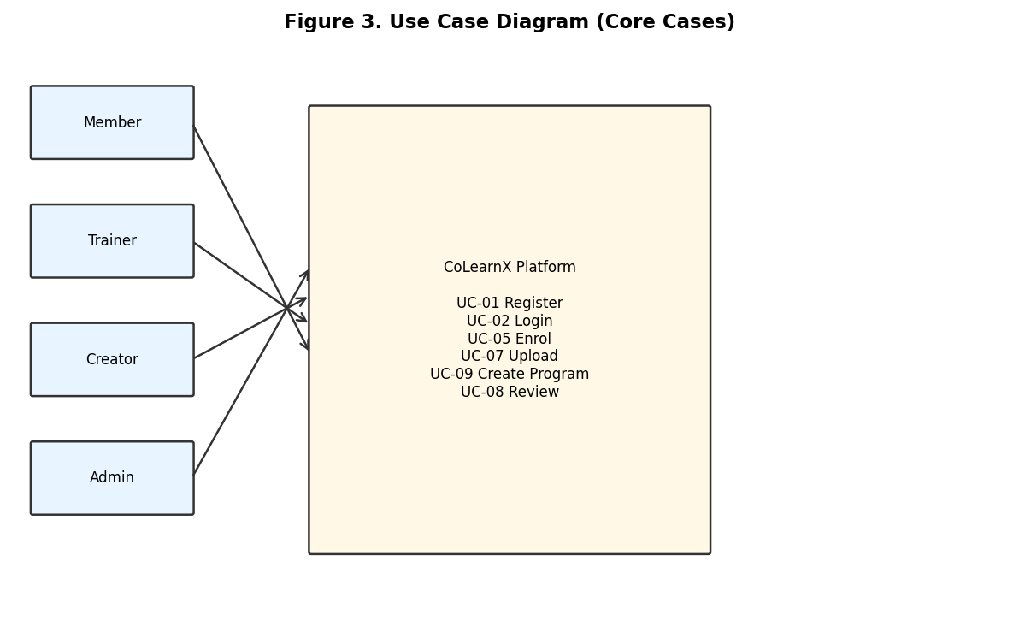
Figure 3. Use case diagram (core cases)

12. Use Case Catalogue
ID | Name | Primary Actor | Priority | Screen | FR
UC-01 | Register Account | Guest | P0 | GLB-02 | FR-01
UC-02 | Login | All roles | P0 | GLB-03 | FR-02
UC-03 | Complete Interest Onboarding | Member | P0 | GLB-02 | FR-01
UC-04 | Browse Program Catalog | Member | P0 | MBR-02 | FR-08
UC-05 | Enrol in Program with Credits | Member | P0 | MBR-03/04 | FR-10
UC-06 | View Member Dashboard | Member | P0 | MBR-01 | FR-07
UC-07 | Upload Learning Material | Creator | P0 | CRT-01 | FR-21
UC-08 | Review and Approve Content | Admin | P0 | ADM-02 | FR-26
UC-09 | Create and Publish Program | Trainer | P0 | TRN-02 | FR-15-18
UC-10 | Record Participation | Trainer | P0 | TRN-05 | FR-20
UC-11 | Manage User Profile | All roles | P0 | GLB-05 | FR-06
UC-12 | Audit Credit Ledger | Admin | P0 | ADM-04 | FR-28
UC-13 | Add to Wishlist | Member | P1 | MBR-02 | FR-12
UC-14 | View Certificates | Member | P1 | MBR-08 | FR-13
UC-15 | Manage Subscription | Member | P1 | MBR-06 | FR-14
UC-16 | Process Refund | Admin | P1 | ADM-05 | FR-29
UC-17 | View Notifications | All roles | P1 | GLB-06 | FR-35
UC-18 | Forgot Password | Guest | P1 | GLB-03 | FR-03

13. Detailed Use Case Specifications

UC-01: Register Account
Actors: See use case catalogue.
Preconditions: User authenticated with appropriate role.
Postconditions: System state updated per functional requirements.
Main Flow:
- 1. Actor opens GLB-02 screen.
- 2. Actor completes required form fields.
- 3. System validates input server-side.
- 4. System persists changes to database.
- 5. System confirms success to user.
Alternative Flows:
- A1 Validation failure: inline field errors.
Exception Flows:
- E1 Server error: show retry message.
Business Rules: See Section 30 Business Rules.
Related: GLB-02, FR-01

UC-02: Login
Actors: Primary: All roles.
Preconditions: User has registered account with Active status.
Postconditions: JWT access token issued. Refresh token stored. Role-based navigation loaded.
Main Flow:
- 1. User navigates to login page (GLB-03).
- 2. User enters email and password.
- 3. User optionally selects Remember me.
- 4. User submits form.
- 5. System validates credentials against User table.
- 6. System generates JWT with role claim.
- 7. System stores refresh token if Remember me.
- 8. System redirects to role-appropriate dashboard.
Alternative Flows:
- A1 Invalid credentials: show generic error.
- A2 OAuth placeholder: show not implemented in PoC.
Exception Flows:
- E1 Account suspended: show contact admin message.
Business Rules: BR-06 Role determines default landing page.
Related: US-GLB-02, Figure 6, FR-02

UC-03: Complete Interest Onboarding
Actors: See use case catalogue.
Preconditions: User authenticated with appropriate role.
Postconditions: System state updated per functional requirements.
Main Flow:
- 1. Actor opens Onboarding screen.
- 2. Actor completes required form fields.
- 3. System validates input server-side.
- 4. System persists changes to database.
- 5. System confirms success to user.
Alternative Flows:
- A1 Validation failure: inline field errors.
Exception Flows:
- E1 Server error: show retry message.
Business Rules: See Section 30 Business Rules.
Related: Onboarding, FR-01

UC-04: Browse Program Catalog
Actors: See use case catalogue.
Preconditions: User authenticated with appropriate role.
Postconditions: System state updated per functional requirements.
Main Flow:
- 1. Actor opens MBR-02 screen.
- 2. Actor completes required form fields.
- 3. System validates input server-side.
- 4. System persists changes to database.
- 5. System confirms success to user.
Alternative Flows:
- A1 Validation failure: inline field errors.
Exception Flows:
- E1 Server error: show retry message.
Business Rules: See Section 30 Business Rules.
Related: MBR-02, FR-08

UC-05: Enrol in Program with Credits
Actors: Primary: Member. Secondary: System, Trainer (notification).
Preconditions: Member is authenticated. Program is published. Session is open. Member credit balance >= program credit cost.
Postconditions: Enrollment record created with Confirmed status. CreditTransaction debits member wallet. CourseSession.EnrolledCount incremented. Trainer notified (N-01).
Main Flow:
- 1. Member opens program detail page (MBR-03).
- 2. Member selects course date/session and sponsorship type.
- 3. Member clicks sticky Enrol Now bar.
- 4. System displays credit spend confirmation modal (MBR-04).
- 5. Member confirms enrolment.
- 6. System begins database transaction.
- 7. System validates credit balance and session capacity.
- 8. System inserts CreditTransaction and updates User.CreditBalance.
- 9. System creates Enrollment with fee/credit snapshots.
- 10. System commits transaction and returns success.
- 11. System redirects member to My Programs (MBR-05).
Alternative Flows:
- A1 Insufficient credits: show error, no debit (BR-01).
- A2 Session full: reject enrolment, suggest another session.
- A3 Member cancels modal: no state change.
Exception Flows:
- E1 Concurrent enrolment exceeds capacity: transaction rolls back.
- E2 API timeout: show retry message, no partial debit.
Business Rules: BR-01, BR-02, BR-04, BR-05
Related: US-MBR-03, SEQ-05 (Figure 5), FR-10, FR-31

UC-06: View Member Dashboard
Actors: See use case catalogue.
Preconditions: User authenticated with appropriate role.
Postconditions: System state updated per functional requirements.
Main Flow:
- 1. Actor opens MBR-01 screen.
- 2. Actor completes required form fields.
- 3. System validates input server-side.
- 4. System persists changes to database.
- 5. System confirms success to user.
Alternative Flows:
- A1 Validation failure: inline field errors.
Exception Flows:
- E1 Server error: show retry message.
Business Rules: See Section 30 Business Rules.
Related: MBR-01, FR-07

UC-07: Upload Learning Material
Actors: See use case catalogue.
Preconditions: User authenticated with appropriate role.
Postconditions: System state updated per functional requirements.
Main Flow:
- 1. Actor opens CRT-01 screen.
- 2. Actor completes required form fields.
- 3. System validates input server-side.
- 4. System persists changes to database.
- 5. System confirms success to user.
Alternative Flows:
- A1 Validation failure: inline field errors.
Exception Flows:
- E1 Server error: show retry message.
Business Rules: See Section 30 Business Rules.
Related: CRT-01, FR-21

UC-08: Review and Approve Content
Actors: See use case catalogue.
Preconditions: User authenticated with appropriate role.
Postconditions: System state updated per functional requirements.
Main Flow:
- 1. Actor opens ADM-02 screen.
- 2. Actor completes required form fields.
- 3. System validates input server-side.
- 4. System persists changes to database.
- 5. System confirms success to user.
Alternative Flows:
- A1 Validation failure: inline field errors.
Exception Flows:
- E1 Server error: show retry message.
Business Rules: See Section 30 Business Rules.
Related: ADM-02, FR-26

UC-09: Create and Publish Program
Actors: See use case catalogue.
Preconditions: User authenticated with appropriate role.
Postconditions: System state updated per functional requirements.
Main Flow:
- 1. Actor opens TRN-02 screen.
- 2. Actor completes required form fields.
- 3. System validates input server-side.
- 4. System persists changes to database.
- 5. System confirms success to user.
Alternative Flows:
- A1 Validation failure: inline field errors.
Exception Flows:
- E1 Server error: show retry message.
Business Rules: See Section 30 Business Rules.
Related: TRN-02, FR-15

UC-10: Record Participation
Actors: See use case catalogue.
Preconditions: User authenticated with appropriate role.
Postconditions: System state updated per functional requirements.
Main Flow:
- 1. Actor opens TRN-05 screen.
- 2. Actor completes required form fields.
- 3. System validates input server-side.
- 4. System persists changes to database.
- 5. System confirms success to user.
Alternative Flows:
- A1 Validation failure: inline field errors.
Exception Flows:
- E1 Server error: show retry message.
Business Rules: See Section 30 Business Rules.
Related: TRN-05, FR-20

UC-11: Manage User Profile
Actors: See use case catalogue.
Preconditions: User authenticated with appropriate role.
Postconditions: System state updated per functional requirements.
Main Flow:
- 1. Actor opens GLB-05 screen.
- 2. Actor completes required form fields.
- 3. System validates input server-side.
- 4. System persists changes to database.
- 5. System confirms success to user.
Alternative Flows:
- A1 Validation failure: inline field errors.
Exception Flows:
- E1 Server error: show retry message.
Business Rules: See Section 30 Business Rules.
Related: GLB-05, FR-06

UC-12: Audit Credit Ledger
Actors: See use case catalogue.
Preconditions: User authenticated with appropriate role.
Postconditions: System state updated per functional requirements.
Main Flow:
- 1. Actor opens ADM-04 screen.
- 2. Actor completes required form fields.
- 3. System validates input server-side.
- 4. System persists changes to database.
- 5. System confirms success to user.
Alternative Flows:
- A1 Validation failure: inline field errors.
Exception Flows:
- E1 Server error: show retry message.
Business Rules: See Section 30 Business Rules.
Related: ADM-04, FR-28

Part IV – User Stories

14. Epic Map
- Epic 1: Identity and Access (Journey A step 1)
- Epic 2: Member Learning and Credits (Journey A)
- Epic 3: Trainer Program Management (Journey B)
- Epic 4: Creator Content Library (Journey C)
- Epic 5: Admin Governance (Journey D)
- Epic 6: Certificates and Subscriptions

15. User Story Backlog

US-GLB-01
As a visitor, I want to view a public landing page, so that I understand CoLearnX value.
Priority: P1 | Screen: GLB-01 | Use Case: UC-01 | FR: FR-01
Acceptance: Landing shows hero and role CTAs.

US-GLB-02
As a user, I want to log in securely, so that I access my role dashboard.
Priority: P0 | Screen: GLB-03 | Use Case: UC-02 | FR: FR-02
Acceptance: JWT issued; wrong password shows error.

US-GLB-03
As a new member, I want to select interests, so that programs are recommended.
Priority: P0 | Screen: Onboarding | Use Case: UC-03 | FR: FR-01
Acceptance: Skip or continue saves interests.

US-GLB-04
As a user, I want role-based navigation, so that I only see permitted menus.
Priority: P0 | Screen: GLB-04 | Use Case: UC-02 | FR: FR-06
Acceptance: Member vs Trainer sidebars differ.

US-MBR-01
As a member, I want a dashboard with credit balance, so that I know enrolment capacity.
Priority: P0 | Screen: MBR-01 | Use Case: UC-06 | FR: FR-07
Acceptance: Shows 120 credits and upcoming programs.

US-MBR-02
As a member, I want to search programs, so that I find relevant training.
Priority: P0 | Screen: MBR-02 | Use Case: UC-04 | FR: FR-08
Acceptance: Filter by credits, level, date.

US-MBR-03
As a member, I want to enrol using credits, so that I join without cash payment.
Priority: P0 | Screen: MBR-03/04 | Use Case: UC-05 | FR: FR-10
Acceptance: Atomic debit; insufficient credits blocked.

US-MBR-04
As a member, I want to view my enrolled programs, so that I access learning materials.
Priority: P0 | Screen: MBR-05 | Use Case: UC-05 | FR: FR-11
Acceptance: List shows active and completed.

US-MBR-05
As a member, I want a credit wallet history, so that I audit spending.
Priority: P1 | Screen: MBR-06 | Use Case: UC-12 | FR: FR-31
Acceptance: Ledger matches balance.

US-MBR-06
As a member, I want to view certificates, so that I prove completion.
Priority: P1 | Screen: MBR-08 | Use Case: UC-14 | FR: FR-13
Acceptance: Four stage certificates shown.

US-MBR-07
As a member, I want to manage subscription, so that I access premium features.
Priority: P1 | Screen: MBR-06 | Use Case: UC-15 | FR: FR-14
Acceptance: Pro plan UI; PayPal placeholder.

US-MBR-08
As a member, I want to wishlist programs, so that I save them for later.
Priority: P1 | Screen: MBR-02 | Use Case: UC-13 | FR: FR-12
Acceptance: Heart icon toggles wishlist.

US-TRN-01
As a trainer, I want a dashboard of my cohorts, so that I manage classes.
Priority: P0 | Screen: TRN-01 | Use Case: UC-09 | FR: FR-19
Acceptance: Shows draft and published programs.

US-TRN-02
As a trainer, I want to create programs, so that I offer community training.
Priority: P0 | Screen: TRN-02 | Use Case: UC-09 | FR: FR-15
Acceptance: Draft saved before publish.

US-TRN-03
As a trainer, I want to attach library materials, so that content is attributed.
Priority: P0 | Screen: TRN-03 | Use Case: UC-09 | FR: FR-16
Acceptance: MaterialUsageLog created.

US-TRN-04
As a trainer, I want to set credit price, so that members can enrol.
Priority: P0 | Screen: TRN-02 | Use Case: UC-09 | FR: FR-17
Acceptance: Credit cost shown on catalog.

US-TRN-05
As a trainer, I want to record attendance, so that completion is tracked.
Priority: P0 | Screen: TRN-05 | Use Case: UC-10 | FR: FR-20
Acceptance: Marks enrollment Completed.

US-TRN-06
As a trainer, I want to see enrolled members, so that I prepare sessions.
Priority: P1 | Screen: TRN-04 | Use Case: UC-09 | FR: FR-19
Acceptance: Roster export CSV (PoC).

US-CRT-01
As a creator, I want to upload materials, so that trainers can reuse them.
Priority: P0 | Screen: CRT-01 | Use Case: UC-07 | FR: FR-21
Acceptance: PDF/video/link supported.

US-CRT-02
As a creator, I want to edit my materials, so that content stays current.
Priority: P1 | Screen: CRT-02 | Use Case: UC-07 | FR: FR-22
Acceptance: Version increments on save.

US-CRT-03
As a creator, I want usage statistics, so that I see adoption.
Priority: P1 | Screen: CRT-03 | Use Case: UC-07 | FR: FR-23
Acceptance: Shows programs using material.

US-CRT-04
As a creator, I want adoption notifications, so that I know when used.
Priority: P1 | Screen: GLB-06 | Use Case: UC-17 | FR: FR-24
Acceptance: N-05 trigger fires.

US-CRT-05
As a creator, I want royalty credits, so that contribution is rewarded.
Priority: P2 | Screen: CRT-03 | Use Case: UC-07 | FR: FR-25
Acceptance: PoC: log only.

US-ADM-01
As an admin, I want to review content, so that library quality is maintained.
Priority: P0 | Screen: ADM-02 | Use Case: UC-08 | FR: FR-26
Acceptance: Approve/reject with reason.

US-ADM-02
As an admin, I want to manage users, so that roles are correct.
Priority: P0 | Screen: ADM-03 | Use Case: UC-11 | FR: FR-27
Acceptance: Assign Member/Trainer/Creator.

US-ADM-03
As an admin, I want to audit credit ledger, so that finances are transparent.
Priority: P0 | Screen: ADM-04 | Use Case: UC-12 | FR: FR-28
Acceptance: Filter by user and date.

US-ADM-04
As an admin, I want to process refunds, so that disputes are resolved.
Priority: P1 | Screen: ADM-05 | Use Case: UC-16 | FR: FR-29
Acceptance: Credits restored on refund.

US-ADM-05
As an admin, I want an operations dashboard, so that I monitor platform health.
Priority: P1 | Screen: ADM-01 | Use Case: UC-08 | FR: FR-30
Acceptance: Pending reviews count shown.

16. Story-to-Screen Traceability
Story ID | Role | Screen | Use Case | FR
US-GLB-01 | Global | GLB-01 | UC-01 | FR-01
US-GLB-02 | Global | GLB-03 | UC-02 | FR-02
US-GLB-03 | Global | Onboarding | UC-03 | FR-01
US-GLB-04 | Global | GLB-04 | UC-02 | FR-06
US-MBR-01 | Member | MBR-01 | UC-06 | FR-07
US-MBR-02 | Member | MBR-02 | UC-04 | FR-08
US-MBR-03 | Member | MBR-03/04 | UC-05 | FR-10
US-MBR-04 | Member | MBR-05 | UC-05 | FR-11
US-MBR-05 | Member | MBR-06 | UC-12 | FR-31
US-MBR-06 | Member | MBR-08 | UC-14 | FR-13
US-MBR-07 | Member | MBR-06 | UC-15 | FR-14
US-MBR-08 | Member | MBR-02 | UC-13 | FR-12
US-TRN-01 | Trainer | TRN-01 | UC-09 | FR-19
US-TRN-02 | Trainer | TRN-02 | UC-09 | FR-15
US-TRN-03 | Trainer | TRN-03 | UC-09 | FR-16
US-TRN-04 | Trainer | TRN-02 | UC-09 | FR-17
US-TRN-05 | Trainer | TRN-05 | UC-10 | FR-20
US-TRN-06 | Trainer | TRN-04 | UC-09 | FR-19
US-CRT-01 | Creator | CRT-01 | UC-07 | FR-21
US-CRT-02 | Creator | CRT-02 | UC-07 | FR-22
US-CRT-03 | Creator | CRT-03 | UC-07 | FR-23
US-CRT-04 | Creator | GLB-06 | UC-17 | FR-24
US-CRT-05 | Creator | CRT-03 | UC-07 | FR-25
US-ADM-01 | Admin | ADM-02 | UC-08 | FR-26
US-ADM-02 | Admin | ADM-03 | UC-11 | FR-27
US-ADM-03 | Admin | ADM-04 | UC-12 | FR-28
US-ADM-04 | Admin | ADM-05 | UC-16 | FR-29
US-ADM-05 | Admin | ADM-01 | UC-08 | FR-30

Part V – Interaction and Process Diagrams

17. System Context
Browser → React SPA → ASP.NET Core API → SQLite/SQL Server + File Storage. PayPal (future).

18. System Architecture
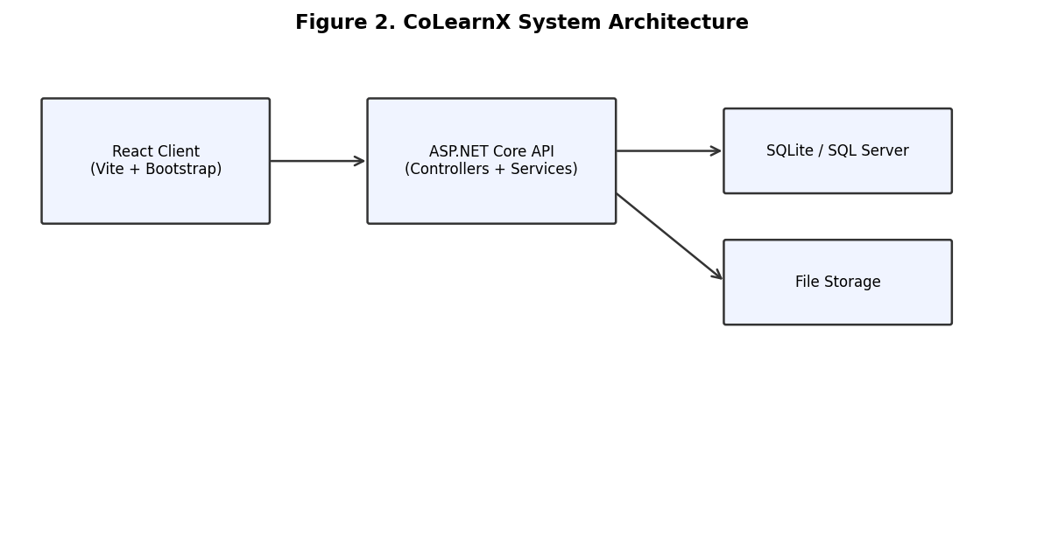
Figure 2. CoLearnX system architecture

19. Sequence Diagrams
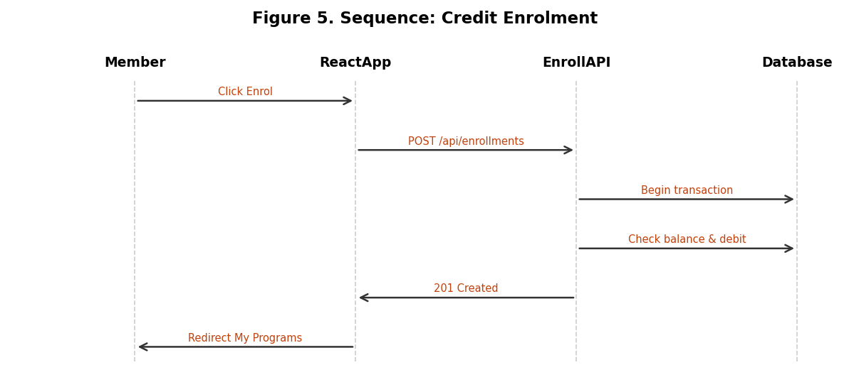
Figure 5. Sequence: credit enrolment
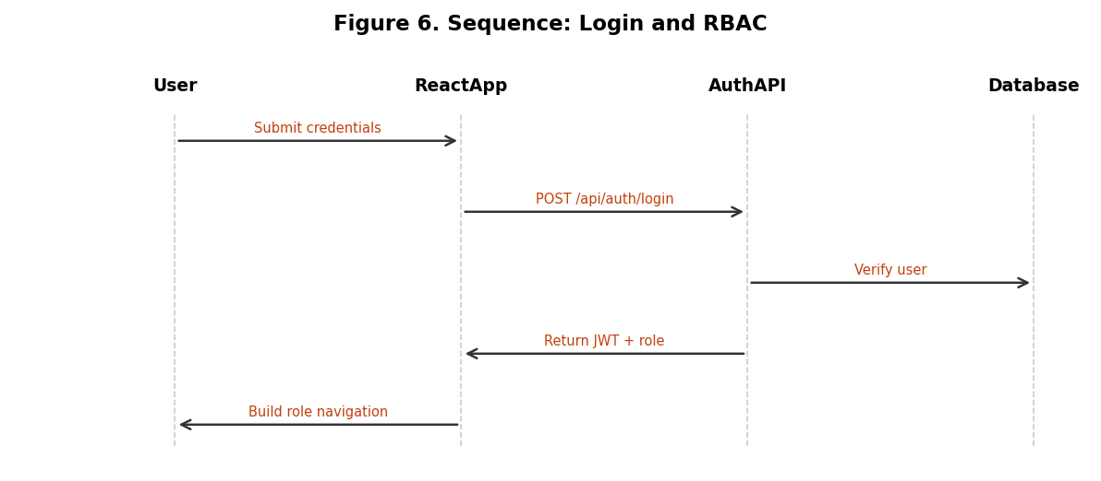
Figure 6. Sequence: login and RBAC
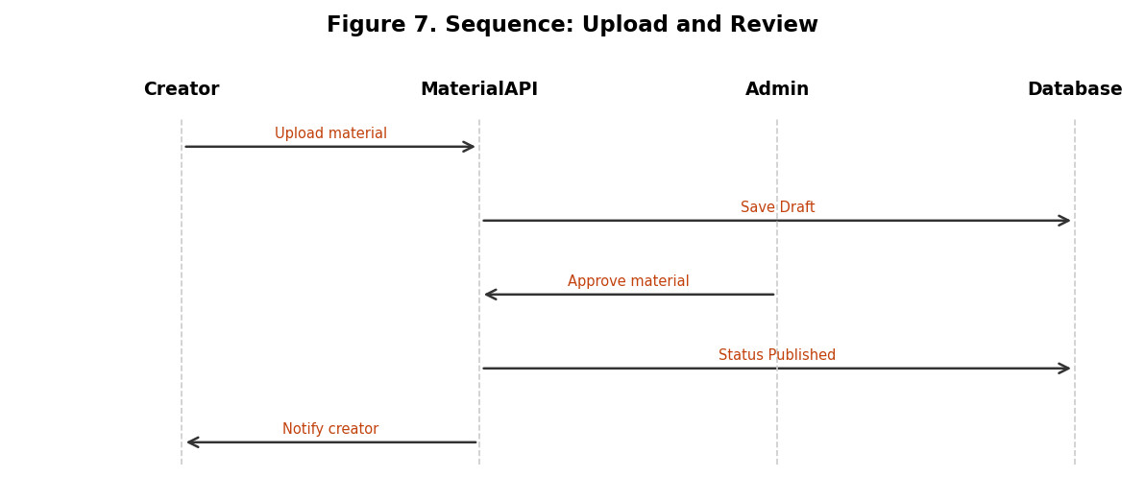
Figure 7. Sequence: upload and review
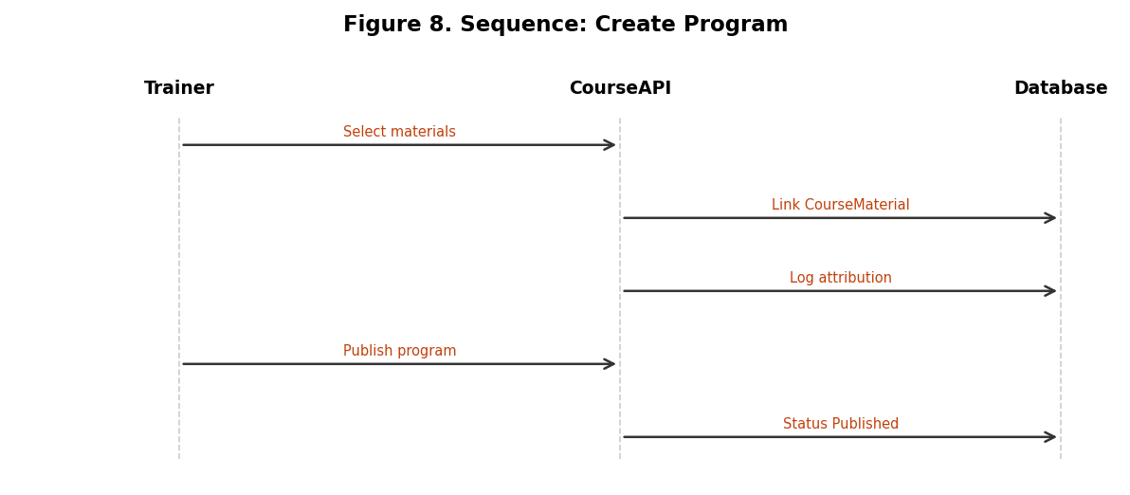
Figure 8. Sequence: create program
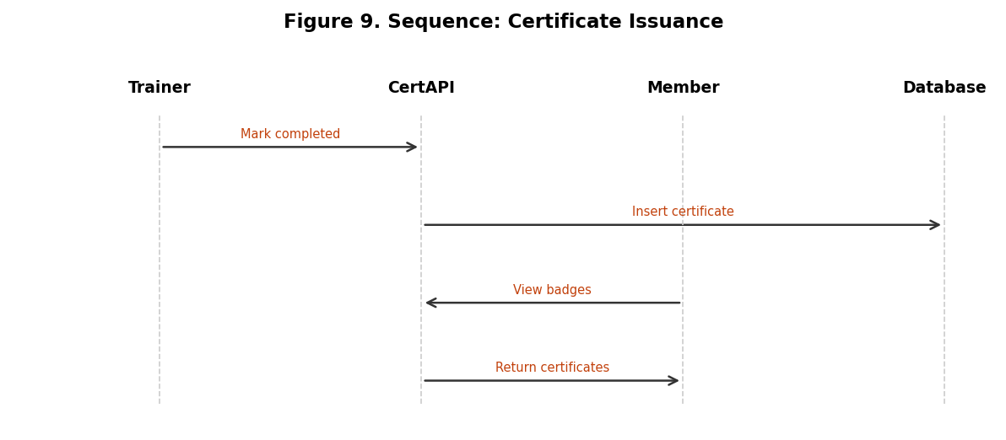
Figure 9. Sequence: certificate issuance

20. Activity Diagram – Enrolment Validation
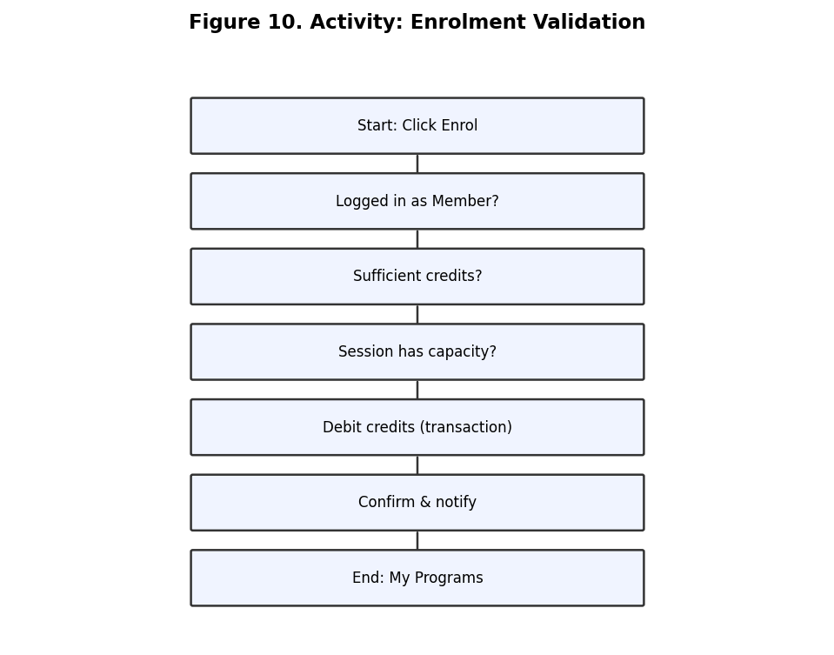
Figure 10. Activity: enrolment validation

21. State Diagram – Enrollment Lifecycle
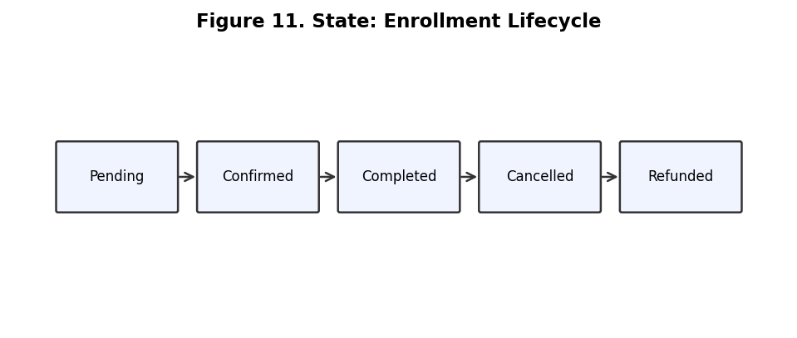
Figure 11. State: enrollment lifecycle

Part VI – UI/UX Design

23. Information Architecture
- /login, /signup, /onboarding/interests
- /, /courses, /courses/:id
- /account, /badges, /payment
- /creator/upload, /creator/programs
- /admin/review, /admin/users, /admin/ledger

24. Screen Inventory
ID | Name | Role | Priority
GLB-01 | Public Landing Page | Global | P1
GLB-02 | Sign Up and Role Selection | Global | P0
GLB-03 | Login and Recovery | Global | P0
GLB-04 | RBAC Navigation Shell | Global | P0
GLB-05 | Account Settings and Profile | Global | P0
GLB-06 | Notification Center | Global | P1
MBR-01 | Member Dashboard | Member | P0
MBR-02 | Program Catalog | Member | P0
MBR-03 | Program Detail and Enrol | Member | P0
MBR-04 | Credit Spend Confirmation Modal | Member | P0
MBR-05 | My Programs and Learning Hub | Member | P0
MBR-06 | Credit Wallet and Subscription | Member | P1
MBR-07 | Post-Program Rating | Member | P2
MBR-08 | Certificates and Badges | Member | P1
TRN-01 | Trainer Dashboard | Trainer | P0
TRN-02 | Create Program Wizard | Trainer | P0
TRN-03 | Content Library Browser | Trainer | P0
TRN-04 | Cohort Roster | Trainer | P1
TRN-05 | Attendance and Completion | Trainer | P0
CRT-01 | Upload Material | Creator | P0
CRT-02 | My Materials | Creator | P1
CRT-03 | Usage Analytics | Creator | P1
ADM-01 | Admin Dashboard | Admin | P1
ADM-02 | Content Review Queue | Admin | P0
ADM-03 | Users and Roles | Admin | P0
ADM-04 | Credit Ledger | Admin | P0
ADM-05 | Disputes and Refunds | Admin | P1

25. Wireframe Mapping (Low-fi PDF)
PDF Frames | Content | Screen IDs
1-2 | Login / Sign Up | GLB-03, GLB-02
6-7 | Interest selection Step 3/3 | Onboarding
9-10 | Homepage featured programs | MBR-01
20-28 | Course detail + Enrol bar | MBR-03, MBR-04
29-34 | Profile / My Account | GLB-05
36-37 | Badge and certificates | MBR-08
42-44 | Payment subscription | MBR-06

26. RBAC Permission Matrix
Capability | Member | Trainer | Creator | Admin
Register / sign in | Y | Y | Y | Y
Browse program catalog | Y | Y | Y | Y
Enrol in program (spend credits) | Y | - | - | -
Top-up / receive credits | Y | P | P | Y
Upload learning materials | - | - | Y | Y
Edit own materials | - | - | Y | Y
Create / publish program | - | Y | - | Y
Set program credit price | - | Y | - | Y
View enrolled member list | - | Y | - | Y
Record participation | - | Y | - | Y
View own usage statistics | Y | Y | Y | Y
Review and approve content | - | - | - | Y
Manage users and roles | - | - | - | Y
Audit platform credit ledger | - | - | - | Y
Issue global credit grants | - | - | - | Y

27. Navigation Shell per Role
Member: Home, Courses, My Account, Payment, Badge
Trainer: Home, Courses, My Programs, Create Program, My Account
Creator: Home, Upload Material, Create Program, My Account
Administrator: Admin Dashboard, Content Review, Users, Credit Ledger, Disputes

Part VII – Data Design

28. Conceptual ER Diagram
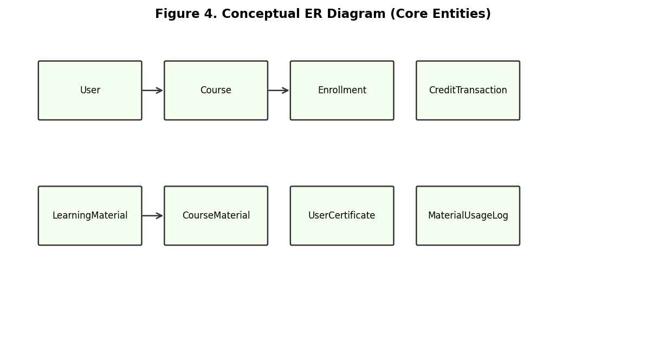
Figure 4. Conceptual ER diagram (core entities)

29. Logical Data Model Summary
Entity | Key Fields | Description
User | Id, Email, FullName, Role, CreditBalance | Root account
Course | Id, Code, Title, TrainerId, CreditCost | Training program
Enrollment | Id, UserId, CourseId, CourseSessionId, Status | Registration record
CreditTransaction | Id, UserId, Amount, BalanceAfter | Credit ledger
LearningMaterial | Id, CreatorId, Title, FilePath, Status | Content library
CourseMaterial | CourseId, MaterialId, UsageType | Attribution link
UserCertificate | Id, UserId, LearningStage, IssuedAt | Earned certificate

30. Business Rules
ID | Rule
BR-01 | User.CreditBalance must never be negative.
BR-02 | Every credit change requires a CreditTransaction row.
BR-03 | Material ownership is immutable; usage logged in MaterialUsageLog.
BR-04 | Only Member role can enrol in programs.
BR-05 | Enrollment requires an open CourseSession with available capacity.
BR-06 | Navigation items rendered based on JWT role claim.

31. Seed Data
Four users (Huang Yousheng/Member, Jane Smith/Trainer, Alex Lee/Creator, Desmond Tan/Admin).
Four courses: INFT2051, INFT3030, INFT3950, INFT2002. Four certificates for Huang Yousheng. Pro subscription.

Part VIII – API and Integration

32. REST API Catalogue
Method | Path | Description | Controller
POST | /api/auth/register | Register new user | Auth
POST | /api/auth/login | Login and receive JWT | Auth
GET | /api/auth/me | Current user profile | Auth
GET | /api/users/{id} | Get user by id | Users
PUT | /api/users/{id} | Update profile | Users
GET | /api/courses | List programs | Courses
GET | /api/courses/{id} | Program detail | Courses
GET | /api/courses/featured | Featured programs | Courses
POST | /api/courses | Create program | Courses
POST | /api/enrollments | Enrol with credits | Enrollments
GET | /api/enrollments/my | My enrolments | Enrollments
GET | /api/materials | List materials | Materials
POST | /api/materials | Upload material | Materials
PUT | /api/materials/{id}/review | Approve/reject | Admin
GET | /api/certificates/my | My certificates | Certificates
GET | /api/admin/credits/ledger | Audit ledger | Admin

33. Notification Triggers
ID | Event | Recipients | Channel
N-01 | Enrolment confirmed | Member, Trainer | In-app, Email
N-02 | Program starting soon | Member, Trainer | In-app, Email
N-03 | Content approved | Creator | In-app
N-04 | Content rejected | Creator | In-app
N-05 | Material adopted by trainer | Creator | In-app
N-06 | Credit royalty earned | Creator | In-app
N-07 | Cohort nearly full | Trainer | In-app
N-08 | Low credit balance | Member | In-app
N-09 | Refund issued | Member, Trainer, Admin | In-app
N-10 | Pending review backlog | Admin | In-app

Part IX – Delivery Planning

34. Milestone Schedule
Period | Deliverable
W1-2 | Environment, routing, Bootstrap scaffold
W3-4 | Auth + wireframe pages (Login, Home, Courses)
W5-7 | EF Core, JWT, enrolment API
W8-9 | Creator upload, admin review, certificates
W10-12 | Integration, UAT, interim report
Part B | Testing, optimisation, final delivery

35. Testing Strategy
- Unit tests: credit deduction logic, validation rules
- Integration tests: auth and enrolment API flows
- UAT: four-role demo scripts from storyboard journeys A-D

36. Risk Register
ID | Risk | Impact | Mitigation
R-01 | HTTPS dev certificate blocks local access | High | Use HTTP in dev or document trust steps
R-02 | Scope creep on OAuth/Payment | High | UI placeholders only in Part A
R-03 | Concurrent enrolment race | Medium | DB transactions and capacity check
R-04 | EF migration complexity | Medium | Start with SQLite for PoC

37. Appendices
Appendix A: Full entity list (27 entities) – see docs/source/plan_content.md
Appendix B: Complete user story backlog – Section 15
Appendix C: Glossary – Credits, Program, Material, Attribution, PoC
Appendix D: Stack – React 19, Vite 8, ASP.NET Core 10, Bootstrap, EF Core

