

《数据结构专周设计》
课程设计

学年学期： 2023-2024上学期
院 别： 计算机科学与数学学院
专 业： 计算机科学与技术
班 级： 计算机2203
学 生： 林仁杰
学 号： 3221602104
指导教师： 姜春茂

目录
1. A类必做 3
1.1 排序题 3
1.1.1 题目的解题思路 3
1.1.2 题目的关键代码 3
1.1.3 流程图（如果有） 3
1.1.4 程序的运行截图 3
1.2 散列表 3
2 B类（较难） 4
2.1 B1 4
2.2.1 题目的解题思路 4
2.2.2 题目的关键代码 4
2.2.3 流程图（如果有） 5
2.2.4 程序的运行截图 ...........................................5
2.2 B2 4
2.2.1 题目的解题思路 4
2.2.2 题目的关键代码 4
2.2.3 流程图（如果有） 5
2.2.4 程序的运行截图 5
3 C类题目 6
3.1 6

1. A类必做

1.1 排序题

1.1.1 题目的解题思路
希尔排序（ShellSort）:平均时间复杂度为O(n log n) 到 O(n^2) 之间，取决于增量序列的选择。通常在中等规模数据集上有不错的表现。
快速排序（QuickSort）: 平均时间复杂度为 O(n log n)，对大多数输入数据有很好的表现。但在最坏情况下可能达到 O(n^2)。
堆排序（HeapSort）: 平均时间复杂度为 O(n log n)，对于大规模数据集的排序具有稳定的性能。
归并排序（MergeSort）: 平均时间复杂度为 O(n log n)，具有稳定的性能，但需要额外的空间来存储临时数组。
计数排序（CountingSort）: 平均时间复杂度为 O(n + k)，在输入范围不太大的情况下表现良好。

1.1.2 题目的关键代码
void swap(int *a, int *b) {
int temp = *a;
*a = *b;
*b = temp;
}
int getMax(int arr[], int n) {
int max = arr[0];
for (int i = 1; i < n; i++) {
if (arr[i] > max) {
max = arr[i];
}
}
return max;
}
void printArray(int arr[], int size) {
printf("[");
for (int i = 0; i < size; i++) {
printf("%d", arr[i]);
if (i < size - 1) {
printf(", ");
}
}
printf("]\n");
}
void shellSort(int arr[], int n) {
int gap, i, j, temp;
for (gap = n / 2; gap > 0; gap /= 2) {
for (i = gap; i < n; i++) {
temp = arr[i];
for (j = i; j >= gap && arr[j - gap] > temp; j -= gap) {
arr[j] = arr[j - gap];
}
arr[j] = temp;
printf("Shell Sort Step: ");
printArray(arr, n);
}
}
}
int partition(int arr[], int low, int high) {
int pivot = arr[high];
int i = (low - 1);
for (int j = low; j <= high - 1; j++) {
if (arr[j] < pivot) {
i++;
swap(&arr[i], &arr[j]);
}
}
swap(&arr[i + 1], &arr[high]);
return (i + 1);
}
void quickSort(int arr[], int low, int high) {
if (low < high) {
int pivot = partition(arr, low, high);
printf("Quick Sort Step: ");
for (int i = low; i <= high; i++) {
printf("%d ", arr[i]);
}
printf("\n");
quickSort(arr, low, pivot - 1);
quickSort(arr, pivot + 1, high);
printf("Quick Sort Step: ");
for (int i = low; i <= high; i++) {
printf("%d ", arr[i]);
}
printf("\n");
}
}
void heapify(int arr[], int n, int i) {
int largest = i;
int left = 2 * i + 1;
int right = 2 * i + 2;
if (left < n && arr[left] > arr[largest]) {
largest = left;
}
if (right < n && arr[right] > arr[largest]) {
largest = right;
}
if (largest != i) {
swap(&arr[i], &arr[largest]);
heapify(arr, n, largest);
}
}
void heapSort(int arr[], int n) {
for (int i = n / 2 - 1; i >= 0; i--) {
heapify(arr, n, i);
}
for (int i = n - 1; i > 0; i--) {
swap(&arr[0], &arr[i]);
heapify(arr, i, 0);
printf("Heap Sort Step %d: [", n - i);
for (int j = 0; j < n; j++) {
printf("%d", arr[j]);
if (j < n - 1) printf(", ");
}
printf("]\n");
}
}
void merge(int arr[], int l, int m, int r) {
int i, j, k;
int n1 = m - l + 1;
int n2 = r - m;
int L[n1], R[n2];
for (i = 0; i < n1; i++) {
L[i] = arr[l + i];
}
for (j = 0; j < n2; j++) {
R[j] = arr[m + 1 + j];
}
i = 0;
j = 0;
k = l;
while (i < n1 && j < n2) {
if (L[i] <= R[j]) {
arr[k] = L[i];
i++;
} else {
arr[k] = R[j];
j++;
}
k++;
}
while (i < n1) {
arr[k] = L[i];
i++;
k++;
}
while (j < n2) {
arr[k] = R[j];
j++;
k++;
}
}
void mergeSort(int arr[], int l, int r) {
if (l < r) {
int m = l + (r - l) / 2;
mergeSort(arr, l, m);
mergeSort(arr, m + 1, r);
printf("Merge Sort (Divided): [");
for (int i = l; i <= r; i++) {
printf("%d", arr[i]);
if (i < r) printf(", ");
}
printf("]\n");
merge(arr, l, m, r);
printf("Merge Sort (Merged): [");
for (int i = l; i <= r; i++) {
printf("%d", arr[i]);
if (i < r) printf(", ");
}
printf("]\n");
}
}
void countSort(int arr[], int n, int exp) {
int output[n];
int count[10] = {0};
for (int i = 0; i < n; i++) {
count[(arr[i] / exp) % 10]++;
}
for (int i = 1; i < 10; i++) {
count[i] += count[i - 1];
}
for (int i = n - 1; i >= 0; i--) {
output[count[(arr[i] / exp) % 10] - 1] = arr[i];
count[(arr[i] / exp) % 10]--;
}
for (int i = 0; i < n; i++) {
arr[i] = output[i];
}
}
void radixSort(int arr[], int n) {
int max = getMax(arr, n);
for (int exp = 1; max / exp > 0; exp *= 10) {
countSort(arr, n, exp);

printf("Sorting array by digit %d: ", exp);
for (int i = 0; i < n; i++) {
printf("%d ", arr[i]);
}
printf("\n");
}
}

1.1.3 流程图（如果有）
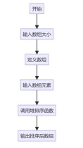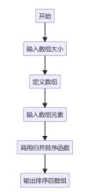

1.1.4 程序的运行截图
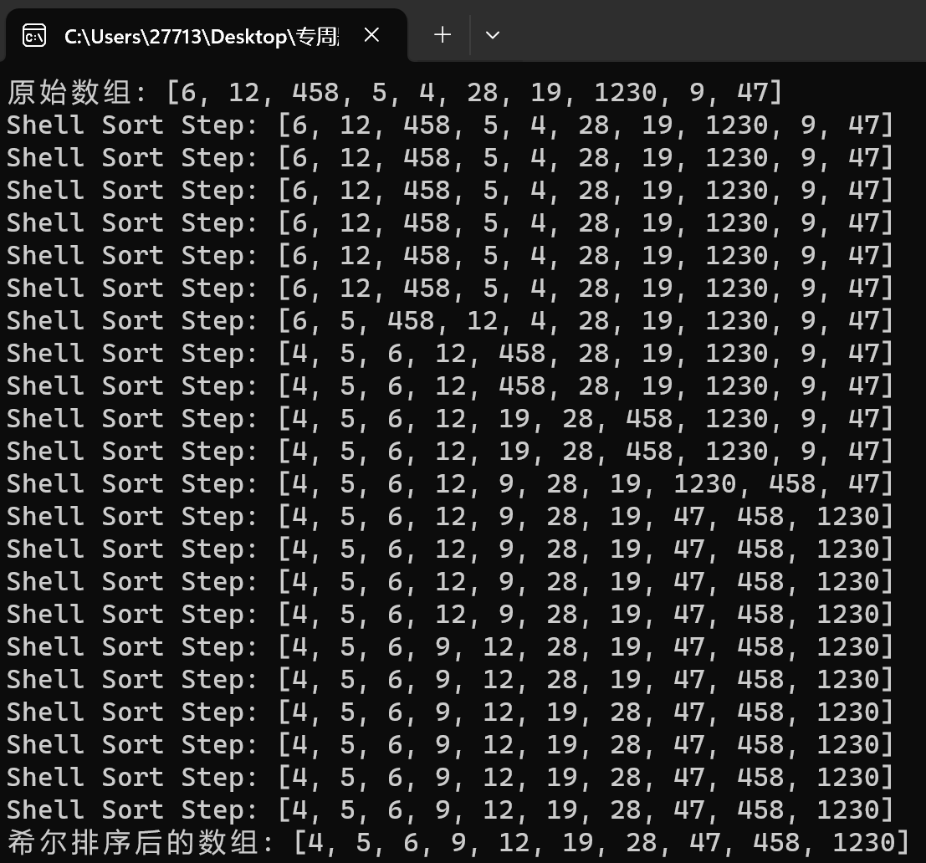
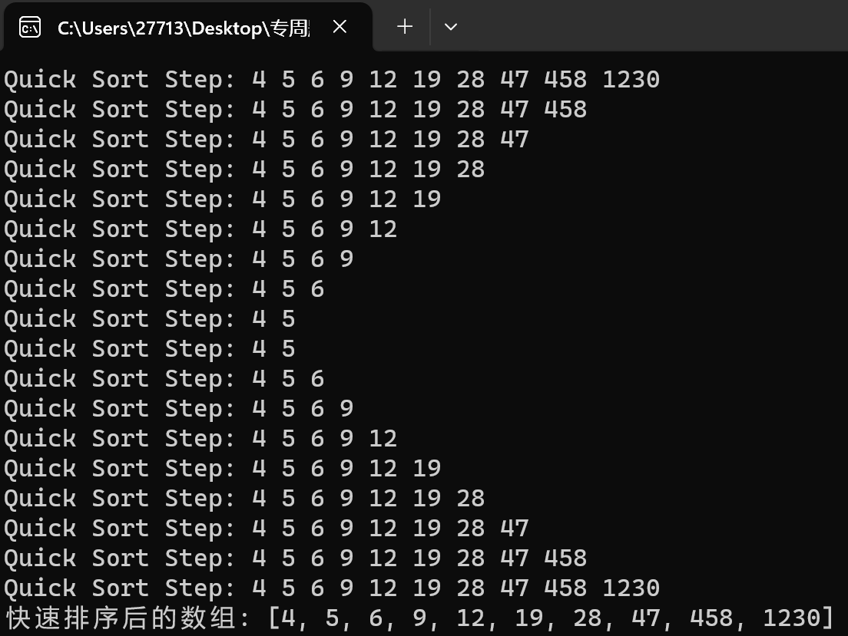

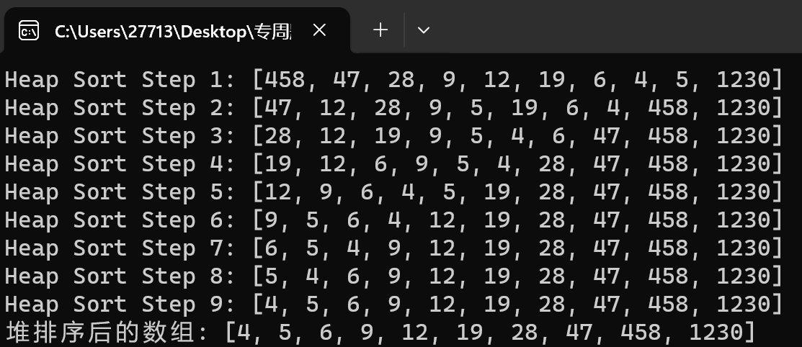
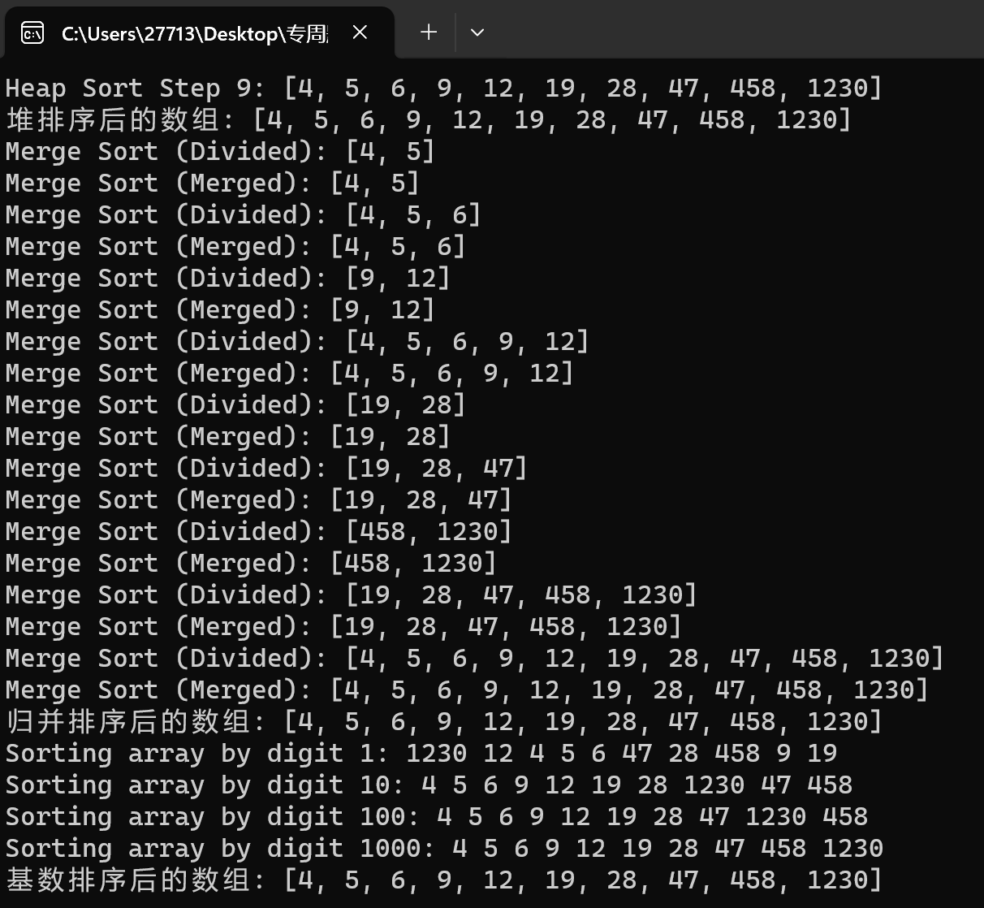

1.2 散列表

1.2.1 题目的解题思路
1. 散列函数设计：选择合适的哈希函数对电话号码进行映射，确保散列后的索引分布均匀。
2. 冲突处理方法：在处理哈希冲突时,可以采用开放地址法线性探测、平方探测等来处理冲突。
3. 存储用户信息：使用散列表来存储用户信息,电话号码作为关键字，用户信息作为值。

1.1.2 题目的关键代码
struct User {
char phone_number[12];
char username[50];
char address[100];
};
struct HashNode {
struct User *user;
};
struct HashTable {
struct HashNode *table[TABLE_SIZE];
};
unsigned long hash_function_1(char *phone_number) {
unsigned long hash = 5381;
int c;

while ((c = *phone_number++)) {
hash = ((hash << 5) + hash) + c; /* hash * 33 + c */
}

return hash % TABLE_SIZE;
}
void insert_linear_probe(struct HashTable *hash_table, struct User *user) {
unsigned long index = hash_function_1(user->phone_number);
unsigned long original_index = index;
do {
if (hash_table->table[index] == NULL) {
hash_table->table[index] = (struct HashNode *)malloc(sizeof(struct HashNode));
hash_table->table[index]->user = user;
return;
}
index = (index + 1) % TABLE_SIZE;
} while (index != original_index);

printf("哈希表已满，无法插入。\n");
}
float calculate_collision_rate(struct HashTable *hash_table) {
int collision_count = 0;
for (int i = 0; i < TABLE_SIZE; i++) {
if (hash_table->table[i] != NULL) {
collision_count++;
}
}
return (float)collision_count / TABLE_SIZE;
}
float calculate_avg_search_length(struct HashTable *hash_table, struct User *users, int num_users) {
int total_search_length = 0;
for (int i = 0; i < num_users; i++) {
unsigned long index = hash_function_1(users[i].phone_number);
unsigned long original_index = index;
int search_length = 1;
while (hash_table->table[index] != NULL) {
if (strcmp(hash_table->table[index]->user->phone_number, users[i].phone_number) == 0) {
total_search_length += search_length;
break;
}
index = (index + 1) % TABLE_SIZE;
search_length++;
if (index == original_index) {
// Not found
break;
}
}
}
return (float)total_search_length / num_users;
}
struct User {
char phone_number[12];
char username[50];
char address[100];
};
struct HashNode {
struct User *user;
};
struct HashTable {
struct HashNode *table[TABLE_SIZE];
};
unsigned long hash_function_1(char *phone_number) {
unsigned long hash = 5381;
int c;
while ((c = *phone_number++)) {
hash = ((hash << 5) + hash) + c;
}
return hash % TABLE_SIZE;
}
unsigned long probe_sequence(int attempt) {
return attempt * attempt;
}
void insert_quadratic_probe(struct HashTable *hash_table, struct User *user) {
unsigned long index = hash_function_1(user->phone_number);
unsigned long original_index = index;
int attempt = 0;
do {
if (hash_table->table[index] == NULL) {
hash_table->table[index] = (struct HashNode *)malloc(sizeof(struct HashNode));
hash_table->table[index]->user = user;
return;
}
index = (original_index + probe_sequence(attempt)) % TABLE_SIZE;
attempt++;
} while (attempt < TABLE_SIZE);
printf("Hashtable is full, cannot insert.\n");
}
float calculate_collision_rate(struct HashTable *hash_table) {
int collision_count = 0;
for (int i = 0; i < TABLE_SIZE; i++) {
if (hash_table->table[i] != NULL) {
collision_count++;
}
}
return (float)collision_count / TABLE_SIZE;
}
float calculate_avg_search_length(struct HashTable *hash_table, struct User *users, int num_users) {
int total_search_length = 0;
for (int i = 0; i < num_users; i++) {
unsigned long index = hash_function_1(users[i].phone_number);
unsigned long original_index = index;
int attempt = 0;
while (hash_table->table[index] != NULL) {
if (strcmp(hash_table->table[index]->user->phone_number, users[i].phone_number) == 0) {
total_search_length += attempt + 1;
break;
}
index = (original_index + probe_sequence(attempt)) % TABLE_SIZE;
attempt++;
if (attempt >= TABLE_SIZE) {
break;
}
}
}
return (float)total_search_length / num_users;
}
struct User {
char phone_number[12];
char username[50];
char address[100];
};
struct ListNode {
struct User *user;
struct ListNode *next;
};
struct HashTable {
struct ListNode *table[TABLE_SIZE];
};
unsigned long hash_function_1(char *phone_number) {
unsigned long hash = 5381;
int c;
while ((c = *phone_number++)) {
hash = ((hash << 5) + hash) + c;
}
return hash % TABLE_SIZE;
}
void insert_chaining(struct HashTable *hash_table, struct User *user) {
unsigned long index = hash_function_1(user->phone_number);
struct ListNode *new_node = (struct ListNode *)malloc(sizeof(struct ListNode));
new_node->user = user;
new_node->next = NULL;
if (hash_table->table[index] == NULL) {
hash_table->table[index] = new_node;
} else {
struct ListNode *current = hash_table->table[index];
while (current->next != NULL) {
current = current->next;
}
current->next = new_node;
}
}
float calculate_collision_rate(struct HashTable *hash_table) {
int collision_count = 0;
for (int i = 0; i < TABLE_SIZE; i++) {
if (hash_table->table[i] != NULL && hash_table->table[i]->next != NULL) {
collision_count++;
}
}
return (float)collision_count / TABLE_SIZE;
}
float calculate_avg_search_length(struct HashTable *hash_table, struct User *users, int num_users) {
int total_search_length = 0;
for (int i = 0; i < num_users; i++) {
unsigned long index = hash_function_1(users[i].phone_number);
if (hash_table->table[index] != NULL) {
struct ListNode *current = hash_table->table[index];
int search_length = 1;
while (current != NULL) {
if (strcmp(current->user->phone_number, users[i].phone_number) == 0) {
total_search_length += search_length;
break;
}
current = current->next;
search_length++;
}
}
}

return (float)total_search_length / num_users;
}
1.2.3 流程图（如果有）
线性探测法
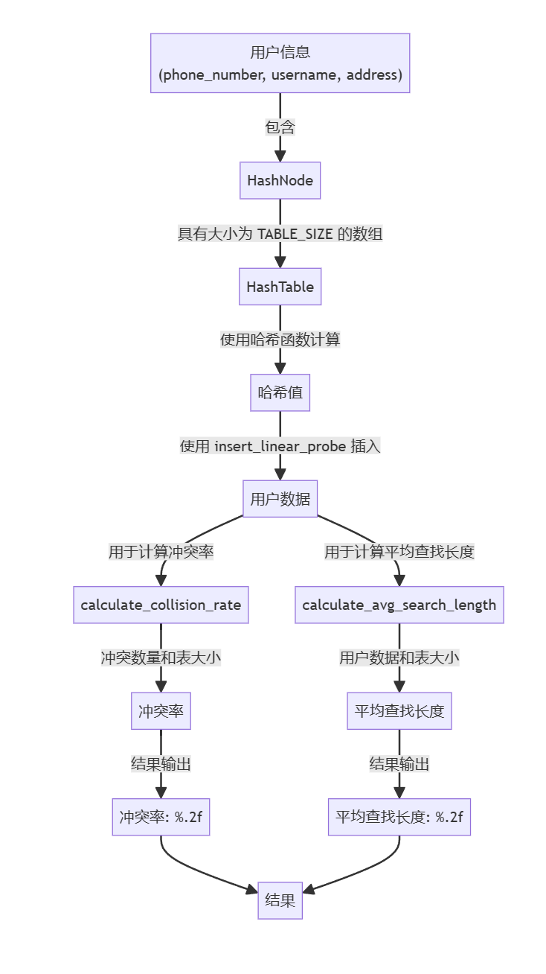

1.1.4 程序的运行截图
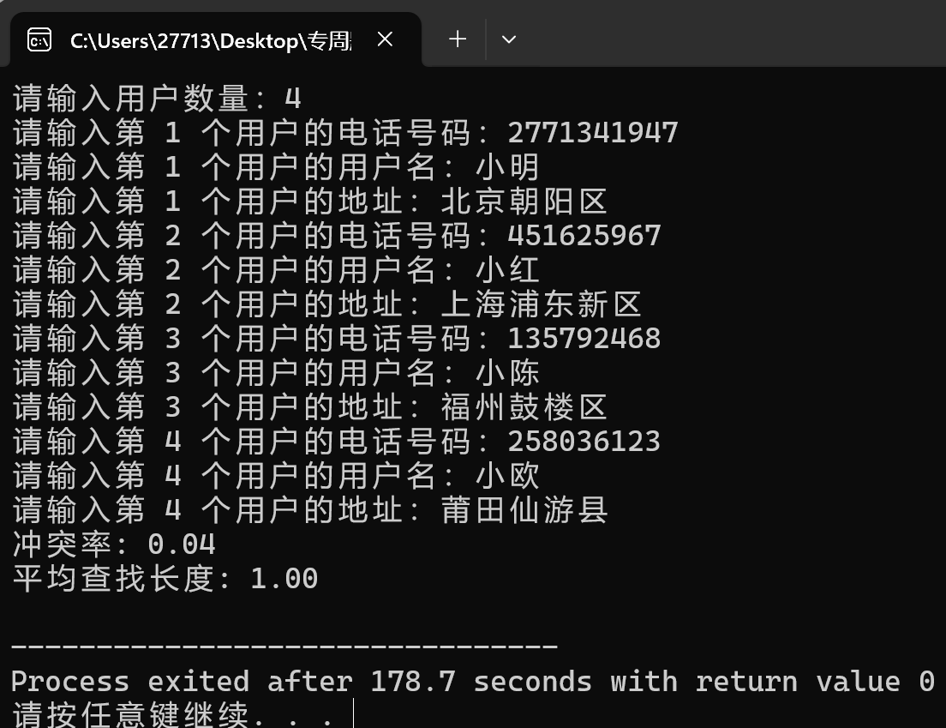
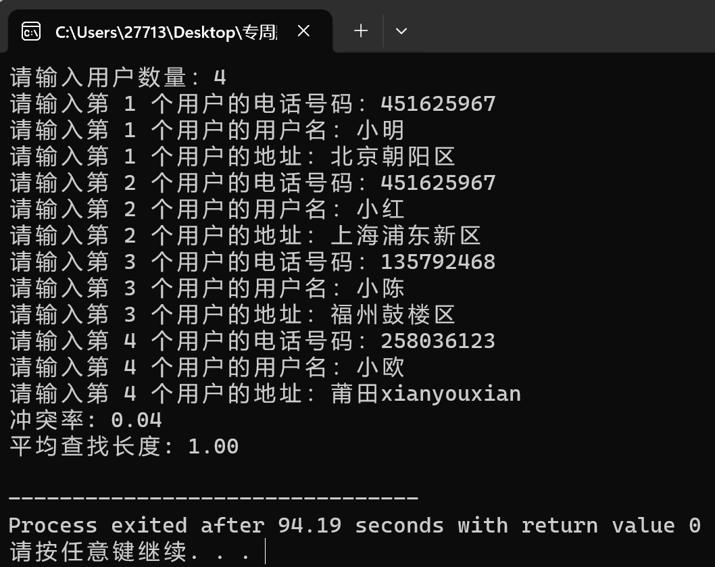
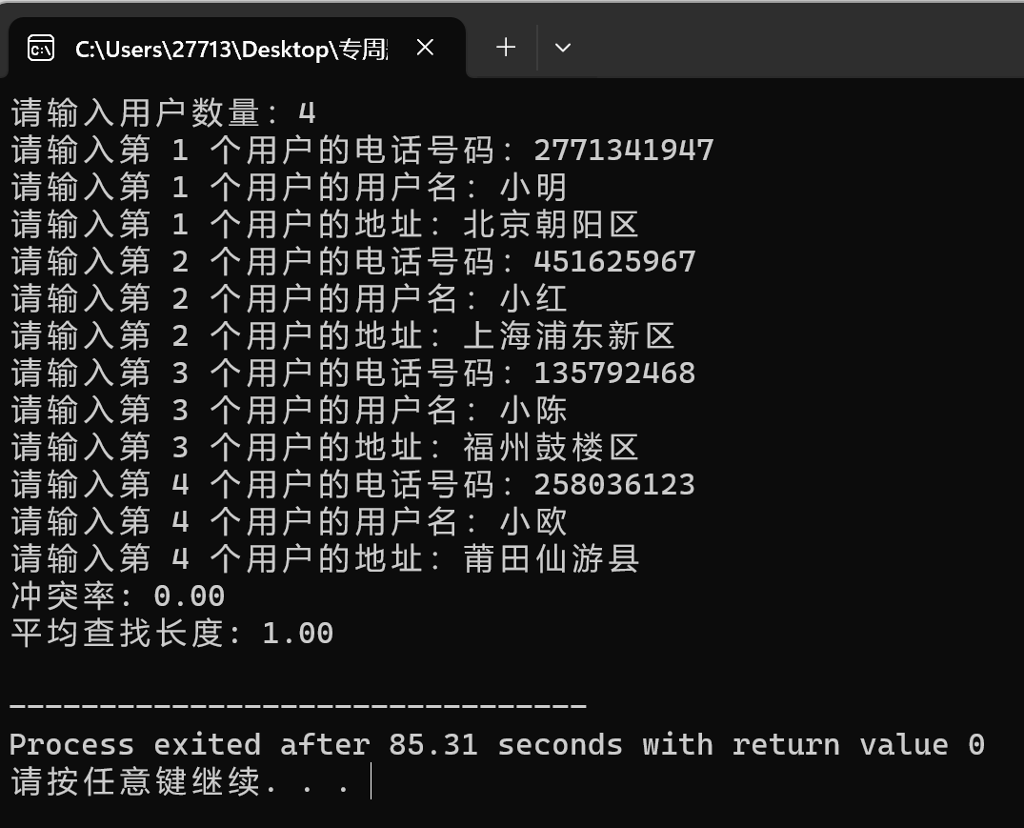

2 B类（较难）
选择1，4，6，9.

2.1 你选择的题目1
B1，涉及到串，数组

2.1.1 题目的解题思路
这个问题需要找出一个 DNA 基因序列中的最长回文子序列。一种方法是使用 Manacher 算法，它能在 O(n)的时间内找到最长回文子序列。这个算法通过动态规划的思想来实现，但需要额外的空间来存储信息。另一种方法是暴力匹配算法，但在效率上通常不如 Manacher 算法。比较这两种算法的时间和空间复杂度可以帮助理解它们之间的差异。 Manacher 算法在这种情况下更为高效。
Manacher 算法的时间复杂度为 O(n)，空间复杂度为 O(n)；而暴力匹配算法的时间复杂度为 O(n^3)，空间复杂度为 O(1)。 Manacher 算法在寻找最长回文子串时更有效率。

2.1.2 题目的关键代码
马拉车算法
char* longestPalindrome(char *s) {
int n = strlen(s);
if (n == 0) {
return "";
}
int N = 2 * n + 1;
int L[N];
L[0] = 0;
L[1] = 1;
int C = 1;
int R = 2;
int maxLen = 0;
int maxIndex = 0;
for (int i = 2; i < N; i++) {
int i_mirror = 2 * C - i;
L[i] = 0;
if (R > i) {
L[i] = min(R - i, L[i_mirror]);
}
while (i + 1 + L[i] < N && i - 1 - L[i] >= 0 &&
((i + 1 + L[i]) % 2 == 0 || s[(i + 1 + L[i]) / 2] == s[(i - 1 - L[i]) / 2])) {
L[i]++;
}
if (i + L[i] > R) {
C = i;
R = i + L[i];
}
if (L[i] > maxLen) {
maxLen = L[i];
maxIndex = i;
}
}
int start = (maxIndex - maxLen) / 2;
s[start + maxLen] = '\0';
return &s[start];
}
暴力匹配
char* longestPalindrome(char *s) {
int n = strlen(s);
if (n == 0) {
return "";
}
int maxLen = 0;
int start = 0;
for (int i = 0; i < n; i++) {
for (int j = i; j < n; j++) {
if (isPalindrome(s, i, j) && (j - i + 1) > maxLen) {
start = i;
maxLen = j - i + 1;
}
}
}
s[start + maxLen] = '\0';
return &s[start];
}

2.1.3 流程图（如果有）

2.1.4 程序的运行截图
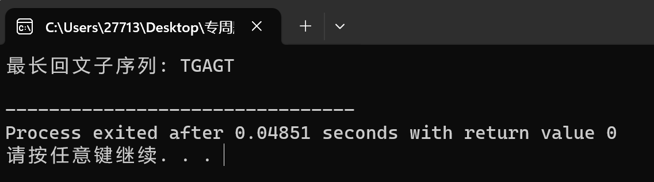
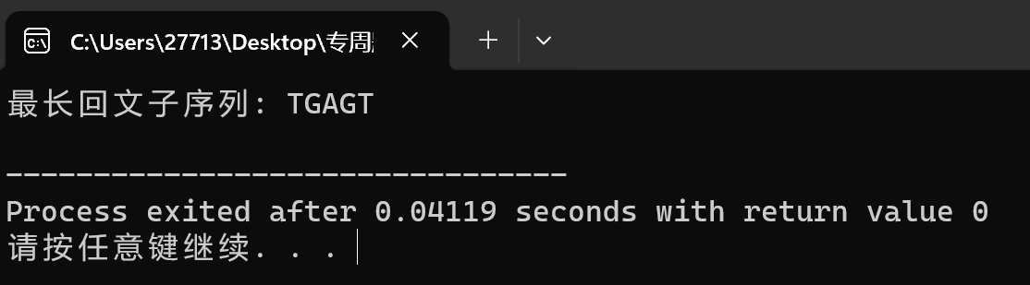

2.2 你选择的题目B4
涉及到栈，递归。

2.2.1 题目的解题思路
1. 回溯算法框架：使用递归函数进行回溯，尝试在每一行放置一个皇后，并检查是否满足规则。
2. 逐行放置皇后：递归函数会逐行进行，对于每一行，尝试将皇后放置在这一行的每一个位置。放置皇后后，检查是否与之前的皇后位置冲突（同一列或对角线），若冲突则回溯，尝试下一个位置。
3. 标记冲突位置：可以使用数组或其他方式记录已经放置皇后的位置，便于检查新放置的皇后是否与已有皇后位置冲突。
4. 得到所有解：当成功放置了8个皇后时，得到了一个有效解，记录并输出解的情况。继续回溯，尝试得到所有解。

2.2.2 题目的关键代码
int board[N];
bool is_safe(int row, int col) {
for (int i = 0; i < row; ++i) {
if (board[i] == col ||
board[i] - i == col - row ||
board[i] + i == col + row) {
return false;
}
}
return true;
}
void print_solution() {
for (int i = 0; i < N; ++i) {
printf("(%d, %d) ", i, board[i]);
}
printf("\n");
}
void solve_n_queens(int row) {
if (row == N) {
print_solution();
return;
}

for (int col = 0; col < N; ++col) {
if (is_safe(row, col)) {
board[row] = col;
solve_n_queens(row + 1);
}
}
}

2.2.3 流程图（如果有）

2.2.4 程序的运行截图
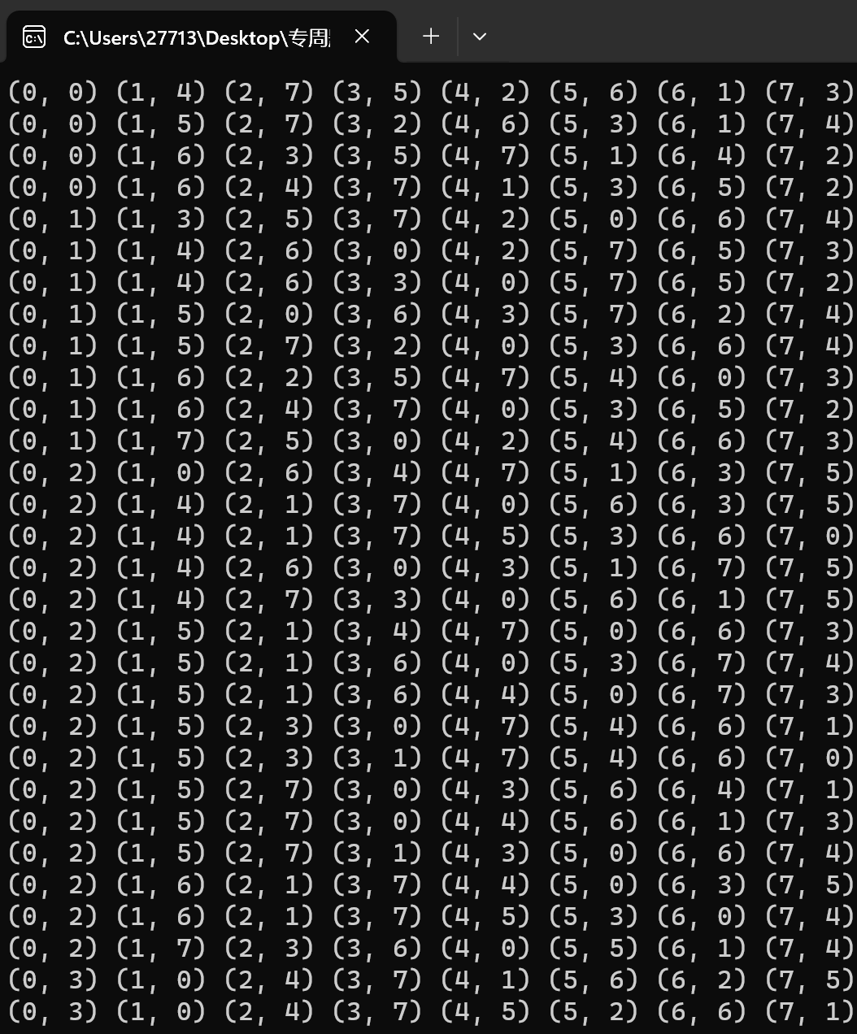

2.3 你选择的题目B6
涉及到队列和图，有向图的表示，关键路径算法

2.3.1 题目的解题思路
1. 创建图表示：使用邻接矩阵表示图，根据输入的边的信息构建二维数组，`graph[i][j]` 表示节点 `i` 到节点 `j` 的距离，无边的情况设为无穷大。
2. Dijkstra算法实现:初始化距离数组 `dist[]`，起始节点到各节点的距离初始值为无穷大，起始节点的距离为0。使用最小堆作为优先队列，将起始节点放入堆中。
从堆中取出距离最小的节点，遍历其相邻节点，更新起始节点到这些节点的距离。重复这个过程直到堆为空。
3. 输出最短路径：得到所有节点到起始节点的最短距离后，输出节点6（终点）到节点0（起点）的最短距离，即 `dist[6]` 的值。

2.3.2 题目的关键代码
void perform_dfs(int current_node, int N, int source);
int adj_matrix[MAX_NODES][MAX_NODES] = {0};
int durations[MAX_NODES] = {0};
int visited[MAX_NODES] = {0};
int max_duration = 0;
int path[MAX_NODES] = {0};
int path_index = 0;
void find_critical_paths(int N);
int main() {
int N, M;
printf("请输入节点总数N和箭头总数M：");
scanf("%d %d", &N, &M);
printf("请输入每条箭头的起始节点、终止节点和持续时间：\n");
for (int i = 0; i < M; i++) {
int start, end, duration;
scanf("%d %d %d", &start, &end, &duration);
adj_matrix[start][end] = 1;
durations[end] = duration;
}
find_critical_paths(N);
return 0;
}
void perform_dfs(int current_node, int N, int source) {
visited[current_node] = 1;
path[path_index++] = current_node;
if (current_node == N) {
int current_duration = 0;
for (int i = 0; i < path_index - 1; i++) {
current_duration += durations[path[i]];
}
if (current_duration > max_duration) {
max_duration = current_duration;
}
for (int i = 0; i < path_index; i++) {
printf("%d ", path[i]);
}
printf("\n");
} else {
for (int i = 0; i <= N; i++) {
if (adj_matrix[current_node][i] == 1 && !visited[i]) {
perform_dfs(i, N, source);
}
}
}
visited[current_node] = 0;
path_index--;
}
void find_critical_paths(int N) {
for (int i = 0; i <= N; i++) {
if (!visited[i]) {
perform_dfs(i, N, i);
}
}
printf("最长路径的持续时间：%d\n", max_duration);
}

2.2.3 流程图（如果有）
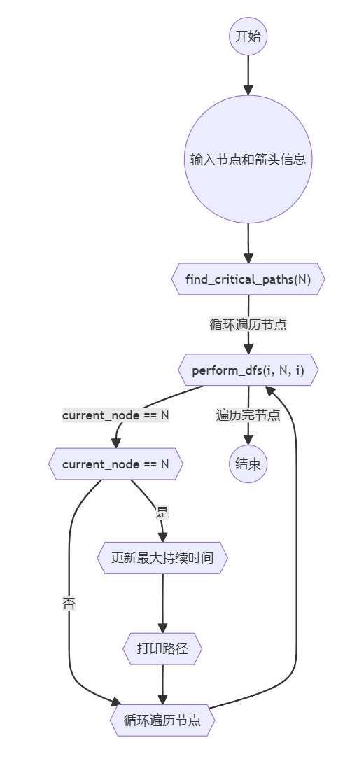

2.2.4 程序的运行截图
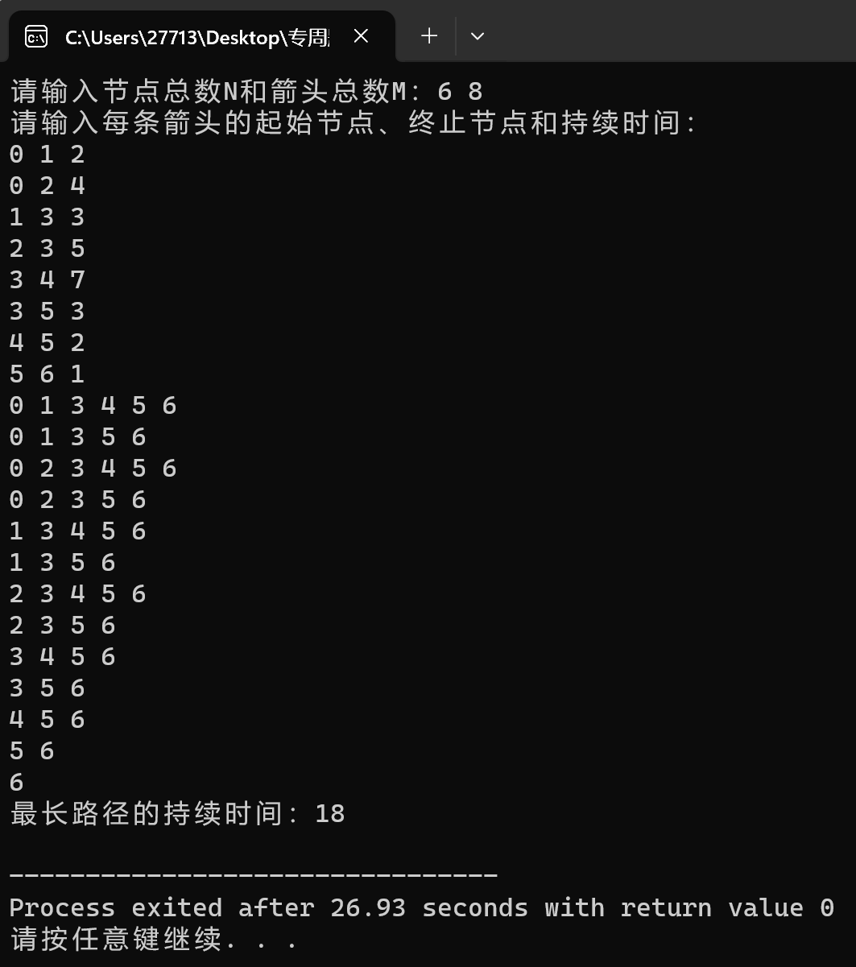

2.2 你选择的题目B9
涉及到图的表示，DFS算法。

2.2.1 题目的解题思路
1. 深度优先搜索（DFS）
使用DFS来检查从一个节点出发，是否可以访问到图中的所有其他节点。这个过程可以从任何一个节点开始，只要能访问到所有其他节点即可。
2. 反转图
构建原始图的反转图（即将所有边的方向反转），即将边的方向颠倒。这可以通过交换边的起始和结束节点来实现。
3. 再次DFS检查
对反转后的图再次进行DFS检查，从同一个起始节点开始。确认是否可以从这个起始节点访问到反转后图中的所有其他节点。
如果在这两个步骤中，所有节点都可以相互访问，则该图是强连通图。否则，就不是强连通图。

2.2.2 题目的关键代码
struct Graph {
int vertices;
int edges[MAX_NODES][MAX_NODES];
};
void initializeGraph(struct Graph *g, int vertices) {
g->vertices = vertices;
for (int i = 0; i < vertices; ++i) {
for (int j = 0; j < vertices; ++j) {
g->edges[i][j] = 0;
}
}
}
void addEdge(struct Graph *g, int src, int dest) {
g->edges[src][dest] = 1;
}
void dfs(struct Graph *g, int v, bool visited[]) {
visited[v] = true;
for (int i = 0; i < g->vertices; ++i) {
if (g->edges[v][i] && !visited[i]) {
dfs(g, i, visited);
}
}
}
bool isStronglyConnected(struct Graph *g) {
bool visited[MAX_NODES] = { false };
dfs(g, 0, visited);
for (int i = 0; i < g->vertices; ++i) {
if (!visited[i]) {
return false;
}
}
struct Graph reverseGraph;
initializeGraph(&reverseGraph, g->vertices);
for (int i = 0; i < g->vertices; ++i) {
for (int j = 0; j < g->vertices; ++j) {
if (g->edges[i][j]) {
addEdge(&reverseGraph, j, i);
}
}
}
for (int i = 0; i < g->vertices; ++i) {
visited[i] = false;
}
dfs(&reverseGraph, 0, visited);
for (int i = 0; i < g->vertices; ++i) {
if (!visited[i]) {
return false;
}
}
return true;
}

2.2.3 流程图（如果有）
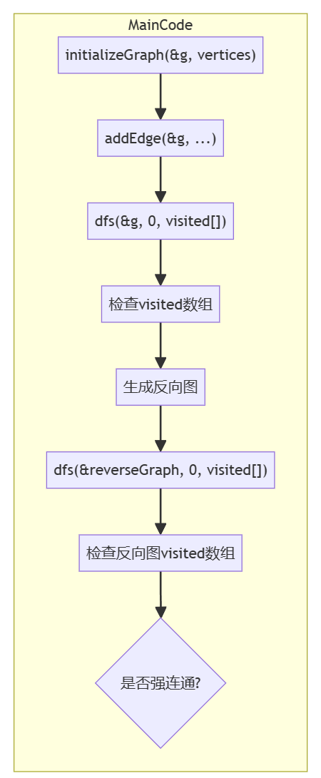

2.2.4 程序的运行截图
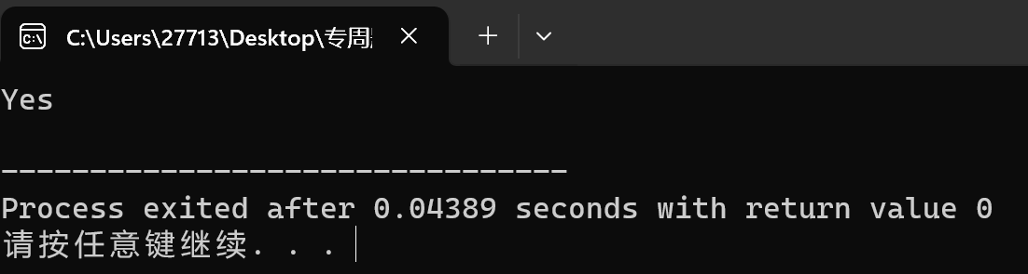

3 C类题目
我选择了14，15，16，18，19，20，21，23，24，25，26，27，28，29，30，31，32，40，42共19道题。

3.1

14.换硬币
void findchange(int amount) {
int coins[] = {25, 10, 5, 1};
int coincount[4] = {0};
printf("找零 %d 分，期望输出：", amount);
for (int i = 0; i < 4; ++i) {
coincount[i] = amount / coins[i];
amount %= coins[i];
}
for (int i = 0; i < 4; ++i) {
if (coincount[i] > 0) {
printf("%d 个 %d 分硬币 ", coincount[i], coins[i]);

}
}
}
printf("\n");
}
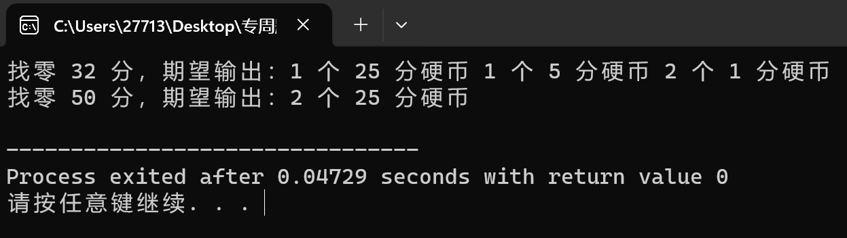

15.摆动序列
int max(int* nums, int numssize) {
if (numssize < 2) {
return numssize;
}
int a = 1;
int b = 1;
while (b < numssize && nums[b] == nums[b - 1]) {
b++;
}
if (b == numssize) {
return a;
}
int c = nums[b] - nums[b - 1];
a++;
for (; b < numssize; b++) {
int d = nums[b] - nums[b - 1];
if ((d > 0 && c <= 0) || (d < 0 && c >= 0)) {
a++;
c = d;
}
}
return a;
}
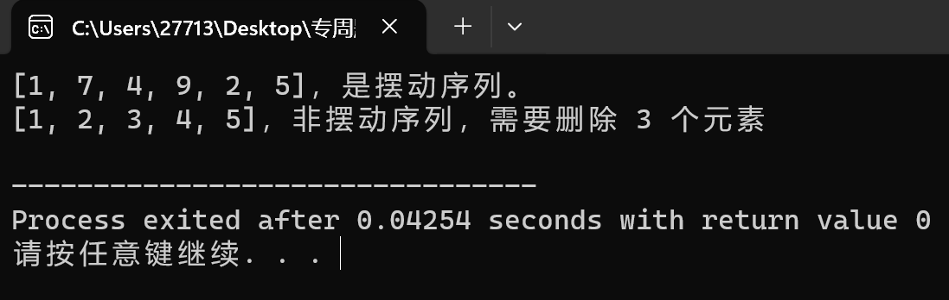
16.子序列
bool haha(int* A, int ASize, int* B, int BSize) {
int i = 0, j = 0;
while (i < ASize && j < BSize) {
if (A[i] == B[j]) {
j++;
}
i++;
}
return j == BSize;
}
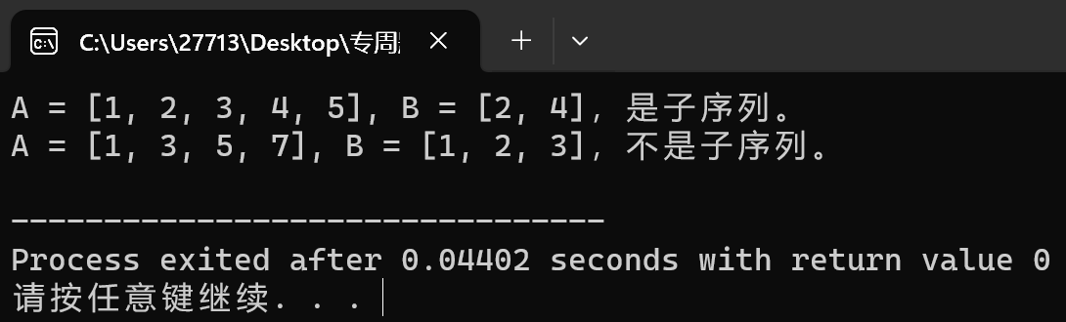
- 约瑟夫环
#include <stdio.h>
#include <stdlib.h>
struct Node {
int data;
struct Node* next;
};
struct Node* createNode(int data) {
struct Node* node = (struct Node*)malloc(sizeof(struct Node));
node->data = data;
node->next = NULL;
return node;
}
void buildCircle(struct Node** head, int total) {
struct Node* cur = NULL;
struct Node* prev = NULL;
for (int i = 1; i <= total; i++) {
cur = createNode(i);
if (*head == NULL) {
*head = cur;
} else {
prev->next = cur;
}
prev = cur;
}
cur->next = *head;
}
void josephus(struct Node** head, int interval) {
struct Node* cur = *head;
struct Node* prev = NULL;
while (cur->next != cur) {
for (int i = 1; i < interval; i++) {
prev = cur;
cur = cur->next;
}
prev->next = cur->next;
printf("%d ", cur->data);
free(cur);
cur = prev->next;
}
*head = cur;
}
int main() {
int total = 10;
int interval = 3; // 报数间隔
struct Node* head = NULL;
buildCircle(&head, total);
printf("淘汰的顺序：");
josephus(&head, interval);
printf("\n最后剩下的人：%d\n", head->data);
return 0;
}

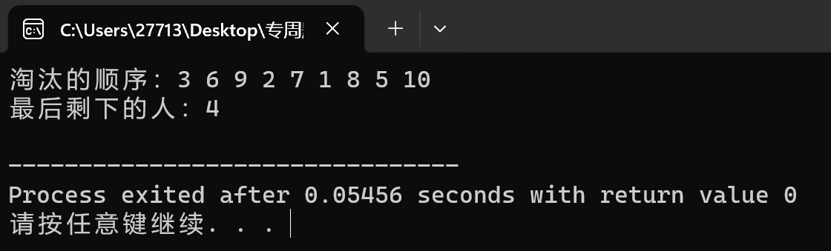
- 集合的交并集
#include <stdio.h>
#include <stdlib.h>
struct Node {
int data;
struct Node* next;
struct Node* prev;
};
struct Node* crNode(int data) {
struct Node* n = (struct Node*)malloc(sizeof(struct Node));
n->data = data;
n->next = n->prev = n;
return n;
}
void insert(struct Node* hd, int data) {
struct Node* newNode = crNode(data);
newNode->next = hd->next;
newNode->prev = hd;
hd->next->prev = newNode;
hd->next = newNode;
}
void printSet(struct Node* hd, const char* nm) {
printf("集合 %s = {", nm);
struct Node* cur = hd->next;
while (cur != hd) {
printf("%d", cur->data);
if (cur->next != hd) {
printf(", ");
}
cur = cur->next;
}
printf("}\n");
}
void intersection(struct Node* s1, struct Node* s2) {
struct Node* cur1 = s1->next;
while (cur1 != s1) {
struct Node* cur2 = s2->next;
while (cur2 != s2) {
if (cur1->data == cur2->data) {
printf("%d ", cur1->data);
break;
}
cur2 = cur2->next;
}
cur1 = cur1->next;
}
}
void unionSet(struct Node* s1, struct Node* s2) {
struct Node* cur1 = s1->next;
while (cur1 != s1) {
printf("%d ", cur1->data);
cur1 = cur1->next;
}
struct Node* cur2 = s2->next;
while (cur2 != s2) {
if (cur2->data != s1->next->data) {
printf("%d ", cur2->data);
}
cur2 = cur2->next;
}
}
int main() {
struct Node* set1 = crNode(-1); // 集合 1 的头结点
struct Node* set2 = crNode(-1); // 集合 2 的头结点
int arr1[] = {8, 9, 10, 11, 12};
int arr2[] = {10, 11, 12, 13, 14};
for (int i = 0; i < 5; ++i) {
insert(set1, arr1[i]);
insert(set2, arr2[i]);
}
printf("集合操作结果：\n");
printf("交集：");
intersection(set1, set2);
printf("\n并集：");
unionSet(set1, set2);
printf("\n");
return 0;
}

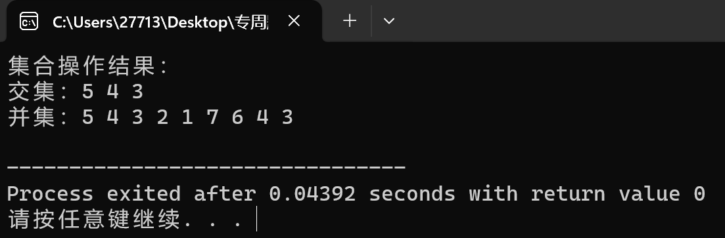
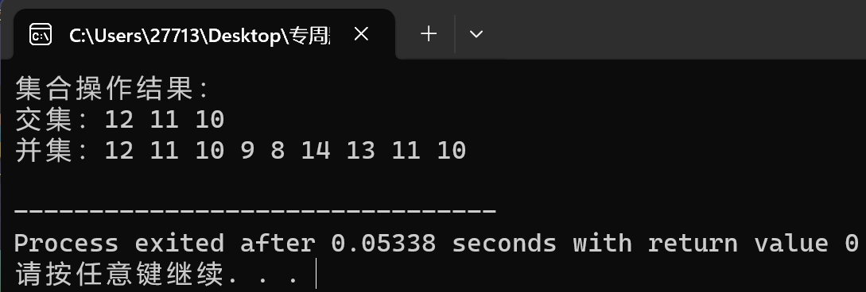
- 链表奇偶拆分
#include <stdio.h>
#include <stdlib.h>
struct Node {
int data;
struct Node* next;
};
struct Node* crNode(int data) {
struct Node* n = (struct Node*)malloc(sizeof(struct Node));
n->data = data;
n->next = NULL;
return n;
}
void append(struct Node** hd, int data) {
struct Node* newNode = crNode(data);
if (*hd == NULL) {
*hd = newNode;
return;
}
struct Node* temp = *hd;
while (temp->next != NULL) {
temp = temp->next;
}
temp->next = newNode;
}
void splitList(struct Node* hd, struct Node** odd, struct Node** even) {
struct Node* od = NULL;
struct Node* ev = NULL;
int pos = 1;
while (hd != NULL) {
if (pos % 2 == 0) {
append(&ev, hd->data);
} else {
append(&od, hd->data);
}
hd = hd->next;
pos++;
}
*odd = od;
*even = ev;
}
void printList(struct Node* hd) {
while (hd != NULL) {
printf("%d ", hd->data);
hd = hd->next;
}
printf("\n");
}
int main() {
struct Node* hd1 = NULL;
append(&hd1, 1);
append(&hd1, 2);
append(&hd1, 3);
append(&hd1, 4);
append(&hd1, 5);
append(&hd1, 6);
append(&hd1, 7);
append(&hd1, 8);
append(&hd1, 9);
append(&hd1, 10);
printf("输入链表：");
printList(hd1);
struct Node* odd = NULL;
struct Node* even = NULL;
splitList(hd1, &odd, &even);
printf("L1 = ");
printList(odd);
printf("L2 = ");
printList(even);
return 0;
}
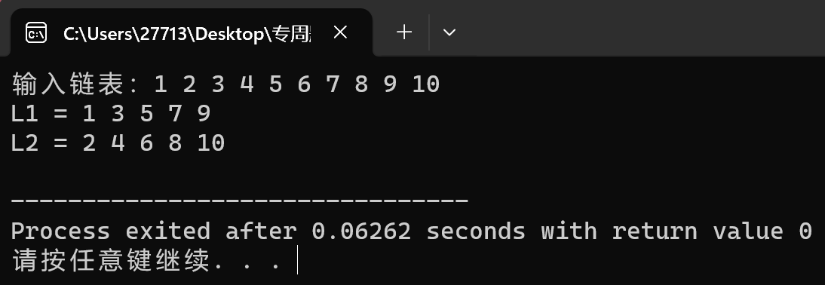
21.两序列中位数问题
#include <stdio.h>
#include <stdlib.h>
double findMedianSortedArrays(int* nums1, int nums1Size, int* nums2, int nums2Size) {
int total = nums1Size + nums2Size;
int* merged = (int*)malloc(sizeof(int) * total);
int i = 0, j = 0, k = 0;
while (i < nums1Size && j < nums2Size) {
if (nums1[i] < nums2[j]) {
merged[k++] = nums1[i++];
} else {
merged[k++] = nums2[j++];
}
}
while (i < nums1Size) {
merged[k++] = nums1[i++];
}
while (j < nums2Size) {
merged[k++] = nums2[j++];
}
double median;
if (total % 2 == 0) {
median = (merged[total / 2 - 1] + merged[total / 2]) / 2.0;
} else {
median = merged[total / 2];
}
free(merged);
return median;
}
int main() {
int nums1[] = {1, 3, 5, 7, 9};
int nums2[] = {2, 4, 6, 8, 10};
int nums1Size = sizeof(nums1) / sizeof(nums1[0]);
int nums2Size = sizeof(nums2) / sizeof(nums2[0]);
double median = findMedianSortedArrays(nums1, nums1Size, nums2, nums2Size);
printf("中位数: %f\n", median);
return 0;
}
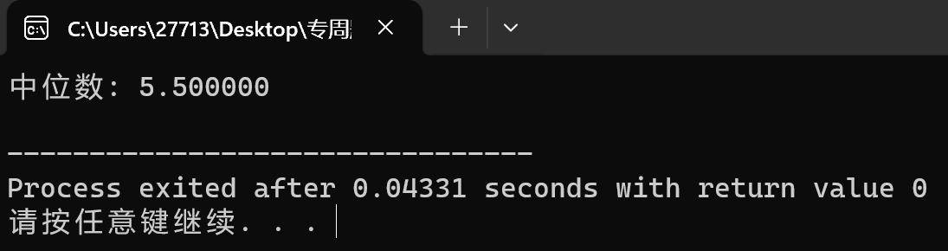
23. 合法出栈序列判断
#include <stdio.h>
#include <stdbool.h>
#include <string.h>
#define MAX_SIZE 100
bool validateStackSequence(const char *sequence, const char *characters) {
int seqLen = strlen(sequence);
int stack[MAX_SIZE];
int top = -1;
int charIndex = 0;
for (int i = 0; i < seqLen; i++) {
while (sequence[i] != characters[charIndex] && characters[charIndex] != '\0') {
charIndex++;
}
if (characters[charIndex] == '\0') {
return false;
}
stack[++top] = charIndex;
while (top != -1 && stack[top] == charIndex) {
top--;
charIndex--;
}
}
return top == -1;
}
int main() {
const char *seq1 = "edcba";
const char *seq2 = "abcde";
const char *charset = "abcde";
bool isValid1 = validateStackSequence(seq1, charset);
bool isValid2 = validateStackSequence(seq2, charset);
if (isValid1) {
printf("%s 是合法的出栈序列\n", seq1);
} else {
printf("%s 不是合法的出栈序列\n", seq1);
}
if (isValid2) {
printf("%s 是合法的出栈序列\n", seq2);
} else {
printf("%s 不是合法的出栈序列\n", seq2);
}
return 0;
}
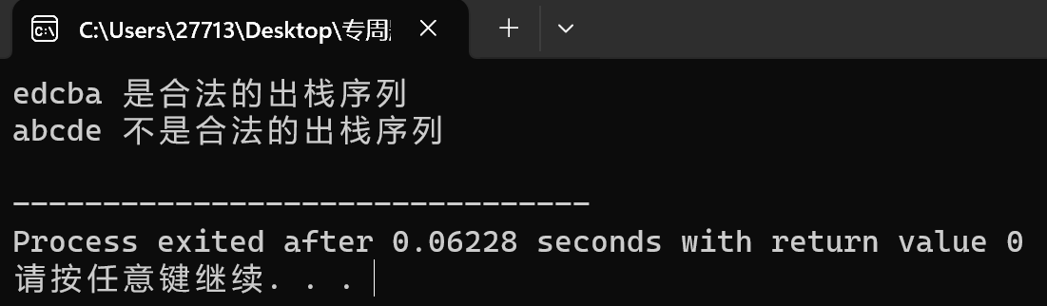
24十进制转换成其他进制
#include <stdio.h>
void decimalToBinary(int n) {
printf("十进制 %d 转换为二进制: ", n);
for (int i = 31; i >= 0; i--) {
int bit = (n >> i) & 1;
printf("%d", bit);
}
printf("\n");
}
void decimalToOctal(int n) {
printf("十进制 %d 转换为八进制: %o\n", n, n);
}
void decimalToHexadecimal(int n) {
printf("十进制 %d 转换为十六进制: %X\n", n, n);
}
int main() {
int num1 = 10;
int num2 = 31;
decimalToBinary(num1);
decimalToOctal(num1);
decimalToHexadecimal(num1);
decimalToBinary(num2);
decimalToOctal(num2);
decimalToHexadecimal(num2);
return 0;
}
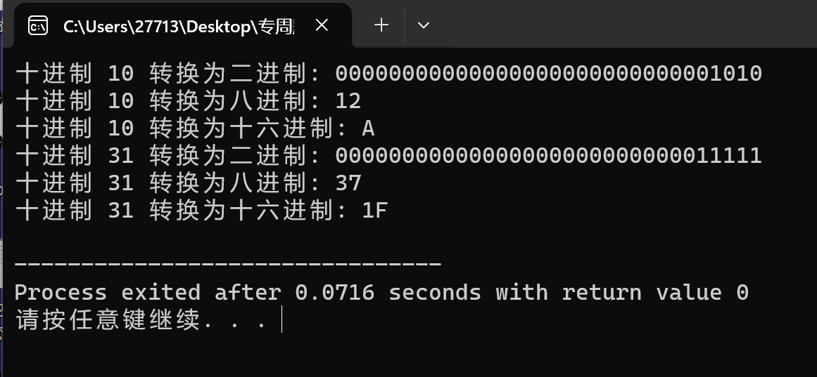
25KMP算法实现
#include <stdio.h>
#include <string.h>
void computeNext(const char *pattern, int *next, int length) {
int i = 1;
int j = 0;
next[0] = 0;

while (i < length) {
if (pattern[i] == pattern[j]) {
next[i] = j + 1;
i++;
j++;
} else {
if (j != 0) {
j = next[j - 1];
} else {
next[i] = 0;
i++;
}
}
}
}
int KMPSearch(const char *text, const char *pattern) {
int lenText = strlen(text);
int lenPattern = strlen(pattern);
if (lenPattern == 0) return 0;
int next[lenPattern];
computeNext(pattern, next, lenPattern);
int i = 0;
int j = 0;
while (i < lenText) {
if (text[i] == pattern[j]) {
if (j == lenPattern - 1) {
return i - j;
}
i++;
j++;
} else {
if (j != 0) {
j = next[j - 1];
} else {
i++;
}
}
}
return -1;
}
int main() {
const char *text1 = "ababcabcacbab";
const char *pattern1 = "abcac";
const char *text2 = "hello world";
const char *pattern2 = "world";
int pos1 = KMPSearch(text1, pattern1);
int pos2 = KMPSearch(text2, pattern2);
printf("Pattern 1的位置: %d\n", pos1);
printf("Pattern 2的位置: %d\n", pos2);
return 0;
}

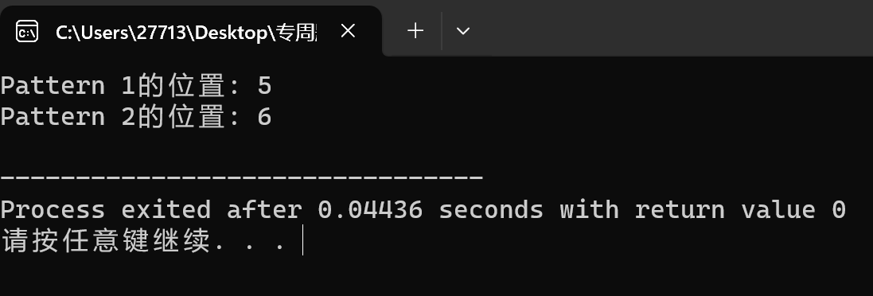
26英文句子格式化
#include <stdio.h>
#include <string.h>
#include <ctype.h>
void formatSentence(char *s) {
int i = 0, j = 0;
int len = strlen(s);
while (isspace((unsigned char)s[i])) {
i++;
}
while (i < len) {
if (!isspace((unsigned char)s[i]) || (i > 0 && !isspace((unsigned char)s[i - 1]))) {
s[j++] = s[i];
}
i++;
}
if (j > 0 && isspace((unsigned char)s[j - 1])) {
j--;
}
s[j] = '\0';
}
int main() {
char sentence1[] = "This is an example sentence.";
char sentence2[] = " Hello world! ";
printf("输入: \"%s\"\n", sentence1);
formatSentence(sentence1);
printf("期望输出: \"%s\"\n\n", sentence1);
printf("输入: \"%s\"\n", sentence2);
formatSentence(sentence2);
printf("期望输出: \"%s\"\n", sentence2);
return 0;
}

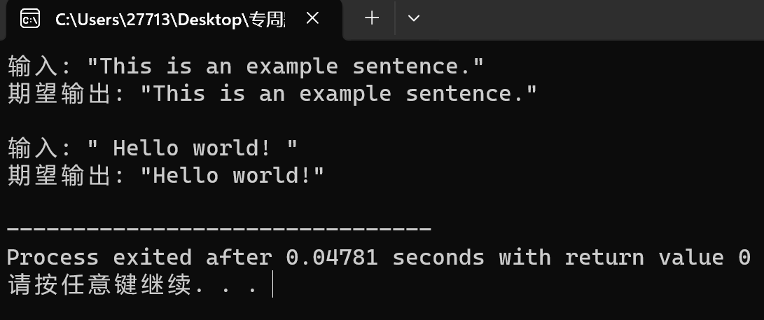
27. 稀疏矩阵的运算
typedef struct {
int row;
int col;
int value;
} Term;
typedef struct {
Term terms[MAX_TERMS];
int rows;
int cols;
int num_terms;
} SparseMatrix;
void initSparseMatrix(SparseMatrix *matrix, int rows, int cols) {
matrix->rows = rows;
matrix->cols = cols;
matrix->num_terms = 0;
}
void addTerm(SparseMatrix *matrix, int row, int col, int value) {
if (matrix->num_terms >= MAX_TERMS) {
printf("稀疏矩阵已满，无法添加更多元素。\n");
return;
}
matrix->terms[matrix->num_terms].row = row;
matrix->terms[matrix->num_terms].col = col;
matrix->terms[matrix->num_terms].value = value;
matrix->num_terms++;
}
SparseMatrix addSparseMatrices(SparseMatrix matrix1, SparseMatrix matrix2) {
if (matrix1.rows != matrix2.rows || matrix1.cols != matrix2.cols) {
printf("矩阵维度不匹配，无法相加。\n");
exit(EXIT_FAILURE);
}
SparseMatrix result;
initSparseMatrix(&result, matrix1.rows, matrix1.cols);
int i = 0, j = 0;
while (i < matrix1.num_terms && j < matrix2.num_terms) {
if (matrix1.terms[i].row < matrix2.terms[j].row ||
(matrix1.terms[i].row == matrix2.terms[j].row && matrix1.terms[i].col < matrix2.terms[j].col)) {
addTerm(&result, matrix1.terms[i].row, matrix1.terms[i].col, matrix1.terms[i].value);
i++;
} else if (matrix1.terms[i].row == matrix2.terms[j].row && matrix1.terms[i].col == matrix2.terms[j].col) {
addTerm(&result, matrix1.terms[i].row, matrix1.terms[i].col, matrix1.terms[i].value + matrix2.terms[j].value);
i++;
j++;
} else {
addTerm(&result, matrix2.terms[j].row, matrix2.terms[j].col, matrix2.terms[j].value);
j++;
}
}
while (i < matrix1.num_terms) {
addTerm(&result, matrix1.terms[i].row, matrix1.terms[i].col, matrix1.terms[i].value);
i++;
}
while (j < matrix2.num_terms) {
addTerm(&result, matrix2.terms[j].row, matrix2.terms[j].col, matrix2.terms[j].value);
j++;
}
return result;
}
SparseMatrix multiplySparseMatrices(SparseMatrix matrix1, SparseMatrix matrix2) {
if (matrix1.cols != matrix2.rows) {
printf("矩阵维度不匹配，无法相乘。\n");
exit(EXIT_FAILURE);
}
SparseMatrix result;
initSparseMatrix(&result, matrix1.rows, matrix2.cols);
int resultValue[result.rows][result.cols];
for (int i = 0; i < result.rows; i++) {
for (int j = 0; j < result.cols; j++) {
resultValue[i][j] = 0;
}
}
for (int i = 0; i < matrix1.num_terms; i++) {
for (int j = 0; j < matrix2.num_terms; j++) {
if (matrix1.terms[i].col == matrix2.terms[j].row) {
resultValue[matrix1.terms[i].row][matrix2.terms[j].col] += matrix1.terms[i].value * matrix2.terms[j].value;
}
}
}
for (int i = 0; i < result.rows; i++) {
for (int j = 0; j < result.cols; j++) {
if (resultValue[i][j] != 0) {
addTerm(&result, i, j, resultValue[i][j]);
}
}
}
return result;
}
void printSparseMatrix(SparseMatrix matrix) {
printf("稀疏矩阵的行数：%d\n", matrix.rows);
printf("稀疏矩阵的列数：%d\n", matrix.cols);
printf("稀疏矩阵的非零元素数量：%d\n", matrix.num_terms);
printf("稀疏矩阵的三元组表示：\n");
for (int i = 0; i < matrix.num_terms; i++) {
printf("(%d, %d, %d)\n", matrix.terms[i].row, matrix.terms[i].col, matrix.terms[i].value);
}
}
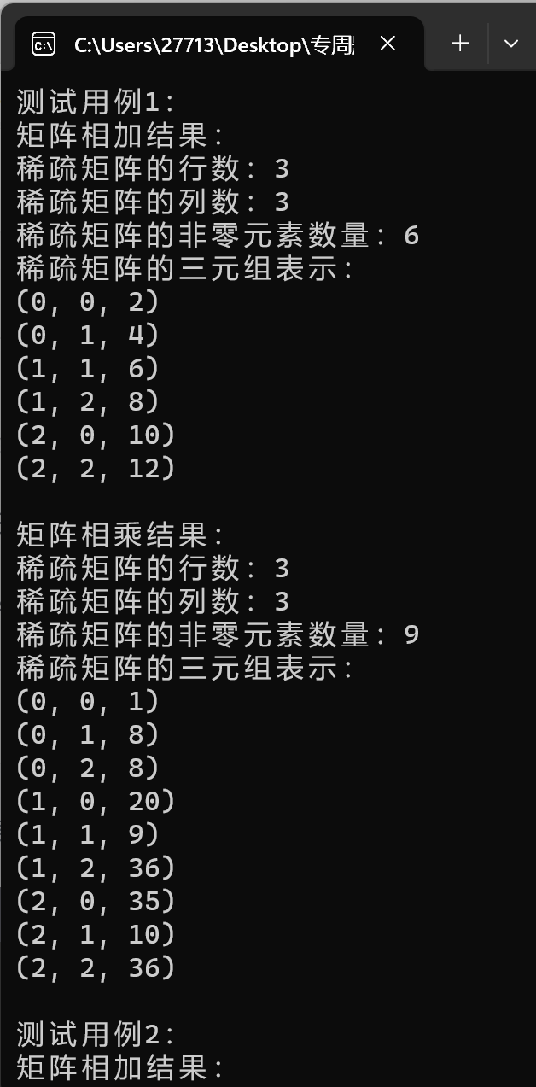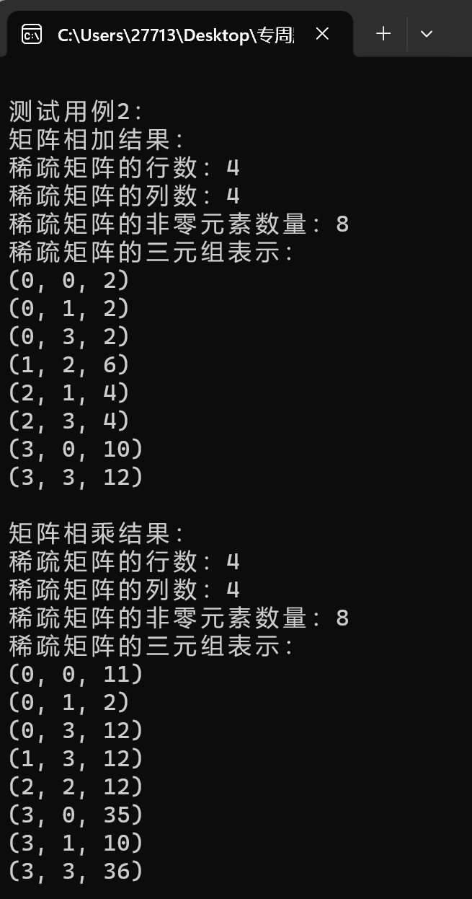
28. 二叉树公共祖先
#include <stdio.h>
#include <stdlib.h>
struct Node {
int val;
struct Node *left;
struct Node *right;
};
struct Node* createNode(int val) {
struct Node* node = (struct Node*)malloc(sizeof(struct Node));
node->val = val;
node->left = NULL;
node->right = NULL;
return node;
}
struct Node* ancestor(struct Node* root, struct Node* p, struct Node* q) {
if (root == NULL || root == p || root == q) {
return root;
}
struct Node* left = ancestor(root->left, p, q);
struct Node* right = ancestor(root->right, p, q);
if (left != NULL && right != NULL) {
return root;
}
return (left != NULL) ? left : right;
}
int main() {
struct Node* root = createNode(3);
root->left = createNode(5);
root->right = createNode(1);
root->left->left = createNode(6);
root->left->right = createNode(2);
root->right->left = createNode(0);
root->right->right = createNode(8);
root->left->right->left = createNode(7);
root->left->right->right = createNode(4);
struct Node* n1 = root->left;
struct Node* n2 = root->right;
struct Node* res = ancestor(root, n1, n2);
if (res != NULL) {
printf("祖先的值：%d\n", res->val);
} else {
printf("未找到祖先\n");
}
return 0;
}

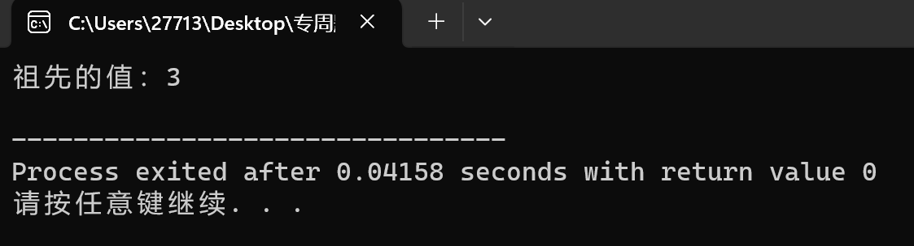
- 判断二叉树类型
typedef struct TreeNode {
int data;
struct TreeNode* left;
struct TreeNode* right;
} TreeNode;
TreeNode* createNode(int data) {
TreeNode* newNode = (TreeNode*)malloc(sizeof(TreeNode));
if (newNode == NULL) {
printf("内存分配失败\n");
exit(EXIT_FAILURE);
}
newNode->data = data;
newNode->left = NULL;
newNode->right = NULL;
return newNode;
}
bool isFullBinaryTree(TreeNode* root) {
if (root == NULL) {
return true;
}
if ((root->left == NULL && root->right != NULL) || (root->left != NULL && root->right == NULL)) {
return false;
}

return isFullBinaryTree(root->left) && isFullBinaryTree(root->right);
}
bool isCompleteBinaryTree(TreeNode* root) {
if (root == NULL) {
return true;
}
TreeNode* queue[1000];
int front = 0, rear = 0;
queue[rear++] = root;
while (front < rear) {
TreeNode* current = queue[front++];
if (current == NULL) {
while (front < rear) {
if (queue[front++] != NULL) {
return false;
}
}
} else {
queue[rear++] = current->left;
queue[rear++] = current->right;
}
}
return true;
}
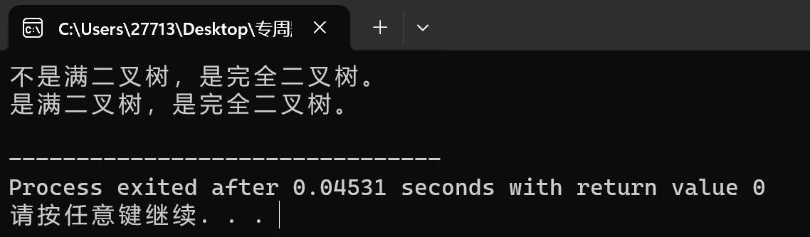
31二叉排序树查找路径
#include <stdio.h>
#include <stdlib.h>
struct Node {
int data;
struct Node* l;
struct Node* r;
};
struct Node* create(int k) {
struct Node* n = (struct Node*)malloc(sizeof(struct Node));
n->data = k;
n->l = n->r = NULL;
return n;
}
struct Node* ins(struct Node* root, int k) {
if (root == NULL) return create(k);

if (k < root->data)
root->l = ins(root->l, k);
else if (k > root->data)
root->r = ins(root->r, k);
return root;
}
void path(struct Node* root, int k) {
if (root == NULL) {
printf("该关键字不存在\n");
return;
}
printf("查找路径: %d ", root->data);
while (root != NULL && root->data != k) {
if (k < root->data) {
printf("-> 左子树 ");
root = root->l;
} else {
printf("-> 右子树 ");
root = root->r;
}
if (root != NULL)
printf("%d ", root->data);
}
if (root == NULL)
printf("-> 关键字不存在\n");
else
printf("-> 已找到关键字\n");
}
int main() {
struct Node* root = NULL;
root = ins(root, 50);
ins(root, 30);
ins(root, 70);
ins(root, 20);
ins(root, 40);
ins(root, 60);
ins(root, 80);
int keyToFind = 60;
printf("在二叉排序树中查找关键字 %d 的路径：\n", keyToFind);
path(root, keyToFind);
return 0;
}

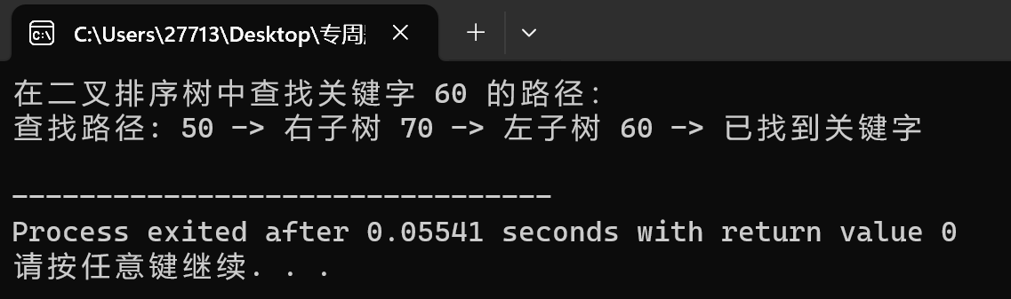
- 二叉树路径输出
#include <stdio.h>
#include <stdlib.h>
struct Node {
char data;
struct Node* left;
struct Node* right;
};
struct Node* createNode(char data) {
struct Node* node = (struct Node*)malloc(sizeof(struct Node));
node->data = data;
node->left = NULL;
node->right = NULL;
return node;
}
int printPath(struct Node* root, char target) {
if (root == NULL)
return 0;
if (root->data == target || printPath(root->left, target) || printPath(root->right, target)) {
printf("%c ", root->data);
return 1;
}
return 0;
}
int main() {
struct Node* r = createNode('A');
r->left = createNode('B');
r->right = createNode('C');
r->left->left = createNode('D');
r->left->right = createNode('E');
r->right->left = createNode('F');
char t = 'F';
printf("从根节点到叶子节点 '%c' 的路径是: ", t);
if (!printPath(r, t)) {
printf("'%c' 不是叶子节点\n", t);
}
free(r->left->left);
free(r->left->right);
free(r->right->left);
free(r->left);
free(r->right);
free(r);
return 0;
}
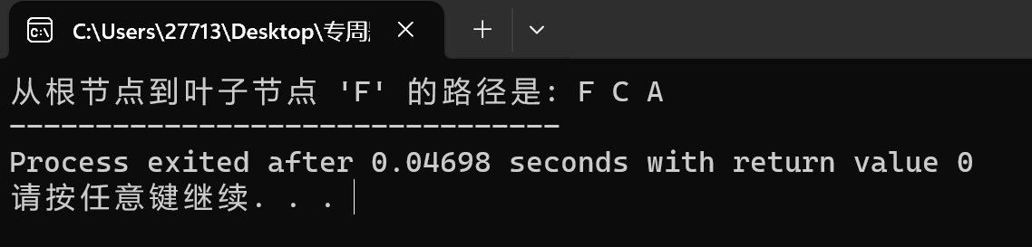
- 二叉搜索树中的范围和
#include <stdio.h>
#include <stdlib.h>
struct TreeNode {
int val;
struct TreeNode *left;
struct TreeNode *right;
};
struct TreeNode* createNode(int val) {
struct TreeNode* newNode = (struct TreeNode*)malloc(sizeof(struct TreeNode));
newNode->val = val;
newNode->left = NULL;
newNode->right = NULL;
return newNode;
}
struct TreeNode* insert(struct TreeNode* root, int val) {
if (root == NULL) {
return createNode(val);
}
if (val < root->val) {
root->left = insert(root->left, val);
} else if (val > root->val) {
root->right = insert(root->right, val);
}
return root;
}
int rangeSumBST(struct TreeNode* root, int low, int high) {
if (root == NULL) {
return 0;
}
int sum = (root->val >= low && root->val <= high) ? root->val : 0;
sum += (root->val > low) ? rangeSumBST(root->left, low, high) : 0;
sum += (root->val < high) ? rangeSumBST(root->right, low, high) : 0;

return sum;
}
int main() {
struct TreeNode* root = NULL;
root = insert(root, 10);
insert(root, 5);
insert(root, 15);
insert(root, 3);
insert(root, 7);
insert(root, 18);
int low = 7, high = 15;
int totalSum = rangeSumBST(root, low, high);
printf("范围内节点的总和为: %d\n", totalSum);
return 0;
}
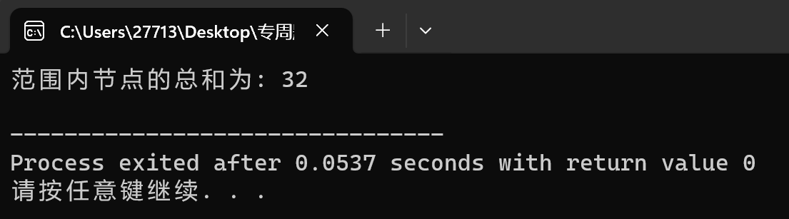

完成后需要提交的材料包括：
- 本文档
- 所有题目的代码.c或者.cpp。文件夹以学号+姓名的方式命名，里边的题目以A.1, A.2, B.4, C.4等方式命名。***同时请保留可执行的.exe文件，以方便教师验证。
- 给出
所有题目的github地址为：
- 所有程序及文档压缩包发QQ邮箱。
本人承诺，本报告系本人独立完成，没有成篇和成段的内容拷贝其他同学的成果。如有不实，除本报告按零分计外，愿意接受纪律处分。

（签字）

最终成绩

