- 查询全部产品信息：
192.168.1.114:18608/app/selectAppProduct
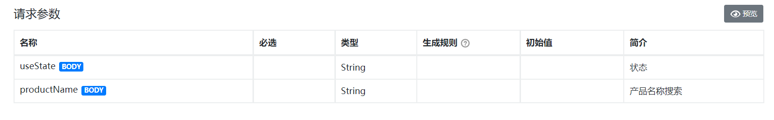
响应参数：
{
"code": "000000",
"data": {
"query": {
"appAccount": "后台账号",
"appLink": "后台链接",
"appPassword": "后台密码",
"applicationConditions": "申请条件",
"createTime": 1541492042000,
"id": 1,
"interestRate": "0.01%",
"isLocked": "0",
"linkType": 0,
"needMaterial": "所需材料",
"orderId": 1,
"pictureUrl": "图片地址",
"processHandle": "办理流程",
"productDetails": "产品详情",
"productIntroduction": "产品简介",
"productLink": "http://www.baidu.com",
"productName": "百度",
"productQuota": "1000",
"productType": 0,
"shortLink": "产品链接",
"timeLimit": "一年",
"useState": "0"
},
"count": 1
},
"message": "成功"
}

2、添加产品：
192.168.1.114:18608/app/saveAppProduct
请求参数：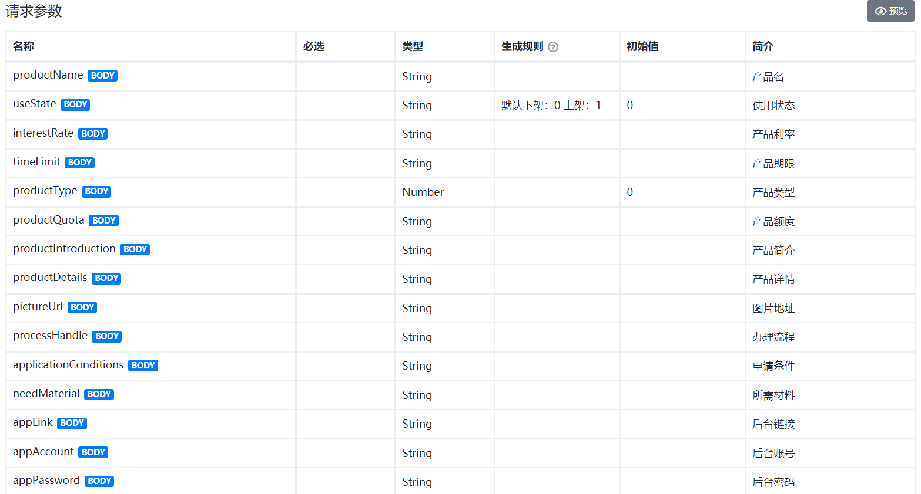
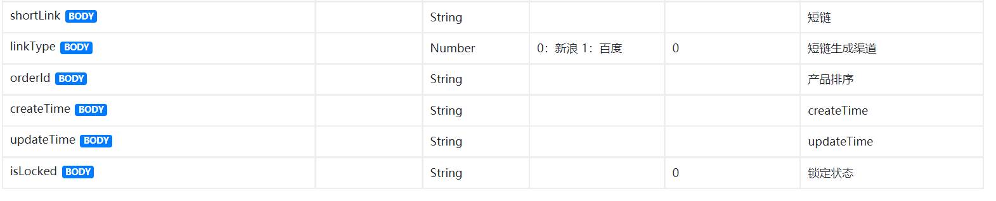
响应参数：
{
"code": "000000",
"message": "成功"
}

冻结产品：
192.168.1.114:18608/app/removeProduct

请求参数：
int id 产品id

产品上下架：

192.168.1.114:18608/app/groundingProduct

int id 产品id
int useState 上架或下架

