James Middleton Lab 2 Report

Aims
The aim of this laboratory was to become more familiar using digital oscilloscopes by investigating the frequency spectra of different types of waveforms using the Fast Fourier Transform (FFT) function of a digital oscilloscope. By analysing sinusoidal, square, amplitude-modulated (AM), and frequency-modulated (FM) signals in both the time and frequency domains, we gained insight into how information is represented and transferred through the frequency spectrum in communication systems.
This experiment connects directly to the principles of wireless communication, where information is transmitted by modulating the amplitude and/or frequency of carrier waves. Understanding the spectral composition of these modulated signals helps explain bandwidth requirements, filtering, and interference in real communication channels.
Method
Equipment used:
- Keysight DSO-X1102G/1202G Digital Oscilloscope
- Built-in Function Generator
- BNC cables and high-impedance (1 MΩ) connections
- USB stick for data capture
The function generator was connected to Channel 1 of the oscilloscope. The oscilloscope’s FFT (spectrum analyser) mode was used to display frequency-domain representations of signals. The main parameters used were:
Timebase: adjusted for 10–20 cycles on screen, FFT window: Hanning, Span: 10 kHz, Centre: 5 kHz, Scale: 5 dB/div, Offset: −40 dBV
Key signal types examined:
- Sinusoidal Wave (1 kHz, 200 mV p-p)
The FFT showed a single spectral peak at 1 kHz, corresponding to the fundamental frequency.
- Square Wave (1 kHz, 200 mV p-p, 50% duty)
The waveform was observed in both time and frequency domains, and the amplitudes of the first several harmonics were measured.
- Amplitude-Modulated (AM) Signal
A 1 kHz carrier was modulated with a 200 Hz signal at several modulation depths.
- Frequency-Modulated (FM) Signal
A 1 kHz carrier was frequency-modulated by a 200 Hz tone with various deviation values (100–500 Hz).
All FFT traces were exported as CSV files and analysed using Python to confirm observed frequency components.

Results

Base Reading: f = 1kHz, V = 200mV, unmodulated sine wave
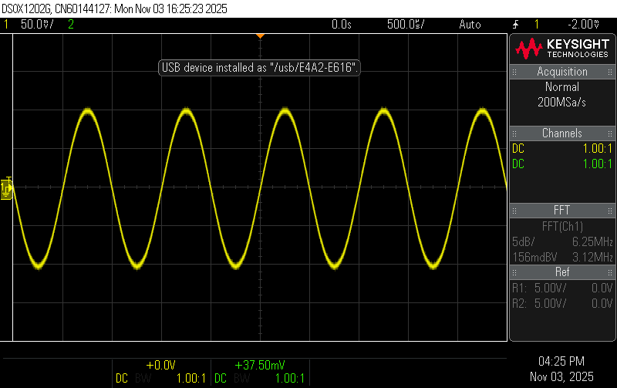
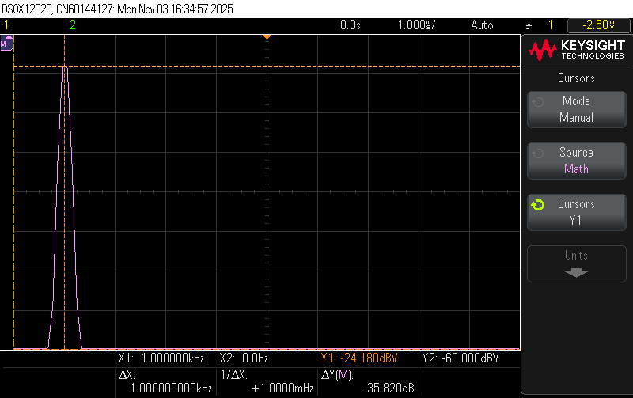

Sinusoidal Wave
The 1 kHz sine wave showed a single strong FFT peak at 1.00 kHz with an amplitude of −24.180 dBV, consistent with the 200 mV peak to peak. The FFT background noise was approximately −60 dBV, confirming a clean signal. This single-frequency spectrum represents an ideal unmodulated carrier used in communication systems.

Square Wave duty cycles: 50% and 25%
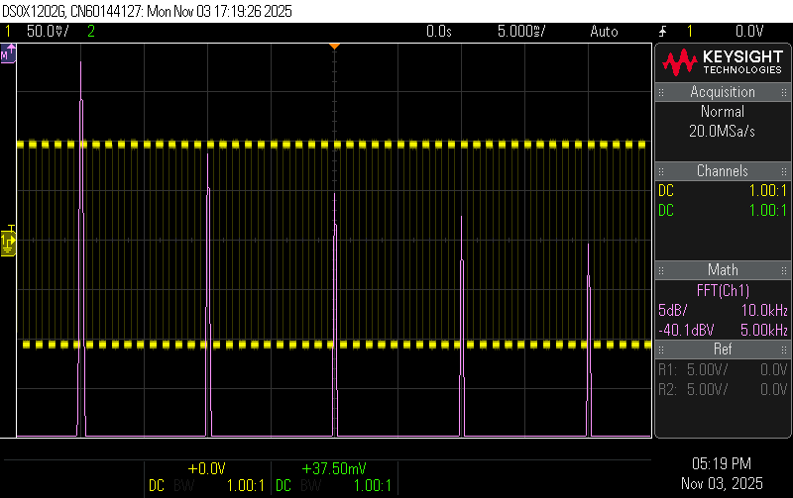
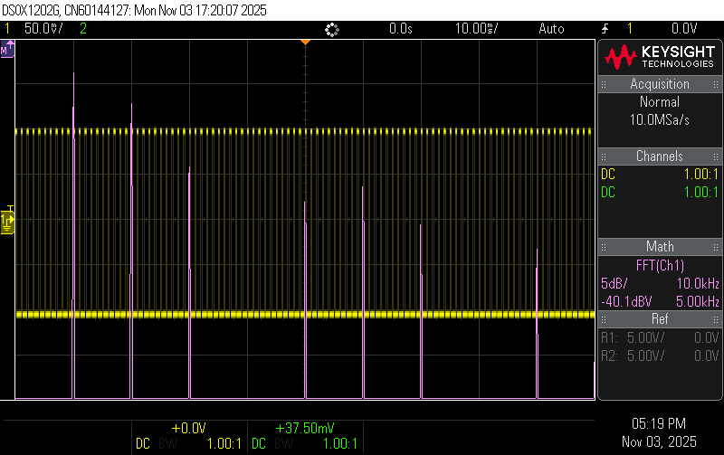

Square Wave
The FFT of the square wave displayed the expected odd harmonics (1 kHz, 3 kHz, 5 kHz, 7 kHz, etc.), decreasing in amplitude approximately as 1/n. Measured amplitudes were:
Frequency | Relative Amplitude (dBV) | Ratio to Fundamental (V2/V1)
1 kHz | −22.1 dBV | 0.63
3 kHz | −31.6 dBV | 0.47
5 kHz | −36.0 dBV | 0.4
7 kHz | −38.9 dBV | 0.35

When the duty cycle was reduced to 25%, even harmonics appeared and some odd harmonics were suppressed, showing how pulse width affects spectral content. This illustrates that waveform shape directly influences bandwidth.

Amplitude-Modulated Signal
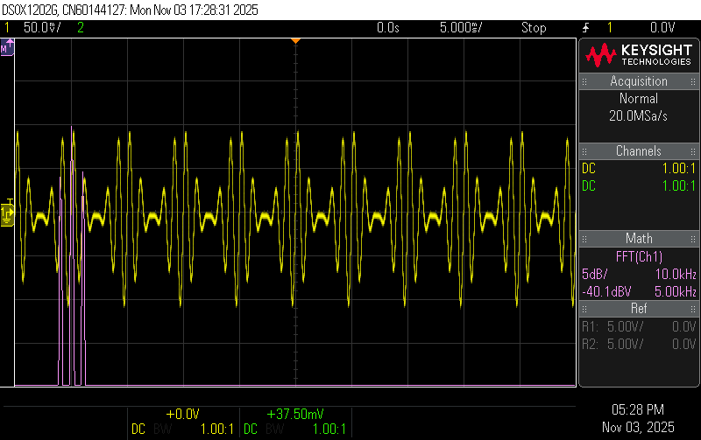
At 100% modulation depth with a 200 Hz modulating tone, three main peaks appeared:
- Baseband: -30dBV, 1kHZ
- Lower Sideband: -35.2dBV, 0.8kHz
- Upper Sideband: -35.2dBV, 1.2kHz

The sidebands’ amplitude difference (~5 dB below carrier) agrees with theoretical expectations for 100% modulation. Reducing modulation depth to 50% decreased sideband levels to around −40 dBV, which shows that sideband amplitude scales with modulation depth. Changing the modulation frequency shifted the sidebands closer or farther from the carrier but did not change their amplitude—confirming that modulation frequency determines sideband spacing, while modulation depth determines sideband magnitude.

Frequency-Modulated Signal
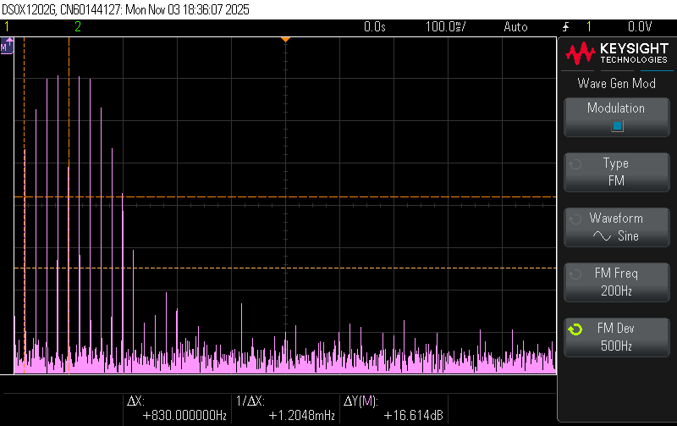
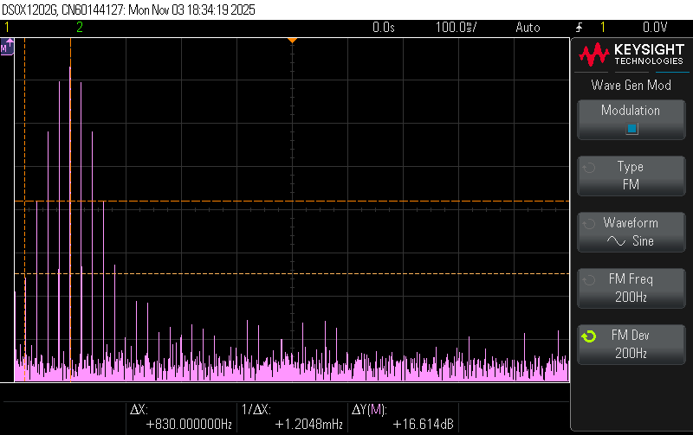

For an FM signal with 1 kHz carrier,200Hz modulating tone, and 200 Hz frequency deviation, the FFT displayed a central carrier peak and several sidebands spaced by 200 Hz. As the deviation increased to 500 Hz, additional sidebands appeared, and the signal bandwidth widened from roughly 1 kHz to 2.5 kHz.
Conclusion

This lab demonstrated how different waveform types and modulation schemes affect the frequency spectrum of a signal.
A pure sine wave produces a single spectral line.
A square wave generates a rich harmonic series, with bandwidth increasing as the waveform becomes more abrupt or non-sinusoidal.
AM introduces sidebands whose spacing equals the modulating frequency and whose amplitude depends on modulation depth.
FM produces multiple sidebands whose number and amplitude depend on modulation index, illustrating bandwidth expansion.
Through the oscilloscope’s FFT and subsequent analysis, the experiment reinforced the connection between time-domain signal characteristics and their frequency-domain representation.

