Communication Systems Tutorial 2

1. a) Radio Frequency Filter: To filter out desired input signals captured by the antenna
Intermediate Frequency Filter: To filter out desired frequencies from the modulated signal

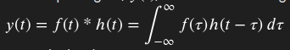
b) Convolution. Multiplying the equation of the frequency domain by the equation of the Impulse response. f(t) * h(t).

c) Synchronous Shift Keying: Uses one common or two synchronized clocks. Does not require start and end bits and communicates information continuously. The receiver knows when each bit starts and ends based on the clock signal. More intricate but more efficient.

Asynchronous Shift Keying: Does not require synchronized clocks. The transmitter send start and ends bits so the receiver knows when to start and stop reading the message. Less intricate but less efficient.

d) The Nyquist-Shannon theorem. A too short sample time may not allow you to capture a full wave cycle of a signal. Too few samples within the sample time will produce a discontinuous distorted signal (aliasing). You must have a sampling frequency that is double the highest frequency of the wave.

e) Synchronous receivers can produce phase shift keying, quadrature phase shift keying, and quadrature amplitude modulation because they can multiply the input phase wave by an quadrature modulator wave, producing a signal that can be both phase and amplitude modulated. Varying the phase (I) and Quadrature (Q) components.
values of I and Q can produce different forms of modulation.
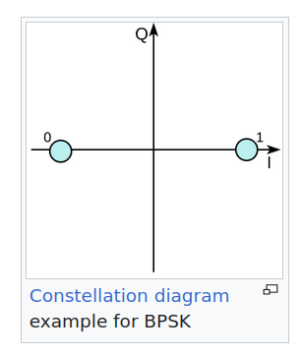
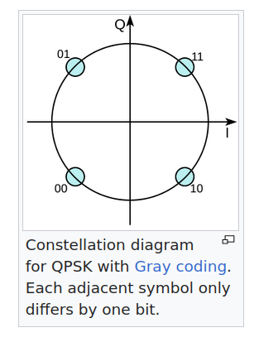
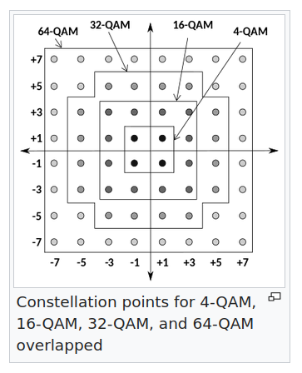

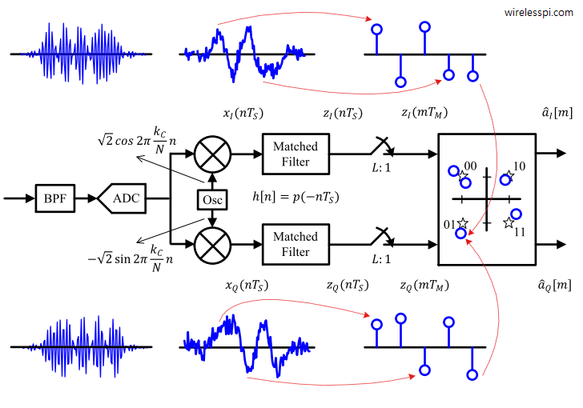

f)

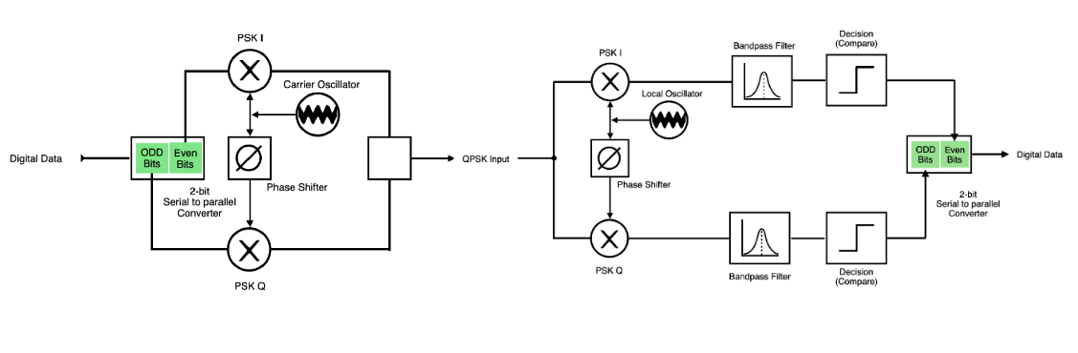
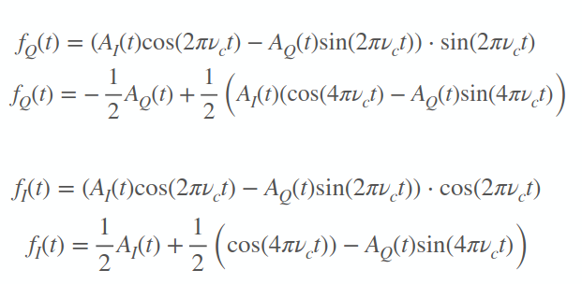

2. a)
Free-space path loss: Natural loss that is directly proportional to the distance between transmitter and receiver. Will increase SNR.
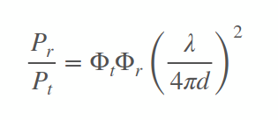

Slow-fading loss: Time-varying loss that is directly proportional to the distance between transmitter and receiver. Will change SNR with respect to time.

Fast-fading loss: Loss due to reflective objects near and around the transmitter. Can cause deep loss and increased bit error rate.
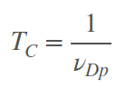

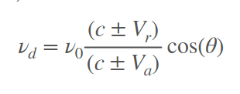
Channel Fading:
Compression or expansion of waves as they propagate from a moving object

Rayleigh Fading: Spectral broadening due to the Doppler effect

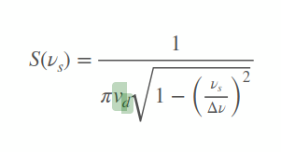

b) ***** LISTEN IN TUTORIAL

c)
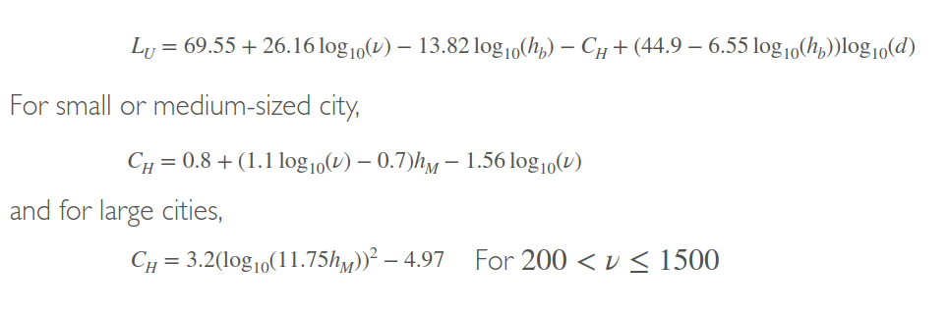
d = 2km
h = 80m

LU = 129.5dBm

d) G > 105.5/30

3. a)
Amplitude modulation: Simple but susceptible to noise

Frequency Modulation: More complicated but more reliable

Phase Modulation: Even more complicated and with no noticable improvement in audio signals. Used for WiFi and sattelite television.

I will use Frequency Modulation.

b)
v = 1,000kHz
L = 175.96dB
Dipole antenna. More stable ground and therefore better signal.

c) There could be unforeseen objects blocking the path between transmitter and receiver. 1,000kHz is a common frequency and could therefore be interfered with by other broadcasts. The system would require a powerful battery to amplify the signal over a distance as long as 50km so it could be impractical.

d)
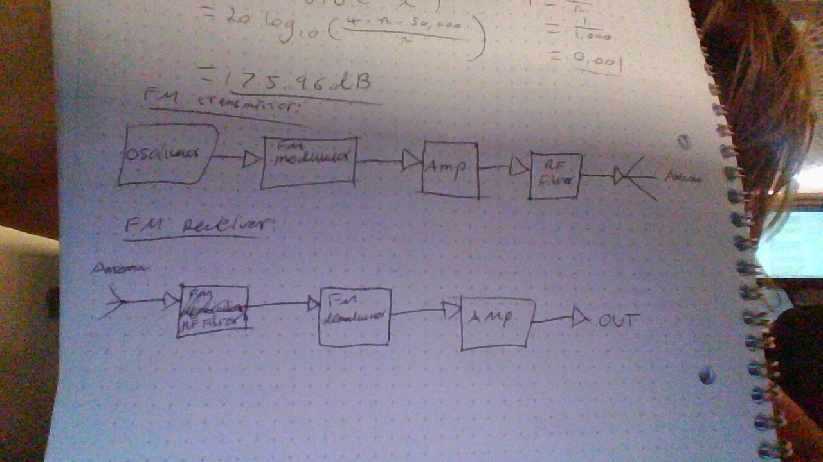
Must have a source for the original signal. Must modulate the carrier wave with said signal. Must filter the signal to make transmission smooth. Must amplify the signal for transmission over distance. Need an antenna to broadcast the signal.

Need an antenna to catch the signal. Need a filter to get rid of noise. Need an amplifier to make the signal easier to read. Need a filter to make the signal smooth. Need an amp to make sure the signal is strong at the output.

