# Изображения

## Привязка к параграфу, wrap off

'Can't Stop Feeling' first surfaced as one of the songs recorded at 'The Chateau' (Franz's earliest practice area) in 2003. It was tipped to be released as a single in 2004 but, as it didn't appear on the album [Franz Ferdinand](http://en.wikipedia.org/wiki/Franz_Ferdinand_(album)), was dismissed in favour of [Michael](http://en.wikipedia.org/wiki/Michael_(Franz_Ferdinand_song)). It was played live on few occasions on the bands early tours. The band played it once on their 2005-2006 world tour. It was then resurrected with different instrumentation in 2007 as the band road tested new songs for possible inclusion onto their 3rd album. After December 2007, it was dropped from their live performances. The song was finally released on the album [Tonight: Franz Ferdinand](http://en.wikipedia.org/wiki/Tonight:_Franz_Ferdinand) in 2009, again with different instrumentation and announced to be the albums 3rd single on May 20th 2009. The album/single version was given it's live debut on 3rd July of that same year, a mere 3 days before its release.

A music video was created for the song and uploaded on [YouTube](http://en.wikipedia.org/wiki/YouTube) on 1 July 2009 by the band's record label's official YouTube page.[[2]](http://en.wikipedia.org/wiki/Can't_Stop_Feeling" \l "cite_note-1)

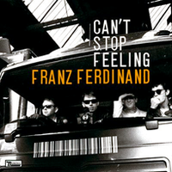

The video features all four members of the band. It shows the band in [Glasgow](http://en.wikipedia.org/wiki/Glasgow), [Scotland](http://en.wikipedia.org/wiki/Scotland) (the band's home city). It also features the band pushing the scenes away as they do so themselves.

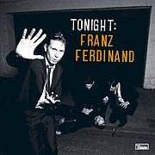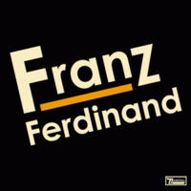

## Привязка к параграфу, page wrap

Rammstein is a German rock band from Berlin, formed in 1994. The band consists of members Till Lindemann (lead vocals), Richard Z. Kruspe (lead guitar and backing vocals), Paul H. Landers (rhythm guitar, backing vocals), Oliver "Ollie" Riedel (bass guitar), Christoph "Doom" Schneider (drums and electronic percussion) and Christian "Flake" Lorenz (keyboards). They are widely accepted as part of the Neue Deutsche Härte scene, alongside bands such as Oomph!, Eisbrecher, and Die Krupps. Their sound has been dubbed as Tanz-Metal (lit. "Dance Metal").[1][2][3] Their songs are usually in German, but they have also performed songs entirely or partially in other languages such as English ("Pussy", "Amerika", "You Hate", "Angel"; covers of Depeche Mode's "Stripped" and Ramones' "Pet Sematary"), Spanish ("Te quiero puta!"), French ("Amour" and "Frühling in Paris"), and Russian ("Moskau"). As of 2008, they had sold over 15 million records worldwide.[4] Rammstein's entire catalogue is published by Universal Music Group. Since its formation, Rammstein has had no changes in lineup.

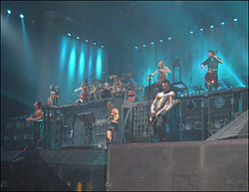

Rammstein takes their name indirectly from the German town of [Ramstein-Miesenbach](http://en.wikipedia.org/wiki/Ramstein-Miesenbach), the site of the [flight show disaster](http://en.wikipedia.org/wiki/Ramstein_airshow_disaster) on 28 August 1988. The band's signature song, "[Rammstein](http://en.wikipedia.org/wiki/Rammstein_(song))", is a commemoration of the [Ramstein airshow disaster](http://en.wikipedia.org/wiki/Ramstein_airshow_disaster). The second "m" in the band's name makes it translate literally as "[ramming stone](http://en.wikipedia.org/wiki/Battering_ram)" to convey the Teutonic sound of their music. In a short period before the band became well known, they performed using the name "Rammstein-Flugschau" (literally meaning "Rammstein-Airshow").

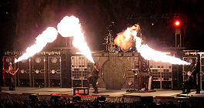

## Sapcing

Rammstein takes their name indirectly from the German town of Ramstein-Miesenbach, the site of the flight show disaster on 28 August 1988. The band's signature song, "Rammstein", is a commemoration of the Ramstein airshow disaster. The second "m" in the band's name makes it translate literally as "ramming stone" to convey the Teutonic sound of their music. In a short period before the band became well known, they performed using the name "Rammstein-Flugschau" (literally meaning "Rammstein-Airshow"). Rammstein takes their name indirectly from the German town of Ramstein-Miesenbach, the site of the flight show disaster on 28 August 1988. The band's signature song, "Rammstein", is a commemoration of the Ramstein airshow disaster. The second "m" in the band's name makes it translate literally as "ramming stone" to convey the Teutonic sound of their music. In a short period before the band became well known, they performed using the name "Rammstein-Flugschau" (literally meaning "Rammstein-Airshow").

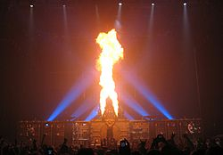

According to Kruspe, the on-stage wackiness is entirely deliberate (Rammstein's motto according to Schneider is: "Do your own thing. And overdo it!"). The aim is to get people's attention and have fun at the same time: "You have to understand that 99 percent of the people don't understand the lyrics, so you have to come up with something to keep the drama in the show. We have to do something. We like to have a show; we like to play with fire. We do have a sense of humor. We do laugh about it; we have fun... but we're not Spinal Tap. We take the music and the lyrics seriously. It's a combination of humor, theater and our East German culture, you know?"[19] Their onstage antics have also led them to trouble. During their stint on the American Family Values Tour 1998, alongside acts such as rapper Ice Cube, Korn, Limp Bizkit and Orgy, the band was arrested for indecency. In one of the more infamous moments, Rammstein's vocalist, Till Lindemann engaged in simulated sodomy with the keyboardist, Christian Lorenz, during their performance of "Bück dich" in Worcester, Massachusetts. They were subsequently arrested and fined $25 and spent one night in jail. The band attempted to appeal the fine, and spent more in legal fees and court fees than the $25 fine.

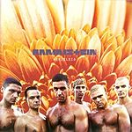

## Привязка к символу (to character)

The New York Times described Rammstein's music as a "powerful strain of brutally intense rock… bring[ing] gale-force music and spectacular theatrics together".[22] The members have not been shy about courting controversy and have periodically attracted condemnation from morality campaigners. Their stage act earned them a night in jail in June 1999 after a liquid-ejecting dildo was used in a concert in Worcester, Massachusetts. Back home in Germany, the band has faced repeated accusations of fascist sympathies because of the dark and sometimes militaristic imagery of their videos and concerts, including the use of excerpts from the film Olympia by Leni Riefenstahl in the video for the Depeche Mode song "Stripped". Their cover of their debut album Herzeleid, released in Germany in 1995, showed the band members bare-chested in a style that resembled Strength Through Joy in the eyes of some critics, who accused the band of trying to sell themselves as "poster boys for the Master Race".[23] Rammstein have vigorously denied this and said that they want nothing to do with politics or supremacy of any kind. Christian "Flake" Lorenz, annoyed by the claim, has remarked that it is just a photo, and should be understood as such. Herzeleid has since been given a different cover in North America, depicting the band members' faces.

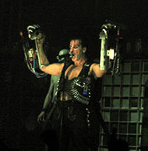

## As character

The lyrics of Rammstein and above all their utterance by singer Till Lindemann are an essential element of music and shape the perception by fans and a wider public. This is, among other things that are often very controversial, and taboo subjects such as sadomasochism ("Bück dich", "Rein Raus" and "Bestrafe mich"), homosexuality ("Mann gegen Mann"), intersexuality ("Zwitter"), incest ("Laichzeit" and "Spiel mit mir"), pedophilia ("Weißes Fleisch" and "Halleluja"), incestuous pedophilia ("Tier"), necrophilia ("Heirate mich"), pyromania ("Benzin" and "Hilf mir"), cannibalism ("Mein Teil"), religious images ("Asche zu Asche", "Engel") having sex and violence ("Wollt ihr das Bett in Flammen sehen?", "Rein Raus). Rammstein also uses lyrics of classical German literature, e.g. Johann Wolfgang von Goethe's famous poems Der Erlkönig (1778) and Das Heidenröslein (1771) for the songs "Dalai Lama" and "Rosenrot", respectively.[17]

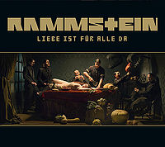

## Измененные размеры изображений

Rosenrot (German: "rose-red", listen) is the fifth album by German rock band Rammstein. It was released on October 28, 2005 in Germany, December 6, 2005 in Canada, and March 28, 2006 in the United States. A limited edition with a bonus DVD is also available. [1]

The album includes six songs artistically omitted from Reise, Reise. The album's first title was Reise, Reise Volume Two, but on August 18, 2005 the album was announced as Rosenrot.[2]

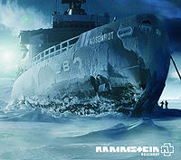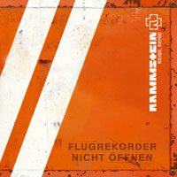

## Crop

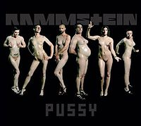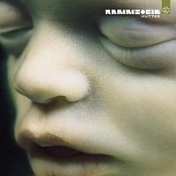

## Другие свойства

## Anchor to page

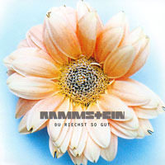

The video was directed by [Jonas Åkerlund](http://en.wikipedia.org/wiki/Jonas_Åkerlund) and was released online on [September 16](http://en.wikipedia.org/wiki/September_16), [2009](http://en.wikipedia.org/wiki/2009). The video features the band playing the song wearing leather outfits, interspersed with 6 pornographic videos featuring each of the band members as a different stereotypical pornographic character: Till as the Playboy, Christoph as the CEO, Paul as the Cowboy, Oliver as Mr. Pain, Richard as the Partyboy, and Flake as Heeshie (a hermaphrodite). Each scene features a band member engaging in foreplay with a different woman, and the scenes become more explicit until the end of the video everyone is having [sex](http://en.wikipedia.org/wiki/Sex) and the band members [ejaculate](http://en.wikipedia.org/wiki/Ejaculate). Several pirated copies of the video have since been uploaded to [YouTube](http://en.wikipedia.org/wiki/YouTube) and subsequently removed, due to YouTube's policy against adult material. The video can be viewed at <http://www.visit-x.net/rammstein>, where the video was officially released.