Q-3
1.
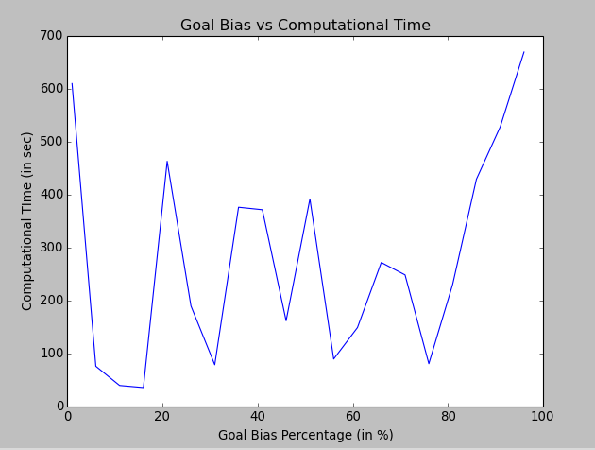
As the goal bias increases, the computational time also increases as the RRT algorithm will sample less random node and will always try to take goal as sample. It will try to move towards goals without exploring whole C-space. And hence the shape of the graph. The lowest computational time was around 36 second for goal bias of 16%.

2. The computed path is displayed in red. It was made sure that there is no collision and robot is able to achieve its desired position.
To check, comment the function shortcut_smooth and run the hw3.py script.

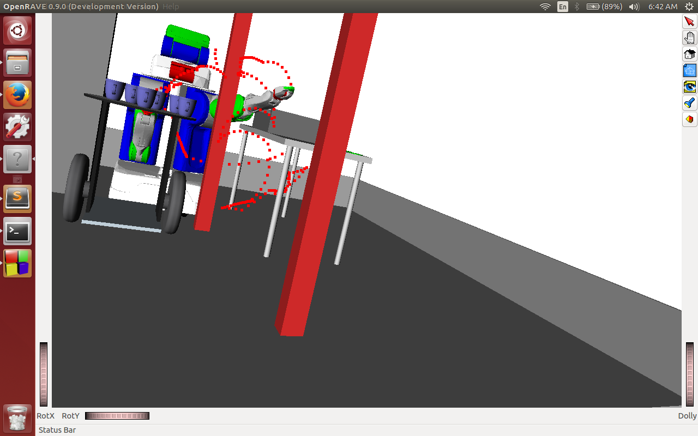
Q-4
Smoothened path

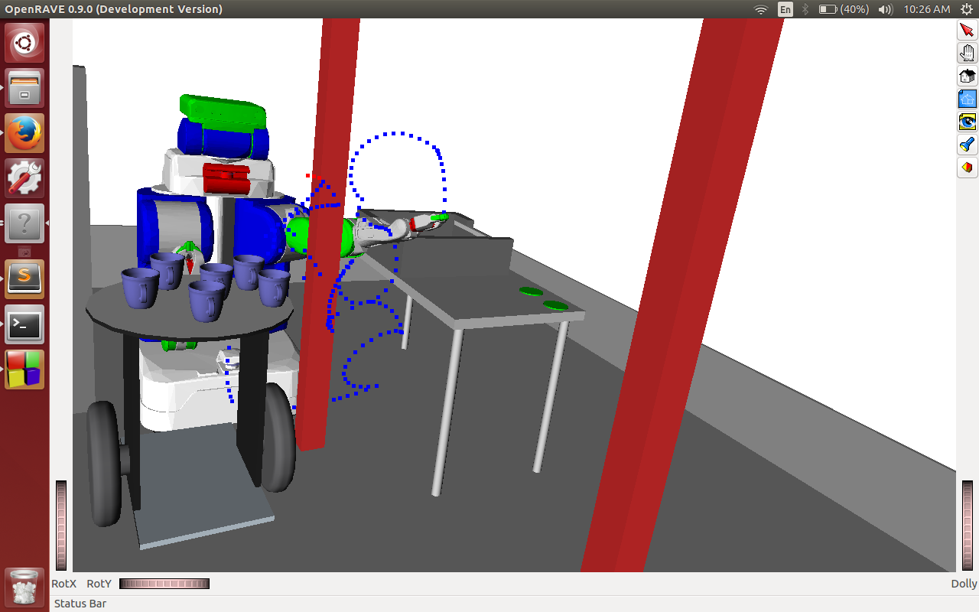

q-5
Time(s),Length of path,Number of nodes
249.702,166,3471,
500.45,167,3474,
751.703,167,3478,
1003.26,167,3479,
1256.07,167,3482,
1509.61,167,3491,
1763.46,167,3492,
2018.8,167,3497,
2274.47,167,3498,
2530.91,167,3500,
2793.55,167,3519,
3056.63,167,3520,
3320.21,167,3521,
3584.39,167,3523,
3849.03,167,3524,
4114.2,167,3527,
4383.49,167,3544,
4655.11,167,3550,
4929.88,167,3570,
5207.44,167,3580,
5485.26,167,3581,
5764.18,167,3586,
6043.51,167,3588,
6323.28,167,3591,
6604.24,167,3595,
6885.5,167,3596,
7167.11,167,3597,
7449.04,167,3599,
7731.55,167,3602,
8015.1,167,3605,

