LAB CA
Course Name: | DevOps | Semester: | VII
Date of Performance: | ___ / ___ / ______ | DIV/ Batch No:
Student Name: | Surabhi Khutal  Atharva Patil  Viren Rathod | Roll No: | 160101233068  16010124814  16010124817

DevOps Lab CA Mini Project Report

1 Title
ClearCSV CSV Data Quality and DevOps Application
Faculty: Prof. Smita Sankhe Academic year: 2026–2027

Abstract
ClearCSV inspects and cleans CSV files in the browser, preserves the original dataset and exports a cleaned copy. An optional Save run action sends only quality counts, a generated identifier and application version to a Fastify API. PostgreSQL stores this shared history; CSV rows, headers and filenames remain in browser memory.
The project combines React and TypeScript with three containerized service boundaries, controlled SQL migrations, readiness checks, persistent storage, tested backup restoration and explicit application rollback. Local verification passed 37 frontend and helper tests, 19 API tests, five PostgreSQL integration tests and 14 browser checks. This report explains the implementation and distinguishes demonstrated local results from configured three-host deployment. GitHub Actions verified and published both application images.

2 Problem Definition and Objectives

2.1 Problem statement
CSV exports often contain missing cells, repeated records and mixed numeric and text values. Manual repair can introduce unnoticed changes. ClearCSV exposes these issues before cleaning, lets users select operations, and keeps the original available for comparison. Shared summary history adds a useful durable record without storing the source files.

2.2 Project objectives
• Read valid UTF-8 comma-separated files, including quoted commas, escaped quotes, embedded newlines and a UTF-8 byte order mark.
• Report overall and per-column quality, then optionally remove duplicate rows and fill missing values using median or mode.
• Keep invalid numeric text and identifiers intact; allow inspection and CSV download even when history is unavailable.
• Validate and save explicit summary metadata through a small API with safe retry behavior and bounded recent history.
• Package independently replaceable frontend, API and database services with controlled migrations and persistent storage.
• Verify source, browsers, database behavior and containers before publishing release images; demonstrate restoration and rollback.

2.3 Scope and success criteria
The practical covers one local full-stack Compose application, an isolated local staging demonstration, and executable configurations for three Linux hosts. It includes a real migration tool and PostgreSQL restore assertions. Remote host deployment requires actual hosts, private networking, credentials and gateway controls. A passing local simulation or a published image is not evidence of a remotely running service.
No per-user accounts, server-side CSV parser, queue or Kubernetes cluster is required. The API is intended for trusted classroom users behind a VPN or authenticated gateway. CORS controls browser origin behavior and does not authenticate clients.

3 Requirements and Technology
Requirement | Implemented behavior
Accepted input | UTF-8 .csv with a header and at least one data row
Input limits | 5 MiB; 20,000 data rows; 100 columns; 250,000 cells
Preview | Eight rows per page; full accepted dataset analyzed
Cleaning options | Duplicate removal and missing filling independently optional
Original data | Preserved in transient React state throughout cleaning
Optional persistence | Shared summary counts and version only; CSV remains local
Service failure | History shows recovery controls; CSV clean and download still work

3.1 Selected toolchain
Technology | Pinned version or image | Role
React and React DOM | 19.3.0 | UI and state
TypeScript and Vite | 7.0.2 and 8.3.4 | Types and frontend bundle
Papa Parse | 5.7.0 | CSV parse and serialize
Fastify and CORS plugin | 5.12.7 and 11.3.1 | Metadata API
pg and node-pg-migrate | 8.23.1 and 9.0.0 | SQL access and migrations
Vitest and Playwright | 5.0.4 and 1.64.0 | Unit and browser checks
Node and pnpm | 24.x and 11.25.0 | Locked build toolchain
Database image | postgres:17.6-alpine | Durable metadata

package.json and pnpm-lock.yaml record exact package versions. The Node engine accepts >=24 <25; the Docker build pins Node 24.22.2 on Alpine 3.24. Frontend icons use Lucide React and fonts are self-hosted. Vercel remains a separate static frontend hosting option.

4 Browser CSV Processing

4.1 Reading and validation
validateFile() rejects wrong extensions, empty files and files above the byte limit. App.tsx reads File.arrayBuffer() and decodes with a fatal UTF-8 TextDecoder. Invalid encodings produce a readable error instead of silently substituting characters. parseCsv() removes an initial BOM and delegates comma-separated tokenization to Papa Parse with dynamic typing disabled.
Header names are trimmed and must be nonblank and unique. Each row must have exactly the header width. The parser applies the row, column and cell caps as well as the encoded byte cap. Physically blank lines are skipped, but explicitly quoted empty single-column records are retained. Whitespace-only cells normalize to an empty string; other nonempty values remain strings.
Function | Responsibility
parseCsv(text) | Return Dataset {headers, rows} or a clear validation error
analyzeDataset(dataset) | Return rows, columns, missing, duplicate and invalid counts plus per-column reports
cleanDataset(dataset, options) | Return a copied cleaned dataset, filledCells and removedRows
serializeCsv(dataset) | Return quoted CSV with CRLF separators and export protection

4.2 Quality analysis
A missing cell is empty after normalization. Duplicate rows count extra occurrences beyond the first, comparing the complete normalized row. A column is likely numeric when at least 80% of its nonempty values are finite decimal or scientific-notation numbers and none is a leading-zero integer identifier such as 001.
Hexadecimal, Infinity, currency strings and thousands separators are not interpreted as numeric values. Invalid numeric counts apply only to columns inferred as numeric; arbitrary text columns are not reported as numeric errors. This 80% inference is a documented heuristic, not a user-supplied schema or a business-rule validator.

4.3 Cleaning and Safe Export
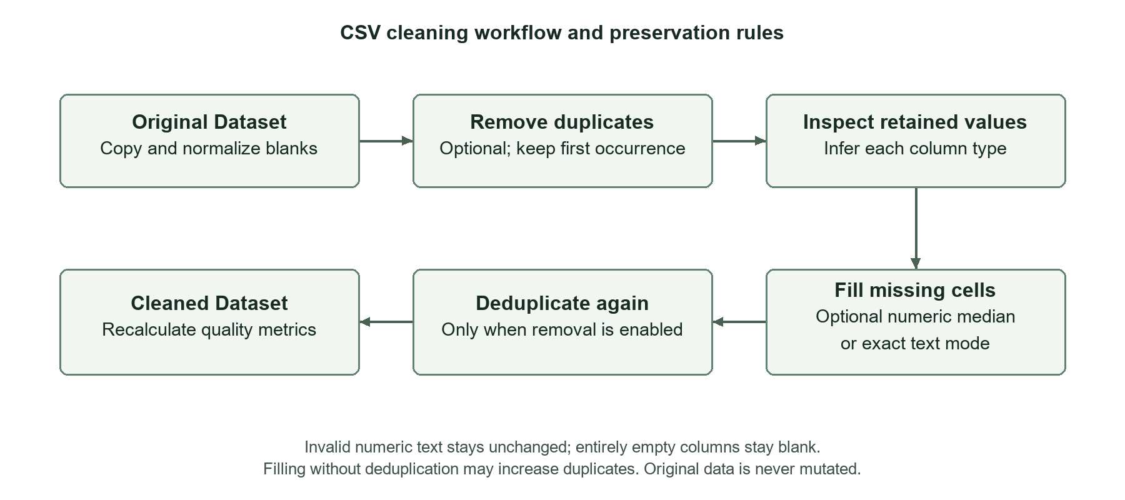
Figure 1. Optional cleaning creates a copy and preserves the original dataset.
When selected, duplicate removal retains the first occurrence before calculating replacement statistics. Numeric blanks use the median of valid numbers; text blanks use the most frequent exact value. A mode tie keeps the first value encountered. Entirely empty columns stay empty and invalid numeric text remains unchanged. A final deduplication pass removes duplicates created by filling only when removal is enabled.
Filling without duplicate removal may legitimately increase the duplicate count. filledCells counts replacements made, including cells in rows removed by the final pass; removedRows is the input-to-output row difference. Analysis is recalculated from the cleaned data, so the inferred type can change when the retained distribution changes.

4.4 Preview state and export
Original and Cleaned switch between paginated previews; a separate summary compares metrics side by side. Changing options or replacing the file invalidates stale cleaned results and downloads. An operation identifier prevents an earlier asynchronous file read from replacing a newer selection.
serializeCsv() quotes commas, quotes and embedded newlines; explicitly quotes empty cells; and adds no index column. Formula-like text and headers receive an apostrophe, including dangerous text preceded by whitespace or a leading tab, carriage return or newline. Valid finite numeric strings, including negative numbers, remain unchanged. The download handler adds a UTF-8 BOM, creates a Blob and later revokes its object URL. Median arithmetic uses floating point.

5 Three Service Architecture
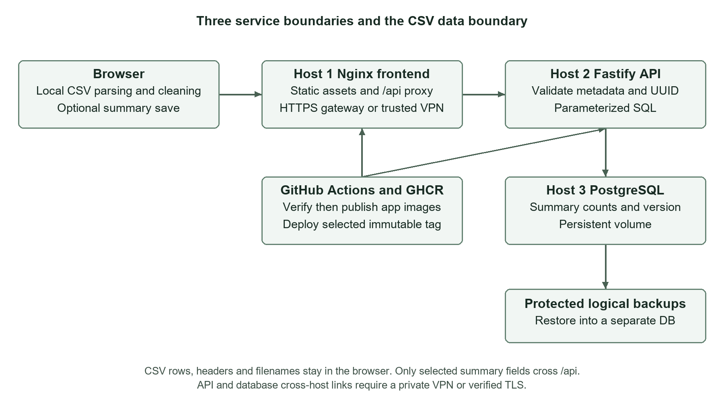
Figure 2. Source-derived three-tier design and optional metadata boundary.
The browser owns CSV parsing, quality analysis, cleaning and export. Nginx serves the built UI and proxies same-origin /api/ requests to the API. Fastify validates summary fields and uses parameterized pg queries. PostgreSQL stores the summary record and server timestamp. The migration command is a short-lived use of the API image, not a fourth image or a permanent fourth application service.
Local Compose connects frontend and API on the app network and API and PostgreSQL on an internal data network. PostgreSQL has no published local host port. Separate hosts instead require private routing: Docker bridge network names do not connect machines. Nginx uses the API host’s private hostname and port, while the API uses the database host’s private address.
GitHub Actions verifies the source and running stack. A trusted main or version push can then publish frontend and API images to GHCR. A separate manual deployment path selects an already published immutable tag and verifies the exact versions on configured hosts. Browser CSV contents do not enter this delivery or metadata path.

6 Optional Shared Run History

6.1 User workflow and data boundary
After Clean data succeeds, Save run becomes available when history is configured. It is an explicit optional action. createRunId() generates a UUID. createRunSummary() selects that ID, input/output rows, missing and duplicate counts before/after, and the frontend version. saveRun() reconstructs only those fields for JSON. It never includes filenames, headers, raw cells or the downloadable CSV.
The browser shows Saving, Saved or Retry save. A successful response inserts the saved row without duplicating its ID, while Refresh history reloads recent records. Stale refresh responses cannot overwrite newer results. History request failure leaves the CSV workflow usable and gives a recovery message. Reloading clears the transient CSV workspace but fetches saved summaries again.
Field | Source and meaning
id | Browser-generated UUID; retained for retry of that cleaned result
inputRows and outputRows | Dataset row counts before and after cleaning
missingBefore and missingAfter | Missing-cell quality counts
duplicatesBefore and duplicatesAfter | Extra repeated-row quality counts
appVersion | Frontend release version shown with the summary
createdAt | Timestamp assigned by PostgreSQL, returned by the API

6.2 Runtime and standalone configuration
Docker startup creates /config.json with apiUrl empty, historyEnabled true and the runtime APP_VERSION. Empty apiUrl means requests stay on the frontend origin and Nginx proxies them. API_UPSTREAM is a server-side hostname:port; it is not a browser address and must not include http://.
Without VITE_API_URL or enabled runtime history configuration, the standalone CSV application keeps history disabled. Optional VITE_API_URL and VITE_APP_VERSION override runtime values at build time. Vercel hosts only the frontend; enabling remote history there requires a separately hosted HTTPS API and an exact matching CORS_ORIGIN.

7 API Contract and Reliability
Endpoint | Observed contract
GET /health | 200 with status ok and version only when database and required schema respond; otherwise 503
GET /api/runs | Newest first by timestamp and ID; default 20, accepted limit 1 to 100
POST /api/runs | 201 new summary; 200 identical UUID retry; 409 same UUID with different metadata

7.1 Validation and retry correctness
The JSON schema requires all summary fields, rejects unknown properties and disables coercion. UUIDs are normalized to lowercase. Input rows must be 1 to 20,000; output rows cannot exceed input rows. Missing and duplicate counts must remain within their row and column bounds, and missingAfter cannot exceed missingBefore. appVersion is at most 100 characters from a restricted character set.
duplicatesAfter may exceed duplicatesBefore because filling with deduplication disabled can create repeated rows. The service enforces the output-row bound rather than incorrectly assuming duplicates always decrease. Fastify caps the request body at 4,096 bytes. Invalid JSON/schema returns 400, an oversized body 413, unsupported media 415, and unknown routes 404.
A parameterized INSERT uses ON CONFLICT (id) DO NOTHING. If a retry finds the same UUID, all stored metadata must match before returning the existing row. A conflict returns 409. This makes network retries idempotent without creating a second record or silently accepting changed data. PostgreSQL independently enforces table constraints.

7.2 Readiness logging and recovery
Readiness queries the required app_version column rather than merely opening a socket. Startup retries database/schema access within a bounded loop. Pool connection and query timeouts bound failures, and later requests reconnect after database recovery. Driver failures return 503 without SQL or credentials. Logs contain route, method, status and elapsed time, excluding bodies, identifying metadata and connection strings. SIGTERM and SIGINT trigger bounded graceful shutdown.

8 Database Schema and Controlled Migrations
processing_runs stores one UUID primary key, a server-generated timestamptz, six integer quality counts and app_version. A descending index on created_at and id supports stable bounded recent-history retrieval. Database checks mirror the row and count bounds. Parameterized SQL and strict API validation provide separate safeguards.
Migration | Up behavior | Down behavior
1761955200000 create processing runs | Create constrained table and recent-history index | Drop processing_runs and its data
1761955201000 add app version | Add nonnull varchar(100), default unknown for earlier rows | Drop version column; stored version values are lost

node-pg-migrate records applied steps in pgmigrations, uses a database lock and transactions, and makes repeated up runs a no-op when current. Migrations are reviewed commands, not side effects of every API start. The API image includes the migration runner and SQL files. Once released, a migration is retained unchanged and further evolution uses a new migration.
docker compose run --rm migrate
docker compose exec db psql -U clearcsv -d clearcsv -c 'TABLE pgmigrations;'
# With protected PG* configuration for the intended database:
pnpm build:api
pnpm db:migrate up

8.1 Guarded reversal demonstration
The runner refuses down unless ALLOW_DB_ROLLBACK is exactly disposable and the requested count is exactly one. The guard is an operator acknowledgement; it cannot detect valuable data. The demo creates a separate migration-test database, applies the first schema and inserts a row, adds the version column, backs up, reverses one step and reapplies it. Core counts survive, but the dropped version returns as unknown. Restoring the pre-down backup into another database recovers the original version. These are different outcomes, not equivalent recovery methods.
Application rollback should retain compatible additive schema and use forward fixes where possible. Reversing the first migration destroys the table. A required column disappearing also makes the current API unready until schema is restored.

9 Container Packaging and Local Topology
Image | Build and runtime behavior
Frontend | Node 24.22.2-alpine3.24 builds dist; nginxinc/nginx-unprivileged:1.30.6-alpine serves on 8080 as 101:101
API | Node 24.22.2-alpine3.24 builds dist-api; production dependencies and migrations copied into Node runtime; user node
Database | Official postgres:17.6-alpine; persistent postgres_data volume; pg_isready health check
Migration command | Same API image; one-shot migrate up; successful exit required before API startup

Both app Dockerfiles install the pinned pnpm version and use the frozen lockfile. The frontend runtime receives built static assets rather than the build toolchain. API runtime receives production dependencies, compiled server code and migration files. Build contexts exclude environment files, secrets, backups, dependency folders and generated evidence.
Local Compose waits for database health, migration success and API health before starting the dependent services. API containers have a read-only root filesystem and writable /tmp tmpfs. Both apps drop all capabilities and request no-new-privileges. The API port defaults to loopback 3000, frontend to loopback 8080; PostgreSQL stays inside the internal network.

9.1 Distinct health signals
Check | Meaning
/health on frontend | Nginx responds; does not by itself prove API/database readiness
/api-health via frontend | Proxy reaches API; database/schema must be ready
/config.json | Exact frontend appVersion, history enabled, same-origin apiUrl
API /health version | Identifies the expected API release as well as readiness
Container health state | Docker probe result; deployment also verifies live endpoint JSON

The frontend entrypoint validates APP_VERSION and API_UPSTREAM before producing JSON and proxy configuration. Nginx security headers restrict resource origins and framing. Its browser connection policy allows self because API requests use the same-origin proxy.

10 Local Setup and Reproduction
Prerequisites are Git, Node 24.x, pnpm 11.25.0 and Docker Engine with Compose v2.20 or newer. Windows uses Docker Desktop’s Linux engine. Run from the repository root and create the local password once. Keep .env and secrets outside version control; .env.example contains only defaults.
pnpm install --frozen-lockfile
Copy-Item .env.example .env
# Create once; do not overwrite an existing database password:
node -e "const f=require('node:fs'),c=require('node:crypto');
f.mkdirSync('secrets',{recursive:true,mode:0o700});
f.chmodSync('secrets',0o700);
f.writeFileSync('secrets/postgres_password',c.randomBytes(32).toString('hex'),
{mode:0o444,flag:'wx'});
f.chmodSync('secrets/postgres_password',0o444);"
docker compose build
docker compose up -d --wait --wait-timeout 180
pnpm test:containers
docker compose ps -a
The documented Node secret-generation command refuses to overwrite an existing file. Restrict the parent directory; the API’s mounted file must remain readable by its nonroot user. Compose secrets are file mounts in this setup, not an encrypted vault. Changing only the password file does not rotate an initialized PostgreSQL role.

10.1 Practical demonstration
Open http://127.0.0.1:8080, load sample data, clean and choose Save run. The result is 12 to 10 rows, six to zero missing cells and two to zero duplicate rows. Refresh the page: the source workspace resets but the saved summary remains. Verify db, api and frontend healthy and migrate exited with code 0.
curl.exe --fail http://127.0.0.1:8080/health
curl.exe --fail http://127.0.0.1:8080/api-health
curl.exe --fail http://127.0.0.1:8080/api/runs
# Preserve the metadata volume during ordinary shutdown:
docker compose down
docker compose up -d --wait --wait-timeout 180
This machine’s main stack uses API port 13001 because unrelated software already occupied 3000; that process was left running. Staging uses frontend 18080 and API 13000. Port overrides belong in .env; update CORS_ORIGIN when the frontend origin changes. Local frontend-only development uses pnpm dev on 5173 or pnpm build and pnpm preview on 4173.

11 Continuous Integration and Delivery
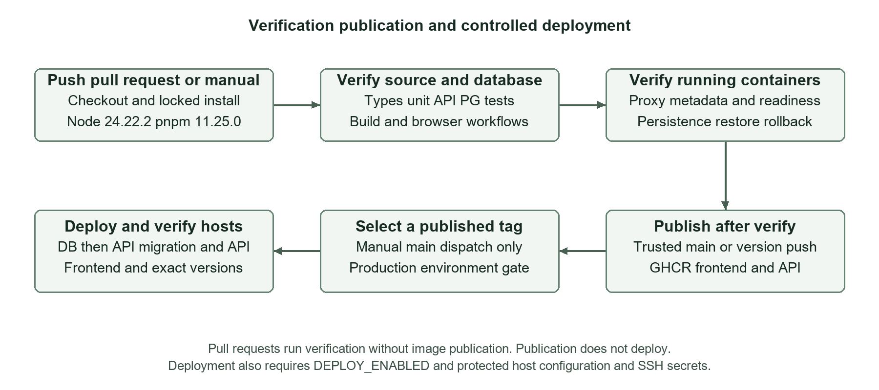
Figure 3. Verification gates publication and a separate controlled deployment path.
The workflow runs on push, pull request and manual dispatch. The verify job installs locked dependencies, typechecks both projects, tests CSV/helpers and API validation, runs deployment verifier/mocked flow tests, exercises real PostgreSQL integration, builds both outputs and runs browser workflows. It then migrates and starts a real API for live history browser checks.
Compose verification builds both app images, starts database/migration/API/frontend, checks proxy and exact JSON versions, saves and reads real metadata, rejects invalid summaries and verifies UUID retries. The isolated DevOps demo then proves persistence, restoration, outage recovery, controlled bad-release failure, application rollback and disposable migration reversal/recovery. Failed browser evidence is uploaded with limited retention; cleanup runs even after failure.

11.1 Publication and deployment gates
publish depends on verify and runs only for trusted main or version-tag pushes. It uses package write permission and GITHUB_TOKEN to publish frontend and API images to GHCR with sha followed by the full commit. Existing SHA images are reused; an existing release tag with different content is refused. A version tag must match package.json and descend from main.
deploy is separately enabled only on manual main dispatch with deploy selected, DEPLOY_ENABLED true and a production environment. It selects a published sha or version tag, uses verified SSH known hosts, runs database then API migration/API then frontend, and checks exact health/version data. Production environment protection depends on repository settings. Green verification or publication alone does not prove a host deployment.

12 Deployment Across Three Linux Hosts
Host | Service and port | Allowed inbound traffic
1 Frontend | Nginx 8080 behind HTTPS gateway | Authorized clients or trusted VPN
2 API | Fastify 3000 | Frontend private source address
3 Database | PostgreSQL 5432 | API private source address

Each x86_64 amd64 Linux host needs Docker, Compose v2.20+, Bash, curl, Python 3 and flock. Published CI images target amd64, not multiple architectures. Copy deploy/ and keep stable absolute checkout/configuration paths between releases. The manual script runs on its current machine; the configured GitHub job supplies SSH execution.
Prepare VPN/private DNS, Docker-aware firewall rules, protected env files, secret files and registry login before deploying. Default bindings are 127.0.0.1; API/database must be changed to their intended private interfaces for cross-host use. API_UPSTREAM is the private API hostname:port reached by Nginx. Compose service names do not resolve across separate machines.
# On database host, create the external volume once:
docker volume create clearcsv-postgres-data
bash deploy/remote-deploy.sh database /etc/clearcsv/database.env up
# On API host, explicitly apply reviewed schema before the app:
bash deploy/remote-deploy.sh api /etc/clearcsv/api.env migrate up
bash deploy/remote-deploy.sh api /etc/clearcsv/api.env up
# On frontend host, after the matching API is healthy:
bash deploy/remote-deploy.sh frontend /etc/clearcsv/frontend.env up
Each deployment pulls the explicit GHCR tag, waits for container health and checks the live endpoint and exact release. /config.json must identify the selected frontend tag with history enabled and empty apiUrl; /api-health must identify the matching API tag. The external database volume survives normal container replacement and Compose shutdown.
No three remote hosts were provisioned or contacted for the reported local evidence. The three role configurations parse successfully and deployment behavior is exercised with local command mocks; the remote infrastructure and access controls remain operator prerequisites.

12.1 Configuration Secrets and Network Controls
Setting group | Required configuration
Runtime and images | APP_VERSION must match the explicit FRONTEND_IMAGE/API_IMAGE tag; latest and untagged application images rejected
Host addressing | Bind private interfaces; API_UPSTREAM host:port; PGHOST/PGPORT; exact CORS_ORIGIN
Database access | PGDATABASE/PGUSER; password file on API and DB hosts with same value; never commit or print it
Transport | Encrypted private VPN or verified TLS between hosts; HTTPS and authentication gateway for clients
CI deployment variables | DEPLOY_ENABLED, DEPLOY_PATH and optional DEPLOY_ENV_DIR, default /etc/clearcsv
CI deployment secrets | SSH key, pinned known hosts, user/port and the three host addresses

Store each role env file outside Git under an operator-controlled directory. The script reads dotenv through Compose rather than sourcing it as a shell program. Environment variables override env files, so clear stale exported values before local deployment. API and DB secret files need the correct ownership/read access for their container users.
Private GHCR packages require least-privilege registry read credentials on application hosts. registry-login.sh uses password-stdin and a protected token file. Protect Docker’s saved credentials or use a credential helper. Never enable shell tracing around secrets. The deployment state files contain image references and versions, not credentials.
Restrict API 3000 to the frontend private address and PostgreSQL 5432 to the API private address. Docker-published ports can bypass ordinary UFW rules, so apply Docker-aware controls such as DOCKER-USER and verify denial from another host. Stock PostgreSQL Compose relies on the VPN; it does not provision database TLS. Where TLS is configured, use PGSSLMODE=verify-full and a trusted CA with a matching hostname.
CORS is not authentication, and this API has no user accounts or per-record authorization. Summary history is shared among trusted users. Browser origin checks, input validation and a small body cap reduce accidental misuse but do not substitute for the private network and authenticated access boundary.

13 Persistence Backup and Outage Recovery

13.1 Persistence and recovery procedure
A named volume preserves PostgreSQL data across container recreation. It is not a backup: deletion, corruption or host loss may affect it. The local demonstration records metadata, recreates the database container with the same volume, and verifies the same UUID afterward. It separately takes a pg_dump logical backup, restores into a fresh disposable database and asserts the original row and metadata.
For operator backups, protect the dump and copy it off the database host. On Windows, the documented Node wrapper captures bytes directly, avoiding older PowerShell text-redirection encoding changes. For actual recovery, pause writes, restore to a new database, compare expected IDs/counts, then deliberately repoint the API. Retain the old database until recovery is accepted.
# Bash commands; restore only into a NEW disposable database:
mkdir -p backups && chmod 700 backups
docker compose exec -T db pg_dump -U clearcsv -d clearcsv \
--no-owner --no-privileges > backups/clearcsv.sql
docker compose exec db createdb -U clearcsv clearcsv_restore_test
docker compose exec -T db psql -U clearcsv -d clearcsv_restore_test \
-v ON_ERROR_STOP=1 --single-transaction < backups/clearcsv.sql
docker compose exec db psql -U clearcsv -d clearcsv_restore_test -c \
'SELECT id,input_rows,output_rows FROM processing_runs;'

13.2 Failure and recovery behavior
Stopping PostgreSQL in the isolated staging demo makes API readiness return 503 while Nginx continues serving the application. CSV processing and export remain local and usable; summary save/history displays an unavailable state. Restarting PostgreSQL restores API readiness and the existing summary becomes readable without discarding the volume.
Troubleshooting separates frontend /health, proxied /api-health and runtime version JSON. Check DNS/VPN reachability, Docker-aware firewall rules, secret readability, credentials and migration state before replacing data or relaxing bindings. Logs exclude request bodies and database driver messages; still redact application data before sharing diagnostics.

14 Release Rollback and Database Recovery
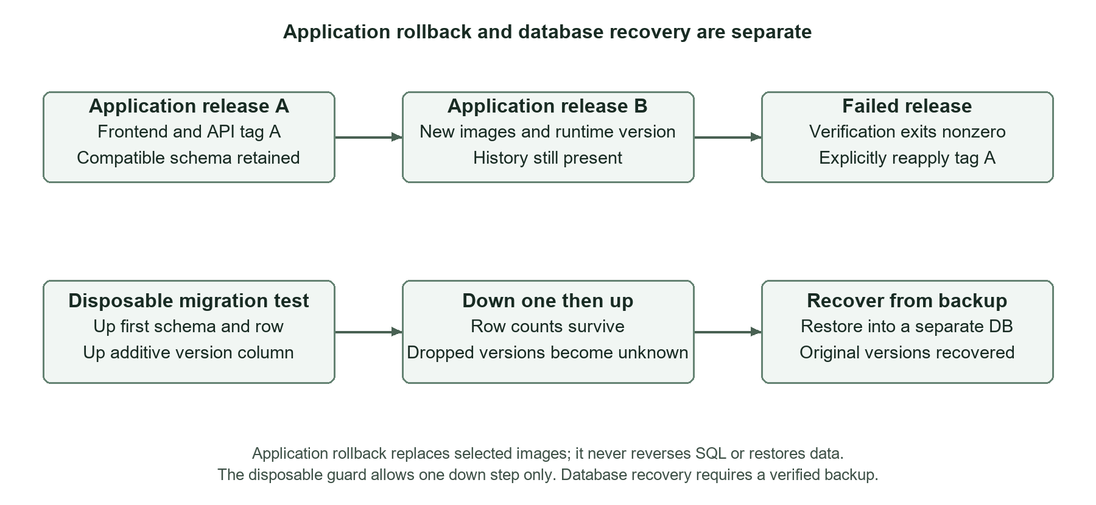
Figure 4. Image rollback retains compatible schema; data recovery uses a verified backup.
The actual staging sequence deploys 1.0.0-demo.1, saves a summary, upgrades app images to 1.0.0-demo.2 and saves another summary. A deliberately bad API exits with code 42 and fails verification. The script explicitly reapplies release 1 and checks its frontend/API versions; both summary records remain. A failed release is reported as failure, not hidden by an automatic rollback.
remote-deploy.sh rollback uses the image and APP_VERSION in the supplied reviewed env file. It does not guess a previous tag, reverse migrations or restore data. current-release and previous-release retain verified local image/version references. Schema compatibility must be assessed before applying an earlier application image.
# On API host then frontend host, using reviewed release A files:
bash deploy/remote-deploy.sh api /etc/clearcsv/api-release-a.env rollback
bash deploy/remote-deploy.sh frontend /etc/clearcsv/frontend-release-a.env rollback
# Verify /api-health, /config.json and the same history UUIDs.
The separate migration demo uses clearcsv_migration_test and clearcsv_recovered_test, not the running metadata database. Down one removes app_version; up adds it back with unknown. Only restoration from the pre-down backup recovers the earlier version values. This demonstrates the limit of reversible schema: reapplying SQL cannot recreate discarded data.

15 Verification Strategy and Observed Results
Verification combines pure processing cases, API validation/outage cases, real PostgreSQL tests, browser actions, running-container checks and an isolated release demonstration. Local checks were completed on 1 November 2026. No line-coverage percentage is claimed. Counts below distinguish individual tests from grouped smoke/demo assertions.
Check | Observed local result
Frontend and helpers | 37 passed: original 32 CSV cases and five history helpers
API validation and failure behavior | 19 passed
Real PostgreSQL integration | 5 passed with fresh disposable schemas/container
Desktop and mobile browser suite | 14 passed with real API save and reload enabled
pnpm check | Both typechecks, frontend/API tests and both production builds passed
Container smoke | Proxy/config/readiness, save/read, idempotent retry and invalid input passed
Isolated DevOps demo | All nine assertion groups passed
Deployment JSON verifier | 4 tests passed
Deployment shell checks | Syntax and mocked success/failure/rollback/guard flows passed
Configuration and workflow lint | Three remote Compose roles validate; actionlint 1.7.7 passed

Playwright uses Chromium at desktop 1440 × 1080 and the installed iPhone 13 profile, 390 × 664. Browser concurrency is bounded to two after an initial highly concurrent run hit the API connection timeout. All 14 checks passed on the bounded rerun and again against rebuilt final images. Test assertions were retained.
Regression cases cover case-insensitive UUID retry normalization and valid duplicate increases after filling without deduplication. Runtime inspection confirmed API user node, frontend 101:101 and no local PostgreSQL host port. Generated secrets, backups and demo state are ignored and were not included in source delivery.

15.1 Concrete Staging Evidence and CSV Results
The isolated Compose project clearcsv-disposable-demo recorded its final local assertions at 2026-11-01T18:20:34.736Z. Its results file identifies release 1 after rollback and records remoteDeploymentTested false. The following UUIDs were verified after database recreation, release replacement and application rollback.
Record | Actual identifier
Release 1 summary | 48105b40-7b23-4852-a3c0-ad3a34975f9b
Release 2 summary | 396b3c9d-c613-43c4-aaa3-999da660e8c5

The nine grouped assertions prove release readiness/storage, nonroot users, volume persistence, dump/restore, outage/recovery, release 2 versioning, bad-release failure, release 1 rollback with both rows, and separate migration down/up plus backup recovery. The actual assertion record is retained locally in ignored .devops-demo/results.json; protected SQL backups are not committed or uploaded.

15.2 CSV functional results
Dataset | Rows before after | Missing before after | Duplicates before after | Invalid before after
Built-in sample | 12 / 10 | 6 / 0 | 2 / 0 | 0 / 0
Student sample | 14 / 12 | 5 / 0 | 2 / 0 | 1 / 1
Large student CSV | 5,000 / 4,500 | 898 / 0 | 500 / 0 | 176 / 159

With both options enabled, the sample fills age with median 33, salary with 66,000 and department with Engineering. City modes tie and Bengaluru wins by first appearance. The small student file fills age with 21.5 and score with 84.5 while absent remains flagged. The large file has ten columns and about 416 KB; 500 rows are removed and 807 cells filled. Its original missing count includes gaps in removed duplicates. Invalids fall only because duplicate rows are removed; invalid text itself is preserved.
The following retained CSV screenshots document the unchanged functional processing workflow. They precede the history enhancement and support the displayed CSV metrics, rather than the new service topology. The current history and CI evidence follows separately.

16 CSV Functional Screenshots

16.1 Built in sample before cleaning
The built-in synthetic sample has 12 rows, five columns, six missing cells and two extra duplicate rows. Amber cells identify gaps and Column quality shows per-column counts. All accepted rows are analyzed while the preview shows eight at a time.
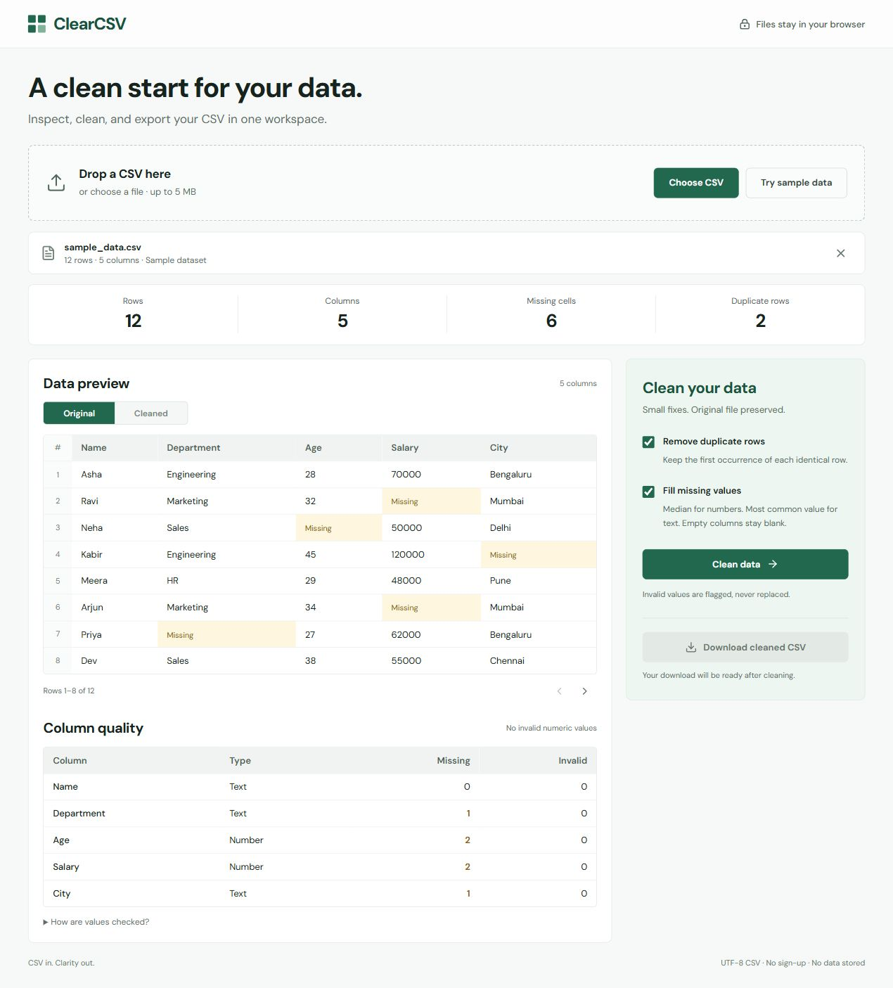
Figure 5. Retained local CSV capture of original sample metrics before cleaning.

16.2 Built in sample after cleaning
Both options produce ten rows, no missing cells and no duplicates. The side-by-side metrics retain the original counts, while Original and Cleaned select separate previews. The download control exports the cleaned copy.
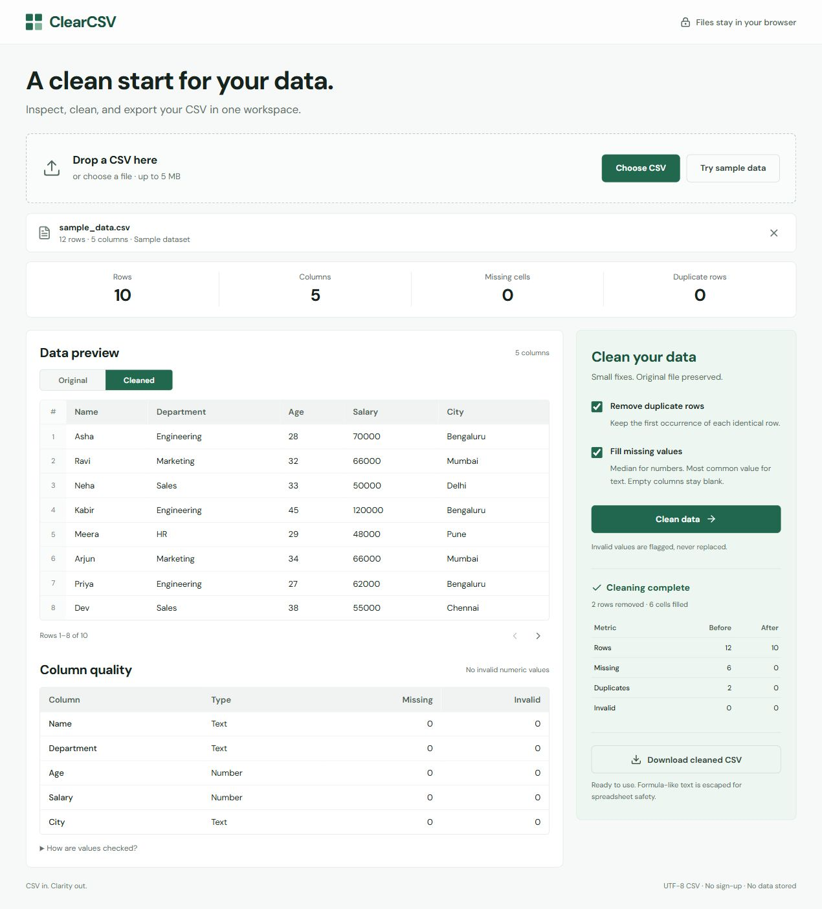
Figure 6. Retained local CSV capture showing sample comparison and cleaned preview.

16.3 Large CSV before cleaning
The 5,000-row, ten-column dataset fits every input limit. Analysis reports 898 missing cells, 500 duplicate rows and 176 invalid numeric cells. Pagination limits rendered rows without reducing the dataset used for analysis.
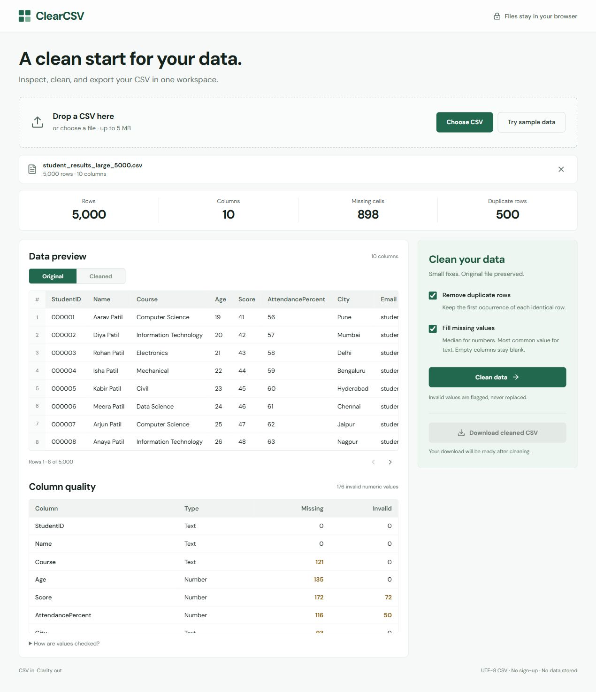
Figure 7. Retained local CSV capture of the large original dataset and quality issues.

16.4 Large CSV after cleaning
The result contains 4,500 rows with no missing cells or duplicates. The 159 remaining invalid numeric values stay available for manual review. This behavior preserves text whose intended correction cannot be inferred safely.
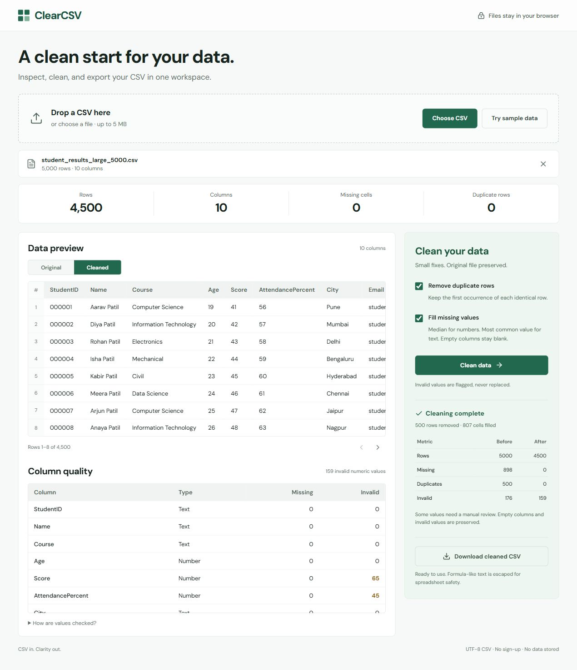
Figure 8. Retained local CSV capture of 500 rows removed and 807 cells filled.

17 Current History and Runtime Evidence
The current full-stack interface exposes optional Save run, Refresh history and the runtime release version. A saved record contains summary counts only. Refreshing the browser clears its source workspace while the shared record is fetched again from PostgreSQL through the API.
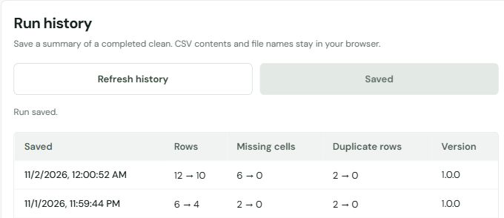
Figure 9. Cropped actual history panel showing Save run success and its first two rows.
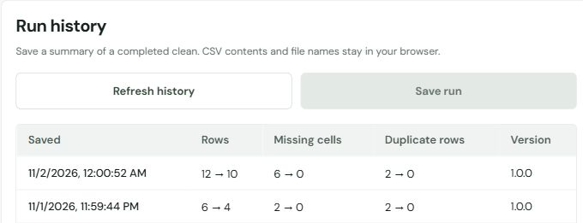
Figure 10. Cropped actual panel after reload retains the same rows; Save run is disabled.
Runtime surface | Verified configuration
Main full stack | Frontend 127.0.0.1:8080; API 127.0.0.1:13001
Isolated staging | Frontend 127.0.0.1:18080; API 127.0.0.1:13000
Staging final release | 1.0.0-demo.1 after explicit app rollback
Persistent state | Both actual release UUIDs remain in PostgreSQL

18 GitHub Actions and Registry Evidence
GitHub Actions run 41336945319 succeeded on main. Verification and GHCR publication completed for the tested enhanced implementation below.
Evidence | Observed GitHub result
Tested source commit | da2caaa24b447cc5166af4e61a3d7b0cd84afcf5
Verification job | Success: 37 frontend/helper, 19 API, 5 PostgreSQL and 4 deployment JSON tests
Browser workflows | 12 static plus 2 live API history checks passed
Running stack and staging | Container smoke and all nine DevOps assertion groups passed
GHCR publication | Success: immutable frontend and API images pushed
Production host deployment | Skipped by the separate manual deployment gate
Vercel repository status | Success for this commit; frontend hosting only

Open the current GitHub Actions run
Published GHCR repositories:
ghcr.io/27athsp/lab-ca-devops-frontend
ghcr.io/27athsp/lab-ca-devops-api
Tag for both: sha-da2caaa24b447cc5166af4e61a3d7b0cd84afcf5
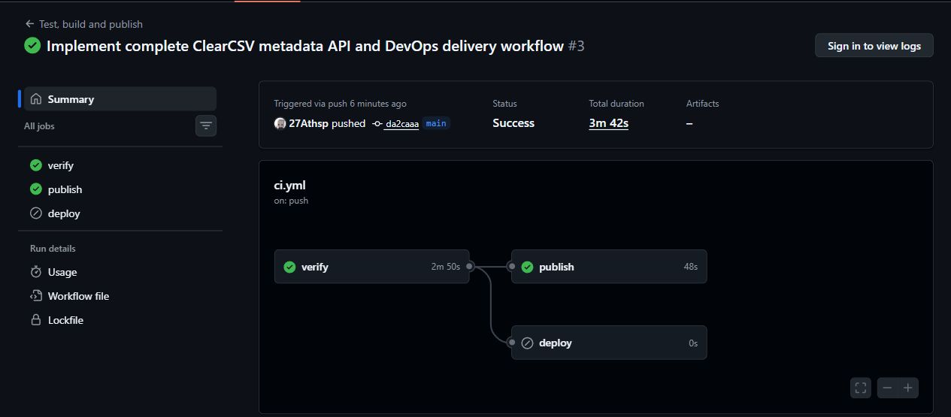
Figure 11. Cropped actual run summary showing successful verify and publish jobs.
The run completed on 1 November UTC, 2 November 2026 in India. Remote deployment was skipped. Two managed-action Node20 warnings and two Ubuntu runner notices were nonblocking; application builds use Node24.
Vercel reports frontend-only success. No remote API or database hosting is established; the live website was not opened during verification.

19 Limitations Future Scope and Conclusion

19.1 Current limits
• UTF-8 comma-separated CSV only; no XLSX, TSV, JSON, date schemas, outlier detection or domain validation.
• 5 MiB, 20,000 rows, 100 columns and 250,000 cells; processing uses the browser main thread.
• Numeric type inference is heuristic. Empty columns stay blank, invalid numeric text is retained, and medians use floating-point arithmetic.
• The original and cleaned CSV exist only in browser memory; saved history cannot reconstruct a source file.
• Shared history has no per-user authentication or authorization, retention policy or pagination beyond the bounded recent list.
• Three-host scripts need real infrastructure and access controls; the local evidence does not establish remote production availability.

19.2 Useful extensions
Next steps can add explicit per-column schemas, user-selected fill strategies, Web Worker processing and carefully scoped XLSX support. Remote use should first implement the intended authenticated gateway, tested firewall/VPN rules, protected credentials and off-host backup retention. Per-user access or sensitive metadata would require application authentication and authorization. Measured coverage and enforced repository checks can strengthen release review.

19.3 Conclusion
ClearCSV preserves a complete browser CSV inspection, cleaning and safe-download workflow while adding optional durable summary history. The service boundary stores only metadata and leaves the CSV in the user’s browser. Correct sample and 5,000-row results show the distinction between missing-value filling, duplicate removal and invalid text preservation.
The enhanced practical supplies pinned frontend/API/database images, controlled SQL migrations, readiness and version checks, gated CI publication and executable three-host deployment. Actual local tests demonstrate persistent data, verified restoration, outage recovery and explicit image rollback. Reversible schema and recoverable data are treated separately, making the demonstrated DevOps behavior precise and repeatable.

Appendix A Verification and Demonstration Commands
pnpm check
pnpm test:db
pnpm exec playwright install chromium
pnpm test:e2e
# Against the running full stack in PowerShell:
$env:HISTORY_E2E='true'
$env:E2E_BASE_URL='http://127.0.0.1:8080'
pnpm test:e2e
Remove-Item Env:HISTORY_E2E,Env:E2E_BASE_URL
pnpm test:containers
node scripts/devops-demo.mjs
# Remove only the disposable staging project when no longer needed:
node scripts/devops-demo.mjs cleanup
pnpm test:db creates a random-name password-protected PostgreSQL container on a random loopback port and removes its own fixture. Existing disposable test databases can use pnpm test:integration with protected PG settings; the database name guard requires _test. Ordinary static browser runs skip the live API cases unless explicitly enabled.
# Linux checks for deployment tooling; these do not contact hosts:
python3 -m unittest discover -s deploy -p 'test_*.py'
bash -n deploy/remote-deploy.sh deploy/registry-login.sh
bash deploy/test-remote.sh
# Only against an explicitly disposable DB with protected PG settings:
ALLOW_DB_ROLLBACK=disposable pnpm db:migrate down 1
pnpm db:migrate up
Source area | Responsibility
src/lib/processor.ts | CSV parser, analyzer, cleaner and serializer
src/lib/history.ts and RunHistory.tsx | Configuration, summary selection, retry and history UI
api/ and migrations/ | Fastify service, database pool, runner and SQL
compose.yaml and docker/ | Local services, runtime config and same-origin proxy
deploy/ | Three-host role configs, guarded deploy/rollback and verification
scripts/ and tests/ | Containers, disposable DB/staging and browser/unit assertions

Appendix B Viva and References
Viva question | Concise answer
Why three services? | Separate UI delivery, metadata validation and durable storage so each can be replaced independently.
Is CSV uploaded? | No. Only selected summary counts, UUID and version are sent after Save run.
Is a named volume a backup? | No. It survives container replacement; an independent dump and tested restore provide recovery.
What does readiness prove? | The API can query its required schema; version JSON also identifies the selected release.
Why keep migrations separate? | Schema changes need controlled execution and failure reporting before server replacement.
What does rollback undo? | Selected app images. It does not undo SQL or recover lost data.
Does CORS secure shared history? | No. Private networking and authenticated trusted access establish the deployment boundary.
Does green CI prove remote deployment? | No. Host health, exact runtime versions and data checks must also pass on the actual hosts.

References
Project source and reproduction guide https://github.com/27Athsp/LAB-CA-DEVOPS
DevOps demonstration evidence guide https://github.com/27Athsp/LAB-CA-DEVOPS/blob/main/docs/DEVOPS_DEMO.md
Three host deployment guide https://github.com/27Athsp/LAB-CA-DEVOPS/blob/main/docs/THREE_HOST_DEPLOYMENT.md
React documentation https://react.dev/
Fastify documentation https://fastify.dev/docs/latest/
PostgreSQL backup and restore documentation https://www.postgresql.org/docs/17/backup.html
Docker Compose documentation https://docs.docker.com/compose/
ClearCSV frontend website https://lab-ca-devops.vercel.app/

