Laboratory Exercise 5

# INTRODUCTION TO JAVASCRIPT

|  |  |  |  |
| --- | --- | --- | --- |
| **Name:** | PETER MILES ANTHONY L. LAPORRE | **Date:** | 09/15/2023 |
| **Program:** | B.S. IN COMPUTER ENGINEERING | **Section:** | A361 |

**Intended Learning Outcomes:**

1. Create output with JavaScript.
2. Utilize JavaScript variables and data types.

Using your output from Laboratory Task 4, include a button/check box/radio button/toggle switch that

will change your website into

**DARK MODE**

. Here is an example output:

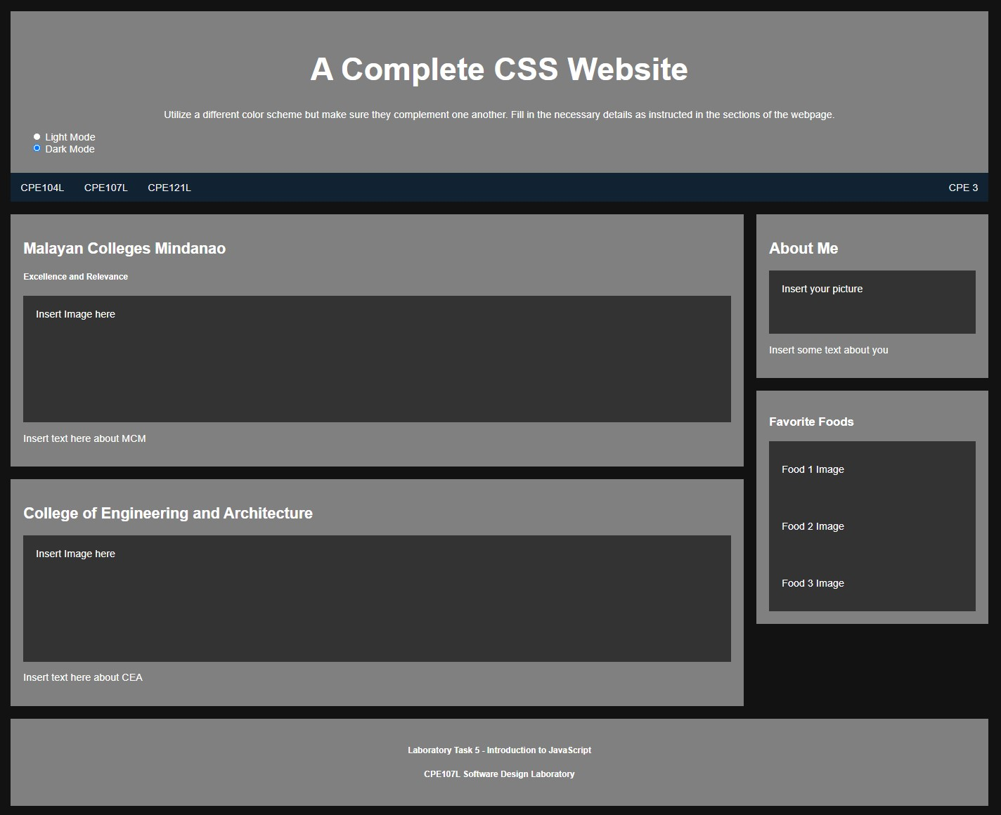

**CPE143**

**L**

**Web Design and Development**

================================================================================

**HTML Source Code:**

<!-- Name: Peter Miles Anthony L. Laporre -->

<!-- Course: Bachelor of Science in Computer Engineering -->

<!DOCTYPE html>

<html>

    <!-- linking CSS file to HTML file-->

    <head>

        <link rel = "stylesheet" href = "task4style.css">

        <title> Laboratory Task 4 - A Complete CSS Website </title>

    </head>

    <body>

        <header>

            <!-- import javascript file -->

            <script src = "javaFile.js"></script>

            <h1> A Complete CSS Website </h1>

            <h6> Peter Miles Anthony L. Laporre - B.S. in Computer Engineering </h6>

            <!-- making buttons -->

            <button onclick = buttonMode()> Light Mode </button>

            <button onclick = buttonMode()> Dark Mode </button>

        </header>

        <div>

            <div class = "NavBar">

                <a href = "https://www.google.com"> CPE104L</a>

                <a href = "https://www.youtube.com"> CPE107L </a>

                <a href = "https://www.mcm.edu.ph"> CPE121L </a>

                <a class = "weird" href = "https://mcm.edu.ph/programs/college/college-of-engineering-and-architecture/computer-engineering/"> CPE </a>

            </div>

            <div class = "box">

                <div class = "SchoolBox">

                    <h5> Mapua Malayan Colleges Mindanao </h5>

                    <p> Excellence and Relevance</p>

                    <img src = "logoMMCM.png">

                    <div class = "aboutMMCM">

                        <p> Mapúa Malayan Colleges Mindanao is a branch encompassing Mapua University's technological and academic excellence in Mindanao,

                             building a community of competent and innovative leaders globally in demand (MMCM, 2023). </p>

                    </div>

                </div>

                <div class = "selfBox">

                    <div class = "aboutSelf">

                        <img src = "mePic.jpg" width = "100" height = "125">

                        <h5> About Me: </h5>

                        <details>

                            <Summary> Info </Summary>

                            <p> Name: Peter Miles Anthony L. Laporre </p>

                            <p> Age: 21 </p>

                            <p> Occupation: Student </p>

                            <p>  Address: Km.31, Purok Caimito, Cagangohan, Panabo City </p>

                        </details>

                        <details>

                            <summary> School Info </summary>

                            <p> Email Address: pmaLaporre@mcm.edu.ph </p>

                            <p> Course: B.S. in Computer Engineering </p>

                            <p> Year: Junior/3rd Year </p>

                            <p> Organization: Institute of Computer Engineers of the Philippines </p>

                        </details>

                    </div>

                </div>

                <div class = "CEABox">

                    <h5> College of Engineering and Architecture </h5>

                    <img src = "CpE_CEA.jpeg" width = "90%" height = "80%">

                    <div class = "aboutCEA">

                        <p> College of Engineering and Architecture (CEA) transforms its graduates to become globally competitive,

                            innovative leaders, socially responsible and result-oriented engineers and architects.

                            Mapúa MCM-CEA commits to educate students imbued with good moral and ethical values while engaging economically

                            viable research and innovation that is relevant locally and beyond (MMCM, 2023). </p>

                    </div>

                </div>

                <div class = "foodBox">

                    <h5> Favorite Foods </h5>

                    <p> Scabetche </p>

                    <img src = "scabetche.jpeg" width = "125" height = "125">

                    <p> Bicol Express </p>

                    <img src = "bicol_express.webp" width = "125" height = "125">

                    <p> Chicken Adobo </p>

                    <img src = "Chicken_adobo.jpg" width = "125" height = "125">

                </div>

            </div>

        </div>

    </body>

    <footer>

        <h3> Laboratory Task 4 - Advanced CSS Styling </h3>

        <h3> CPE143L - Web Design and Development (Laboratory) </h3>

        <details>

            <summary> References </summary>

            <p> https://mcm.edu.ph/ </p>

            <p> https://mindanaotimes.com.ph/wp-content/uploads/2023/04/MMCMPhoto5_MCM-unveils-new-logo-new-name-as-Mapua-Malayan-Colleges-Mindanao-1536x1024.jpg </p>

        </details>

    </footer>

</html>

**_________________________________________________________________________________________**

**CPE143L Web Design and Development (Laboratory)**

College of Engineering and Architecture Page | 1

Laboratory Exercise 5

# INTRODUCTION TO JAVASCRIPT

**CSS Source Code:**

header {

    text-align: center;

    border-style: groove;

    background: gray;

}

body {

    background-color: white;

    background-repeat: no-repeat;

    background-attachment: fixed;

    background-size: 100%;

    text-align: center;

}

div.box{

    width: 100%;

    height: 100%;

    display: flex;

    flex-direction: row;

    flex-wrap: wrap;

}

div.NavBar {

    background: red;

    border-style: groove;

    height: 30px;

    font-size: 15px;

    text-align: left;

    font-family: "Times New Roman";

}

a.weird {

    float: right;

}

div.SchoolBox{

    width: 850px;

    height: 450px;

    background-color: gray;

    padding: 1%;

    margin: 1%;

    border-style: groove;

}

div.aboutSelf{

    width: 350px;

    height: 600px;

    background-color: gray;

    padding: 1%;

    margin: 1%;

    border-style: groove;

    float: right;

}

div.CEABox{

    width: 850px;

    height: 850px;

    background-color: gray;

    padding: 1%;

    margin: 1%;

    border-style: groove;

}

div.foodBox {

    width: 350px;

    height: 600px;

    background-color: gray;

    padding: 1%;

    margin: 1%;

    border-style: groove;

    float: right;

}

.DarkMode {

    background-color: navy;

    color: white;

}

.LightMode {

    background-color: red;

    color: black;

}

li{

    font-size: 20%;

    text-align:justify;

}

p {

    text-align: justify;

}

h5 {

    font-size: 125%;

}

footer {

    border-style: groove;

    background: red;

    font-family: Arial;

    font-size: 12px;

    text-align: center;

    padding: 1%;

    font-weight: 100;

}

**JavaScript Source Code:**

// making the buttons work

function buttonMode(){

    var element = document.body;

    element.classList.toggle("DarkMode")

}

**Output:**

**Findings and Observations:**

|  |
| --- |
| To accomplish this laboratory task, I modified one design of my output to make the dark mode option function. I was looking throughout the internet at how to manipulate the different class designs and how to change it with the use of JavaScript via a button click but to no avail. In the future, I hope I can make it work with what I have in mind and properly. |

**_________________________________________________________________________________________**

**CPE143L Web Design and Development (Laboratory)**

College of Engineering and Architecture Page | 2