|  |  |  |  |
| --- | --- | --- | --- |
| **Name:** | PETER MILES ANTHONY L. LAPORRE | **Date:** | 09/15/2023 |
| **Program:** | B.S. IN COMPUTER ENGINEERING | **Section:** | A361 |

**Intended Learning Outcomes:**

1. Write functions to react to events.
2. Validate HTML forms.

Design a simple form that contains the following details:

•

First Name

•

Middle Initial

•

Last Name

•

E

-

Mail Address

Here is an example form:

The form must be able to validate if the First Name, Middle Initial, and Last Name fields have

corresponding inputs (regardless of content).

The form must also validate if there is an invalid e

-

mail

address format presented. There must be an alert message

to signify that there are invalid inputs.

Here is a sample output:

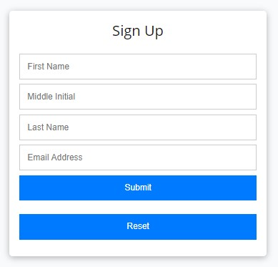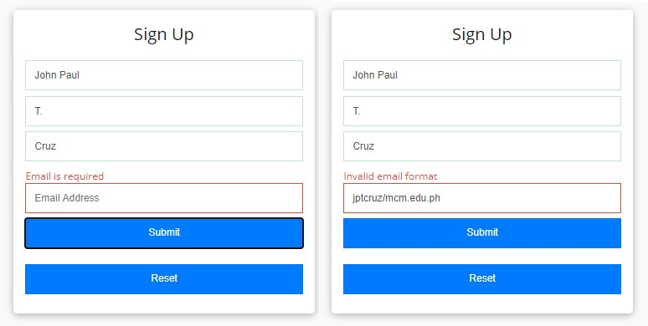

Emmy Grace

T.

Requillo

Email Address

Emmy Grace

T.

Requillo

e

g

tolentino/mcm.edu.ph

The form must be able to see if there are no inputs placed. Here is a sample output:

Once the form validates all inputs, an alert box must be seen that says

**Success!**

Here is a sample output:

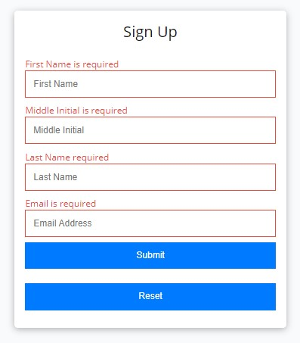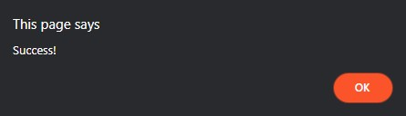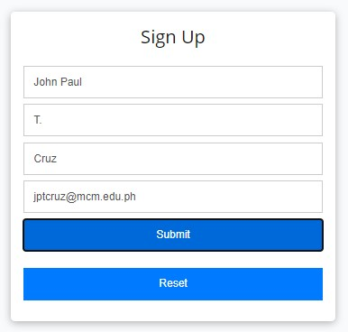

Emmy Grace

T.

Requillo

eg

tolentino@mcm.edu.ph

===============================================================================

**HTML Source Code:**

<!-- Name: Peter Miles Anthony L. Laporre -->

<!-- Course: Bachelor of Science in Computer Engineering -->

<!DOCTYPE html>

<html>

<head>

    <title>Simple Form Validation</title>

    <!-- linking CSS file -->

    <link rel = "stylesheet" href = "validData.css">

</head>

<body>

    <!-- Form creation -->

    <form id="myForm">

        <label for = "firstName">First Name</label>

        <input type = "text" id = "firstName" required>

        <label for = "middleInitial">Middle Initial</label>

        <input type = "text" id = "middleInitial" required>

        <label for = "lastName">Last Name</label>

        <input type = "text" id = "lastName" required>

        <label for = "email" >E-Mail Address</label>

        <input type = "text" id = "email" required>

        <input type = "submit" value = "Submit">

    </form>

    <!-- loading javascript file -->

    <script src = "validData.js"></script>

</body>

</html>

**CSS Source Code:**

body {

    font-family: Arial, sans-serif;

    text-align: left;

}

form {

    margin: 20px auto;

    max-width: 400px;

    padding: 20px;

    border: 1px solid #ccc;

    border-radius: 5px;

}

label {

    display: block;

    margin-bottom: 5px;

}

input[type = "text"] {

    width: 90%;

    padding: 10px;

    margin-bottom: 10px;

    border: 1px solid #ccc;

    border-radius: 5px;

}

input[type = "submit"] {

    background-color: #3498db;

    color: #fff;

    border: none;

    padding: 10px 20px;

    border-radius: 5px;

    cursor: pointer;

}

input[type="submit"]:hover {

    background-color: #2980b9;

}

**JavaScript Source Code:**

const form = document.getElementById("myForm")

        // to function the form

        form.addEventListener("submit", function(event) {

            event.preventDefault(); // Prevent the form from submitting

            const firstName = document.getElementById("firstName").value;

            const middleInitial = document.getElementById("middleInitial").value;

            const lastName = document.getElementById("lastName").value;

            const email = document.getElementById("email").value;

            if (!firstName || !middleInitial || !lastName || !isValidEmail(email)) {

                alert("Invalid inputs. Please check your entries.");

            } else {

                alert("Success!");

                form.reset(); // Clear the form

            }

        });

        function isValidEmail(email) {

            const emailRegex = /^[^\s@]+@[^\s@]+\.[^\s@]+$/;

            return emailRegex.test(email);

        }

**Output:**

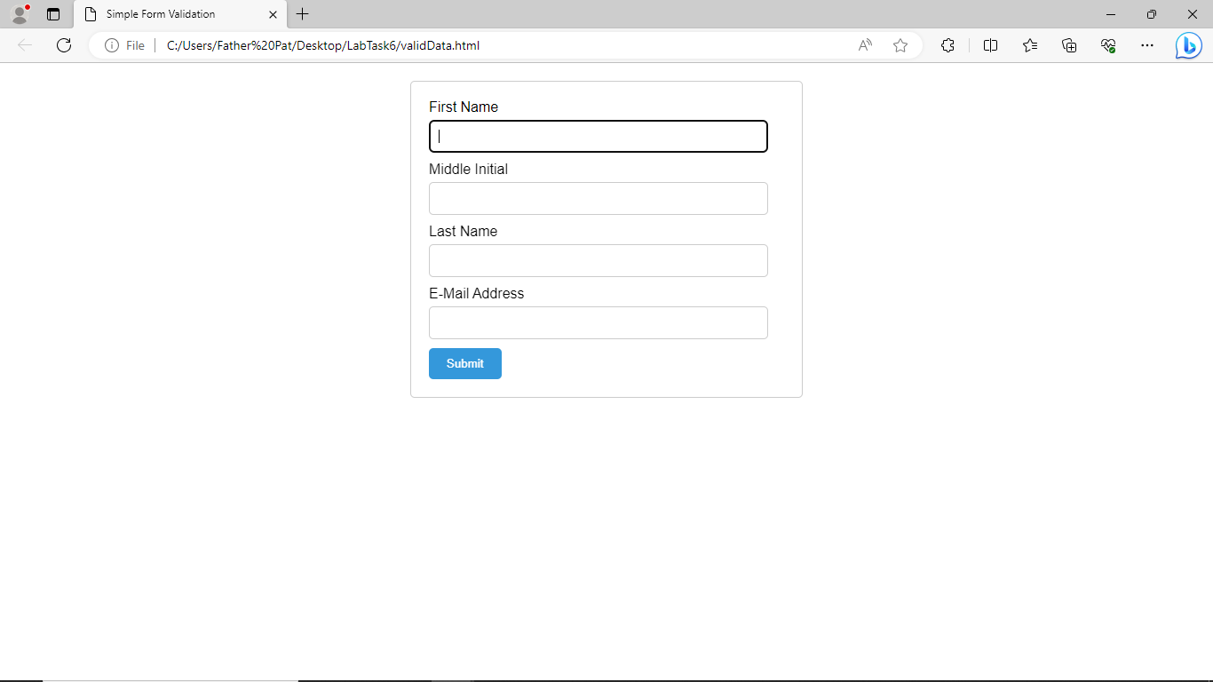

**Findings and Observations:**

|  |
| --- |
| In accomplishing the laboratory task, I did seek help on the internet for some solutions on how to make a form and make it work like a form validation. I haven’t mastered it yet and I’m hoping the next lessons will help me utilize the elements and operations used in the lab task. |