**Web Application Development Lab**

**Assignment – 1**

**HTML**

1. **Create a HTML page and perform the following operation –**
   1. **Display “Web Application Development” in an h1 tag**
   2. **Display “Master in Computer Application” in an h4 tag**
   3. **Display a moving text “Happy Learning” with the yellow background color. Use different attributes to control the speed, behavior, and direction.**
   4. **Write a paragraph about HTML using p tag**
   5. **Take any image and display in the web page. Control the height and the width of the image.**
   6. **Create a hyperlink to link google.com using anchor tag**

**Code:-**

<!DOCTYPE html>

<html lang="en">

<head>

<meta charset="UTF-8">

<meta name="viewport" content="width=device-width, initial-scale=1.0">

<title>22mmcb28||Prem</title>

</head>

<body>

<h1>Web Application Devlopment</h1>

<h4>Master in Computer Application</h4>

<marquee behavior="altrnate" direction="right" scrollamount="10" bgcolor="yellow">Happy Learning</marquee>

<p>

The HyperText Markup Language or HTML is the standard markup language for documents designed to be displayed in a web browser. It defines the meaning and structure of web content. It is often assisted by technologies such as Cascading Style Sheets (CSS) and scripting languages such as JavaScript.

</p>

<img src="./../images/calm.avif" alt="image of the south korea" height="650px" width="500px">

<br>

<a href="https://www.google.com/">Google</a>

</body>

</html>

1. **Create a HTML page and perform the following operation –**
   1. **Display the following unordered List –** 
      * **Water**
      * **Milk**
      * **Tea**
      * **Coffee**
      * **Juice**
   2. **Display the following ordered list –**
2. **Asia** 
   * + 1. **Africa**
       2. **North America**
       3. **South America**
       4. **Antarctica**
       5. **Europe**
       6. **Oceania**
   1. **Display the following nested list –**
3. **Algebraic Formula:** 
   1. **(a + b)2 = a2+b2+2ab**
   2. **(a - b)2 = a2+b2 -2ab**
4. **Co-Ordinate Geometric Formula:** 
   1. **Distance between (x1,y1) and (x2,y2) is √ ((x1-x2) 2+(y1-y2) 2**
   2. **The midpoint between (x1,y1) and (x2,y2) is ((1/2)(x1 + x2), (1/2)(y1 + y2))**

**Code:-**

<!DOCTYPE html>

<html lang="en">

<head>

<meta charset="UTF-8">

<meta name="viewport" content="width=device-width, initial-scale=1.0">

<title>22mmcb28||Prem</title>

</head>

<body>

<ol type="a">

<li>Display the following unordered List –</li>

<ul type="square">

<li>Water</li>

<li>Milk</li>

<li>Tea</li>

<li>Coffee</li>

<li>juice</li>

</ul>

<li>Display the following ordered list –</li>

<ol type="I">

<li>Asia</li>

<li>Africa</li>

<li>Antartica</li>

<li>Nort America</li>

<li>South America</li>

<li>Europe</li>

<li>Oceania</li>

</ol>

<li>Display the following nested list –</li>

<ol type="1">

<u><li>Algebraic Formula:</li></u>

<ul>(a + b) <sup>2</sup>= a<sup>2</sup>+b<sup>2</sup>+2ab</ul>

<ul>(a - b) <sup>2</sup>= a<sup>2</sup>+b<sup>2</sup>-2ab</ul>

<u><li>Co-Ordinate Geometric Formula:</li></u>

<ul>Distance between (x<sub>1</sub>,y<sub>1</sub>) and (x<sub>2</sub>,y<sub>2</sub>) is √ ((x<sub>1</sub>-x<sub>2</sub>)<sup>2</sup>+(y<sub>1</sub>-y<sub>2</sub>)<sup>2</sup>

</ul>

<ul>The midpoint between (x <sub>1</sub>,y<sub>1</sub>) and (x<sub>2</sub>,y<sub>2</sub>) is ((1/2)(x<sub>1</sub> + x<sub>2</sub>), (1/2)(y<sub>1</sub> + y<sub>2</sub>))</ul>

</ol>

</ol>

</body>

</html>

**3. Design a web page using HTML to display the following tables.**

* 1. **Create a simple table to display the student’s information like roll number, name, mobile, email, and profile photo. Enter at least two records.**
  2. **Create the table as given bellow.**

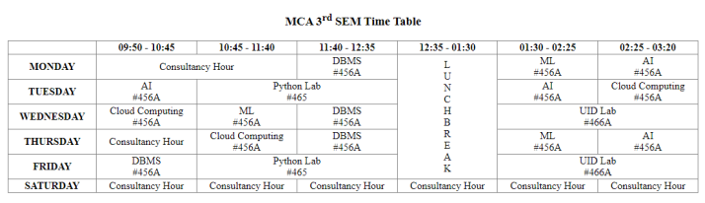

**Code:-**

<!DOCTYPE html>

<html lang="en">

<head>

<meta charset="UTF-8">

<meta name="viewport" content="width=device-width, initial-scale=1.0">

<title>22mmcb28||Prem</title>

</head>

<body>

<table border="1" align="center">

<caption>Student’s information</caption>

<tr>

<th>Roll Number</th>

<th>Name</th>

<th>Mobile</th>

<th>Email</th>

<th>Profile Photo</th>

</tr>

<tr>

<td>19</td>

<td>Deadpool</td>

<td>8144214385</td>

<td>dp@gmail.com</td>

<td>

<img src="./../images/deadpool.jpg" alt="Deadpool image" height="175px" width="125px">

</td>

</tr>

<tr>

<td>38</td>

<td>John Wick</td>

<td>8144226465</td>

<td>jw@gmail.com</td>

<td>

<img src="./../images/john.jpg" alt="johnwick image" height="175px" width="125px">

</td>

</tr>

</table>

<table border="1" rules="all" align="center">

<caption>MCA 3<sup>rd</sup> SEM Time Table</caption>

<tr>

<th></th>

<th>09:50-10:45</th>

<th>10:45-11:40</th>

<th>11:40-12:35</th>

<th>12:35-01:30</th>

<th>01:30-02:25</th>

<th>02:25-03:20</th>

</tr>

<tr align="center">

<th>MONDAY</th>

<td colspan="2">Consultancy Hour</td>

<td>DBMS #456A</td>

<td rowspan="5">L<br>U<br>N<br>C<br>H<br>B<br>R<br>E<br>A<br>K</td>

<td>ML #456A</td>

<td>AI #456A</td>

</tr>

<tr>

<th>TUESDAY</th>

<td>AI #456A</td>

<td colspan="2">Python Lab #456A</td>

<td>AI #456A</td>

<td>Cloud Computing #456A</td>

</tr>

<tr>

<th>WEDNESDAY</th>

<td>Cloud Computing #456A</td>

<td>ML #456A</td>

<td>DBMS #456A</td>

<td colspan="2">UID #456A</td>

</tr>

<tr>

<th>THURSDAY</th>

<td>Consultancy Hour</td>

<td>Cloud Computing #456A</td>

<td>DBMS #456A</td>

<td>ML #456A</td>

<td>AI #456A</td>

</tr>

<tr>

<th>FRIDAY</th>

<td>DBMS #456A</td>

<td colspan="2">Python Lab #456A</td>

<td colspan="2">UID #456A</td>

</tr>

<tr>

<th>SATURDAY</th>

<td>Consultancy Hour</td>

<td>Consultancy Hour</td>

<td>Consultancy Hour</td>

<td>Consultancy Hour</td>

<td>Consultancy Hour</td>

<td>Consultancy Hour</td>

</tr>

</table>

</body>

</html>

**4. Design a web page to display a simple login form with email and password filed. Also create a button for Log In.**

**Code:-**

<!DOCTYPE html>

<html lang="en">

<head>

<meta charset="UTF-8">

<meta name="viewport" content="width=device-width, initial-scale=1.0">

<title>22mmcb28||prem</title>

</head>

<body>

<form action="#" method="post">

<table align="center">

<caption>Login Here</caption>

<tr>

<td>Email</td>

<td><input type="email" name="email"></td>

</tr>

<tr>

<td>Password</td>

<td><input type="password" name="password"></td>

</tr>

<tr>

<td align="right" colspan="2">

<input type="submit" value="Login">

</td>

</tr>

</table>

</form>

</body>

</html>

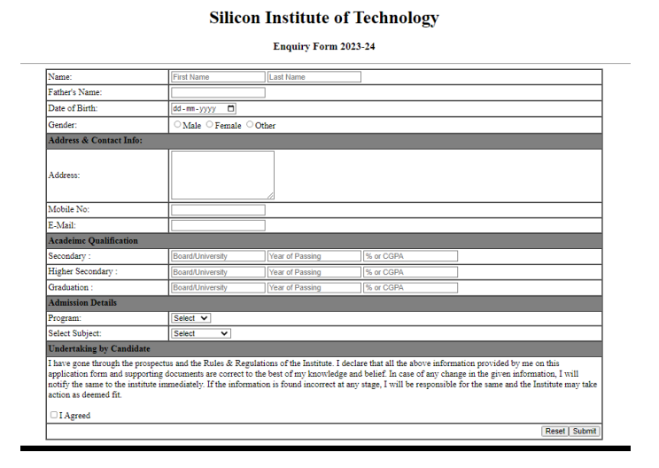**5. Design a web page to display the enquiry page given bellow by combining both HTML Table and Form tag. Program should have options – B.Tech, M.Tech, MCA, M.Sc. Subject should have options – CSE, CST, CEN, EIE, EE, EEE, MCA, and Data Science.**

**Code:-**

<!DOCTYPE html>

<html lang="en">

<head>

<meta charset="UTF-8">

<meta name="viewport" content="width=device-width, initial-scale=1.0">

<title>22mmcb28||Prem</title>

</head>

<body>

<form action="">

<h1 align="Center">Silicon Institute of Technology</h1>

<h4 align="Center">Enquiry Form 2023-2024</h4>

<table border="1" rules="all">

<tr>

<td>Name:</th>

<td>

<input type="text" placeholder="First Name">

<input type="text" placeholder="Last Name">

</td>

</tr>

<tr>

<td>Father's Name:</th>

<td>

<input type="text">

</td>

</tr>

<tr>

<td>Date of Birth:</th>

<td>

<input type="date">

</td>

</tr>

<tr>

<td>Gender</th>

<td>

<input type="radio" name="radiobtn">Male

<input type="radio" name="radiobtn">Female

<input type="radio" name="radiobtn">Other

</td>

</tr>

<tr>

<th colspan="4" align="left" bgcolor="grey">Address & Contact Info:</th>

</tr>

<tr>

<td>Address:</th>

<td><textarea name="" id="" cols="30" rows="10"></textarea></td>

</tr>

<tr>

<td>Mobile No:</th>

<td><input type="number" row="6" col="4"></td>

</tr>

<tr>

<td>E-Mail:</th>

<td><input type="text" row="6" col="4"></td>

</tr>

<tr>

<th colspan="4" align="left" bgcolor="grey">Academic Qualification</th>

</tr>

<tr>

<td>Secondary :</td>

<td><input type="text" placeholder="BoardUniversity">

<input type="text" placeholder="Year of Passing"><input type="text"placeholder="% of CGPA"></td>

</tr>

<tr>

<td>Higher Secondary :</td>

<td><input type="text" placeholder="BoardUniversity">

<input type="text" placeholder="Year of Passing"><input type="text"placeholder="% of CGPA"></td>

</tr>

<tr>

<td>Graduation :</td>

<td><input type="text" placeholder="BoardUniversity">

<input type="text" placeholder="Year of Passing"><input type="text"placeholder="% of CGPA"></td>

</tr>

<tr>

<th colspan="4" align="left" bgcolor="grey">Admission Details </th>

</tr>

<tr>

<td>Program: </td>

<td> <select>

<option >Select </option>

<option >B.Tech</option>

<option> M.Tech</option>

<option > MCA</option>

<option >M.Sc</option>

</select></td>

</tr>

<tr>

<td>Select Subject: </td>

<td><select>

<option >Select </option>

<option >CSE</option>

<option> CST</option>

<option > CEN</option>

<option >EIE</option>

<option >EE</option>

<option> EEE</option>

<option > MCA</option>

<option > Data Science

</option>

</select></td>

</tr>

<tr>

<th colspan="4" align="left" bgcolor="grey">Undertaking by candidated </th>

</tr>

<tr>

<td colspan="4">

I have gone through the prospectus and the Rules & Regulations of the Institute. I declare that all the above information provided by me on this application form and supporting documents are correct to the best of my knowledge and belief. In case of any change in the given information, I will notify the same to the institute immediately. If the information is found incorrect at any stage, I will be responsible for the same and the Institute may take action as deemed fit.

<br>

<input type="checkbox">I Agreed

</td>

</tr>

<tr align="right">

<td colspan="4">

<button>Reset</button>

<button>Submit</button>

</td>

</tr>

</table>

</form>

</body>

</html>

**6. Design a web page and perform the following operation –**

**a. Link an audio file to the html page**

**b. Display a video on the web page**

**c. Link one YouTube video onto your web page**

**d. Display the Google Map location of SIT Bhubaneswar on your web page**

**Code:-**

<!DOCTYPE html>

<html lang="en">

<head>

<meta charset="UTF-8">

<meta name="viewport" content="width=device-width, initial-scale=1.0">

<title>22mmcb28||Prem</title>

</head>

<body>

<audio controls autoplay>

<source src="./media/bells.mp3" type="audio/mpeg">Audio not supported By browser

</audio>

<video controls autoplay>

<source src="./media/Piper.mp4" type="video/mp4">Video not supported By browser

</video>

<br>

<iframe width="500" height="350" src="https://www.youtube.com/embed/krXGJzt6vLQ?si=WWbJCXLhL2Nd6F19" title="YouTube video player" frameborder="0" allow="accelerometer; autoplay; clipboard-write; encrypted-media; gyroscope; picture-in-picture; web-share" allowfullscreen></iframe>

<br>

<iframe width="400" height="250" src="https://www.google.com/maps/embed?pb=!1m18!1m12!1m3!1d14963.120784448427!2d85.79603625074333!3d20.35069711659523!2m3!1f0!2f0!3f0!3m2!1i1024!2i768!4f13.1!3m3!1m2!1s0x3a1908e064769e73%3A0x9288172f3a98c7a4!2sSilicon%20Institute%20of%20Technology!5e0!3m2!1sen!2sin!4v1697444439226!5m2!1sen!2sin" width="600" height="450" style="border:0;" allowfullscreen="" loading="lazy" referrerpolicy="no-referrer-when-downgrade"></iframe>

</body>

</html>