BAMAT207 Probability and Statistics

Probabilistic SMS Spam Detection
Project Activity | Probability and Random Variables
Student: Kushal Bagla Roll number: 25BAI0044
Submission deadline: 27 October 2026
This project classifies SMS messages as spam or genuine messages using probability analysis and Multinomial Naive Bayes. The trained model achieved 98.07% accuracy on 1,035 held-out messages, with 14 missed spam messages and 6 genuine messages incorrectly flagged as spam.

1 Dataset Handling
The official UCI SMS Spam Collection contains 5,574 records. Each line is split at its first tab to preserve literal quotation marks and message content. A SHA-256 checksum verifies the downloaded source. There are no missing or blank labels or messages. Removing 403 exact duplicate messages leaves 5,171 records; the first occurrence is retained. No conflicting labels were found. Spam is encoded as 1 and ham as 0.
Class | Original | Duplicates removed | Cleaned
Ham | 4,827 | 309 | 4,518
Spam | 747 | 94 | 653
Total | 5,574 | 403 | 5,171

2 Dataset Analysis
P(Spam) = 653 / 5171 = 0.12628118 (12.6281%)
P(Ham) = 4518 / 5171 = 0.87371882 (87.3719%)
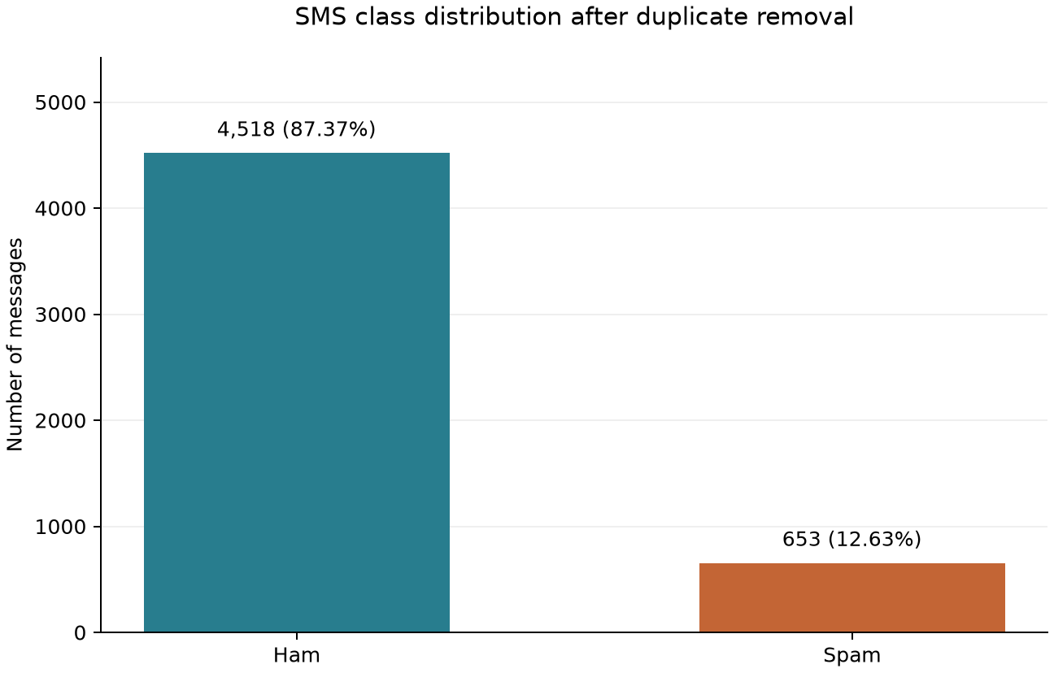

3 Word Based Probability Analysis
For each suspicious word, W denotes the event that a message contains that whole word, ignoring case. Repeated occurrences count once per message. Regular-expression word boundaries are used: “FREE!” matches free, but freedom does not; winning does not match win. No stemming is applied.
All counts use the same cleaned population of 5,171 messages, including 653 spam messages. Let n(W) count messages containing W and n(S and W) count spam messages containing it.

Direct conditional probability
P(Spam | W) = n(S and W) / n(W)

Verification using Bayes theorem
P(Spam | W) = [P(W | Spam) × P(Spam)] / P(W)
P(W | Spam) = n(S and W) / 653
P(W) = n(W) / 5171
Word | All with word | Spam | Ham | P(Spam | W)
free | 203 | 148 | 55 | 0.72906404
prize | 73 | 73 | 0 | 1.00000000
win | 55 | 49 | 6 | 0.89090909
urgent | 62 | 57 | 5 | 0.91935484
offer | 30 | 24 | 6 | 0.80000000

Worked substitutions for all five words
Free: direct = 148/203 = 0.72906404
Bayes = [(148/653) × (653/5171)] / (203/5171) = 0.72906404
Prize: direct = 73/73 = 1.00000000
Bayes = [(73/653) × (653/5171)] / (73/5171) = 1.00000000
Win: direct = 49/55 = 0.89090909
Bayes = [(49/653) × (653/5171)] / (55/5171) = 0.89090909
Urgent: direct = 57/62 = 0.91935484
Bayes = [(57/653) × (653/5171)] / (62/5171) = 0.91935484
Offer: direct = 24/30 = 0.80000000
Bayes = [(24/653) × (653/5171)] / (30/5171) = 0.80000000
All five direct and Bayes results agree within an absolute numerical tolerance of 10⁻¹². The notebook and exported table also show P(W) and P(W | Spam). A conditional probability is undefined if its conditioning event has no observations; all five words occur in this dataset.
All 73 cleaned messages containing prize are spam in this dataset. This observed proportion of 1 does not guarantee that every future message containing prize is spam. These empirical word probabilities are descriptive and are not predictions for complete new messages.

4 Random Variable Analysis
Select one of the 5,171 cleaned messages uniformly at random. Define Y = 1 if the message is spam and Y = 0 if it is ham. Then Y is a Bernoulli random variable with p = P(Spam).
E(Y) = 0 × (1 − p) + 1 × p = p
E(Y) = 653 / 5171 = 0.12628118
Since Y² = Y, E(Y²) = p. Therefore:
Var(Y) = E(Y²) − [E(Y)]² = p − p² = p(1 − p)
Var(Y) = (653/5171) × (4518/5171) = 0.11033425
The mean and population variance of the numeric target labels independently match these values. Population variance uses ddof=0 because each cleaned record has probability 1/5171; the sample-variance denominator N − 1 is not used.

5 Data Preparation
train_test_split uses test_size=0.20, stratify=target and random_state=42. Integer rounding allocates 4,136 messages to training and 1,035 to testing, approximately 80% and 20%. The split manifest preserves each source line and its partition.
Class | Training | Testing
Ham | 3,614 | 904
Spam | 522 | 131
Total | 4,136 | 1,035

Exact duplicates are removed before splitting. Checks confirm that the partitions share neither source records nor exact message text. The fixed seed makes the split reproducible; stratification preserves the spam–ham proportions as closely as integer counts allow.

6 Model Building
The pipeline combines CountVectorizer() and MultinomialNB() with default parameters. CountVectorizer lowercases text and produces discrete word-count features using tokens with at least two word characters. No stop-word removal or stemming is used. The learned vocabulary contains 7,669 tokens.
Both the vocabulary and classifier are fitted only on training messages. Test messages are transformed with that vocabulary, and unseen words are ignored. The classifier uses additive smoothing with alpha = 1. It models word counts under the Naive Bayes conditional-independence assumption.
No model settings are chosen using the test scores, and the five suspicious words do not restrict the model vocabulary. The saved pipeline retains both fitted components and remains trained only on the training partition. Reloading it reproduces the predictions and probabilities.

7 Model Evaluation
The held-out test set contains 1,035 messages: 904 ham and 131 spam. Spam is the positive class. The always-ham baseline achieves 87.3430% accuracy; reporting spam precision and recall helps assess performance beyond the majority-class baseline.
Metric | Calculation | Result
Accuracy | (898 + 117) / 1035 | 98.0676%
Spam precision | 117 / (117 + 6) | 95.1220%
Spam recall | 117 / (117 + 14) | 89.3130%
Spam F1 | 234 / (234 + 6 + 14) | 0.921260

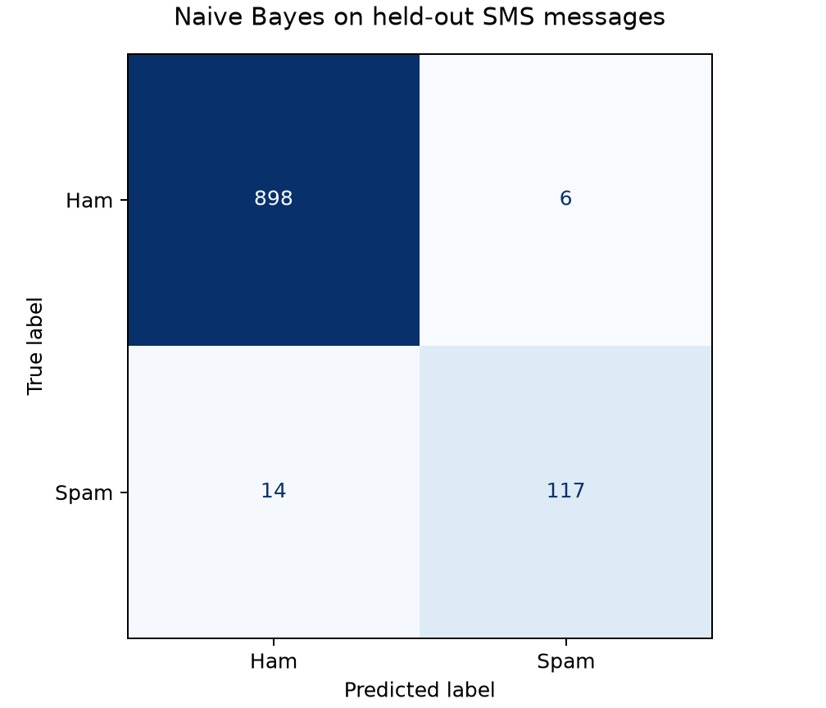
The matrix has actual labels in rows and predicted labels in columns. There are 898 true negatives, 117 true positives, 14 false negatives and 6 false positives.
Missed spam: 14 of 131 spam messages (10.69%) were classified as genuine. Genuine messages flagged as spam: 6 of 904 ham messages (0.66%) were incorrectly classified as spam. Every error is exported with its source line, message, actual label, predicted label and class probabilities.
The complete report includes per-class precision, recall, F1-score, support, macro averages and weighted averages. These results describe one reproducible split, not cross-validation. Similar but non-identical messages may remain across partitions, and future SMS traffic may differ from this historical dataset. Model probabilities are not calibrated.

8 Real Time Testing
Users can enter a new SMS through the notebook or the command-line prompt. The existing pipeline predicts its class and both probabilities without retraining. Blank messages are rejected. If no vocabulary words are recognized, the output states that the prediction uses class priors only.

Measured prediction for the assignment example
Congratulations! You have won a free prize. Claim now.
Prediction: Spam
P(Spam | Message) = 0.9999998276
P(Ham | Message) = 1.724077006e-07
These are the model’s measured outputs. The assignment’s 0.96 and 0.04 probabilities are illustrative. The two calculated probabilities sum to 1 within floating-point precision.

How to run
Open sms_spam_detection.ipynb and run the cells in order. Set RUN_INTERACTIVE = True in Activity 8 to enter messages; type /quit to stop. From the repository root, the alternative command is python -m src.predict. A single message can be supplied with --message "Your SMS here". Install the pinned dependencies in requirements.txt using Python 3.12.

Verification and Learning Outcome
All 17 unit tests passed. The completed notebook was executed, and checks cover dataset integrity, cleaning, word matching, Bayes calculations, Bernoulli moments, split reproducibility, training-only vocabulary learning, error labels, saved-model reloads and prediction inputs. The interactive prompt was tested for blank-input recovery, prediction and exit.
The project connects dataset frequencies with conditional probability and Bayes’ theorem, represents spam as a Bernoulli variable, and uses discrete word counts in an AI classifier. The confusion matrix shows why accuracy alone is insufficient. Reproducible code and meaningful Git commits support a digital project portfolio.

Submission Files and Repository
The repository contains the executed notebook, cleaned dataset and summary, class-distribution chart, five-word probability calculations, trained pipeline, performance reports, confusion matrix, error details and this report.
Repository: https://github.com/27Kushal/sms-spam-detection

References
Almeida, T. and Hidalgo, J. (2011). SMS Spam Collection. UCI Machine Learning Repository. https://doi.org/10.24432/C5CC84. Dataset licence: Creative Commons Attribution 4.0 International.
BAMAT207 Probability and Statistics Project Activity — Probabilistic SMS Spam Detection. Supplied course assignment brief.

