**CSCE5430: Software Engineering**

**College connect application**

**Team Members:**

Tejaswini Jalli

Priyanka Pabbireddy

Viveknath Reddy Katta

Sirisha Chowdary Gottipati

Link for GitHub repository:

<https://github.com/27Priya/Software_Engineering_Project>

**Goals and Objectives of the Project:**

**Motivation:** These days, several universities offer online courses, students can’t communicate with one another and their respective faculty members. To overcome this situation, we have implemented the following application so that it bridges the distance between the students and faculty through digital communication. This program includes forums and personal chat rooms for students to use whenever they have questions about their assignments, projects, or any other subject-related material. This facilitates student’s work while also assisting them in improving their knowledge with one another.

**Significance:** The main goal of executing this project is to keep students and professors linked and to provide answers to their questions. Students can contact or express their doubts to their particular faculty of their courses without being personally met or scheduling appointments with teachers despite their busy days.

**Objectives:** To establish better communication for discussions and debates regarding the academic work among the course related people. People involved in the course work can share their thoughts and support the common ideas. This chat room can be visited at any time by logging in using their credentials. Users who are affiliated with a university and have an active university email can only register and login to the chat application. This can be accomplished by creating a web-based application.

**Tools & Technologies:**

Scripting Languages: Python, JavaScript

Framework                : Django, Bootstrap.

Markup Language     : HTML, CSS

Database                   : MySQL, SQLlite3

**Flow of Project:**

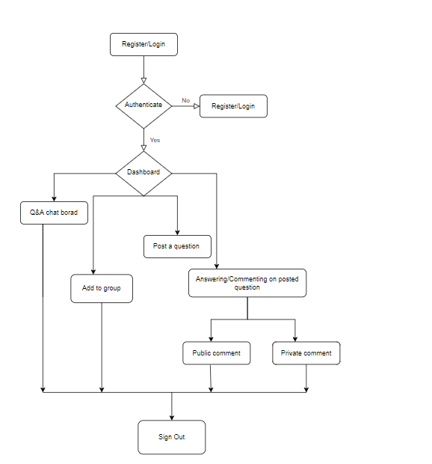

**Features:**

* Students can register into the application and perform sign in actions.
* Any student can post their doubts about the course work in the chat application.
* One can share the reaction or opinion about the post of other students doubts/questions
* Students can create group and share the code of the group across everyone who would like to join the group
* We can reply back to a post directly to the person who posted it or can reply to them in the forum that is accessible to everyone.

**References:**

<https://www.edubots.eu/articles/creating-a-safe-space-for-leeds-university-students-using-differ-chat-app>