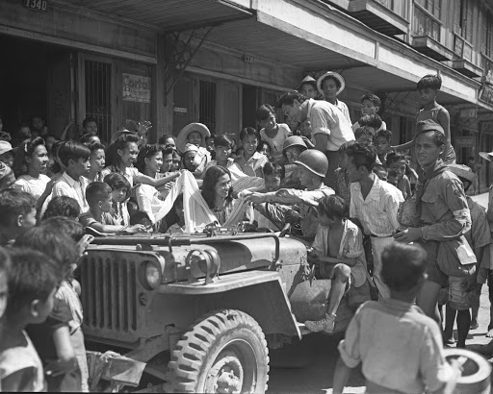Japanese Taxation Era:   
  
   
  
During the period of Japanese occupation in the Philippines from 1942 to 1945, the landscape of economic governance underwent a profound transformation under the influence of the Imperial Japanese forces. The establishment of the Japanese-Sponsored Philippine Republic, led by President Jose P. Laurel, marked a significant chapter in Philippine history, characterized by altered administrative structures and the implementation of various economic policies, including taxation. This era witnessed the imposition of taxes and levies to finance the Japanese war efforts and facilitate the exploitation of local resources. The taxation policies during this period were part of a broader strategy aimed at consolidating control over the occupied territories and sustaining the logistical demands of the Japanese military machine. Exploring the intricacies of Japanese taxation in the Philippines during 1942-1945 provides insights into the economic dynamics and challenges faced by the Filipino population under foreign occupation, reflecting a pivotal chapter in the nation's history.  
  
Here are key points related to Japanese-era taxation in the Philippines:

* On January 2, 1942, the Japanese took over Manila and seized over $20.5 million in U.S. and local money, along with an unspecified amount of foreign currency and bullion. The Japanese used this money to buy raw materials, rice, and weapons for their war efforts. Instead of the previous currency, the Japanese introduced new money in 1942, including coins and bills in different denominations.
* In 1943, new money notes of 1, 5, and 10 Pesos were introduced. In 1944, a 100 Pesos note was added, followed by a 500 Pesos note during a period of inflation. Towards the end of the war in 1945, a 1,000 Pesos note was issued. The plates for this note were finished in Manila just before U.S. troops arrived on February 3, 1945. The Japanese printed the 1,000 Pesos note while retreating from Manila to Baguio. During this time, the Japanese were in a defensive position and low on supplies, so they mixed printer's ink with duplicator fluid to make it last longer.
* In the Philippines during World War II, the Japanese government introduced a new currency called the Japanese government-issued Philippine peso in different amounts. The Japanese made it illegal to have guerrilla money, and only their currency was allowed. People who had guerrilla notes could be arrested or even killed. Some Filipinos jokingly called the new money "Mickey Mouse money." War survivors often share stories of going to the market with bags full of these Japanese bills. According to one account, 75 "Mickey Mouse" pesos, which was about 35 U.S. dollars at the time, could buy a single duck egg. In 1944, a box of matches cost more than 100 Mickey Mouse pesos.

Image of mickey mouse money:

* 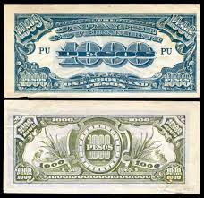In the Philippines during World War II, the Japanese in 1945, the Japanese introduced a 1,000 Pesos note. This currency, printed before the war, earned the nickname "Mickey Mouse Money" in the Philippines because of its extremely low value caused by serious inflation. To illustrate, a kilogram of sweet potatoes cost approximately 1000 Mickey Mouse Money.  
    
    
  image of 1000 peso mickey mouse money:

In conclusion, the period of Japanese taxation in Philippine history during World War II was marked by significant economic challenges and hardships for the Filipino population. The Japanese occupation led to the introduction of new taxes, forced rice procurement, and the replacement of the local currency with Japanese-issued fiat money. These economic policies were part of the broader exploitation of the Philippine economy to support the Japanese war machine. The impact of Japanese-era taxation was felt deeply by the population, contributing to food shortages, inflation, and economic difficulties. The resistance against Japanese rule, including opposition to taxation, played a crucial role in the eventual liberation of the Philippines. Overall, this period remains a testament to the resilience of the Filipino people in the face of foreign occupation and economic adversity.

References:  
  
<https://mcclungmuseum.utk.edu/object-of-the-month/japanese-peso-note/#:~:text=These%20peso%20were%20non%2Daffectionately,were%20needed%20due%20to%20hyperinflation>.

<https://www.roots.gov.sg/Collection-Landing/listing/1083473>  
  
<https://ideas.repec.org/p/phs/dpaper/200307.html>