* 1. **6. Modules introduction, Export and Import:**

**Task 1:** Create a module that exports a function, a class, and a variable.

//module1.js

export function greets()

{

    return "Hello World!";

}

export class Person

{

    constructor(name,age)

    {

        this.name=name;

        this.age=age;

    }

    details()

    {

        return "My name is "+this.name;

    }

}

export var greet="Hai";

//module1main.js

import { greets,Person,greet } from "./module1.js";

console.log(greets());

const per=new Person("John",20);

console.log(per.details());

console.log(greet);

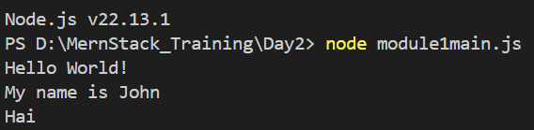

* 1. **Task 2:** Import the module in another JavaScript file and use the exported entities.

//module1main.js

import { greets,Person,greet } from "./module1.js";

console.log(greets());

const per=new Person("John",20);

console.log(per.details());

console.log(greet);

* 1. **Output:**
  2. 
  3. **Task 3:** Use named exports to export multiple functions from a module.

1. task28.js
2. export function add(num1,num2)
3. {
4. return num1+num2;
5. }
6. export function sub(num1,num2)
7. {
8. return num1-num2;
9. }
10. export function mul(num1,num2)
11. {
12. return num1+num2;
13. }
14. export function div(num1,num2)
15. {
16. return num1/num2;
17. }

Task28main.js

import {add,sub,mul,div} from './task28module.js'

console.log("Addtion = "+add(20,4));

console.log("Subtraction = "+sub(20,4));

console.log("Multiplication = "+mul(20,4));

console.log("Division = "+div(20,4));

* 1. **Output:**
  2. 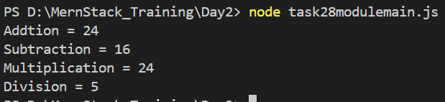
  3. **Task 4:** Use named imports to import specific functions from a module.

1. task28.js
2. export function add(num1,num2)
3. {
4. return num1+num2;
5. }
6. export function sub(num1,num2)
7. {
8. return num1-num2;
9. }
10. export function mul(num1,num2)
11. {
12. return num1+num2;
13. }
14. export function div(num1,num2)
15. {
16. return num1/num2;
17. }

Task28main.js

import {add,sub,mul,div} from './task28module.js'

console.log("Addtion = "+add(20,4));

console.log("Subtraction = "+sub(20,4));

console.log("Multiplication = "+mul(20,4));

console.log("Division = "+div(20,4));

* 1. **Output:**

1. 
   1. **Task 5:** Use default export and import for a primary function of a module.
2. //task30.js
3. export default function display(name,place)
4. {
5. return "My name is "+name+" from "+place;
6. }

//task30main.js

1. import display from './task30.js'
2. console.log(display("John","Coimbatore"));
   1. **Output:**
3. 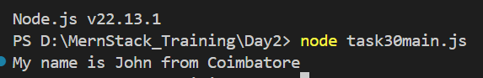

**7. Browser: DOM Basics:**

* 1. **Task 1:** Select an HTML element by its ID and change its content using JavaScript.

<!DOCTYPE html>

<html lang="en">

<head>

    <meta charset="UTF-8">

    <meta name="viewport" content="width=device-width, initial-scale=1.0">

    <title>Document</title>

</head>

<body>

    <p id="main">Hello World!</p>

    <script>

        document.getElementById("main").innerHTML="Hello John";

    </script>

</body>

</html>

* 1. **Output:**

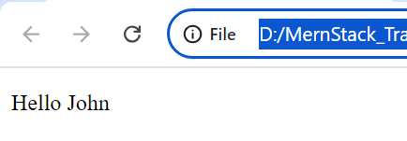

* 1. **Task 2:** Attach an event listener to a button, making it perform an action when clicked.

1. <!DOCTYPE html>
2. <html lang="en">
3. <head>
4. <meta charset="UTF-8">
5. <meta name="viewport" content="width=device-width, initial-scale=1.0">
6. <title>Document</title>
7. </head>
8. <body>
9. <button onclick="change()" id="main">Button</button>
10. <script>
11. function change()
12. {
13. document.getElementById("main").addEventListener('click',function(){alert("Button Clicked");});
14. }
15. </script>
16. </body>
17. </html>
    1. **Output:**
18. 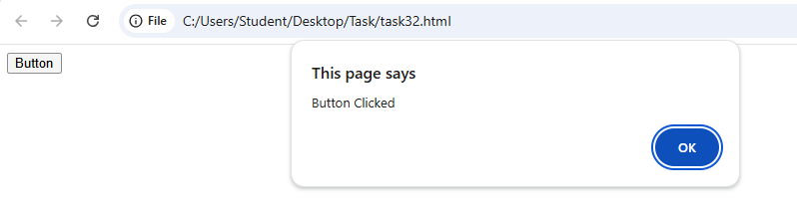
    1. **Task 3:** Create a new HTML element and append it to the DOM.
19. <!DOCTYPE html>
20. <html lang="en">
21. <head>
22. <meta charset="UTF-8">
23. <meta name="viewport" content="width=device-width, initial-scale=1.0">
24. <title>Document</title>
25. </head>
26. <body>
27. <ul id="main">
28. <li>Books</li>
29. <li>Notes</li>
30. <li>Pencils</li>
31. </ul>
32. <button onclick="appendItem()">Append Button</button>
33. <script>
34. function appendItem()
35. {
36. let item=document.createElement("li");
37. let appItem=document.createTextNode("Pens");
38. item.appendChild(appItem);
39. document.getElementById("main").appendChild(item);
40. }
41. </script>
42. </body>
43. </html>
    1. **Output:**
    2. 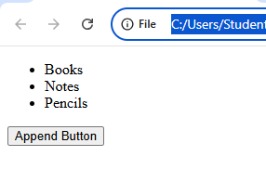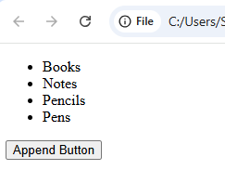
    3. **Task 4:** Implement a function to toggle the visibility of an element.
44. <!DOCTYPE html>
45. <html lang="en">
46. <head>
47. <meta charset="UTF-8">
48. <meta name="viewport" content="width=device-width, initial-scale=1.0">
49. <title>Document</title>
50. </head>
51. <body>
52. <button id="main" onclick="visible()">Visibility Button</button>
53. <p id="para" style="display: block;">This is a content.</p>
54. <script>
55. function visible()
56. {
57. if(document.getElementById("para").style.display=='block')
58. {
59. document.getElementById("para").style.display='none';
60. }
61. else
62. {
63. document.getElementById("para").style.display='block'
64. }
65. }
66. document.getElementById("main").addEventListener('click',visible());
67. </script>
68. </body>
69. </html>
    1. **Output:**
    2. 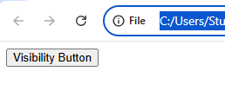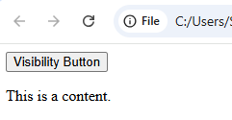
    4. **Task 5:** Use the DOM API to retrieve and modify the attributes of an element.
70. <!DOCTYPE html>
71. <html lang="en">
72. <head>
73. <meta charset="UTF-8">
74. <meta name="viewport" content="width=device-width, initial-scale=1.0">
75. <title>Document</title>
76. </head>
77. <body>
78. <img id="images" src="image1.jpeg" alt="Original Image" width="200" height="100">
79. <button id="main">Modify Button</button>
80. <script>
81. function modify()
82. {
83. document.getElementById("images").setAttribute('src','image2.jpeg');
84. document.getElementById("images").setAttribute('alt','Modified Image');
85. document.getElementById("images").setAttribute('width','300');
86. document.getElementById("images").setAttribute('height','200');
87. }
88. document.getElementById("main").addEventListener('click',modify);
89. </script>
90. </body>
91. </html>
92. **Output:**
93. 