|  |
| --- |
|  |
| THE CAKE MAKER |
| Project Documentation of DISM (Semester II) |

SAHAR MUSHTAQ KHANJI

**Faculty** = Miss Aatika Liaquat

**Batch Code** = 1803B2

**Curriculum**= 6673

**Semester**= HDSE-2

**Table of Contents: -**

1. Acknowledgment....................................................................................................... 4
2. Abstract………………………………………………………………………………………………………………… 4
3. Declaration…………………………………………………………………………………………………………… 5
4. Certificate…………………………………………………………………………………………………………….. 6
5. **CHAPTER I :** INTRODUCTION…………………………………………………………………………………. 8
6. Problem Statement………………………………………………………………………………… 8

* Objectives…………………………………………………………………………………… 8
* Functional Requirements……………………………………………………………. 9
* System Administrator…………………………………………………………………. 9
* System User………………………………………………………………………………… 9

1. Need of Project……………………………………………………………………………………… 10
2. **CHAPTER II** : PROJECT MAKING & BACKGROUNDS………………………………………………. 11
3. Project Duration………………………………………………………………………………………. 12
4. Task Sheet……………………………………………………………………………………………….. 13
5. **CHAPTER III** : SOFTWARE & HARDWARE REQUIREMENTS…………………………………… 14
6. Hardware Requirements……………………………………………………………………………. 15
7. Software Requirements……………………………………………………………………………… 15
8. **CHAPTER IV** : WORKFLOW SUBMISSION CHECKLIST…………………………………………… 16
9. Workflow Submission Checklist…………………………………………………………………….. 17
10. Screenshots…………………………………………………………………………………………………… 18
11. Application Map…………………………………………………………………………………………….20
12. **CHAPTER V**: CONCLUSION………………………………………………………………………………….. 20
13. Remarks………………………………………………………………………………………………………… 22
14. Application……………………………………………………………………………………………………. 22
15. Problem Faced……………………………………………………………………………………………… 22
16. Future Enhancement……………………………………………………………………………………… 22

1- Acknowledgement:

We would want to appreciate and thank all of those people who helped us during this journey of completing our project. Without everyone’s support, we could not have accomplished our work.

We express our sincere gratitude to our faculty “--Miss Aatika Liaquat--" and our coordinator for their amazing support and guidance, continuous encouragement and supervision throughout the course of the present work. It’s of no doubt that we have been very fortunate to work under such a supportive and cooperative teacher/coordinator

And last but not the least we are extremely grateful to the whole faculty and administration of Aptech, for providing us all the facilities that were mandatory, without which this project could not be a success.

2- Abstract:

The capstone project **“The Cake “**, I have been working on is about the development of a desktop application for a Cake Shop. It’s made using PHP and MySQL Database Mainly. This application has as purpose to help my client in managing his work; as for any Owners well as their employees.

The Cake application will offer several features such as the page should be designed with a banner at the top of the page. The home page covers a brief description of the entire website / presentation as well as a brief history of cake. About us divides the page into three sections vertically. Provide the foundation, mission and vision on these sections. On click on the order button a purchase form page appears on a new browser window. The purchase form page has all the form fields to capture the entire transaction and the users' details like making the client work easy and efficient. The report reflects the work done and its progress and describes in more details of this project’s stages. The project’s first stage is the requirements and specification stage. During this stage, the client’s needs are gathered and proceeded; for The Cake application, the requirements were expressed explicitly.

Once this phase done, comes up the feasibility study where the technical aspect is

tackled. This stage is partially driven by the application’s type to be developed, technology

enablers such as programming language, and database.

After the feasibility study done comes the design and analysis phase with the design of

database entities.

Finally comes the implementation phase with a description of all the necessary tools

used to develop the application.

3- Declaration

We are writing this to declare that all the work which is being written bellow in this Project Report entitled “—**THE CAKE MAKER**--” is a veritable record of our own work submitted to the Aptech NN, Karachi, Pakistan during the year 2020 in the partial fulfillment of semester IV (HDSE-II) project We also declare that we have not submitted the material being presented in this Project Report for the award of any other degree elsewhere.

Signatures:

SAHAR MUSHTAQ STUDENT 1098556

Certificate: -



This is to certify that,

Ms.

**SAHAR MUSHTAQ**

Has successfully Designed & Developed

**THE CAKE MAKER**

Date of Issue:

**31th-JAN-2020**

Date of Submission:

**1th-MARCH-2020**

Authorized Signature: **Miss Aatika Liaquat**

INTRODUCTION

Problem Statement: -

Introduction

The main purpose is to create an informative, interactive and business website for Cake manufacturers. The brand name is “The Cake” and the shop is located all over the country. The website has to be informative enough for the end users / viewers to know brief of the various products and its prices and the availability.

Functional Requirements

The website should cover the following links / pages:

1. Home page: The page should be designed with a banner at the top of the page. The home page should cover a brief description of the entire website / presentation as well as a brief history of cake.
2. About us: divide the page into three sections vertically. Provide the foundation, mission and vision on these sections.
3. All products: the product page should be designed with all the products / thumbnails along with brief details of the individual products, such as
   1. item code
   2. Price
   3. Egg less/with Egg
   4. order button
4. On click on the order button a purchase form page should appear on a new browser window. The purchase form page should have all the form fields to capture the entire transaction and the users' details like
   1. Name
   2. Address
   3. Contact number
   4. Item code
   5. Quantity
   6. Delivery address
   7. Delivery Date
5. On click on the zoom button an enlarged image of the same product should appear on a new browser window.
6. Products by event: provide a categorized sub-navigation on this page such as
   1. Birthday
   2. Anniversary
   3. Engagement
   4. Marriage and so on.

Each and every sub-navigational button should be linked to an individual page. All the individual page should be designed with selected / categorized thumbnails along with brief details of the individual products, such as item code, price, zoom and order button.

1. Store location: The page should have the of searching the store as per the user’s preference. It should display all the details of the store.
2. Site Map: The site map page should contain the entire navigational structure / diagram in a visual form and all the links (page names) of the diagram should be programmed for hyperlink to the respective pages.
3. The administrator should be able to add/update/delete the various products and user details.
4. User should also be able to create the account and track all his orders.

Need of Project: -

Some of the benefits of Project are as under: -

* Re-enforcement of Skills happens in the experiential learning process.
* A mentor, ensuring that you do not get drifted, constantly guides you.
* It gives you a lot of confidence to face an interview as you have worked on a project. You can explain virtually everything on the subject you have learnt.
* A nice, final, black, hardbound report adds to you credentials and enhances your job prospects.
* Projects is compulsory (Sem-End Project) and is supposed to be done over and above the assignments given in your course books.
* It is advised that if a student follows the projects and submits Assignments, he would definitely have an edge over other students.
* Students need to submit their project report along with working application and source code in the stipulated time.



PROJECT MAKING & BACKGROUND

PROJECT DURATION: -

* Analysis- 3 days
* Design – 17 days
* Development –5 days
* Testing – 3 days
* Documentation -2 days

|  |  |  |  |  |
| --- | --- | --- | --- | --- |
| Analysis | Design | Database | Testing | Documentation |

|  |  |  |  |  |  |  |  |  |  |  |  |  |  |  |  |  |  |  |  |  |  |  |  |  |  |  |  |  |  |
| --- | --- | --- | --- | --- | --- | --- | --- | --- | --- | --- | --- | --- | --- | --- | --- | --- | --- | --- | --- | --- | --- | --- | --- | --- | --- | --- | --- | --- | --- |
| 1 | 2 | 3 | 4 | 5 | 6 | 7 | 8 | 9 | 10 | 11 | 12 | 13 | 14 | 15 | 16 | 17 | 18 | 19 | 20 | 21 | 22 | 23 | 24 | 25 | 26 | 27 | 28 | 29 | 30 |

TASK SHEET

|  |  |  |  |  |  |
| --- | --- | --- | --- | --- | --- |
| **No.** | **Task** | **Actual Start Date** | **Actual Days** | **Team Mate Name** | **Status** |
| 1. | Case Study | 31st Jan  2020 | 2 | SAHAR MUSHTAQ KHANJI | Completed |
| 2. | UI Designing | 2nd Feb  2020 | 9 | SAHAR MUSHTAQ KHANJI | Completed |
| 3. | SCENARIO Making | 19th Feb  2020 | 8 | SAHAR MUSHTAQ KHANJI | Completed |
| 4. | Material Searching | 22nd Feb  2020 | 3 | SAHAR MUSHTAQ KHANJI | Completed |
| 5. | Database Connectivity | 25th Feb  2020 | 8 | SAHAR MUSHTAQ KHANJI | Completed |
| 6. | Documentation | 29th Feb 2020 | 2 | SAHAR MUSHTAQ KHANJI | Completed |



SOFTWARE & HARDWARE REQUIREMENTS

HARDWARE REQUIREMENTS: -

* A minimum computer system that will help you access all the tools in the courses is a Pentium 166 or better.
* 64 Megabytes of RAM or better.

SOFTWARE REQUIREMENTS: -

* Notepad
* Browser Google



WORKFLOW SUBMISSION CHECKLIST

## 

WORKFLOW SUBMISSION CHECKLIST:-

|  |  |  |  |
| --- | --- | --- | --- |
| **S.NO** | **LIST OF ITEMS** | **Remarks** | **COMMENTS** |
| 1. | Do All Forms Linked together | **Yes** | By making their objects. |
| 2. | Database Connected | **Yes** | Using  MDF FILE |
| 3. | Page Colors As Per Common Guidelines | **Yes** | Professional Color Combination |
| 4. | All SQL Queries Working | **Yes** | Linked through a single Connection Class |
| 5. | DOCUMENTATION Included | **Yes** | All 3 word documents. |
| 6. | Project Zip File | **Yes** | Created using WinRAR |

SCREENSHOTS: -

# Login Page

# 

# DashBoard

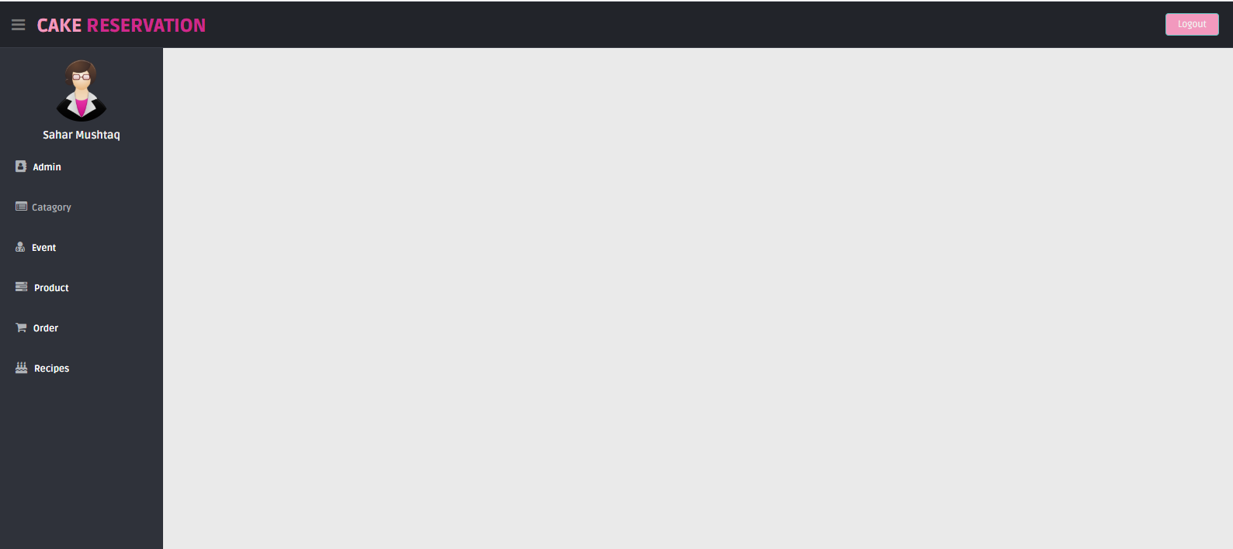

# 

# 

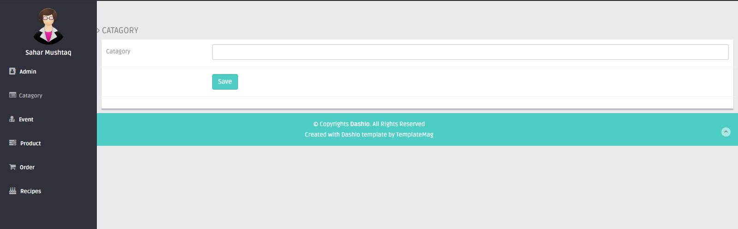

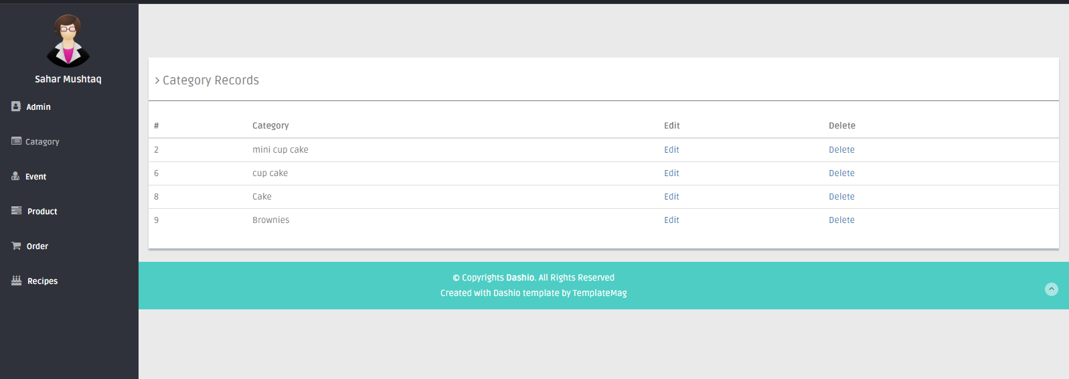

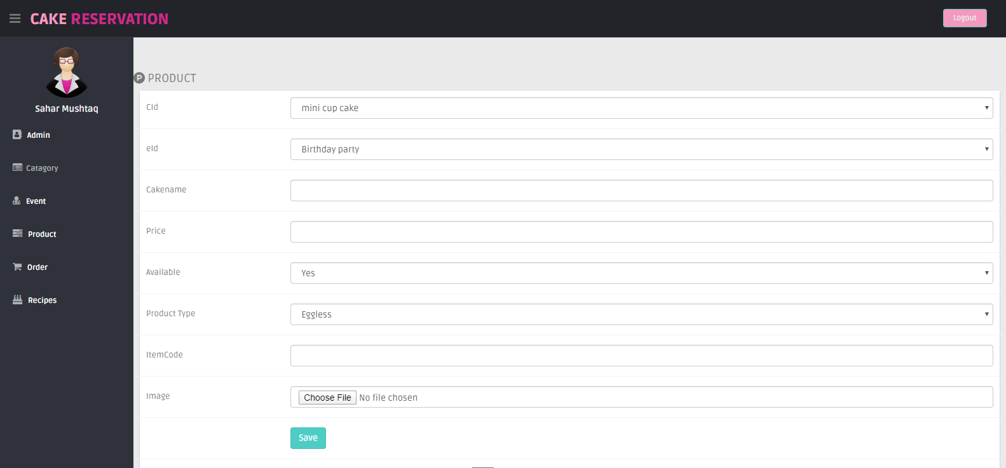

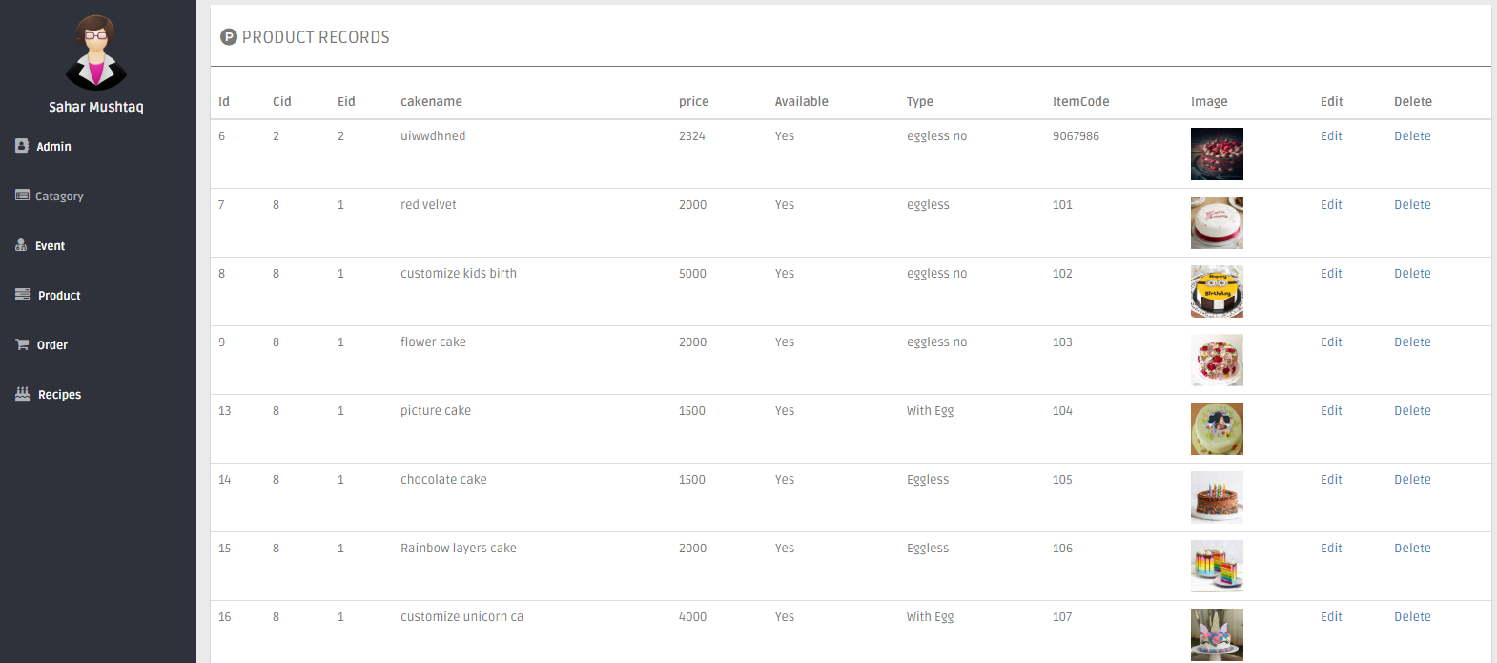

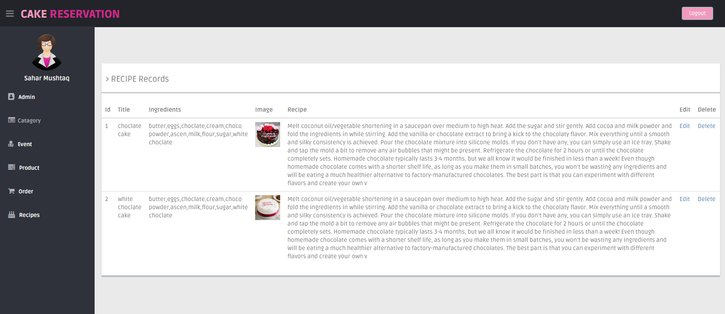

APPLICATION MAP: -

**TCS**

**LOGIN**

**USER**

**ADMIN**



ORDER

CONTACT

HOME

ABOUT

EVENT



RECIPE

CONTACT

EVENT

ABOUT

HOME

CONCLUSION

Remarks: -

It is very nice initiative that has made us work harder on our project and it has polished our skills now we are capable of making a php website all by our own self. We are very thankful to you.

Application: -

It’s a cake shop website. It can be used widely for making online orders and with further enhancements. It is also very useful for the customer that face a lot of problems in time managing booking and rush towards shops for booking cake for their events.

Problem Faced: -

The main problem we faced in the duration of project is the load shedding problem. We work on project then suddenly computer was off.

Future Enhancement: -

I proceed toward more approaches in online prosperity by means of other addition in shop’s menu.