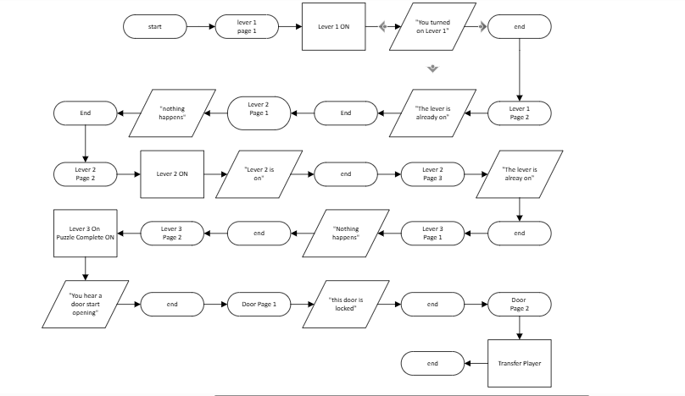
Create Map Event
Name: Lever 3
Trigger: Action Button
Pages: 3
Options: Direction Fix
Create Map Event
Name: Lever 2
Trigger: Action Button
Pages: 3
Options: Direction Fix
Create Map Event
Name: Door
Trigger: Action Button
Pages: 2
Options: Direction Fix
Create Map Event
Name: Lever 1
Trigger: Action Button
Pages: 2
Options: Direction Fix

This challenge is to find the correct order of the levers to open the door.

