Return Stone [Movement, Item, Branches, Switches]
Create an Item that players can interact with to teleport back to specific places they’ve visited before.

Start by creating the Return Stone item. For my first two maps I like to do the outside of my player’s home, and the inside as the second map. On the first map (the outside), create a Door event as shown below. On the inside map, create an “exit” event.
Create: Comon Event
Name | Return Stone
Switch | #0001
Trigger | Parallel

Create: Map Event
Name | Home
Priority | Below Player
Trigger | Player Touch
Page | 2
Condition | Self-Switch A
Options | Direction Fix

Create: Map Event
Name | Home
Priority | Below Player
Trigger | Player Touch
Page | 1
Condition | None
Options | Direction Fix

Create: Item
  303 | Name | Return Stone | Type | Key Item
 | Consum. | No | Scope | All Allies
 | Occasion | Menu Screen | Effect | Common event Return Stone

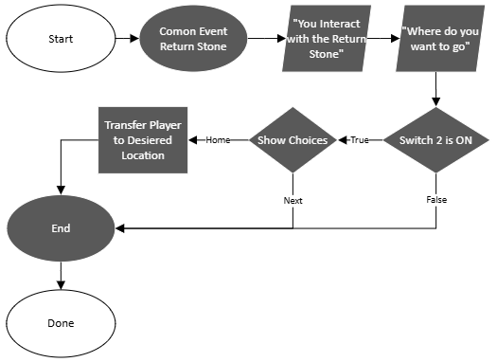

Follow the flow chart on the RIGHT to “register” a new location into the list of available return options:
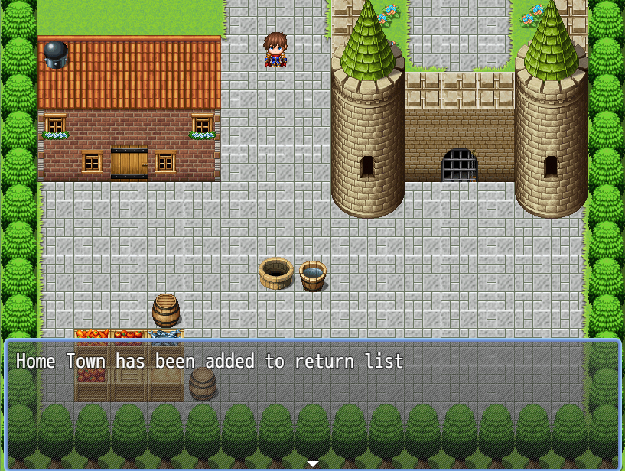

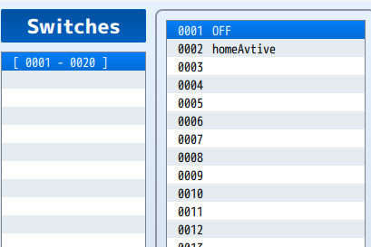

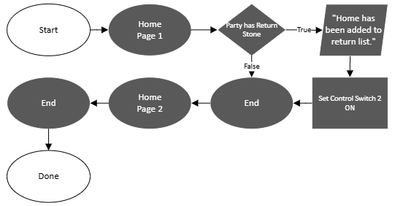

Follow the flow chart on the LEFT to create the basic structure for the Return Stone common event. This is what will actually let you interact with the Return Stone Item.

