2/3/2016



____________________________________________________

This assignment conducted by _____________________________________

Leader 1) Fikri saoudi 1141327209

2)Ahmad Hamdan 1131121467

To linda

MULTIMEDIA UNIVERSITY

**List of content**

Business Rules 2

ERD 3

Data dictionary 4

Data Definition Command (**DDL**) 5

1.1 Create tables and Data insertion : 5

2 Data Manipulation Command (DML) 16

2.1 aggregate functions: 16

2.2 group by and aggregate functions (count,sum) 17

2.3 Select and order by and join 18

2.4 Select and LIKE 19

2.5 sub-query and join 19

2.6 Nested query or sub query 20

2.7 VIEW 21

2.8 TRIGGER: 22

2.9 Stored procedure : 24

2.10 Displaying "top n records” 26

2.11 Group by with HAVING 27

2.12 auto increment by 1 for newly inserted row 28

# Business Rules

# 

each customer may purchase many songs

each song can be purchased by many customer

each customer may purchase many albums

each album can be purchased by many customer

each album contains many songs

each song is contained by an album

artist release many songs

songs can be released by one or more artists

# ERD

# Data dictionary

|  |  |  |  |  |  |  |  |  |
| --- | --- | --- | --- | --- | --- | --- | --- | --- |
| Table Name | Attribute Name | Contents/Description | Data Type | Format | Range | Nullable | PK / FK | FK Referenced Table |
| ARTIST | artist_ID  artist_name  artist_gender  artist_country  singing_kind | artist ID  the artist name  artist sex  artist country  artist style of signing | int  Varchar (30)  Char(1)  Varchar (30)  Varchar (30) | #####  Xxxxxxx  X  Xxxxxx  Xxxxxx | 1-100 | No  No  Yes  Yes  Yes | PK |  |
| RELEASE | song_ID  artist_ID  date | songID  artistID  date | int  Varchar (30) | ###  Xxxxxxx |  | No  Yes | PK /FK  PK /FK | SONG  ARTIST |
| SONG | Song_ID  Album_ID  Song_name  Song_category  Duration  Song_price  Song_language | SongID  AlbumiD  Song name  Song type  Duration  Song price  language | int  int  Varchar (30)  Varchar (30)  Decimal(4,2)  Decimal(7,2)  Varchar (30) | ###  ###  Xxxxxx  Xxxxxx  Xxxxxx |  | No  Yes  No  Yes  Yes  Yes  yes | PK  FK | ALBUM |
| ALBUM | Albim_ID  Name  Album_kind |  | int  Varchar (30)  Varchar (30) | #####  Xxxxxx  ##  Xxxxxx  Xxxxxx  Xxxxxx  YYYY-MM-DD |  | No  Yes  Yes  Yes  Yes  Yes  Yes | PK |  |
| PURCHASES | Customer_ID  Song_ID  Date |  | int  int  date | ####  Xxxxxx  Yyyy-mm-dd |  | No  Yes  Yes | PK/FK  PK/FK | COSTUMER  SONG |
| COSTUMER | Costumer_ID  Costumer_name  Costumer_birthdate  Costumer_gender  Costumer_phone |  | Int  Varchar (30)  Date  Chat(1)  Varchar (30) | #####  Xxxxxx  Yyyy-mm-dd  X  Xxxxxx | 0-100 | No  No  Yes  Yes  Yes | PK |  |
| PURCHASEALB | Costomer_ID  Album_ID  date |  | int  int  date | #####  #####  Yyyy-mm-dd | 1-5 | No  No  Yes | PK/FK  PK/FK | COSTUMER  ALBUM |

# Data Definition Command (**DDL**)

## Create tables and Data insertion :

***ARTIST TABLE :***

create table ARTIST(

ARTIST_ID int not null,

ARTIST_NAME varchar(30),

ARTIST_GENDER char(1) check(ARTIST_GENDER in('F','M')),

ARTIST_COUNTRY varchar(30),

SINGING_KIND varchar(30),

primary key(ARTIST_ID)

);

***Insert data in table:***

insert into ARTIST values(111,'EMINEM','M','USA','RAP');

insert into ARTIST values(112,'PCY','M','KOREA','HIP HOP');

insert into ARTIST values(113,'ASSALAH','F','SYRIA','ROMANTIC');

insert into ARTIST values(114,'SNOOP DOGG','M','USA','POP');

insert into ARTIST values(115,'INDILA','F','FRANCE','CLASSIC');

select * from ARTIST;

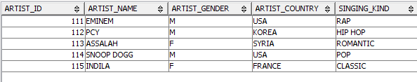

***ALBUM table:***

create table ALBUM(

ALBUM_ID int not null,

ALBUM_NAME varchar(30),

ALBUM_KIND varchar(30),

primary key(ALBUM_ID)

);

***Insert data in table:***

insert into ALBUM values(1991,'RECOVERY','RAP');

insert into ALBUM values(1992,'PCY-DA','HIP HOP');

insert into ALBUM values (1993,'HAYATI','ROMANTIC');

insert into ALBUM values(1994,'BUSH','RAP');

insert into ALBUM values(1995,'MINI WORLD','CLASSIC');

SELECT * FROM ALBUM;

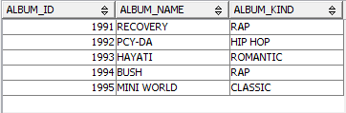

***SONG Table***

create table SONG(

SONG_ID int not null,

ALBUM_ID int,

SONG_NAME varchar(30),

SONG_CATEGORY varchar(30),

DURATION decimal(4,2),

SONG_PRICE decimal(7,2),

SONG_LANGUAGE varchar(30),

primary key(SONG_ID),

foreign key(ALBUM_ID)references ALBUM

);

***Insert data:***

insert into SONG values(1,1991,'NOT AFRAID','CLASSEC',3.50,30.00,'ENGLISH');

insert into SONG values(2,1991,'NO LOVE','JAZZ',4.20,12.50,'ENGLISH');

insert into SONG values(3,1991,'SOO BAD','CLASSEC',5.20,11.30,'ENGLISH');

insert into SONG values(4,1991,'DONT WORRY','HIP HOP',3.15,10.10,'ENGLISH');

insert into SONG values(5,1992,'THE DAY WILL COME','RAP',3.33,20.01,'KOREAN');

insert into SONG values(6,1992,'DREAM','CLASSEC',3.17,5.90,'ENGLISH @ KOREAN');

insert into SONG values(7,1992,'DADDY','HIP HOP',4.02,4.04,'KOREAN');

insert into SONG values(8,1992,'LOVE YOU','HIP HOP',3.16,6.80,'KOREAN');

insert into SONG values(9,1993,'AKTAR','ROMANTIC',7.75,4.11,'ARABIC');

insert into SONG values(10,1993,'HAYATI','SLOW SONG',5.02,4.50,'MIX ARABIC @ FRANCE');

insert into SONG values(11,1993,'WEHNA SAWA','DANCING SONG',4.15,8.60,'ARABIC');

insert into SONG values(12,1993,'ENTA OMRY','ARAB CLASSIC',7.10,6.81,'ARABIC');

insert into SONG values(13,1994,'THIS CITY','RAP',2.50,2.30,'ENGLISH');

insert into SONG values(14,1994,'AWAKE','CLASSEC',4.45,5.40,'ENGLISH @ ITALY');

insert into SONG values(15,1994,'RUN AWAY','PIT BOX',2.40,1.70,'ENGLISH');

insert into SONG values(16,1994,'COME BACK','PIT BOX',2.40,1.75,'ENGLISH');

insert into SONG values(17,1995,'LOVE STORY','ROMANTIC',2.55,4.50,'FRANCE');

insert into SONG values(18,1995,'RUN RUN','CLASSEC',6.20,8.50,'FRANCE');

insert into SONG values(19,1995,'RIGHT NOW ','RAP',3.40,3.60,'ENGLISH');

insert into SONG values(20,1995,'BEAUTIFUL','RAP',2.50,6.20,'ENGLISH');

SELECT * FROM SONG;

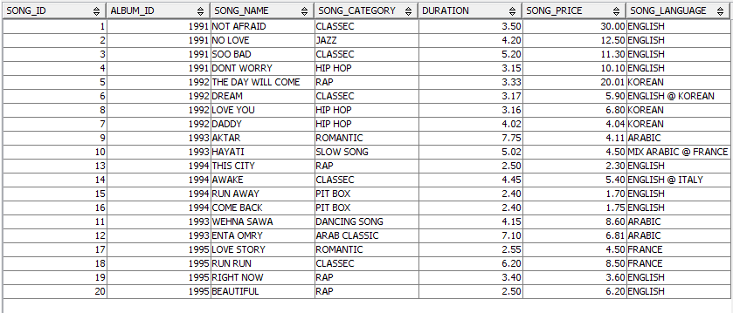

***CUSTOMER table:***

CREATE TABLE CUSTOMER(

CUSTOMER_ID int not null,

CUSTOMER_NAME varchar(30),

CUSTOMER_BIRTHDATE date,

CUSTOMER_GENDER char(1) check(CUSTOMER_GENDER in ('M','F')),

CUSTOMER_PHONE varchar(10),

PRIMARY KEY(CUSTOMER_ID)

);

***Insert Data:***

INSERT INTO CUSTOMER VALUES(111,'FIKRI','1990-05-30','M','0112342557');

INSERT INTO CUSTOMER VALUES(112,'AMINA','1995-11-05','F','0116632565');

INSERT INTO CUSTOMER VALUES(113,'AMIN','1968-07-09','M','0132342564');

INSERT INTO CUSTOMER VALUES(114,'RIMA','1957-08-27','F','0142342565');

INSERT INTO CUSTOMER VALUES(115,'RAMI','1999-02-17','M','0162342565');

INSERT INTO CUSTOMER VALUES(116,'TARIK','1993-01-20','M','0182342565');

INSERT INTO CUSTOMER VALUES(117,'NADIR','1990-03-05','M','0112379565');

INSERT INTO CUSTOMER VALUES(118,'MONIR','1970-12-06','M','0172342657');

INSERT INTO CUSTOMER VALUES(119,'SARAH','1985-10-23','F','0192345657');

SELECT * FROM CUSTOMER;

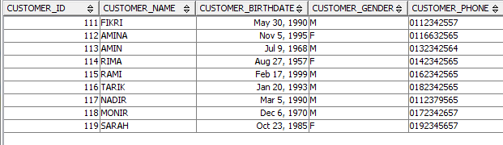

***PURCHASEALB table:***

CREATE TABLE PURCHASEALB(

CUSTOMER_ID int not null,

ALBUM_ID int not null,

DATE date,

primary key(CUSTOMER_ID,ALBUM_ID),

foreign key (CUSTOMER_ID) references CUSTOMER,

foreign key(ALBUM_ID) references ALBUM

);

***Insert Data:***

INSERT INTO PURCHASEALB VALUES(111,1993,'2015-12-08');

INSERT INTO PURCHASEALB VALUES(113,1995,'2016-01-05');

INSERT INTO PURCHASEALB VALUES(116,1993,'2014-12-04');

INSERT INTO PURCHASEALB VALUES(119,1994,'2015-03-18');

SELECT * FROM PURCHASEALB;

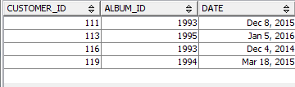

***PURCHASES table:***

CREATE TABLE PURCHASES(

CUSTOMER_ID int not null,

SONG_ID int not null,

DATE date,

primary key(CUSTOMER_ID,SONG_ID),

foreign key (CUSTOMER_ID) references CUSTOMER,

foreign key(SONG_ID) references SONG

);

***Insert data:***

INSERT INTO PURCHASES VALUES(112,1,'2013-11-08');

INSERT INTO PURCHASES VALUES(112,15,'2015-12-08');

INSERT INTO PURCHASES VALUES(114,5,'2016-01-07');

INSERT INTO PURCHASES VALUES(115,19,'2014-12-09');

INSERT INTO PURCHASES VALUES(117,13,'2015-03-14');

INSERT INTO PURCHASES VALUES(117,9,'2012-03-13');

INSERT INTO PURCHASES VALUES(117,18,'2013-03-11');

INSERT INTO PURCHASES VALUES(118,10,'2011-03-19');

SELECT * FROM PURCHASES;

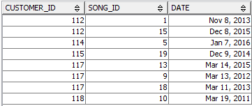

***RELEASE table:***

CREATE TABLE RELEASE(

SONG_ID int not null,

ARTIST_ID int not null,

DATE date,

primary key(SONG_ID,ARTIST_ID),

foreign key (ARTIST_ID) references ARTIST,

foreign key(SONG_ID) references SONG

);

***Insert Data:***

INSERT INTO RELEASE VALUES(19,111,'2008-03-25');

INSERT INTO RELEASE VALUES(20,111,'2007-08-20');

INSERT INTO RELEASE VALUES(13,111,'2010-05-18');

INSERT INTO RELEASE VALUES(5,111,'2009-09-11');

INSERT INTO RELEASE VALUES(8,112,'2008-02-22');

INSERT INTO RELEASE VALUES(3,112,'2008-12-21');

INSERT INTO RELEASE VALUES(7,112,'2006-09-15');

INSERT INTO RELEASE VALUES(4,112,'2008-09-13');

INSERT INTO RELEASE VALUES(9,113,'2005-04-29');

INSERT INTO RELEASE VALUES(12,113,'2004-11-21');

INSERT INTO RELEASE VALUES(17,113,'2002-07-19');

INSERT INTO RELEASE VALUES(10,113,'2005-03-15');

INSERT INTO RELEASE VALUES(2,114,'2008-02-09');

INSERT INTO RELEASE VALUES(15,114,'2006-10-11');

INSERT INTO RELEASE VALUES(16,114,'2009-09-17');

INSERT INTO RELEASE VALUES(11,114,'2010-06-15');

INSERT INTO RELEASE VALUES(1,115,'2008-02-09');

INSERT INTO RELEASE VALUES(6,115,'2006-09-10');

INSERT INTO RELEASE VALUES(14,115,'2005-04-04');

INSERT INTO RELEASE VALUES(18,115,'2007-07-06');

SELECT * FROM RELEASE;

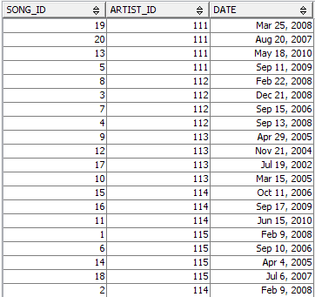

# Data Manipulation Command (DML)

## aggregate functions:

Select ARTIST_NAME,SONG_NAME,SONG_PRICE,SONG_CATEGORY,DURATION

FROM SONG,ARTIST,RELEASE

WHERE ARTIST.ARTIST_ID = RELEASE.ARTIST_ID

AND RELEASE.SONG_ID = SONG.SONG_ID

AND SONG.ALBUM_ID<=1995

AND SONG_PRICE=(SELECT max(SONG_PRICE)FROM SONG);



## group by and aggregate functions (count,sum)

SELECT COUNT(SONG_NAME)AS COUNT_SONG, SONG_CATEGORY,SUM(SONG_PRICE) AS TOTAL_PRICE

FROM SONG

GROUP BY SONG_CATEGORY;

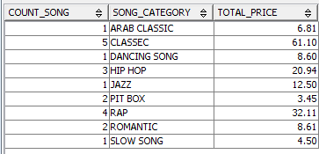

## Select and order by and join

Select CUSTOMER_NAME,SONG_NAME,SONG_PRICE,SONG_CATEGORY,ARTIST_NAME,PURCHASES.DATE,CUSTOMER_PHONE

FROM SONG,CUSTOMER,PURCHASES,ARTIST,RELEASE

WHERE PURCHASES.SONG_ID = SONG.SONG_ID

AND PURCHASES.CUSTOMER_ID = CUSTOMER.CUSTOMER_ID

AND ARTIST.ARTIST_ID = RELEASE.ARTIST_ID

AND RELEASE.SONG_ID = SONG.SONG_ID

ORDER BY CUSTOMER_NAME DESC;

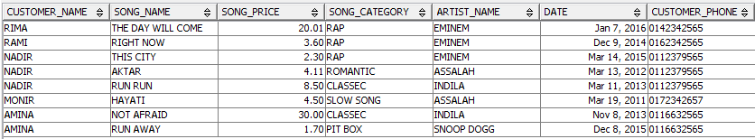

## Select and LIKE

SELECT ARTIST_NAME ,ARTIST_COUNTRY,ARTIST_GENDER

FROM ARTIST

WHERE ARTIST_GENDER='M'

AND ARTIST_COUNTRY LIKE 'USA';

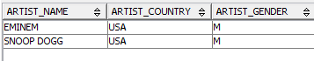

## sub-query and join

SELECT CUSTOMER_NAME,ALBUM_NAME,CUSTOMER_PHONE ,DATE

FROM CUSTOMER,PURCHASEALB,ALBUM

WHERE PURCHASEALB.ALBUM_ID = ALBUM.ALBUM_ID

AND PURCHASEALB.CUSTOMER_ID = CUSTOMER.CUSTOMER_ID

AND DATE=(SELECT MIN(DATE)FROM PURCHASEALB);



## Nested query or sub query

UPDATE SONG

SET SONG_PRICE = (SELECT AVG(SONG_PRICE) FROM SONG)

WHERE ALBUM_ID IN (SELECT ALBUM_ID FROM ALBUM WHERE ALBUM_NAME = 'BUSH');

SELECT SONG_NAME,SONG_PRICE,ALBUM.ALBUM_ID,ALBUM_NAME

FROM SONG,ALBUM

WHERE ALBUM.ALBUM_ID = SONG.ALBUM_ID

AND ALBUM_NAME = 'BUSH';

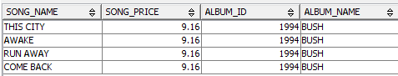

## VIEW

CREATE VIEW BUYERS AS

SELECT * FROM CUSTOMER

WHERE CUSTOMER_BIRTHDATE BETWEEN '1990-01-01' AND '1999-01-01'

AND CUSTOMER_PHONE LIKE'%65';

SELECT * FROM BUYERS;

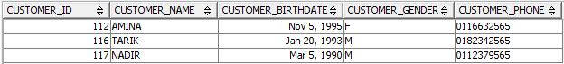

## TRIGGER:

CREATE TRIGGER AUTO_PRICE

AFTER INSERT ON SONG

FOR EACH ROW MODE DB2SQL

UPDATE SONG

SET SONG_PRICE = 5

WHERE SONG_CATEGORY = 'RAP'

AND SONG_PRICE IS NULL;

***Insert in table***

INSERT INTO SONG VALUES (21,1995,'FULL MARK','RAP',3.08,NULL,'ENGLISH');

INSERT INTO SONG VALUES (22,1995,'FULL MARK','RAP',3.08,NULL,'ENGLISH');

SELECT * FROM SONG;

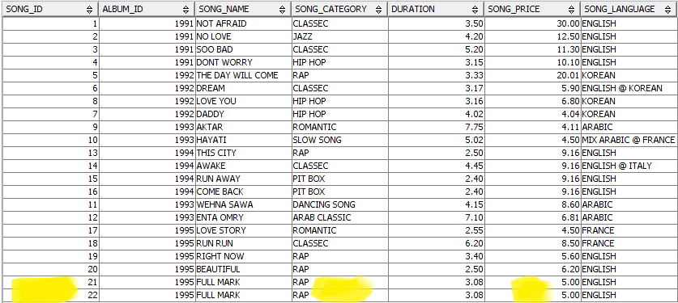

## Stored procedure :

CREATE PROCEDURE DISC(IN DISCOUNT INT)

BEGIN

UPDATE SONG

SET SONG_PRICE = SONG_PRICE - DISCOUNT

WHERE SONG_PRICE > 6;

END@

CALL DISC(2);

SELECT * FROM SONG;

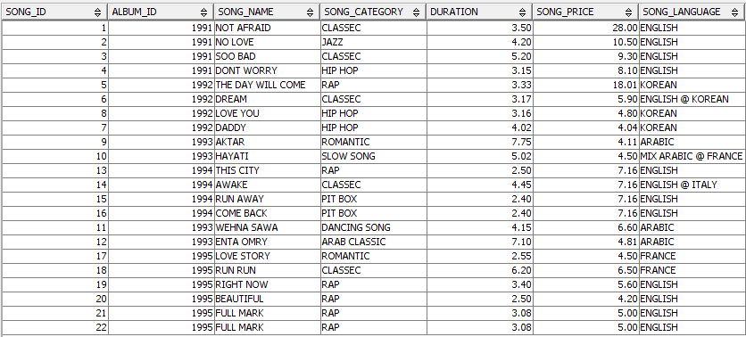

## Displaying "top n records”

SELECT SONG_NAME,SONG_PRICE

FROM SONG

ORDER BY SONG_PRICE DESC

LIMIT 5;

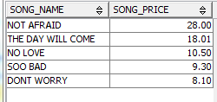

SELECT DATE,ARTIST_NAME,SONG_NAME,SONG_CATEGORY

FROM RELEASE,ARTIST,SONG

WHERE ARTIST.ARTIST_ID = RELEASE.ARTIST_ID

AND SONG.SONG_ID = RELEASE.SONG_ID

ORDER BY DATE ASC

LIMIT 5;

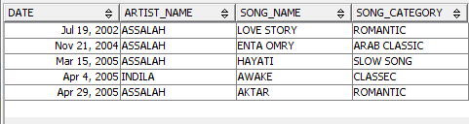

## Group by with HAVING

SELECT ARTIST_NAME,COUNT(SONG_LANGUAGE) AS ENGLISH_TYPE

FROM SONG,ARTIST,RELEASE

WHERE

ARTIST.ARTIST_ID=RELEASE.ARTIST_ID

AND RELEASE.SONG_ID=SONG.SONG_ID

AND SONG.SONG_LANGUAGE='ENGLISH'

GROUP BY ARTIST_NAME

HAVING COUNT(SONG_LANGUAGE)>1;

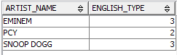

## auto increment by 1 for newly inserted row

**Note since table SONG has a lot of dependencies**

**We created another table with same attribute**

**To show the new trigger .**

***SONG2 TABLE***

create table SONG2(

SONG_ID int not null,

ALBUM_ID int,

SONG_NAME varchar(30),

SONG_CATEGORY varchar(30),

DURATION decimal(4,2),

SONG_PRICE decimal(7,2),

SONG_LANGUAGE varchar(30),

primary key(SONG_ID),

foreign key(ALBUM_ID)references ALBUM

);

INSERT IN TABLE ( THE SAME INPUT OF TABLE SONG )

***First way***

INSERT INTO SONG2

(SELECT * FROM SONG2)

***Second way***

insert into SONG2 values(1,1991,'NOT AFRAID','CLASSEC',3.50,30.00,'ENGLISH');

insert into SONG2 values(2,1991,'NO LOVE','JAZZ',4.20,12.50,'ENGLISH');

insert into SONG2 values(3,1991,'SOO BAD','CLASSEC',5.20,11.30,'ENGLISH');

insert into SONG2 values(4,1991,'DONT WORRY','HIP HOP',3.15,10.10,'ENGLISH');

insert into SONG2 values(5,1992,'THE DAY WILL COME','RAP',3.33,20.01,'KOREAN');

insert into SONG2 values(6,1992,'DREAM','CLASSEC',3.17,5.90,'ENGLISH @ KOREAN');

insert into SONG2 values(7,1992,'DADDY','HIP HOP',4.02,4.04,'KOREAN');

insert into SONG2 values(8,1992,'LOVE YOU','HIP HOP',3.16,6.80,'KOREAN');

insert into SONG2 values(9,1993,'AKTAR','ROMANTIC',7.75,4.11,'ARABIC');

insert into SONG2 values(10,1993,'HAYATI','SLOW SONG',5.02,4.50,'MIX ARABIC @ FRANCE');

insert into SONG2 values(11,1993,'WEHNA SAWA','DANCING SONG',4.15,8.60,'ARABIC');

insert into SONG2 values(12,1993,'ENTA OMRY','ARAB CLASSIC',7.10,6.81,'ARABIC');

insert into SONG2 values(13,1994,'THIS CITY','RAP',2.50,2.30,'ENGLISH');

insert into SONG2 values(14,1994,'AWAKE','CLASSEC',4.45,5.40,'ENGLISH @ ITALY');

insert into SONG2 values(15,1994,'RUN AWAY','PIT BOX',2.40,1.70,'ENGLISH');

insert into SONG2 values(16,1994,'COME BACK','PIT BOX',2.40,1.75,'ENGLISH');

insert into SONG2 values(17,1995,'LOVE STORY','ROMANTIC',2.55,4.50,'FRANCE');

insert into SONG2values(18,1995,'RUN RUN','CLASSEC',6.20,8.50,'FRANCE');

insert into SONG2 values(19,1995,'RIGHT NOW ','RAP',3.40,3.60,'ENGLISH');

insert into SONG2 values(20,1995,'BEAUTIFUL','RAP',2.50,6.20,'ENGLISH');

select * from song2

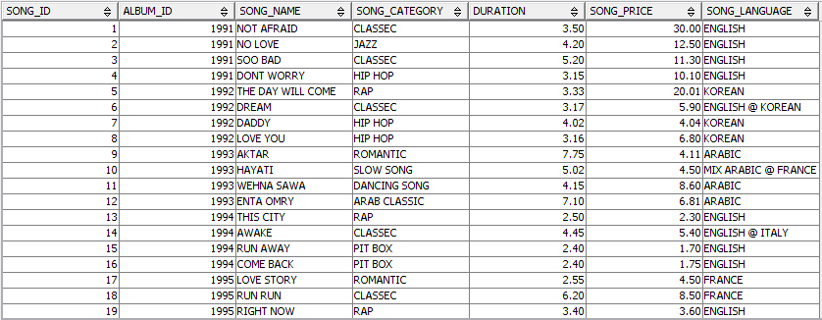

**Create trigger :**

CREATE TRIGGER NEWADDP

AFTER INSERT ON SONG

REFERANCING AS N

FOR EACH ROW MODE DB2SQL

UPDATE SONG

SET SONG­_PRICE=N.SONG_PRICE +1;

***Insert in table song2***

insert into SONG2 values(24,1994,'COME BACK','PIT BOX',2.40,39.00,'ENGLISH';

