**TASK NO-2**

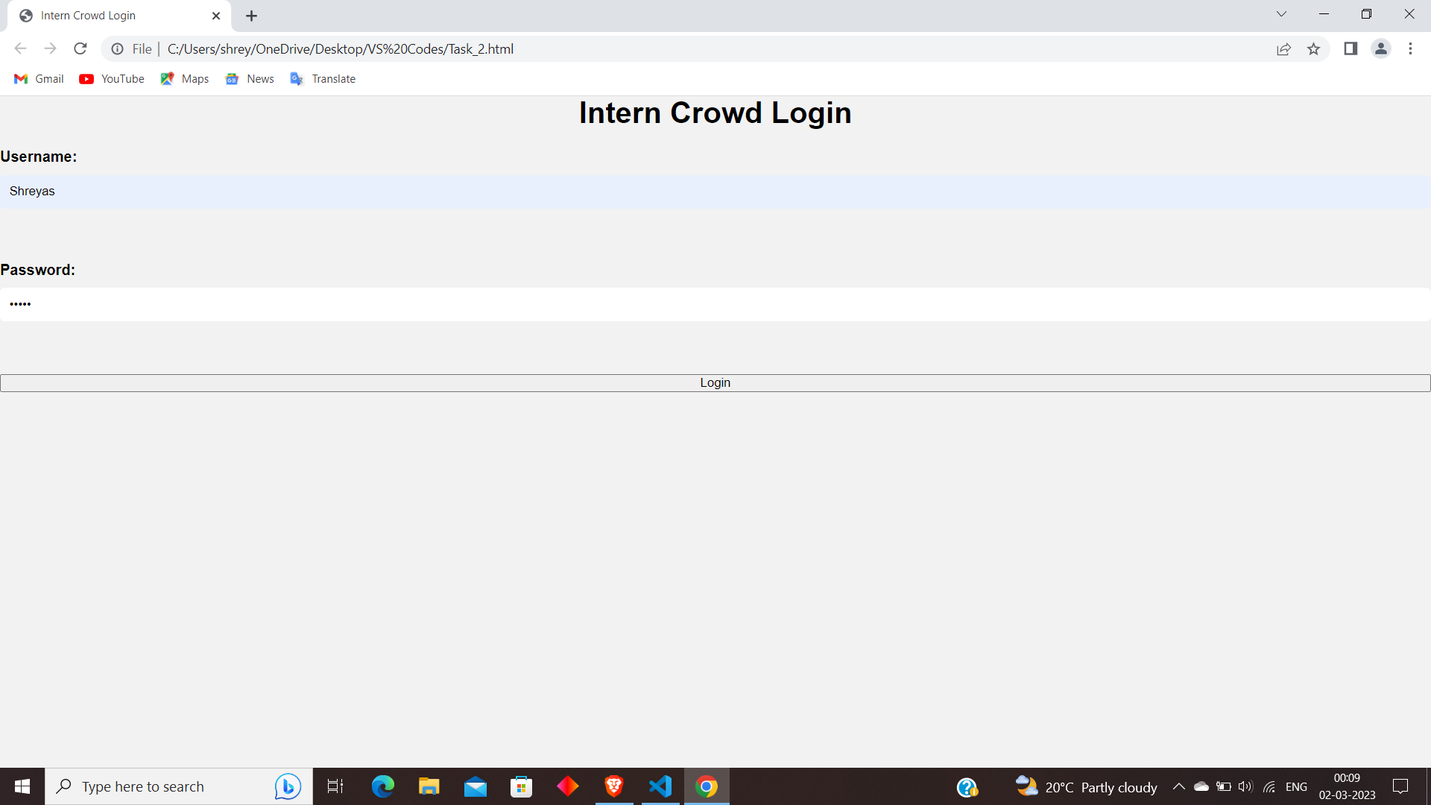

HTML CODE:-

<!DOCTYPE html>

<html>

  <head>

    <link rel="stylesheet" href="style.css">

    <title>Intern Crowd Login</title>

  </head>

  <body>

    <h1>Intern Crowd Login</h1>

    <form action="#" method="POST">

      <label for="username">Username:</label>

      <input type="text" id="username" name="username" required><br><br>

      <label for="password">Password:</label>

      <input type="password" id="password" name="password" required><br><br>

      <input type="submit" value="Login">

    </form>

  </body>

</html>

CSS CODE:-

* {

    margin: 0;

    padding: 0;

    box-sizing: border-box;

  }

  body {

    font-family: Arial, sans-serif;

    background-color: #f2f2f2;

  }

  .container {

    margin: 50px auto;

    max-width: 500px;

    padding: 20px;

    background-color: #fff;

    border-radius: 5px;

    box-shadow: 0 0 10px rgba(0, 0, 0, 0.2);

  }

  h1 {

    text-align: center;

    margin-bottom: 20px;

  }

  form {

    display: flex;

    flex-direction: column;

  }

  label {

    margin-bottom: 10px;

    font-weight: bold;

  }

  input[type="text"],

  input[type="password"] {

    padding: 10px;

    margin-bottom: 20px;

    border-radius: 5px;

    border: none;

  }

  button[type="submit"] {

    padding: 10px;

    background-color: #4CAF50;

    color: #fff;

    border: none;

    border-radius: 5px;

    cursor: pointer;

  }

  button[type="submit"]:hover {

    background-color: #3e8e41;

  }