# -*- coding: utf-8 -*-

"""

Created on Mon Feb 27 11:03:44 2023

@author: xiaoyu

"""

import random

import matplotlib.pyplot as plt

import time

# define do function

def do(n_agents):

random.seed(0)

# create a new agents list

agents = []

# create random points

for i in range(n_agents):

agents.append([random.randint(0, 99), random.randint(0, 99)])

# calculate the max distance

max_d = get_max_distance(agents)

print("maxd", max_d)

# create a new function to calculate distance between two random points

def get_distance(x0, y0, x1, y1):

x = x1 - x0

y = y1 - y0

distance = (x*x + y*y) ** 0.5

return distance

# create a new function to calculate max distacne between two points

def get_max_distance(agents):

max_distance = 0

for i in range(len(agents)):

a = agents[i]

for j in range(len(agents)):

b = agents[j]

distance = get_distance(a[0], b[0], a[1], b[1])

max_distance = max(max_distance, distance)

return max_distance

# create a list to store timing results

run_times = []

#for n_agents in range(500, 5000, 500):

for n_agents in range(500, 5000, 500):

print(n_agents)

start = time.perf_counter()

do(n_agents)

end = time.perf_counter()

print("Time taken to calculate maximum distance", end-start, "second")

run_times.append(end-start)

# create a plot of times

plt.title("Time taken to calculate maximum distance for different numbers of agents")

plt.xlabel("Number of agents")

plt.ylabel("Time")

i = 0

for n_agents in range(500, 5000, 500):

plt.scatter(n_agents, run_times[i], color='black')

i = i + 1

plt.show()

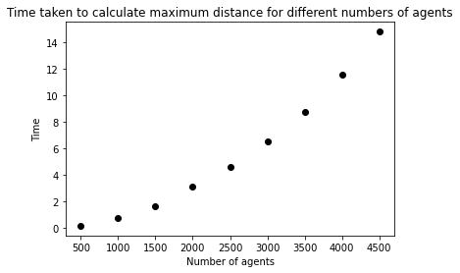

# -*- coding: utf-8 -*-

"""

Created on Wed Feb 22 09:54:15 2023

@author: xiaoyu

"""

import random

import matplotlib.pyplot as plt

import time

def do(n_agents):

random.seed(0)

# create a list called 'agents'

agents = []

# create 3 random points in the agents list ([49, 97], [53, 5], [33, 65])

for i in range(n_agents):

agents.append([random.randint(0, 99), random.randint(0, 99)])

# calculate the maximum distance

max_d = get_max_distance(agents)

print("maxd", max_d)

# create function to calculate distance between two random points

def get_distance(x0, y0, x1, y1):

x = x1 - x0

y = y1 - y0

distance = (x*x + y*y) ** 0.5

return distance

# create function to calculate the max distance between two random points

def get_max_distance(agents):

# calculate the max distance between two any two points

max_distance = 0

# range(len(agents)) means range = [0,1,2]

for i in range(len(agents)):

a = agents[i]

for j in range(i + 1, len(agents)):

# if i < j:

# print("i", i, "j", j)

b = agents[j]

distance = get_distance(a[0], b[0], a[1], b[1])

max_distance = max(max_distance, distance)

return max_distance

# create a list to store timing results

run_times = []

startr = 500

stopr = 5000

stepr = 500

#for n_agents in range(500, 5001, 500):

for n_agents in range(startr, stopr, stepr):

print(n_agents)

start = time.perf_counter()

do(n_agents)

end = time.perf_counter()

print("Time taken to calculate maximum distance", end-start, "second")

run_times.append(end-start)

# create a plot of times

plt.title("Time taken to calculate maximum distance for different numbers of agents")

plt.xlabel("Number of agents")

plt.ylabel("Time")

i = 0

for n_agents in range(startr, stopr, stepr):

plt.scatter(n_agents, run_times[i], color='black')

i = i + 1

plt.show()

