SideMenu SA
1、Introduction
SideMenu is a frame that helps to switch from one scene to another scene by touching a button or sliding left or right.

Examples:
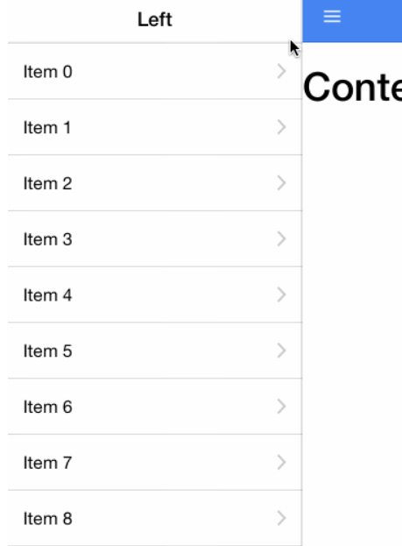
- Stockholders
Through our discussion, we think the students and the app developers are the stockholders. For students, they can learn from SideMenu, knowing how it is designed and use it in practical program. As for app developers, they directly use the frame in the app or modify it to make it perfect.
- Context View
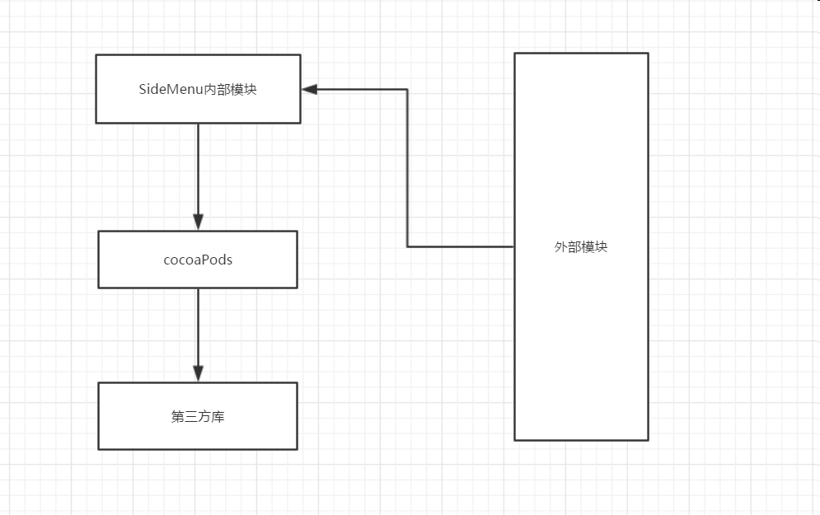

External Module：that is the app which use SideMenu
Internal Module：this is the SideMenu frame, in this module it shows how SideMenu is implemented
CocosPods: CocoaPods is a third class library management tool for OS X and iOS. With the CocoaPods tool, we can add a dependency library called "Pods" to the project and easily manage its version.
Third Class: this is SideMenu dependency library
(to be continued)

- Use case View
