./

Report – Resistor Colour code Calculator

Course Code: <CODE>



Worked By : NIVESH PRATAP KATIYAR

SF-ID : 280439

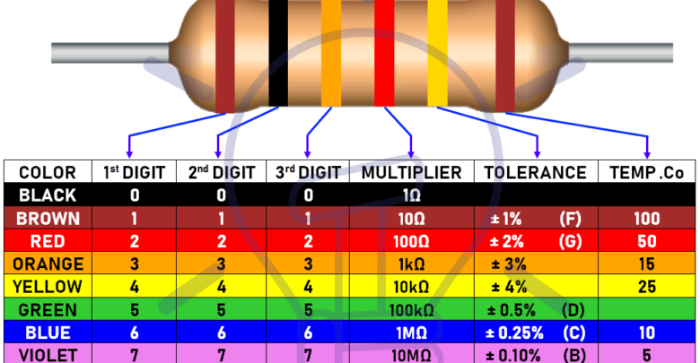

COLOUR CHART

**ABOUT:**

* There are a wide range of sorts of Resistor accessible which can be utilized in both electrical and electronic circuits to control the progression of flow or to deliver a voltage drop from multiple points of view. But in order to perform the work, resistor needs to have some type of "resistive" or "obstruction" values. Resistors are available in wide range of values which are used as per requirements.
* The resistance value, tolerance, and wattage rating are printed in a number or letters on the large size of resistor having high values but in small size of resistor the resistance value, tolerance, and wattage rating are printed in a form of colour band which is called Resistance colour band. This project is based on C programming concepts which is perfectly assembled to find the exact value of resistor in Ohms by using resistor colour code.
* Resistance colour code calculator is a software program used to find the resistance value of the resistor. The entire format of the software is built on C programming language. This main agenda of this software is to find the resistance value of the resistor by using colour code bands. It refers to a number of efficient automated systems designed for calculating the resistance value.

# 