**Name: arjun kulshrestha**

Class: (Bca aiml )1B

Roll No:007

**Q1: What does CSS stand for? Name three types of CSS. List three common properties used in CSS for styling text?**

Ans:

Cascading Style Sheets (CSS) is used to style HTML elements on web pages. It defines how elements are displayed, including layout, colors, fonts, and other properties. CSS targets HTML elements and applies style rules to dictate their appearance.

In this article, we’ll explore three primary types of CSS: *Inline, Internal, and External*. Understanding these methods will help you apply styles effectively and efficiently.

**Three types of CSS:**

**Inline CSS:**Written directly in the Cascading Style Sheets (CSS) is used to style HTML elements on web pages. It defines how elements are displayed, including layout, colors, fonts, and other properties. CSS targets HTML elements and applies style rules to dictate their appearance.

In this article, we’ll explore three primary types of CSS: Inline, Internal, and External. Understanding these methods will help you apply styles effectively and efficiently.

* HTML tag, which applies only to that specific element.
* **Internal CSS:**Placed within the <style> tag in the HTML document’s <head>, applying to that single document.
* **External CSS:**Written in a separate .css file and linked to the HTML, affecting multiple pages.

**Three common properties for styling text**

* font-family: Specifies the font of the text.
* font-size: Sets the size of the text.
* color: Changes the color of the text.

**Q2: Explain the difference between internal, external, and inline CSS.**

1. **Inline CSS**

Applied directly in the HTML tag using the style attribute. It affects only that specific element.

**For example:**



**2.Internal CSS**

Defined within a <style> tag inside the HTML <head>. This style applies to the entire HTML document.

**For example:**



**External CSS**

Stored in a separate .css file and linked to the HTML

document using the <link> tag. This can affect multiple

HTML documents.

**For example:**

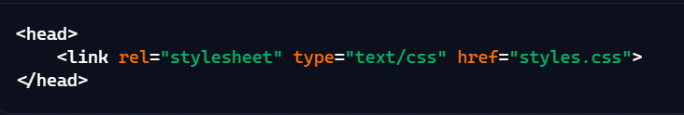

**In styles.css:**

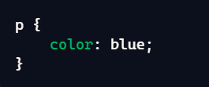

**Q3: How does the position: absolute differ from position: relative?**

**Ans:** **position: absolute** and **position: relative** in CSS define

how elements are placed on a page, but they work

differently**.**

**position: relative**

* Positions the element relative to its original place in the document flow.
* If you set top, right, bottom, or left properties, it moves the element from where it would normally be.

**Example:**

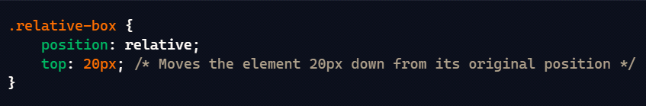

**position: absolute**

* Removes the element from the normal document flow and places it relative to the nearest positioned ancestor (an element with any position value other than static).
* If there’s no such ancestor, it defaults to the <html> element.

**Example:**

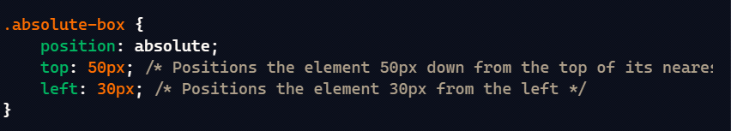

**Q4: Describe the difference between id and class selectors in CSS?**

**Ans:**

**id as Selector:**

* **Uniqueness:** Each id must be unique within a page, used for one element only.
* **Usage:** Often used for elements needing a single, unique identifier, like a navigation bar or footer.
* **Syntax:** Use the hash (#) symbol in CSS.

**Example in CSS:**



**IN HTML:**



**class as Selector:**

* **Reusability:** Classes can be reused on multiple elements throughout a page.
* **Usage:** Great for applying the same style to multiple elements, like buttons, text sections, etc.
* **Syntax:** Use the dot (.) symbol in CSS.

**Example in CSS:**

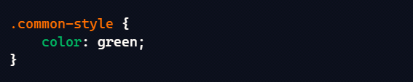

**Example In HTML:**

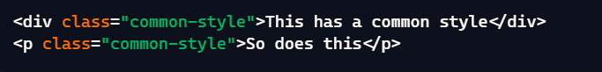

**In short:**  id is for single use, unique styling; class is for

repeatable, reusable styling across multiple elements.

Which one are you currently working with?

**Q5: Use CSS to create a hover effect that changes the text color of a button when a user hovers over it.**

**Ans:** <html>

<head>

<style>

. hover-button {

color: black;

background-color: lightgray;

padding: 10px 20px;

border: none;

cursor: pointer;

}

.hover-button: hover {

color: red;

}

</style>

<title>Button Hover Effect</title>

</head>

<body>

<button class="hover-button">Hover over me! </button></body>

</html>

 

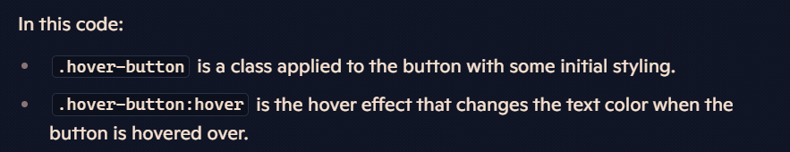

**Q6: Style a form using CSS so that the input fields have a specific width, border color, and padding.**

**<html>**

**<head>**

**<title> Form </title>**

**<style>**

**.styled-1 {**

**width: 600px;**

**border: 2px solid;**

**padding: 10px;**

**margin-border:10px;**

**border-radius: 5px;**

**border-color: red;**

**}**

**</style>**

**</head>**

**<body bgcolor="silver">**

**<h1>FORM</h1>**

**<form class="styled-1">**

**<fieldset>**

**<legend><font color="red" size="5" face="arial"><b>COLLEGE FORM</b></font></legend>**

**<label for="fname" id="name" ><b>Name:</label><br>**

**<input type="text" required>**

**<label for="12th Marks" id="name" class="styled-1"><b> 12th Marks(%):</b></label>**

**<input type="number" max="100" min="33" required/>**

**<b> Upload here</b>**

**<input type="file"/><br>**

**<label for="Email" id=name required>Email:</label><br>**

**<input type="Email"/>**

**<label for="10th Marks" id="name" required class="styled-1" ><b>10th Marks(%):</b></label>**

**<input type="number" max="100" min="33"/>**

**<b> Upload here</b>**

**<input type="file" name="mark sheet"/><br>**

**<label for="Name" id=name>Father's Name:</label><br>**

**<input type="text"/>**

**<font color="red">Charactor certificate</font>**

**<input type="file" required/><br>**

**<label for="Course Name" id=name>Course Name:</label><br>**

**<input type="text"/>**

**<font color="red">Migration certificate</font>**

**<input type="file"/><br><br>**

**<b>Phone No:</b>**

**<input type="text" size="9" maxlength="10" required/>**

**<hr>**

**<b><font size="2" color="red" face="arial"><u> gender</u></font></b><br>**

**<input type="radio" name="gender"/>**

**<label for="gender" name="gender">Male</label>**

**<input type="radio" name="gender"/>**

**<label for="gender" name="gender">female</label>**

**<input type="radio" name="gender"/>**

**<label for="gender" name="gender">others</label><br>**

**<b><font size="2" color="red" face="arial" ><u>Subject</u></font></b><br>**

**<input type="Checkbox"/>**

**<label for="Subject" name="subject">Wt</label>**

**<input type="Checkbox"/>**

**<label for="Subject" name="subject">Dbms</label>**

**<input type="Checkbox"/>**

**<label for="Subject" name="subject">ITPC</label>**

**<input type="Checkbox"/>**

**<label for="Subject" name="subject">Eng</label>**

**<input type="Checkbox"/>**

**<label for="Subject" name="subject">History</label><br>**

**<font color="red" size="2" face="arial"><u>Section</u></font>**

**<select id="section" name="section" required>**

**<option value="A">A</option>**

**<option value="B" selected>B</option>**

**<option value="C">C</option>**

**<option value="D">D</option>**

**</select><br>**

**<b> cars</b>**

**<input list="cars" name="cars">**

**<datalist id="cars">**

**<option value="Volvo">**

**<option value="Alto">**

**<option value="Creta">**

**<option value="Brezza">**

**</datalist>**

**<hr>**

**<lable for="date" name="birth">DOB:</lable>**

**<input type="date" max="2007" min="2003" required/><br><br>**

**<lable for="date" name="birth">Date of joining</lable>**

**<input type="month" id="joining" required/><br>**

**<br>**

**<textarea rows="5" cols="40">Review:</textarea><br><br>**

**<label for="data" name="datalist">datalist:</label>**

**<button>Submit</button>**

**<button>Cancel</button>**

**</fieldset>**

**</form>**

**</body>**

**</html>**

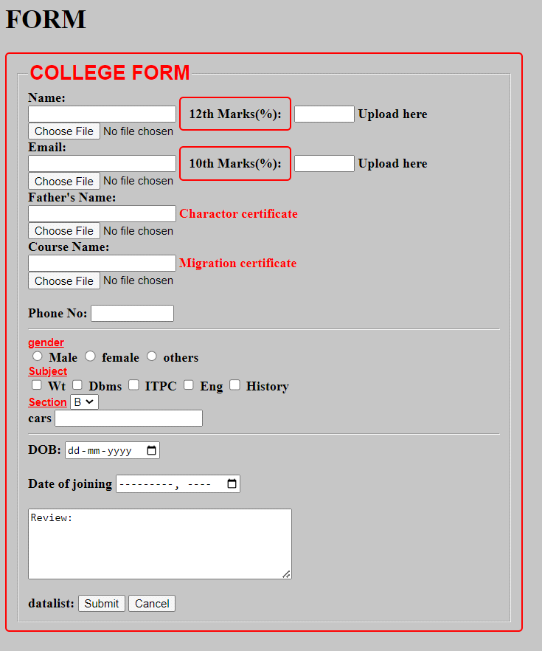

**Q7: Break down the structure of a CSS rule and explain each part of it.**

**Ans: Parts of a CSS Rule:**

* **Selector (p):**This defines the HTML element(s) to which the rule will be applied. In this case, the rule applies to all <p> (paragraph) elements.
* **Declaration Block ({}):**This contains one or more declarations separated by semicolons. Each declaration is made up of a property and a value.
* **Property (color):**This is the aspect of the element that you want to style, such as color, font-size, margin, etc.
* **Value (blue):**This specifies the setting for the property. In this case, the color property is set to blue.

**3.Declaration (color: blue;):**This is a single line within the declaration block that includes a property and a value, ending with a semicolon. Multiple declarations can be used to style multiple properties:

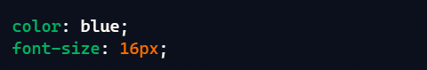

**Q8: Construct a CSS stylesheet for a form that uses advanced selectors, pseudo-classes, and media queries.**

**<html>**

**<head>**

**<style>**

**form > input[type="text"] {**

**width: 100%;**

**padding: 10px;**

**margin: 5px 0;**

**border: 2px solid #333;**

**border-radius: 4px;**

**}**

**form input[type="submit"]:hover {**

**background-color: #4CAF50;**

**color: white;**

**cursor: pointer;**

**}**

**form input[type="text"]:focus {**

**border-color: #555;**

**}**

**input:invalid {**

**border-color: red;**

**}**

**input:valid {**

**border-color: green;**

**}**

**@media (max-width: 600px) {**

**form {**

**display: flex;**

**flex-direction: column;**

**}**

**form input[type="text"] {**

**font-size: 18px;**

**padding: 15px;**

**}**

**}**

**@media (min-width: 601px) and (max-width: 1024px) {**

**form {**

**display: flex;**

**flex-direction: row;**

**justify-content: space-between;**

**}**

**form input[type="text"] {**

**width: 45%;**

**}**

**}**

**</style>**

**</head>**

**<body bgcolor="silver">**

**<h1>FORM</h1>**

**<form>**

**<fieldset>**

**<legend><font color="red" size="5" face="arial"><b>REGISTRATION FORM</b></font></legend>**

**<label for="fname" id=name><b>Name:</label><br>**

**<input type="text" required>**

**<label for="12th Marks" id="name"><b> 12th Marks(%):</b></label>**

**<input type="number" max="100" min="33" required/>**

**<b> Upload here</b>**

**<input type="file"/><br>**

**<label for="Email" id=name required>Email:</label><br>**

**<input type="Email"/>**

**<label for="10th Marks" id="name" required ><b>10th Marks(%):</b></label>**

**<input type="number" max="100" min="33"/>**

**<b> Upload here</b>**

**<input type="file" name="mark sheet"/><br>**

**<label for="Name" id=name>Father's Name:</label><br>**

**<input type="text"/>**

**<font color="red">Charactor certificate</font>**

**<input type="file" required/><br>**

**<label for="Course Name" id=name>Course Name:</label><br>**

**<input type="text"/>**

**<font color="red">Migration certificate</font>**

**<input type="file"/><br><br>**

**<b>Phone No:</b>**

**<input type="text" size="9" maxlength="10" required/>**

**<hr>**

**<b><font size="2" color="red" face="arial"><u> gender</u></font></b><br>**

**<input type="radio" name="gender"/>**

**<label for="gender" name="gender">Male</label>**

**<input type="radio" name="gender"/>**

**<label for="gender" name="gender">female</label>**

**<input type="radio" name="gender"/>**

**<label for="gender" name="gender">others</label><br>**

**<b><font size="2" color="red" face="arial" ><u>Subject</u></font></b><br>**

**<input type="Checkbox"/>**

**<label for="Subject" name="subject">Wt</label>**

**<input type="Checkbox"/>**

**<label for="Subject" name="subject">Dbms</label>**

**<input type="Checkbox"/>**

**<label for="Subject" name="subject">ITPC</label>**

**<input type="Checkbox"/>**

**<label for="Subject" name="subject">Eng</label>**

**<input type="Checkbox"/>**

**<label for="Subject" name="subject">History</label><br>**

**<font color="red" size="2" face="arial"><u>Section</u></font>**

**<select id="section" name="section" required>**

**<option value="A">A</option>**

**<option value="B" selected>B</option>**

**<option value="C">C</option>**

**<option value="D">D</option>**

**</select><br>**

**<hr>**

**<lable for="date" name="birth">DOB:</lable>**

**<input type="date" max="2007" min="2003" required/><br><br>**

**<lable for="date" name="birth">Date of joining</lable>**

**<input type="month" id="joining" required/><br>**

**<br>**

**<textarea rows="5" cols="40">Review:</textarea><br><br>**

**<button>Submit</button>**

**<button>Cancel</button>**

**</fieldset>**

**</form>**

**</body>**

**</html>**

