目录

创建数据库jxsk： - 1 -
创建jxsk中的表： - 1 -
插入jxsk库中各表值： - 1 -
创建数据库jiaoxuedb： - 3 -
创建jiaoxuedb中的表： - 3 -
插入jiaoxuedb库中各表值： - 3 -
实验4：习题 - 5 -
实验5：习题 - 7 -
实验6：习题 - 7 -
实验7：习题 - 8 -
实验8：习题 - 12 -
实验9：习题 - 17 -
实验10：习题 - 20 -
实验11：习题 - 23 -
实验12：习题 - 26 -
实验13：习题 - 38 -

创建数据库jxsk：
create database jxsk
on
(name=jxsk_dat,filename='d:\jxsk_dat.mdf')
log on
(name=jxsk_log,filename='d:\jxsk_log.ldf')
go

创建jxsk中的表：
use jxsk
create table s(
sno char(2) not null,
sn char(8) not null,
sex char(2) null,
age tinyint null,
dept char(10) null)
create table t(
tno char(2) not null,
tn char(8) not null,
sex char(2) null,
age tinyint null,
prof char(10) null,
sal smallint null,
comm smallint null,
dept char(10) null)
create table c(
cno char(2) not null,
cn char(10) not null,
ct tinyint null,
id_tc tinyint null)
create table sc(
sno char(2) not null,
cno char(2) not null,
score tinyint null)
create table tc(
tno char(2) not null,
cno char(2) not null)

插入jxsk库中各表值：
use jxsk

insert into s values('s2','钱尔','男',18,'信息')
insert into s values('s3','孙姗','女',20,'信息')
insert into s values('s4','李思','男',21,'自动化')
insert into s values('s5','周武','男',19,'计算机')
insert into s values('s6','吴丽','女',20,'自动化')
insert into s values('s7','李奇','男',18,'外语')
insert into s values('s8','古明','男',null,'计算机')
insert into s values('s9','赵亦','女',17,'计算机')

insert into t values('t5','张兰','女',39,'副教授',1300,2000,'信息')
insert into t values('t4','张雪','女',51,'教授',1600,3000,'自动化')
insert into t values('t3','刘伟','男',30,'讲师',900,1200,'计算机')
insert into t values('t2','王平','女',28,'讲师',800,1200,'信息')
insert into t values('t1','李力','男',47,'教授',1500,3000,'计算机')

insert into c values('c1','程序设计',60,1)
insert into c values('c2','微机原理',80,2)
insert into c values('c3','数字逻辑',60,3)
insert into c values('c4','数据结构',80,4)
insert into c values('c5','数据库',60,5)
insert into c values('c6','编译原理',60,6)
insert into c values('c7','操作系统',60,7)

insert into sc values('s2','c5',57)
insert into sc values('s2','c6',80)
insert into sc values('s2','c7',null)
insert into sc values('s3','c1',75)
insert into sc values('s3','c2',70)
insert into sc values('s3','c4',85)
insert into sc values('s4','c1',93)
insert into sc values('s4','c2',85)
insert into sc values('s4','c3',83)
insert into sc values('s5','c2',89)
insert into sc values('s9','c1',90)
insert into sc values('s9','c2',85)

insert into tc values('t2','c5')
insert into tc values('t3','c1')
insert into tc values('t3','c5')
insert into tc values('t4','c2')
insert into tc values('t4','c3')
insert into tc values('t5','c5')
insert into tc values('t5','c7')
insert into tc values('t1','c1')
insert into tc values('t1','c4')

创建数据库jiaoxuedb：
create database jiaoxuedb
on
(name=jiaoxuedb_dat,filename='d:\jiaoxuedb_dat.mdf')
log on
(name=jiaoxuedb_log,filename='d:\jiaoxuedb_log.ldf')
go

创建jiaoxuedb中的表：
use jiaoxuedb
create table student(
sno char(10) not null,
sname char(10) not null,
sex char(2) null,
age tinyint null,
dept char(10) null)
create table teacher(
tno char(10) not null,
tname char(10) not null,
sex char(2) null,
age tinyint null,
prof char(10) null,
sal smallint null,
comm smallint null,
dept char(10) null)
create table course(
cno char(10) not null,
cname char(10) not null,
chour tinyint null,
ccredit tinyint null)
create table sc(
sno char(10) not null,
cno char(10) not null,
score tinyint null)
create table tc(
tno char(10) not null,
cno char(10) not null)

插入jiaoxuedb库中各表值：
use jiaoxuedb

/*insert values to student table*/
insert into student values('001101','宋大方','男',19,'计算机')
insert into student values('002102','李王','男',20,'信息')
insert into student values('991101','张彬','男',18,'计算机')
insert into student values('991102','王蕾','女',19,'计算机')
insert into student values('991103','张建国','男',18,'计算机')
insert into student values('991104','李平方','男',18,'计算机')
insert into student values('991201','陈东辉','男',19,'计算机')
insert into student values('991202','葛鹏','男',21,'计算机')
insert into student values('991203','潘桃芝','女',19,'计算机')
insert into student values('991204','姚一峰','男',18,'计算机')
insert into student values('001102','许辉','女',22,'计算机')
insert into student values('001201','王一山','男',20,'计算机')
insert into student values('001202','牛莉','女',19,'计算机')
insert into student values('002101','李丽丽','女',19,'信息')

/*insert values to teacher table*/
insert into teacher values('000006','许红霞','女',39,'讲师',1100,1200,'计算机')
insert into teacher values('000007','许永军','男',57,'教授',2000,3000,'计算机')
insert into teacher values('000008','李贵青','女',65,'教授',2000,3000,'计算机')
insert into teacher values('000009','王一凡','女',43,'讲师',1200,1200,'计算机')
insert into teacher values('000010','田峰','男',33,'助教',500,800,'信息')
insert into teacher values('000001','李英','女',39,'副教授',1500,2000,'信息')
insert into teacher values('000002','张雪','女',51,'教授',1900,3000,'信息')
insert into teacher values('000003','张朋','男',30,'讲师',1000,1200,'计算机')
insert into teacher values('000004','王平','女',28,'讲师',850,1200,'信息')
insert into teacher values('000005','李力','男',47,'教授',1800,3000,'计算机')

/*insert values to course table*/
insert into course values('01001','计算机基础',60,3)
insert into course values('01002','程序设计',80,5)
insert into course values('02003','数据结构',60,6)
insert into course values('02001','数据库',80,6)
insert into course values('02002','计算机网络',60,6)
insert into course values('01003','微机原理',60,8)
insert into course values('02004','操作系统',60,6)
insert into course values('03001','软件工程',60,3)
insert into course values('03002','大型数据库',48,2)
insert into course values('03003','图像处理',48,2)

/*insert values to sc table*/
insert into sc values('991101','01001',88)
insert into sc values('991102','01001',93)
insert into sc values('991103','01001',90)
insert into sc values('991101','01002',90)
insert into sc values('991102','01002',98)
insert into sc values('991103','01002',74)
insert into sc values('991104','01002',85)
insert into sc values('001201','01002',64)
insert into sc values('991104','02001',33)
insert into sc values('991104','01001',35)
insert into sc values('991201','01001',76)

/*insert values to tc table*/
insert into tc values('000001','02001')
insert into tc values('000008','02002')
insert into tc values('000003','02001')
insert into tc values('000011','02003')
insert into tc values('000001','01001')
insert into tc values('000002','01002')
insert into tc values('000002','01003')
insert into tc values('000004','02002')
insert into tc values('000005','01001')
insert into tc values('000006','01002')
insert into tc values('000003','01003')

实验4：习题
基于jiaoxuedb实验
- 对个表创建实体完整性；
use jiaoxuedb

alter table student
add constraint pk_sno primary key(sno)

alter table teacher
add constraint pk_tno primary key(tno)

alter table course
add constraint pk_cno primary key(cno)

alter table student
add constraint unique_s unique(sno)

alter table teacher
add constraint unique_t unique(tno)

alter table course
add constraint unique_c unique(cno)

- 创建表之间的参照完整性。
use jiaoxuedb
alter table sc with nocheck
add constraint fk_s_sc foreign key(sno) references student(sno)
on delete cascade

alter table sc with nocheck
add constraint fk_c_sc foreign key(cno) references course(cno)
on delete cascade

alter table tc with nocheck
add constraint fk_t_tc foreign key(tno) references teacher(tno)
on delete cascade

alter table tc with nocheck
add constraint fk_c_tc foreign key(cno) references course(cno)
on delete cascade

- 用不同的方法创建下面约束。
- “姓名”字段取唯一值：
use jiaoxuedb
alter table student
add constraint unique_sna unique(sname)
alter table teacher
add constraint unique_tna unique(tname)

(2) “性别”字段取值为：‘男’或‘女’；默认值：‘男’；
use jiaoxuedb

alter table teacher with check
add constraint check_t_sex check(sex='男' or sex='女')
alter table teacher
add constraint df_t_sex default '男' for sex

alter table student with check
add constraint check_s_sex check(sex='男' or sex='女')
alter table student
add constraint df_s_sex default '男' for sex

（3）“年龄”和“分数”字段取值限定为：0~100之间。
use jiaoxuedb

alter table student with check
add constraint check_s_age check(age>0 and age<100)
alter table teacher with check
add constraint check_t_age check(age>0 and age<100)

实验5：习题
- 对教师表teacher中的教师号tno创建聚族索引，并按降序排列。
use jiaoxuedb
create clustered index ind_tno
on teacher(tno desc)

- 对学生选课表sc，先按课号cno升序排列，再按成绩score降序排列。
cno升序：
use jiaoxuedb
create clustered index ind_sc_cno on sc(cno asc)
score降序：
use jiaoxuedb
create clustered index ind_sc_score on sc(score desc)

- 对表student中的学号sno创建唯一索引，并按升序排列。
use jiaoxuedb
create unique index ind_s_sno on student(sno asc)

实验6：习题
基于jiaoxuedb实验
1、创建成绩视图score_view,包含学号sno,姓名sn，课程名cn，成绩score。
use jiaoxuedb
go
create view score_view
as select student.sno,sname,cname,score
from student,course,sc
where student.sno=sc.sno and sc.cno=course.cno
go

2、创建一个计算机系学生名单视图s_view，包含学号sno，姓名sn，性别sex。
use jiaoxuedb
go
create view s_view
as select sno,sname,sex
from student
where dept='计算机'
go

- 通过上面的视图，修改学号为991102，课号为01001的成绩记录。
use jiaoxuedb
update score_view set score=100
where sno='991102' and cname=
(select cname from course where cno='01001')
go

5、创建一个视图，计算机系学生的成绩单score_view_cdept,版含学号sno，姓名sn，课程名cn，成绩score。
use jiaoxuedb
go
create view score_view_cdept
as select student.sno,sname,cname,score
from student,course,sc
where student.dept='计算机'
and student.sno=sc.sno
and sc.cno=course.cno
go

6、给视图s_view增加一个年龄age字段。
use jiaoxuedb
go
alter view s_view
as select sno,sname,sex,age
from student
where dept='计算机'
go

7、创建一个教师工资表视图sal_view，版含字段教师名tname，性别sex，职称prof，工资总和salsum，系别dept。
use jiaoxuedb
go
create view sal_view
as select tname,sex,prof,sal+comm as salsum
from teacher
go

8、通过视图查询教师“张明”的工资收入。
use jiaoxuedb
select tname,salsum
from sal_view
where tname='张朋'
go

实验7：习题
基于jiaoxuedb实验
- 查询成绩在80~90之间的记录。
select student.sno,sname,dept,course.cno,score
from student,sc,course
where student.sno=sc.sno
and sc.score between 80 and 90
and sc.cno=course.cno;

- 查询至少有4个同学选修的课程名。
use jiaoxuedb
select cno as 课程号,cname as 课程名
from course
where cno=any
(select
cno as 课程号
from sc
group by cno
having count(*)>=4)
go

- 查询其他系中比“信息系”所有学生年龄都打的学生名单及年龄，并按年龄降序输出。
use jiaoxuedb
select sno as 学号,sname as 姓名,age as 年龄,dept as 专业
from student
where age>all
(select age
from student
where dept='信息')
and dept <> '信息'
order by age desc
go

- 查询与学生张建国同岁的所有学生的学号、姓名和系别。
/*方法一*/
use jiaoxuedb
select sno as 学号,sname as 姓名,age as 年龄,dept as 专业
from student
where age=any
(select age
from student
where sname='张建国')
and sname <> '张建国'
order by age desc
go
/*方法二*/
use jiaoxuedb
select s2.sno,s2.sname,s2.dept
from student s1, student s2
where s1.age=s2.age and s1.sname='张建国' and s2.sname <> '张建国'

- 查询选修了2门以上课程的学生名单。
use jiaoxuedb
select sno as 学号,sname as 姓名,age as 年龄,dept as 专业
from student
where sno=any
(select sno
from sc
group by sno
having count(*) >=2)
go

- 查询至少有一门与“张建国”选课相同的学生的姓名、课程名和系别。
use jiaoxuedb
select sno as 学号,sname as 姓名,age as 年龄,dept as 专业
from student
where sno=any
(select sno
from sc
where cno=any
(select cno
from sc
where sno=’991103’))
and sname <> '张建国'
go

- 查询成绩比该课程平均成绩高的学生的成绩表。
/*方法一*/
use jiaoxuedb
select sno as 学号,sname as 姓名,age as 年龄,dept as 专业
from student
where sno=any
(select sno
from sc x
where score >=
(select avg(score)
from sc y
where y.sno=x.sno));
go
/*方法二*/
select *
from sc sc1
where score >
(select avg(score)
from sc sc2)
and sc1.cno=sc2.cno;
go

- 查询选修课号为01001课程且成绩高于课程01002学生的姓名、此两门课程的k而成名和成绩。
/*方法一*/
use jiaoxuedb
select sname,cname,score
from student ,sc,course
where student.sno=
(select s1.sno
from sc s1,sc s2
where s1.cno='01001' and s2.cno='01002' and s1.score>s2.score and s1.sno=s2.sno)
and sc.sno=student.sno
and course.cno=sc.cno
go
/*方法二*/
use jiaoxuedb
select sname,cname,score
from student ,sc,course
where student.sno=
(select sno
from sc x
where score >=
(select avg(score)
from sc y
where y.sno=x.sno
and x.cno='01001'
and y.cno='01002')
and sc.sno=student.sno
and course.cno=sc.cno)
go

9、查询所有未修01001号课程的学生名单。
use jiaoxuedb
select student.sno,sname
from student
where student.sno in
(select s1.sno
from sc s1
where sno not in
(select s2.sno
from sc s2
where cno='01001'))
go

10、查询每个同学各门课程的平均成绩和最高成绩，按降序排列输出姓名、平均成绩、最高成绩。
use jiaoxuedb
select sname as 姓名,avg(score) as 平均,max(score) as 最高
from student,sc
where student.sno=sc.sno
group by sname
order by sname desc
go

11、查询所有学生都选修了的课程号和课程名。
use jiaoxuedb
select cname as 课程号,cno as 课程名
from course
where not exists
(select *
from student
where not exists
(select * from sc
where student.sno=sc.sno and sc.cno=course.cno));
go

12、查询选修了991102号学生选修了的课程的学生学号和姓名。
use jiaoxuedb
select distinct sno from sc s1 where not exists(select * from sc s2 where sno='991101' and not exists(select * from sc s3 where s1.sno=s3.sno and
s2.cno=s3.cno))
go

实验8：习题
基于jiaoxuedb实验：
1、利用学生名查询该生选修的课程名、成绩、任课教师名。
--创建存储过程
if exists (select name from sysobjects where name='pro_sn' and type='p')
drop procedure pro_sn
go
create procedure pro_sn
@sname_in char(10)
as select student.sname 学生,cname 选修课程,score 分数,tname 教师
from student,sc,teacher,course,tc
where student.sname=@sname_in
and sc.sno=student.sno
and sc.cno=course.cno
and sc.cno=tc.cno
and tc.cno=course.cno
and tc.tno=teacher.tno
go
--执行存储过程
use jiaoxuedb
declare
@sname_in char(10)
select @sname_in='王蕾'
exec pro_sn @sname_in

2、查询某系的学生的最大年龄和最小年龄。
--创建存储过程
if exists (select name from sysobjects where name='pro_age_max_min' and type='p')
drop procedure pro_age_max_min
go
create procedure pro_age_max_min
@sdept_in char(10)
as select dept 系别,max(age) 最大年龄,min(age) 最小年龄
from student
where dept=@sdept_in
group by dept
go
--执行存储过程
use jiaoxuedb
declare
@sdept_in char(10)
select @sdept_in='计算机'
exec pro_age_max_min @sdept_in

3、利用学生姓名和课程名检索该生课程的成绩。
--创建存储过程
if exists (select name from sysobjects where name='pro_qscore' and type='p')
drop procedure pro_qscore
go
create procedure pro_qscore
@sname_in char(10),
@scname_in char(10)
as select sname 学生姓名,cname 课程名,score 分数
from student,sc,course
where student.sname=@sname_in
and course.cname=@scname_in
and sc.sno=student.sno
and sc.cno=course.cno
go
--执行存储过程
use jiaoxuedb
declare
@sname_in char(10),
@scname_in char(10)
select @sname_in='王蕾'
select @scname_in='程序设计'
exec pro_qscore @sname_in,@scname_in

4、根据职称查询人数，并给出“副教授”的人数。
--创建存储过程
if exists (select name from sysobjects where name='pro_prof_count' and type='p')
drop procedure pro_prof_count
go
create procedure pro_prof_count
@prof_in char(10)
as select prof 职称,count(prof) 人数
from teacher
where prof=@prof_in
group by prof
go
--执行存储过程
use jiaoxuedb
declare
@prof_in char(10)
select @prof_in='副教授'
exec pro_prof_count @prof_in
副教授 1

5、统计某系某职称的人数平均年龄、平均工资最高工资。
--创建存储过程
if exists (select name from sysobjects where name='pro_dept_prof' and type='p')
drop procedure pro_dept_prof
go
create procedure pro_dept_prof
@dept_in char(10),
@prof_in char(10)
as select dept 系别,prof 职称,
count(*) 人数,avg(age) 平均年龄,
avg(sal) 平均工资,max(sal) 最高工资
from teacher
where dept=@dept_in and prof=@prof_in
group by dept,prof
go
--执行存储过程
use jiaoxuedb
declare
@dept_in char(10),
@prof_in char(10)
select @dept_in='计算机'
select @prof_in='教授'
exec pro_dept_prof @dept_in,@prof_in

6、查询某系的教师人数、平均年龄和学生人数。
--创建存储过程
if exists (select name from sysobjects where name='pro_dept_count' and type='p')
drop procedure pro_dept_count
go

create procedure pro_dept_count
@dept_in char(10)
as select dept,count(teacher.dept) 教师人数,avg(age) 教师平均年龄
into #a
from teacher
where teacher.dept=@dept_in
group by dept

select dept,count(student.dept) 学生人数
into #b
from student
where dept=@dept_in
group by dept

select #a.dept 系别,教师人数,教师平均年龄,学生人数
from #a,#b
where #a.dept=#b.dept

go
--执行存储过程
use jiaoxuedb
declare
@dept_in char(10)
select @dept_in='信息'
exec pro_dept_count @dept_in

7、利用课程名查询选修该课程的学生姓名、系别、成绩，并给出“程序设计”课程的该查询信息。
--创建存储过程
if exists (select name from sysobjects where name='pro_cname' and type='p')
drop procedure pro_cname
go
create procedure pro_cname
@cname char(10)
as select sname,sex,dept,score
from student,sc,course
where cname=@cname
and sc.cno=course.cno
and sc.sno=student.sno
go
--执行存储过程
use jiaoxuedb
declare
@cname char(10)
select @cname='程序设计'
exec pro_cname @cname
张彬 男 计算机 90
王蕾 女 计算机 98
张建国 男 计算机 74
李平方 男 计算机 85
王一山 男 计算机 64

8、利用教师姓名和课程名检索该教师该任课的课程名、课时数、选课人数、平均成绩、最高成绩，并查询教师“张雪”的“微机原理”课程的情况记录。
--创建存储过程
if exists (select name from sysobjects where name='pro_tname_cname' and type='p')
drop procedure pro_tname_cname
go

create procedure pro_tname_cname
@tname char(10),
@cname char(10)
as select tname,cname,sum(chour) 课时数,count(sno) 选课人数,avg(score) 平均成绩
from teacher,course,sc,tc
where tname=@tname
and cname=@cname
and tc.tno=teacher.tno
and tc.cno=course.cno
and sc.cno=course.cno
group by tname,cname
go
--执行存储过程
use jiaoxuedb
declare
@tname char(10),
@cname char(10)
select @tname='张雪'
select @cname='微机原理'
exec pro_tname_cname @tname,@cname
没有学生选“微机原理”这门课程，故课时数，选课人数，平均成绩，统统为零。

9、删除上面第1题创建的存储过程。
use jiaoxuedb
drop procedure pro_sn

10、删除上面第3、4题创建的存储过程。
use jiaoxuedb
drop procedure pro_qscore
drop procedure pro_prof_count

实验9：习题
基于jxsk实验：
1、为表sc创建一触发器：当插入或修改一个记录时，确保此记录的成绩在0~100之间。
use jxsk
go
if exists (select name from sysobjects where name='score_sc_tri' and type='tr')
drop trigger score_sc_tri
go
create trigger score_sc_tri
on sc for insert,update
as
declare @score_read tinyint
select @score_read=score from inserted
if @score_read < 0 or @score_read > 100
begin
print '成绩超出0~100！请重新输入。'
rollback transaction
end
go

2、为教师表t创建一触发器：男职工年龄不能超过60周岁，女职工职称是“教授”的年龄不能超过60岁，其他女职工年龄不能超过55岁。
use jxsk
go
if exists (select name from sysobjects where name='age_t_tri' and type='tr')
drop trigger age_t_tri
go
create trigger age_t_tri
on t for insert,update
as
declare @sex_read char(2)
declare @age_read tinyint
declare @prof_read char(10)

select @sex_read=sex from inserted
select @age_read=age from inserted
select @prof_read=prof from inserted

if ( @sex_read = '男' and @age_read > 60 )
or (@sex_read = '女' and @prof_read = '教授' and @age_read > 60)
or (@sex_read = '女' and @prof_read <> '教授' and @age_read > 60)
begin
print '数据不合法。'
rollback transaction
end
go

3、为表c、表tc和表sc创建参照完整性：级联删除和级联修改触发器。
--级联删除
use jxsk
go
if exists (select name from sysobjects where name='dc_sc_tc' and type='tr')
drop trigger dc_sc_tc
go
create trigger dc_sc_tc
on c for delete
as
declare @cno_del char(2)
select @cno_del=cno from deleted
delete from sc where cno=@cno_del
delete from tc where cno=@cno_del
go
--级联更新
use jxsk
go
if exists (select name from sysobjects where name='uc_sc_tc' and type='tr')
drop trigger uc_sc_tc
go
create trigger uc_sc_tc
on c for update
as
declare @cno_old char(2)
declare @cno_new char(2)
select @cno_old=cno from deleted
select @cno_new=cno from inserted
update sc set cno=@cno_new where cno=@cno_old
update tc set cno=@cno_new where cno=@cno_old
go
--验证级联删除
use jxsk
delete from c where cno='c2'
go
--验证级联更新
use jxsk
update c set cno='c0' where cno='c1'
go

4、为表t创建一个触发器：当职称从“讲师”晋升为“副教授”时，岗位津贴自动增加500元；从“副教授”晋升为“教授”时，岗位津贴自动增加900元。
use jxsk
go
if exists (select name from sysobjects where name='ut' and type='tr')
drop trigger ut
go
create trigger ut
on t for update
as
declare @prof_old char(10)
declare @prof_new char(10)
declare @tno char(2)

select @prof_old=prof from deleted
select @prof_new=prof from inserted
select @tno=tno from deleted
if @prof_old='讲师' and @prof_new='副教授'
begin
update t set comm=comm+500 where tno=@tno
end

if @prof_old='副教授' and @prof_new='教授'
begin
update t set comm=comm+900 where tno=@tno
end

go

- 为表sc创建一触发器，将成绩按下列对应关系由分数转换成等级；
（×题目有错：原sc表score列数据类型定义为tinyint无法转换成“不及格”，“及格”，“中”……等char型的数据）
小于60：不及格
60~70：及格
70~80：中
80~90：良
90~100：优
use jxsk
go
create trigger usc
on sc for update,insert
as
declare @sno char(2)
declare @score tinyint

select @sno=sno from sc
select @score=score from sc

if @score < 60
begin
update sc set score='不及格' where sno=@sno
end

if @score > 60 and @score < 70
begin
update sc set score='及格' where sno=@sno
end

if @score > 70 and @score < 80
begin
update sc set score='中' where sno=@sno
end

if @score > 80 and @score < 90
begin
update sc set score='良' where sno=@sno
end

if @score > 90 and @score < 100
begin
update sc set score='优' where sno=@sno
end

go

实验10：习题
基于jxsk实验
1、求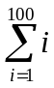
declare @sum smallint,@i smallint
set @sum=0
set @i=1
while (@i <= 100)
begin
set @sum = @sum + @i
set @i = @i + 1
end
print '总和是：'+str(@sum)

2、求 10!
declare @n int,@i smallint
set @n=1
set @i=2
while (@i <= 10)
begin
set @n = @n * @i
set @i = @i + 1
end
print '10! ='+str(@n)

3、查询各系的教师人数、学生人数，并按学生人数和教师人数升序排列。
use jxsk
select s.dept,count(distinct tno) "教师数",count(distinct sno) "学生数"
from t full join s
on s.dept=t.dept
group by s.dept
order by "教师数" asc,"学生数" asc
go

4、查询姓王学生的总人数及在各系的人数分布以及每个人的姓名、姓名、年龄。
use jxsk
select dept as 系别,sn as 姓名,sex as 性别,age as 年龄
from s
where sn like '王%'
order by dept,sn,sex,age
compute count(sn) by dept
compute count(sn)
go

5、查询学生中重名的名字，人数和分布在几个系中，并按重名人数降序排列。
use jxsk
select s1.sn as 姓名,s1.dept as 系别
from s s1,s s2
where s1.sn=s2.sn and s1.sno <> s2.sno
order by s1.dept,s1.sn
compute count(s1.sn) by s1.dept
compute count(s1.sn)
go

6、求出每个职称中工资最高、最低教师的姓名、性别、年龄、工资，并给出各职称的平均工资。职称有：助教、讲师（包括工程师）、副教授（包括高级工程师）、教授（包括研究员）。
use jxsk
select prof,tn as 姓名,sex,age,sal+comm as 工资
from t
order by prof
compute max(sal+comm) by prof
compute min(sal+comm) by prof
compute avg(sal+comm) by prof
go

7、按分数段查询课程名、各分数段人数。分数段划分：60分以下、60~70、70~80、80~90、90~100。
use jxsk
select cn as 课程名,count(*) as '60以下人数'
from c,sc
where sc.cno = c.cno and score < 60
group by cn

select cn as 课程名,count(*) as '60~70人数'
from c,sc
where sc.cno = c.cno and score > 60 and score < 70
group by cn

select cn as 课程名,count(*) as '70~80人数'
from c,sc
where sc.cno = c.cno and score > 70 and score < 80
group by cn

select cn as 课程名,count(*) as '80~90人数'
from c,sc
where sc.cno = c.cno and score > 80 and score < 90
group by cn

select cn as 课程名,count(*) as '90~100人数'
from c,sc
where sc.cno = c.cno and score > 90 and score < 100
group by cn
go

8、教师“刘伟”已调离该校，要求删除骄傲学数据库jxsk中与刘伟有关的信息，并列出这些被删除的信息。
use jxsk
select tno,tn,sex,age,prof,sal,comm,dept
from t
where tn='刘伟'
delete from t
where tn='刘伟'
go

9、查询比教师“张雪”工资低的教师的姓名、性别、出生日期、职称、工资。要求先列出“张雪”的姓名、性别、出生日期、职称和工资。然后依次列出所有查询得到的教师的信息。
use jxsk
(select tn as 姓名,sex as 性别,2008-age as 出生日期, prof as 职称, sal+comm as 工资
from t
where tn = '张雪')
union
(select t1.tn as 姓名,t1.sex as 性别,2008-t1.age as 出生日期, t1.prof as 职称, t1.sal+t1.comm as 工资
from t t1,t t2
where t2.tn = '张雪' and t1.tn <> '张雪'and (t1.sal+t1.comm) < (t2.sal+t2.comm))
order by (sal+comm) desc
go

10、查询每位教师的姓名、职称、课程数、总课时数，并按课时数降序排列。
use jxsk
select distinct tn as 姓名, prof as 职称,cn as 课程,ct as 课时
from t,c,tc
where t.tno=tc.tno and tc.cno=c.cno
order by tn,ct desc
compute sum(ct) by tn
compute sum(ct)
go

实验11：习题
基于jiaoxuedb实验
1、用sql语句创建一用户定义的数据类型agetype。要求：系统数据类型为tinyint，可为空，取值范围是0~100，用于学生表和教师表中的年龄字段和选课表中成绩字段的数据类型。
use jiaoxuedb
go
exec sp_addtype agetype,'tinyint','null'
go
create rule ru_agetype as @agetype between 0 and 100
go
exec sp_bindrule 'ru_agetype','agetype'
go

2、用企业管理器创建数据类型nametype。要求：系统数据类型为varchar，长度10个字节，不能为空，用于教师名，学生名，职称字段的数据类型。
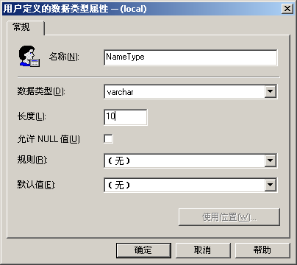
--tsql
use jiaoxuedb
go
exec sp_addtype nametype,'varchar (10)','not null'
go

3、创建一个函数，要求：根据学生姓名和课程名查询该生该课程的成绩。
--创建函数
use jiaoxuedb
go
create function score_fun (@sname_in char(10), @cname_in char(10))
returns tinyint
as
begin
declare @score_out tinyint
select @score_out=score
from sc,student,course
where student.sname=@sname_in and course.cname=@cname_in and student.sno=sc.sno and course.cno=sc.cno
return (@score_out)
end
go
--执行函数
use jiaoxuedb
declare @s_score tinyint

exec @s_score=score_fun '张建国','程序设计'
print '张建国 的 程序设计 成绩是：'+str(@s_score)
go

4、创建一个函数，要求：根据教师姓名查询该教师所教课程名、学生人数、平均成绩、最高成绩、最低成绩。
--创建函数
use jiaoxuedb
go
use jiaoxuedb
go
create function t_sc_fun (@tname_in char(10))
returns table
as
return (select cname as 课程名,count(sno) as 学生人数,avg(score) as 平均成绩,max(score) as 最高成绩,min(score) as 最低成绩
from teacher,tc,course,sc
where @tname_in=teacher.tname and teacher.tno=tc.tno
and course.cno=tc.cno and sc.cno=tc.cno
group by cname)
go
--执行函数
use jiaoxuedb
declare @tname_in char(10)
select * from t_sc_fun ('李英')
go

5、创建一个函数，要求：统计各系个支撑的总人数、男女人数、平均年龄。
--创建函数
use jiaoxuedb
go
create function t_prof_fun (@prof_in char(10))
returns @t_prof_table table (职称 char(10) ,人数 tinyint,
男性人数 tinyint,女士人数 tinyint,均年龄 tinyint)
as
begin
declare @man tinyint
declare @female tinyint

insert @t_prof_table
select prof,count(tno),
man=(select count(*) as man from teacher where @prof_in=prof and sex='男' group by prof),
female=(select count(*) as female from teacher where @prof_in=prof and sex='女' group by prof),
avg(age) as 平均年龄
from teacher
where @prof_in=teacher.prof
group by prof
return
end
go
--执行函数
use jiaoxuedb
select * from t_prof_fun ('讲师')
go

实验12：习题
1、创建一个windows认证的登陆账号newuser，只允许该用户对数据库jiaoxuedb查询。
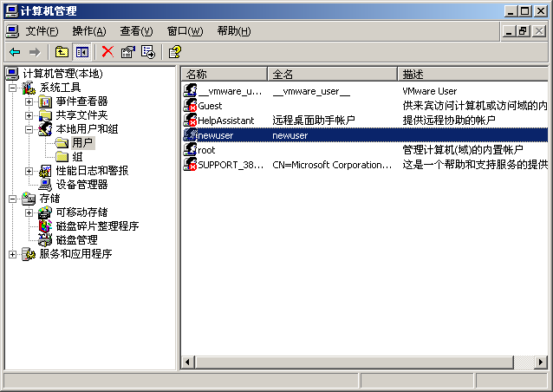
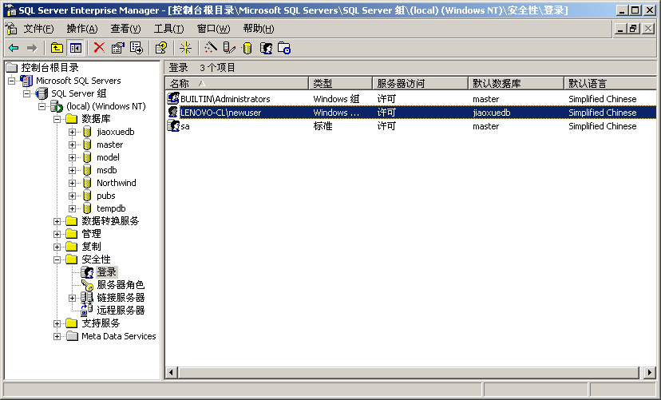
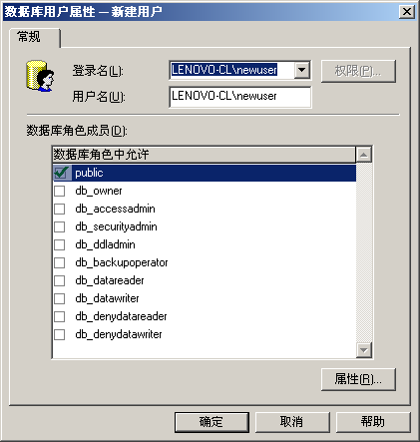
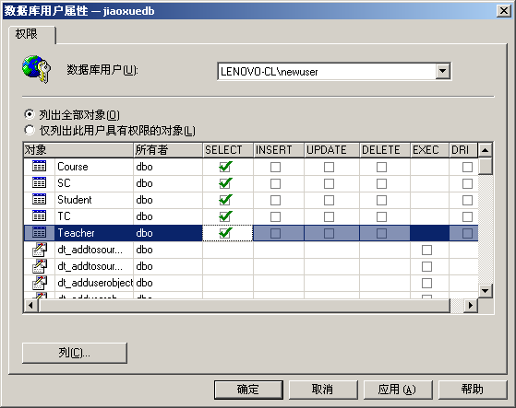

2、创建一个windows认证的登陆账号student，并将其设置为系统管理员帐号。
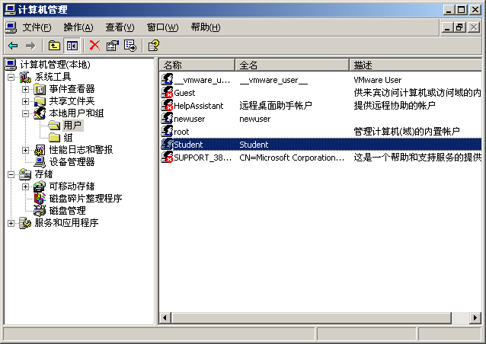
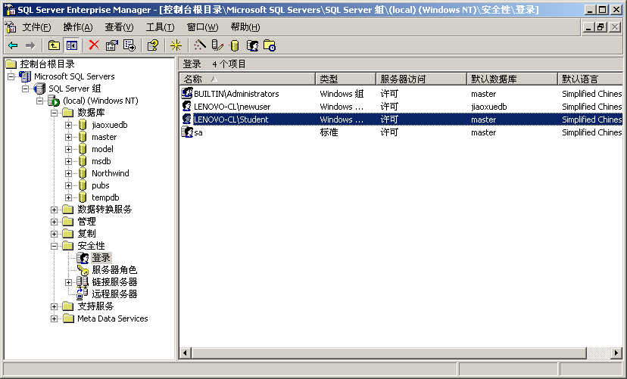
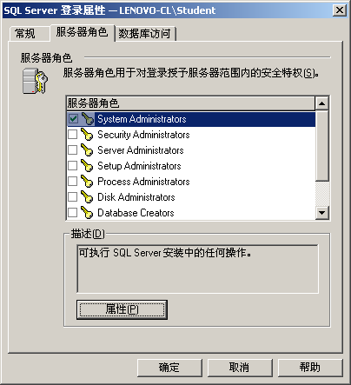

3、创建一个sql server认证的登陆账号sqlteacher，并将其设置允许使用数据库jiaoxuedb进行查询，对表sc中的列score进行插入，修改，删除操作。
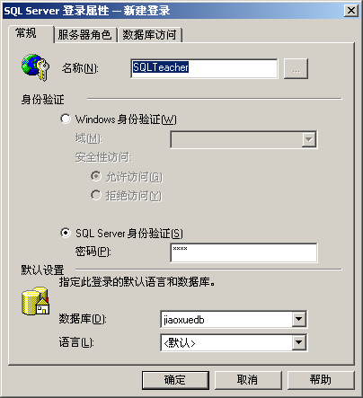
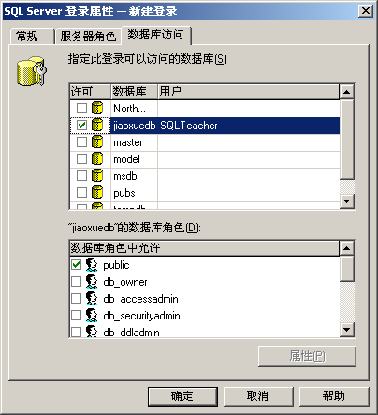
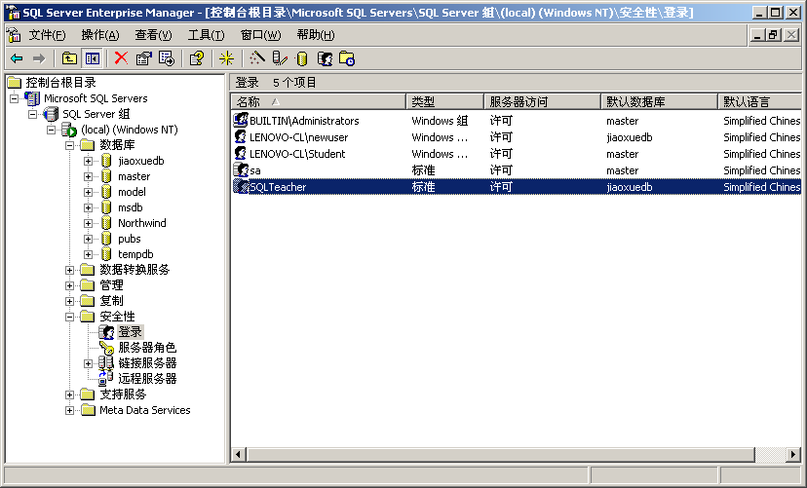
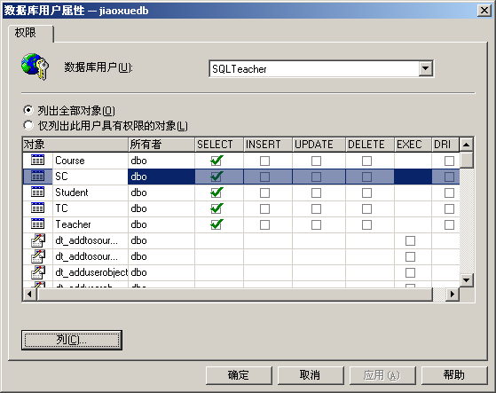
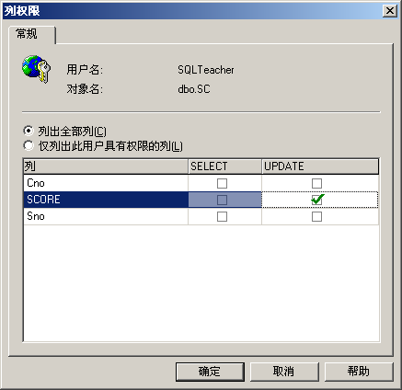

4、创建一个sql server认证的登陆账号sqladmin，并将其设置允许使用数据库jiaoxuedb进行查询，对表student、teacher、course、tc、sc表中的非score列进行插入、修改、删除操作。
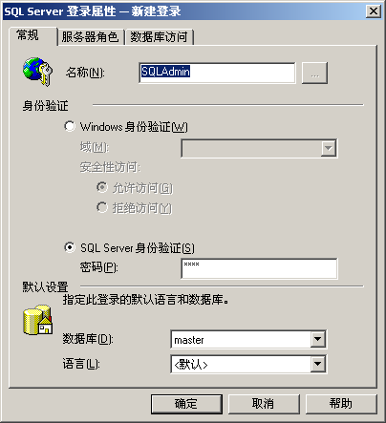
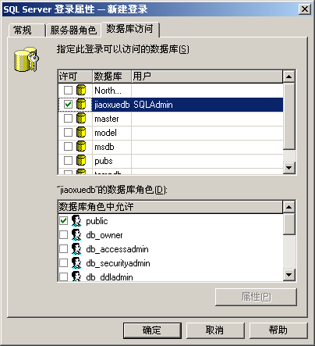
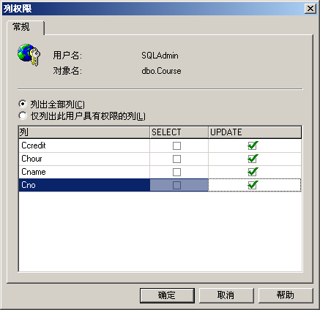
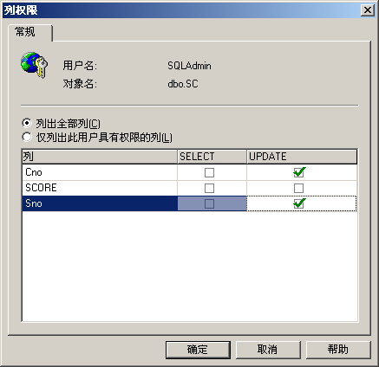
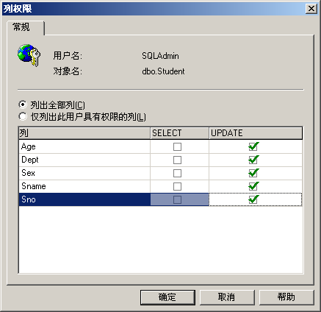
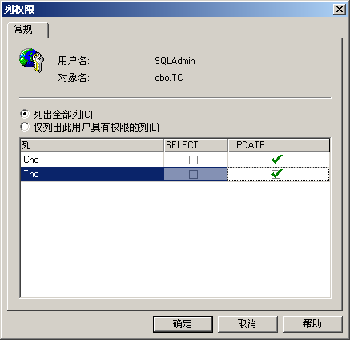
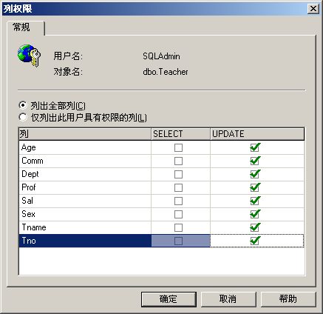

5、创建一个角色newstudent，使其具有对数据库jiaoxuedb进行任何操作的权限。并将上面创建的用户：newuser、sqladmin、sqlteacher添加到此用户中。
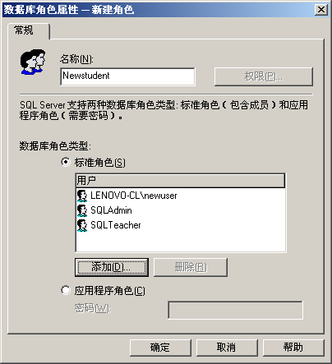
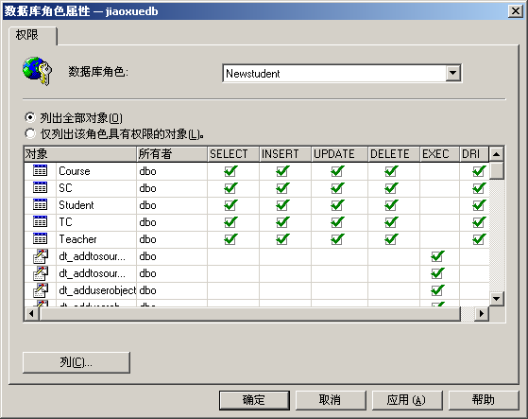

实验13：习题

1、编写一个事务：对于考试违纪的学生，对其采取考试成绩降一个档次的处罚。考试成绩分为5档次：优、良、中、及格、不及格。

begin transaction

use jiaoxuedb

go

select sno,cno,grade=

case when score<60 then '不及格'

when score<70 and score>=60 then '及格'

when score<80 and score>=70 then '中等'

when score<90 and score>=80 then '良好'

when score>=90 and score<=100 then '优秀'

end

from sc where flag=0

union

select sno,cno,grade=

case when score-10<60 then '不及格'

when score-10<70 and score>=60 then '及格'

when score-10<80 and score>=70 then '中等'

when score-10<90 and score>=80 then '良好'

end

from sc where flag=1

commit

2.对于发生教学事故的教师要进行罚款处理，假如用x表示罚款数额。编写一个罚款事务，要求：从被罚款的教师工资中扣除罚款额x，若工资额大于等于罚款额x，则提交罚款，否则，扣除工资的一半作为罚款额，剩余罚款额以后再扣除，并修改显示剩余的罚款额x。

begin transaction

use jiaoxuedb

declare @pay int,@name char(10),@sal int

set @pay=1000

set @name='李英'

select @sal=sal from teacher where tn=@name

if @sal>@pay

begin

update teacher set sal=sal-@pay where tn=@name

select @sal=sal from teacher where tn=@name

print @name+'经过处罚后还剩余的工资为：'+str(@sal)

commit

end

else

begin

update teacher set sal=sal-sal/2 where tn=@name

select @pay=@pay-sal from teacher where tn=@name

print @name+'还欠款'+str(@pay)

end

go

3.完成下面事务设计：某高校嘉奖优秀教师：增加津贴500元；若此教师为助教，则可破格将其晋升为讲师。获得优秀教师的条件是：至少任两门课课程，并且每门课程的及格率100%，优秀率33%。

4.设计一个事务，给所有在册的非新生学生增加1岁，要求，50人作为一个事务提交一次。

