**CIS-660 Lab 1**

**Part 3 and Part 4**

**Submitted By:**

**Name: Mohamed Gani Mohamed Sulthan**

**CSU ID: 2811619**

**Grail Id: momohame@grail.eecs.csuohio.edu**

**Master’s in computer science**

**Part 3: Calculating Proximity of Two Binary Object Vectors With Simple Matching, Jaccard Similarity, Cosine Similarity**

Make sure each attribute is transformed in a same scale for numeric attributes and Binarization for each nominal attribute, and each discretized numeric attribute to standardization.

Make sure to apply a correct similarity measure for nominal (one hot encoding)/binary attributes and numeric attributes respectively. You can bring indicator variable or a different weight for each attribute as discussed in class.

1. **Calculate Similarity in Simple Matching, Extended Jaccard Similarity, and Cosine Similarity between two following objects of your transformed input data**

**- CustomerKey: 11000 and CustomerKey: 11001**

**Step 1:** To calculate the similarities we need to fetch the respective rows using dataFrame.loc function

**Step 2:** After fetching the two values from the dataframe started doing the simple matching, extended jaccard similarity and cosine similarity.

**Step 3:** For that we need to remove the CustomerKey and GeographyKey to predict accurately

**Step 4**: I have written three methods, simple_matching, jaccard_similarity and cosine_similarity

**Code**:

#Calculating similarities

#Fetch the required rows

calculating_similarity = dataFrame.loc[dataFrame['CustomerKey'].isin([11000, 11001])]

print(calculating_similarity)

#Dropping the CustomerKey and GeographyKey to get accurate values

calculating_similarity = calculating_similarity.drop(columns=['CustomerKey', 'GeographyKey'])

calculating_similarity = calculating_similarity.values.tolist()

print(calculating_similarity)

#Assiging list in to two lists

length = len(calculating_similarity)

# To seprate the list

middle_index = length//length

custKey1 = calculating_similarity[:middle_index]

custKey2 = calculating_similarity[middle_index:]

print(custKey1)

print(custKey2)

1. **Calculate Similarity in Simple Matching, Extended Jaccard Similarity, and Cosine Similarity between two following objects of your transformed input data**

**- CustomerKey: 11000 and CustomerKey: 11012**

**Step 1:** To calculate the similarities we need to fetch the respective rows using dataFrame.loc function

**Step 2:** After fetching the two values from the dataframe started doing the simple matching, extended jaccard similarity and cosine similarity.

**Step 3:** For that we need to remove the CustomerKey and GeographyKey to predict accurately

**Step 4**: I have written three methods, simple_matching, jaccard_similarity and cosine_similarity

**Code**:

#Calculating similarities

#Fetch the required rows

calculating_similarity = dataFrame.loc[dataFrame['CustomerKey'].isin([11000, 11012])]

print(calculating_similarity)

#Dropping the CustomerKey and GeographyKey to get accurate values

calculating_similarity = calculating_similarity.drop(columns=['CustomerKey', 'GeographyKey'])

calculating_similarity = calculating_similarity.values.tolist()

print(calculating_similarity)

#Assiging list in to two lists

length = len(calculating_similarity)

# To seprate the list

middle_index = length//length

custKey1 = calculating_similarity[:middle_index]

custKey2 = calculating_similarity[middle_index:]

print(custKey1)

print(custKey2)

**Part 4: Correlation Analysis by Building a Correlation Matrix**

1. **Build a Correlation Matrix for Every Pair of the Features for the entire Data Set**
2. **Visualize Your Correlation Matrix of All the Features in a Heat Map.**

Step 1: Using the dataFrame function corr() to get the correlation matrix for

the data frame

Step 2: Display the correlation matrix using matplotlib

#Building Correlartion Matrix for dataframe

dataFramecorrMatrix = dataFrame.corr()

print (dataFramecorrMatrix)

plt.figure(figsize=(18, 12), dpi=80)

sn.heatmap(dataFramecorrMatrix, annot=True)

1. **Divide your data set into two data sets: One with Bike Buyer = 1 and the other set with Bike Buyer = 0**

#Dividing dataframe by BikeBuyer = 0 and BikeBuyer = 1

bikeBuyer_0 = dataFrame[dataFrame['BikeBuyer'] == 0]

bikeBuyer_1 = dataFrame[dataFrame['BikeBuyer'] == 1]

**Dataset with BikeBuyer = 0**

**Dataset with BikeBuyer = 1**

1. **Then build a Correlation Matrix for Every pair of the Features for the record set with Bike Buyer = 1 and the other record set with Bike Buyer = 0 respectively.**

**BikeBuyer_0 Correlation Matrix:**

**Code:**

#Building Correlartion Matrix for bikeBuyer0

bikeBuyer_0_corr = bikeBuyer_0.corr()

plt.figure(figsize=(18, 12), dpi=80)

sn.heatmap(bikeBuyer_0_corr, annot=True)

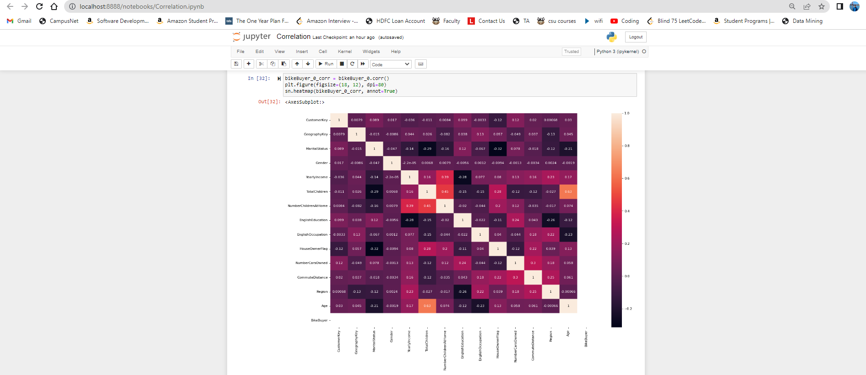

**BikeBuyer_1 Correlation Matrix:**

**Code:**

#Building Correlartion Matrix for bikeBuyer1

bikeBuyer_1_corr = bikeBuyer_1.corr()

plt.figure(figsize=(18, 12), dpi=80)

sn.heatmap(bikeBuyer_1_corr, annot=True)

1. **From three correlation matrix built from 1 and 3 above, Compare the Correlation values between two features Age and Yearly Income with the Correlation between two features Commute Distance and Yearly Income.**

To do the correlation matrix for the selected features, get the specific columns from the dataframe and do the corr function with the selected another column from the dataframe

**Code:**

#Comparing two features(Age and YearlyIncome) from alll the selected dataframes

print('Full Correlation for Age and YearlyIncome', dataFrame['Age'].corr(dataFrame['YearlyIncome']))

print('Bike buyer 0 Correlation for Age and YearlyIncome', bikeBuyer_0_corr['Age'].corr(bikeBuyer_0_corr['YearlyIncome']))

print('Bike buyer 1 Correlation for Age and YearlyIncome', bikeBuyer_1_corr['Age']. corr(bikeBuyer_1_corr['YearlyIncome']))

1. **Compare and discuss which two features are correlated more strongly than the others for each data set from 1 and 3.**

Step 1: I have taken all the three dataframes to do the strongly correlation with the other attributes.

Step 2: By using upper function we can get the strongly correlation difference in the dataframe

Step 3: We can set the correlation value and filter it accordingly

**Code:**

#Create correlation matrix #Select upper triangle of correlation matrix #Find features with correlation greater than 0.6

strong_corr_matrix_df = dataFrame.corr().abs()

upper = strong_corr_matrix_df.where(np.triu(np.ones(strong_corr_matrix_df.shape), k=1).astype(np.bool))

strongly_corr_df = [column for column in upper.columns if any(upper[column] > 0.5)]

print("Strongly Correlated for actual DF", strongly_corr_df)

strong_corr_matrix_b0 = bikeBuyer_0_corr.corr().abs()

upper = strong_corr_matrix_b0.where(np.triu(np.ones(strong_corr_matrix_b0.shape), k=1).astype(np.bool))

strongly_corr_b0 = [column for column in upper.columns if any(upper[column] > 0.6)]

print("Strongly Correlated for BikeBuyer 0 DF", strongly_corr_b0)

strong_corr_matrix_b1 = bikeBuyer_1_corr.corr().abs()

upper = strong_corr_matrix_b1.where(np.triu(np.ones(strong_corr_matrix_b1.shape), k=1).astype(np.bool))

strongly_corr_b1 = [column for column in upper.columns if any(upper[column] > 0.6)]

print("Strongly Correlated for BikeBuyer 1 DF", strongly_corr_b1)

**Strongly Correlated two features:**

Step 1: From the selected attributes, I did the plot using matplotlib.pyplot module

Step 2: By assigning the x- axis and y-axis from the strongly correlated selected attributes, I plotted the graph

Step 3: Below are the different highly correlated features for three different dataframes

**Code:**

print('Scatter plotting for actual dataframe')

plt.scatter(dataFrame['TotalChildren'],dataFrame['Age'])

plt.plot(np.unique(dataFrame['TotalChildren']), np.poly1d(np.polyfit(dataFrame['TotalChildren'], dataFrame['Age'], 1)) (np.unique(dataFrame['TotalChildren'])),color='red')

print('Scatter plotting for bike buyer 0 dataframe')

plt.scatter(bikeBuyer_0['TotalChildren'],bikeBuyer_0['NumberChildrenAtHome'])

plt.plot(np.unique(bikeBuyer_0['TotalChildren']), np.poly1d(np.polyfit(bikeBuyer_0['TotalChildren'], bikeBuyer_0['NumberChildrenAtHome'], 1)) (np.unique(bikeBuyer_0['TotalChildren'])),color='red')

print('Scatter plotting for bike buyer 1 dataframe')

plt.scatter(bikeBuyer_1['HouseOwnerFlag'],bikeBuyer_1['Age'])

plt.plot(np.unique(bikeBuyer_1['HouseOwnerFlag']), np.poly1d(np.polyfit(bikeBuyer_1['HouseOwnerFlag'], bikeBuyer_1['Age'], 1)) (np.unique(bikeBuyer_1['HouseOwnerFlag'])),color='red')

**Actual Dataframe:**

**BikeBuyer0:**

**BikeBuyer 1:**

