1. Different meaning of data.

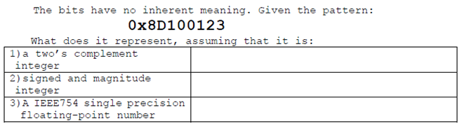

1. IEEE 754, Carry-flag，Overflow-flag……

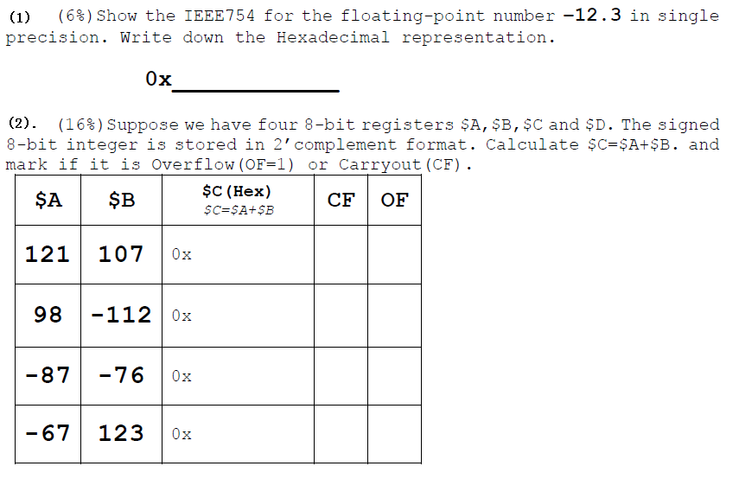

1. please select the best option from option list and fill corresponding letter of A-K into blank below.

|  |  |  |  |  |  |  |  |
| --- | --- | --- | --- | --- | --- | --- | --- |
| **Question** | **（1）** | **（2）** | **（3）** | **（4）** | **（5）** | **（6）** | **（7）** |
| **Answer** |  |  |  |  | 不做 | 不做 | 不做 |

(1).A number is represented as 0x7F800000 in IEEE 754 Single precision number format, its value is .

(2). IEEE754 single precision representation for -1 is .

(3). A number is represented as 10101101_00010000_00000000_00000000 in 2’s complement format, original value of this number is .

(4). A number is represented as 0xF0000320 in 1’s complement format, original value of this number is .

~~(5).Value of machine code for instruction ‘jr $ra’ is~~ . （本题不做）

~~(6).Value of machine code for instruction ‘andi $t2, $t2, 4’ is .~~ （本题不做）

~~(7).Value of machine code for instruction ‘sub $t0,$t1,$t2’ is .~~ （本题不做）

Options for above blanks are listed below:

(A) 0x03E00008 (B) 0XBF800000 (C) 0XBF100000 (D) -0x0FFFFCDF

(E) 0x314A0004 (F) +∞ (G) -0x52F00000 (H) 0x12A4022

(I) 0x12A4020 (J) -0x52700000 (K) None of above