CALCULATING FAMILY EXPENCES

TEAM ID: CD348A4B9C5BC6BAC4847400AAF5EC7A

TEAM MEMBERS:

TEAM LEADER: RITHIKA.S

TEAM MEMBER 1: MENAKADEVI.M

TEAM MEMBER 2: MEENAKSHI

TEAM MEMBER 3:PADMAPRIYA.S

PROBLEM STATEMENT: Calculating Family Expenses using Service Now

OBJECTIVE:

TASK INITIATION:

MILESTONE 1: Setting Up Service Now Instance

ACTIVITY: To set up a new or existing service now instance.

1. Open the <https://developer.servicenow.com> link.
2. If you have an account in service now login to it .
3. If not create a new one by sign up option.
4. Enter the valid credentials and enter into the service noe developers page.

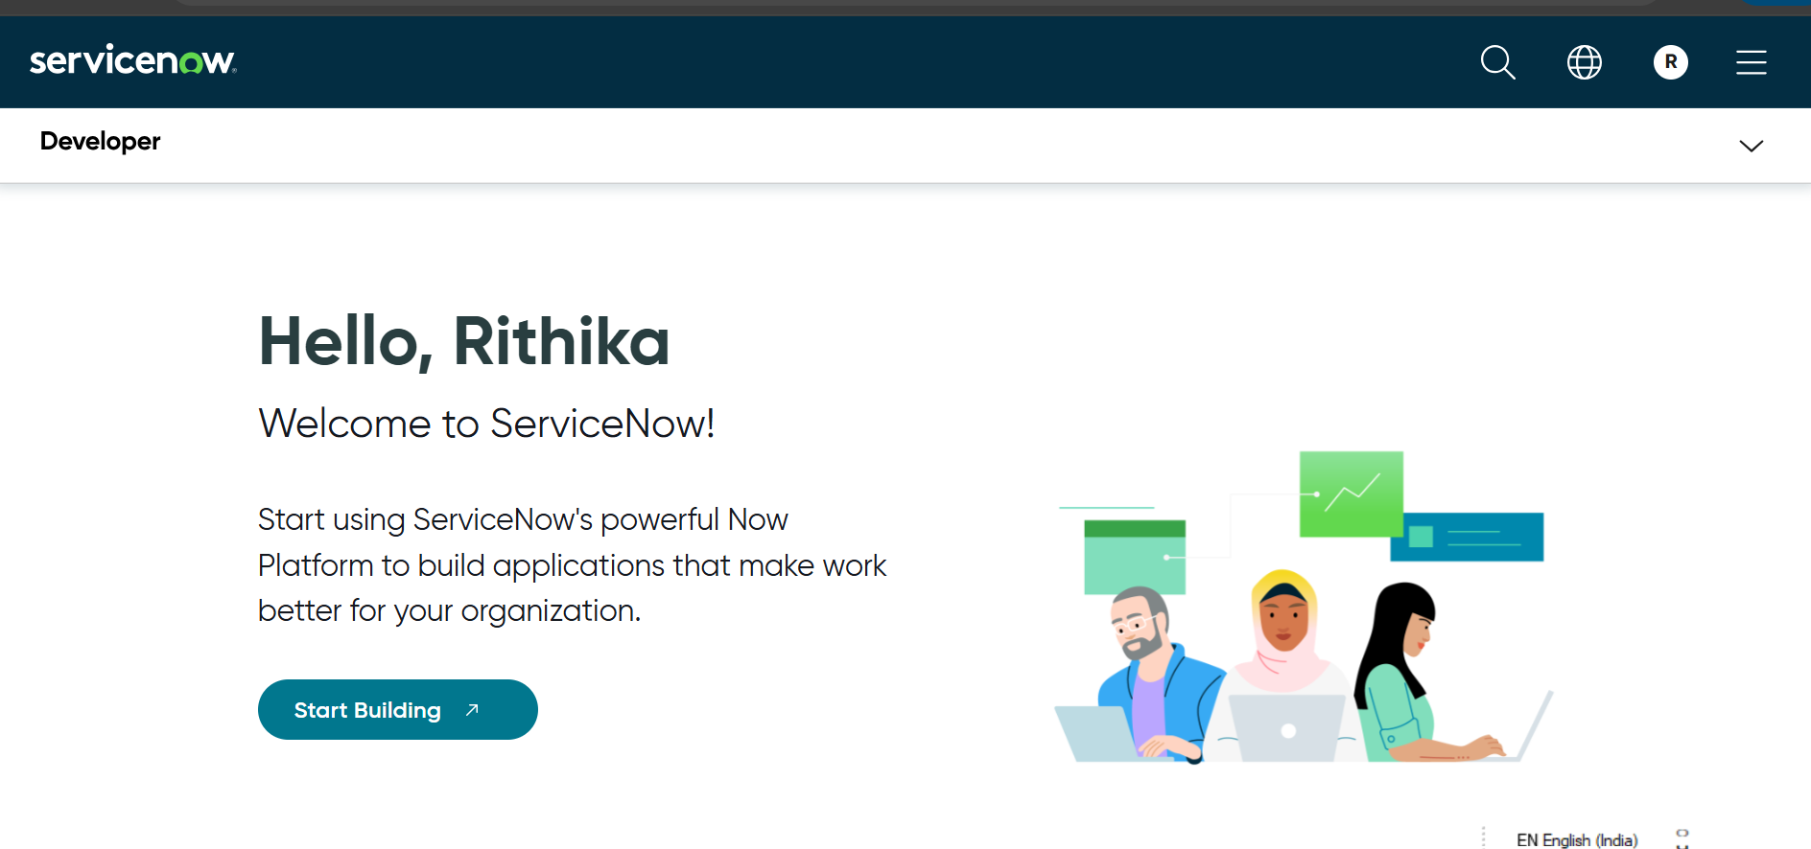

### MILESTONE 2: Creation Of New Update Set

### ACTIVITY: To create a new update set

### Open service now.

### Click on ALL>>Search local update set then click NEW.

### Enter the name “FAMILY EXPENCES” .

### Click on “Submit and make current”.

### 

### MILESTONE 3: CREATION OF TABLES

### ACTIVITY 1: To create a family expence table

### Open service now .

### Go to ALL>>search TABLES>>click NEW.

### Enter the label as “family expenses”, name as “auto-populated”,new menu name as “Family expenditure”.

### Go to header ‘Right click’ >> click on Save.

### 

### ACTIVITY 2: Creating fields

### Insert

### i)first row with label as “ Number” and type as “String”,

### ii)second row with label as “Date” and type as “Date” ,

### iii)third row with label as “ Amount” and type as “Integer”,

### iv)fourth row with label as “expense details” and type as “ String” and “max length” as “800”.

### Go to header ‘Right click’ >> click on Save.

### 

### ACTIVITY 3: Making number field as auto number

### Go to service now.

### Click on number field>>select advanced view>> now in default value check the box and the dynamic default value as “get next padded number”.

### Click on update.

### 

### Go to ALL>>Number maintainance>>click NEW.

### Enter the table as “ family expense” and prefix as “MFE”.

### Click on submit.

### 

### ACTIVITY 4: Configure the form

### Go to ALL>>search “family expense” >>click NEW.

### Go to header >>tight click >>select configure >>select form design.

### Arrange as per the requirement

### Make number as read only field and date ,amount as mandatory field.

### Click on save.

### 

### MILESTONE 4:CREATION OF DAILY EXPENSE TABLE

### ACTIVITY 1: To create daily expense table

### Open service now .

### Go to ALL>>search TABLES>>click NEW.

### Enter the label as “daily expenses”, name as “auto-populated”, add module to menu “ as “Family expenditure”.

### Go to header ‘Right click’ >> click on Save.

### 

### ACTIVITY 2: Creation of fields

### Insert

### i)first row with label as “ Number” and type as “String”,

### ii)second row with label as “Date” and type as “Date” ,

### iii)third row with label as “ Expense” and type as “Integer”,

### iv) fourth row with label as “Family member name” and type as “ Reference” and “max length” as “800”.

### v)fifth row with label as “Comments” and type as “ String” and “max length” as “800”.

### Go to header ‘Right click’ >> click on Save.

### 

### ACTIVITY 3:Making number field as auto populated

### Go to service now.

### Click on number field>>select advanced view>> now in default value check the box and the dynamic default value as “get next padded number”.

### Click on update.

### 

### Go to ALL>>Number maintainance>>click NEW.

### Enter the table as “ daily expense” and prefix as “MFE”.

### Click on submit.

### 

### ACTIVITY 4: Configure the form

### Go to ALL>>search “daily expense” >>click NEW.

### Go to header >>tight click >>select configure >>select form design.

### Arrange as per the requirement

### Make number as read only field and date ,amount as mandatory field.

### Click on save.

### 

### MILESTONE 5: CREATION OF RELATIONSHIP

### ACTIVITY : TO CREATE RELATIONSHIP BETWEEN FAMILY AND DAILY EXPENSE TABLE.

### Open the service now

### Go to ALL>>search Relationship >>NEW.

### Enter the “name” as “daily expense” and “applies to table” as “family expenses”

### 

### MILESTONE 6: CONFIGURING RELATED LIST ON FAMILY EXPENSES

### ACTIVITY 1: To configure the list of family expenses.

### Open service now

### Go to ALL>>search family expenses>>click NEW.

### Go to header >>right click>>click configure then “related list”

### Move the daily expenses to selected column.

### Click on save

### 

### MILESTONE 7: CREATION OF BUSINESS RULES

### ACTIVITY: To create business rule

### Open service now

### Go to ALL>>search “Business rules”>>click NEW.

### Enter the name as “Family expenses BR and table as “daily expenses”

### Check the box advanced

### In when to run check the insert and update box.

### Write the code

(function executeRule(current, previous /*null when async*/) {

var FamilyExpenses = new GlideRecord('u_family_expenses');

FamilyExpenses.addQuery('u_date',current.u_date);

FamilyExpenses.query();

if(FamilyExpenses.next())

{

FamilyExpenses.u_amount += current.u_expense;

FamilyExpenses.u_expense_details += ">"+current.u_comments+":"+"Rs."+current.u_expense+"/-";

FamilyExpenses.update();

}

else

{

var NewFamilyExpenses = new GlideRecord('u_family_expenses');

NewFamilyExpenses.u_date = current.u_date;

NewFamilyExpenses.u_amount = current.u_expense;

NewFamilyExpenses.u_expense_details += ">"+current.u_comments+":"+"Rs."+current.u_expense+"/-";

NewFamilyExpenses.insert();

}

})(current, previous);

### Go to header>>right click>>click save.

### 

### MILESTONE 8:CONFIGURE THE RELATIONSHIP

### ACTIVITY : To configure the relationship.

### Open service now

### Go to ALL>>search relationship>>click new.

### Open daily expense relationship.

### Enter Family expense for applies to table.

### Write the code

(function refineQuery(current, parent) {

// Add your code here, such as current.addQuery(field, value);

current.addQuery('u_date',parent.u_date);

current.query();

})(current, parent);

### Click on update.

### 

### CONCLUTION.