- Git 使用 smartgit使用
- Bootstrap web前端CSS框架
- jQuery
- jQuery UI
- JSON
- JavaScript
- html5
- css3
- Maven
- Springmvc
- Mybatis

项目模块

NGDMS_PROJECT 聚合模块 父NGDMS

Base 业务基础模块 父NGDMS_PROJECT

CommonModule 技术架构模块（公用的） 父NGDMS_PROJECT

ModelGenerator 自动生成mapper.xml 和 mapper.java文件 父NGDMS

WebApp 主工程模块 父NGDMS_PROJECT

NGDMS_PROJECT聚合模块

pom.xml
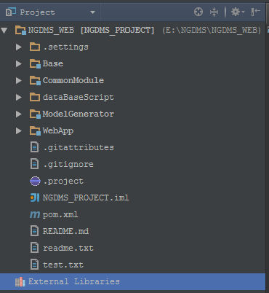

IDEA工具要用的文件，不要更新到git

Base 业务基础模块

baseConfig.xml
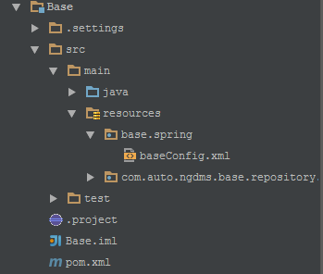

baseConfig.xml
<?xml version="1.0" encoding="UTF-8"?>
<beans xmlns="http://www.springframework.org/schema/beans"
xmlns:xsi="http://www.w3.org/2001/XMLSchema-instance"
xmlns:aop="http://www.springframework.org/schema/aop"
xmlns:tx="http://www.springframework.org/schema/tx"
xmlns:jdbc="http://www.springframework.org/schema/jdbc"
xmlns:context="http://www.springframework.org/schema/context"
xmlns:p="http://www.springframework.org/schema/p"
xmlns:mvc="http://www.springframework.org/schema/mvc"
xsi:schemaLocation="
http://www.springframework.org/schema/context http://www.springframework.org/schema/context/spring-context.xsd
http://www.springframework.org/schema/beans http://www.springframework.org/schema/beans/spring-beans.xsd
http://www.springframework.org/schema/jdbc http://www.springframework.org/schema/jdbc/spring-jdbc.xsd
http://www.springframework.org/schema/tx http://www.springframework.org/schema/tx/spring-tx.xsd
http://www.springframework.org/schema/aop http://www.springframework.org/schema/aop/spring-aop.xsd
http://www.springframework.org/schema/mvc http://www.springframework.org/schema/mvc/spring-mvc.xsd">
<context:component-scan base-package="com.auto.ngdms.base.repository"/>
<context:component-scan base-package="com.auto.ngdms.base.service"/>
</beans>

CommonModule 技术架构模块
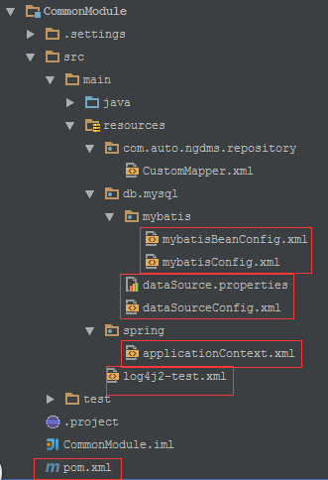

sql 文件 新增字段
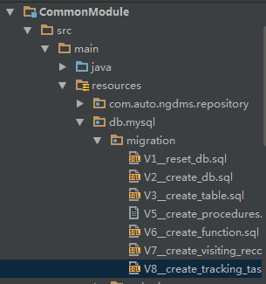

ModelGenerator 自动生成mapper.xml 和mapper.java文件
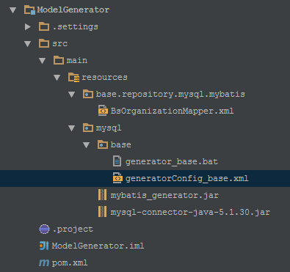

生成文件配置

表: bs_configuration
<table schema="ngdms" tableName="bs_configuration" alias="bsCon" domainObjectName="BsConfiguration"
enableCountByExample="true" enableUpdateByExample="true"
enableDeleteByExample="true" enableSelectByExample="true"
selectByExampleQueryId="true">
<columnOverride column="IS_VALID" javaType="com.auto.ngdms.util.db.ConstSet.Validity" />
<columnOverride column="IS_SELL" javaType="com.auto.ngdms.util.db.ConstSet.YesNo" />
<columnOverride column="IS_DOWN" javaType="com.auto.ngdms.util.db.ConstSet.YesNo" />
</table>

表: bs_brand
<table schema="ngdms" tableName="bs_brand" alias="bsBrd" domainObjectName="BsBrand"
enableCountByExample="true" enableUpdateByExample="true"
enableDeleteByExample="true" enableSelectByExample="true"
selectByExampleQueryId="true">
<columnOverride column="IS_VALID" javaType="com.auto.ngdms.util.db.ConstSet.Validity" />
<columnOverride column="IS_DOWN" javaType="com.auto.ngdms.util.db.ConstSet.YesNo" />
<columnOverride column="IS_SELL" javaType="com.auto.ngdms.util.db.ConstSet.YesNo" />
</table>

表: bs_series
<table schema="ngdms" tableName="bs_series" alias="bsSer" domainObjectName="BsSeries"
enableCountByExample="true" enableUpdateByExample="true"
enableDeleteByExample="true" enableSelectByExample="true"
selectByExampleQueryId="true">
<columnOverride column="IS_VALID" javaType="com.auto.ngdms.util.db.ConstSet.Validity" />
<columnOverride column="IS_DOWN" javaType="com.auto.ngdms.util.db.ConstSet.YesNo" />
<columnOverride column="IS_SELL" javaType="com.auto.ngdms.util.db.ConstSet.YesNo" />
</table>

表: bs_model
<table schema="ngdms" tableName="bs_model" alias="bsMod" domainObjectName="BsModel"
enableCountByExample="true" enableUpdateByExample="true"
enableDeleteByExample="true" enableSelectByExample="true"
selectByExampleQueryId="true">
<columnOverride column="IS_VALID" javaType="com.auto.ngdms.util.db.ConstSet.Validity" />
<columnOverride column="IS_DOWN" javaType="com.auto.ngdms.util.db.ConstSet.YesNo" />
<columnOverride column="IS_SELL" javaType="com.auto.ngdms.util.db.ConstSet.YesNo" />
</table>

表: 媒体小类 bs_media_detail
<table schema="ngdms" tableName="bs_media_detail" alias="bsMedDet" domainObjectName="BsMediaDetail"
enableCountByExample="true" enableUpdateByExample="true"
enableDeleteByExample="true" enableSelectByExample="true"
selectByExampleQueryId="true">
<columnOverride column="IS_VALID" javaType="com.auto.ngdms.util.db.ConstSet.Validity" />
<columnOverride column="PARENT_MEDIA_CODE" javaType="com.auto.ngdms.util.db.ConstSet.InfoChannel" />
</table>

表: 业务往来客户 bs_part_customer
<table schema="ngdms" tableName="bs_part_customer" alias="bsParCust" domainObjectName="BsPartCustomer"
enableCountByExample="true" enableUpdateByExample="true"
enableDeleteByExample="true" enableSelectByExample="true"
selectByExampleQueryId="true">
<columnOverride column="IS_VALID" javaType="com.auto.ngdms.util.db.ConstSet.Validity" />
<columnOverride column="IS_ALL_SUPPLY" javaType="com.auto.ngdms.util.db.ConstSet.YesNo" />
<columnOverride column="CUSTOMER_TYPE_CODE" javaType="com.auto.ngdms.util.db.ConstSet.BizCustomerType" />
<columnOverride column="SALES_BASE_PRICE_TYPE" javaType="com.auto.ngdms.util.db.ConstSet.PriceType" />
<columnOverride column="DOWN_TAG" javaType="com.auto.ngdms.util.db.ConstSet.YesNo" />
<columnOverride column="CUS_RECEIVE_SORT" javaType="com.auto.ngdms.util.db.ConstSet.CusRecCategory" />
<columnOverride column="BALANCE_CURRENCY" javaType="com.auto.ngdms.util.db.ConstSet.Currency" />
</table>

表: 车辆主数据生成 vm_vs_product
<table schema="ngdms" tableName="vm_vs_product" alias="vmVsPro" domainObjectName="VmVsProduct"
enableCountByExample="true" enableUpdateByExample="true"
enableDeleteByExample="true" enableSelectByExample="true"
selectByExampleQueryId="true">
<columnOverride column="IS_VALID" javaType="com.auto.ngdms.util.db.ConstSet.Validity" />
<columnOverride column="DOWN_TAG" javaType="com.auto.ngdms.util.db.ConstSet.YesNo" />
<columnOverride column="IS_SALED_UPLOAD" javaType="com.auto.ngdms.util.db.ConstSet.YesNo" />
<columnOverride column="PRODUCT_STATUS" javaType="com.auto.ngdms.util.db.ConstSet.VehicleProductStatus" />
<columnOverride column="PRODUCT_TYPE" javaType="com.auto.ngdms.util.db.ConstSet.VehicleProType" />
</table>

表 库存维护 vm_vs_stock
<table schema="ngdms" tableName="vm_vs_stock" alias="vmVsSto" domainObjectName="VmVsStock"
enableCountByExample="true" enableUpdateByExample="true"
enableDeleteByExample="true" enableSelectByExample="true"
selectByExampleQueryId="true">
<columnOverride column="HAS_CERTIFICATE" javaType="com.auto.ngdms.common.util.db.ConstSet.YesNo" />
<columnOverride column="IS_SECONDHAND" javaType="com.auto.ngdms.common.util.db.ConstSet.YesNo" />
<columnOverride column="IS_VIP" javaType="com.auto.ngdms.common.util.db.ConstSet.YesNo" />
<columnOverride column="IS_TEST_DRIVE_CAR" javaType="com.auto.ngdms.common.util.db.ConstSet.YesNo" />
<columnOverride column="IS_CONSIGNED" javaType="com.auto.ngdms.common.util.db.ConstSet.YesNo" />
<columnOverride column="IS_PROMOTION" javaType="com.auto.ngdms.common.util.db.ConstSet.YesNo" />
<columnOverride column="IS_PURCHASE_RETURN" javaType="com.auto.ngdms.common.util.db.ConstSet.YesNo" />
<columnOverride column="IS_PRICE_ADJUSTED" javaType="com.auto.ngdms.common.util.db.ConstSet.YesNo" />
<columnOverride column="IS_DIRECT" javaType="com.auto.ngdms.common.util.db.ConstSet.YesNo" />
<columnOverride column="DOWN_TAG" javaType="com.auto.ngdms.common.util.db.ConstSet.YesNo" />
<columnOverride column="IS_REFITTING_CAR" javaType="com.auto.ngdms.common.util.db.ConstSet.YesNo" />
<columnOverride column="IS_LOCK" javaType="com.auto.ngdms.common.util.db.ConstSet.YesNo" />
<columnOverride column="IS_LARGE_CONSUMER" javaType="com.auto.ngdms.common.util.db.ConstSet.YesNo" />
<columnOverride column="DISCHARGE_STANDARD" javaType="com.auto.ngdms.common.util.db.ConstSet.EffluentStandard" />
<columnOverride column="STOCK_OUT_TYPE" javaType="com.auto.ngdms.common.util.db.ConstSet.VehicleOutStockType" />
<columnOverride column="STOCK_STATUS" javaType="com.auto.ngdms.common.util.db.ConstSet.VehicleStockStatus" />
<columnOverride column="DISPATCHED_STATUS" javaType="com.auto.ngdms.common.util.db.ConstSet.PeiCheVehicleStatus" />
<columnOverride column="MAR_STATUS" javaType="com.auto.ngdms.common.util.db.ConstSet.Massloss" />
<columnOverride column="STOCK_IN_TYPE" javaType="com.auto.ngdms.common.util.db.ConstSet.VehicleStorageBizType" />
</table>

表:采购价格历史 vm_vehicle_purchase_log
<table schema="ngdms" tableName="vm_vehicle_purchase_log" alias="vmVehPurLog" domainObjectName="VmVehiclePurchaseLog"
enableCountByExample="true" enableUpdateByExample="true"
enableDeleteByExample="true" enableSelectByExample="true"
selectByExampleQueryId="true">
</table>

表 装潢单sa_decoration_order
<table schema="ngdms" tableName="sa_decoration_order" alias="saDecOrder" domainObjectName="SaDecorationOrder"
enableCountByExample="true" enableUpdateByExample="true"
enableDeleteByExample="true" enableSelectByExample="true"
selectByExampleQueryId="true">
<columnOverride column="PAY_OFF" javaType="com.auto.ngdms.util.db.ConstSet.YesNo" />
<columnOverride column="COMPLETE_TAG" javaType="com.auto.ngdms.util.db.ConstSet.YesNo" />
</table>

表在途管理 vm_vs_shipping_notify
<table schema="ngdms" tableName="vm_vs_shipping_notify" alias="vmVsShipNoti" domainObjectName="VmVsShippingNotify"
enableCountByExample="true" enableUpdateByExample="true"
enableDeleteByExample="true" enableSelectByExample="true"
selectByExampleQueryId="true">
<columnOverride column="HAS_CERTIFICATE" javaType="com.auto.ngdms.common.util.db.ConstSet.YesNo" />
<columnOverride column="IS_ALLOCATED" javaType="com.auto.ngdms.common.util.db.ConstSet.YesNo" />
<columnOverride column="IS_CONSIGNED" javaType="com.auto.ngdms.common.util.db.ConstSet.YesNo" />
<columnOverride column="IS_CONSIGNING" javaType="com.auto.ngdms.common.util.db.ConstSet.YesNo" />
<columnOverride column="IS_DIRECT" javaType="com.auto.ngdms.common.util.db.ConstSet.YesNo" />
<columnOverride column="OEM_TAG" javaType="com.auto.ngdms.common.util.db.ConstSet.YesNo" />
<columnOverride column="IS_LARGE_CONSUMER" javaType="com.auto.ngdms.common.util.db.ConstSet.YesNo" />
</table>

表:车辆入库 vm_vs_stock_entry
<table schema="ngdms" tableName="vm_vs_stock_entry" alias="vmVsStoEnt" domainObjectName="VmVsStockEntry"
enableCountByExample="true" enableUpdateByExample="true"
enableDeleteByExample="true" enableSelectByExample="true"
selectByExampleQueryId="true">
<columnOverride column="STOCK_IN_TYPE" javaType="com.auto.ngdms.common.util.db.ConstSet.VehicleStorageBizType" />
<columnOverride column="IS_ALL_FINISHED" javaType="com.auto.ngdms.common.util.db.ConstSet.YesNo" />
<columnOverride column="IS_PAYOFF" javaType="com.auto.ngdms.common.util.db.ConstSet.YesNo" />
<columnOverride column="IS_PAYOFF_FINANCE" javaType="com.auto.ngdms.common.util.db.ConstSet.YesNo" />
</table>

表:车辆入库明细 vm_vs_stock_entry_item
<table schema="ngdms" tableName="vm_vs_stock_entry_item" alias="vmVsStoEntItem" domainObjectName="VmVsStockEntryItem"
enableCountByExample="true" enableUpdateByExample="true"
enableDeleteByExample="true" enableSelectByExample="true"
selectByExampleQueryId="true">
<columnOverride column="HAS_CERTIFICATE" javaType="com.auto.ngdms.common.util.db.ConstSet.YesNo" />
<columnOverride column="INSPECTION_RESULT" javaType="com.auto.ngdms.common.util.db.ConstSet.CheckResult" />
<columnOverride column="MAR_STATUS" javaType="com.auto.ngdms.common.util.db.ConstSet.Massloss" />
<columnOverride column="IS_FINISHED" javaType="com.auto.ngdms.common.util.db.ConstSet.YesNo" />
<columnOverride column="DOWN_TAG" javaType="com.auto.ngdms.common.util.db.ConstSet.YesNo" />
<columnOverride column="IS_DIRECT" javaType="com.auto.ngdms.common.util.db.ConstSet.YesNo" />
<columnOverride column="IS_UPLOAD" javaType="com.auto.ngdms.common.util.db.ConstSet.YesNo" />
<columnOverride column="DISCHARGE_STANDARD" javaType="com.auto.ngdms.common.util.db.ConstSet.EffluentStandard" />
<columnOverride column="IS_LARGE_CONSUMER" javaType="com.auto.ngdms.common.util.db.ConstSet.YesNo" />
<columnOverride column="VEHICLE_TYPE" javaType="com.auto.ngdms.common.util.db.ConstSet.MotorVehicleType" />
</table>

sql 脚本所在svn 的位置?

idea 生成po类的序列号
默认情况下Intellij IDEA是关闭了继承了java.io.Serializable的类生成serialVersionUID的警告。如果需要ide提示生成serialVersionUID，那么需要做以下设置：
1、setting->Inspections->Serialization issues，将serialzable class without "serialVersionUID"打上勾；
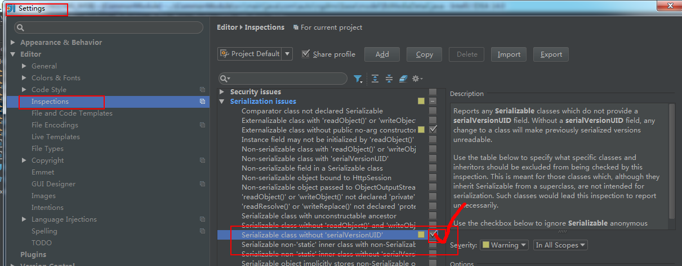
- 将光标放到类名上，按atl＋enter键，就会提示生成serialVersionUID了。
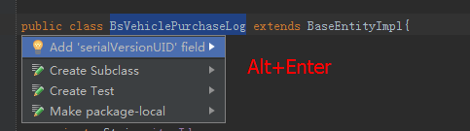

生成po类 和 mapper

第一种操作

BsBrand.java
继承BsBaseEntityImpl类，删掉id 和 setter getter 方法, 重写toString方法，并生成序列号，
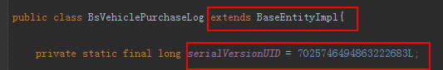

public class BsBrand extends BaseEntityImpl

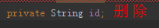
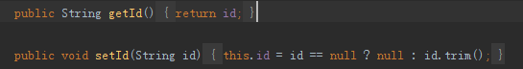

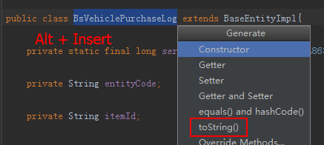
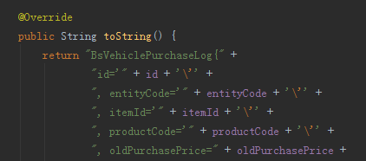

BsMediaDetailExample.java
- 删除一些公共的方法，然后重新继承过来
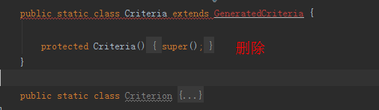

public static class Criteria extends BaseCriteria
{

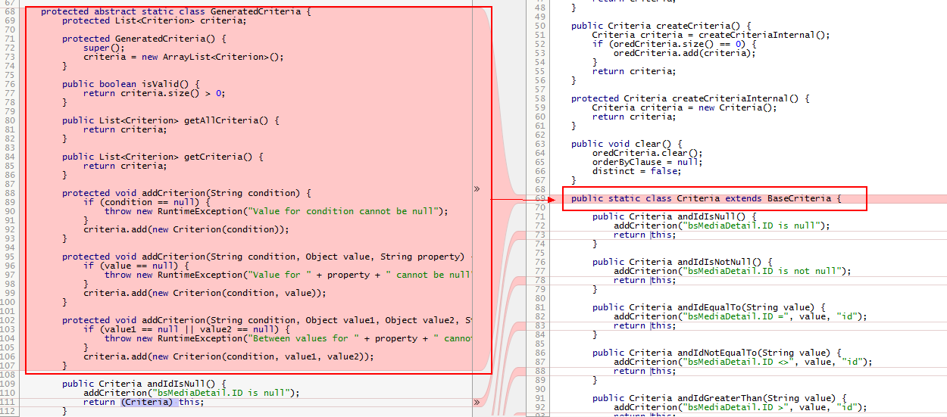

把所有的 return (Criteria) this 改成: return this;
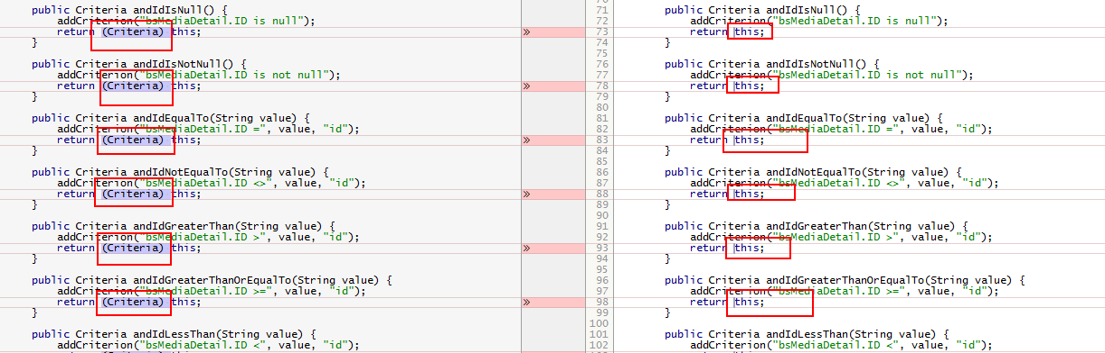

BsBrandMapper.java
添加一些方法，因为重名了，无法自动生成
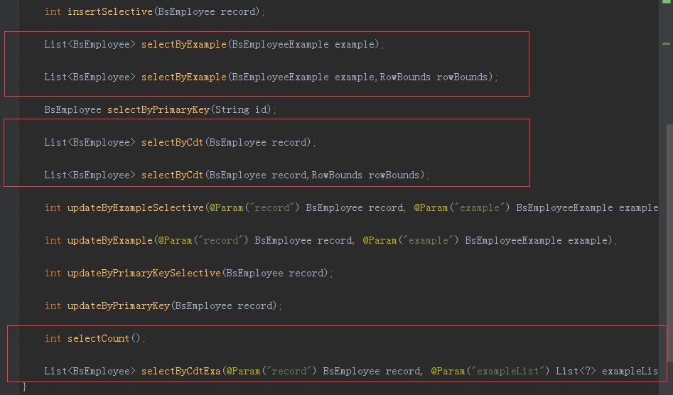

List<BsBrand> selectByExample(BsBrandExample example);
List<BsBrand> selectByExample(BsBrandExample example,RowBounds rowBounds);

List<BsVsStock> selectByCdt(BsVsStock record);
List<BsVsStock> selectByCdt(BsVsStock record, RowBounds rowBounds);

int selectCount();
List<BsBrand> selectByCdtExa(@Param("record") BsBrand record, @Param("exampleList") List<?> exampleList);

bsbrandmapper.xml 修改补充
- MySQL在做删除时带有表别名将报错，所以手动修改deleteByExample方法
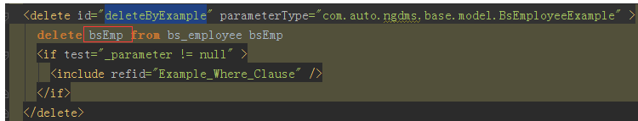
- 在最后添加

<!--手动添加-->
<select id="selectCount" resultType="int">
select count(*)
from bs_vs_product bsVsProduct
</select>
<sql id="RecordEqualClause">
<if test="record != null">
<if test="record.entityCode != null" >
and bsBrd.ENTITY_CODE = #{record.entityCode,jdbcType=VARCHAR}
</if>
<if test="record.brandCode != null" >
and bsBrd.BRAND_CODE = #{record.brandCode,jdbcType=VARCHAR}
</if>
<if test="record.brandName != null" >
and bsBrd.BRAND_NAME = #{record.brandName,jdbcType=VARCHAR}
</if>
</if>
</sql>
<select id="selectByCdtExa" resultMap="BaseResultMap">
select
<include refid="Base_Column_List"/>
from bs_brand bsBrd
<where>
<include refid="com.auto.ngdms.repository.CustomMapper.ExampleListEqualClause"/>
<include refid="RecordEqualClause"/>
</where>
</select>

第二种抽取
王夫利<wfl80152@163.com> 2015-11-16 10:24:11
使用方法 参考 BsSysStatusMapper.java BsSysStatusMapper.xml
王夫利<wfl80152@163.com> 2015-11-16 10:25:20
Example 改造方式参考 BsSysStatusCriteria.java ，即 生成的 BsSysStatusExample.java --> 改造成 BsSysStatusCriteria.java

BsBrand.java
public class SaDecorationOrder extends BaseEntityImpl{
private static final long serialVersionUID = 2520919714938041911L;

BsBrandExmple.java
public class SaDecorationOrderCriteria extends BaseCriteria {
public SaDecorationOrderCriteria andIdIsNull() {
addCriterion("saDecOrder.ID is null");
return this;
}

Service.java
BsBrandCriteria BaseExample

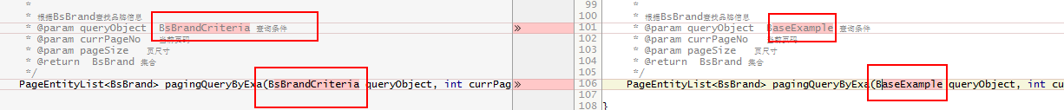

serviceImpl.java

BsBrandCriteria BaseExample

BsBrandDao.java

BaseExample
public interface SaDecorationOrderDao extends DaoInterface<SaDecorationOrder,String,BaseExample> {
}

BsBrandDaoImpl.java
将 BsBrandCriteria 替换为: BaseExample
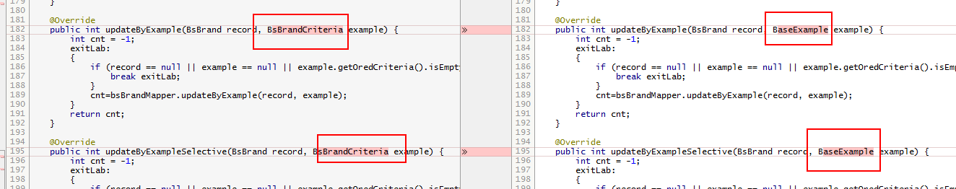

BsBrandMapper.java
- 添加一些方法，因为重名了，无法自动生成

List<BsBrand> selectByExample(BsBrandExample example);
List<BsBrand> selectByExample(BsBrandExample example,RowBounds rowBounds);

List<BsVsStock> selectByCdt(BsVsStock record);
List<BsVsStock> selectByCdt(BsVsStock record, RowBounds rowBounds);

int selectCount();
List<BsBrand> selectByCdtExa(@Param("record") BsBrand record, @Param("exampleList") List<?> exampleList);

SaDecorationOrderCriteria BaseExample

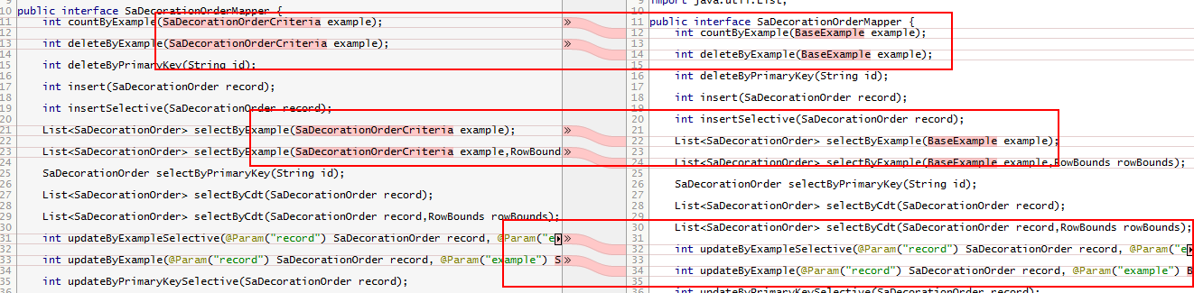

BsBrandMapper.xml

parameterType
将com.auto.ngdms.sale.model.SaDecorationOrderCriteria 改成: com.auto.ngdms.model.BaseExample

<!--手动添加 -->
<select id="selectCount" resultType="int">
select count(*) from bs_media_detail bsMediaDetail
</select>
<sql id="RecordEqualClause">
<if test="record != null">
<if test="record.id != null" >
and bsMedDet.ID = #{record.id,jdbcType=VARCHAR},
</if>
<if test="record.entityCode != null" >
and bsMedDet.ENTITY_CODE = #{record.entityCode,jdbcType=VARCHAR},
</if>
<if test="record.mediaDetailCode != null" >
and bsMedDet.MEDIA_DETAIL_CODE = #{record.mediaDetailCode,jdbcType=VARCHAR},
</if>
<if test="record.mediaDetailName != null" >
and bsMedDet.MEDIA_DETAIL_NAME = #{record.mediaDetailName,jdbcType=VARCHAR},
</if>
<if test="record.parentMediaCode != null" >
and bsMedDet.PARENT_MEDIA_CODE = #{record.parentMediaCode,jdbcType=VARCHAR},
</if>
<if test="record.isValid != null" >
and bsMedDet.IS_VALID = #{record.isValid,jdbcType=VARCHAR},
</if>
<if test="record.createBy != null" >
and bsMedDet.CREATE_BY = #{record.createBy,jdbcType=VARCHAR},
</if>
<if test="record.createDate != null" >
and bsMedDet.CREATE_DATE = #{record.createDate,jdbcType=TIMESTAMP},
</if>
<if test="record.updateBy != null" >
and bsMedDet.UPDATE_BY = #{record.updateBy,jdbcType=VARCHAR},
</if>
<if test="record.updateDate != null" >
and bsMedDet.UPDATE_DATE = #{record.updateDate,jdbcType=TIMESTAMP},
</if>
</if>
</sql>
<select id="selectByCdtExa" resultMap="BaseResultMap">
select
<include refid="Base_Column_List" /> from bs_media_detail bsMediaDetail
<where>
<include refid="com.auto.ngdms.common.repository.mybatis.CustomMapper.ExampleListEqualClause"/>
<include refid="RecordEqualClause" />
</where>
</select>

第三种抽取

Brand.java
继承BsBaseEntityImpl类，删掉id 和 setter getter 方法, 重写toString方法，并生成序列号，

extends BaseEntityImpl<String> implements Serializable

BsPartCustomerCriteria.java
extends BaseCriteria

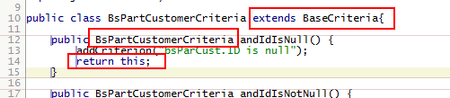

Mapper.java

BaseExample

List<BsBrand> selectByExample(BaseExample example);
List<BsBrand> selectByExample(BaseExample example,RowBounds rowBounds);

List<BsVsStock> selectByCdt(BsVsStock record);
List<BsVsStock> selectByCdt(BsVsStock record, RowBounds rowBounds);

int selectCount();
List<BsBrand> selectByCdtExa(@Param("record") BsBrand record, @Param("exampleList") List<?> exampleList);

Mapper.xml
parameterType
将com.auto.ngdms.sale.model.SaDecorationOrderCriteria 改成: com.auto.ngdms.common.model.BaseExample

<!--手动添加 -->
<select id="selectCount" resultType="int">
select count(*) from bs_media_detail bsMediaDetail
</select>
<sql id="RecordEqualClause">
<if test="record != null">
<if test="record.id != null" >
and bsMedDet.ID = #{record.id,jdbcType=VARCHAR},
</if>
<if test="record.entityCode != null" >
and bsMedDet.ENTITY_CODE = #{record.entityCode,jdbcType=VARCHAR},
</if>
<if test="record.mediaDetailCode != null" >
and bsMedDet.MEDIA_DETAIL_CODE = #{record.mediaDetailCode,jdbcType=VARCHAR},
</if>
<if test="record.mediaDetailName != null" >
and bsMedDet.MEDIA_DETAIL_NAME = #{record.mediaDetailName,jdbcType=VARCHAR},
</if>
<if test="record.parentMediaCode != null" >
and bsMedDet.PARENT_MEDIA_CODE = #{record.parentMediaCode,jdbcType=VARCHAR},
</if>
<if test="record.isValid != null" >
and bsMedDet.IS_VALID = #{record.isValid,jdbcType=VARCHAR},
</if>
<if test="record.createBy != null" >
and bsMedDet.CREATE_BY = #{record.createBy,jdbcType=VARCHAR},
</if>
<if test="record.createDate != null" >
and bsMedDet.CREATE_DATE = #{record.createDate,jdbcType=TIMESTAMP},
</if>
<if test="record.updateBy != null" >
and bsMedDet.UPDATE_BY = #{record.updateBy,jdbcType=VARCHAR},
</if>
<if test="record.updateDate != null" >
and bsMedDet.UPDATE_DATE = #{record.updateDate,jdbcType=TIMESTAMP},
</if>
</if>
</sql>
<select id="selectByCdtExa" resultMap="BaseResultMap">
select
<include refid="Base_Column_List" /> from bs_media_detail bsMediaDetail
<where>
<include refid="com.auto.ngdms.common.repository.mybatis.CustomMapper.ExampleListEqualClause"/>
<include refid="RecordEqualClause" />
</where>
</select>

6.WebApp 主工程模块
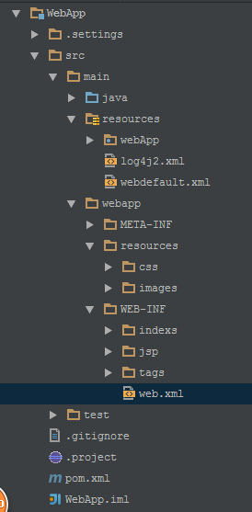

前端
jqgrid
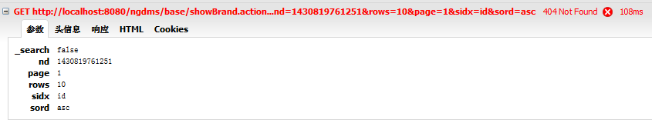
sidx 即 : sortname ：指定默认的排序列，可以是列名也可以是数字。此参数会在被传递到Server端。
rows 即: rowNum ：用于设置Grid中一次显示的行数，默认值为20。正是这个选项将参数rows（prmNames中设置的）通过url选项设置的链接传递到Server。注意如果Server返回的数据行数超过了rowNum的设定，则Grid也只显示rowNum设定的行数。
sord // 表示采用的排序方式的参数名称

order: "sord", // 表示采用的排序方式的参数名称
search:"_search", // 表示是否是搜索请求的参数名称
nd:"nd", // 表示已经发送请求的次数的参数名称

一、 jqGrid的加载。
1.引用相关头文件
引入CSS：
<link href="Scripts/jquery-ui-1.8.1.custom.css" rel="stylesheet" type="text/css" />
<link href="Scripts/ui.jqgrid.css" rel="stylesheet" type="text/css" />
引入JS：
<script src="Scripts/jquery-1.5.1.js" type="text/javascript"></script>
<script src="Scripts/jquery-ui.min.js" type="text/javascript"></script>
<script src="Scripts/grid.locale-en.js" type="text/javascript"></script>
<script src="Scripts/jquery.jqGrid.min.js" type="text/javascript"></script>
因为jqGrid3.6及以后的版本集成了jQuery UI，所以，此处需要导入UI相关js和css。另外grid.locale-en.js这个语言文件必须在jquery.jqGrid.min.js之前加载，否则会出问题。
2.将jqgrid加入页面中
根据jqGrid的文档，要想生成一个jqGrid，最直接的方法就是：
$("#list").jqGrid(options);
其中list是页面上的一个table：<table id="list"></table>
下面是一个简单的例子：
<script type="text/javascript">

$(document).ready(function () {

jQuery("#list").jqGrid({

url: 'Handler.ashx',

datatype: "json",

mtype: 'GET',

colNames: ['SalesReasonID', 'Name', 'ReasonType', 'ModifiedDate'],

colModel: [

{ name: 'SalesReasonID', index: 'SalesReasonID', width: 40, align: "left", editable: true },

{ name: 'Name', index: 'Name', width: 100, align: "center" },

{ name: 'ReasonType', index: 'ReasonType', width: 100, align: "center" },

{ name: 'ModifiedDate', index: 'ModifiedDate', width: 150, align: "center", search: false }

],

rowList: [10, 20, 30],

sortname: 'SalesReasonID',

viewrecords: true,

sortorder: "desc",

jsonReader: {

root: "griddata",

total: "totalpages",

page: "currpage",

records: "totalrecords",

repeatitems: false

},

pager: jQuery('#pager'),

rowNum: 5,

altclass: 'altRowsColour',

//width: 'auto',

width: '500',

height: 'auto',

caption: "DemoGrid"

}).navGrid('#pager', { add: true, edit: true, del: true,search:false,refresh:false }); ;

})
二、 jqgrid的重要选项
具体的options参考，可以访问jqGrid文档关于option的章节（http://www.trirand.com/jqgridwiki/doku.php?id=wiki:options）。其中有几个是比较常用的，重点介绍一下：
- url ：jqGrid控件通过这个参数得到需要显示的数据，具体的返回值可以使XML也可以是Json。
- datatype ：这个参数用于设定将要得到的数据类型。类型包括：json 、xml、xmlstring、local、javascript、function。
- mtype : 定义使用哪种方法发起请求，GET或者POST。
- height ：Grid的高度，可以接受数字、%值、auto，默认值为150。
- width ：Grid的宽度，如果未设置，则宽度应为所有列宽的之和；如果设置了宽度，则每列的宽度将会根据shrinkToFit选项的设置，进行设置。
- shrinkToFit ：此选项用于根据width计算每列宽度的算法。默认值为true。如果shrinkToFit为true且设置了width值，则每列宽度会根据 width成比例缩放；如果shrinkToFit为false且设置了width值，则每列的宽度不会成比例缩放，而是保持原有设置，而Grid将会有 水平滚动条。
- autowidth ：默认值为false。如果设为true，则Grid的宽度会根据父容器的宽度自动重算。重算仅发生在Grid初始化的阶段；如果当父容器尺寸变化了，同时也需要变化Grid的尺寸的话，则需要在自己的代码中调用setGridWidth方法来完成。
- pager ：定义页码控制条Page Bar，在上面的例子中是用一个div(<div id=”pager”></div>)来放置的。
- sortname ：指定默认的排序列，可以是列名也可以是数字。此参数会在被传递到Server端。
- viewrecords ：设置是否在Pager Bar显示所有记录的总数。
- caption ：设置Grid表格的标题，如果未设置，则标题区域不显示。
- rowNum ：用于设置Grid中一次显示的行数，默认值为20。正是这个选项将参数rows（prmNames中设置的）通过url选项设置的链接传递到Server。注意如果Server返回的数据行数超过了rowNum的设定，则Grid也只显示rowNum设定的行数。
- rowList ：一个数组，用于设置Grid可以接受的rowNum值。例如[10,20,30]。
- colNames ：字符串数组，用于指定各列的题头文本，与列的顺序是对应的。
- colModel ：最重要的数组之一，用于设定各列的参数。（稍后详述）
- prmNames ：这是一个数组，用于设置jqGrid将要向Server传递的参数名称。（稍后详述）
- jsonReader ：这又是一个数组，用来设定如何解析从Server端发回来的json数据。（稍后详述）
2.1 prmNames选项
prmNames是jqGrid的一个重要选项，用于设置jqGrid将要向Server传递的参数名称。其默认值为：
prmNames : {
page:"page", // 表示请求页码的参数名称
rows:"rows", // 表示请求行数的参数名称
sort: "sidx", // 表示用于排序的列名的参数名称
order: "sord", // 表示采用的排序方式的参数名称
search:"_search", // 表示是否是搜索请求的参数名称
nd:"nd", // 表示已经发送请求的次数的参数名称
id:"id", // 表示当在编辑数据模块中发送数据时，使用的id的名称
oper:"oper", // operation参数名称
editoper:"edit", // 当在edit模式中提交数据时，操作的名称
addoper:"add", // 当在add模式中提交数据时，操作的名称
deloper:"del", // 当在delete模式中提交数据时，操作的名称
subgridid:"id", // 当点击以载入数据到子表时，传递的数据名称
npage: null,
totalrows:"totalrows" // 表示需从Server得到总共多少行数据的参数名称，参见jqGrid选项中的rowTotal
}
2.2 jsonReader选项
jsonReader是jqGrid的一个重要选项，用于设置如何解析从Server端发回来的json数据，如果Server返回的是xml数据，则对应的使用xmlReader来解析。jsonReader的默认值为：
jsonReader : {
root: "rows", // json中代表实际模型数据的入口
page: "page", // json中代表当前页码的数据
total: "total", // json中代表页码总数的数据
records: "records", // json中代表数据行总数的数据
repeatitems: true, // 如果设为false，则jqGrid在解析json时，会根据name来搜索对应的数据元素（即可以json中元素可以不按顺序）；而所使用的name是来自于colModel中的name设定。
cell: "cell",
id: "id",
userdata: "userdata",
subgrid: {
root:"rows",
repeatitems: true,
cell:"cell"
}
}
假如有下面一个json字符串：
{"totalpages":"3","currpage":"1","totalrecords":"11","griddata": [{"SalesReasonID":"1","Name":"Price","ReasonType":"Other","ModifiedDate":"1998 年6月1日"},{"SalesReasonID":"2","Name":"On Promotion","ReasonType":"Promotion","ModifiedDate":"1998年6月1日"}, {"SalesReasonID":"3","Name":"Magazine Advertisement","ReasonType":"Marketing","ModifiedDate":"1998年6月1日"}, {"SalesReasonID":"4","Name":"Television Advertisement","ReasonType":"Marketing","ModifiedDate":"1998年6月1日"}, {"SalesReasonID":"5","Name":"Manufacturer","ReasonType":"Other","ModifiedDate":"1998 年6月1日"}]}
其对应的jsonReader为：jsonReader: {
root: "griddata",
total: "totalpages",
page: "currpage",
records: "totalrecords",
repeatitems: false
}
注：cell、id在repeatitems为true时可以用到，即每一个记录是由一对id和cell组合而成，即可以适用另一种json结构。援引文档中的例子：
repeatitems为true时：
jQuery("#gridid").jqGrid({
...
jsonReader : {
root:"invdata",
page: "currpage",
total: "totalpages",
records: "totalrecords"
},
...
});
json结构为：
{
"totalpages": "xxx",
"currpage": "yyy",
"totalrecords": "zzz",
"invdata" : [
{"id" :"1", "cell" :["cell11", "cell12", "cell13"]}, // cell中不需要各列的name，只要值就OK了，但是需要保持对应
{"id" :"2", "cell" :["cell21", "cell22", "cell23"]},
...
]
}
repeatitems为false时：
jQuery("#gridid").jqGrid({
...
jsonReader : {
root:"invdata",
page: "currpage",
total: "totalpages",
records: "totalrecords",
repeatitems: false,
id: "0"
},
...
});
json结构为：
{
"totalpages" : "xxx",
"currpage" : "yyy",
"totalrecords" : "zzz",
"invdata" : [
{"invid" : "1","invdate":"cell11", "amount" :"cell12", "tax" :"cell13", "total" :"1234", "note" :"somenote"}, // 数据中需要各列的name，但是可以不按列的顺序
{"invid" : "2","invdate":"cell21", "amount" :"cell22", "tax" :"cell23", "total" :"2345", "note" :"some note"},
...
]
}
2.3 colModel的重要选项
colModel也有许多非常重要的选项，在使用搜索、排序等方面都会用到。这里先只说说最基本的。
- name ：为Grid中的每个列设置唯一的名称，这是一个必需选项，其中保留字包括subgrid、cb、rn。
- index ：设置排序时所使用的索引名称，这个index名称会作为sidx参数（prmNames中设置的）传递到Server。
- label ：当jqGrid的colNames选项数组为空时，为各列指定题头。如果colNames和此项都为空时，则name选项值会成为题头。
- width ：设置列的宽度，目前只能接受以px为单位的数值，默认为150。
- sortable ：设置该列是否可以排序，默认为true。
- search ：设置该列是否可以被列为搜索条件，默认为true。
- resizable ：设置列是否可以变更尺寸，默认为true。
- hidden ：设置此列初始化时是否为隐藏状态，默认为false。
- formatter ：预设类型或用来格式化该列的自定义函数名。常用预设格式有：integer、date、currency、number等（具体参见文档 ）。
三、 注意事项
1. 动态改变Add Form或者Edit Form中的select的内容，如：改变下图中的Comparator下拉中的内容。
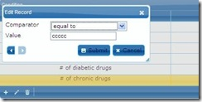
$("#list_d").navGrid('#pager_d',{add:true,edit:true,del:true,search:false,refresh:false},
{
checkOnSubmit:false, closeAfterEdit: true,recreateForm:true,
beforeInitData:function(formid){
initComparator();
},
beforeShowForm: function(formid){
$("#list_d").jqGrid('setColProp', 'Name', { editrules:{required:false},});
$('#tr_Name', formid).hide();
}
}，//edit
{},//add
{}//del
）
beforeInitData, beforeShowForm在每次点击编辑的时候都会执行。initComparator的作用是通过ajax获取数据，然后利 用$("#list_d").jqGrid('setColProp', 'Comparator', { editoptions: { value: valueString} });来设置Comparator下拉中的内容。其中valueString的格式如下’ equal to: equal to; not equal to: not equal to’。键值之间用冒号隔开，2项之间用分号隔开。注意：把recreateForm设为true，否则'setColProp'只在第一次调用时有效。
2. var rowNum = parseInt($(this).getGridParam("records"), 10); 得到数据条数。
3. jQuery("#list_d").clearGridData();清空数据。
4. jQuery("#list").getCell(ids,"Key");获取第ids行的key列。
5. $("#list").jqGrid('setSelection', "1");选中第一行。放在loadComplete：中在gird加载完成的时候自动选中第一行。 loadComplete:function(data){$("#list").jqGrid('setSelection', "1");
}
6. 对于像1中的可编辑的字段，可以设定rule，参见http://www.trirand.com/jqgridwiki/doku.php?id=wiki:common_rules#editrules
7. 修改Option，以URL为例
jQuery("#list_d").jqGrid('setGridParam',{url:"xxx.aspx",page:1}).trigger('reloadGrid');

IDEA

Maven 乱码
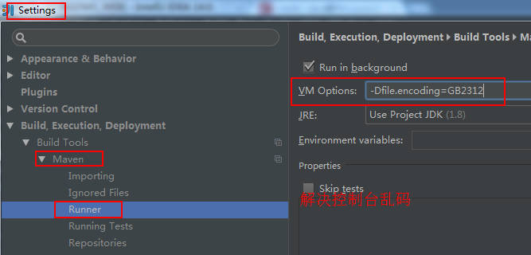

Idea配置
1.皮肤设置
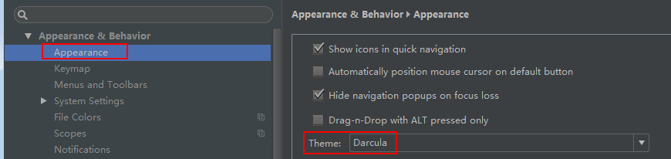

IDEA插件
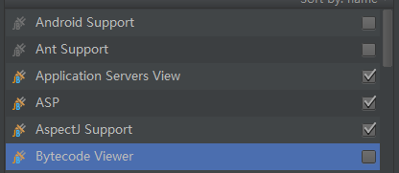
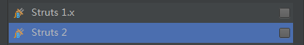
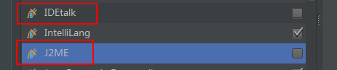

git

smartgit
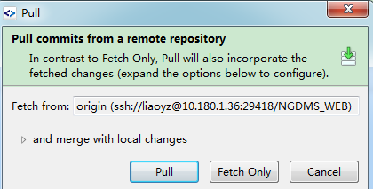
Pull commits from a remote repository
In contrast to Fetch Only, Pull will also incorporate the
fetched chagners (expand the options below to configure).

and merge with local changes
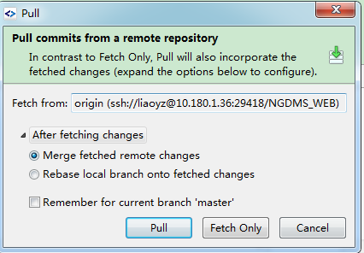
After fetching changes
Merge fetched remote changes
Rebase local branch onto fetched changes

Remember for current branch ‘master’

jsonarray

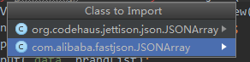
org.codehaus.jettison.json.JSONArray
com.alibaba.fastjson.JSONArray

settings
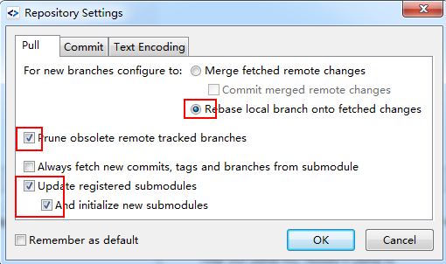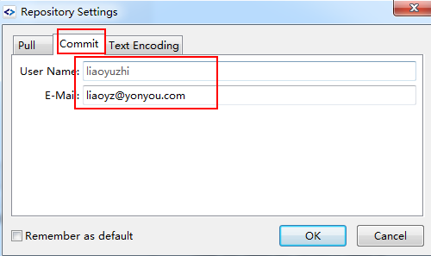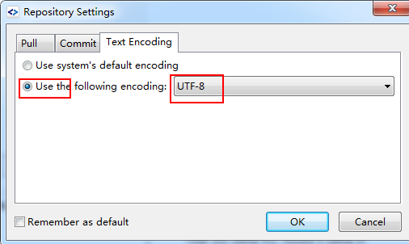

.git文件夹添加勾子 , commit-msg
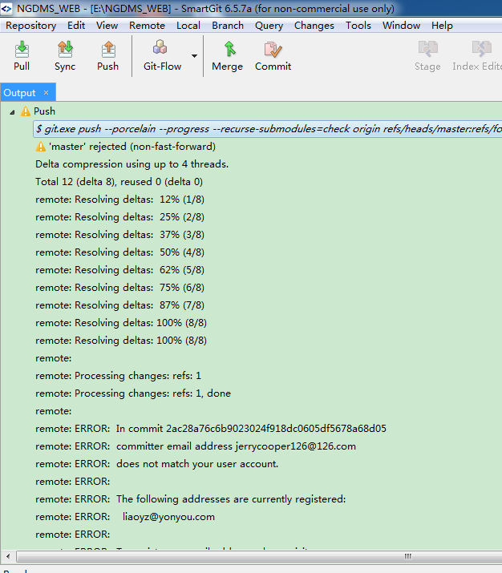
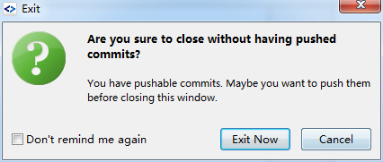

解决 : 在smartgit的设置settings 里修改提交邮箱. 原为: jerrycooper126@126.com 修改为 liaoyz@yonyou.com
.git文件夹添加勾子 , commit-msg

commit-msg: F:\youyou学习文档

push to 提交代码到远程库错误
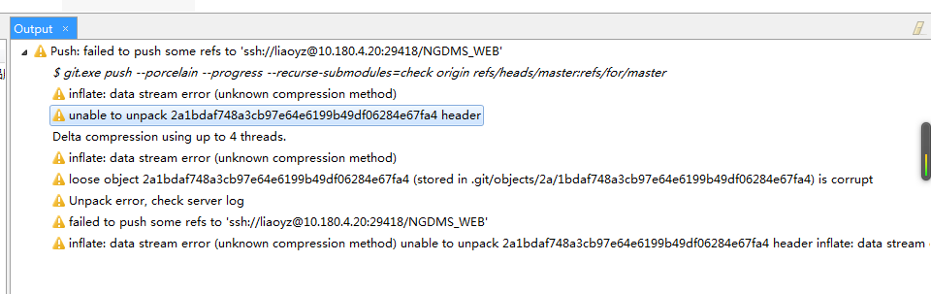
inflate: data stream error (unknown compression method)
unable to unpack id
Delta compression using up to 4 threads.
loose object id is corrupt
Unpack error, check server log

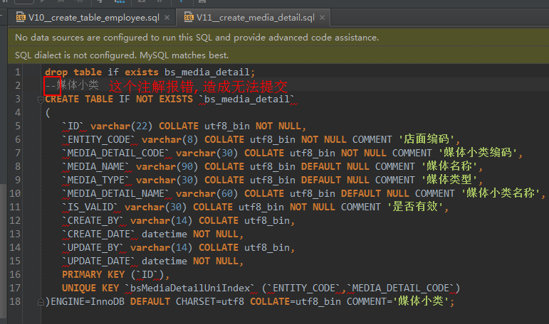

提交到远程库的代码如何作废
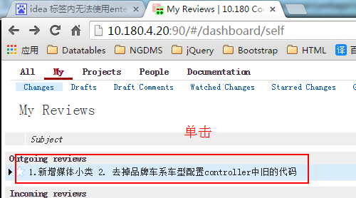
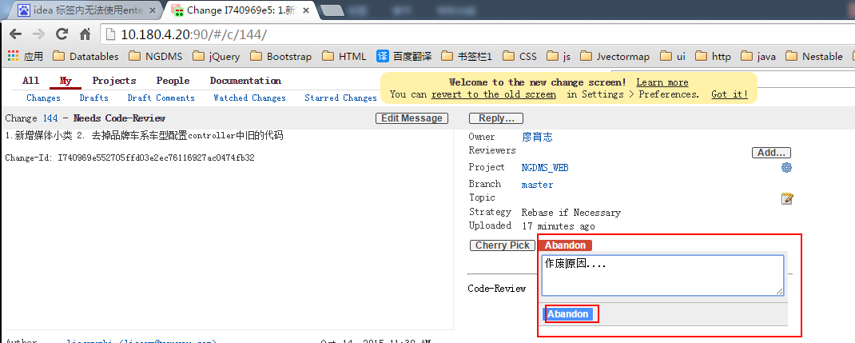

代码审核不通过My Revies和 smartgit 操作
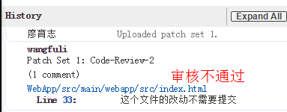
第一步：找到提交的ID refs/changes/44/144/2
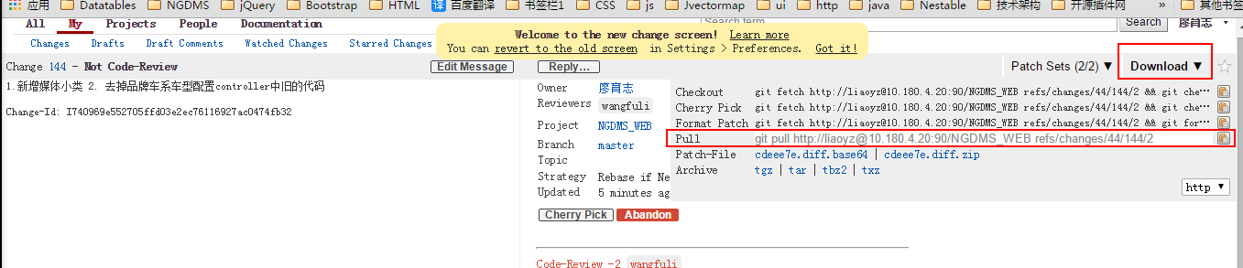

第二步：暂存本地操作
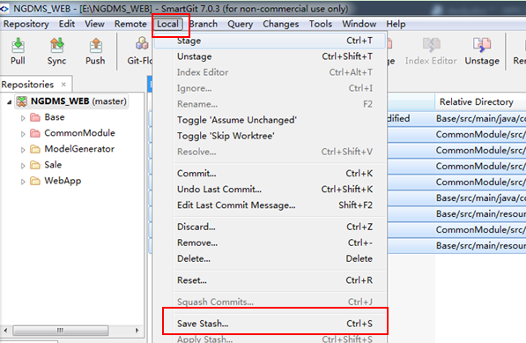

第三步：Fetch More
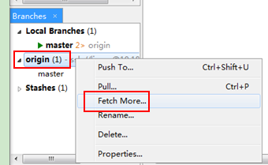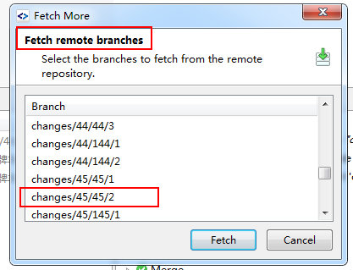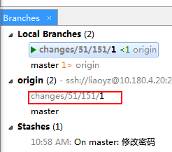
在origin 出现的分支里右键 选择check out ,之后如下图:
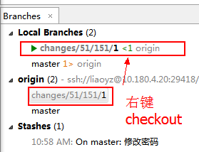
修改changes/51/151/1 这个分支完成后, commit提交时, 选log的changeid ;

不需要切换到master分支合并再提交.

第四步: 删掉多余的分支切换回到Stashes里
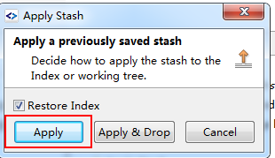

补充: 当推送到远程后 , Rebase到本地master分支 , 不采用合并(merge)
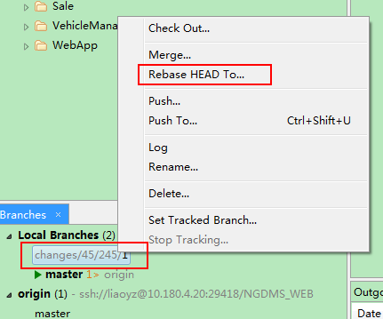

解决冲突后, 要staged . 再右键选择Rebase HEAD To…
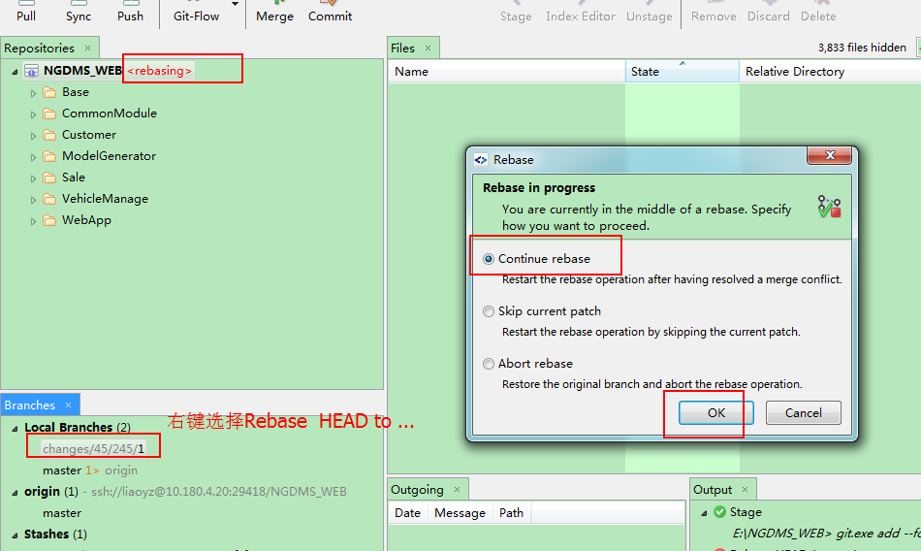

Ignore忽略文件不做提交
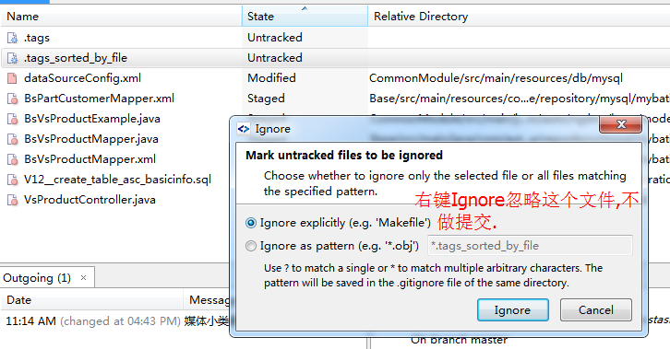

An internal error has been detected!
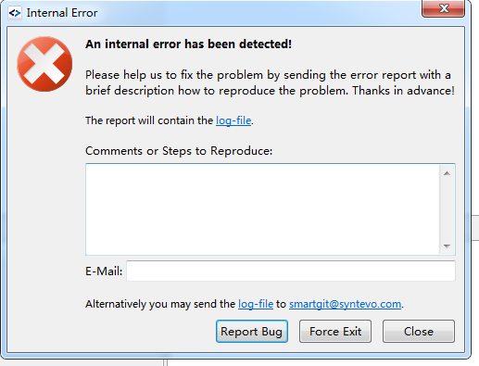
An internal error has been detected!
Please help us to fix the problem by sending the error report with a brief description how to reproduce the problem. Thanks in advance!
The report will contail the log-file.

406 acceptable
<!--<mvc:annotation-driven content-negotiation-manager="contentNegotiationManager"/>-->
<mvc:annotation-driven content-negotiation-manager="contentNegotiationManager">
<mvc:message-converters>
<bean class="com.alibaba.fastjson.support.spring.FastJsonHttpMessageConverter"/>
</mvc:message-converters>
</mvc:annotation-driven>

使用@ResponseBody 时会报这个错. 在pom.xml里配置上述内容即可.

400 Bad Request
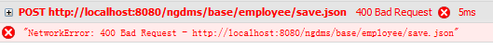
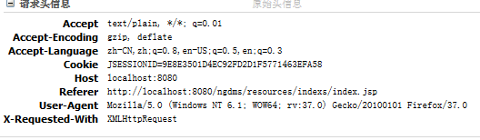

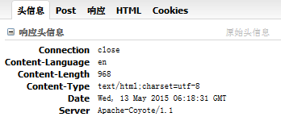

原因: 有个字段的类型是枚举类型 , 后台不能配置 , 所以报400

js获取项目路径
//js获取项目根路径，如： http://localhost:8080/ngdms
function getRootPath(){
//获取当前网址，如： http://localhost:8080/ngdms/resources/indexs/index.jsp
var curWwwPath=window.document.location.href;
//获取主机地址之后的目录，如： ngdms/resources/indexs/index.jsp
var pathName=window.document.location.pathname;
var pos=curWwwPath.indexOf(pathName);
//获取主机地址，如： http://localhost:8080
var localhostPaht=curWwwPath.substring(0,pos);
//获取带"/"的项目名，如：/ngdms
var projectName=pathName.substring(0,pathName.substr(1).indexOf('/')+1);
return(localhostPaht+projectName);
}

全选全不选不显示打勾
最近在调试复选框的应用，在ie没有问题，考虑到兼容性，试试了firefox，遇到了问题。
复选框绑定了click事件，点一次选中，再点击取消选中，依次类推。这个功能在ie中没问题，但是在firefox中测试的时候，前两次都没有问题，可 以正常显示选中和取消，但当再去选中的时候，复选框的属性checkbox值变为"checked"，没问题，但是复选框却不在显示选中状态，明明属性值 改了，但是却不显示勾选，太诡异了。代码修改了却得不到正确的显示状态，纠结了很久，找不到原因。
正解：后来经偶像指点，原来是jQuery版本问题。我操作属性用的是
$("**").attr("attrName");而jQuery的版本用的是1.9，这就是存在一个兼容性和稳定性问题。
jQuery API明确说明，1.6+的jQuery要用prop，尤其是checkBox的checked的属性的判断，即
$("input[type='checkbox']").prop("checked");
$("input[type='checkbox']").prop("disabled", false);
$("input[type='checkbox']").prop("checked", true);
在使用是将attr改为prop，问题得解。
你遇到这个奇怪的问题了吗？赶紧试试吧~~
$('#checkAllBox').click(function(){
// alert("全选全不选");
if($('#checkAllBox').prop('checked')){
$("input[name='checkbox-inline']").prop('checked',true);
}else{
$("input[name='checkbox-inline']").prop('checked',false);
}
});

2. 换成 prop('checked',true) ，当ckAll被选中时，所有列表checkbox都会被选中
$('#ckAll').click(function(){
if($('#ckAll').prop('checked')){
$('.tab-list .ckbox').each(function(i,n){
$(n).prop('checked',true);
});
}else{
$('.tab-list .ckbox').each(function(i,n){
$(n).prop('checked',false);
});
}
});

代码打包

持续集成(CI)，用于代码 打包、单元测试、生成代码文档、发包等
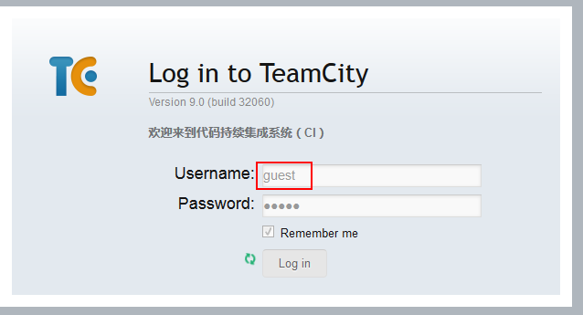guest guest
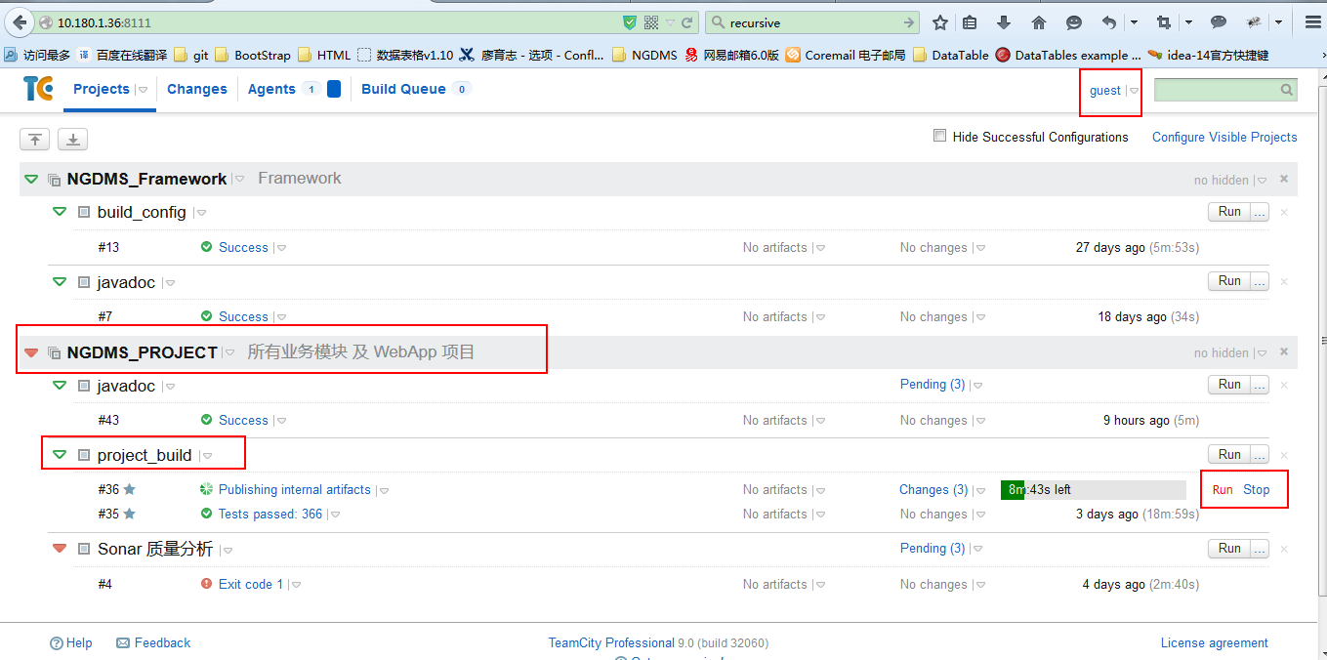

编译报错:
[INFO] --- maven-resources-plugin:2.7:resources (default-resources) @ WebApp ---
[INFO] Using 'UTF-8' encoding to copy filtered resources.
[INFO] Copying 9 resources
[INFO]
[INFO] --- maven-compiler-plugin:3.2:compile (default-compile) @ WebApp ---
[INFO] Changes detected - recompiling the module!
[INFO] Compiling 19 source files to E:\NGDMS_WEB\WebApp\target\classes
[INFO] -------------------------------------------------------------
[ERROR] COMPILATION ERROR :
[INFO] -------------------------------------------------------------
[ERROR] ���һ��ѭ��: true
E:\NGDMS_WEB\WebApp\src\main\java\com\auto\ngdms\base\web\PayTypeController.java:[3,32] ����: �Ҳ�������
[ERROR] ����: �� BsPayType
λ��: ����� com.auto.ngdms.base.model
E:\NGDMS_WEB\WebApp\src\main\java\com\auto\ngdms\base\web\PayTypeController.java:[4,32] ����: �Ҳ�������
[ERROR] ����: �� BsPayTypeExample
λ��: ����� com.auto.ngdms.base.model
E:\NGDMS_WEB\WebApp\src\main\java\com\auto\ngdms\base\web\PayTypeController.java:[5,34] ����: �Ҳ�������
[ERROR] ����: �� BsPayTypeService
λ��: ����� com.auto.ngdms.base.service
E:\NGDMS_WEB\WebApp\src\main\java\com\auto\ngdms\base\web\PayTypeController.java:[31,12] ����: �Ҳ�������
[ERROR] ����: �� BsPayTypeService
λ��: �� PayTypeController
E:\NGDMS_WEB\WebApp\src\main\java\com\auto\ngdms\base\web\PayTypeController.java:[37,48] ����: �Ҳ�������
[ERROR] ����: �� BsPayType
λ��: �� PayTypeController
E:\NGDMS_WEB\WebApp\src\main\java\com\auto\ngdms\base\web\PayTypeController.java:[61,48] ����: �Ҳ�������
[ERROR] ����: �� BsPayType
λ��: �� PayTypeController
E:\NGDMS_WEB\WebApp\src\main\java\com\auto\ngdms\base\web\PayTypeController.java:[85,29] ����: �Ҳ�������
[ERROR] ����: �� BsPayType
λ��: �� PayTypeController
E:\NGDMS_WEB\WebApp\src\main\java\com\auto\ngdms\base\web\PayTypeController.java:[97,40] ����: �Ҳ�������
[ERROR] ����: �� BsPayType
λ��: �� PayTypeController
E:\NGDMS_WEB\WebApp\src\main\java\com\auto\ngdms\base\web\PayTypeController.java:[108,31] ����: �Ҳ�������
[ERROR] ����: �� BsPayType
λ��: �� PayTypeController
E:\NGDMS_WEB\WebApp\src\main\java\com\auto\ngdms\base\web\PayTypeController.java:[119,36] ����: �Ҳ�������
[ERROR] ����: �� BsPayType
λ��: �� PayTypeController
E:\NGDMS_WEB\WebApp\src\main\java\com\auto\ngdms\base\web\PayTypeController.java:[131,28] ����: �Ҳ�������
[ERROR] ����: �� BsPayType
λ��: �� PayTypeController
E:\NGDMS_WEB\WebApp\src\main\java\com\auto\ngdms\base\web\InvoiceTypeController.java:[3,32] ����: �Ҳ�������
[ERROR] ����: �� BsInvoiceType
λ��: ����� com.auto.ngdms.base.model
E:\NGDMS_WEB\WebApp\src\main\java\com\auto\ngdms\base\web\InvoiceTypeController.java:[4,32] ����: �Ҳ�������
[ERROR] ����: �� BsInvoiceTypeExample
λ��: ����� com.auto.ngdms.base.model
E:\NGDMS_WEB\WebApp\src\main\java\com\auto\ngdms\base\web\InvoiceTypeController.java:[5,34] ����: �Ҳ�������
[ERROR] ����: �� BsInvoiceTypeService
λ��: ����� com.auto.ngdms.base.service
E:\NGDMS_WEB\WebApp\src\main\java\com\auto\ngdms\base\web\InvoiceTypeController.java:[31,12] ����: �Ҳ�������
[ERROR] ����: �� BsInvoiceTypeService
λ��: �� InvoiceTypeController
E:\NGDMS_WEB\WebApp\src\main\java\com\auto\ngdms\base\web\InvoiceTypeController.java:[37,48] ����: �Ҳ�������
[ERROR] ����: �� BsInvoiceType
λ��: �� InvoiceTypeController
E:\NGDMS_WEB\WebApp\src\main\java\com\auto\ngdms\base\web\InvoiceTypeController.java:[61,48] ����: �Ҳ�������
[ERROR] ����: �� BsInvoiceType
λ��: �� InvoiceTypeController
E:\NGDMS_WEB\WebApp\src\main\java\com\auto\ngdms\base\web\InvoiceTypeController.java:[85,29] ����: �Ҳ�������
[ERROR] ����: �� BsInvoiceType
λ��: �� InvoiceTypeController
E:\NGDMS_WEB\WebApp\src\main\java\com\auto\ngdms\base\web\InvoiceTypeController.java:[97,40] ����: �Ҳ�������
[ERROR] ����: �� BsInvoiceType
λ��: �� InvoiceTypeController
E:\NGDMS_WEB\WebApp\src\main\java\com\auto\ngdms\base\web\InvoiceTypeController.java:[108,31] ����: �Ҳ�������
[ERROR] ����: �� BsInvoiceType
λ��: �� InvoiceTypeController
E:\NGDMS_WEB\WebApp\src\main\java\com\auto\ngdms\base\web\InvoiceTypeController.java:[119,36] ����: �Ҳ�������
[ERROR] ����: �� BsInvoiceType
λ��: �� InvoiceTypeController
E:\NGDMS_WEB\WebApp\src\main\java\com\auto\ngdms\base\web\InvoiceTypeController.java:[131,28] ����: �Ҳ�������
[INFO] 22 errors
[INFO] -------------------------------------------------------------
[INFO] ------------------------------------------------------------------------
[INFO] BUILD FAILURE
[INFO] ------------------------------------------------------------------------
[INFO] Total time: 23.620s
[INFO] Finished at: Mon May 25 13:31:49 CST 2015
[INFO] Final Memory: 10M/109M
[INFO] ------------------------------------------------------------------------
[ERROR] Failed to execute goal org.apache.maven.plugins:maven-compiler-plugin:3.2:compile (default-compile) on project WebApp: Compilation failure: Compilation failure:
[ERROR] ���һ��ѭ��: true
[ERROR] E:\NGDMS_WEB\WebApp\src\main\java\com\auto\ngdms\base\web\PayTypeController.java:[3,32] ����: �Ҳ�������
[ERROR] ����: �� BsPayType
[ERROR] λ��: ����� com.auto.ngdms.base.model
[ERROR] E:\NGDMS_WEB\WebApp\src\main\java\com\auto\ngdms\base\web\PayTypeController.java:[4,32] ����: �Ҳ�������
[ERROR] ����: �� BsPayTypeExample
[ERROR] λ��: ����� com.auto.ngdms.base.model
[ERROR] E:\NGDMS_WEB\WebApp\src\main\java\com\auto\ngdms\base\web\PayTypeController.java:[5,34] ����: �Ҳ�������
[ERROR] ����: �� BsPayTypeService
[ERROR] λ��: ����� com.auto.ngdms.base.service
[ERROR] E:\NGDMS_WEB\WebApp\src\main\java\com\auto\ngdms\base\web\PayTypeController.java:[31,12] ����: �Ҳ�������
[ERROR] ����: �� BsPayTypeService
[ERROR] λ��: �� PayTypeController
[ERROR] E:\NGDMS_WEB\WebApp\src\main\java\com\auto\ngdms\base\web\PayTypeController.java:[37,48] ����: �Ҳ�������
[ERROR] ����: �� BsPayType
[ERROR] λ��: �� PayTypeController
[ERROR] E:\NGDMS_WEB\WebApp\src\main\java\com\auto\ngdms\base\web\PayTypeController.java:[61,48] ����: �Ҳ�������
[ERROR] ����: �� BsPayType
[ERROR] λ��: �� PayTypeController
[ERROR] E:\NGDMS_WEB\WebApp\src\main\java\com\auto\ngdms\base\web\PayTypeController.java:[85,29] ����: �Ҳ�������
[ERROR] ����: �� BsPayType
[ERROR] λ��: �� PayTypeController
[ERROR] E:\NGDMS_WEB\WebApp\src\main\java\com\auto\ngdms\base\web\PayTypeController.java:[97,40] ����: �Ҳ�������
[ERROR] ����: �� BsPayType
[ERROR] λ��: �� PayTypeController
[ERROR] E:\NGDMS_WEB\WebApp\src\main\java\com\auto\ngdms\base\web\PayTypeController.java:[108,31] ����: �Ҳ�������
[ERROR] ����: �� BsPayType
[ERROR] λ��: �� PayTypeController
[ERROR] E:\NGDMS_WEB\WebApp\src\main\java\com\auto\ngdms\base\web\PayTypeController.java:[119,36] ����: �Ҳ�������
[ERROR] ����: �� BsPayType
[ERROR] λ��: �� PayTypeController
[ERROR] E:\NGDMS_WEB\WebApp\src\main\java\com\auto\ngdms\base\web\PayTypeController.java:[131,28] ����: �Ҳ�������
[ERROR] ����: �� BsPayType
[ERROR] λ��: �� PayTypeController
[ERROR] E:\NGDMS_WEB\WebApp\src\main\java\com\auto\ngdms\base\web\InvoiceTypeController.java:[3,32] ����: �Ҳ�������
[ERROR] ����: �� BsInvoiceType
[ERROR] λ��: ����� com.auto.ngdms.base.model
[ERROR] E:\NGDMS_WEB\WebApp\src\main\java\com\auto\ngdms\base\web\InvoiceTypeController.java:[4,32] ����: �Ҳ�������
[ERROR] ����: �� BsInvoiceTypeExample
[ERROR] λ��: ����� com.auto.ngdms.base.model
[ERROR] E:\NGDMS_WEB\WebApp\src\main\java\com\auto\ngdms\base\web\InvoiceTypeController.java:[5,34] ����: �Ҳ�������
[ERROR] ����: �� BsInvoiceTypeService
[ERROR] λ��: ����� com.auto.ngdms.base.service
[ERROR] E:\NGDMS_WEB\WebApp\src\main\java\com\auto\ngdms\base\web\InvoiceTypeController.java:[31,12] ����: �Ҳ�������
[ERROR] ����: �� BsInvoiceTypeService
[ERROR] λ��: �� InvoiceTypeController
[ERROR] E:\NGDMS_WEB\WebApp\src\main\java\com\auto\ngdms\base\web\InvoiceTypeController.java:[37,48] ����: �Ҳ�������
[ERROR] ����: �� BsInvoiceType
[ERROR] λ��: �� InvoiceTypeController
[ERROR] E:\NGDMS_WEB\WebApp\src\main\java\com\auto\ngdms\base\web\InvoiceTypeController.java:[61,48] ����: �Ҳ�������
[ERROR] ����: �� BsInvoiceType
[ERROR] λ��: �� InvoiceTypeController
[ERROR] E:\NGDMS_WEB\WebApp\src\main\java\com\auto\ngdms\base\web\InvoiceTypeController.java:[85,29] ����: �Ҳ�������
[ERROR] ����: �� BsInvoiceType
[ERROR] λ��: �� InvoiceTypeController
[ERROR] E:\NGDMS_WEB\WebApp\src\main\java\com\auto\ngdms\base\web\InvoiceTypeController.java:[97,40] ����: �Ҳ�������
[ERROR] ����: �� BsInvoiceType
[ERROR] λ��: �� InvoiceTypeController
[ERROR] E:\NGDMS_WEB\WebApp\src\main\java\com\auto\ngdms\base\web\InvoiceTypeController.java:[108,31] ����: �Ҳ�������
[ERROR] ����: �� BsInvoiceType
[ERROR] λ��: �� InvoiceTypeController
[ERROR] E:\NGDMS_WEB\WebApp\src\main\java\com\auto\ngdms\base\web\InvoiceTypeController.java:[119,36] ����: �Ҳ�������
[ERROR] ����: �� BsInvoiceType
[ERROR] λ��: �� InvoiceTypeController
[ERROR] E:\NGDMS_WEB\WebApp\src\main\java\com\auto\ngdms\base\web\InvoiceTypeController.java:[131,28] ����: �Ҳ�������
[ERROR] -> [Help 1]
[ERROR]
[ERROR] To see the full stack trace of the errors, re-run Maven with the -e switch.
[ERROR] Re-run Maven using the -X switch to enable full debug logging.
[ERROR]
[ERROR] For more information about the errors and possible solutions, please read the following articles:
[ERROR] [Help 1] http://cwiki.apache.org/confluence/display/MAVEN/MojoFailureException

Process finished with exit code 1

Datatables

获取隐藏列的值
dt.row(row).data()

获取当前页码信息
initTable.api().page.info();
initTable.api().page();
initTable.api().page.len();

添加, 修改, 删除 刷新当前页面
dt.ajax.reload(null,false)
当在第二页时, 刷新后不会跳转到第一页.

排序
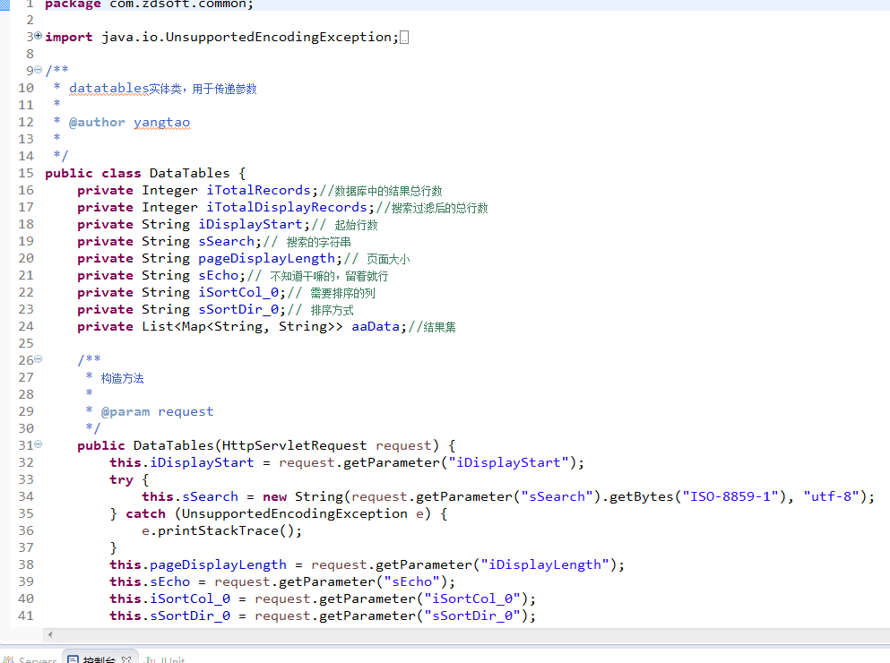

排序2
【DTN】sz-js-hehe(849485440) 12:20:25
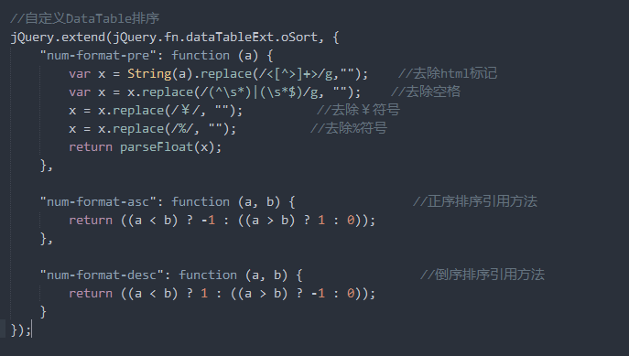

多选tr
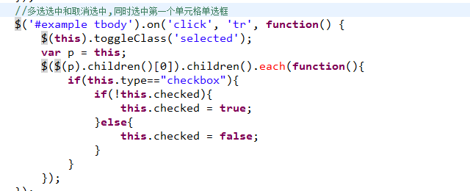

日期格式转换
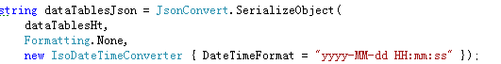

【DT1.9】mir<mirari@vip.qq.com> 14:48:43
js端日期转换引入一个datejs包即可,Date类型直接toString("格式")即可,不用这么麻烦

大数据 , 国际化
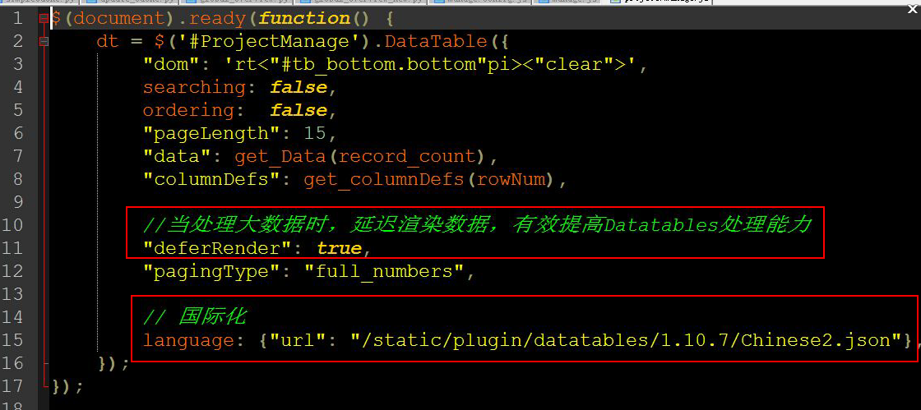

重新绑定数据
已经初始化好了datatables对象了，然后我要重新绑定数据，有没有方法？类似于setData的方法
$('#example').dataTable().api().clear().rows.add(jsondata).draw();jsondata需为json对象

分页参数
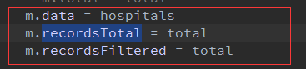

日期插件
【DTN】有问题@我(806400289)

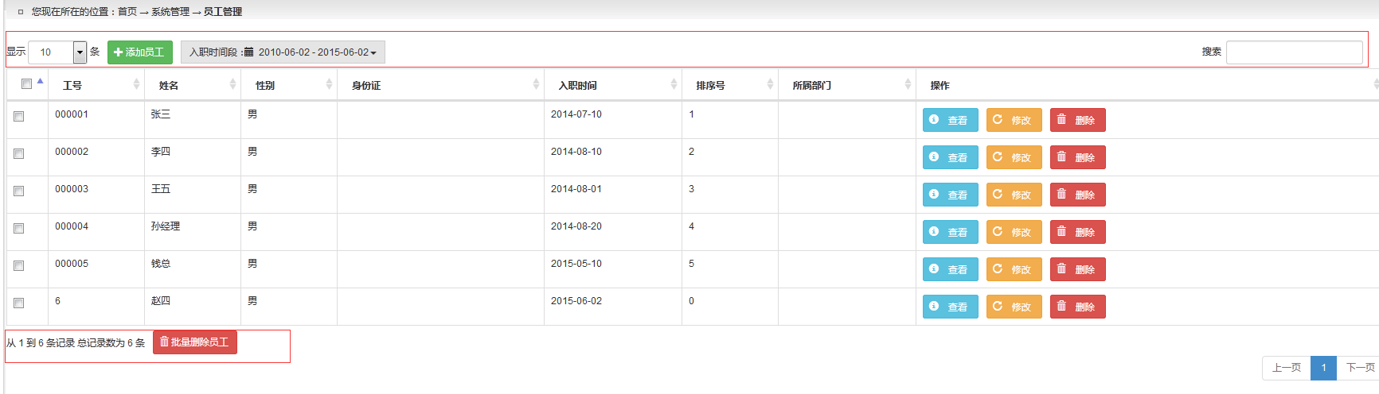

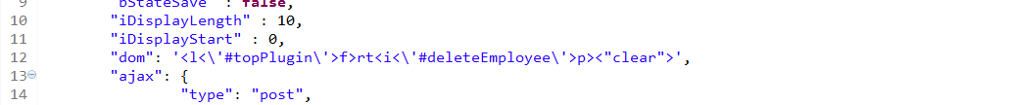

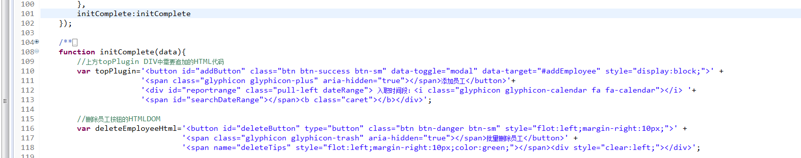

<div id=”reportrange” class=”pull-left dateRange” >
入职时间段:<i class=”glyphicon ></i>
<span id=”searchDateRange”></span><b class=”caret”></b>
</div>

给Datatables动态赋值
【DT1.8】青岛-net-cryonmyshou(3210827284) 9:24:12
@问：动态给属性给赋值 答： var oTable = $('#example').dataTable();
// get settings object after table is initialized
var oSettings = oTable.fnSettings();
// disable sorting on column "1"
oSettings.aoColumns[1].bSortable = false;

datatables 分页指定跳转到多少页
【DT1.8】湖北-php-is_human(10519294) 10:28:38
"fnDrawCallback": function (oSetting) {
check_num=0;
var div = $('<div></div>');
var inp = $('<input />');
inp.addClass('span3');
inp.attr('type','text');
div.attr('id','div');
div.css('float','left');
div.css('margin-top','-28px');
div.append("è·³è½¬åˆ°ç¬¬&nbsp;");
div.append(inp);
$('#div').remove();
div.append('&nbsp;é¡µ');
$('.fg-toolbar').append(div);
if (oTable === undefined) {
oTable = $(".data-table-ajax").dataTable();
}
inp.keyup(function(e){
if ($(this).val() && $(this).val() > 0) {
var redirectpage = $(this).val() - 1;
oTable.fnPageChange(redirectpage, true);
}
});

去掉Datatables的提示
【DT1.10】tj-j-volcan(952151309) 11:31:32
jquery.dataTables.js 默认警告级别 是alert 改成 none 就成了

bootstrap-dialog
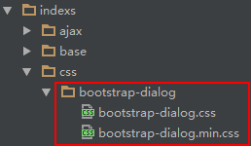
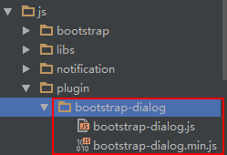

bootstrap 菜单
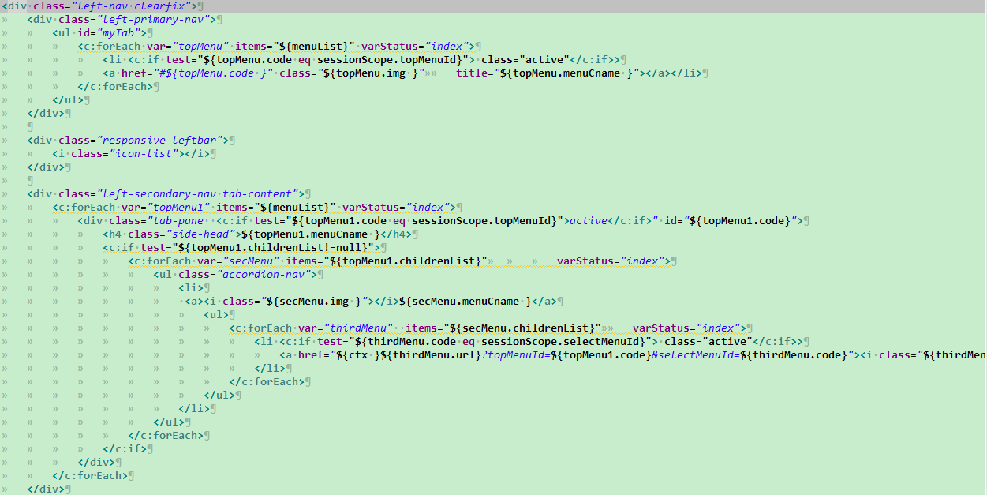

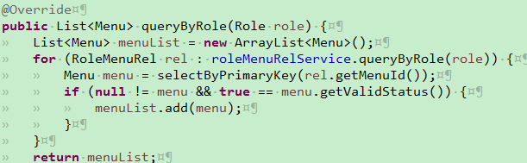

新增数据时地址栏数据偶尔会重定向到controller的路径
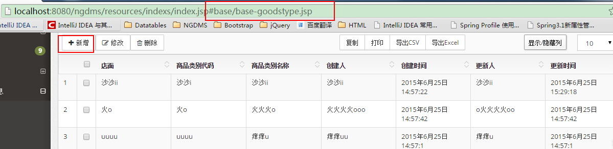
变成
刘行 2015/6/25 18:00:25
那不是相当于重新访问了一个页面
廖育志 2015/6/25 18:00:31
是的
刘行 2015/6/25 18:00:37
你页面不动
一段时间就会自动跳转？
廖育志 2015/6/25 18:01:49
不是,
廖育志 2015/6/25 18:03:03
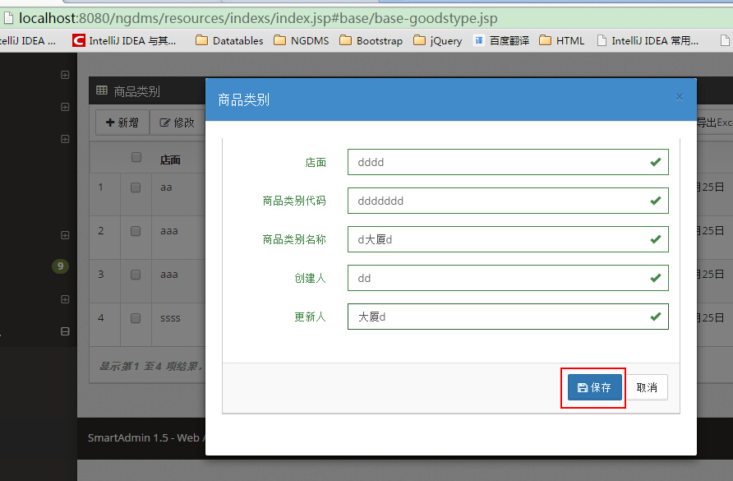点击保存后会变成 图1 或 图2
图1
图2

我怀疑是浏览器的问题,
因为我用firefox浏览器新增了40多条数据都没有出现这样的情况, 用chrome浏览器新增几条或10几条数据偶尔会出现这种情况.

chrome浏览器对bootstrapvalidate 插件支持不稳定 ; 现在改用jQueryvalidation

bootstrap 的标签添加个title属性就可以提示信息(鼠标hover)

bootstrap退出
bootstrap退出弹窗修改
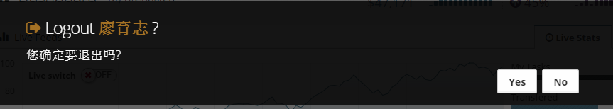
修改文件: app.min.js
红色方框为修改过的内容
"userLogout": function(a) {
function b() {
window.location = a.attr("href")
}
$.SmartMessageBox({
"title": "<i class='fa fa-sign-out txt-color-orangeDark'></i> 退出账号: <span class='txt-color-orangeDark'><strong>" + $("#show-shortcut").text() + "</strong></span> ",
"content": a.data("logout-msg") || "You can improve your security further after logging out by closing this opened browser",
"buttons": "[取消][确定]"
}, function(a) {
"确定" == a && ($.root_.addClass("animated fadeOutUp"),
setTimeout(b, 1e3))
}
)
},

重置本地设置
修改文件 : app.min.js 红色方框为修改内容

"resetWidgets": function(a) {
$.SmartMessageBox({
"title": "<i class='fa fa-refresh' style='color:green'></i> 重置本地设置",
"content": a.data("reset-msg") || "Would you like to RESET all your saved widgets and clear LocalStorage?1",
"buttons": "[取消][确定]"
}, function(a) {
function b(){
var refreshTime = localStorage.getItem("refreshTime");
localStorage.clear();
if(null != refreshTime){
localStorage.setItem("refreshTime",refreshTime);
}
}
"确定" == a && localStorage && (b(),
location.reload())
}
)
},

关掉数据库升级脚本的运行
王夫利<wfl80152@163.com> 16:02:25
各位，
在自己的机器上注释掉下面的 xml 配置 ，可以关掉 数据库升级脚本的运行，

但，不要把注释掉的代码提交到 git 服务器

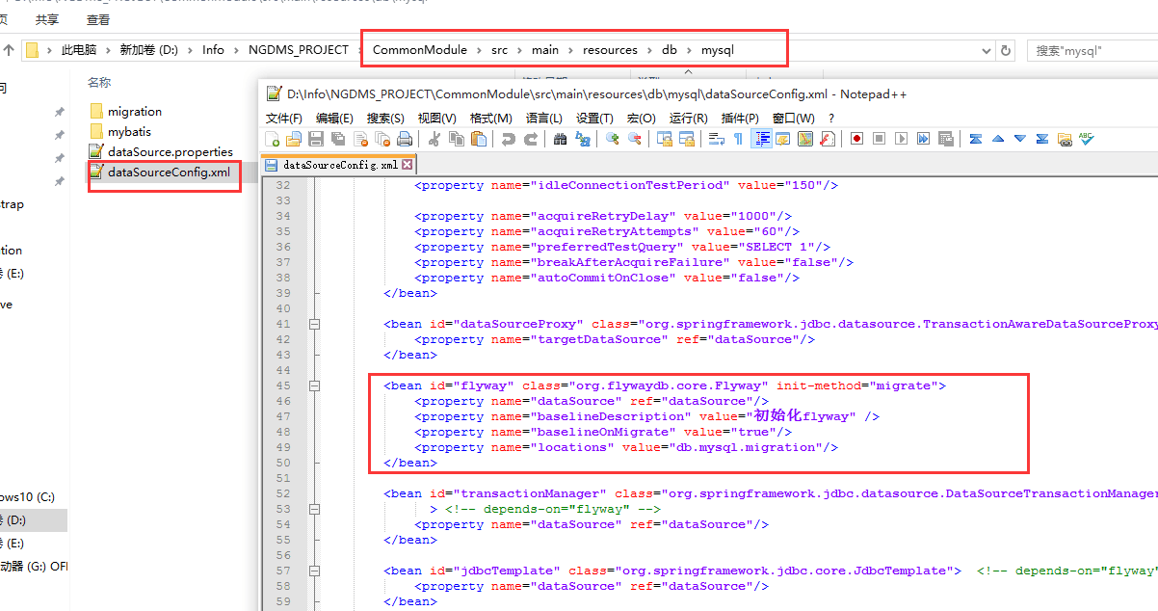

Bower 更新项目的组件
修改bower.json文件
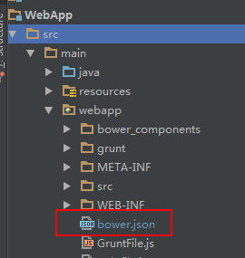

进入到目录执行 bower install
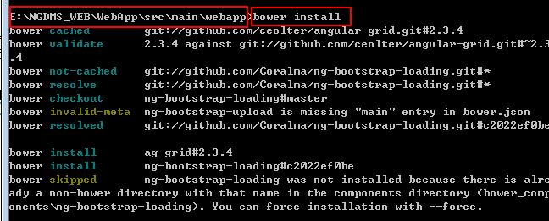

NGDMS项目异常处理
一.各位：
后台异常传递到前台的机制已经建好了，
实现方法如下：
1 在 后台 Controller 中抛出业务类型异常，
2 在 GlobalExceptionController 中增加特定的业务处理方法
3 前台接收异常信息并提示出消息
参见下图：
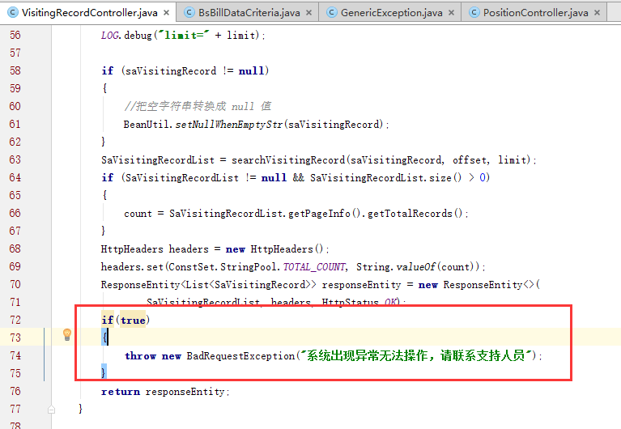
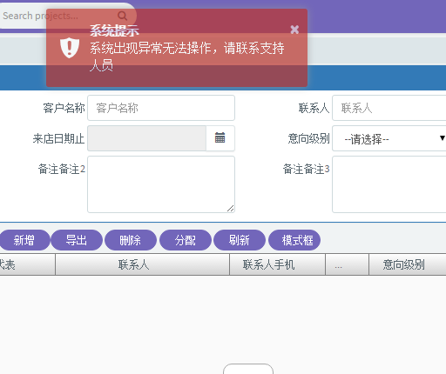
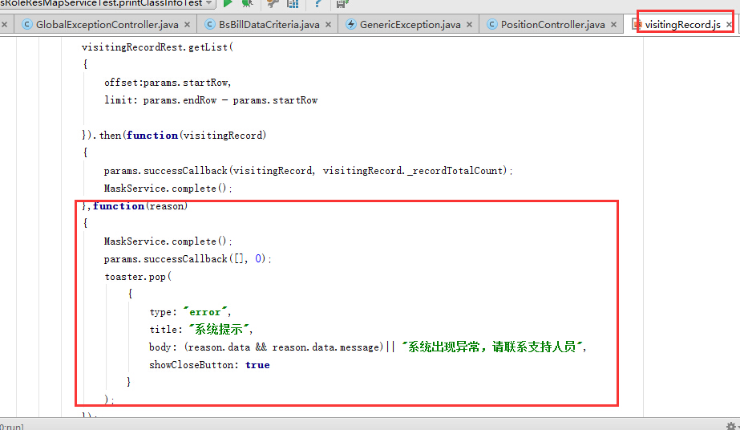

二.后台特定的业务异常，请建在如下包下
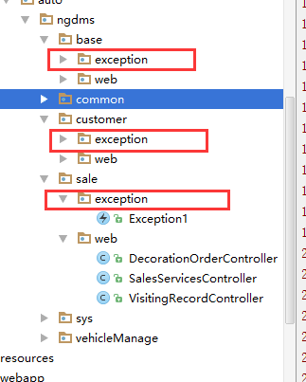

相关系统生成的业务编号都从这个常量文件中获取
朱青云(41276955) 2015-11-24 18:54:00
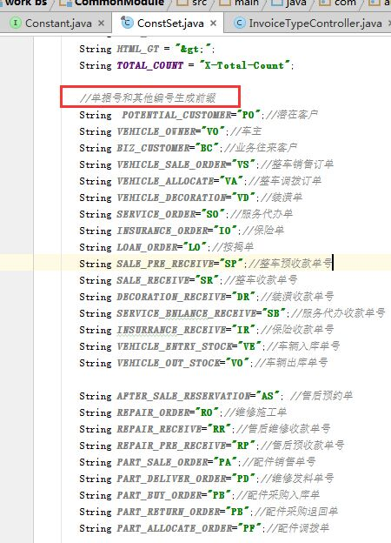@全体成员 相关系统生成的业务编号都从这个常量文件中获取

用户信息获取 舒鹏飞
- 舒鹏飞(383867644) 17:21:42
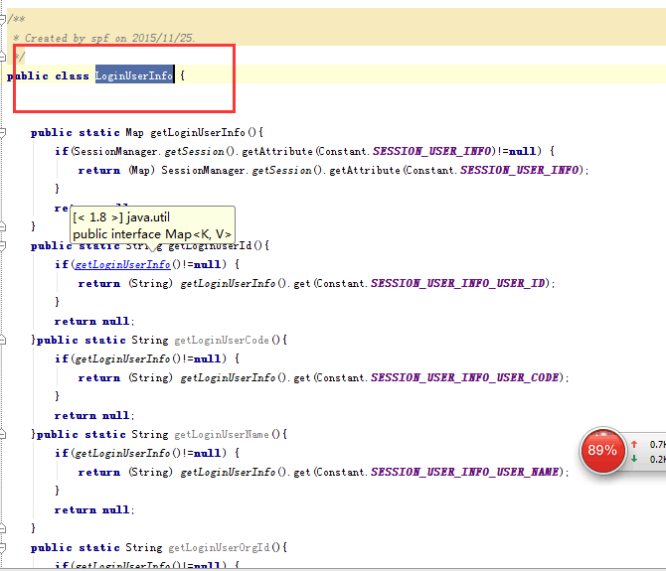
后台获取登入用户公共信息的类及方法
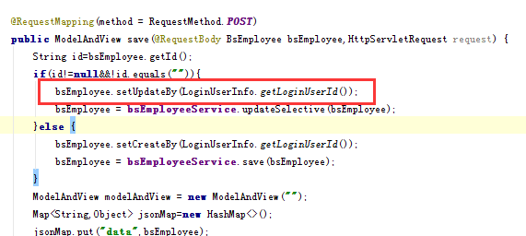
需要使用时直接调用
舒鹏飞(383867644) 17:23:28
前台获取注入服务"userResLoad"
通过服务属性loginUserInfo.获取
前台提供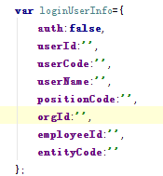
舒鹏飞(383867644) 17:24:29
后台提供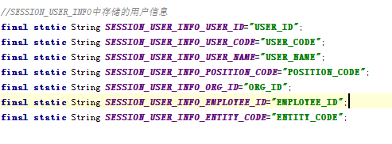

大

