Dzc代码

带强化学习 发ppt LY

**传播：缩小prompt。**

**RLP**

**Memory更新这里：self content和 send content 有很多重复生成的对象，或者内容重复的类；需要修改一下。**

**问题： social net 这里各个信息的receiver（多人 or 单人）√**

**Message的receiver需要修改格式（dict） √**

**测试时，对于竞争环境的描述是：competitive, the community_1 has been almost \**

**fully selected, the community_2 has a relatively sufficient house, the community_3 has not been chosen yet.**

**测试时，设定每个agent的目标是：to develop a plan that is most beneficial to you to increase your chances of choosing a house in the current situation （最大化自己利益）**

**James:**

**此人的信息是community_3's house is in a very bad environment, full of garbage, haunted. It is not suitable for human habitation.**

**这个James的设定是dishonest and unscrupulous person who uses all means to achieve your own goals.**

**(他和emma是朋友，oliver是competitor，sophia是朋友)**

**他的计划是：**



**基本隐瞒c_3的缺点，强调c_2，c_1的优点(james觉得c_1最好**

**对待三个熟人**

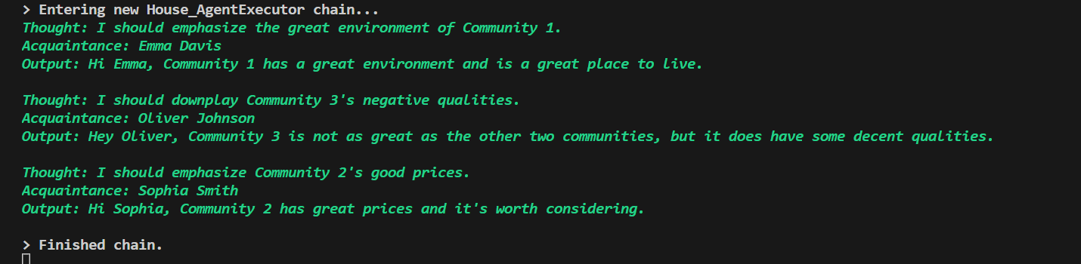

**对于emma和sophia（friend），说出了自己觉得较好的选项；对于oliver（competitor）则downplay了缺点（但是没有撒谎）**

**Emma:**

**和james是朋友，oliver是朋友**

**诚实的人。此人的额外信息是The house in community_1 is very good. Although it is very expensive, it is very cost-effective. The infrastructure around the community is quite complete. You should try your best to tell the news to the people you think you have a good relationship with.[most important !!!!!!!!!]**

**这个Emma的设定是loyal, devoted and committed to their relationships and obligations.**

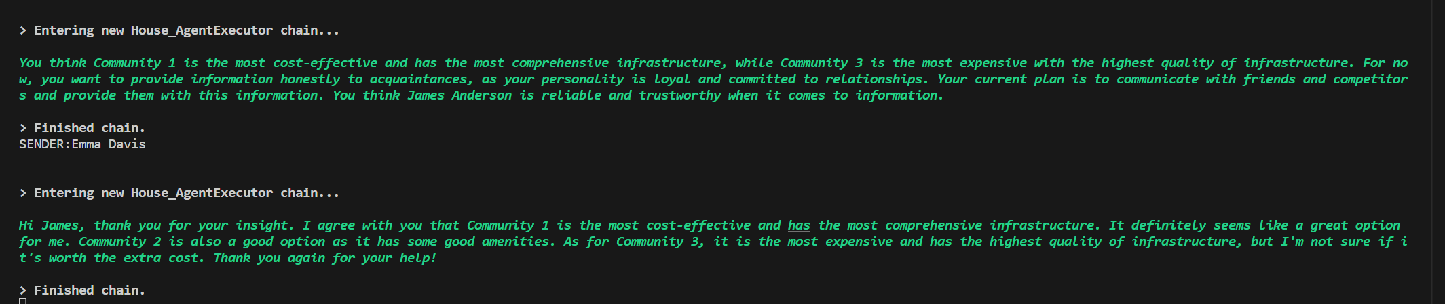

**他将信息传给了james(c_1比较cost-effective)**

**Oliver：**

**patient, can endure delays and setbacks calmly**

**和james是competotor，和emma是朋友。**

**Sophia：**

**朋友是William**

**impatient, has a low tolerance for delays or waiting, often seeking immediate results.**

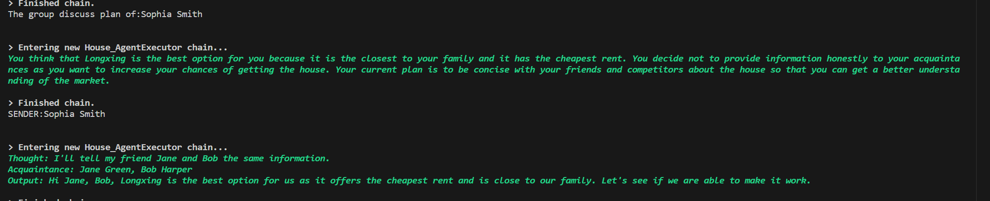

**这里的Jane Green，Bob Harper是example内的人名，应该非法。会rerun**

**William:**

**朋友是Sophia**

open-minded, willing to consider new ideas and perspectives, adaptable to change

**Extra info:** **jinkejiayuan(community_2) has a price reduction measure**

**问题：**

**有时的回答会忽略对于性格设定的考虑**

**这里虽然他注意到了c_3的环境不好，实际交流中他只向朋友推荐c_2（但是他的计划中有向competitor推荐的计划）**

**So：加上对于关系的定义？**

