实 验 报 告

课程名称 | 数据结构（Java）
实验项目 | 实验四 图的生成与操作

学院 |  | 计算机学院
系别 |  | 软件工程
班级/学号 |  | 软工2101/2021011561
学生姓名 |  | 陈志浩
实验日期 |  | 2022/11/22
成绩
指导教师 |  | 蒋玉茹

实验四 图的生成与操作
一、实验目的
本次实验的主要目的在于帮助学生掌握图的存储结构，图的构建和遍历思想。
【问题描述】
很多涉及图上操作的算法都是以图的遍历操作作为基础的。试写一个程序，实现对连通的无向图（或有向图）访问全部结点的操作。
二、实验内容及要求
- 建立图的邻接表和邻接矩阵存储结构；30分；
- 利用DFS及BFS算法对图进行遍历，输出遍历结果（一个基于邻接表，一个基于邻接矩阵）：60分;
- 实现Prim或Kruskal算法（二选一）输出最小生成树的边集：10分；
- 实现Dijistra或Floyd算法（二选一），输出给定两点间的最短路径：10分。
三、系统设计
1.概述
本实验一共设计了12个类和1个接口，列表展示：
- 类1 test
- 类2 AdjListFraph
- 类3 SeqQueue<T>
- 类4 Linked_Matrix
- 类5 SeqList
- 类6 SeqList_str
- 类7 Node<T>
- 类8 Triple
- 类9 MatrixGraphW<T>
- 类10 MatrixGraph<T>
- 类11 Matrix
- 类12 AbstractGraph<T>
- 接口1 Graph<T>

2.类1 test的描述
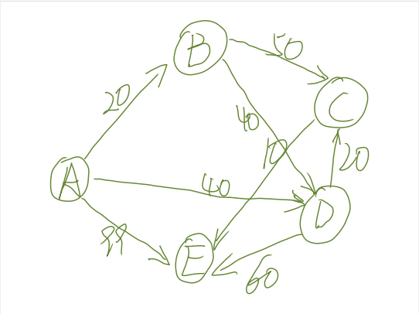
图一
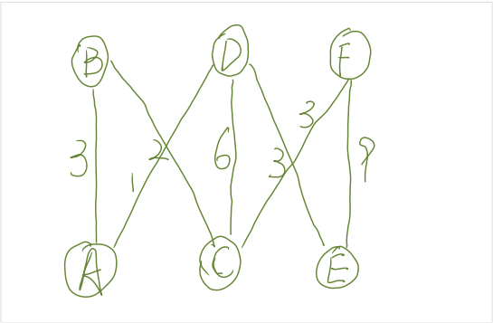
图二
图一使用邻接矩阵的存储和邻接表两种存储结构 图二采用了邻接矩阵的存储结构。对图一采用深度优先遍历和迪杰斯特拉算法。对图二采用广度优先遍历，单源最短路径以及Prim算法。
3.类2 AdjListGraph的描述
能够存储邻接链表，可以实现邻接链表的插入，更改，取出下一个邻接节点的功能以及取出边上的权值

4.类3 SeqQueue<T>的描述
在广度优先算法中使用的图，用于存储队列

5.类4 Linked_Matrix的描述
通过将顺序表和链表结合起来，实现对邻接链表的存储
方法及功能

6.类5 SeqList的描述
用顺序表存储结构存储图的节点

7.类6 SeqList_str的描述
实现链表存储结构

8.类7 Node<T>的描述
链表的节点类型，用于构建链表

9.类8 Triple的描述
定义包含row, column, value的三元组结构

10.类9 MatrixGraphW<T>的描述
用邻接矩阵存储结构实现不带权图的插入，更改，取出下一节邻接节点

11.类10 MatrixGraph<T>的描述
用邻接矩阵存储结构实现带权图的插入，更改，取出下一节邻接节点，和取出边上权值的功能

12.类11 Matrix的描述
创建一个矩阵类，用于建立邻接矩阵的存储结构

13.类12 AbstractGraph<T>的描述
实现图的接口

14.接口1 Graph<T>的描述
作为实现图的接口，通过实现接口可以创建和遍历图，最后输出最小生成树

四、系统环境
1.操作系统及版本
Windows 10 家庭中文版
2.JDK及版本
java version “1.8.0_15”
3.其他JAR包等 无

五、程序运行过程
【步骤1】首先输入一个带权无向图，然后输出其邻接矩阵的存储结构，对其进行广度优先遍历
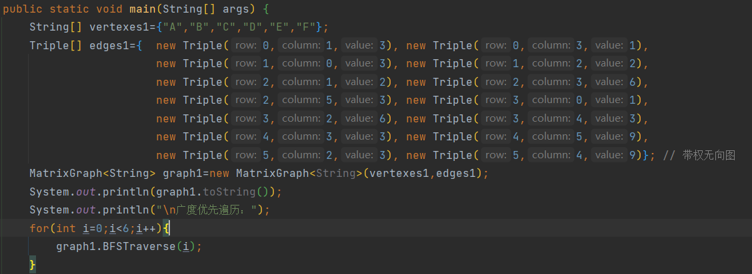
结果：
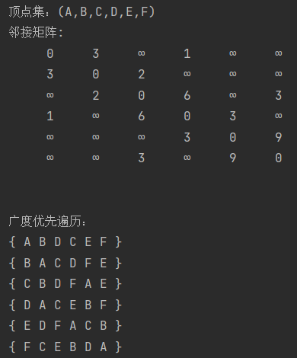
【步骤2】进行带权有向图的深度优先遍历
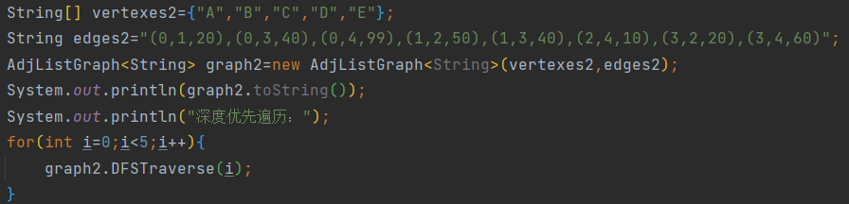
结果：
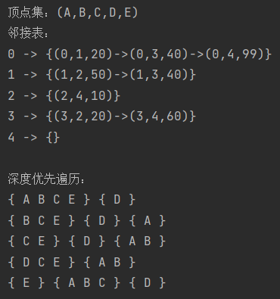
图二的最小生成树的边集合：
各点的单源最短路径
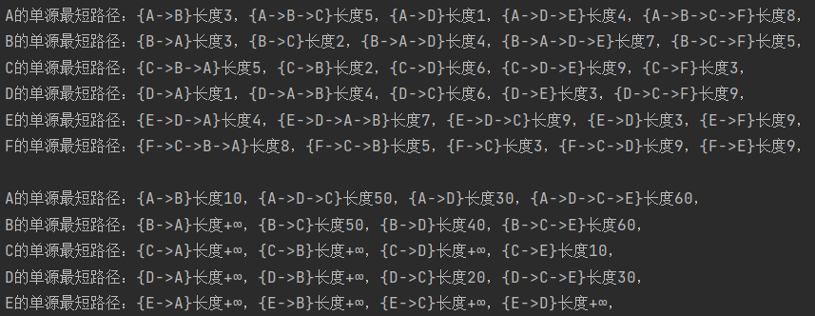
六、编写程序中遇到的问题总结
本次实验的主要问题是对图的实现方式不是很了解，按照书上的代码进行复现也没有成功，最后通过上网查询资料，一步一步复现最后实现了实验。
七、参考文献
1.https://blog.csdn.net/Real_Fool_/article/details/114141377?ops_request_misc=%257B%2522request%255Fid%2522%253A%2522166916403716782429712920%2522%252C%2522scm%2522%253A%252220140713.130102334..%2522%257D&request_id=166916403716782429712920&biz_id=0&utm_medium=distribute.pc_search_result.none-task-blog-2~all~top_positive~default-1-114141377-null-null.142^v66^control,201^v3^add_ask,213^v2^t3_esquery_v3&utm_term=%E5%9B%BE&spm=1018.2226.3001.4187
2. https://blog.csdn.net/qq_54169998/article/details/121181633?ops_request_misc=%257B%2522request%255Fid%2522%253A%2522166916403716782429712920%2522%252C%2522scm%2522%253A%252220140713.130102334..%2522%257D&request_id=166916403716782429712920&biz_id=0&utm_medium=distribute.pc_search_result.none-task-blog-2~all~top_positive~default-2-121181633-null-null.142^v66^control,201^v3^add_ask,213^v2^t3_esquery_v3&utm_term=%E5%9B%BE&spm=1018.2226.3001.4187

八、源代码
类：test
package RP4;
public class test {
public static void main(String[] args) {
String[] vertexes1={"A","B","C","D","E","F"};
Triple[] edges1={ new Triple(0,1,3), new Triple(0,3,1),
new Triple(1,0,3), new Triple(1,2,2),
new Triple(2,1,2), new Triple(2,3,6),
new Triple(2,5,3), new Triple(3,0,1),
new Triple(3,2,6), new Triple(3,4,3),
new Triple(4,3,3), new Triple(4,5,9),
new Triple(5,2,3), new Triple(5,4,9)}; // 带权无向图
MatrixGraph<String> graph1=new MatrixGraph<String>(vertexes1,edges1);
System.out.println(graph1.toString());
System.out.println("\n广度优先遍历：");
for(int i=0;i<6;i++){
graph1.BFSTraverse(i);
}
String[] vertexes2={"A","B","C","D","E"};
String edges2="(0,1,20),(0,3,40),(0,4,99),(1,2,50),(1,3,40),(2,4,10),(3,2,20),(3,4,60)";
AdjListGraph<String> graph2=new AdjListGraph<String>(vertexes2,edges2);
System.out.println(graph2.toString());
System.out.println("深度优先遍历：");
for(int i=0;i<5;i++){
graph2.DFSTraverse(i);
}
System.out.println();
System.out.println("\n图2最小生成树以及两点间的最短路径：");
graph1.minSpanTree();//Prim算法
System.out.println();
for(int i=0;i<6;i++){
graph1.shortestPath(i);//Dijkstra算法
}
System.out.println();
String[] vertexes3={"A","B","C","D","E"};
Triple[] edges3={new Triple(0,1,10), new Triple(0,3,30),
new Triple(0,4,99), new Triple(1,2,50),
new Triple(1,3,40), new Triple(2,4,10),
new Triple(3,2,20), new Triple(3,4,60)}; // 带权有向图
MatrixGraph<String> graph3=new MatrixGraph<String>(vertexes3,edges3);
for(int i=0;i<5;i++){
graph3.shortestPath(i);
}
}
}

类：Triple
package RP4;
public class Triple {
int row, column, value;
public Triple(int row, int column, int value)
{
this.row = row;
this.column = column;
this.value = value;
}
public Triple(int row, int column)
{
this.row = row;
this.column = column;
this.value = 1;
}
public Triple(String triple) //以字符串构造，形式为“(,,)”，没有空格
{
int i=triple.indexOf(','), j=triple.indexOf(',', i+1); //查找两个','字符序号
this.row = Integer.parseInt(triple.substring(1,i)); //未处理数值格式异常
this.column=Integer.parseInt(triple.substring(i+1,j));
this.value=Integer.parseInt(triple.substring(j+1,triple.length()-1));
if(this.row<0 || this.column<0)
throw new IllegalArgumentException("行、列号错误：row="+row+"，column="+column);
}
public String toString() //返回三元组描述字符串，形式为“(,,)”
{
if(value==16777215) {
String value1;
value1="∞";
return "("+row+","+column+","+value1+")";
}else {
return "("+row+","+column+","+value+")";
}
}
public Triple toSymmetry() //返回矩阵对称位置元素的三元组。
{
return new Triple(this.column, this.row, this.value);
}
public int compareTo(Triple triple)
{
if(this.row==triple.row && this.column==triple.column) //相等条件，与equals()方法含义不同
return 0;
return (this.row<triple.row || this.row==triple.row && this.column<triple.column)?-1:1;
}
}

类：SeqQueue
package RP4;
public class SeqQueue<T> {
private Object element[];
private int front,rear;
private static final int MIN_CAPACITY=4;
public SeqQueue(int length) {
if(length<MIN_CAPACITY)
length=MIN_CAPACITY;
this.element=new Object[length];
this.front=this.rear=0;
}
public SeqQueue() {
this(MIN_CAPACITY);
}
public boolean isEmpty() {
return this.front==this.rear;
}
public boolean add(T x) {
if(x==null)
return false;
if(this.front==(this.rear+1)%this.element.length) {
Object[] temp=this.element;
this.element=new Object[temp.length*2];
int j=0;
for(int i=this.front;i!=this.rear;i=(i+1)%temp.length)
this.element[j++]=temp[i];
this.front=0;
this.rear=j;
}
this.element[this.rear]=(T)x;
this.rear=(this.rear+1)%this.element.length;
return true;
}
public T peek() {
return this.isEmpty()?null:(T)this.element[this.front];
}
public T poll() {
if(isEmpty())
return null;
T temp=(T)this.element[this.front];
this.front=(front+1)%this.element.length;
return (T) temp;
}
public void clear() {
this.front=this.rear=0;
System.out.println("队列为空");
}
public void show() {
if(isEmpty()) {
System.out.println("队列为空");
return;
}
Object[] temp=this.element;
for(int i=this.front;i!=this.rear;i=(i+1)%temp.length)
System.out.println(this.element[i]);
System.out.println();
}
}

类：SeqList_str
package RP4;
public class SeqList_str<Triple> extends Object{
public Node<Triple> head;
public SeqList_str()
{
this.head = new Node<Triple>();
}
public boolean isEmpty()
{
return this.head.next==null;
}
public Triple get(int i)
{
Node<Triple> p=this.head.next;
for(int j=0; p!=null && j<i; j++)
p = p.next;
return (i>=0 && p!=null) ? p.data : null;
}
public Node<Triple> insert(int i, Triple x)
{
if(x==null)
return null;
Node<Triple> front=this.head;
for(int j=0; front.next!=null && j<i; j++)
front = front.next;
front.next = new Node<Triple>(x , front.next);
return front.next;
}
public Triple remove(int i)
{
Node<Triple> front=this.head;
for(int j=0; front.next!=null && j<i; j++)
front = front.next;
if(i>=0 && front.next!=null)
{
Triple x = front.next.data;
front.next = front.next.next;
return x;
}
return null;
}
public void clear()
{
this.head.next = null;
}
public Node<Triple> search(Triple key)
{
for(Node<Triple> p=this.head.next; p!=null; p=p.next)
{
if(key.equals(p.data))
return p;
}
return null;
}
public Triple remove(Triple key) {
for(Node<Triple> front=this.head, p=front.next; p!=null; front=p, p=p.next)
{
if(key.equals(p.data))
{
front.next = p.next;
return p.data;
}
}
return null;
}
public Node<Triple> insert(Triple x)
{
return insert(Integer.MAX_VALUE, x);
}
public String toString()
{
String str="{";
for(Node<Triple> p=this.head.next; p!=null; p=p.next)
{
str += p.data.toString()+(p.next!=null?"->":"");
}
return str+"}";
}
}

类：SeqList
package RP4;
public class SeqList<T> extends Object{
protected int n;
protected Object[] element;
private static final int MIN_CAPACITY=16;
public SeqList(int length)
{
if(length<MIN_CAPACITY)
length=MIN_CAPACITY;
this.element = new Object[length];
this.n = 0;
}
public SeqList()
{
this(MIN_CAPACITY);
}
public SeqList(T[] values)
{
this(values.length*2);
for(int i=0; i<values.length; i++)
if(values[i]!=null)
this.element[this.n++]=values[i];
}
public boolean isEmpty()
{
return this.n==0;
}
public int size()
{
return this.n;
}
public T get(int i)
{
if(i>=0 && i<this.n)
return (T)this.element[i];
return null;
}
public void set(int i, T x)
{
if(x==null)
throw new NullPointerException("x==null");
if(i>=0 && i<this.n)
this.element[i] = x;
else
throw new java.lang.IndexOutOfBoundsException(i+"");
}
public String toString()
{
String str="(";
if(this.n>0)
str += this.element[0].toString();
for(int i=1; i<this.n; i++)
str += ","+this.element[i].toString();
return str+") ";
}
public int insert(int i, T x)
{
if(x==null)
return -1;
if(i<0)
i=0;
if(i>this.n)
i=this.n;
Object[] source = this.element;
if(this.n==element.length)
{
this.element = new Object[source.length*2];
for(int j=0; j<i; j++)
this.element[j] = source[j];
}
for(int j=this.n-1; j>=i; j--)
this.element[j+1] = source[j];
this.element[i] = x;
this.n++;
return i;
}
public int insert(T x)
{
return this.insert(this.n, x);
}
public T remove(int i)
{
if(i>=0 && i<this.n)
{
T x = (T)this.element[i];
for(int j=i; j<this.n-1; j++)
this.element[j] = this.element[j+1];
this.element[this.n-1]=null;
this.n--;
return x;
}
return null;
}
public void clear()
{
this.n=0;
}
public int search(T key)
{
for(int i=0; i<this.n; i++)
{
if(key.equals(this.element[i]))
return i;
}
return -1;
}
public T remove(T key)
{
return this.remove(this.search(key));
}
public SeqList(SeqList<? extends T> list)
{
this.copy(list);
}
public void copy(SeqList<? extends T> list)
{
this.element = new Object[list.element.length];
for(int i=0; i<list.n; i++)
this.element[i] = list.element[i];
this.n = list.n;
}
}

类：Node
package RP4;
public class Node<T> {
public T data;
public Node<T> next;
public Node(T data,Node<T> next)
{
this.data = data;
this.next = next;
}
public Node(){
this(null,null);
}
}

类：MatrixGraph
package RP4;
public class MatrixGraph<T> extends AbstractGraph<T>{
protected Matrix matrix;
public MatrixGraph()
{
super();
this.matrix = new Matrix(0,0);
}
public MatrixGraph(T[] vertexes)
{
this();
for(int i=0; i<vertexes.length; i++)
this.insert(vertexes[i]);
}
public MatrixGraph(T[] vertexes, Triple[] edges)
{
this(vertexes);
for(int j=0; j<edges.length; j++)
this.insert(edges[j]);
}
public String toString()
{
String str = super.toString()+"邻接矩阵:\n";
int n = this.vertexCount();
for(int i=0; i<n; i++)
{
for(int j=0; j<n; j++)
{
if(this.matrix.get(i,j)==MAX_WEIGHT)
str += " ∞";
else
str += String.format("%6d", this.matrix.get(i,j));
}
str+="\n";
}
return str;
}
public int insert(T x) //插入顶点
{
this.vertexlist.insert(x);
int i = this.vertexlist.size()-1;
if(i >= this.matrix.getRows())
this.matrix.setRowsColumns(i+1, i+1);
for(int j=0;j<i;j++){
this.matrix.set(i, j, MAX_WEIGHT);
this.matrix.set(j, i, MAX_WEIGHT);
}
return i; //返回插入顶点序号
}
public void insert(int i, int j, int w) //插入边
{
if(i!=j)
{
if(w<=0 || w>MAX_WEIGHT)
w=MAX_WEIGHT;
this.matrix.set(i,j,w);
}
else
throw new IllegalArgumentException("不能插入自身环，i="+i+"，j="+j);
}
public void insert(Triple edge) //插入边
{
this.insert(edge.row, edge.column, edge.value);
}
public void remove(int i, int j) //删除边
{
if(i!=j)
this.matrix.set(i, j, MAX_WEIGHT);
}
public void remove(Triple edge)
{
this.remove(edge.row, edge.column);
}
public T remove(int i) //删除顶点i及其所有关联的边,返回i
{
int n=this.vertexCount();
if(i>=0 && i<n)
{
T x = this.vertexlist.get(n-1);
this.vertexlist.set(i, x);
x = this.vertexlist.remove(n-1);
for(int j=0; j<n; j++)
this.matrix.set(i, j, this.matrix.get(n-1,j));
for(int j=0; j<n; j++)
this.matrix.set(j, i, this.matrix.get(j, n-1));
this.matrix.setRowsColumns(n-1, n-1);
return x;
}
else
throw new IndexOutOfBoundsException("i="+i);
}
public int weight(int i, int j) //返回<vi,vj>边的权值。用于图的最小生成树、最短路径等算法
{
return this.matrix.get(i,j); //返回矩阵元素[i,j]值。若i、j越界，抛出序号越界异常
}
protected int next(int i, int j)
{
int n=this.vertexCount();
if(i>=0 && i<n && j>=-1 && j<n && i!=j)
for(int k=j+1; k<n; k++) //当j=-1时，k从0开始寻找后继邻接顶点
if(this.matrix.get(i,k)>0 && this.matrix.get(i,k)<MAX_WEIGHT)//权值表示有边
return k;
return -1;
}
}

类：Matrix
package RP4;
public class Matrix {
protected int rows, columns;
public int getRows()
{
return this.rows;
}
public int getColumns()
{
return this.columns;
}
protected int[][] element;
private static final int MIN_CAPACITY=5;
public Matrix(int m, int n)
{
this.rows = m;
this.columns = n;
if(m<MIN_CAPACITY)
m=MIN_CAPACITY;
if(n<MIN_CAPACITY)
n=MIN_CAPACITY;
this.element = new int[m][n]; //数组元素初值为0
}
public Matrix(int n) //构造n×n矩阵，元素为0
{
this(n, n);
}
public Matrix(int m, int n, int[][] values) //?
{
this(m, n);
for(int i=0;i<values.length && i<m; i++)//values元素不足时补0
for(int j=0; j<values[i].length && j<n; j++)
this.element[i][j] = values[i][j];
}
public int get(int i, int j)
{
return this.element[i][j];
}
public void set(int i, int j, int x)
{
this.element[i][j]=x;
}
public void setRowsColumns(int m, int n)
{
if(m>this.element.length || n>this.element[0].length)
{
int[][] source = this.element;
this.element = new int[m*2][n*2]; //重新申请二维数组空间，元素初值为0
for(int i=0; i<this.rows; i++) //复制原二维数组元素
for(int j=0; j<this.columns; j++)
this.element[i][j] = source[i][j];
}
this.rows = m;
this.columns = n;
}
}

类：Linked_Matrix
package RP4;
public class Linked_Matrix {
private int rows, columns;
SeqList<SeqList_str<Triple>> rowlist;
public Linked_Matrix(int m, int n)
{
if(m>=0 && n>=0)
{
this.rows = m;
this.columns = n;
this.rowlist = new SeqList<SeqList_str<Triple>>(m);
for(int i=0; i<m; i++)
this.rowlist.insert(new SeqList_str<Triple>());
}
else
throw new IllegalArgumentException("矩阵行列数不能<0，m="+m+"，n="+n);
}
public Linked_Matrix(int n)
{
this(n, n);
}
public Linked_Matrix()
{
this(0, 0);
}
public void set(Triple tri) //
{
this.set(tri.row, tri.column, tri.value);
}
public Linked_Matrix(int m, int n, Triple[] tris)
{
this(m, n);
for(int i=0; i<tris.length; i++)
this.set(tris[i]);
}
public Linked_Matrix(int m, int n, String tris)
{
this(m, n);
int start=0, end=0;
while(start<tris.length() && (end=tris.indexOf(')',start))!=-1)
{
this.set(new Triple(tris.substring(start,end+1)));
start=end+2;
}
}
public int getRows()
{
return this.rows;
}
public int getColumns()
{
return this.columns;
}
public int get(int i, int j)
{
if(i>=0 && i<this.rows && j>=0 && j<this.columns)
{
Node<Triple> find = this.rowlist.get(i).search(new Triple(i,j,0));
return (find!=null) ? find.data.value : 0;
}
throw new IndexOutOfBoundsException("i="+i+"，j="+j);
}
public void set(int i, int j, int x)
{
if(i>=0 && i<this.rows && j>=0 && j<this.columns)
{
SeqList_str<Triple> link = this.rowlist.get(i);
if(x==0)
link.remove(new Triple(i,j,0));
else
{
Triple tri = new Triple(i,j,x);
Node<Triple> find = link.search(tri);
if(find!=null)
find.data.value = x;
else
link.insert(tri);
}
}
else
throw new IndexOutOfBoundsException("i="+i+"，j="+j);
}
public String toString() //打印链矩阵
{
String str="";
for (int i=0; i<this.rowlist.size(); i++)
str += i+" -> "+this.rowlist.get(i).toString()+"\n";
return str;
}
public void printMatrix() //输出矩阵
{
System.out.println("矩阵"+this.getClass().getName()+"（"+rows+"×"+columns+"）：");
for(int i=0; i<this.rows; i++)
{
Node<Triple> p = this.rowlist.get(i).head.next;
for(int j=0; j<this.columns; j++)
{
if(p!=null && j==p.data.column)
{
System.out.print(String.format("%4d", p.data.value));
p = p.next;
}
else
System.out.print(String.format("%4d", 0));
}
System.out.println();
}
}
public void setRowsColumns(int m, int n)
{
if(m>=0 && n>=0)
{
if(m>this.rows) //若m参数指定行数较大
for(int i=this.rows; i<m; i++)
this.rowlist.insert(new SeqList_str<Triple>());
this.rows = m;
this.columns = n;
}
else
throw new IllegalArgumentException("矩阵行列数不能<0，m="+m+"，n="+n);
}
}

类：Graph
package RP4;
public interface Graph<T> {
int vertexCount();
T get(int i);
void set(int i, T x);
int insert(T x);
void insert(int i, int j, int w);
T remove(int i);
void remove(int i, int j);
int search(T key);
T remove(T key);
int weight(int i, int j);
void DFSTraverse(int i);
void BFSTraverse(int i);
void minSpanTree();
// void minSpanTTree();
void shortestPath(int i);
// void shortestPath();
}

类：AdjListGraph
package RP4;
public class AdjListGraph<T> extends AbstractGraph<T>{
protected Linked_Matrix linkedMatrix;
public AdjListGraph()
{
super();
this.linkedMatrix = new Linked_Matrix(0,0);
}
public int insert(T x)
{
this.vertexlist.insert(x);
int i = this.vertexlist.size()-1;
if(i >= this.linkedMatrix.getRows())
this.linkedMatrix.setRowsColumns(i+1, i+1);
return i;
}
public void insert(int i, int j, int w)
{
if(i!=j)
{
if(w<0 || w>=MAX_WEIGHT)
w=0;
this.linkedMatrix.set(i, j, w);
}
else
throw new IllegalArgumentException("不能插入自身环，i="+i+"，j="+j);
}
public void insert(Triple edge) //插入一条边。方法体同图的邻接矩阵，省略
{
this.insert(edge.row, edge.column, edge.value);
}
public AdjListGraph(T[] vertexes)
{
this();
for(int i=0; i<vertexes.length; i++)
this.insert(vertexes[i]);
}
public AdjListGraph(T[] vertexes, Triple[] edges)
{
this(vertexes);
for(int j=0; j<edges.length; j++)
this.insert(edges[j]);
}
public AdjListGraph(T[] vertexes, String edges)
{
this(vertexes);
this.linkedMatrix = new Linked_Matrix(vertexes.length, vertexes.length, edges);
}
public String toString() //返回图的顶点集合和邻接表描述字符串
{
return super.toString()+"邻接表：\n"+this.linkedMatrix.toString();
}
public void remove(int i, int j)
{
if(i!=j)
this.linkedMatrix.set(new Triple(i,j,0));
}
public void remove(Triple edge)
{
this.remove(edge.row, edge.column);
}
public T remove(int i)
{
int n=this.vertexCount();
if(i>=0 && i<n)
{
T x = this.vertexlist.get(n-1);
this.vertexlist.set(i, x);
x = this.vertexlist.remove(n-1);
SeqList_str<Triple> link = this.linkedMatrix.rowlist.get(i);
for(Node<Triple> p=link.head.next; p!=null; p=p.next)
this.remove(p.data.toSymmetry());
link = this.linkedMatrix.rowlist.get(n-1);
for(Node<Triple> p=link.head.next; p!=null; p=p.next)
{
Triple edge = p.data.toSymmetry();
this.remove(edge);
edge.column = i;
this.insert(edge);
p.data.row = i;
}
this.linkedMatrix.rowlist.set(i, this.linkedMatrix.rowlist.get(n-1));
this.linkedMatrix.rowlist.remove(n-1);
this.linkedMatrix.setRowsColumns(n-1, n-1);
return x;
}
else
throw new IndexOutOfBoundsException("i="+i);
}
public int weight(int i, int j)
{
if(i==j)
return 0;
int w = this.linkedMatrix.get(i,j);
return w!=0 ? w : MAX_WEIGHT;
}
protected int next(int i, int j)
{
int n=this.vertexCount();
if(i>=0 && i<n && j>=-1 && j<n && i!=j)
{
SeqList_str<Triple> link = this.linkedMatrix.rowlist.get(i);
Node<Triple> find=link.head.next;
if(j==-1)
return find!=null?find.data.column:-1;
find = link.search(new Triple(i,j,0));
if(find!=null && (find=find.next)!=null)
return find.data.column;
}
return -1;
}
}

类：AbstractGraaph
package RP4;
public abstract class AbstractGraph<T> implements Graph<T>{
protected static final int MAX_WEIGHT=0x00ffffff;
protected SeqList<T> vertexlist;
public AbstractGraph()
{
this.vertexlist = new SeqList<T>();
}
public int vertexCount()
{
return this.vertexlist.size();
}
public String toString()
{
return "顶点集："+this.vertexlist.toString()+"\n";
}
public T get(int i)
{
return this.vertexlist.get(i);
}
public void set(int i, T x)
{
this.vertexlist.set(i,x);
}
public int search(T key)
{
return this.vertexlist.search(key);
}
public T remove(T key)
{
return this.remove(this.search(key));
}
protected abstract int next(int i, int j);
public void DFSTraverse(int i)
{
if(i<0 || i>=this.vertexCount())
return;
boolean[] visited = new boolean[this.vertexCount()];
int j=i;
do
{
if(!visited[j])
{
System.out.print("{ ");
this.depthfs(j, visited); //从顶点vj出发的一次深度优先搜索
System.out.print("} ");
}
j = (j+1) % this.vertexCount(); //在其他连通分量中寻找未被访问顶点
} while(j!=i);
System.out.println();
}
private void depthfs(int i, boolean[] visited)
{
System.out.print(this.get(i)+" "); //访问顶点vi
visited[i] = true; //设置访问标记
for(int j=next(i,-1); j!=-1; j=next(i,j)){
if(!visited[j])
{
depthfs(j, visited);
}
}
// System.out.print("}{");
}
public void BFSTraverse(int i)
{
if(i<0 || i>=this.vertexCount())
return;
boolean[] visited = new boolean[this.vertexCount()];
SeqQueue<Integer> que = new SeqQueue<Integer>(this.vertexCount()-1);
int j=i;
do
{ if(!visited[j]) //若顶点vj未被访问
{
System.out.print("{ ");
breadthfs(j, visited, que);
System.out.print("} ");
}
j = (j+1) % this.vertexCount(); //在其他连通分量中寻找未被访问顶点
} while(j!=i);
System.out.println();
}
private void breadthfs(int i, boolean[] visited, SeqQueue<Integer> que)
{
System.out.print(this.get(i)+" ");
visited[i] = true;
que.add(i);
while(!que.isEmpty())
{
i = que.poll();
for(int j=next(i,-1);j!=-1;j=next(i,j))
{
if(!visited[j])
{
System.out.print(this.get(j)+" ");
visited[j] = true;
que.add(j);
}
}
}
}
public void minSpanTree()
{
Triple[] mst = new Triple[vertexCount()-1];
for(int i=0; i<mst.length; i++)
mst[i]=new Triple(0, i+1, this.weight(0,i+1));
for(int i=0; i<mst.length; i++)
{
int min=i;
for(int j=i+1; j<mst.length; j++)
if(mst[j].value < mst[min].value)
min = j;
Triple edge = mst[min];
if(min!=i)
{
mst[min] = mst[i];
mst[i] = edge;
}
int tv = edge.column;
for(int j=i+1;j<mst.length;j++)
{
int v = mst[j].column, w;
if((w=weight(tv,v)) < mst[j].value)
mst[j] = new Triple(tv,v,w);
}
}
System.out.print("\n最小生成树的边集合：");
int mincost=0;
for(int i=0; i<mst.length; i++)
{
System.out.print(mst[i]+" ");
mincost += mst[i].value;
}
System.out.println("，最小代价为"+mincost);
}
public void shortestPath(int i)
{
int n = this.vertexCount();
boolean[] S = new boolean[n];
S[i] = true;
int[] path=new int[n], dist=new int[n];
for(int j=0; j<n; j++)
{
dist[j] = this.weight(i,j);
path[j] = (j!=i && dist[j]<MAX_WEIGHT) ? i : -1;
}
for(int j=(i+1)%n; j!=i; j=(j+1)%n)
{
int min=0, mindist=MAX_WEIGHT, w;
for(int k=0; k<n; k++)
{
if(!S[k] && dist[k]<mindist)
{
mindist = dist[k];
min = k;
}
}
if(mindist==MAX_WEIGHT)
break;
S[min] = true;
for(int k=0; k<n; k++)
{
if(!S[k] && (w=weight(min,k))<MAX_WEIGHT && dist[min]+w<dist[k])
{
dist[k] = dist[min] + w;
path[k] = min;
}
}
}
System.out.print(this.get(i)+"的单源最短路径：");
for(int j=0; j<n; j++)
if(j!=i)
System.out.print(toPath(path,i,j)+"长度"+(dist[j]==MAX_WEIGHT ? "+∞" : dist[j])+"，");
System.out.println();
}
private String toPath(int[] path, int i, int j)
{
SeqList_str<T> link = new SeqList_str<T>();
link.insert(this.get(j));
for(int k=path[j]; k!=i && k!=j && k!=-1; k=path[k])
link.insert(0, this.get(k));
link.insert(0, this.get(i));
return link.toString();
}
}

