Tomography has become one of the most important applications of mathematics to the problems of keeping us alive. Modern medicine relies heavily on imaging methods, beginning at the start of the 20th Century with the early use of X-Rays. Essentially imaging methods take two forms, internal and external.

X-Ray and ultrasound methods work by having an external source of radiation that comes from a source outside the body. The radiation is then detected after it has passed through the body, and an image is constructed from the way that this source is absorbed. When X-Rays are used the process is called computerized axial tomography (CAT). (The word tomography comes from the Greek work tomos meaning "slice" and graphia meaning "describing.")

Other imaging methods, including magnetic resonance imaging (MRI), positron emission tomography (PET), and SPECT, use a source internal to the body. These methods have certain advantages over CAT both in image resolution and in safety, as X-Rays can easily damage soft tissue.

The basic mathematics behind tomography was worked out by the mathematician Radon in 1917. In the 1960’s Allan McLeod Cormack, working in collaboration with Electric and Musical Industries Ltd and Godfrey Hounsfield, developed the first practical scanning device, the celebrated EMI scanner. For this work, Cormack won the Noble Prize.

Early models could only scan an object the size of a human head, but whole body scanners followed shortly after.

Medical imaging works because of a combination of very careful measurement techniques, sophisticated computer algorithms, and powerful mathematics. The mathematics of tomography has many other applications, including imaging the atmosphere, solving an ancient murder mystery, and detecting land-mines.

**CAT and the Radon Transform**

Until relatively recently, if you had something wrong with your insides, you had to be operated on to find out what it was. Any such operation carried a significant risk, especially in the case of problems with the brain. However, this is no longer the case; as we described in the introduction, doctors are able to use a whole variety of scanning techniques to look inside you in a completely safe say. A modern Computerised Axial Tomography (CAT) scanner is illustrated on the left.

In this scanner the patient lies on a bed and passes through the hole in the middle of the device. This hole contains an X-ray source which rotates around the patient. The X-rays from this source pass through the patient and are detected on the other side. The level of intensity of the X-ray can be measured accurately and the results processed. The resulting fan of X-rays is illustrated in the following figure (with a conveniently circular patient).

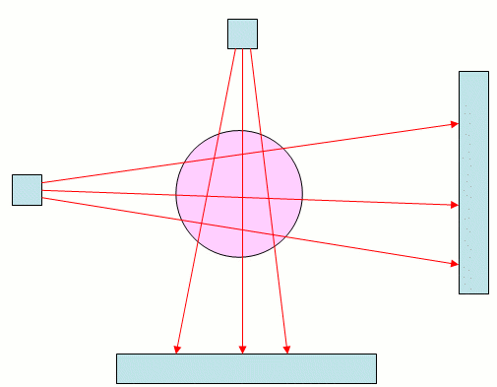

As an X-ray passes through a patient, it is attenuated so that its intensity is reduced. The degree to which this happens depends upon what material the ray passes through: its intensity is reduced more when passing through bone than when passing through muscle, an internal organ, or a tumour. A key step in reconstructing an image of the body from a set of X-ray measurements is to carefully measure exactly how different materials absorb X-rays.

When an X-ray passes through a body, it does so in a straight line, and its total absorption is a combination of the amounts to which it is absorbed by the different materials that it passes through. To see how this happens, we need to use a little calculus. Imagine that the X-ray moves along a straight line and that at a distance $s$into the body it has an intensity $I(s)$. As $s$increases, so $I(s)$decreases as the X-ray is absorbed. Now, if the X-ray travels a small distance $\delta s,$its intensity is reduced by a small amount $\delta I$. This reduction depends both on the intensity of the X-ray and the *optical density* $u(s)$of the material. Provided that the distance travelled is small enough, the reduction in intensity is related to the optical density by the formula

|  |  |  |  |
| --- | --- | --- | --- |
|  | \[ \delta I = -u(s)I(s)\delta s. \] |  |  |

Now, when the X-ray enters the body it will have intensity $I_{start}$and when it leaves it will have intensity $I_{finish}$. We can combine all of the contributions to the reduction in the intensity of the X-ray given by all of the parts of the body that it travels through. Doing this, we find that the attenuation (the reduction in the intensity) is given by

|  |  |  |  |
| --- | --- | --- | --- |
|  | \[ I_{finish} = I_{start} e^{-R}, \] |  |  |

where

|  |  |  |  |
| --- | --- | --- | --- |
|  | \[ R = \int u(s) ds. \] |  |  |

This is the attenuation of one X-ray and it gives some information about the body. Below we see an object irradiated by several X-rays with the intensity of the rays measured on a detector. Here some X-rays pass through all of the object and are strongly absorbed so that their intensity (recorded at the centre of the detector) is low, while others pass through less of the object and are less strongly absorbed. Effectively the object casts a shadow of the X-rays and from this we can work out its basic dimensions. We illustrate this below.

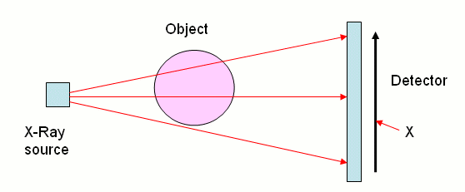

The intensity of the X-ray where it hits the detector depends on the width of object and the length of the path travelled both through the object and the air.

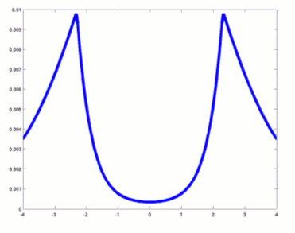

This graph shows the intensity of the rays as they hit the detector. Rays that travel through the full width of the object have lowest intensity, as we can see from the dip in the middle of the graph. Rays that just miss the body have the highest intensity, because of all rays that are not absorbed they travel the shortest distance. This is reflected by the two spikes of the graph. Towards the edges the graph falls off, reflecting the fact that the corresponding rays have travelled a comparatively long distance.

However, the secret to computerised axial tomography is to find out much more about the nature of the object than just its dimensions, by looking at the attenuation of as many X-rays as possible. To do this, we need to think of a number of X-rays at different angles $\theta $and distances $\rho $from the centre of the object. A typical such X-ray is illustrated below.

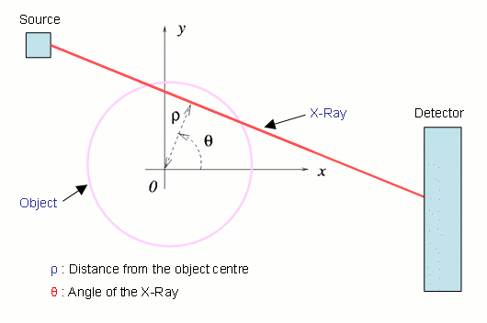

This X-Ray will pass through a series of points $(x,y)$at which the optical density is $u(x,y)$. Using the equation for a straight line these points are given by

|  |  |  |  |
| --- | --- | --- | --- |
|  | \[ (x,y) = (\rho \;  \cos (\theta ) - s\;  \sin (\theta ), \rho \;  \sin (\theta ) + s\;  \cos (\theta )), \] |  |  |

where $s$is the distance along the X-ray. In this case we now have

|  |  |  |  |
| --- | --- | --- | --- |
|  | \[ I_{finish} = I_{start} e^{-R(\rho ,\theta )}, \] |  |  |

where

|  |  |  |  |
| --- | --- | --- | --- |
|  | \[ R(\rho , \theta ) = \int u(\rho \;  \cos (\theta ) - s \;  \sin (\theta ), \rho \;  \sin (\theta ) + s \;  \cos (\theta ))ds. \] |  |  |

The function $R(\rho , \theta )$is called the *Radon transform* of the function $u(x,y)$. The larger $R$is, the more an X-ray of this particular orientation is absorbed. This transformation lies at the heart of the CAT scanners and all problems in tomography. It was first studied by Johann Radon in 1917. (Radon is also famous for some very important discoveries related to the branch of mathematics called *measure theory*, which is the basis of integration.) By measuring the attenuation of the X-rays from as many angles as possible, it is possible to measure this function to a high accuracy. The big question of mathematical tomography is then the problem of *inverting* the Radon transform, in other words

*Can we find the function $u(x,y)$if we know the function $R(\rho , \theta )$?*

Incidentally, this is exactly the same problem faced by our milk deliverer in the previous section. The short answer to this question is YES, provided that we can make enough accurate measurements. A complete explanation of this, together with a quick way of calculating $R(\rho , \theta )$, is given in [this section](https://plus.maths.org/issue47/features/budd/maths.html) (for the brave). However, a quick motivation will be given by the following example. In the two figures below we see on the left a square and on the right its Radon transform in which the large values of $R(\rho , \theta )$are shown as darker points.

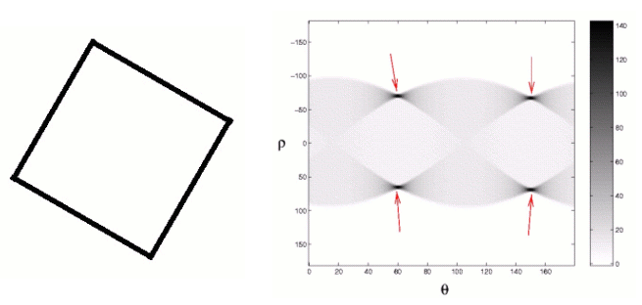

The key point to note in these two images is that the four straight lines making up the sides of the square show up as points of high intensity (arrowed) in the Radon transform. The arrowed points give both the orientation of the lines and their distances from the centre of the square. The reasons that lines give large values for $R$at certain points is that an X-ray passing straight through a line is strongly absorbed, whereas one which misses it, even slightly, is hardly absorbed at all.

Listen to our [podcast](https://plus.maths.org/podcasts/PlusPodcastJune08_2.mp3) on the Fourier transform.

Basically the Radon transform is good at finding straight lines in an image. One method for finding $u(x,y)$, called the *filtered back projection algorithm*, works (roughly) by assuming that the original image is made up of straight lines and drawing those corresponding to the high values of $R$. This method is fast but not particularly accurate. However, it is possible to find $u(x,y)$accurately and quickly, and algorithms to do this are implemented in the scanning devices. The original development of such devices uses a mathematical object known as *Fourier transform* to invert Radon transforms. If you're up for some serious maths, read the [section on how this is done](https://plus.maths.org/issue47/features/budd/maths.html). Most of the maths here is university level, but the section contains some lovely mathematical ideas.

Tomography has many applications quite different from those in medicine. An interesting example comes from archaeology, where tomography was used to determine the cause of Tutankhamen's death. A CAT scan of the mummy revealed a swelling in the knee, indicating that death was the result of a massive infection. The cause of this was probably an injury inflicted by a fall. Whether Tutankhamen was pushed or fell by accident, however, will have to remain a mystery which even a CAT scanner cannot solve.

More generally, we can apply tomography to any problem where we have information about the average of a function along a straight line. It can also be used to find evidence for straight lines in an image (such as the edge of an object). We will now describe two examples of how tomography is used.

**Tomography, GPS and how to land an aircraft safely**

Orbiting the Earth are a large number of GPS satellites that are transmitting radio signals down to the ground. If you can detect the signals and find the phase difference between the signals from several different satellites, then you can work out your location with a high degree of accuracy. GPS positioning methods are very widely used by aircraft navigation systems, SATNAV devices and hikers. However, one of the problems with this system is that variations in the *ionosphere* (the upper part of the Earth's atmosphere) can affect the radio signals and change their phase by small amounts. This phase change can lead to errors in the position given by the GPS system. These are not very large and are perfectly acceptable for navigating. However, when landing an aeroplane it is vital that its height is known to very high precision and even small GPS errors can have large consequences. Here an accurate understanding of the state of the ionosphere is essential.

There are many other reasons why understanding the ionosphere is important. Chief amongst these is that fact that the ionosphere has a very significant effect on the propagation of radio waves and on communication in general. Roughly speaking, radio waves can bounce off the ionosphere, greatly increasing the range of a radio transmitter.

Remarkably, it is possible to monitor the state of the ionosphere using tomography. In the problem of imaging a patient we shone X-rays through their body. To image the ionosphere we use the transmissions from the GPS satellites. These form a very convenient set of "straight lines" passing through the ionosphere. The paths that they take are shown in the figure below.

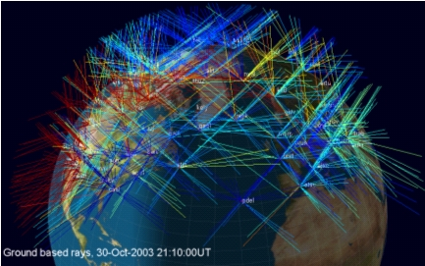

The phase of the radio waves is affected by the electron content of the atmosphere, so that the total change in the phase is proportional to the integral of the electron density along the ray path. If we can measure these phase changes, then we can estimate the electron density integrals and work out the Radon transform of the electron density. We seem to be in exactly the same situation as in the medical imaging problem and hence able to work out the electron density at any point in the atmosphere.

Well, not quite. There are two big differences between this problem and the CAT problem. Firstly, the satellites are usually moving relative to the Earth. Secondly, there are large parts of the Earth's surface where we cannot make any measurements. These include the oceans, where there are no receivers for the satellite signals, and the poles, which do not have satellites orbiting above them. Thus we have a lot less information than we had in the case of the CAT scanner. This means that we are often in the situation of the milk deliverer who couldn't distinguish between two different arrangements of milk bottles, each of which led to the same set of measurements.

To get round this problem in the case of the ionosphere, we have to use a-priori information about the state of the ionosphere, or in other words a reasoned guess of what the solution should look like. This will allow us to reject one solution which doesn't look like this guess and to choose the solution which looks as much like the guess as possible. Fortunately, we understand the physics of the ionosphere well enough for our reasoned guess to be pretty close to the truth. By doing this (together with some other clever refinements) it is possible to use tomography to find the state of the ionosphere. In the figures below we illustrate a calculation (using the MIDAS software developed at the University of Bath) of an ionospheric storm (in red) developing over the southern part of the USA.

|  |  |  |
| --- | --- | --- |
| Image showing an ionospheric storm. | Image showing an ionospheric storm. | Image showing an ionospheric storm. |

**Detecting land-mines**

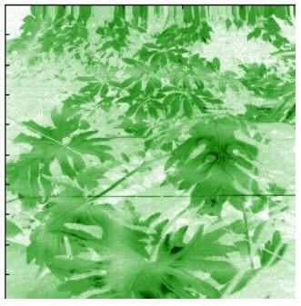

Can you find the three trip-wires hidden in this image?

Anti-personnel land-mines are one of the nastiest aspects of the modern warfare. They are typically triggered by almost invisible trip-wires attached to the detonators. Any algorithm for the detection of trip-wires must work quickly and not get confused by the leaves and foliage that obscure the wire. An example of the problem that such an algorithm has to face is given in the figure below, in which some trip-wires are hidden in an artificial jungle.

Finding trip-wires involves finding partly obscured straight lines in an image. Fortunately, just such a method exists; it is the Radon transform! For the problem of finding the trip-wires we don't need to find the inverse, instead we can apply the Radon transform directly to the image. Of course life isn't quite as simple as this for real images of trip-wires, and some extra work has to be done to detect them. In order to apply the Radon transform the image must first be pre-processed to enhance any edges. Following the application of the transform to the enhanced image a threshold must then be applied to the resulting values to distinguish between true straight lines caused by trip-wires (corresponding to large values of R) and false lines caused by short leaf stems (for which R is not quite as large).

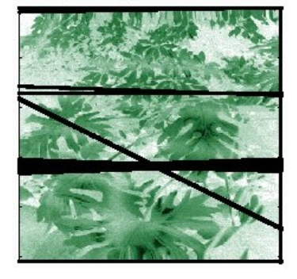

Following a sequence of calibration calculations and analytical estimates with a number of different images, it is possible to derive a fast algorithm which detects the trip-wires by first filtering the image, then applying the Radon transform, then applying a threshold and then applying the inverse Radon transform. The result of applying this method to the previous image is given on the left, with the three detected trip-wires are highlighted.

Note how the method has not only detected the trip-wires, but, from the width of the lines, an indication is given of the reliability of the calculation.