OTC REST API Guide

T-Systems International

Version 0.1

Last revised 2016.02.07

**Draft**

- Internal -

Contents

T-Systems International 1

Metadata of Document 4

Joint Underwriting (optional) 4

Proof of Releases 5

Valid Documents 5

Change History 5

Short Description 5

1 Introduction 6

2 Preconditions 6

2.1 Access 6

2.2 Packages 6

3 Service Overview 6

4 OTC CLI Interface 7

5 OTC CLI Functionality 7

5.1 Configuration functions 7

5.1.1 User configuration 7

5.1.2 Proxy Configuration 7

5.2 Output formats 8

5.3 IAM Features 8

5.3.1 Generate IAM Token Based on Username and Password 8

5.4 ECS features 8

5.4.1 List ECS instances 8

5.4.2 Get ECS instance details 9

5.4.3 Get ECS quotas information 9

5.4.4 Create ECS instances 9

5.4.5 List public IP address 10

5.4.6 Allocate-address 10

5.4.7 Allocate-address 10

5.4.8 List cloud images 11

5.4.9 Start-Stop-Restart instances 11

5.5 Volume features 12

5.5.1 List Volumes 12

5.5.2 Create Volumes 12

5.5.3 Attach Volume 12

5.5.4 Detach Volume 12

5.5.5 Delete Volume 13

5.6 Backup functions 13

5.6.1 List backups 13

5.6.2 Create backup 14

5.6.3 Delete backup 14

5.7 S3 Features 14

5.7.1 Create Bucket 14

5.7.2 List Bucket 14

5.7.3 List Bucket Objects 14

5.7.4 Get File Content 15

5.7.5 Upload Content 15

5.7.6 Download Content 15

5.8 VPC features 15

5.8.1 List Virtual Private Clouds 15

5.8.2 Create New Virtual Private Clouds 16

5.8.3 List Subnets of VPC 16

5.8.4 Create Subnet 16

5.8.5 List Security Groups 16

5.8.6 Create Security Group 17

5.8.7 Create Security Group Rule 17

5.8.8 List flavors 17

6 Obtaining a Project ID 17

7 AK and SK Generation 18

Imprint

|  |  |  |
| --- | --- | --- |
| Publisher | | |
| T-Systems International GmbH  PIA | | |
|  |  |  |
| Filename | Document Number | Document Designation |
| API-Guide-REST_vXX.docx |  | OTC API document |
|  |  |  |
| Version | Stand | Status |
| 0.3 | 08.01.2016 | DRAFT |
|  |  |  |
| Author | Content Reviewed by | Released by |
| Zsolt Nagy | - | Zsolt Nagy |
| Budapest, 06.02.2016 | Budapest, -.01.2016 | Budapest,07.02.2016 |
|  |  |  |
| Contact | Phone / Fax | E-Mail |
| Zsolt Nagy | +205800369 | [Z.Nagy@t-systems.com](mailto:Z.Nagy@t-systems.com) |
|  |  |  |

Metadata of Document

|  |  |
| --- | --- |
| Title of document | API-Guide-REST_v01.docx |
| Scope | CSS |
| Kind of Document | API-Guide-REST_v01.docx |
| Privacy | Internal |
| Publishing Organisation | PIA |
| Owner of Document | Kurt Garloff, Wenner, Sebastian, |
| Author | Zsolt Nagy |
| Process | INM, CHM, PRM, |
| Language | EN |
| Review Interval | 1 year |
| Preserve Period | 1 year |

Joint Underwriting (optional)

|  |  |  |  |
| --- | --- | --- | --- |
| Scope | Name | Date |  |
|  |  |  |  |
|  |  |  |  |
|  |  |  |  |
|  |  |  |  |
|  |  |  |  |

Proof of Releases

By signing, this document is released as a mandatory instruction for employees.  
Preceding versions are invalid from its release date on.

|  |  |  |  |
| --- | --- | --- | --- |
|  | Coordinated (Author) | formal checked (Editor) | released (Owner) |
| Name |  |  |  |
| Date |  |  |  |

Valid Documents

|  |  |
| --- | --- |
| File Name | Remarks |
|  |  |
|  |  |
|  |  |

Change History

|  |  |  |  |
| --- | --- | --- | --- |
| Version | Date | Author | Changes / Remarks |
| 0.1 | 06.02.2016. | Zsolt Nagy | Creation |
|  |  |  |  |
|  |  |  |  |
|  |  |  |  |
|  |  |  |  |
|  |  |  |  |
|  |  |  |  |
|  |  |  |  |
|  |  |  |  |
|  |  |  |  |

Short Description

This documentation contains how you can add new user to the Open Telecom Cloud.

# Introduction

This document describes how should use Huawei REST interface via OTC console applications.

# Preconditions

## Access

* HTTPS access to OTC machines. ( if your DNS not resolving the OTC host then following could be added to “host” file
  + 46.29.103.37 ecs.eu-de.otc.t-systems.com
  + 46.29.103.37 evs.eu-de.otc.t-systems.com
  + 46.29.103.37 vbs.eu-de.otc.t-systems.com
  + 46.29.103.37 ims.eu-de.otc.t-systems.com
  + 46.29.103.37 vpc.eu-de.otc.t-systems.com
  + 46.29.103.37 elb.eu-de.otc.t-systems.com
  + 46.29.103.37 ces.eu-de.otc.t-systems.com
  + 46.29.103.37 as.eu-de.otc.t-systems.com
  + 46.29.103.37 rds.eu-de.otc.t-systems.com
  + 46.29.103.37 antiddos.eu-de.otc.t-systems.com
  + 46.29.103.37 iam.eu-de.otc.t-systems.com
  + 46.29.103.37 cae.eu-de.otc.t-systems.com
  + 46.29.103.37 container.eu-de.otc.t-systems.com
  + 46.29.103.37 vdi.eu-de.otc.t-systems.com

## Packages

* At least Java 1.7 version need to run otc client

# Service Overview

This service based on a Huawei Cloud API interfaces. Detailed description available in following documents.

**Huawei API interface documents:**

* Auto Scaling API Reference 20160115 01.pdf
* Cloud Eye Service API Reference 20160115 01.pdf
* Elastic Cloud Server API Reference 20160115 01.pdf
* Elastic Load Balance API Reference 20160115 01.pdf
* Elastic Volume Service API Reference 20160115 01.pdf
* Identity and Access Management API Reference 2016-1-11 01 .pdf
* Image Management Service API Reference 20160115 01.pdf
* Object Storage Service API Reference 2016-01-15 01.pdf
* OpenStack API Reference 20160115 01.pdf
* Virtual Private Cloud API Reference 20160115 01.pdf
* Volume Backup Service API Reference 20160115 01.pdf

# OTC CLI Interface

Purposes of the OTC Tool to manage OTC via command line similar way than AWS with AWS cli tools . OTC Cli provides common interface to operation team and external DEVOPS to manage their cloud services.

# OTC CLI Functionality

## Configuration functions

OTC client tool could use environment variable or internal configuration. (one method mandatory to use the tool)

### Environment Variable Configuration

**Mandatory**

OS_USERNAME="XXXXXXX OTC0000000000100000YYYY"

OS_PASSWORD=XXXXXXXXXXXXXXXXXXXXXXX

**Optional for S3 access**

S3_ACCESS_KEY_ID=XXXXXXXXXXXXXXXXXXXXX

S3_SECRET_ACCESS_KEY=XXXXXXXXXXXXXXXXXXXXXXXXXXXXXXXXX

**Examples (linux):**

export OS_USERNAME="XXXXXXX OTC0000000000100000YYYY"

export OS_PASSWORD=XXXXXXXXXXXXXXXXXXXXXXX

**Optional for S3 access**

export S3_ACCESS_KEY_ID=XXXXXXXXXXXXXXXXXXXXX

export S3_SECRET_ACCESS_KEY=XXXXXXXXXXXXXXXXXXXXXXXXXXXXXXXXX

### User configuration with Configure Command

**Command:**

otc configure

**Output:**

Enter a Username:

12345678901234567890123456789012

Enter a API Key:

123456789012345678901234

Enter a Access Key:

XXXXXVNOMK0UXXXX

Enter a Secret Key:

XXXXlQ7nNvBXXXXXXXXXXXXXXXXXXXXXX

### Proxy Configuration

**Command:**

otc configure-proxy

**Output:**

Enter a proxy host:

qhub03.hu.t-internal.com

Enter a proxy port:

3128

(use values what using in your system )

## Output formats

**Command:**

otc main_command subcommand --output [table, json, text] (default: table)

**Examples:**

otc ecs describe-instances --output json

otc ecs describe-instances 09bdd206-b48f-482e-b64b-34f376b75c91 --output text

otc ecs describe-flavors --output table

## Queries

Otc cli tool provide services to define special filters on top of the query result. This feature could be usefull if you want to get specific subset of the result. For this filtering/quering functionality this the JSON path library. (<https://github.com/jayway/JsonPath>)

**Command:**

otc [main command] [sub command] –query “[query specification]”

**Examples:**

**List all VM id:**

otc ecs describe-instances --query ".id"

**List groupid, portmin field where name security group name contains "default":**

otc ecs describe-security-groups --output json --query "$..security_groups[?(@.name =~ /.*default/i)].security_group_rules[*].['security_group_id','port_range_min']"

## IAM Features

### Generate IAM Token Based on Username and Password

**Command:**

otc iam token

**Output:**

generated token.

## ECS features

### List ECS instances

**Command:**

otc ecs describe-instances

**Output:**

+------------------------------------+-----------------------+

|id |name |

+------------------------------------+-----------------------+

|f1c2d1e0-36fb-443e-ac18-eab70706235c|instancename |

|b6c602b1-06d0-4bdb-b764-5d43b47abc14|ecs-3dce |

|097da903-ab95-44f3-bb5d-5fc08dfb6cc3|ecs-8e83 |

+------------------------------------+-----------------------+

### Get ECS instance details

**Command:**

otc ecs describe-instances --instance-ids [instance-id]

Example:

**Output:**

+----------------------------------------------------+------------------------------------------------------+

|Key |Value |

+----------------------------------------------------+------------------------------------------------------+

|server.status | |

|server.updated | |

|server.hostId |ACTIVE |

|server.OS-EXT-SRV-ATTR:host |2016-03-04T09:13:55Z |

|server.addresses.a86336d6-6.OS-EXT-IPS-MAC:mac_addr |deb765850ebd5f097bb74fd51cebe1559cda61fbfb374 |

|server.addresses.a86336d6-6.version |pod01.eu-de-01 |

|server.addresses.a86336d6-6.addr |fa:16:3e:18:95:de |

|server.addresses.a86336d6-6.OS-EXT-IPS:type |4 |

|server.addresses.a86336d6-6.OS-EXT-IPS-MAC:mac_addr |10.0.0.33 |

|server.addresses.a86336d6-6.version |fixed |

|server.addresses.a86336d6-6.addr |fa:16:3e:18:95:de |

|server.addresses.a86336d6-6.OS-EXT-IPS:type |4 |

|server.links.href |100.64.57.224 |

|server.links.rel |floating |

|server.links.href |https://compute.region.eu-de.otc-tsi.de/v2/1c76b75c91 |

|server.links.rel |self

….. |

+----------------------------------------------------+------------------------------------------------------+

### Get ECS quotas information

**Command:**

ecs describe-quotas

**Output:**

+------------------------------------+---------------------------------+

|Key | Value|

+------------------------------------+---------------------------------+

|quota_set.gigabytes_SAS.reserved | 0|

|quota_set.gigabytes_SAS.limit | -1|

…

|quota_set.snapshots.in_use | 0|

|quota_set.id | 1c95bf65e2724ebbb504abc8a46b0a03|

+------------------------------------+---------------------------------+

### Create ECS instances

**Command:**

otc ecs run-instances --count [number of instances] --admin-pass [amin password of running instance] --instance-type [instance flavour] --instance-name [name of the instance] --image-name [image name] --subnet-name [subnet name] --vpc-name [vpc of instance] -- group-name [security group] --key-name [SSH key] –file[1-5] [target file=source file] [--associate-public-ip-address][ --wait-instance-running]

**Example:**

otc ecs run-instances --count 1 --admin-pass testpass123! --instance-type c1.medium --instance-name instancename --image-name Standard_CentOS_6.7_latest --subnet-name testsubnet --vpc-name testvpc -- group-name testsecgroup --key-name testsshkeypair --file1 /otc/target=/otc/soruce

#### File Injection

Could inject max 5 file with following parameter:

* -- file[1-5] /targetdir/targetfile =/sourcedir/sourcefile

### List public IP address

**Command:**

otc ecs describe- addresses

**Example:**

+-------------------------------------+-------+------------------+-------------------+

|id |status |public_ip_address |private_ip_address |

+-------------------------------------+-------+------------------+-------------------+

|11025575-c178-4f54-9c01-819daca7bxxx |ELB |46.29.96.250 |null |

|23998f53-054b-4372-9875-888c36b38xxx |ACTIVE |46.29.96.1xx |192.168.1.13 |

|3b98fcf0-4fed-4d98-997b-0781c8163xxx |ACTIVE |46.29.96.2xx |192.168.1.12 |

|74e83b91-41e4-4dee-b931-3d9ad92dbxxx |ACTIVE |46.29.96.171 |192.168.1.8 |

|c297424b-2660-46ea-8950-865ef9c95xxx |ACTIVE |46.29.96.212 |192.168.1.10 |

+-------------------------------------+-------+------------------+-------------------+

### Allocate-address

Allocate public ip address from public ip pool

**Command:**

otc ecs allocate-address

**Example:**

otc ecs allocate-address

### Allocate-address

Assodicate public ip with Network Interface Id

**Command:**

otc ecs associate-address --public-ip 46.29.96.246 --network-interface-id [network card (NIC) interface id]

**Example:**

otc ecs associate-address --public-ip 46.29.96.246 --network-interface-id b197b8af-fe63-465f-97b6-5e5b89exxx

### List cloud images

**URL:**

**Command:**

otc ecs describe-images

**Example:**

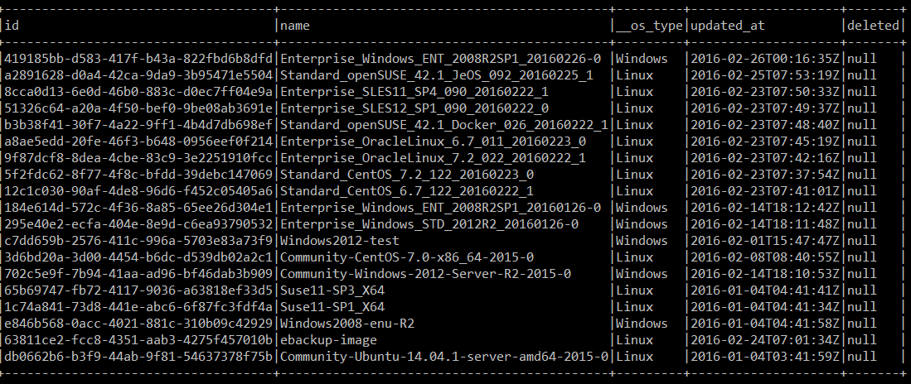

### Start-Stop-Restart instances

**URL:**

<https://ecs.eu-de.otc.t-systems.com/v1/$PROJECT_ID/cloudservers/action>

**Command:**

otc ecs reboot-instances --instance-ids [instance-id]

otc ecs stop-instances --instance-ids [instance-id]

otc ecs start-instances --instance-ids [instance-id]

**Example:**

otc ecs stop-instances --instance-ids b6c602b1-06d0-4bdb-b764-5d43b47XXXXX

{"job_id":"2c9eb2c1532f8bed015332895bXXXX"}

## Volume features

### List Volumes

**Command:**

otc ecs describe-volumes

**Examples:**

+----------------+-------------------+----------+-----+----------+---------+---------------+-----------+

|id |name |volumetype| size|status |bootable |attachments |created_at |

+----------------+-------------------+----------+-----+----------+---------+---------------+-----------+

|b8923533-638c01 |myvolum |SATA | 100|available |false |[] |2016-03-13 |

|c08df08b-ab783e |instanc-volume-0000|SATA | 40|in-use |true |[{server_id=}] |2016-03-10 |

|9719a833-800915 |instanc-volume-0000|SATA | 40|in-use |true |[{server_id=}] |2016-03-10 |

|fbe1f160-378af7 |instanc-volume-0000|SATA | 40|in-use |true |[{server_id=}] |2016-03-10 |

|c14283aa-0cf4a5 |instanc-0000 |SATA | 40|in-use |true |[{server_id=}] |2016-03-09 |

|65e63ef3-137e03 |instanc-0000 |SATA | 40|in-use |true |[{server_id=}] |2016-03-09 |

|e38d9e03-f3372c |instanc-0000 |SATA | 40|in-use |true |[{server_id=}] |2016-03-09 |

+----------------+-------------------+----------+-----+----------+---------+---------------+-----------+

### Create Volumes

**Command:**

otc ecs create-volume --size [size of the disk] --volume-type [volume type: SATA|SSD, SAS]

**Examples:**

otc ecs create-volume --size 100 --volume-type SATA

### Attach Volume

Attach volume to VM instance

**Command:**

otc ecs attach-volume --instance-ids [instance-id] --volume-id [volume id]

**Examples:**

otc ecs attach-volume --instance-ids f344b625-6f73-44f8-ad56-9fcb05a523c4 --volume-id 8c0de9a7-9f61-4613-a68a-21f456cb7298

### Detach Volume

Detach volume from VM instance

**Command:**

otc ecs detach-volume --instance-ids f344b625-6f73-44f8-ad56-9fcb05a523c4 --volume-id 8c0de9a7-9f61-4613-a68a-21f456cb7298

**Examples:**

otc ecs detach-volume --instance-ids f344b625-6f73-44f8-ad56-9fcb05a523c4 --volume-id 8c0de9a7-9f61-4613-a68a-21f456cb7298

### Delete Volume

Delete volume

**Command:**

otc ecs delete-volume --volume-id [volume-id]

**Examples:**

otc ecs delete-volume --volume-id 8c0de9a7-9f61-4613-a68a-21f456cb7298

## Backup functions

### List backups

Command:

ecs describe-snapshots

Example:

+-------------------------------------+-----------------------------------------------------------+

|Key |Value |

+-------------------------------------+-----------------------------------------------------------+

|backups.status |available |

|backups.description |null |

|backups.links.href |https://volume.region.eu-de.otc-tsi.de/v2/xxxxxxxxxxxxxx |

|backups.links.rel |self |

|backups.links.href |https://volume.region.eu-de.otc-tsi.de/1c95bf65e2xxxxxxx |

|backups.links.rel |bookmark |

|backups.availability_zone |eu-de-01 |

|backups.volume_id |b197b8af-fe63-465f-97b6-5e5b89e2xxxx |

|backups.fail_reason |null |

|backups.service_metadata |{\ebk_T_S\: 1, \bootable\: true, \backupurl\: \32332a36-\} |

|backups.id |0c942ff7-454e-494c-8f19-c40ba15e1da7 |

|backups.size |40 |

|backups.object_count |null |

|backups.container |1e000941-72a8-4467-a30b-f3250exxxxxx |

|backups.name |null |

|backups.os-bak-tenant-attr:tenant_id |1c95bf65e2724ebbb504axxxxxxxxxxx |

|backups.created_at |2016-03-08T23:26:13.395891 |

+-------------------------------------+-----------------------------------------------------------+

### Create backup

**Command:**

otc ecs create-snapshot --volume-id [volumeid]

**Example:**

otc ecs create-snapshot --volume-id b197b8af-fe63-465f-97b6-5e5b89e2818d

### Delete backup

**Command:**

otc ecs delete-snapshot --snapshot-id [snapshot id]

**Example:**

otc ecs delete-snapshot --snapshot-id 0c942ff7-454e-494c-8f19-c40ba15e1da7

## S3 Features

### Create Bucket

**Command:**

otc s3api create-bucket [bucketname]

**Example:**

otc s3 create-bucket mybucket

Bucket created: my-bucket

### List Bucket

otc s3 list

+----------+--------+--------------------------------+

|Bucketname|Owner |Owner Id |

+----------+--------+--------------------------------+

|newbucket |MYUSER |XXXXXXXXXXXXXXXX890c9a1673718c2b|

|otccli |MYUSER |XXXXXXXXXXXXXXXX890c9a1673718c2b|

+----------+--------+--------------------------------+

### List Bucket Objects

**Command:**

otc s3 list mybucket/

**Example**

otc s3 list mybucket/

+------------------------+--------+

|File | Size|

+------------------------+--------+

|setup_2016.02.29.exe |37153967|

|setup_2016.02.29.zip |37658811|

|setup_2016.02.29_new.zip|37658759|

+------------------------+--------+

totalItems: 3 totalSize: 112471537

### Get File Content

s3api get-object --bucket [bucket-name] --key [object-name]

### Upload Content

**Command:**

otc s3 cp [local-filename] s3://[bucket-name]/[objectname]

**Example:**

otc s3 cp c:\tmp\setup_2016.02.29.zip s3://otccli/setup_2016.02.29.zip

### Download Content

**Command:**

otc s3 cp s3://[bucket-name]/[objectname] [local-filename]

**Example:**

otc s3 cp s3://mybucket/filename.txt /localdir/filename.txt

## VPC features

### List Virtual Private Clouds

**Command:**

otc vpc list

**Example:**

otc vpc list

+------------------------------------+-----------+------+--------------+

|id |name |status|cidr |

+------------------------------------+-----------+------+--------------+

|a86336d6-6467-XXX5-9df1-4bdca1dbXXXX|myvpc |OK |10.0.0.0/8 |

|ec317f48-3719-XXX0-bef8-4f86daaXXXXX|default-vpc|OK |192.168.0.0/16|

+------------------------------------+-----------+------+--------------+

### Create New Virtual Private Clouds

**Command:**

otc ecs create-vpc --vpc-name [vpcname] --cidr [ciddr]

**Example:**

otc ecs create-vpc --vpc-name testvpc --cidr 10.0.0.0/8

### List Subnets of VPC

**URL:** <https://vpc.eu-de.otc.t-systems.com/v1/$PROJECT_ID/subnets>

**Command:**

otc ecs describe-subnets

**Example:**



### Create Subnet

otc subnet create --subnet-name subnetname --cidr cidr --gateway-ip gateway --primary-dns primary-dns --secondary-dns sec-dns --availability-zone az --vpc-name vpc-name

Example:

otc subnet create --subnet-name testsubnet --cidr 10.0.2.0/8 --gateway-ip 10.0.0.2 --primary-dns 217.150.148.148 --secondary-dns 195.244.235.14 --availability-zone eu-de-01 --vpc-name testvpc

### List Security Groups

**URL:** <https://vpc.eu-de.otc.t-systems.com/v1/$PROJECT_ID/security-groups>

**Command:**

otc ecs describe-security-groups

**Output:**

+-------------------------------+---------------------------+-------------------------+

|id |name |vpc_id |

+-------------------------------+---------------------------+-------------------------+

|437549af-5350-4edb-b41d8b1d20c9|default |a86336d6-6467-4045-db7155|

|bcb07057-c84f-4c71-d391ed901c04|testsecgroup |a86336d6-6467-4045-db7155|

|d08659b9-a0b7-4276-8cde863cbd85|default |default |

|e4c694e1-f69e-4776-03f3cfe3c663|default |ec317f48-3719-4d90-a8985f|

+-------------------------------+---------------------------+-------------------------+

### Create Security Group

**Command:**

otc ecs securitecs y-group create –group-name [security-group name] --vpc-name [vpcname ]

**Example:**

otc security-group create –group-name testsecgroup --vpc-name testvpc

### Create Security Group Rule

**Command:**

otc ecs authorize-security-group-[ingress|egress] --security-group-name gorupname --protocol protocol --ethertype IPv4-IPv6 --portmin portstart –portmax portend

**Example:**

otc ecs authorize-security-group-ingress --security-group-name testsecgroup --protocol tcp --ethertype IPv4 --portmin 80 --portmax 80

### List flavors

**URL:** <https://ecs.eu-de.otc.t-systems.com/v1/$PROJECT_ID/cloudservers/flavors>

**Command:**

otc ecs describe-flavors

# Obtaining a Project ID

A project ID (the project ID can be project_id or tenant_id because project_id has the same meaning as tenant_id in this document)

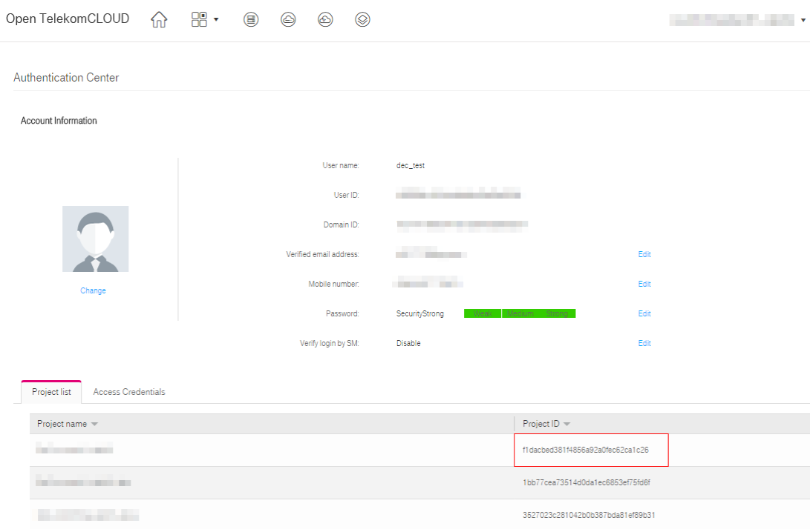

# AK and SK Generation

Sign up and log in to the management console, and click Authentication Center in the upper right corner of the page.

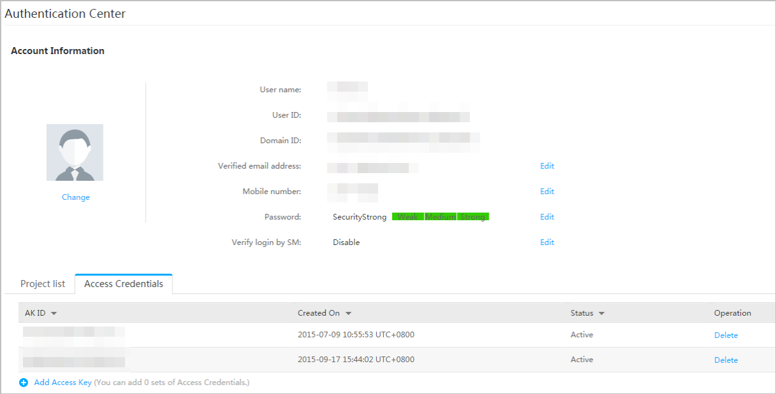

Click Add Access Key, and the Add Access Key page is displayed

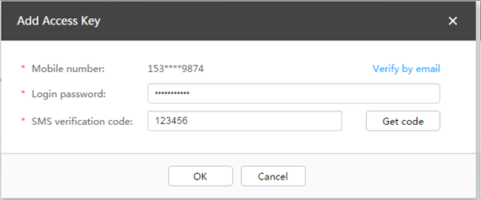

Enter the password ( YOUR PASSWORD ) and the short message verification code, and click OK to download the access key (CSV file) and keep the key secure.