OTC REST API Guide

T-Systems International

Version 0.1

Last revised 2016.02.07

**Draft**

- Internal -

Table of Contents

manage

Imprint

|  |  |  |
| --- | --- | --- |
| Publisher | | |
| T-Systems International GmbH Computing Services & Solutions  PIA HU | | |
|  |  |  |
| Filename | Document Number | Document Designation |
| API-Guide-REST_vXX.docx |  | OTC API document |
|  |  |  |
| Version | Stand | Status |
| 0.1 | 08.01.2016 | DRAFT |
|  |  |  |
| Author | Content Reviewed by | Released by |
| Zsolt Nagy | - | Zsolt Nagy |
| Budapest, 06.02.2016 | Budapest, -.01.2016 | Budapest,07.02.2016 |
|  |  |  |
| Contact | Phone / Fax | E-Mail |
| Zsolt Nagy | +205800369 | [Z.Nagy@t-systems.com](mailto:Z.Nagy@t-systems.com) |
|  |  |  |

Metadata of Document

|  |  |
| --- | --- |
| Title of document | API-Guide-REST_v01.docx |
| Scope | CSS |
| Kind of Document | API-Guide-REST_v01.docx |
| Privacy | Internal |
| Publishing Organisation | PIA |
| Owner of Document | Wenner, Sebastian |
| Author | Zsolt Nagy |
| Process | INM, CHM, PRM, |
| Language | EN |
| Review Interval | 1 year |
| Preserve Period | 1 year |

Joint Underwriting (optional)

|  |  |  |  |
| --- | --- | --- | --- |
| Scope | Name | Date |  |
|  |  |  |  |
|  |  |  |  |
|  |  |  |  |
|  |  |  |  |
|  |  |  |  |

Proof of Releases

By signing, this document is released as a mandatory instruction for employees.  
Preceding versions are invalid from its release date on.

|  |  |  |  |
| --- | --- | --- | --- |
|  | Coordinated (Author) | formal checked (Editor) | released (Owner) |
| Name |  |  |  |
| Date |  |  |  |

Valid Documents

|  |  |
| --- | --- |
| File Name | Remarks |
|  |  |
|  |  |
|  |  |

Change History

|  |  |  |  |
| --- | --- | --- | --- |
| Version | Date | Author | Changes / Remarks |
| 0.1 | 06.02.2016. | Zsolt Nagy | Creation |
|  |  |  |  |
|  |  |  |  |
|  |  |  |  |
|  |  |  |  |
|  |  |  |  |
|  |  |  |  |
|  |  |  |  |
|  |  |  |  |
|  |  |  |  |

Short Description

This documentation contains how you can add new user to the Open Telecom Cloud.

# Introduction

This document describes how should use OTC API via Huawie REST interface.

# Preconditions

## Access

HTTPS access to OTC machines.

# Service Overview

This service based on a Huawei Cloud API interfaces. Detailed description available in following documents.

**Huawei API interface documents:**

* Auto Scaling API Reference 20160115 01.pdf
* Cloud Eye Service API Reference 20160115 01.pdf
* Elastic Cloud Server API Reference 20160115 01.pdf
* Elastic Load Balance API Reference 20160115 01.pdf
* Elastic Volume Service API Reference 20160115 01.pdf
* Identity and Access Management API Reference 2016-1-11 01 .pdf
* Image Management Service API Reference 20160115 01.pdf
* Object Storage Service API Reference 2016-01-15 01.pdf
* OpenStack API Reference 20160115 01.pdf
* Virtual Private Cloud API Reference 20160115 01.pdf
* Volume Backup Service API Reference 20160115 01.pdf

# OTC CLI Interface

Purposes of the OTC Tool to manage OTC via command line similar way than AWS with AWS cli tools . OTC Cli provides common interface to operation team and external DEVOPS to manage their cloud services.

# OTC CLI Functionality

## IAM Features

URL: <https://iam.eu-de.otc.t-systems.com/v3/auth/tokens>

### Generate IAM Token Based on Username and Password

**JSON Request:**

{

"auth": {

"identity": {

"methods": [

"password"

],

"password": {

"user": {

"name": "'"$USERNAME"'",

"password": "'"$PASSWORD"'",

"domain": {

"name": "'"$USERNAME"'"

}

}

}

},

"scope": {

"project": {

"id": "'"$PROJECT_ID"'"

}

}

}

}

otc iam token

## ECS features

### List ECS instances

otc ecs list

### Create ECS instances

(use defaults from environment configuration file (otc_env.sh)

otc ecs create

**JSON Request:**

{

"server": {

"availability_zone": "eu-de-01",

"name": "'"$INSTANCE_NAME"'",

"imageRef": "'"$IMAGE_ID"'",

"root_volume": {

"volumetype": "SATA"

},

"flavorRef": "'"$INSTANCE_TYPE"'",

"vpcid": "'"$VPCID"'",

"security_groups": [

{

"id": "'"$SECUGROUP"'"

}

],

"nics": [

{

"subnet_id": "'"$SUBNETID"'"

}

],

"adminPass": "'"$ADMINPASS"'",

"count": '"$NUMCOUNT"',

"},": {

"__vnc_keymap": "de"

}

}

}

### Create Multiple ECS instances with default parameters

otc ecs create --count 2

### Create multiple ECS instances with custom parameters

./otc ecs create --count 2 --admin-pass testpass123! --instance-type computev1-1 --instance-name tt3 --image-name Community-CentOS-7.0-x86_64-2015-0 --subnet-name testsubnet --vpc-name testvpc --security-group-name testsecgroup

### List cloud images

**URL:**

<https://ims.eu-de.otc.t-systems.com/v2/images>

otc images list

### Start-Stop-Restart instances

**URL:**

<https://ecs.eu-de.otc.t-systems.com/v1/$PROJECT_ID/cloudservers/action>

otc ecs reboot-instances instance-id

otc ecs stop-instances instance-id

otc ecs start-instances instance-id

**JSON request:**

{

"'"$ECSACTION"'":

{

"type":"'"$ECSACTIONTYPE"'",

"servers": [ { "id": "'"$ECSACTIONSERVERID"'" }]

}

}'

## S3 Features

export S3_ACCESS_KEY_ID=YOUR ACCESS KEY

export S3_SECRET_ACCESS_KEY=YOUR SECRET KEY

export S3_HOSTNAME=obs.otc.t-systems.com

### Create Bucket

otc s3 create newbucket

### List Bucket

otc s3 list

### List files in Specific Bucket

otc s3 list mybucket/

### Get File Content

otc s3 get mybucket/myfile.txt

### Upload Content

otc s3 put mybucket/myfile.txt filename=/tmp/myfile.txt

## VPC features

### List Virtual Private Clouds

URL: <https://vpc.eu-de.otc.t-systems.com/v1/$PROJECT_ID/vpcs>

otc vpc list

### Create New Virtual Private Clouds

otc vpc create --vpc-name testvpc --cidr ciddr

eg:

otc vpc create --vpc-name testvpc --cidr 10.0.0.0/8

### List Subnets of VPC

**URL:** <https://vpc.eu-de.otc.t-systems.com/v1/$PROJECT_ID/subnets>

otc subnet list

### Create Subnet

otc subnet create --subnet-name subnetname --cidr cidr --gateway-ip gateway --primary-dns primary-dns --secondary-dns sec-dns --availability-zone az --vpc-name vpc-name

example:

otc subnet create --subnet-name testsubnet --cidr 10.0.2.0/8 --gateway-ip 10.0.0.2 --primary-dns 217.150.148.148 --secondary-dns 195.244.235.14 --availability-zone eu-de-01 --vpc-name testvpc

### List Security Groups

**URL:** <https://vpc.eu-de.otc.t-systems.com/v1/$PROJECT_ID/security-groups>

otc security-group list

### Create Security Group

otc security-group create -g security-group name --vpc-name vpcname

eg:

otc security-group create -g testsecgroup --vpc-name testvpc

### List flavors

**URL:** <https://ecs.eu-de.otc.t-systems.com/v1/$PROJECT_ID/cloudservers/flavors>

otc flavors list

# Obtaining a Project ID

A project ID (the project ID can be project_id or tenant_id because project_id has the same meaning as tenant_id in this document)

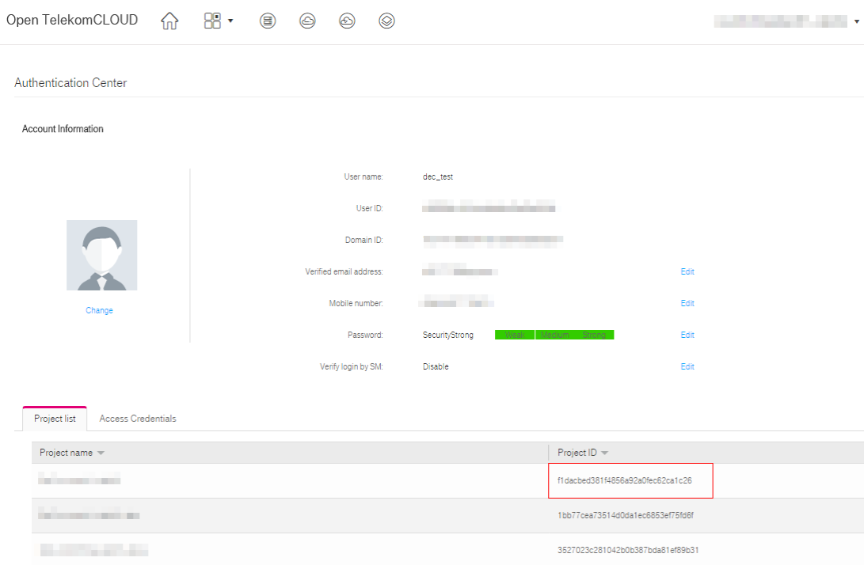

# AK and SK Generation

Sign up and log in to the management console, and click Authentication Center in the upper right corner of the page.

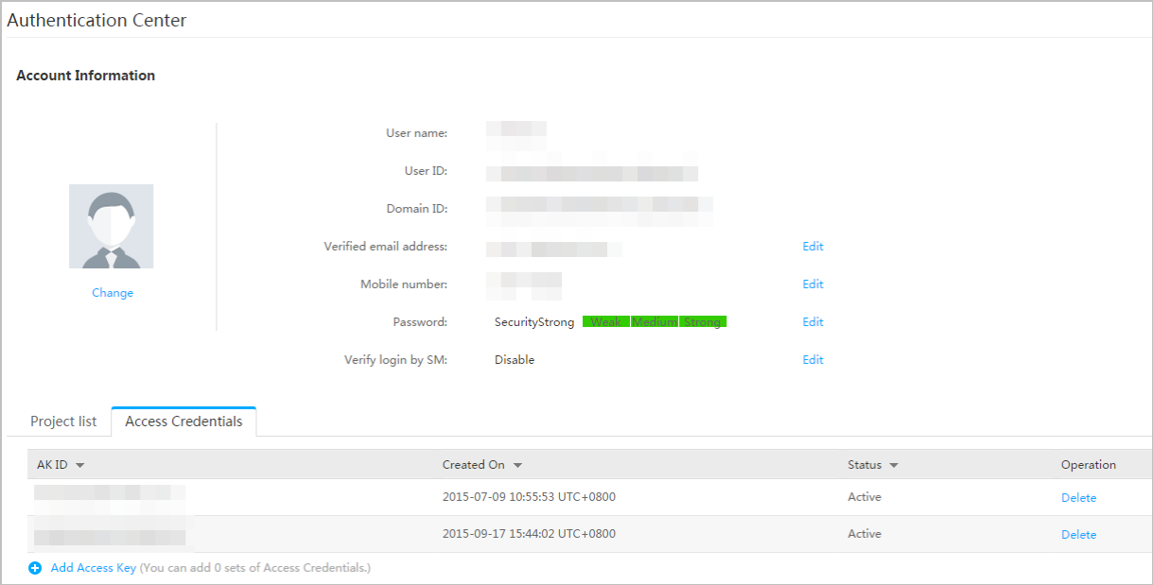

Click Add Access Key, and the Add Access Key page is displayed

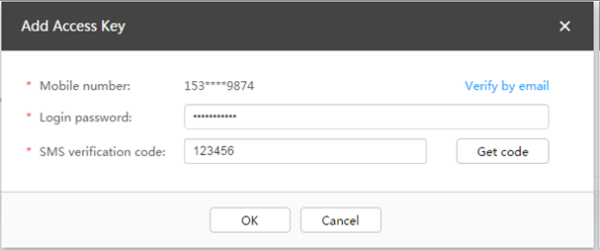

Enter the password ( YOUR PASSWORD ) and the short message verification code, and click OK to download the access key (CSV file) and keep the key secure.